Supplementary Material of the paper:

Depth and Spatial variation of the Shear Wave attenuation parameters in the shallow crust and lower crust/upper mantle of Mt. Etna (Italy)

Giampiccolo Elisabetta¹, Tuvè Tiziana¹, Bianco Francesca², Del Pezzo Edoardo^{2,3}.

¹INGV Osservatorio Etneo. Piazza Roma 2, Catania, Italy.
²Osservatorio vesuviano. Via Diocleziano, 328. 80124 Napoli, Italy
³Andalusian Institute of Geophysics. University of Granada, 18071. Granada, Spain

This supplementary material contains information about data and methods. It consists of two Tables with information about seismic stations and the number of data used (Table S1 and S2).
It contains also Table S3, Table S4, and Figure 1S that show details useful to address the reliability of computed attenuation parameters among distinct sectors.
Table S1: Coordinates of the stations of Mt. Etna Seismic Network used for the present study
Station | Long. E | Lat. N
EBCN | 14.986 | 37.752
EBDA | 15.122 | 37.634
EBEL | 15.008 | 37.740
EBEM | 15.010 | 37.730
ECAN | 14.907 | 37.889
ECBD | 15.087 | 37.780
ECCS | 15.064 | 37.711
ECHR | 14.913 | 37.686
ECNE | 15.002 | 37.765
ECNV | 14.713 | 37.596
ECPN | 14.987 | 37.744
ECTS | 15.121 | 37.883
ECZM | 14.904 | 37.731
EFIU | 15.210 | 37.790
EMCN | 15.034 | 37.791
EMFO | 15.090 | 37.736
EMFS | 14.998 | 37.720
EMGR | 15.007 | 37.670
EMNR | 15.026 | 37.817
EMPL | 14.970 | 37.679
EMSA | 14.945 | 37.498
EMSG | 14.950 | 37.822
ENIC | 15.022 | 37.631
EPCM | 14.956 | 37.746
EPDN | 15.017 | 37.766
EPIT | 15.057 | 37.811
EPLC | 14.986 | 37.765
EPMN | 15.177 | 37.820
EPOZ | 15.189 | 37.672
EPZF | 14.876 | 37.829
ESAL | 15.135 | 37.755
ESCV | 14.815 | 37.747
ESLN | 14.974 | 37.693
ESML | 14.879 | 37.618
ESPC | 15.027 | 37.693
ESVO | 14.947 | 37.773
ETAR | 15.059 | 37.663
ETFI | 14.998 | 37.739
EVRN | 15.136 | 37.689
EZPO | 15.107 | 37.824

Table S2. Number of waveforms used for the attenuation study, for each depth range and sector investigated.

Depth | Total | NE | NW | SE | SW
0-15 km | 14,277 | 5863 | 1863 | 3271 | 3460
15-40 km | 2008 | 262 | 1201 | 126 | 419

Table S3. Measured B₀ and Le⁻¹ and corresponding Quality Factors, together with the 1-sigma uncertainties, in each sector for the depth range 0-15 km. The number of waveforms used for the inversion in each sector is also reported (N.W.).

Sector | N.W. | f(Hz) | B₀ | Le⁻¹ | Q_{i}⁻¹ | Q_{s}⁻¹ | Q_{t}⁻¹
NE |  | 1.5 | 0.80±0.0 | 0.068±0.002 | 0.0051±0.0002 | 0.0200±0.0008 | 0.0252±0.0010
NE | 5683 | 3 | 0.60±0.0 | 0.064±0.0 | 0.0048±0.0 | 0.0071±0.0 | 0.0119±0.0
NE |  | 6 | 0.45±0.050 | 0.072±0.008 | 0.0037±0.0007 | 0.0030±0.0003 | 0.0067±0.0010
NE |  | 12 | 0.30±0.075 | 0.044±0.008 | 0.0014±0.0003 | 0.0006±0.0002 | 0.0020±0.0005
NW |  | 1.5 | 0.80±0.0 | 0.052±0.060 | 0.0039±0.0006 | 0.0155±0.0023 | 0.0193±0.0029
NW | 1863 | 3 | 0.65±0.025 | 0.068±0.010 | 0.0044±0.0011 | 0.0082±0.0021 | 0.0126±0.0032
NW |  | 6 | 0.55±0.075 | 0.088±0.018 | 0.0037±0.0012 | 0.0045±0.0020 | 0.0082±0.0032
NW |  | 12 | 0.25±0.10 | 0.040±0.010 | 0.0014±0.0004 | 0.0005±0.0002 | 0.0019±0.0006
SE |  | 1.5 | 0.85±0.0 | 0.092±0.004 | 0.0051±0.0003 | 0.0290±0.0017 | 0.0342±0.0020
SE | 3271 | 3 | 0.75±0.0 | 0.108±0.020 | 0.0050±0.0001 | 0.0150±0.0004 | 0.0200±0.0005
SE |  | 6 | 0.50±0.075 | 0.072±0.016 | 0.0033±0.0047 | 0.0034±0.0020 | 0.0067±0.0067
SE |  | 12 | 0.20±0.10 | 0.024±0.006 | 0.0009±0.0003 | 0.0002±0.0001 | 0.0011±0.0004
SW |  | 1.5 | 0.85±0.0 | 0.084±0.006 | 0.0047±0.0004 | 0.0265±0.0024 | 0.0312±0.0028
SW | 3460 | 3 | 0.75±0.0 | 0.104±0.002 | 0.0048±0.0004 | 0.0145±0.0012 | 0.0193±0.0016
SW |  | 6 | 0.65±0.025 | 0.116±0.010 | 0.0038±0.0004 | 0.0070±0.0010 | 0.0108±0.0014
SW |  | 12 | 0.45±0.125 | 0.052±0.018 | 0.0013±0.0011 | 0.0011±0.0007 | 0.0024±0.0018

Table S4. Measured B₀ and Le⁻¹ and corresponding Quality Factors, together with the 1-sigma uncertainties, in each sector for the depth range 15-40 km. The number of waveforms used for the inversion in each sector is also reported (N.W.).

Sector | N.W. | f(Hz) | B₀ | Le⁻¹ | Q_{i}⁻¹ | Q_{s}⁻¹ | Q_{t}⁻¹
NE |  | 1.5 | 0.85±0.0 | 0.104±0.050 | 0.0058±0.0033 | 0.0328±0.0189 | 0.0386±0.0222
NE | 262 | 3 | 0.75±0.150 | 0.108±0.044 | 0.0050±0.0031 | 0.0150±0.0075 | 0.0201±0.0106
NE |  | 6 | 0.50±0.100 | 0.056±0.020 | 0.0026±0.0057 | 0.0026±0.0021 | 0.0052±0.0078
NE |  | 12 | 0.25±0.125 | 0.028±0.014 | 0.0010±0.0007 | 0.0003±0.0001 | 0.0013±0.0008
NW |  | 1.5 | 0.75±0.025 | 0.040±0.012 | 0.0037±0.0012 | 0.0111±0.0039 | 0.0149±0.0051
NW | 1201 | 3 | 0.65±0.025 | 0.056±0.006 | 0.0036±0.0006 | 0.0068±0.0013 | 0.0104±0.0019
NW |  | 6 | 0.40±0.150 | 0.036±0.026 | 0.0020±0.0029 | 0.0013±0.0009 | 0.0033±0.0038
NW |  | 12 | 0.40±0.050 | 0.036±0.004 | 0.0010±0.0002 | 0.0007±0.0 | 0.0017±0.0002
SE |  | 1.5 | 0.85±0.050 | 0.032±0.034 | 0.0018±0.0010 | 0.0101±0.0090 | 0.0119±0.0100
SE | 126 | 3 | 0.70±0.125 | 0.048±0.052 | 0.0027±0.0043 | 0.0062±0.0040 | 0.0089±0.0083
SE |  | 6 | 0.65±0.175 | 0.068±0.050 | 0.0022±0.0018 | 0.0041±0.0020 | 0.0063±0.0038
SE |  | 12 | 0.55±0.175 | 0.040±0.046 | 0.0008±0.0027 | 0.0010±0.0008 | 0.0019±0.0035
SW |  | 1.5 | 0.80±0.0 | 0.052±0.0 | 0.0039±0.0 | 0.0155±0.0 | 0.0193±0.0
SW | 419 | 3 | 0.75±0.0 | 0.068±0.0 | 0.0032±0.0 | 0.0095±0.0 | 0.0126±0.0
SW |  | 6 | 0.55±0.025 | 0.052±0.006 | 0.0022±0.0007 | 0.0027±0.0009 | 0.0048±0.0016
SW |  | 12 | 0.35±0.0 | 0.020±0.0 | 0.0006±0.0 | 0.0003±0.0 | 0.0009±0.0

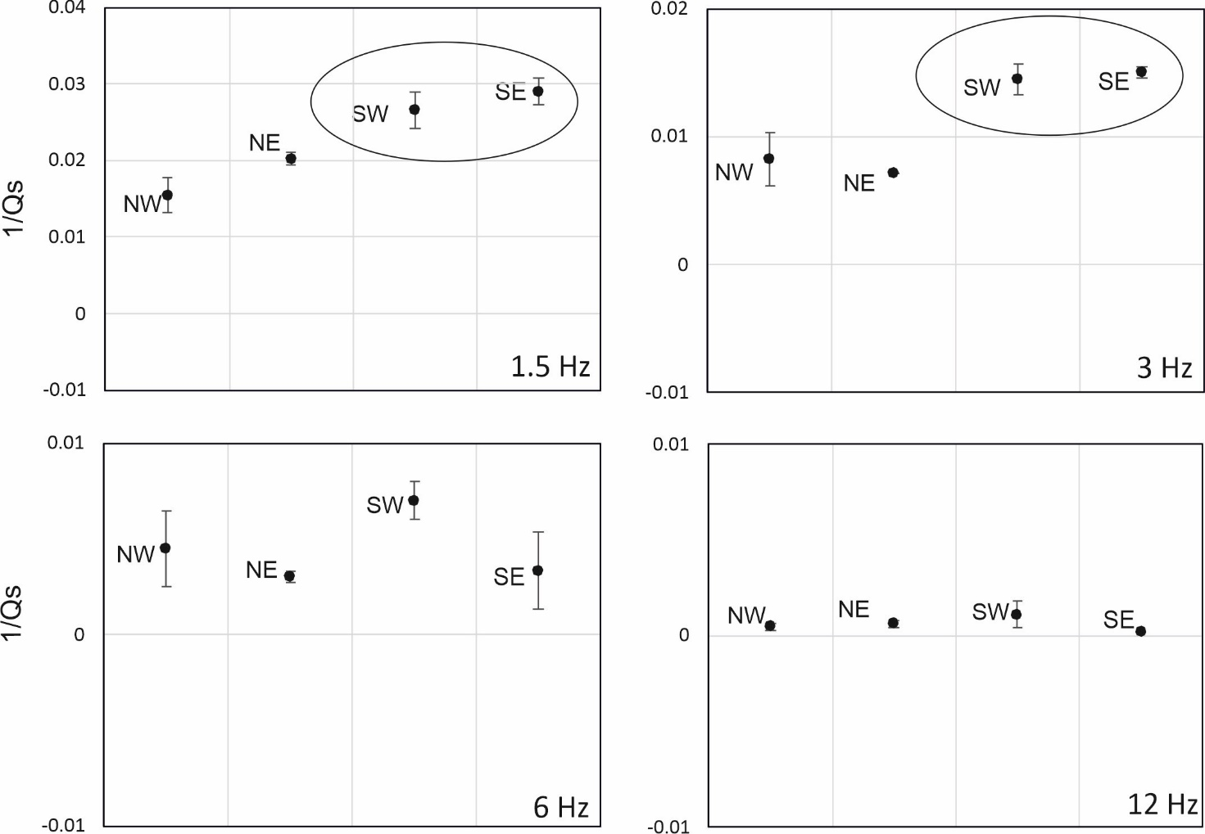

Fig. S1. Inverse of Q_{s} obtained at each frequency and at each sector in the 0-15 km depth range

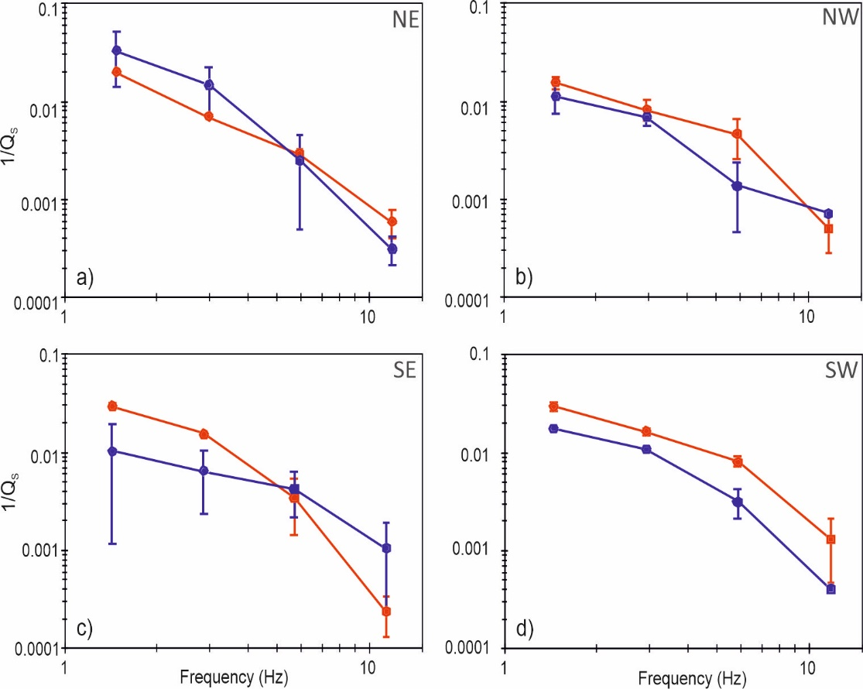

Fig. S2. Inverse of Q_{s} vs. frequency obtained at each sector, for 0- 15 km (red) and 15-40 km (blue) group of earthquakes.

