Pure and Applied Geophysics

Supporting Information for
The Gutenberg–Richter Relation May Not Hold for the Anthropogenic Seismicity
A. Kostoglou¹, B. Orlecka-Sikora¹, S. Lasocki¹, and F. Tong¹

¹Institute of Geophysics, Polish Academy of Sciences, Warsaw, Poland
Corresponding author: Anastasios Kostoglou (tkostoglou@igf.edu.pl)

Contents of this file

Text Supplementary note 1 to Supplementary note 4
Figures S1 to S95
Tables S1 to S18

Introduction
This supporting information includes four supplementary notes to the main article. The first one includes the description of original anthropogenic seismicity datasets and the determination and subsequent testing of the subsets from each catalog. The second one is a breakdown of the power of commonly used exponentiality tests that supports our decision to use the Anderson – Darling test. The third supplementary note is a description of the testing procedure used to evaluate the significance of the b–value variations in the testing of exponentiality of a seismic catalog and finally the fourth supplementary note contains information about the Kernel Density Estimator used in the main article

Supplementary note 1 – Description of anthropogenic seismicity catalogs and determination of subsets for testing.
The anthropogenic seismicity catalogs used to assess the complexity of frequency magnitude distributions were acquired from the EPISODES platform of Thematic Core Service – Anthropogenic Hazards (TCS – AH). In this supplement, we provide a short description about the datasets we used, followed by a more detailed view of the testing process. Specifically, for each Episode we present a short introduction accompanied by a table with the of existing information in the EPISODES platform that were used or considered for the data processing. This is followed by a step-by-step description of the process that supports the selection of seismicity sub-catalogs whose magnitude distributions were tested for non-exponential or complex characteristics. The final results of the testing for non-exponentiality and complexity of sub-catalogs appear on Tables 1, 2 and 3 of the main manuscript.

Geothermal Energy Production

Soultz-Sous-Forêts 2004

Introduction
The Soultz-sous-Forêts 2004 episode involves seismicity associated with the stimulation of GPK4 well. The 2004 and 2005 injections are the only considered injections from Soultz-sous-Forêts site out of the five available datasets of EPISODES platform. The 1993 injection EPISODE contains a break in the FMD likely due to the scaling relationship used to calculate moment magnitudes. The 2000 and 2003 injection EPISODES FMDs contain magnitude bins that are not represented due to the repetitiveness of certain magnitudes. In the 2004 stimulation, the borehole was stimulated two times, once for a low – flow injection to evaluate initial injectivity of the well and subsequently the full stimulation experiment EOST & GEIE EMC. (2018a). Information on the whole dataset is presented in Table S1.

Data analysis
During the first stage of pre–stimulation injection seismicity occurs at very low rates between September 08 and September 12 producing a total of 90 earthquakes. This period is excluded from further investigation due to low amount of data. The stimulation phase starts on September 13 and is immediately followed by high earthquake activity (Fig. S1) which continues to produce 5715 earthquakes until about September 20. Seismic activity appears to occur in a single fault zone (Dorbath et al., 2009), therefore, we decided to consider a single seismicity cluster (Fig. S2).
The curvature of the frequency magnitude distribution is rather shallow (Fig. S3) which causes more conservative completeness calculated with the mGFT method (M_{C} = 0.3) which leaves 694 earthquakes with M≥M_{C}. We calculated the Mc values using an 8 × 8 grid over the study area, confirming that the chosen value of 0.3 is higher than the Mc calculated for any individual grid point (Fig. S4). The cumulative distribution of earthquakes with M≥M_{C} supports the establishment of one period of stationary earthquake rate between September 13 and September 16 with 532 earthquakes (Fig. S5 – P1C11) which occur along the entire area of seismic activity (Fig. S2 – P1C11).
The Anderson–Darling test for the P1C11 subcatalog suggests that exponential distribution can be rejected (H₀¹), and the complexity of the PDF cannot be rejected based on the Multimodality (H₀²) and Multibump (H₀³) tests (Table 1 – Soultz-Sous-Forêts 2004).

Soultz-Sous-Forêts 2005

Introduction
The Soultz-sous-Forêts 2005 episode involves earthquakes associated with the second stimulation of the GPK4 well which occurred during February – March 2005 (EOST, & GEIE EMC., 2018c). Information on the dataset obtained from the EPISODES platform is presented in Table S2.

Data analysis
The catalog contains 3709 earthquakes that occur after four injection incidents (Fig. S5) with a delay of at least a day between injection onset and increase of seismic activity. The epicentral distribution of all earthquakes (Fig. S6) shows seismicity tightly clustered in N–S extending area, similar to the 2004 injection in the Soultz-sous-Forêts field. We do not consider any further clustering and proceed to further processing considering a single spatial cluster. We investigate the complexity of the FMD only for earthquakes related to the first injection which is the most data rich with 2967 earthquakes (Fig. S6).
Similar to the 2004 stimulation, the FMD is rather shallow (Fig. S8), and the M_{C} as calculated by the mGFT method is -0.4, leaving 1303 earthquakes for further examination. The Mc values calculated over a 7×7 grid over the study area, confirm that the chosen value of -0.4 is equal or higher than the Mc calculated for all grid points (Fig. S9). The cumulative earthquake distribution reveals that earthquake occurrence rate can be considered stationary starting a few hours after seismicity onset and for about 36-37 hours after earthquake occurrence onset (Fig. S10). The selected stationary period contains 721 earthquakes. We name the subcatalog containing those events, P1C1.
The Anderson – Darling test for subcatalog P1C1 (Table 1 – Soultz-Sous-Forêts 2005) suggests that exponential distribution of the PDF can be rejected (H₀¹ < 0.05). The multimodality and multibump test suggest the null hypothesis of only one mode and bump of the PDF of P1C1 cannot be rejected, therefore failing to claim PDF complexity with statistical significance (H₀², H₀³ > 0.1).

Cooper Basin 2005

Introduction
The Cooper Basin geothermal field contains 3 catalogs, the one from 2003 is not examined in this study due to inhomogeneities at higher magnitudes and the 2005 and 2012 catalogs presented in the Supplementary notes. The 2005 episode refers to the September 2005 Habanero #1 well stimulation for 13 days.

Data analysis
The 2005 catalog contains 8283 earthquakes (Table S3) which occurred over a period of 19 days. Seismic activity onset is delayed by about 24 hours after injection onset and drops significantly almost immediately after the stopping of injection (Fig. S11). Seismicity is manifested in two clusters, a smaller one to the south which contains about 1800 of the 8283 earthquakes and a larger cluster to the north of the injection point (Fig. S12). The disperse seismicity around the injection well are considered part of the southern cluster. P-wave polarity analysis revealed largely similar fault mechanisms among the events, with only a few exhibiting different orientations (Baisch et al., 2009).
We calculated different magnitudes of completeness for the two clusters. The completeness magnitude is -0.2 for the bigger north cluster and -0.3 for the south cluster (Fig. S13). The spatial distribution of Mc values over a 10x10 grid for the north cluster and a 5x5 grid for the south cluster confirm that the chosen Mc equal or higher than the Mc value in any of the gridded areas (Fig. S14). The cumulative activity was explored separately for the north and south clusters (Fig. S15). The seismicity of the north cluster is continuous with slowly changing rate which allowed us to identify three consecutive stationary periods marked by red (P1C1), green(P2C1) and blue (P3C1) areas in the plot (Fig. S15–Top). For the south cluster we identify two stationary periods, marked by yellow (P4C2) and magenta (P4C2) colors (Fig. S15–bottom).
The Anderson–Darling test for the five selected clusters supports rejection of exponential PDF for the three subclusters of the northern cluster, P1C1 (red), P2C1 (green), P3C1 (blue) and (Table 1 – Cooper Basin 2005). Out of those three clusters only for one of them, P1C1, can be considered to have a complex PDF by the rejected null hypothesis both of the Multibump test (Table 1).

The Geyshers Prati 9 and Prati 29 cluster

Introduction
This catalog documents seismicity induced by fluid injection in the Prati 9 and Prati 29 wells, located in northwestern part of the Geyshers geothermal field in California (IS EPOS 2017a). Seismicity was recorded by a network of 31 short-period surface geophones operated by Lawrence–Berkeley National Laboratory (Kwiatek et al., 2015).

Data Analysis
The catalog contains 1252 earthquakes over a seven-year period, between December 2007 and August 2014 (Table S4), with increased activity corresponding to periods of increased injection rate (Fig. S16). The earthquakes occurred mostly in a single cluster (Fig. S17), with depths between 2 and 3 km, with a few earthquakes in the northernmost and southernmost part of the cluster in depths between 1.5 and 2 km. We did not exclude those events from processing, but they were left unused as they did not belong to a stationary period anyway.
The catalog in the Episodes platform is provided for magnitudes above the magnitude of completeness M_{C} = 1.4 (Kwiatek et al., 2015). The mGFT method suggests an M_{C} equal to 2.0 and therefore we adopt that value (Fig. S18). The spatial distribution of Mc over a 5x5 grid of the study area is always lower than the calculated value of 2.0 for the whole area (Fig. S19). The cumulative earthquake distribution versus time (Fig. S20) allowed the identification of only one period periods of stationary activity rate, P1C1. Smaller stationary periods can also be identified but none contains more than 60 earthquakes.
The Anderson–Darling test for the four selected subcatalog does not suggest the rejection of exponential PDF (Table 1 – The Geyshers) and therefore the Multimodality and Multibump tests were not applied.

St. Gallen

Introduction
The St. Gallen episode catalog includes microseismicity of the Molasse Basin, in northeast Switzerland (IS EPOS, 2018a). A sequence that led to a M3.5 earthquake took place in July 2013 due to stimulation of a borehole well in a fault zone that previously had only one recorded earthquake of M≥3.0 (Diehl et al., 2017).

Data Analysis
The catalog contains 347 earthquakes that occurred in a period of little less than two years (Table S5). The majority of earthquakes were recorded during the 2013 crisis which is also a period of stable network configuration, allowing us to continue with a single magnitude of completeness calculation. The majority of earthquake activity can likely be attributed to the activation of one fault (Fig. S21) with only a few earthquakes occurring at distances of about 500m to the northeast. We selected 316 earthquakes only in the main cluster of seismicity for further analysis.
The magnitude of completeness for the selected cluster of seismicity is M_{C}=-0.6 (Fig. S22), and leaves 273 earthquakes for further processing. The calculated Mc values over a 5x5 grid of the whole area are lower of equal than the calculated value of -0.6 for the whole area (Fig. S23). The cumulative earthquake distribution of earthquakes with M≥M_{C} shows only one stationary period (Fig. S24 – P1C1) with 174 earthquakes, which corresponds to the period of the M3.5 earthquake crisis. We selected this period for further testing.
The Anderson–Darling test did not provide enough statistical evidence to reject the exponentiality null hypothesis for the PDF of the P1C1 subcatalog and therefore we did not proceed to the Multimodality and Multibump tests (Table 1 – Sankt Gallen).

Carbfix

Introduction
The Carbfix episode refers to the CO2 sequestration in the Hengill Area in southwestern Iceland (IS EPOS, 2018b). The seismicity included in the EPISODES platform is related to the Hellisheidi production field which contains numerous wells for direct measurements of temperature and pressure (Gunnarsson et al., 2011) although in the Episodes platform information is somewhat fragmented, i.e., there is information about well positions but rock temperature and well path is provided only about one well and groundwater measurements for another two wells (Table S6).

Data analysis
The 1081 earthquakes included in the catalog form a small number of clusters. (Fig. S25). Since the information of technological activities is not known for every well but also because seismicity is sparse, we examined only the spatial distribution of the catalog. We identified three areas which we call the north, east and center area and two spatial clusters within each area which are noted by separate colors, yellow and cyan for the north area, red and green at the east, magenta and blue for the central ones (Fig. S25 – left). In the case of the central area the blue and magenta clusters are recognized by the epicentral distribution but for the north and east areas depth has to be taken into account (Fig. S26).
The magnitudes of completeness for the two north clusters are M_{C}=1.0 (Fig. S27a,d) leaving too few events to form any stationary subcatalogs (55 events for the yellow colored and 49 events for the cyan colored cluster). For the two clusters in the eastern part of the area of study the completeness is M_{C}=1.0 (Fig. S27b) for the green colored and M_{C}=0.9 (Fig. S27e) for the red colored cluster. Finally, for the two clusters of the central area the completeness level is M_{C}=0.9 for both clusters. For the two eastern clusters and the two central clusters the magnitude of completeness over a 2x2 grid was calculated to access the spatial variability of Mc (Fig. S28). The values estimated the gridded areas are were found to be lower or equal over the calculated values of Fig. S27. The cumulative distribution of earthquakes with M≥M_{C} versus time reveals that stationary rate periods with more than 60 earthquakes can be established only for the magenta colored central subcluster (Fig. S29b) and the red colored eastern subcluster (Fig. S29c).
Finally, the Anderson – Darling test for the two subcatalogs of stationary event rate does not lead to rejection of the exponentiality hypothesis (Table 1 – Carbfix). The Multimodality and Multibump tests were not performed in this case.

Conventional, unconventional hydrocarbon extraction and underground gas storage

Cotton Valley

Introduction
The Cotton Valley episode includes induced earthquakes caused by hydraulic fracturing. It is a study designed by an industry consortium to monitor two wells for the optimization of hydraulic fracture designs and accurately map fracture geometry (IS EPOS, 2019). The episode contains data of one day of injection at the GCU 21–10 well during Stage 2 of the 1st Phase of the experiment (Rutledge et al., 2004).

Data analysis
The episode catalog contains 888 earthquakes that occurred in a single day (Table S7). Seismic activity is related two four injection periods, two of which lasted only a few minutes and did not produce enough earthquakes to test. The third injection lasted little less than an hour and produced an adequate number of events to consider for testing and the final injection period lasted about two and a half hours, producing the bulk of seismicity for this catalog (Fig. S30). Earthquakes occurred in a narrow zone of about 500m length spreading outwards from the injection well (Fig. S31). Even though a small cluster exists at the western edge of seismicity we decided to consider seismicity as a single cluster due to the small distances between this cluster and the main cluster of seismicity.
We estimated a completeness magnitude of M_{C}=-2.0 by the mGFT method (Fig. S32). We calculated the Mc over a 3x3 grid of the area and we observe than in one grid point the value is -1.9, higher than the selected value of -2.0. (Fig. S33). We decided not to change the Mc because the earthquakes in the gridded area where Mc is calculated to be 1.9 occurred during the final period and increasing the Mc would cause the final period to contain 55 events, fewer than the 60 event threshold. But even if we selected Mc=1.9 for that area the results of the AD and multimodality tests are the same as with the selected Mc=2.0. We identified three stationary rate periods (Fig. S34), one during the third injection period (P1C1), one during the fourth injection period (P2C1) and one covering seismic activity after the injection stopped (P3C1).
The Anderson–Darling test (H₀¹) rejects the null hypothesis of exponentiality of the PDF for two of the three examined catalogs, the second one, P2C1, which is related to the last injection period and the last one, P3C1, which is related to post injection seismicity. The Multimodality (H₀²) and Multibump (H₀³) tests for those two catalogs suggest that the PDFs of these two magnitude distributions are complex, after the rejection of both the uni-mode and uni-bump null hypotheses for each one (Table 3 – Cotton).

Groningen

Introduction
The Groningen field is a giant natural gas field in the northeastern part of the Netherlands and is the largest natural gas field in Europe (IS EPOS, 2017b). Induced seismicity from the gas production is happening since 1991 and increased rates have been observed since 2003 (Dost et al., 2017).

Data Analysis
The available catalog contains 1889 earthquakes and covers a period between 1986 and 2022 while the station data exist only after April of 2015 (Table S9). Earthquake activity appears to be increased since 2011 (Fig. S35a) which led us to consider that possibly there were changes in the seismic network configuration. There is not adequate information of natural gas production to consider it as a factor in further analysis. In order to consider possible differences in network configurations or any other changes for which we do not have enough data in the platform, we mapped the changes of the completeness level of the data, using a non-overlapping moving window of 60. The completeness level decreases in the end of 2010 (Fig. S35b) which lead us to form three periods with different completeness levels, one being from the beginning of the catalog until the end of January 2011 and the second from February 2011 until mid-February 2015 and the third between mid-Frebruary 2015 and the end of the catalog. We considered earthquakes that belong to the northeastern edge of the recorded seismicity that form a distinct cluster of seismicity in an area that shows higher event density due to the distribution of reservoir compaction (Bourne et al., 2015) (Fig. S36).
The completeness magnitude of the data for the period from the beginning of recordings until the end of January 2011 was calculated to be M_{C}=1.2 (Fig. S37a), an M_{C}=0.9 for the second period until mid-February 2015 (Fig. S37b) and an M_{C}=0.6 for the third and final period. The spatial distribution of the completeness magnitude for each of the identified periods over a 3x3 grid reveals that in the gridded areas the Mc is equal or smallet to the selected Mc for each period over the whole area (Fig. S38)The cumulative earthquake distribution for the first period revealed one stationary rate period (Fig. S39a – P1C1) and for the second period with lower completeness level we identified one stationary rate period, P2C1 (Fig. S39b) and for the third examined subcatalog we identified two stationary periods, P3C1 and P4C1 (Fig 39c).
The Anderson–Darling test null hypothesis for exponential distribution (H₀¹) was not rejected for any of the four examined periods (Table 3 – Groningen). The multimodality and multibump tests were not performed.

Lacq gas field

Introduction
This catalog is related to seismic activity in the LACQ gas field in France IS EPOS (2018c). There are several catalogs to this episode in the EPISODES platform, each one enclosing a larger area as a multiple of the gas reservoir length. We selected the catalog of a size of 3 times the length of the gas reservoir, as this is a distance in which impact on seismicity is larger than randomized regional tectonic seismicity (Grasso et al., 2018).

Data analysis
The catalog contains 489 earthquakes between August 1963 and December 2011 (Table S9) with earthquake activity increasing after about 1995 (Fig. S40a). We excluded 52 earthquakes located at Pyrenean Mountain range to the south, leaving a total of 437 earthquakes for further testing. Due to the changes of the seismic network during this time period we mapped the temporal changes of the magnitude of completeness calculated with the maximum curvature method, by creating a rolling window with a window length of 100 earthquakes and a step of 25 earthquakes. The results (Fig. S40b) suggest that the completeness level of the catalog changes in the beginning of 1996 which leads us to consider two periods, pre 1996 and post 1996. Earthquakes occurred in the vicinity of the gas field area (Fig. S41) and did not require any further clustering.
The magnitude of completeness of the data pre-1996 was estimated to be M_{C}=2.2 (Fig. S42a) and the completeness of the data post 1996 was estimated to be M_{C}=1.8 (Fig. S42b). The spatial distribution of Mc for the two selected periods is equal or lower to the calculated Mc over the whole area for each of the periods (Fig. S43). The cumulative earthquake distribution of earthquakes with M≥M_{C} allows for the identification of one stationary rate period for the catalog pre-1996 (Fig. S44a) named P1C1, and two stationary periods for the catalog post-1996 (Fig. S44b), named P2C1 and P3C1.
The Anderson–Daring test for the reveals that the exponentiality null hypothesis (H₀¹) cannot be rejected for any of the subcatalogs. Subsequently the Multimodality and Multibump tests are not performed (Table 3 – LACQ).

Gazli hydrocarbon field

Introduction
The Gazli catalog refers to seismicity in the vicinity of the Gazli gas field in Uzbekistan (IS EPOS, 2019b). Three earthquakes with M7.0 have occurred in the area in 1976 and 1984 in a region where seismicity is low (Bossu et al., 1996) and connected more to the gas field activity rather than residual stress from the strong earthquakes (Plotnikova et al., 1996). There are four catalogs available in the EPISODES platform, a local catalog which contain earthquakes recorded by a local dense network in 1991 and three catalogs defined by the distance of the earthquakes from the gas field (1L, 3L and 10L, where L is the length of the gas field) and cover a larger time period but contain very few data. We selected the local catalog for the data analysis.

Data Analysis
The selected catalog contains 441 earthquakes recorded over a 40-day period (Table S10) with earthquakes occurring at a more or less stable rate that cannot be easily correlated with injected gas volume, because of the sparseness of the injected gas volume dataset (Fig. S45). The majority of the seismic activity is located at distances of about 10 km from the southwest edge of the gas field (Fig. S46). We did not consider earthquakes at longer distances.
We calculated an M_{C}=0.8 with the mGFT method (Fig. S47). The spatial distribution of Mc over a 3x3 grid of the area reveals that Mc in each gridded area is lower than the Mc calculated for the whole area (Fig. S48). The cumulative number of earthquakes with M≥M_{C} allow for the identification of one stationary rate period by visual inspection (Fig. S49), named P1C1 and marked by red colored circles in Fig. S46 and with a red colored area in Fig. S49.
The Anderson – Darling test for exponentiality of the PDF of subcatalog P1C1 does not suggest the rejection of exponential PDF and therefore the Multimodal and Multibump tests are not performed.(Table 3 – Gazli 1991).

Starfish

Introduction
The Starfish episode concerns acoustic emissions induced by the repetitive cooling cycles on a footwall salt block monitored by 16 ultrasonic sensors (IS EPOS, 2017c). The objective of the project was to determine the failure mechanism involved with repeating cooling stages and assess influence of thermal loading of high–frequency gas storage operations on stability of salt cavities.

Data Analysis
The catalog contains 53038 earthquakes of very low magnitudes (Table S11) which occurred during the four periods of heating cycles, with seismic activity peaking during temperature increase in each period and quickly dropping along with temperature decrease (Fig. S50). The size of the test area was a few meters with the bulk of seismicity in the center and fewer earthquakes at the edges. Therefore no further clustering is performed and for each period seismicity is treated as a single cluster (Fig. S51).
For the second and the third heating – cooling cycle we calculated M_{c} equal to -4.6 and -4.8 respectively (Fig. S52c,d). For the first cycle we observe two periods of seismicity, one at the beginning of cooling and one later during a period of steady temperature readings (Fig. 40a). We calculate a different completeness level for each period, M_{c}=-4.2 for the former and M_{c}=-4.3 for the latter (Fig. 42a,b) .Similarly, in the final cycle we observe two periods of cooling, one around January 21 and one around February 04 (Fig. 40d). We calculate M_{c}=-4.7 for the first and M_{c}=-4.8 for the second (Fig. 42e,f). The spatial distribution of Mc over a 5x5 grid in each of the examined subcatalogs is always lower or equal to the calculated Mc for the whole area (Fig. S53).
The cumulative distribution of earthquakes with M≥M_{C} (Fig. S54) reveals that for in every period there is an initial onset of seismicity in which we could identify a stationary rate period (P1C11, P2C1, P3C1, P4C11) with the seismicity rate ever changing afterwards (Fig. S54). Additionally, there is one more stationary period during the first cycle (P1C12) and one stationary period during the second cooling on the fourth cycle (P4C12) (Fig. 54a,d).
The Anderson – Darling test reveals that the exponential distribution can be rejected for all of the examined subcatalogs except for the last. Furthermore, the Multimodality test suggests that all examined subcatalogs except P1C12 and P4C12 are likely complex by the rejection of the uni-bump null hypotheses. The Multibump test suggests multiple bumps for the examined subcatalog of the second and third heating periods (Table 3 – Starfish).

Underground mining

Pyhasalmi Mine

Introduction
The Pyhasalmi mine catalog contains earthquakes caused by underground mining of copper, zinc, and pyrite in Central Finland (IS EPOS, 2017d). The mining area does not contain any faults (Kühn et al., 2013) and microseismic underground network of high sample rates was set up to record seismic activity.

Data Analysis
The catalog contains 7059 earthquakes recorded over a 15-month period (Table S12). Even though there are available information about some of the mine polygons and their temporal advance the information are not adequate to lead the formulation of study areas. We therefore chose several clusters to study over a by attempting to select earthquake clusters in areas with dense seismicity, attempting to avoid blasts. We focus on two areas, the Northeastern cluster of seismicity and the northwestern cluster (Fig. S55a). Seismicity in those areas is tightly clustered which ensures that there will be enough earthquakes after the selection of stationary rate periods to perform the testing.
The magnitude of completeness for the northwestern cluster (Fig. S56a) was estimated to be M_{C}=-1.0 by the mGFT method. The northeastern cluster shows a higher completeness level of M_{C}=-0.9 (Fig. S56b). For both clusters the Mc calculated over a 5x5 grid is lower than the calculated Mc for the whole area (Fig. S57).
The cumulative distribution of earthquakes with M≥M_{C} for both clusters reveal that it is rather hard to define stationary rate periods as there are small jumps in cumulative event rate frequently. We adopted the broader approach, which is to define stationary periods that could include sudden increases in seismic activity when they are short lived and the seismicity rate before and after that is similar. By that approach we selected two periods for the NE cluster (Fig. S58a) forming subclusters P1C1, P2C1 and three periods for the NW cluster (Fig. S58b), forming subclusters P1C2, P2C2, P3C2. The existence of blasts was not found to effect the change of seismicity rate (Fig. 58).
The Anderson – Darling test leads to rejection of the exponentiality for four of the examined subcatalogs. The Multimodality test suggests also that the four subcatalogs are complex which is supported also by the Multibump test for two of those subcatalogs, P2C1 and P3C2 (Table 2 – Pyhasalmi).

Gisos–Cerville

Introduction
The Episode of Gisos–Cerville (IS EPOS, 2017e) contains anthropogenic seismicity due to a well monitored experiment of underground solution mining in the Lorraine Basin, France. The seismic activity in response to the caving and cavity collapses in 2008 and 2009 (Kinscher et al., 2016) was monitored by high-resolution seismic sensors, recording 22455 earthquakes with magnitudes ranging from -2.9 to 1.4.

Data analysis
The earthquake catalog covers a period of one and a half year between March 2008 and September 2009 (Table S13), with the majority of earthquakes occurring between March and June of 2008 (Fig. S59a), and then within a 48-hour period in February 2009 (Fig. S59b). For the 2009 activity higher seismic activity follows increase of the ground water level above sea (Fig. S59b). The earthquake locations reveal that earthquakes occurred in the same area in both the 2008 and 2009 activity (Fig. S60), creating a single cluster for both periods. Therefore, we examine the two periods of seismicity separately considering one spatial cluster.
We calculated a magnitude of completeness of -0.7 for both the 2008 and the 2009 seismic activity (Fig. S61). The spatial distribution of Mc, calculated over a 5×5 grid covering the study area, indicates that in both examined periods, the overall estimated Mc exceeds the values computed for individual grid cells (Fig. S62). By examination of the cumulative activity of earthquakes with M ≥ -0.7 we identified two periods that could be considered stationary for the 2008 seismic activity (Fig. S63a), colored with red (P1C1) and green (P2C1) colors and two periods that could be considered stationary for the 2009 activity (Fig. S63b), colored with blue (P3C1) and yellow (P4C1) colors.
The results of the Anderson – Darling test for those five catalogs shows that in four of those exponential distribution of the PDFs can be rejected with the exception of catalog P3C1. For the subcatalogs P1C1 and P2C1 the multimodality test suggests the likely existence of multiple modes and therefore complexity of the PDF (Table 2 – GISOS-Cerville).

LGCD mines

Introduction
The LGCD episode refers to induced seismicity by the copper ore exploitation of mines in the Legnica Glogow Copper District (LGCD) in Poland, using the room and pillar method. The catalog is compiled from recordings of a surface seismic network at a sampling rate of 100Hz of the Institute of Geophysics of the Polish Academy of Sciences (IG PAS) (IS EPOS, 2017f). Magnitude distributions with complex characteristics have been observed for some seismic zones of the LGCD area (Lasocki & Orlecka-Sikora, 2008; Lasocki, 2001).

Data Analysis
The seismic network configuration can be considered stable after February 10, 2016, as only two stations are added after that period and until the end of the study period. We selected 5159 earthquakes after February 10 of 2016 for further analysis. The mine areas available on the EPISODES platform do not include specific information on mining panels but the epicentral distribution allows for the recognition of seismicity clusters (Fig. S64). We selected visually twelve clusters with more than 100 earthquakes (Fig. S64), to ensure that after the calculation of the magnitude of completeness there would be more than 60 earthquakes after the recognition of stationary rate periods.
The magnitudes of completeness (M_{C}) with the mGFT mehod were calculated for the twelve clusters (Fig. S65; Fig. S66). The magnitudes of completeness were lower for clusters located more centrally (Clusters 3-8) as a result of better coverage from the seismological network. The spatial distribution of Mc for all clusters over a gridded study area reveals that the calculated Mc considering all events is always equal or higher than the calculated Mc for any of the grid areas (Fig. S67; Fig. S68). The plots of the cumulative number of earthquakes with M≥M_{C} allowed for the identification of fifteen stationary seismicity rate periods with more than 60 earthquakes (Fig. S69; Fig. S70) in 9 of the examined clusters (Fig. S71). Clusters 3, 11 and 12 did not contain any stationary rate periods with more than 60 earthquakes.
The Anderson–Darling test of the selected stationary earthquake distribution suggest rejection of exponentiality of the PDFs for seven out of the fifteen subcatalogs. The Multimodality and Multibump tests were applied for those seven subcatalogs plus one more, P1C10, whose H₀¹ value is very close to the 0.05 threshold. Complexity of the distributions can be established with statistical significance only for subcatalog P1C9 (Table 2 – LGCD).

Reservoir Impoundment

Vouglans water reservoir

Introduction
The Vouglans Lake dam, located in valley of Ain River, France, was constructed in 1968 in an area of extremely low seismic activity. Shortly after the construction, a M4.6 earthquake occurred in the vicinity of the reservoir. There are three catalogs in the EPISODES platform refer to seismicity within 1L, 3L and 10L distance from the reservoir center, where L is the reservoir length (IS EPOS, 2018d).

Data analysis
Reservoir triggered seismicity is mostly located the near–field distances (1–3L) rather than the 10L distances (Grasso et al., 2018). In the case of the Vouglans reservoir the 1L catalogs contains too few events (43 earthquakes) and the 3L includes seismicity caused by the complex active deformation in the western Alps (Walpersdorf et al., 2018). For this reason, we selected 167 earthquakes within a circle of about 50 km from the center of the reservoir (Table S15; Fig. S72)
The completeness magnitude of the data is M_{C}1.8 (Fig. S73) as estimated by the mGFT and method. The spatial distribution of Mc over a 2x2 grid of the area reveals that in each of the grid areas the Mc is equal or lower than the calculated Mc for the whole area (Fig. S74). The cumulative earthquake distribution versus time for earthquakes with M≥1.8 suggests one stationary rate period of 112 earthquakes (Fig. S75), named P1C1.
Through the Anderson – Darling test the null hypothesis of exponential distribution cannot be rejected for subcatalog P1C1 and as a result the Multimodality and Multibump tests are not performed (Table 3 – Vouglans).

Val D’ Agri water reservoir

Introduction
The Val D’ Agri EPISODE contains small magnitude earthquakes related to the impoundment of the Pertusillo lake in the southern Apennines, Italy (IS EPOS, 2017g). The fault system of the basin is formed by a NW–SE striking extensional regime (Valoroso et al., 2009). The bulk of microseismicity is located in NW–striking normal faults, SW of the Pertusillo lake and is likely connected with the rapid water level changes of the lake (Valoroso et al., 2009; 2011).

Data Analysis
The catalog contains 1620 earthquakes that cover the whole area around the Pertusillo lake with 1082 of those occurring in the faults system to the SW of the lake (Table S16). We focus on this area and ignore diffuse seismicity around the lake and smaller clusters of seismicity at the NW extension of the fault system. Water level changes of the Pertusillo lake appear to be correlated with seismic activity as unloading of the reservoir is followed by seismicity decrease, loading of the reservoir is followed by slight increase of seismic activity and high-water levels are accompanied by higher earthquake activity levels than other periods (Fig. S76). The earthquakes in the selected area of study occur in an area about 3km to the SW of the lake and cover an area of about 7x4km (Fig. S77).
The magnitude of completeness for the selected cluster of 1082 earthquakes is M_{C}0.2 (Fig. S78). The distribution of Mc in space for a 5x5 grid of the study area is always lower or equal to the calculated Mc for the whole area (Fig. S79). This left 743 earthquakes with M≥0.2 to be plotted in the cumulative earthquake vs time plot (Fig. S80) which allowed for the identification of four stationary rate periods that were used to form four subcatalogs, P1C1 (red area), P2C1 (green area), P3C1 (yellow area) and P4C1 (blue area). The same colors are used in Fig. S77 to identify the epicentral distribution of these subcatalogs.
The Anderson – Darling test for the selected stationary earthquake rate periods show that only for subcatalog P1C1 the PDF can be considered not to be exponential (Table 3 – Val d’ Agri). Furthermore, the Multimodality and Multibump tests for subcatalog P1C1 do not support the hypothesis of a complex distribution by multiple modes or bumps.

Song Tranh 2 deep water reservoir

Introduction
This episode concerns the seismicity caused by the impoundment of the Song Tranh 2 reservoir in central Vietnam (IS EPOS, 2017h). Seismic activity started very soon after the reservoir impoundment (Gahalaut et al., 2016) and is more productive in the immediate vicinity of the reservoir. The investigation of seismicity properties between 2013 and 2015 (Lizurek et al., 2017) illustrated the different properties of the northern and southern parts of the area by examination of fault plane solutions. Five seismicity clusters were recognized and incorporated in this study (Lizurek et al., 2017).

Data Analysis
The catalog covers the period between August 2013 until June 2017 and the seismic network is stable for this period with only some changes in sensors of seismic stations occurring in 2014 and 2015 (Table S17). The evolution of seismicity with water levels was examined separately for the north and south parts of the area (Fig. S81). In the north area the most intense seismic activity occurred during periods of water level unloading in 2014 and during water level maximum in early 2015 (Fig. S81a). In the south area the overall level of background seismicity is lower with some seismic excitations occurring during peak water level periods and one very energetic activity in August 2014 during a low water level period (Fig. S81b).
We adopted the seismicity clusters A–E (Lizurek et al., 2017) with clusters A and E in the north part and clusters B, C and D in the south part of the area. Additionally, we added cluster F in the south part of the area (Fig. S82a). Finally, we selected two smaller clusters A1 and A2 from cluster A to as two subclusters of increased seismicity with subcluster A2 being closer to the reservoir shoreline and Cluster A1 slightly further (Orlecka-Sikora et al., 2023). Cluster E of the north area contains only 77 earthquakes and was not included in further study due to the low number of events.
For subcluster A1 the calculation of the completeness calculated by the mGFT method is 0.9, and for cluster A2 it is 1.0 (Fig. S83). Regarding the clusters of the south part of the region, we calculated M_{C}=0.8 for cluster B and C, M_{C}=1.0 for cluster D and M_{C}=0.7 for cluster F (Fig. S84). We created a 2x2 or 3x3 grid for the areas around the examined clusters and examined the Mc spatial distribution. It is established in for all clusters that the overall calculated Mc is higher than the Mc in each gridded area (Fig. S85). The cumulative plots for earthquakes with M≥M_{C} for each cluster shows one stationary period for cluster A1 of the north area (P1C1) that occurred over a period of about one and a half year, from September 20 2014 until 01 April 2016 (Fig. S86a). Cluster A2 from the northern part of the area has one stationary period (P2C2) between 05 January 2015 and 26 April 2015, which coincides with a period of peaking of the water level of the reservoir (Fig. S86b). The subclusters of the southern part contain only one stationary period (P3C3) with more than 60 earthquakes, which involves earthquakes of cluster C occurring between august 30 and September 03 of 2014, during a period of low water levels in the reservoir (Fig. S86d).
The Anderson – Darling test for the three subcatalogs that refer to stationary periods do not suggest the rejection of exponential distributions for any of the subcatalogs. The two complexity tests are not performed.

Supplementary note 2 – Power of exponentiality tests and information on the applied statistical tests for the exponentiality and complexity of the frequency–magnitude distribution of the anthropogenic earthquakes

2.1 – Testing the power of exponentiality tests
There are several tests to assess whether samples drawn from a distribution follow a specific probability distribution. In previous studies regarding deviation of earthquake data from the Gutenberg–Richter law there are examples of use of the Kolmogorov–Smirnov test (Eaton et al., 2014; Urban et al., 2016), the Lilliefors test (Herrmann & Marzocchi, 2021; Taroni et al., 2021; Herrmann et al., 2022) and the Anderson–Darling test (Leptokaropoulos et al., 2020; Orlecka-Sikora & Cielesta, 2020).
The Kolmogorov–Smirnov (KS) (Massey, 1951) test compares the cumulative distribution function (CDF) of the sample data, $F_{n}\left(x\right)$, with the CDF of the hypothesized distribution, $F(x)$, y calculation of the supremum of the absolute difference at each data point,
$D_{KS}=\sup_{x}|F_{n}\left(x\right)-F(x)$|. (1)
This test requires prior knowledge of the parameters of the hypothesized distribution. Therefore, to perform the test for an exponential distribution, we first fit the data to an exponential model to estimate its parameters. Then, we use the KS test to compare the empirical distribution of the data with the CDF of the fitted exponential distribution.
The Lilliefors (LIL) test (Lilliefors, 1967) is a modified version of the KS test, used when the parameters of the distribution from which data are sampled are unknown and are estimated from the data. The test metric is the maximum of the absolute difference between the sample cumulative distribution $S_{n}(X)$ and the theoretical distribution, $F(X)$ at each data point,
$D_{LIL}=\max_{x}|S_{n}\left(X\right)-F\left(X\right)|$. (2)
The Anderson Darling (AD) test (Anderson & Darling, 1954) is a special case of the Cramer-von Mises test and its test metric is the squared difference between the sample cumulative distribution $F_{n}\left(x\right)$and the theoretical distribution $F(x)$ in the form of:
$D_{AD}=\int_{-∞}^{+∞}{{\left[F_{n}\left(x\right)-F\left(x\right)\right]}^{2}ψ\left(t\right)dt},$ (3)
where $ψ\left(t\right)={[(F\left(x\right)\left(1-F\left(x\right)\right)]}^{-1}$ is a weight function that adds more weight to the tails of the distribution. Comparisons between the aforementioned tests have shown that the one sample KS test is the least powerful while the performance between the AD and LIL tests is similar (Mohd Razali & Bee Wah, 2011; Saculinggan & Balase, 2013). Similar results are obtained for the two-sample KS test against the two-sample AD test showing the superiority of the latter (Engmann & Cousineau, 2011).
We evaluated the ability of those three tests to identify deviations from an exponential distribution at the 0.05 significance level by drawing a progressively higher number of samples (n=20, 30, 40, 50, 60, 70, 80, 90, 100, 200, 300, 400, 500, 600, 700, 800, 900, 1000, 2000, 3000, 4000, 5000, 6000, 7000, 8000, 9000 and 10000) from four cumulative distribution functions (CDFs). The CDFs used to draw samples for testing were calculated from a) a left-truncated exponential PDF with b=1.0, M_{min}=1.0 (Fig. S87a), M_{max}=6.0, which represents a perfect exponential FMD for M≥M_{C}(=M_{min}), b) a concave composite PDF of two exponential distributions with b₁ = 1.0 and b₂ = 1.3, M_{C}=1.5, M_{min}=1.0 and M_{max}=6.0 (Fig. S87b), c) a convex composite PDF of two exponential distributions with b₁ = 1.3 and b₂ = 1.0, M_{C}=1.5, M_{min}=1.0 and M_{max}=6.0 (Fig. S87c), and d) a PDF that is a combination of exponential and normal distributions with b=1.0, M_{min}=1.0, M_{max}=6.0, μ=3.5 and σ=0.3 (Fig. S87d). To further evaluate the sensitivity of the AD test to deviations in the distribution tail we included a test case with a small admixture of a normal distribution centred at μ = 5.0 and σ = 0. 3 (Fig. S87e). The functions that describe the concave and convex PDFs, i.e., a log-linear distribution with a breakdown at M=M_{C}, are described by Utsu et al. (1999). For every sample size, n, we performed the AD, LIL and KS tests 100000 times and then we calculated the median of the p-values for each test. We chose the median instead of the mean value because the distribution of p-values is not necessarily normally distributed. The tests were performed by randomly drawing samples between M_{min} and M_{max} for each sample size.
The results reveal that the AD and LIL tests perform better for the simple exponential distribution and that none of the two outperforms the other consistently (Fig. S88a). The concave composite CDF requires at least 2000 samples for the AD test to reject the null hypothesis and 3000 samples for the KS and LIL tests (Fig. S88b). The results for the convex composite PDF are similar to those of the concave but with 1000 samples needed for the AD test and 2000 for the KS and LIL tests(Fig. S88c). Finally, the mix of exponential and normal distributions with μ=3.5 and σ=0.3 requires at least 60 samples for the AD test to reject the null hypothesis and 90 samples for the KS and LIL tests (Fig. S88d). The mix of exponential distribution and normal with μ=0.5 and σ=0.3 requires as few as 20 samples for the AD test and 30 for the Lilliefors and KS tests (Fig. S88e), further showcasing the sensitivity of the AD test at the distribution tail. for The AD test generally performs better samples drawn from a concave and convex composite CDFs as well as for exponential with normal composite CDF which is the reason behind our choice to apply the AD test for the selected subcatalogs of this study. Furthermore, the minimum of 60 samples needed to reject the null hypothesis in the composite exponential and normal distribution lead us to consider a minimum of 60 earthquake minimum for the examined subclusters.

2.2 – Applied statistical tests for the exponentiality and complexity of the frequency–magnitude distribution of the anthropogenic earthquakes
The Anderson–Darling test for exponential distribution
The Anderson–Darling (AD) test is a statistical test commonly used to evaluate whether a given magnitude distribution—or any sample of a random variable—conforms to a specified theoretical distribution, such as the exponential (Anderson & Darling, 1954; Marsaglia & Marsaglia, 2004). In the context of earthquake frequency magnitude distribution analysis, the b parameter of the Gutenberg–Richter (G–R) law is typically estimated through maximum likelihood estimation (Bender et al., 1983). Subsequently, with the use of (3), the CDF of the magnitude distribution $F_{n}\left(M\right)$ is compared to the CDF of a theoretical exponential distribution that is generated with the b-value that was estimated from the data, expressed as:
$F\left(M\right)=1-e^{-b∙ln10(M-M_{C})}$, (4)
with Mc being the magnitude of completeness. The null hypothesis under the AD test is:

AD test null hypothesis (H₀¹): A magnitude distribution is exponential.

The null hypothesis was tested at the 0.05 significance level. In the cases where H₀¹ < 0.05 the null hypothesis is rejected with the probability of error at less than 0.05.

The multimodality and multibump tests
The smoothed bootstrap multimodality and multibump tests (Silverman, 1986; Efron & Tibshirani, 1998) comprise the non-parametric approach to examine magnitude distributions and were used for subcatalogs where the AD test would reject the null hypothesis of exponentiality. In the context of exponential mixture models, additional modes may appear as local maxima to the right of the global maximum. A bump is an interval [a, b] for which the PDF is concave while outside of this interval it is convex (Fig. S89) (Lasocki & Papadimitriou, 2006). The earthquake magnitude PDF is modeless, except for an artificial mode which is a global maximum corresponding to the magnitude of completeness (Leptokaropoulos et al., 2020). The null hypotheses of the two tests are formed as follows:
Multimodality test null hypothesis (H₀²): The PDF of a magnitude distribution contains only one mode, and
Multibump test null hypothesis (H₀³): The PDF of a magnitude distribution contains no more than one bumps to the right of the global maximum.
The smoothed bootstrap test for multimodality (Silverman, 1986; Efron & Tibshirani, 1993) for a sample data $\left\{M_{i}\right\}$, $i=1,2,3…$, is based on the nonparametric kernel density estimate of the magnitude distribution:
$f\left(M | \left\{M_{i}\right\},h\right)=\frac{1}{nh}\sum_{i=1}^{n}{K\left(\frac{M-M_{i}}{h}\right)}$, (5)
where $h>0$ is a smoothing factor and,
$K\left(ξ\right)=\frac{1}{\sqrt{2π}}\exp\left(-\frac{ξ^{2}}{2}\right)$, (6)
is the Gaussian kernel. The number of modes and bumps in the estimated density decreases as $h$ increases. Two critical smoothing factors are defined, $h_{cr}(1)$, above which the density has only one mode, and $h_{cr}(2)$, above which it has only one bump. These are the reference bandwidths for the null hypotheses of unimodality $(H_{0}^{1})$ and of single bump $(H_{0}^{2})$ respectively and are determined by examining the number of zeros in the first or second derivative of $f$ as $h$ increases in small increments (typically 0.001).
To test the null hypotheses of unimodality $(H_{0}^{1})$ and single-bump structure $(H_{0}^{2})$, smoothed bootstrap samples are generated from the kernel-smoothed distribution $f\left(m | \left\{M_{i}^{\left(k\right)}(l)\right\},h_{cr}(l)\right)$, for $l=1, 2$. Each synthetic sample is constructed as:
$M_{i}^{\left(k\right)}\left(l\right)=M_{i}^{'}+h_{cr}\left(l\right)ε_{i}$, (7)
where $M_{i}^{'}$ is drawn from the original data via bootstrap with replacement, and $ε_{i}$ are random numbers from the kernel $K()$. For each of $R$ resampled datasets, the number of modes or bumps is evaluated from the corresponding derivatives of the estimated PDF. The significance level (p-value) is then computed as the proportion of bootstrap samples that exhibit more than one mode (or bump), indicating deviation from the null hypothesis. A full description of this technique along with the calibration of the test for exponential–like distributions is detailed in Lasocki and Papadimitriou (2006).
For each tested subcatalog, we applied the test by sampling 1000 points from the CDFs and performing 1000 bootstrap iterations. The initial value of the smoothing factor, $h$, was 0.1 and incremented by 0.001. The null hypotheses for both tests were evaluated at the 0.1 significance level.

Supplementary note 3 – Time variations of b–values and effect of b–value variations on exponentiality testing

3.1 – Time Variations of b–values
We examined the b–value variations for the seismicity subclusters that were chosen to investigate deviations from the Gutenber–Richter (GR) distribution. We examined b-value variations in the seismicity subclusters selected to investigate deviations from the Gutenberg–Richter (GR) distribution. To track temporal changes in b-values, we applied a non-overlapping moving window approach, calculating b-values for successive groups of 60 earthquakes. If the number of remaining events in the final window was greater than 55, that group was included in the analysis; otherwise, it was excluded. The b–values were calculated assuming the unbounded GR law, using the maximum likelihood estimate of discrete magnitude values (Bender, 1983) expressed as:
$b=\frac{1}{\ln\left(10\right)\left[〈M〉-\left(M_{C}-\frac{δΜ}{2}\right)\right]}$, (8)
where $M_{C}$ is the magnitude of completeness, $〈M〉$ is the sample mean magnitude of the considered events and $δΜ$ is the round–off interval of the magnitude values.
The subcatalogs from EPISODES related to geothermal energy production are presented in Fig. S90, those related to hydrocarbon extraction and the Starfish episode in Fig. S91, those related to mining in Fig. S92 and those related to reservoir impoundment in Fig. S93.

3.2 - The effect of b–value on exponentiality testing of seismic catalogs
We examined the effect of mixing earthquake Frequency Magnitude Distributions (FMD) with different b–values on the outcome of the Anderson–Darling (A–D) test, used to assess whether the FMDs deviate from exponentiality.
For this test, we created eleven left-hand truncated exponential Probability Density Functions (PDFs) with different b–values, each one containing 1000 elements of magnitudes between M_{min} = 1.0 to from M_{max} = 6.0. The PDFs were created according to the relation (Utsu et al., 1999):
$f_{M}\left(M\right)=β∙exp⁡(-β∙\left(M-M_{min}\right))$, (9)
where,
$β=b∙ln10$. (10)
Each of the eleven PDFs was created with b–values ranging from 0.5 to 1.5 in increments of 0.1.
We drew 100, 200 and 500 samples from the PDFs, representing every b-value. Subsequently, we created mixed distributions consisting of 200 elements (100 with b₁ and 100 with b₂), 400 elements (200 with b₁ and 200 with b₂), and 1000 elements (500 with b₁ and 500 with b₂). The new distributions encompassed every b-value combination between 0.5 and 1.5. Finally, the AD test was applied to the mixed distributions. (Fig. 5).

Supplementary note 4 – The adaptive nonparametric kernel estimator of the magnitude distribution of anthropogenic seismicity

Introduction
Maximum likelihood estimation (MLE) was compared to non-parametric kernel density estimation (KDE) to determine a probability density function from a given set of observations. Three data sets, two synthetic and one from a real seismic catalog, were used in this study. Based on the MLE and KDE results, we could then compute the cumulative density function, exceedance probability, and return period.

4.1 Synthetic Data
Model 1 – Mixture of Two Exponentials
In the first model, a mixture of two exponential distributions was used. These two distributions were defined as:
$f_{m}\left(M\right)=βe^{-β\left(M-M_{min}\right)}$, (11)
where $b=βln10$ is the b-value and $M_{min}=1$ is the minimum magnitude. The b-value of one distribution was set to $b=0.7$ and the other one to $b=1.1$ (Fig. S94).
Using the inverse transform sampling method, 400 observations were drawn, with half coming from the first distribution and the other half from the second distribution. This process was repeated 100000 times.

Model 2 – Exponential Gaussian
In the second model, an exponential function was combined with a gaussian function:
$f_{m}\left(M\right)=0.9 β e^{-β\left(M-M_{min}\right)}+0.1\frac{1}{\sqrt{2π}}e^{-\frac{{\left(M-M_{t}\right)}^{2}}{2σ^{2}} }$, (12)
where $b=βln10$ , $b=1.1$, $M_{min}=1$, $M_{t}=4.5$ , and $σ=0.3$ (Fig. S95). From this distribution, inverse transform sampling was used to draw 400 observations 100000 times.

Real Data - Soultz-Sous-Forets 2004 (SSF04)
The seismic event catalog from the Soultz-Sous-Forets 2004 (SSF04) stimulation (EOST & GEIE EMC, 2018a) was chosen for this study and the time period between 2004-09-13 08:44UTC and 2004-09-16 13:00UTC selected to obtain a suitable number of events. The magnitude of completeness of the catalog in this period was determined to be M_{c} = -1.2. After removing events below M_{c}, there remained 3266 events on which to perform MLE and KDE estimation.

4.2 Density Estimation Methods
We compared the performance of two approaches for estimating the probability density function of the observed data: fitting an exponential (Gutenberg-Richter) distribution using a parametric estimator, and a non-parametric KDE that makes no assumptions about the distribution’s form. For the parametric approach, we employed MLE, a standard method for fitting parametric models to data.

Maximum Likelihood Estimation
Maximum likelihood estimation (MLE) was performed to fit the data to a 2-parameter exponential function of the form:
$f_{m}\left(M\right)=βe^{-β\left(M-M_{c}\right)}$, (13)
where $f_{m}\left(M\right)≥0, β>0, M≥M_{c}$, $b=βln10$ and M_{c} is the minimum magnitude or magnitude of completeness. For the two synthetic data sets (model 1 & 2), the average b-value over the 100000 estimations (Table S18) was used as the resulting probability distribution function (PDF).

Kernel Density Estimation
The non-parametric kernel density estimation (KDE) was done using a diffusion-based kernel density estimator, diffKDE (Pelz & Slawig, 2023). This estimator has three main advantages: (1) consistency at the boundaries, (2) better resolution of multimodal data, and (3) a family of KDEs with different smoothing intensities which can be produced as a by-product of the numerical solution (Pelz et al., 2023). For the two synthetic data sets, the average of the KDE results from the 100000 estimations was used as the resulting PDF.

Exceedance Probability
The exceedance probability was calculated as:
$R=1-e^{-λ(1-F_{m}\left(M\right))Δt}$, (14)
where $λ$ is the activity rate, $Δt$ is the time period, and $F_{m}\left(M\right)$ is the cumulative distribution function (CDF) obtained from performing a cumulative sum of the PDF previously obtained by MLE or KDE. The activity rate $λ$ is the number of observations over a time period $Δt$. For the synthetic models we have 400 observations over some time period that we set to 1, so the activity rate is 400. For the SSF04 catalog, there were 3266 events over a time period of 3.177 days, so the activity rate was 1028 events per day.

Mean Return Period
The Mean Return Period was calculated as:
$T=\frac{1}{λ(1-F_{m}\left(M\right))}$ (15)
where $λ$ is the activity rate and $F_{m}\left(M\right)$ is the CDF.

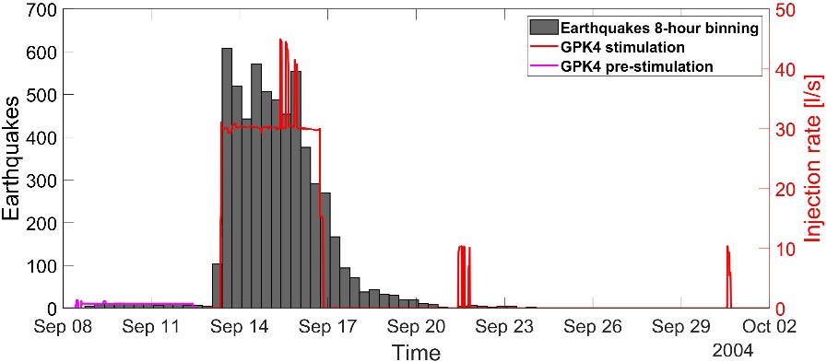

Figure S1. Seismicity of Soultz-sous-Forêts 2004 episode in 8-hour bins (left y-axis, gray histograms), along with injection rate for the GPK4 well during pre and main stimulation (right y-axis, magenta and red line respectively).

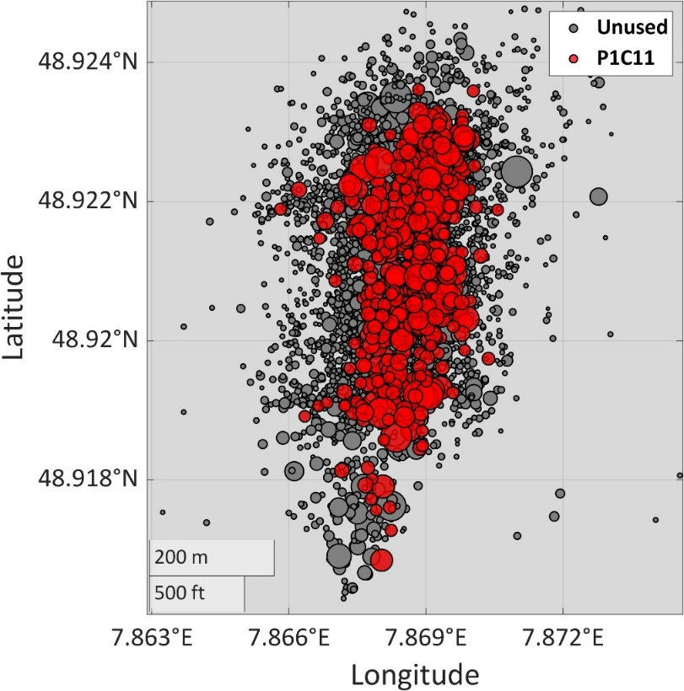

Figure S2. Epicentral distribution of the seismicity of the 5715 earthquakes of Soultz-sous-Forêts, 2004 catalog between September 13 and September 20. The unused earthquakes for magnitude complexity testing are depicted in gray colors. The cluster that was finally selected to assess the magnitude distribution are represented with red color.

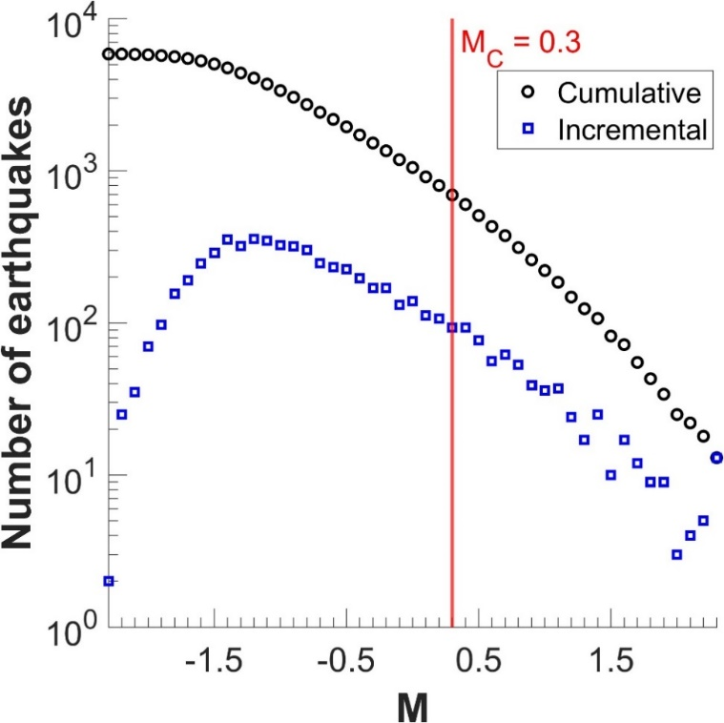

Figure S3. Cumulative and incremental frequency magnitude distributions of the 5715 earthquakes of Soultz-sous-Forêts, 2004 catalog between September 13 and September 20. The chosen magnitude of completeness is marked by the vertical red line.

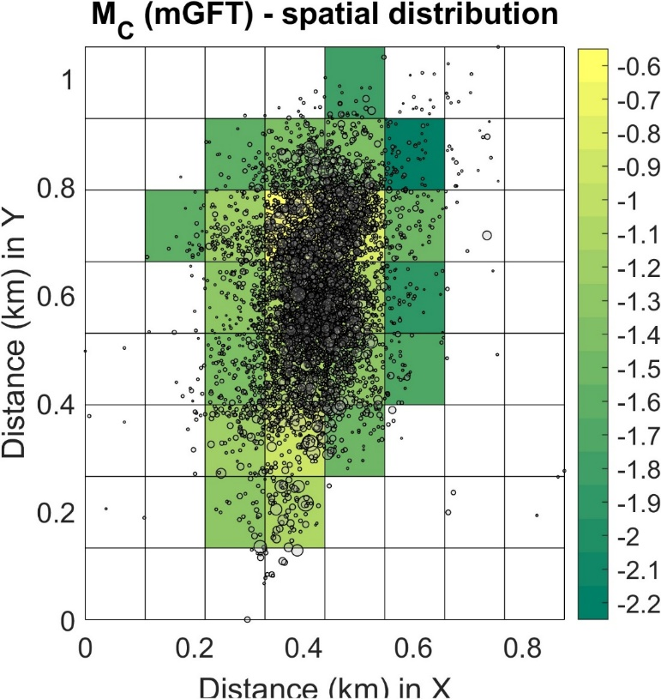

Figure S4. Spatial distribution of the magnitude of completeness over a gridded area for the Soultz-sous-Forêts, 2004 catalog

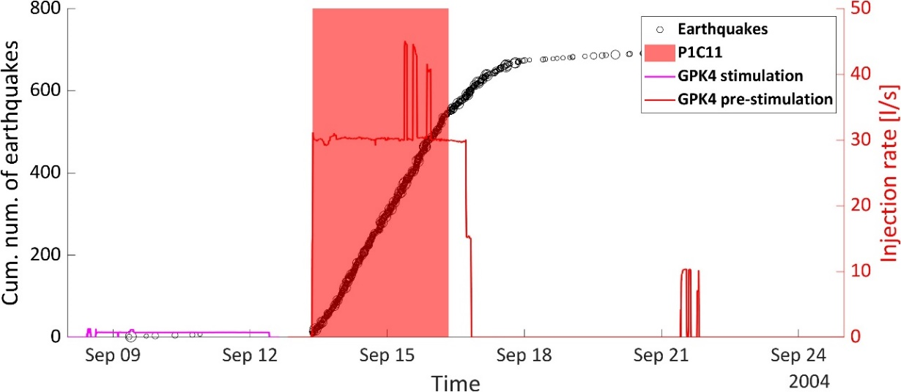

Figure S5. Cumulative number of earthquakes above Mc versus time (Left y-axis) represented with black circles and injection rate versus time represented with red line (right y-axis). The stationary activity rate period is noted with red colored area. The same color is used in Fig. S2 for the epicentral distribution of events in this period.

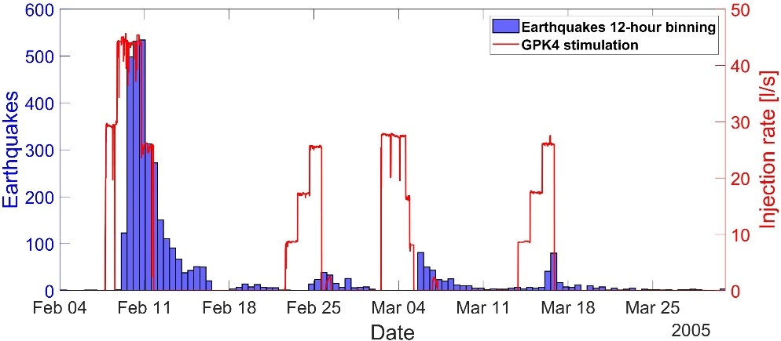

Figure S6. Seismicity of Soultz-sous-Forêts 2005 episode in 12-hour bins (blue histograms), along with injection rate for the GPK4 well (red line).

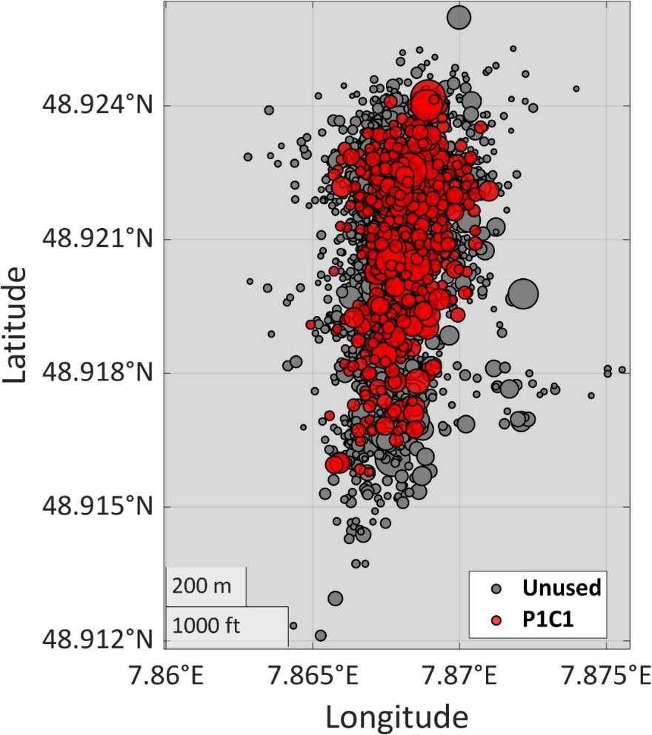

Figure S7. Epicentral distribution of the seismicity of the 3709 earthquakes of Soultz-sous-Forêts, 2005 EPISODE catalog. The unused earthquakes for magnitude complexity testing are depicted in gray colors. The cluster that was finally selected to assess the magnitude distribution are represented with red color.

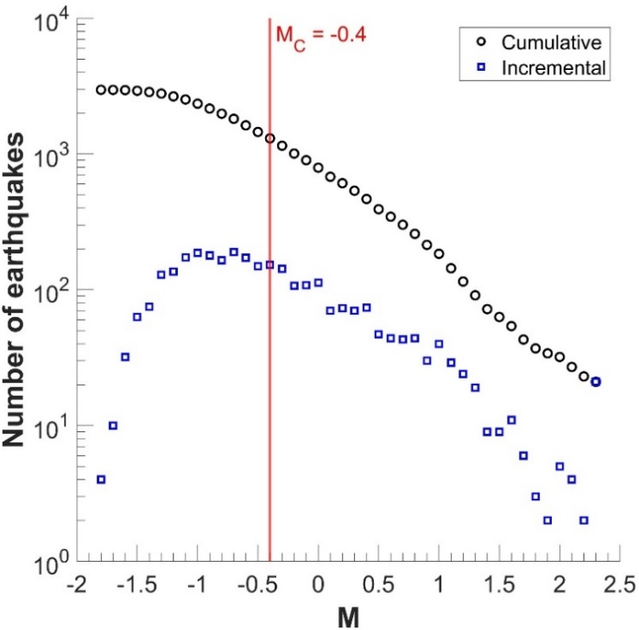

Figure S8. Cumulative and incremental frequency magnitude distributions of the 1373 earthquakes of Soultz-sous-Forêts, 2005 during the first injection. The chosen magnitude of completeness is marked by the vertical red line.

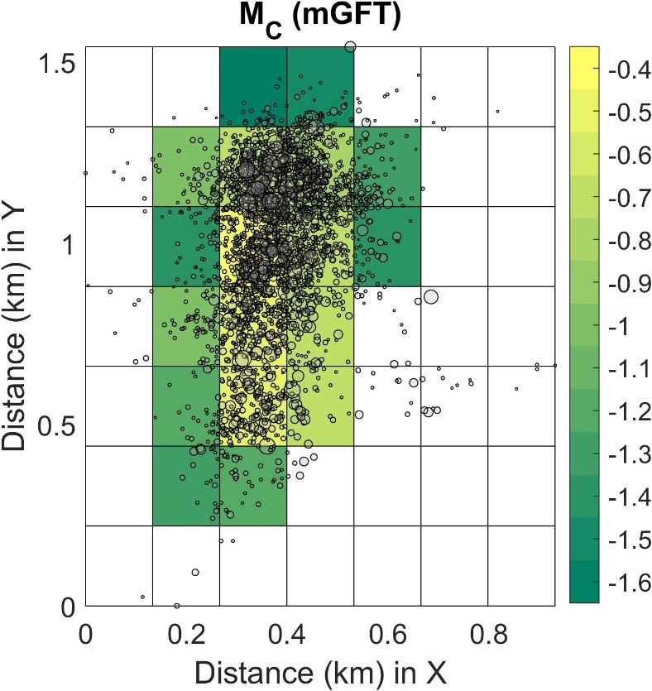

Figure S9. Spatial distribution of the magnitude of completeness over a gridded area for the Soultz-sous-Forêts, 2005 catalog

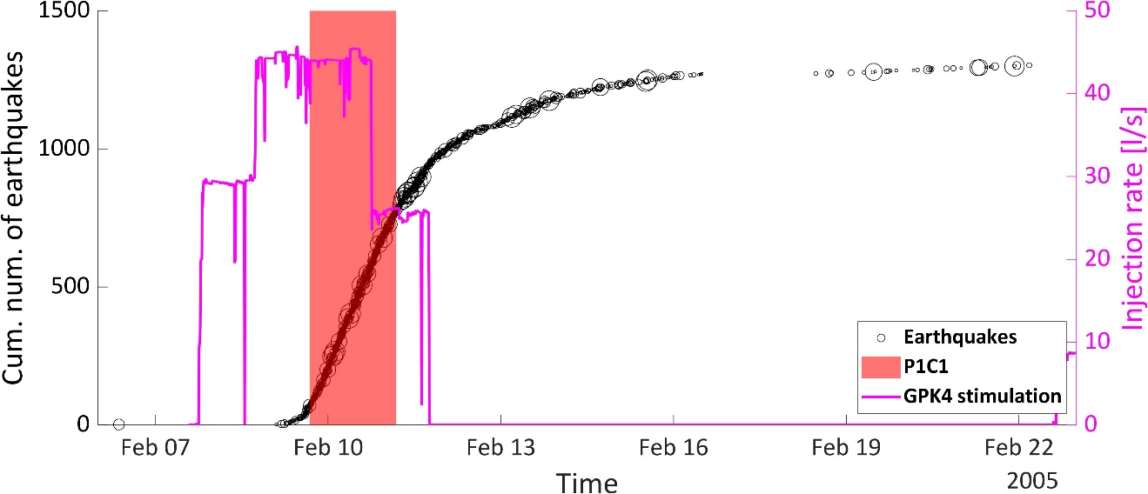

Figure S10. Cumulative number of earthquakes above Mc versus time (Left y-axis) represented with black circles and injection rate versus time represented with red line (right y-axis). The stationary activity rate period is noted with red colored area. The same color is used in Fig. S7 for the epicentral distribution of events in this period.

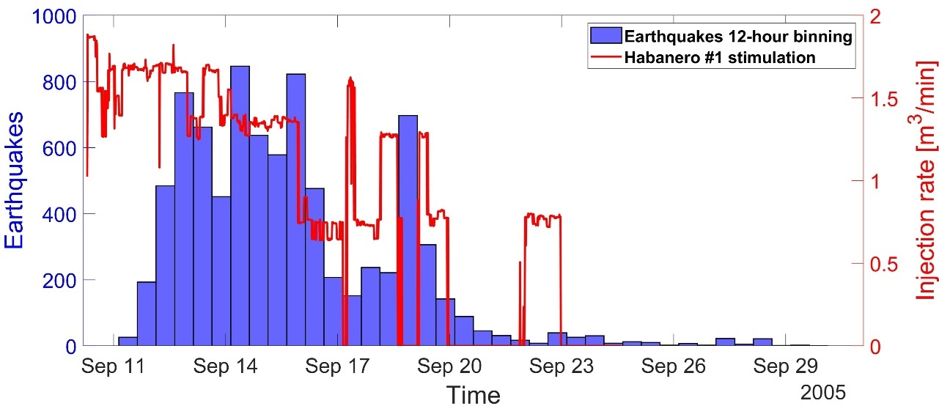

Figure S11. Seismicity caused by the 2005 Habanero well injection in cooper basin in 12-hour bins (left y-axis, blue histograms), along with injection rate for the #1 well (right y-axis, red line).

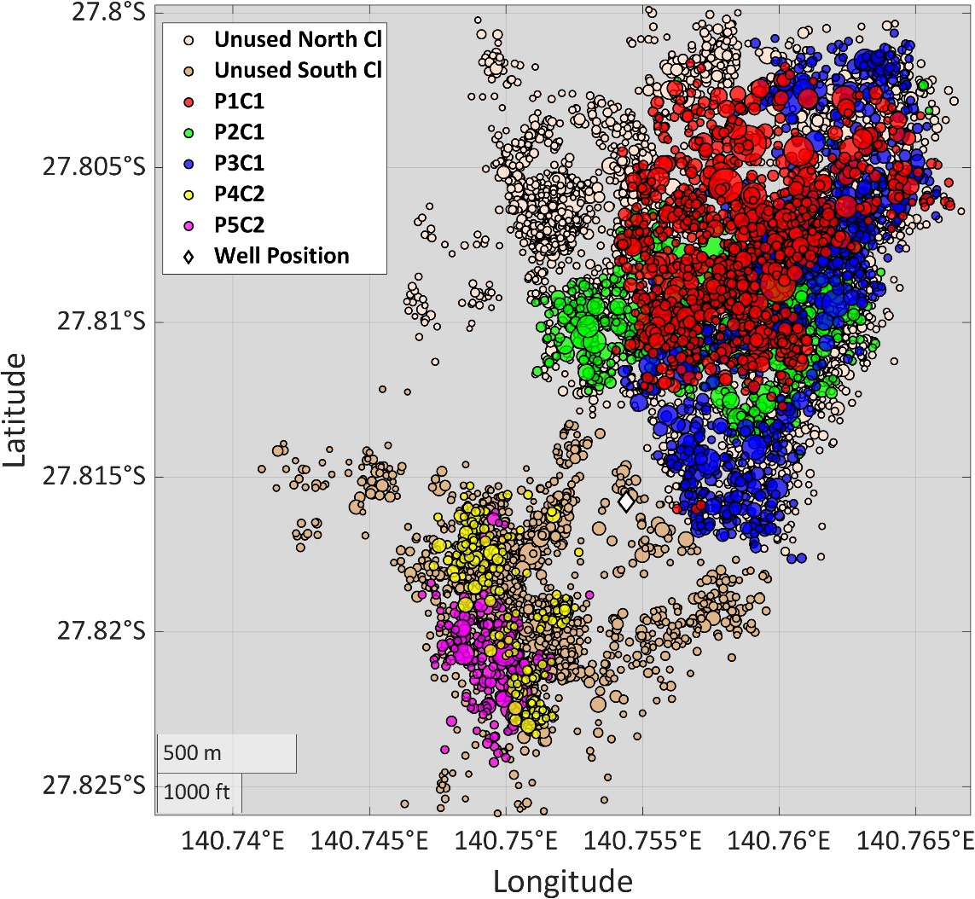

Figure S12. Epicentral distribution of the seismicity of the Cooper basin 2005 stimulation. The unused earthquakes for magnitude complexity testing are depicted in gray colors. The earthquake cluster that were finally selected to assess the magnitude distribution are represented with red, green, cyan, blue, yellow and magenta colors. The well position is represented by the white diamond.

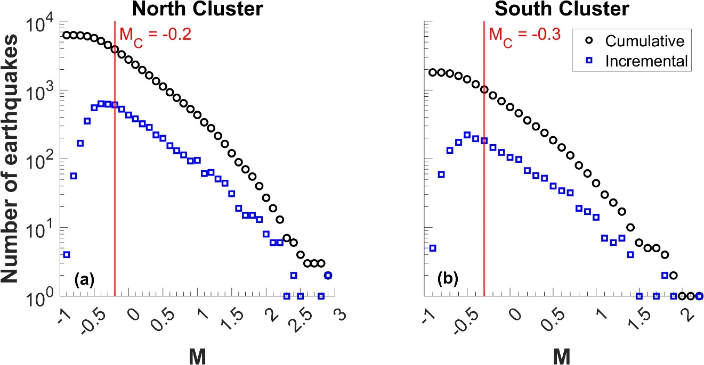

Figure S13. Cumulative and incremental frequency magnitude distributions of the 8283 earthquakes of 2005 Cooper Basin catalog for (a) the north cluster and (b) the south cluster. The chosen magnitudes of completeness are marked by the vertical red lines.

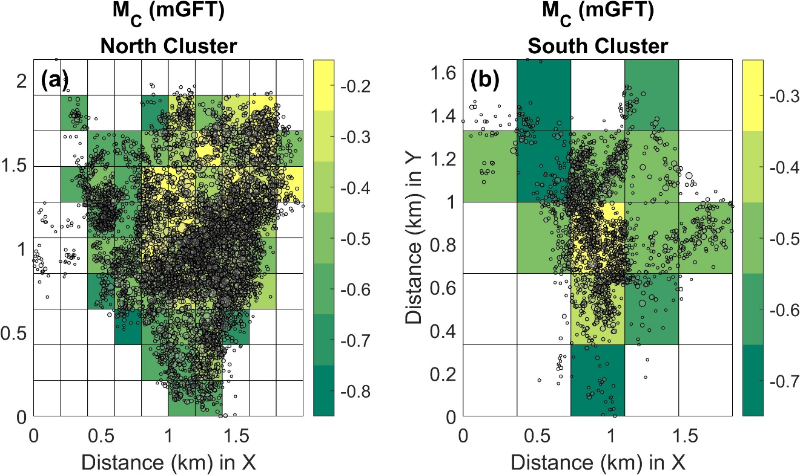

Figure S14. Spatial distribution of the magnitude of completeness over a gridded area for (a) the north and (b) the south cluster of the 2005 Cooper Basin catalog.

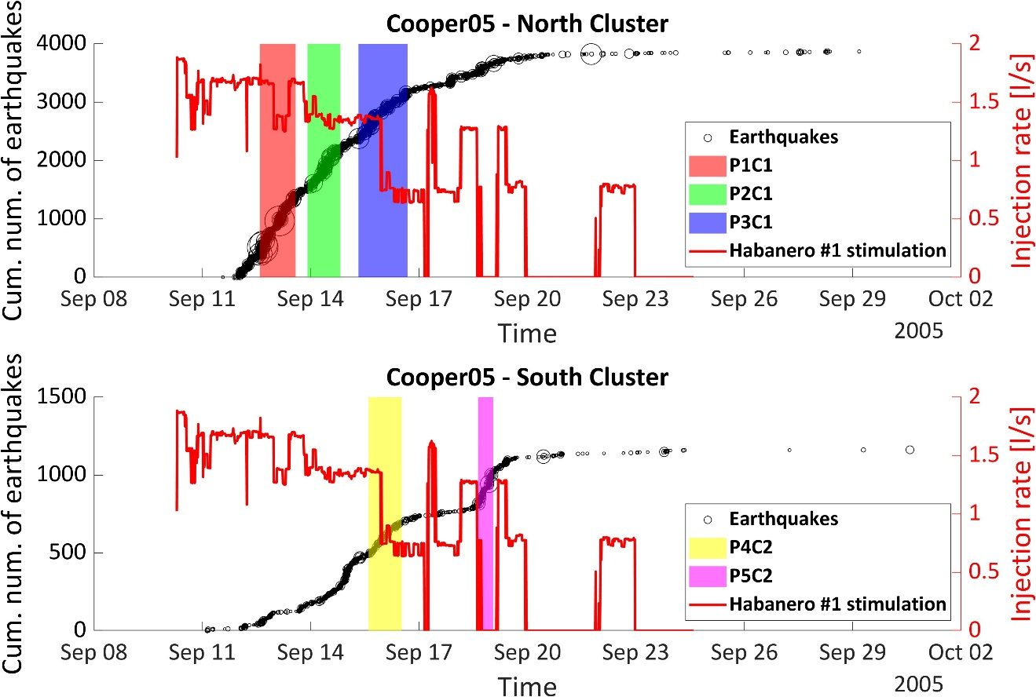

Figure S15. Cumulative number of earthquakes above Mc versus time (Left y-axis) and injection rate versus time (right y-axis) for the north cluster (Top) and the south cluster (bottom). The three stationary activity rate periods are noted with red, green and blue colors for the north cluster colors and the two stationary periods of the south cluster are noted by yellow and magenta colors. The same colors are used in Fig. S12 for the epicentral distribution of events in those periods.

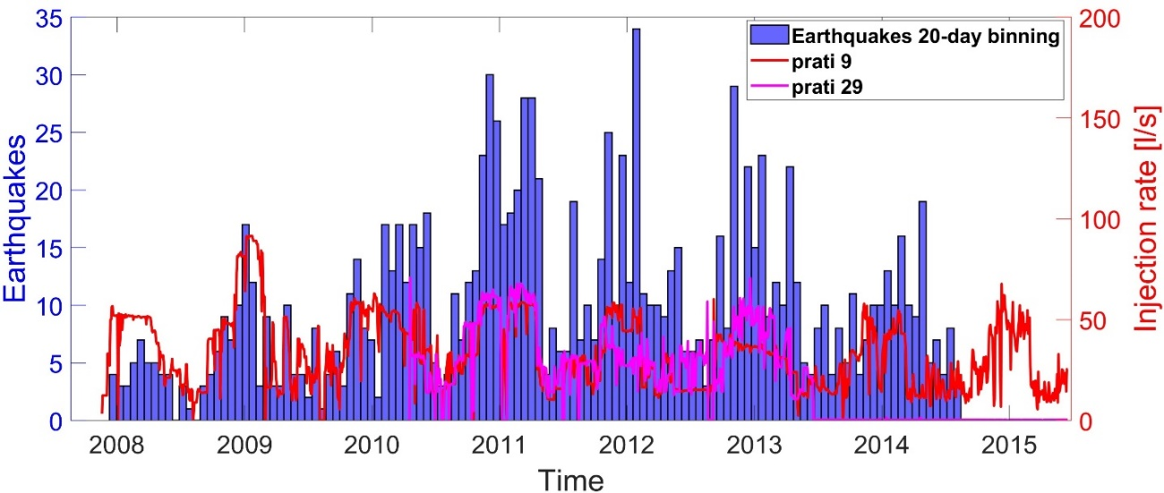

Figure S16. Seismicity in the vicinity of the Prati 9 and Prati 29 injection wells of the Geyshers geothermal field in 20-day bins, (blue histograms), along with injection rate for the Prati 9 (red line) and Prati 29 (magenta line) wells.

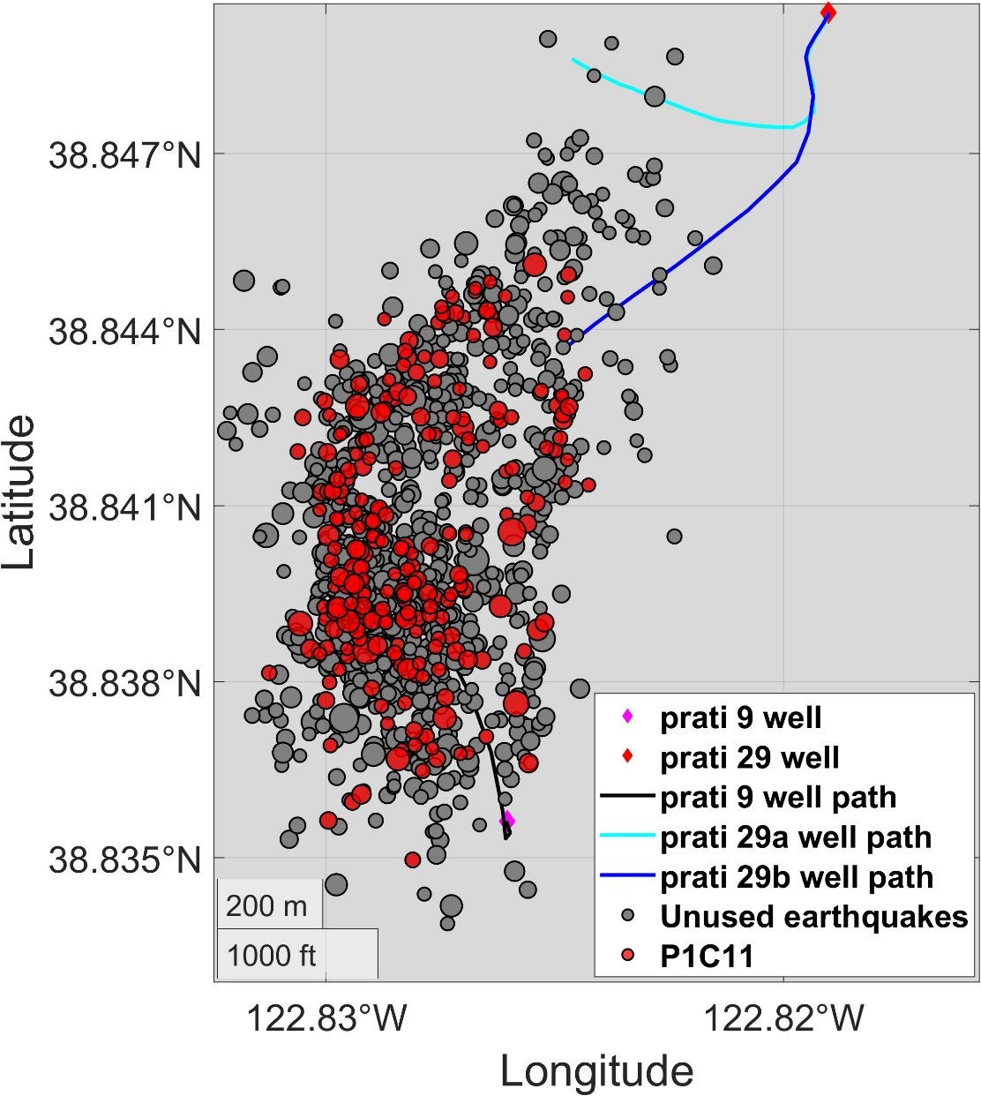

Figure S17. Epicentral distribution of the seismicity of the Geyshers episode catalog. The unused earthquakes for magnitude complexity testing are depicted in gray colors. The earthquake cluster that was selected to assess the magnitude distribution is represented with red colors. The well positions are depicted by a magenta diamond for Prati 9 well and a red diamond for the Prati 29 well. The black line represents the Prati 9 well path while the cyan and blue lines represent the Prati 29 well paths.

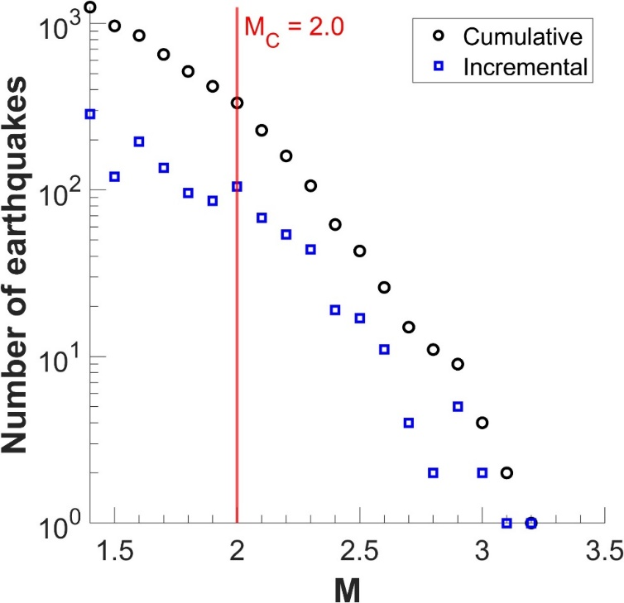

Figure S18. Cumulative and incremental frequency magnitude distributions of the ? earthquakes of the Geyshers Prati 9 and Prati 29 catalog. The chosen magnitude of completeness is marked by the vertical red line.

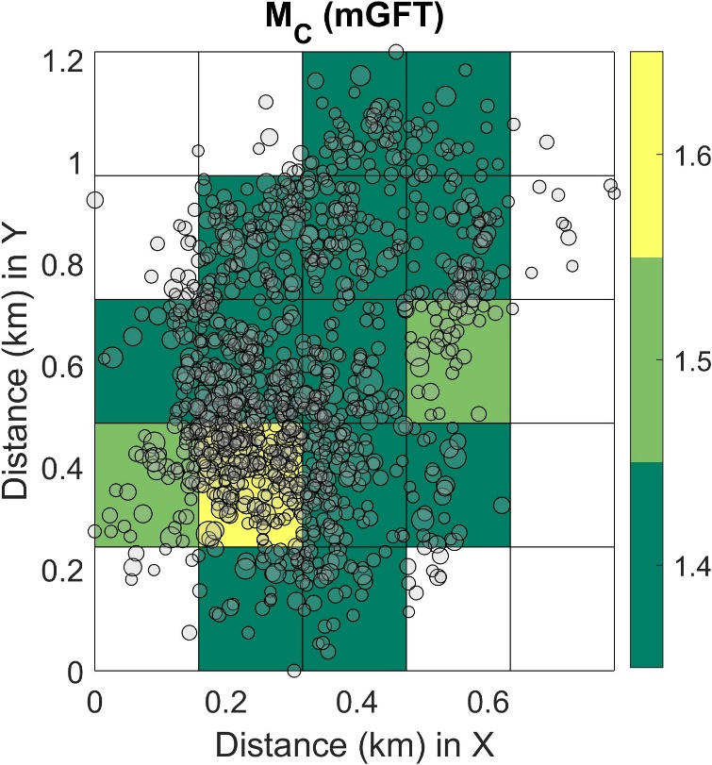

Figure S19. Spatial distribution of the magnitude of completeness over a gridded area for the Geyshers Prati 9 and Prati 29 catalog.

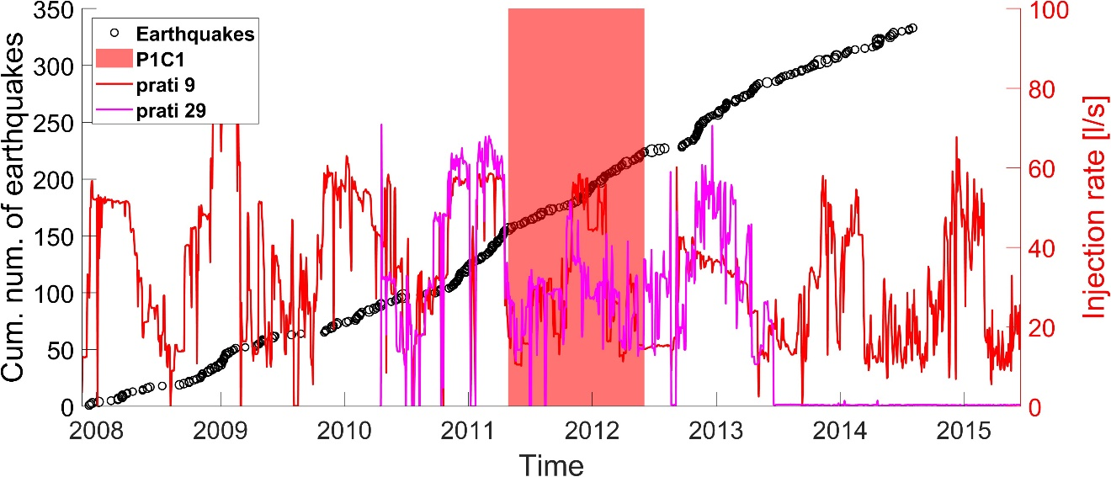

Figure S20. Cumulative number of earthquakes above Mc versus time represented with black circles (Left y-axis) and injection rate versus time represented with red line (right y-axis). The stationary activity rate period is noted with red colored areas. The same color are used in Fig. S17 for the epicentral distribution of events in this period.

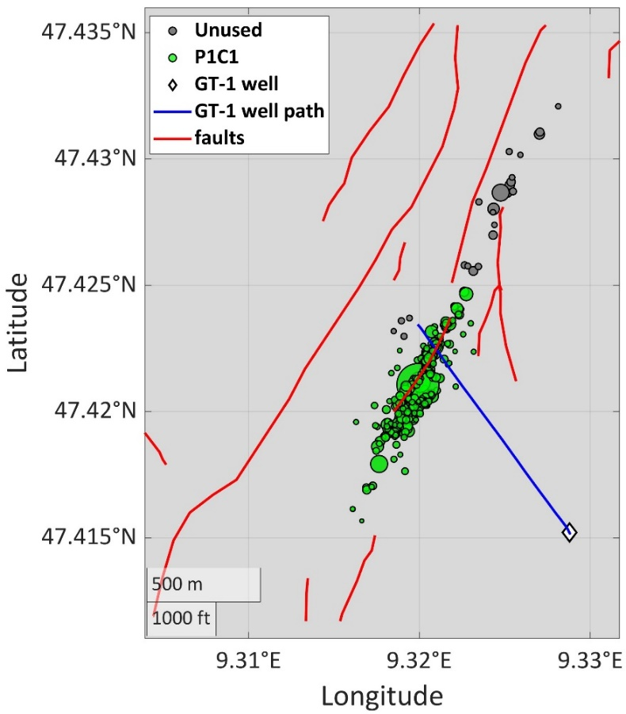

Figure S21. Epicentral distribution of the seismicity of the St. Gallen episode catalog. The unused earthquakes for magnitude complexity testing are depicted in gray colors. The earthquake subcatalog that was selected to assess the magnitude distribution is represented with green colors. The well position is depicted by a white diamond, the blue line represents the GT-1 well path and the red lines represent the fault system of the area.

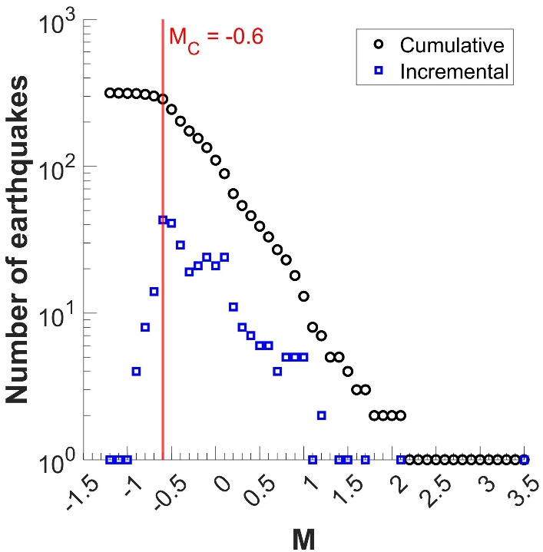

Figure S22. Cumulative and incremental frequency magnitude distributions of the 347 earthquakes of St. Gallen episode catalog. The chosen magnitude of completeness is marked by the vertical red line.

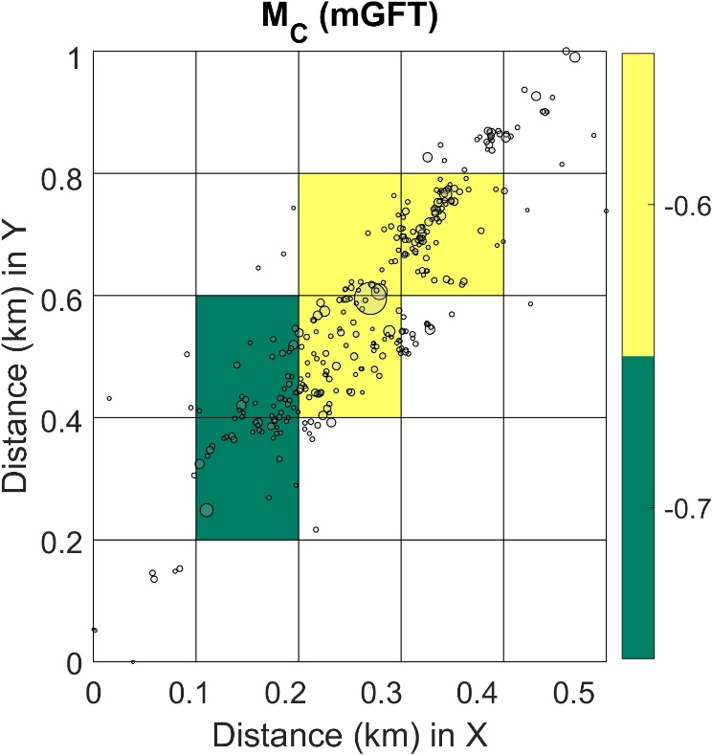

Figure S23. Spatial distribution of the magnitude of completeness over a gridded area for the St. Gallen episode catalog.

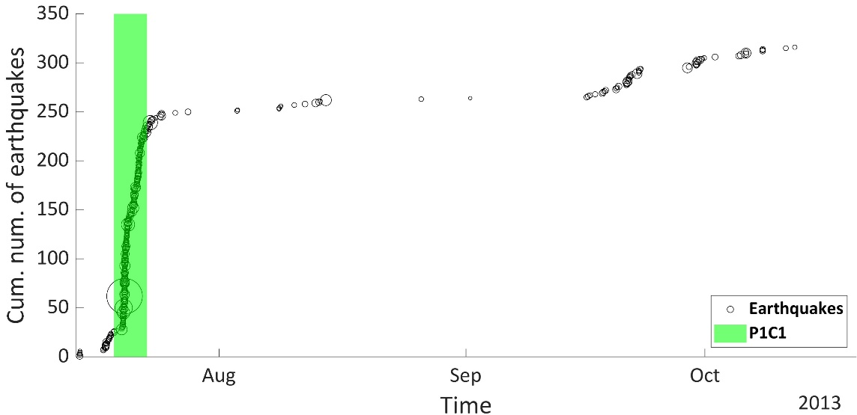

Figure S24. Cumulative number of earthquakes above Mc versus time represented with black circles. The stationary activity rate period is noted by the green colored area. The same color is used in Fig. S21 for the epicentral distribution of events in this period.

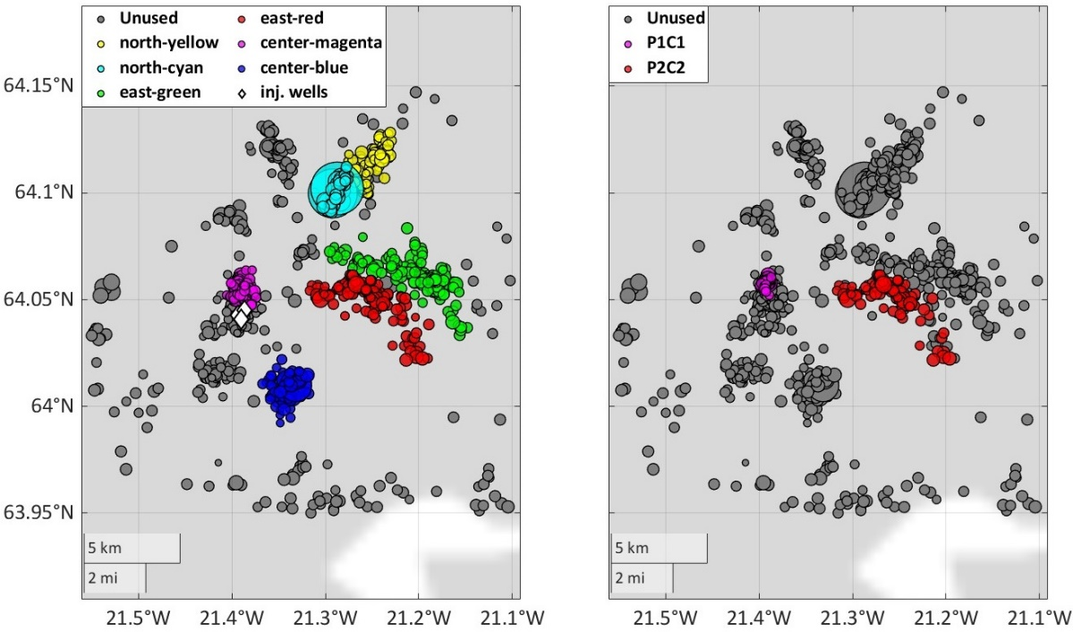

Figure S25. Epicentral distribution of the seismicity of the Carbfix episode catalog earthquakes. On the left subplot the six clusters chosen initially are identified by different colors. On the right subplot only the final subclusters that were selected to assess the magnitude distribution complexity are represented by red and magenta colors. The unused earthquakes for magnitude complexity testing are depicted in gray colors. The injection wells positions are depicted as white diamonds.

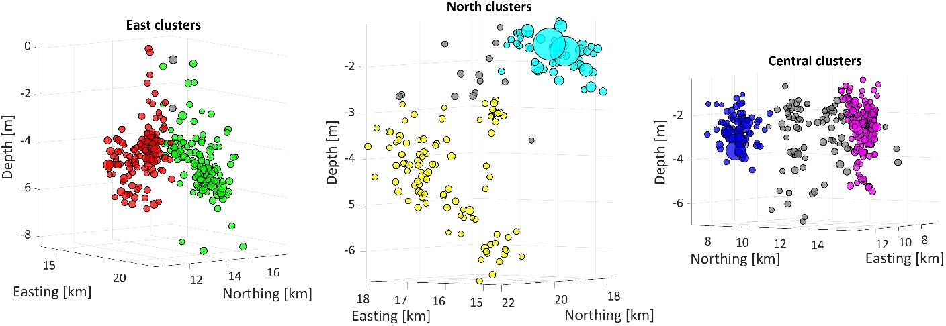

Figure S26.Hypocentral distribution of the identified clusters of east (left), north (middle) and central part of the Carbfix Episode catalog. The colors used correspond to the colors used for the same clusters in the left subplot of Fig. S25.

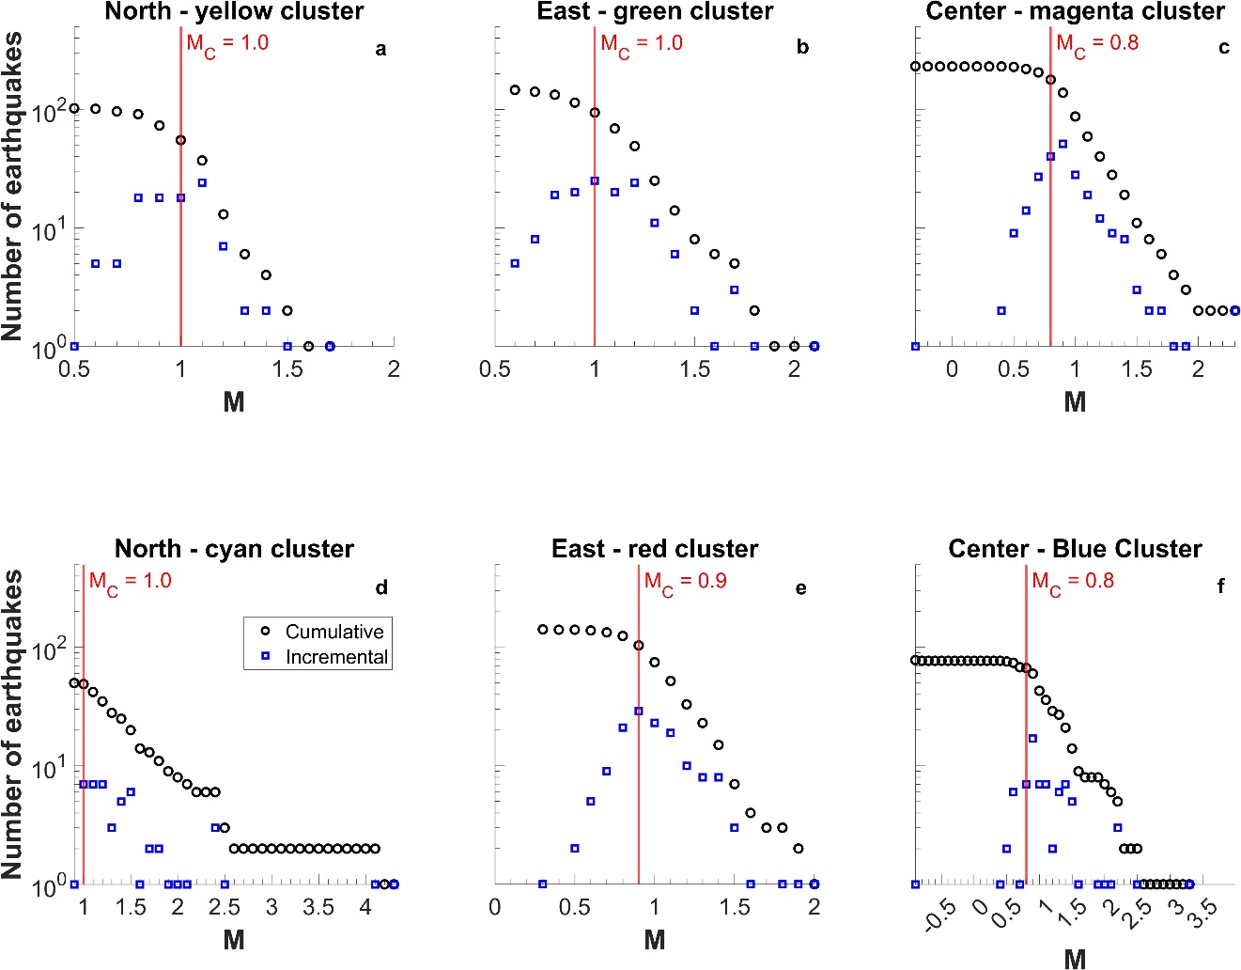

Figure S27. Cumulative and incremental frequency magnitude distributions of the six clusters of seismicity. The chosen magnitudes of completeness are marked by the vertical red lines.

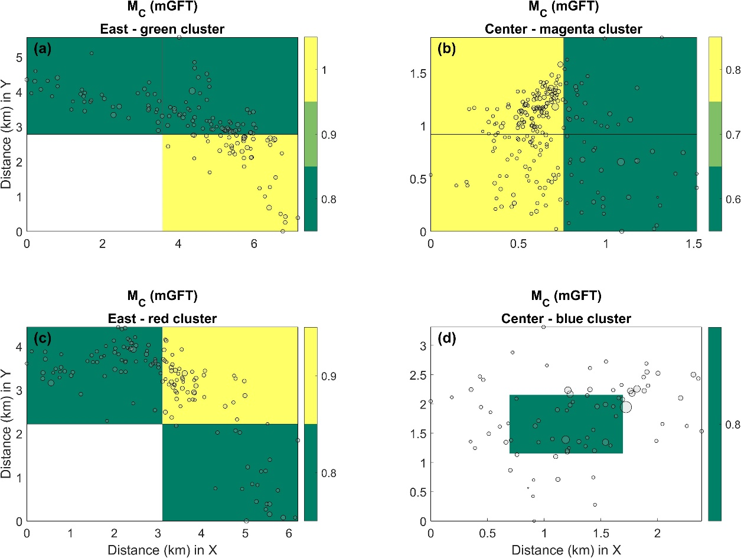

Figure S28. Spatial distribution of the magnitude of completeness over a gridded area for the clusters of the Carbfix episode catalog. The two northernmost clusters were discarded due to low number of events (Fig. 27).

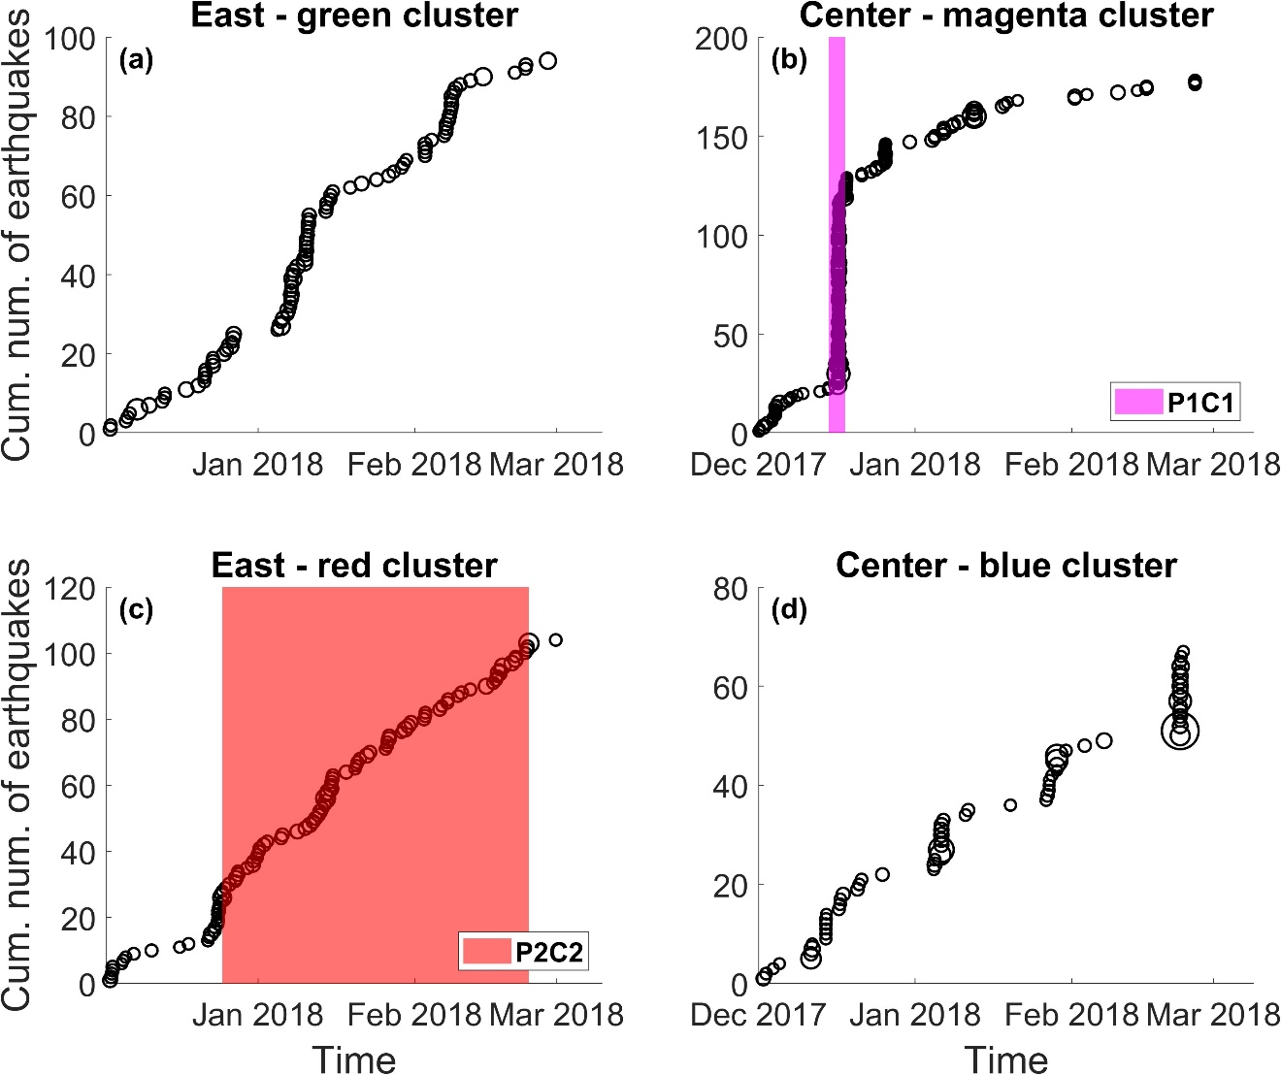

Figure S29. Cumulative number of earthquakes above Mc versus time represented with black circles for each cluster. The stationary activity rate periods in (b) and (c) are noted by the magenta and red colored areas. The same colors are used in the right subplot of Fig. S25b for the epicentral distribution of events in those periods.

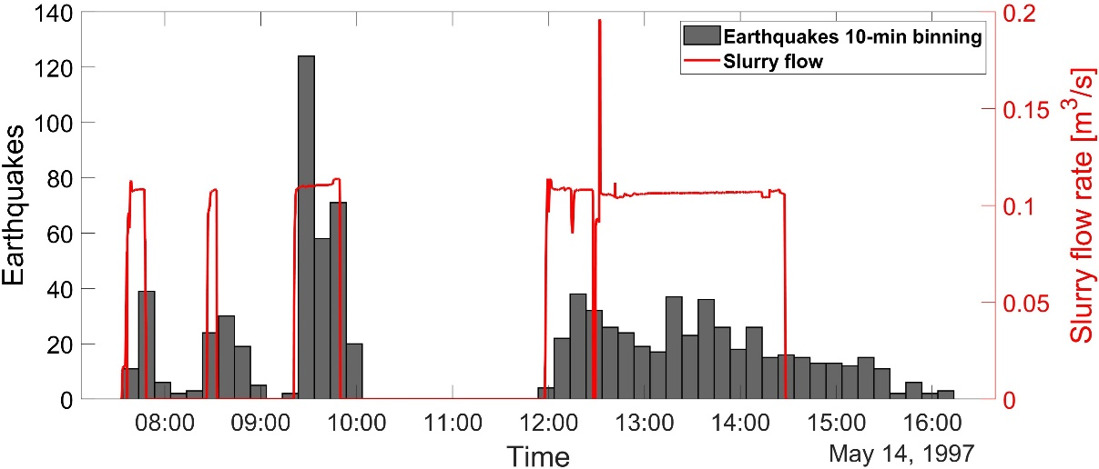

Figure S30. Seismicity of the Cotton valley Episode catalog represented by gray histograms in 10-minute bins (left y-axis), along with slurry flow rate, represented by a red line (right y-axis).

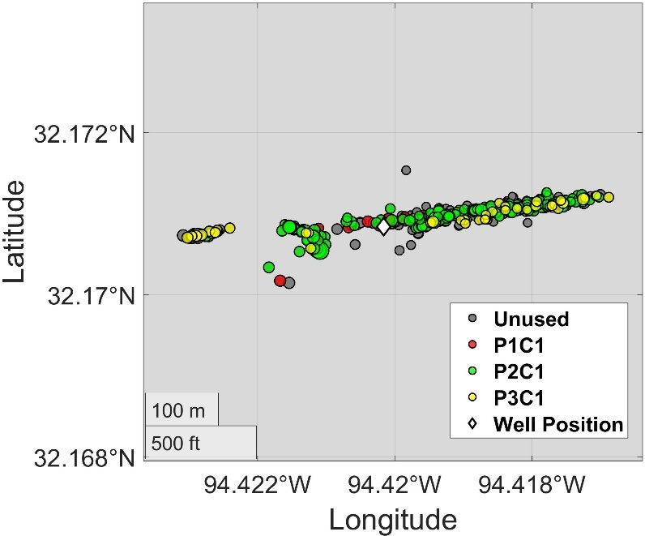

Figure S31. Epicentral distribution of the seismicity of the Cotton Valley episode catalog. The unused earthquakes for magnitude complexity testing are depicted in gray colors. The earthquake subcatalogs that were selected to assess the magnitude distribution complexity are represented by red, green and yellow circles. The injection well position is plotted as a white diamond.

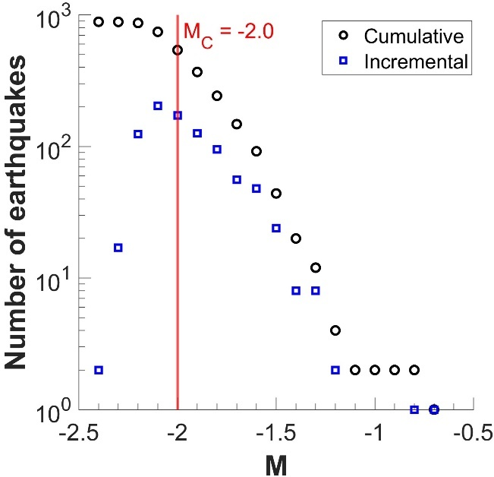

Figure S32. Cumulative and incremental frequency magnitude distributions of the 888 earthquakes of Cotton Valley episode catalog. The chosen magnitude of completeness is marked by the vertical red line.

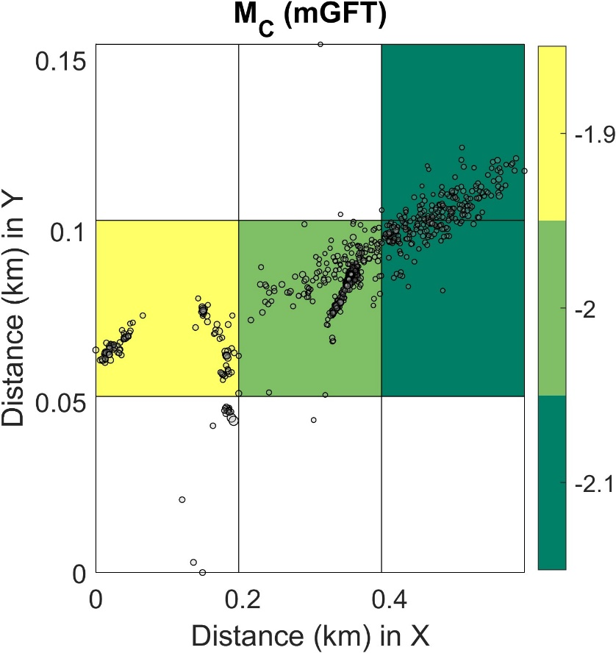

Figure S33 Spatial distribution of the magnitude of completeness over a gridded area for the Cotton Valley episode catalog.

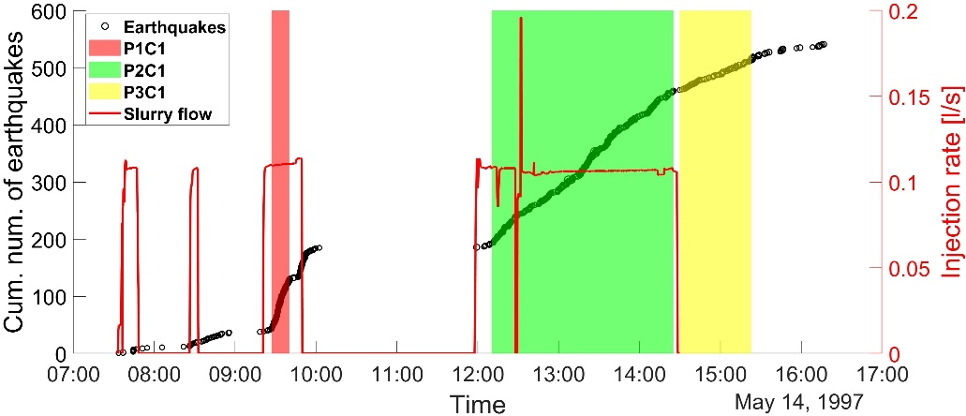

Figure S34. Cumulative number of earthquakes above Mc versus time represented with black circles (Left y-axis) and injection rate versus time represented with red line (right y-axis). The three stationary activity rate periods are noted with red-, green- and yellow-colored areas. The same colors are used in Fig. S31 for the epicentral distribution of earthquakes in those periods.

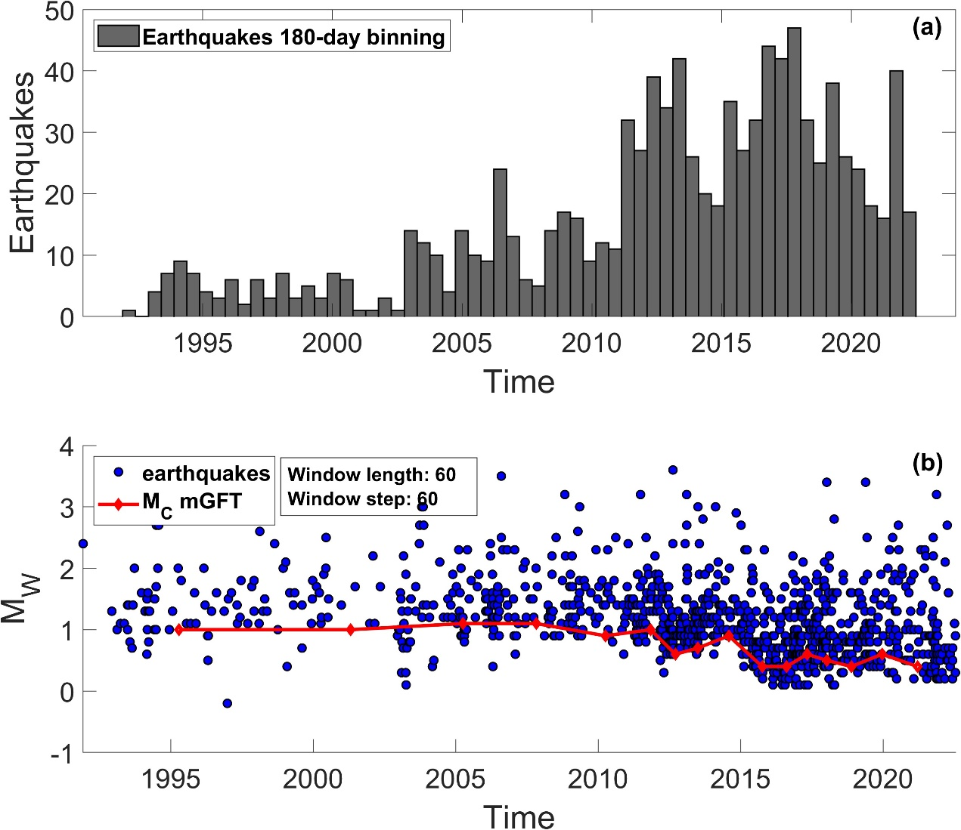

Figure S35. (a) Seismicity of the Groningen field Episode catalog represented by gray histograms in 180-day bins and (b) evolution of the completeness level of the earthquakes estimated with the Maximum Curvature method (red line) along with the recorded earthquake magnitudes (blue circles)

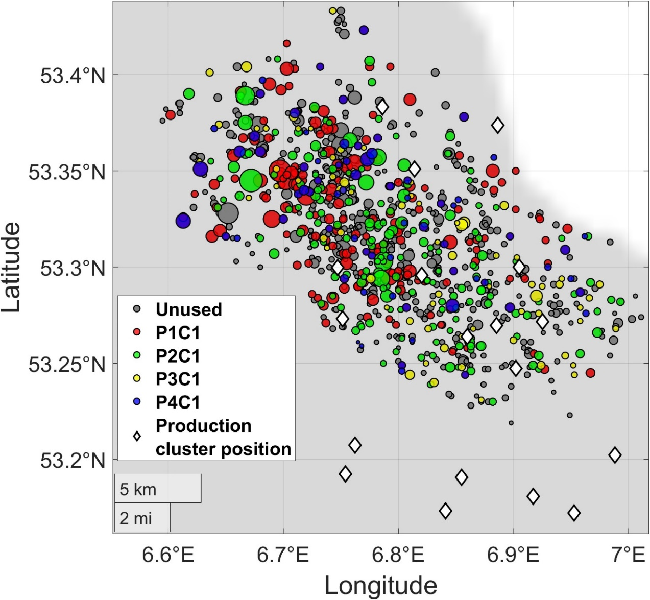

Figure S36. Epicentral distribution of the seismicity of the north eastern part of the Groningen episode catalog. The unused earthquakes for magnitude complexity testing are depicted in gray colors. The earthquake subcatalogs that were selected to assess the magnitude distribution complexity are represented by red, green and yellow circles. The production cluster positions are plotted as white diamonds.

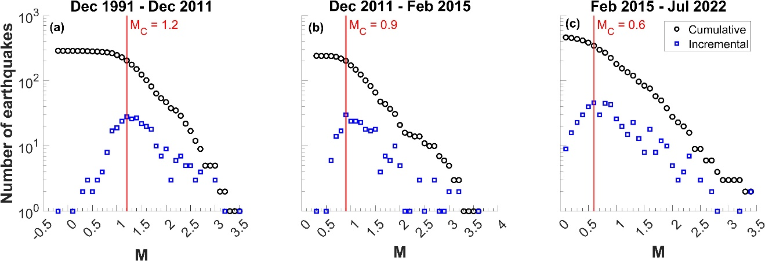

Figure S37. Cumulative and incremental frequency magnitude distributions of Groningen filed catalog in the area shown in Fig. S36 for, (a) the first examined period between December 1991 and February 2011 and (b) the second examined period between February 2011 and mid-February 2015 and (c) the third examined period from mid-February 2015 until July 2022. The selected magnitudes of completeness are marked by the vertical red lines.

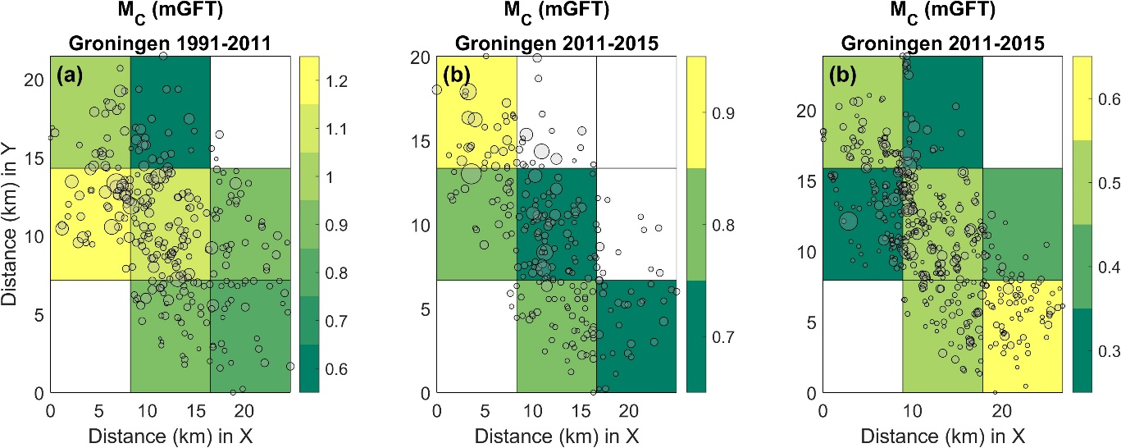

Figure S38. Spatial distribution of the magnitude of completeness over a gridded area for the selected time periods of the Groningen field episode catalog.

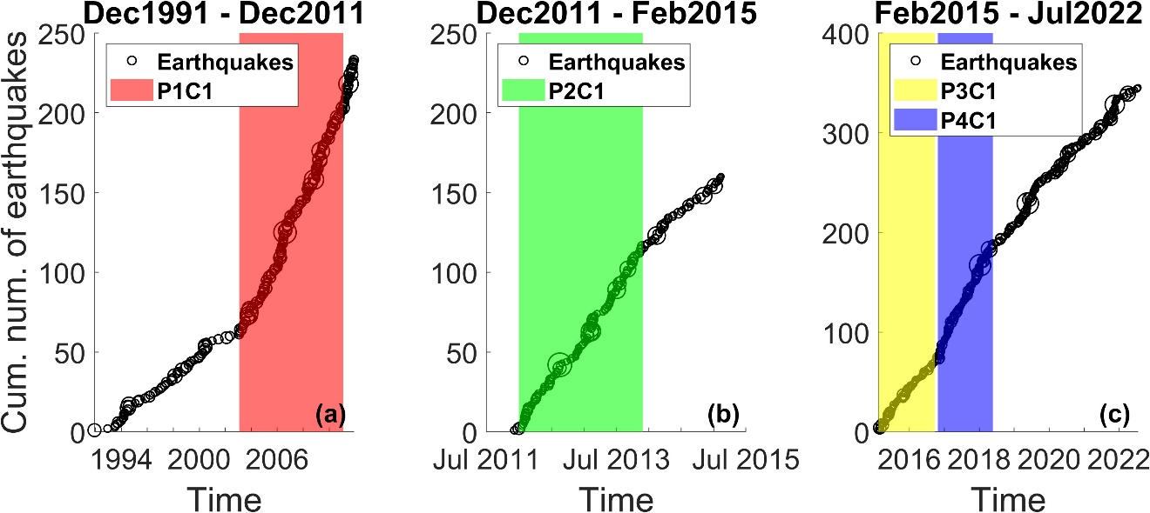

Figure S39. Cumulative number of earthquakes above Mc versus time represented with black circles for (a) the first examined period between December 1991 and December 2011 and (b) the second examined period between December 2011 and mid-February 2015 and (c) the third period between mid-February 2015 until July 2022. The four stationary activity rate periods are noted with red, green, yellow and blue colored areas. The same colors are used in Fig. S36 for the epicentral distribution of earthquakes in those periods.

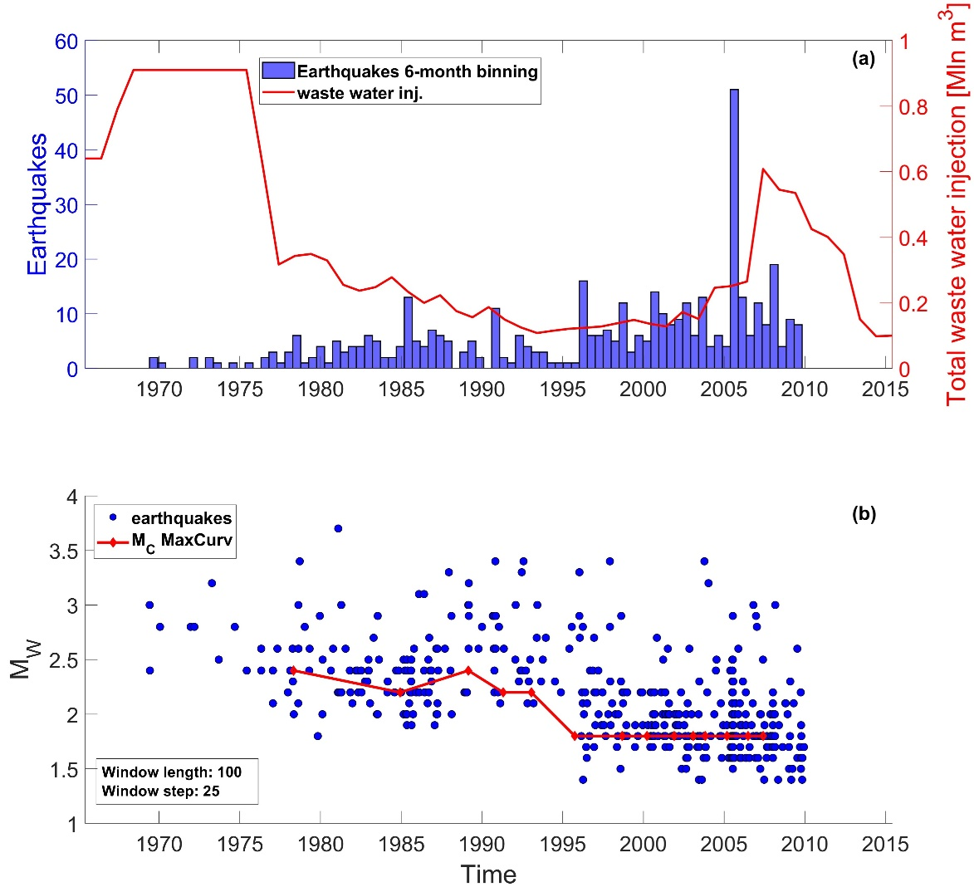

Figure S40. (a) Seismicity of the LACQ field episode catalog represented by blue histograms in 6-month bins (left y-axis) along with total waste water injection represented by a red continuous line (right y-axis) and, (b) evolution of the completeness level of the earthquakes estimated with the Maximum Curvature method (red line) along with the recorded earthquake magnitudes (blue circles)

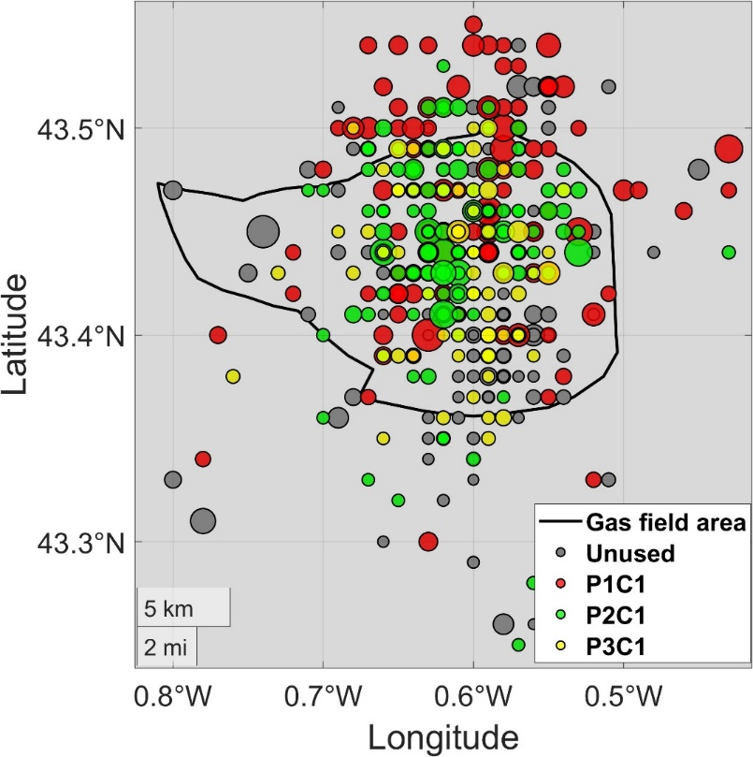

Figure S41. Epicentral distribution of the seismicity of the LACQ episode catalog. The unused earthquakes for magnitude complexity testing are depicted in gray colors. The earthquake subcatalogs that were selected to assess the magnitude distribution complexity are represented by red, green and yellow circles. The area of the Gas field is marked by the black continuous line.

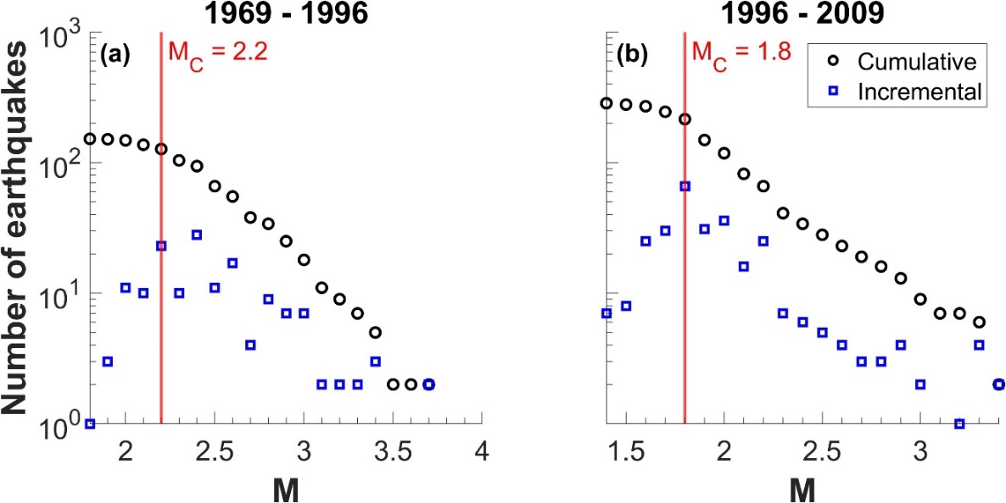

Figure S42. Cumulative and incremental frequency magnitude distributions of LACQ gas filed catalog in the area shown in Fig. S41 for, (a) the first examined period, pre-1996, and, (b) the second examined period post 1996. The chosen magnitudes of completeness are marked by the vertical red lines.

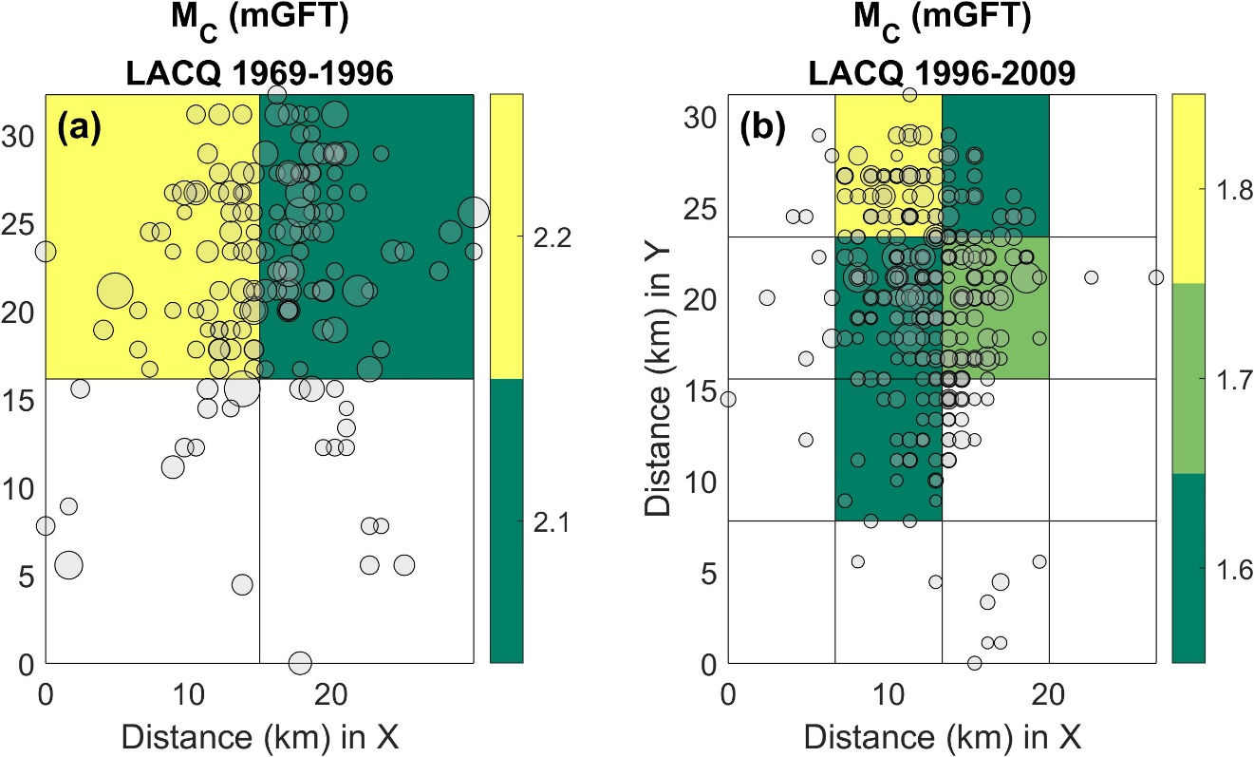

Figure S43. Spatial distribution of the magnitude of completeness over a gridded area for the selected time periods of the LACQ field episode catalog.

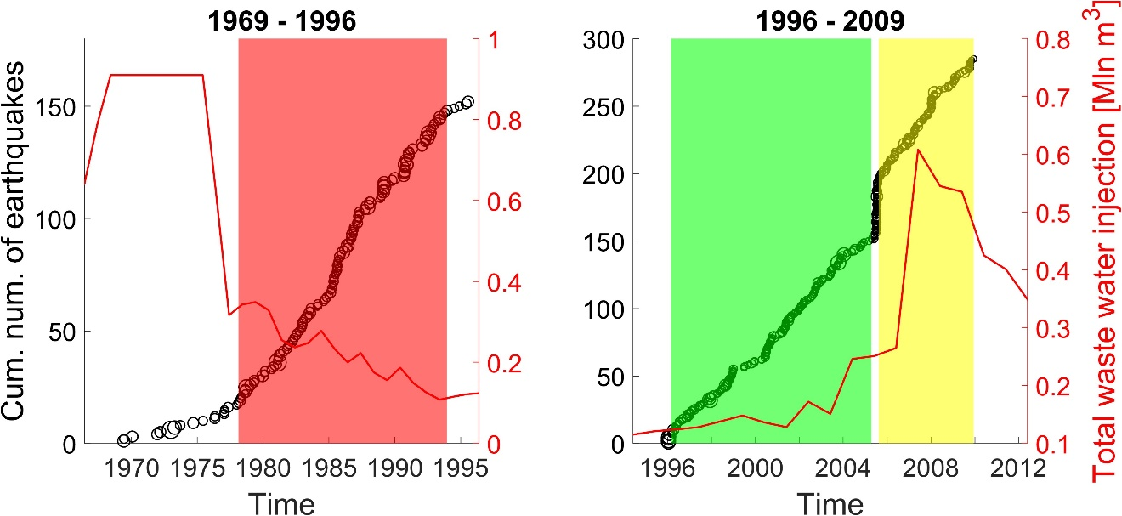

Figure S44. Cumulative number of earthquakes above Mc versus time represented with black circles for, (a) the first examined period before 1996 and (b) the second examined period post 1996. The three stationary activity rate periods are noted with red-, green- and yellow-colored areas. The same colors are used in Fig. S41 for the epicentral distribution of earthquakes in those periods. The total waste water injection is plotted with a red line (right y-axis).

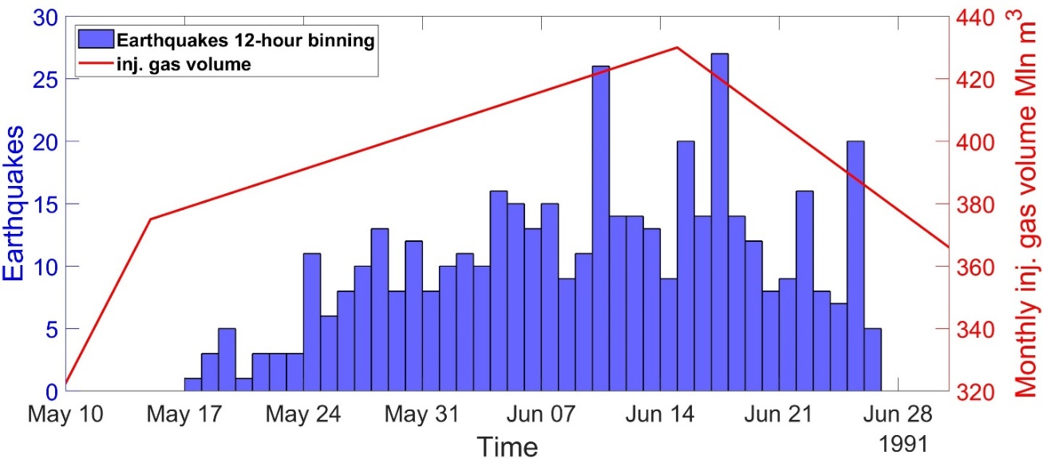

Figure S45. Seismicity of the Gazli gas field episode local catalog represented by blue histograms in 12-hour bins (left y-axis) along with the monthly injected gas volume represented by a red continuous line (right y-axis).

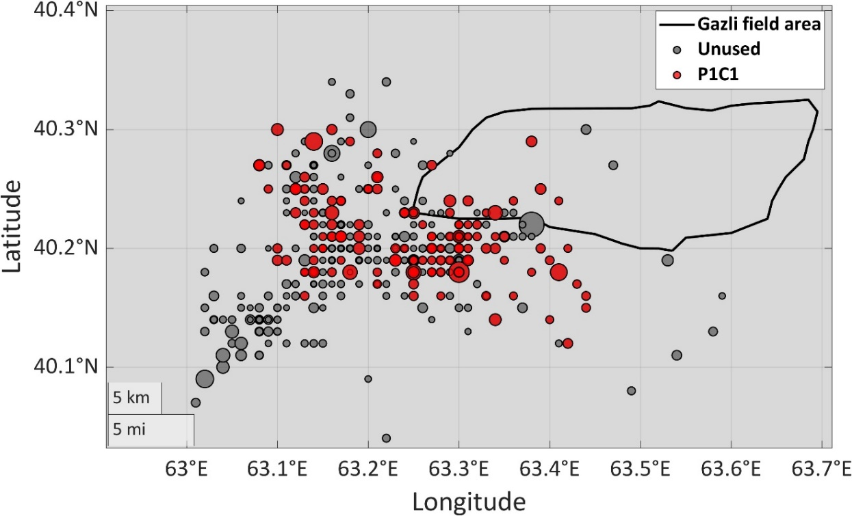

Figure S46. Epicentral distribution of the seismicity of the Gazli local episode catalog. The unused earthquakes for magnitude complexity testing are depicted in gray colors. The earthquake subcatalog that was selected to assess the magnitude distribution complexity (Table 10) is represented by red circles. The area of the gas field is marked by the black continuous line.

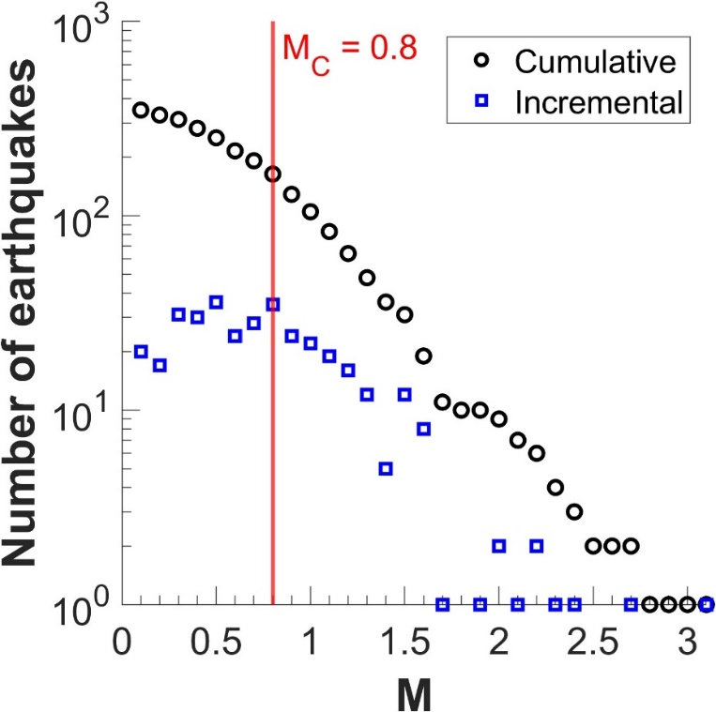

Figure S47. Cumulative and incremental frequency magnitude distributions of Gazli gas field local catalog. The chosen magnitude of completeness is marked by the vertical red line.

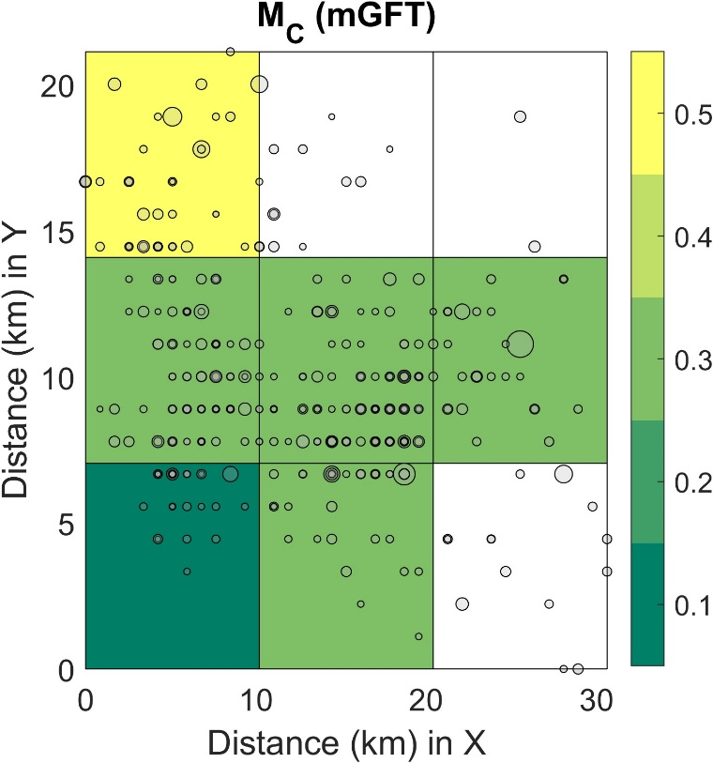

Figure S48. Spatial distribution of the magnitude of completeness over a gridded area for the Gazli gas field local catalog.

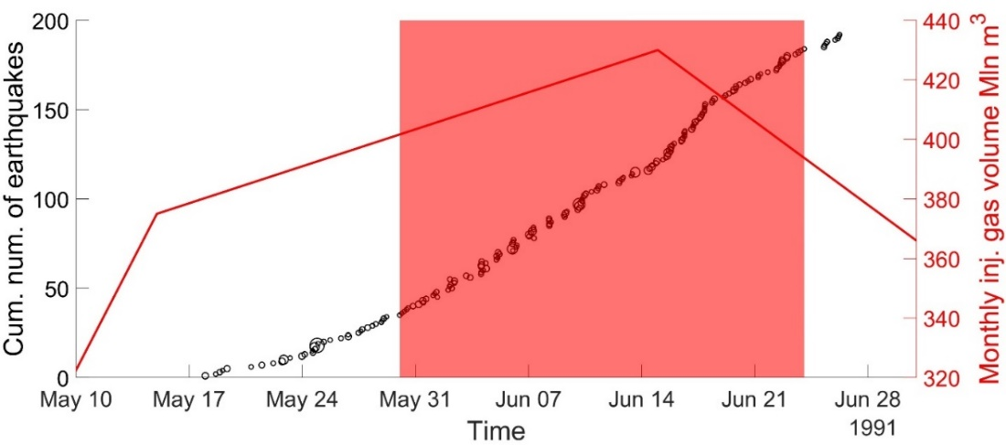

Figure S49. Cumulative number of earthquakes above Mc versus time represented with black circles (left y-axis) along with the monthly injected gas volume represented by a red continuous line (right y-axis). The stationary activity rate period is noted by the red colored area. The same color is used in Fig. S46 for the epicentral distribution of earthquakes in this period.

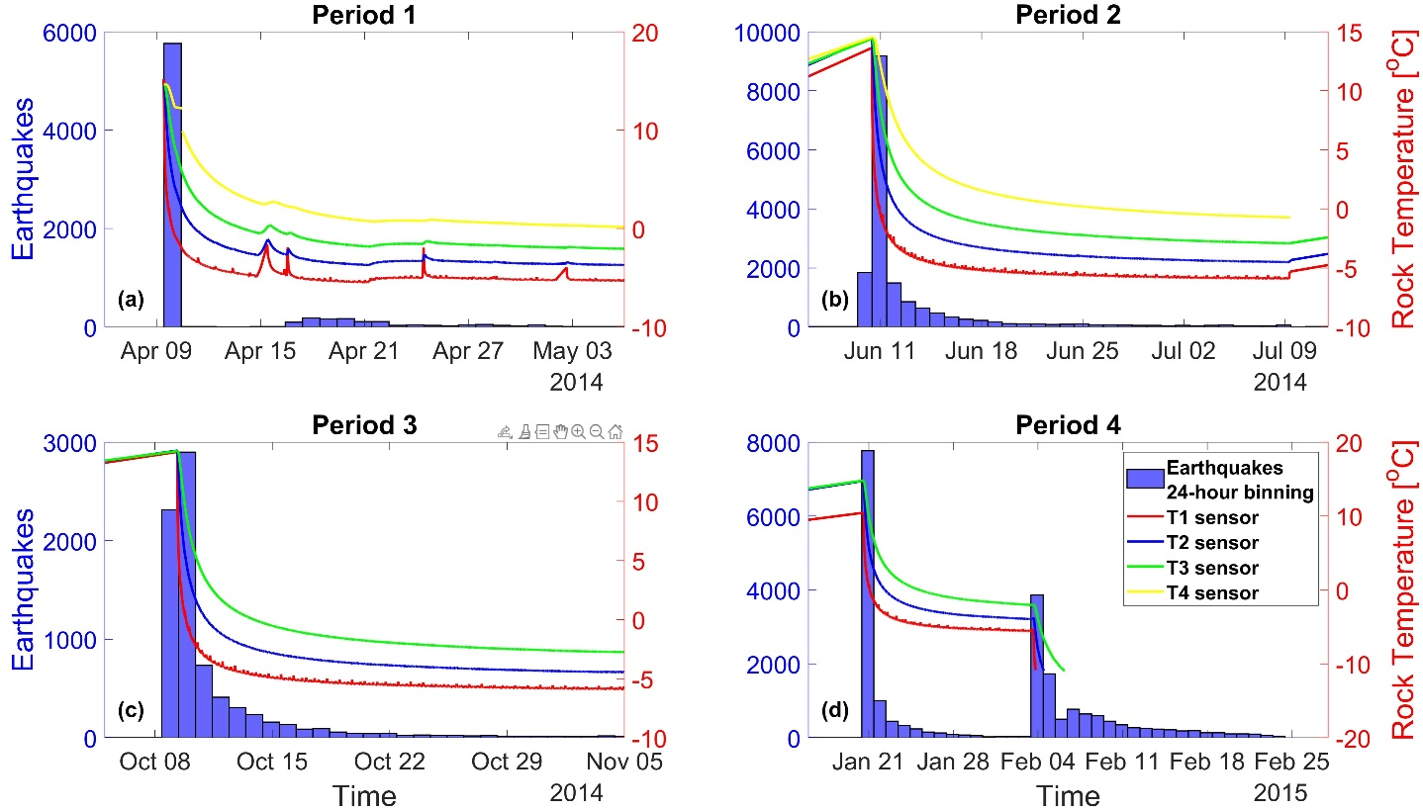

Figure S50. Seismicity of the Starfish episode catalog represented by blue histograms in 24-hour bins (Left y-axis) for, (a) the first heating cycle period, (b) the second heating cycle period, (c) the third heating cycle period and (d) the fourth heating cycle period. Temperature recorded from four sensors appear with red, blue, green and yellow continues lines (right y-axis)

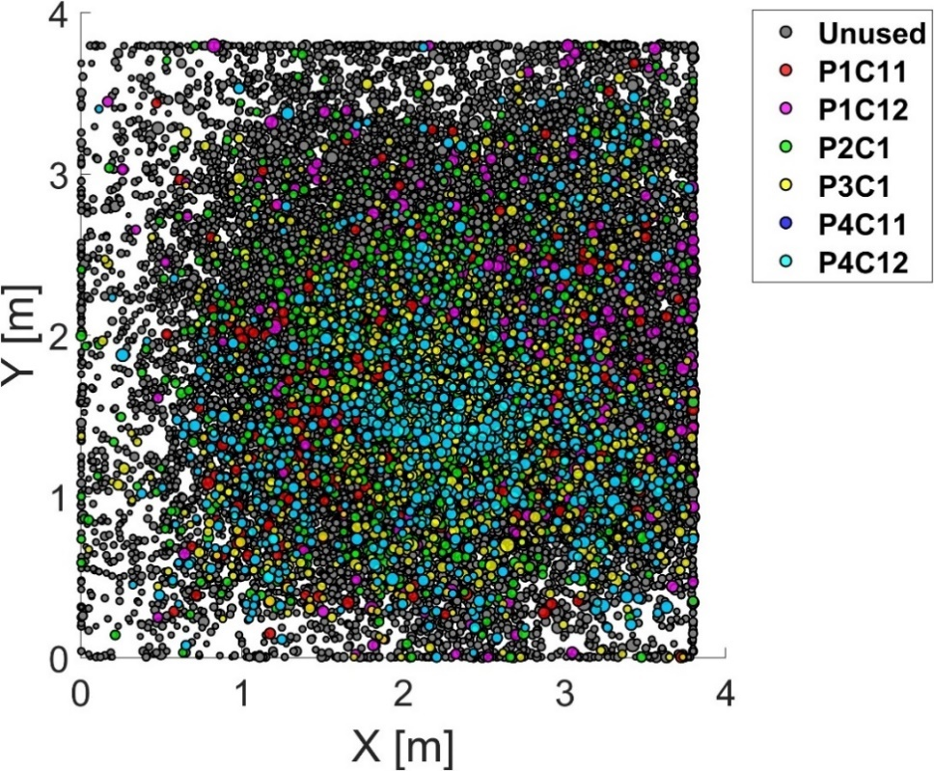

Figure S51. Epicentral distribution of the seismicity of the Starfish episode catalog. The unused earthquakes for magnitude complexity testing are depicted in gray colors. The earthquake subcatalogs that were selected to assess the magnitude distribution complexity are represented by red, magenta, green, yellow, blue and cyan circles.

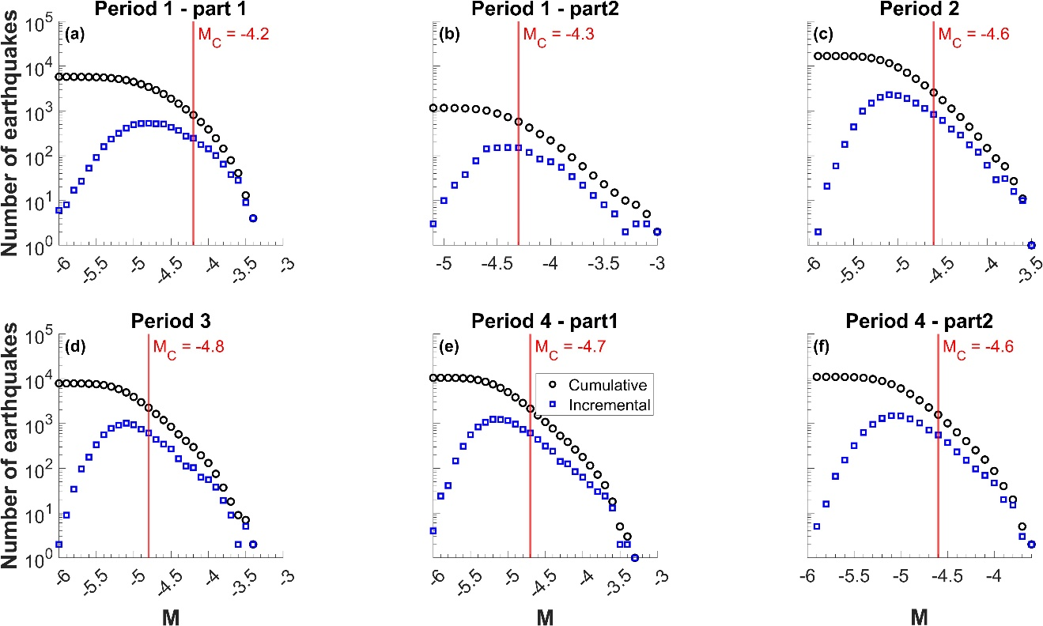

Figure S52. Cumulative and incremental frequency magnitude distributions of the Starfish episode catalog for, (a) the part of the first heating cycle, (b) the second part of the first heating cycle, (c) the second heating cycle, (d) the third heating cycle period, (e) the first part of the fourth heating cycle and (f) the second part of the fourth heating cycle The chosen magnitudes of completeness for each period are marked by the vertical red lines.

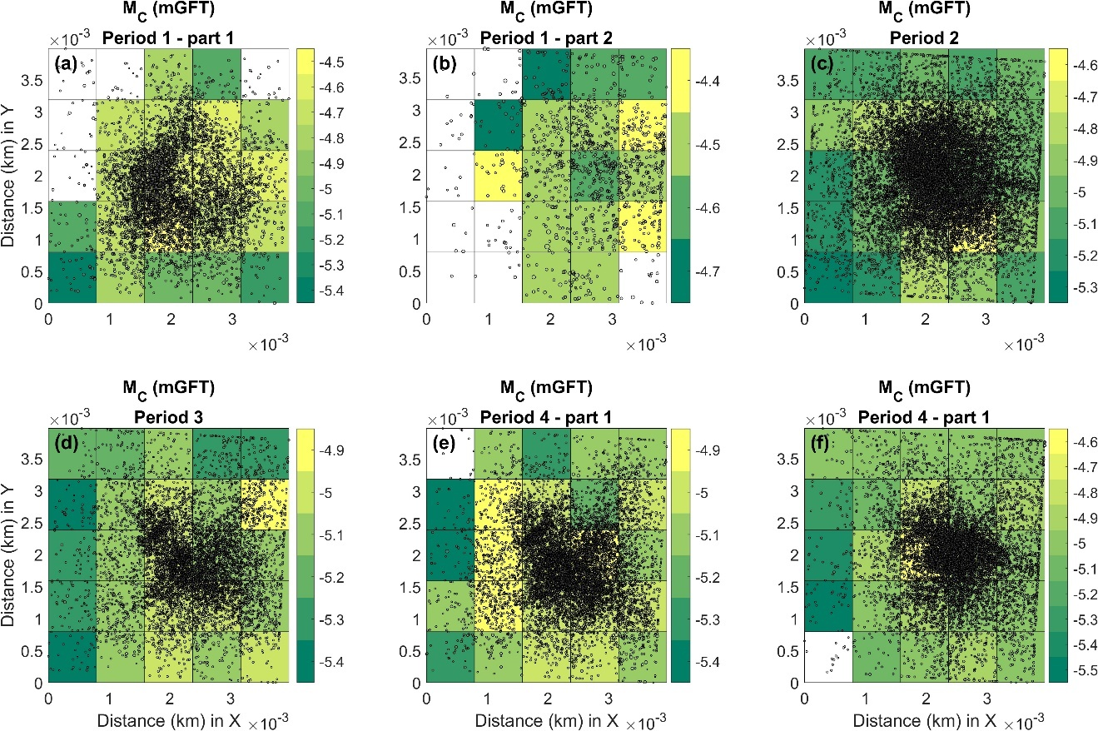

Figure S53. Spatial distribution of the magnitude of completeness over a gridded area for the Starfish catalog for (a) the part of the first heating cycle, (b) the second part of the first heating cycle, (c) the second heating cycle, (d) the third heating cycle period, (e) the first part of the fourth heating cycle and (f) the second part of the fourth heating cycle.

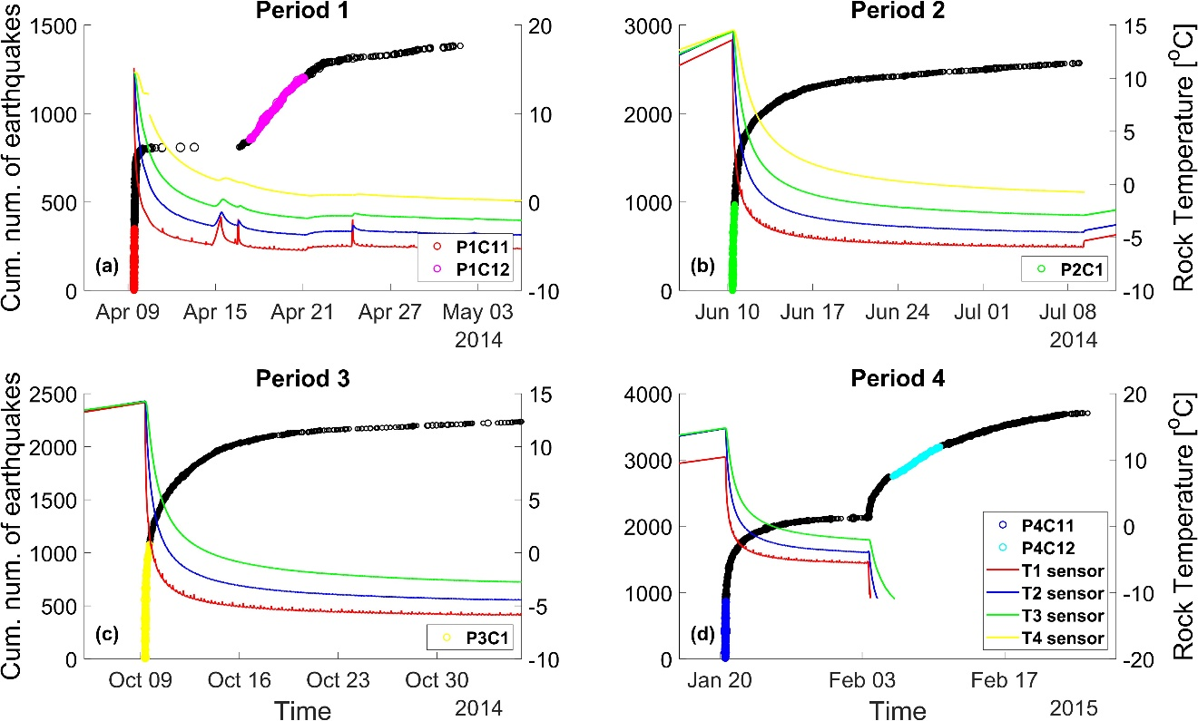

Figure S54. Cumulative number of earthquakes above Mc versus time represented with black circles for, (a) the first heating cycle period, (b) the second heating cycle period, (c) the third heating cycle period and (d) the fourth heating cycle period. The six stationary activity rate periods are noted with red, magenta, green and yellow, blue and cyan colored circles. The same colors are used in Fig. S51 for the epicentral distribution of earthquakes in those periods. Temperature recorded from four sensors appear with red, blue, green and yellow continues lines (right y-axis).

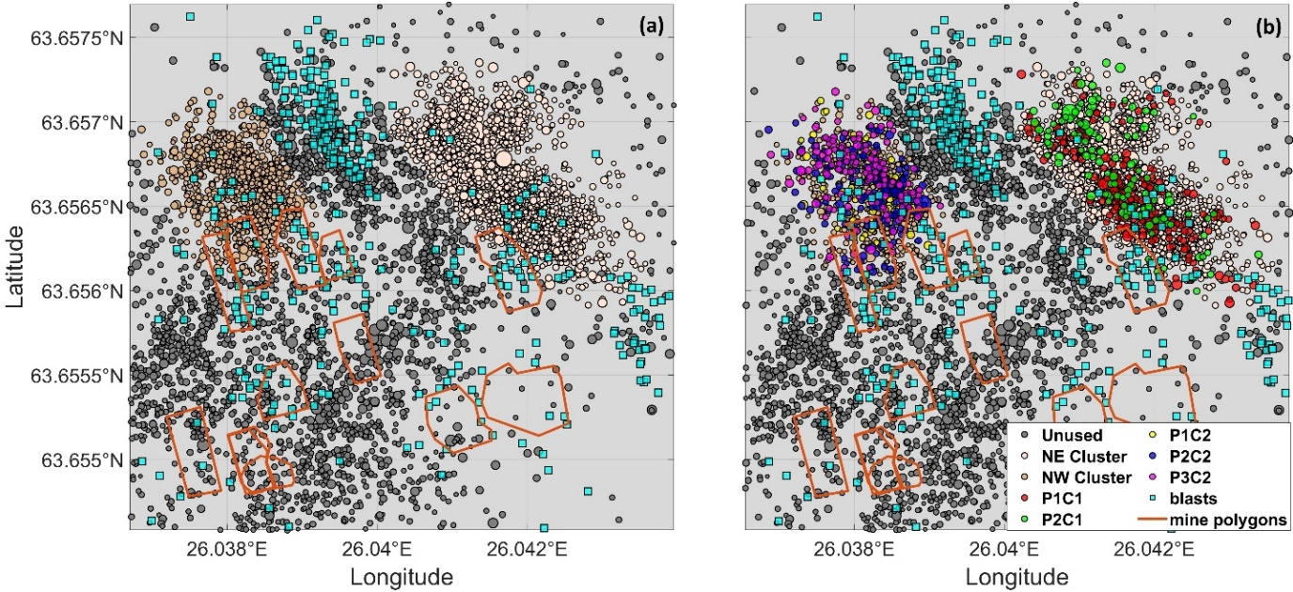

Figure S55. (a) Epicentral distribution of the seismicity of the Pyhasalmi mine episode catalog. The earthquakes that were not used in any step of processing are represented by gray colours, the earthquakes of the NE cluster are represented by the soft pink and those of the NW cluster by the soft brown color, (b) same as (a), with the additional information of the subcatalogs used in the magnitude complexity testing represented by red, green, yellow, blue and magenta circles. The blasts are represented by cyan rectangles The mine polygons appear with brown continuous lines.

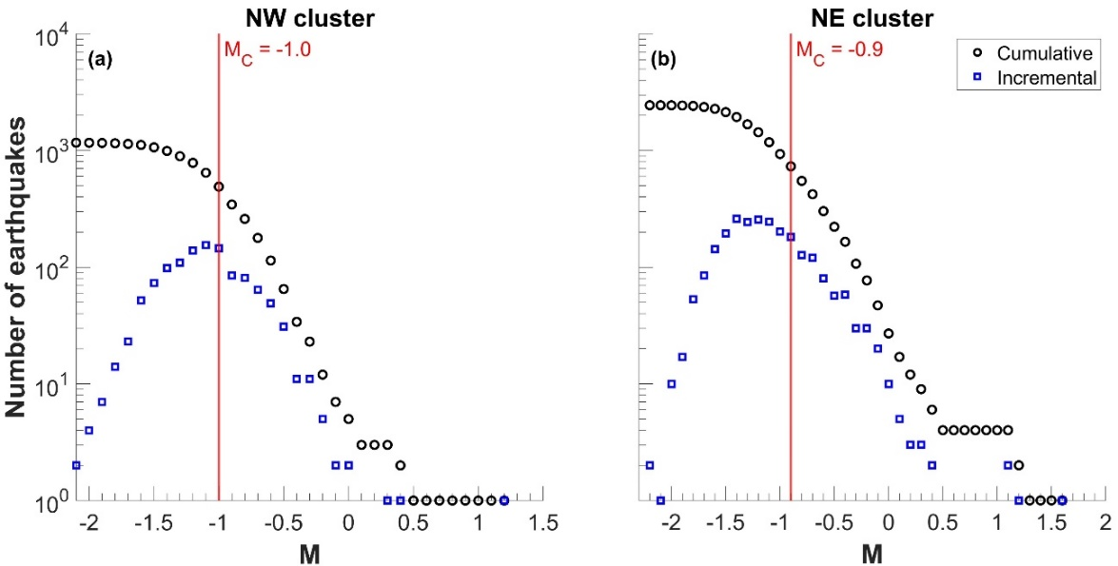

Figure S56. Cumulative and incremental frequency magnitude distributions of the Pyhasalmi mine episode catalog for, (a) the northwestern earthquake cluster and, (b) the northeastern earthquake cluster. The chosen magnitudes of completeness for each period are marked by the vertical red lines.

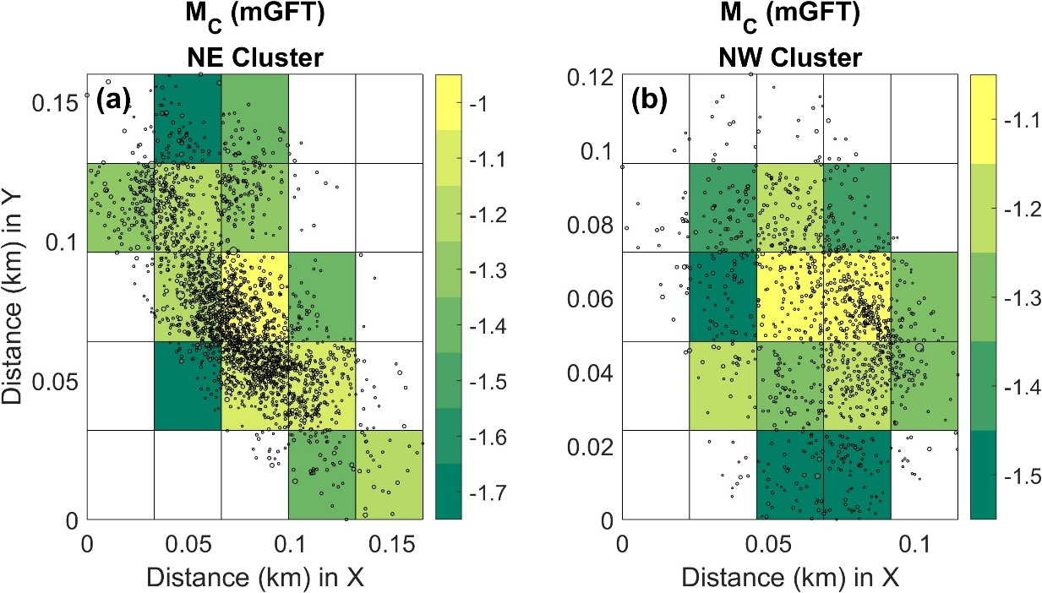

Figure S57. Spatial distribution of the magnitude of completeness over a gridded area for (a) the NE cluster of the and (b) the NW cluster of the Pyhasalmi mine episode catalog

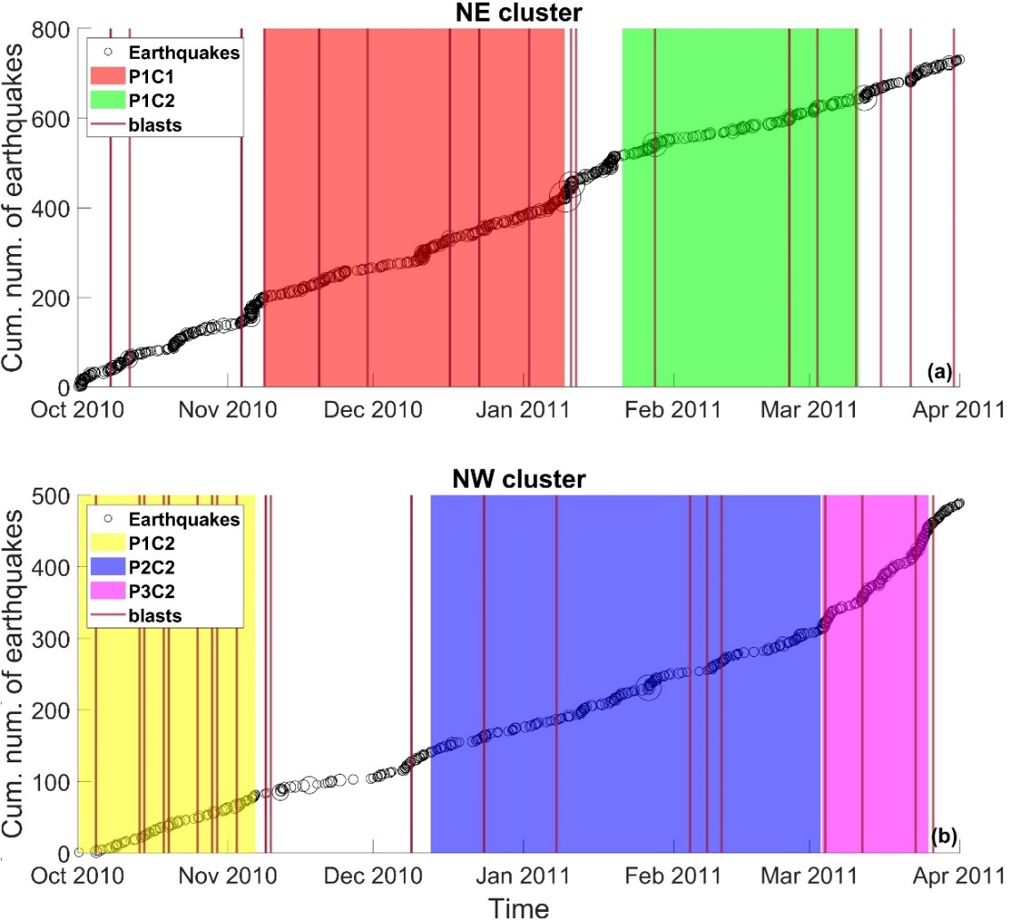

Figure S58. Cumulative number of earthquakes above Mc versus time represented with black circles for, (a) the northwestern earthquake cluster and, (b) the northeastern earthquake cluster. The five stationary activity rate periods are noted with red and green colored areas in (a) and with and yellow-, blue- and magenta-colored areas in (b). The same colors are used in Fig. S55b for the epicentral distribution of earthquakes in those periods. The times of blasts are marked by vertical red lines.

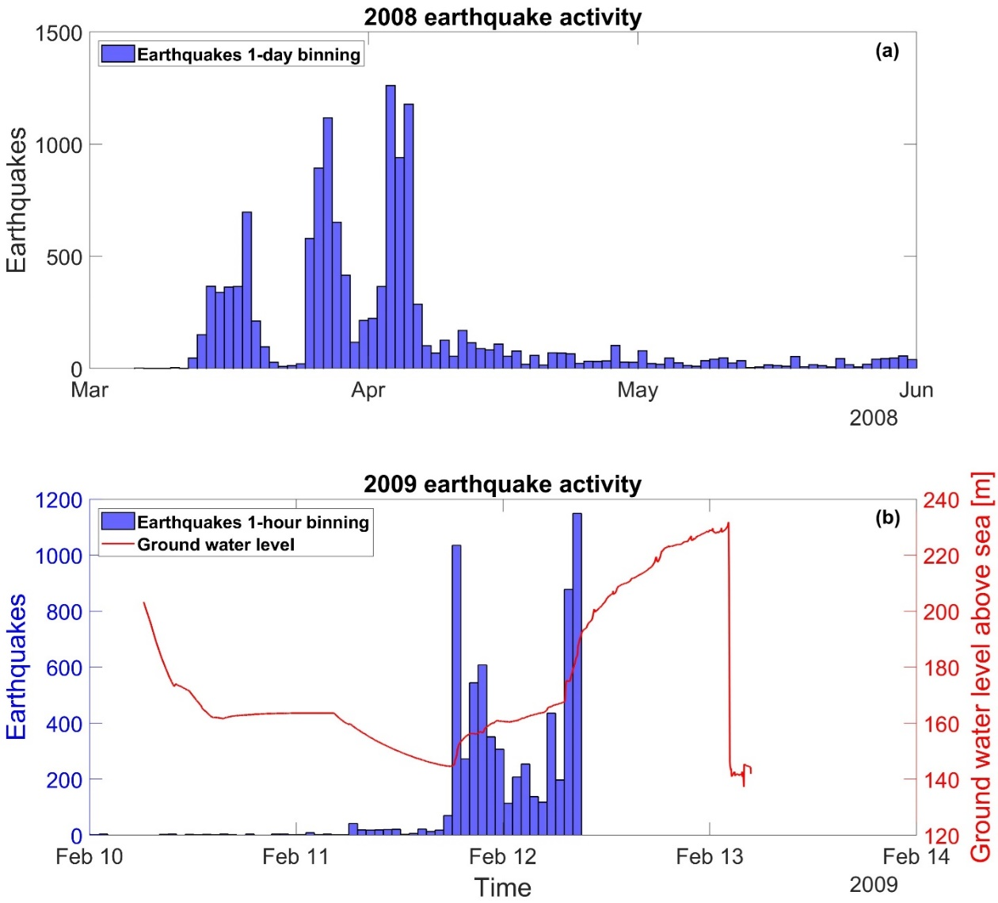

Figure S59. Seismicity of the Gisos - Cerville Episode for (a) The seismic activity of 2008 in 1-day bins (blue histograms), and (b) the seismic activity of 2009 in 1-hour bins (blue histograms) along with ground water level above sea with (red line).

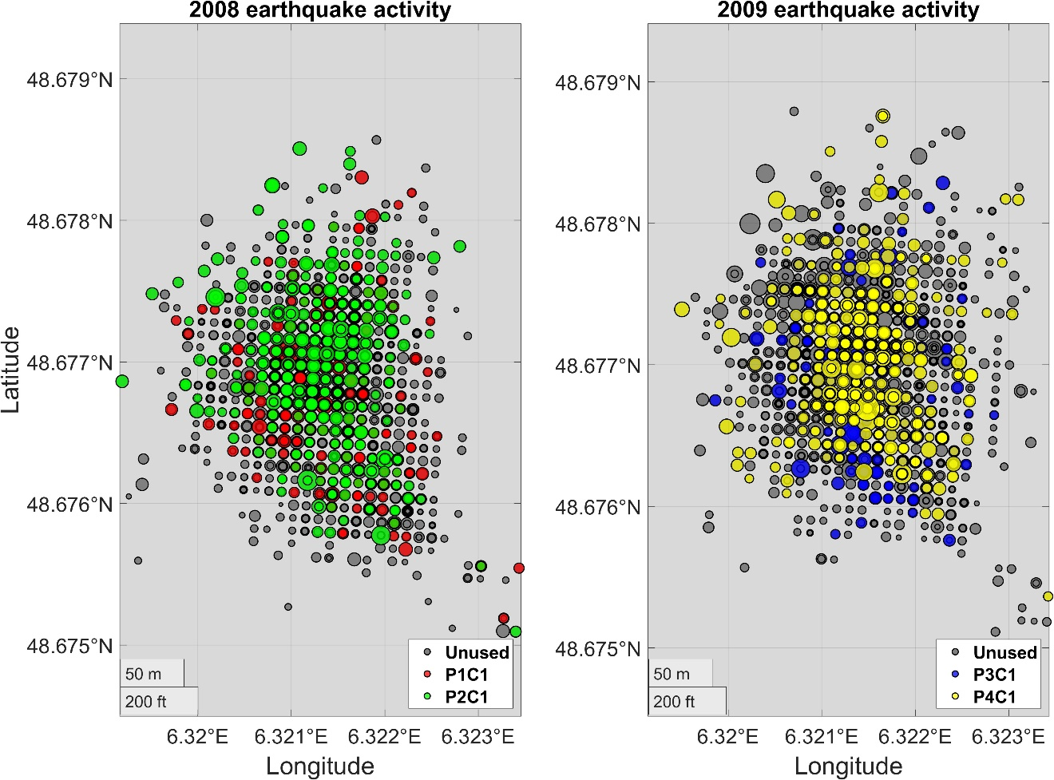

Figure S60. Epicentral distribution of the seismicity of, (a) the 13426 earthquakes of the Gisos–Cerville catalog between March and June 2008, and (b) the 7034 earthquakes in the same are for February 2009. The unused earthquakes for magnitude complexity testing are depicted in gray colors. The clusters that were finally selected to assess the magnitude distribution are represented with red and green colors for the 2008 seismicity and with blue and yellow for the 2009 seismicity.

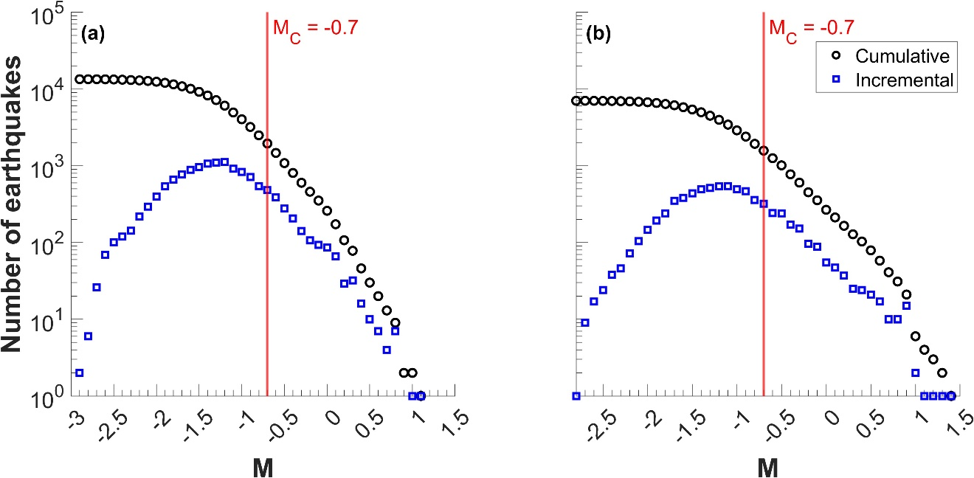

Figure S61. Cumulative and incremental frequency magnitude distributions of, (a) the 13426 earthquakes that occurred in 2008 and (b) the 7034 earthquakes that occurred in 2009. The chosen magnitude of completeness in each catalog is marked by the vertical red line.

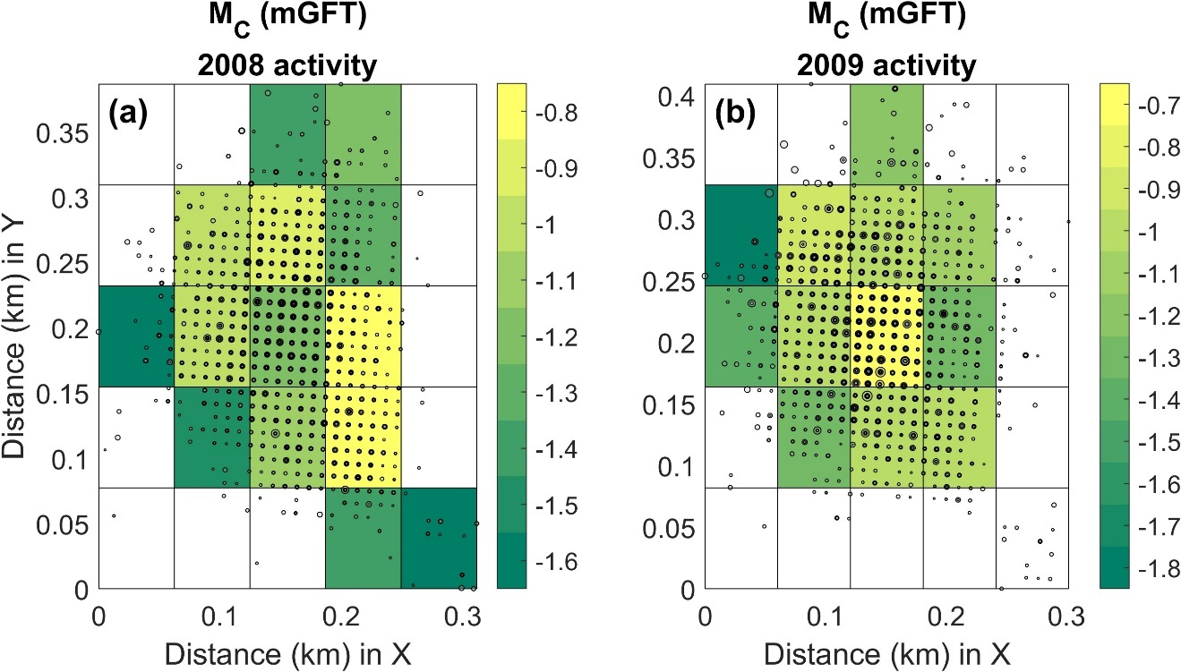

Figure S62. Spatial distribution of the magnitude of completeness over a gridded area for (a) the 2008 and (b) the 2009 earthquake activity of the Gisos–Cerville catalog.

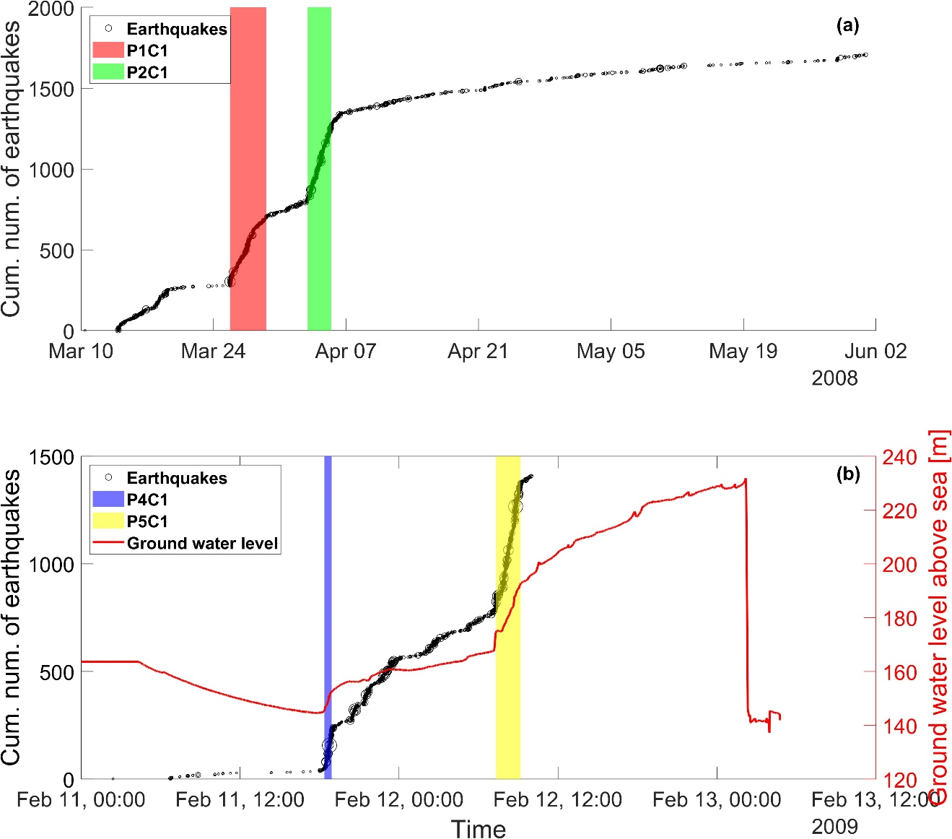

Figure S63. Cumulative number of earthquakes above Mc versus time (Left y-axis) represented with black circles for, (a) the 2008 and (b) the 2009 activity in Gisos–Cerville Episode. Ground water level above sea is plotted with red line (right y-axis) only for the 2009 activity. The stationary activity rate periods are noted with red, green and cyan colored areas for the 2008 activity (a) and with blue- and yellow-colored areas for the 2009 activity (b). The same colors are used in Figure S60 for the epicentral distribution of events in this period.

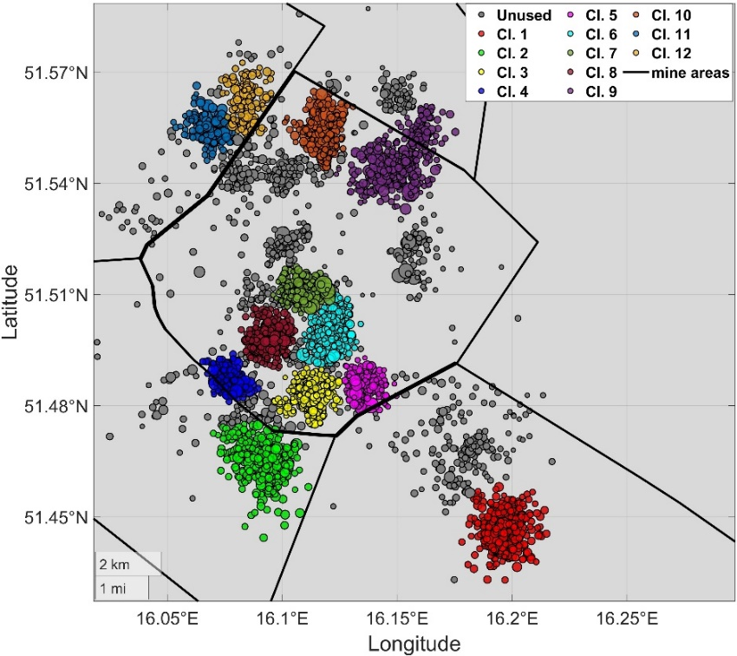

Figure S64. Epicentral distribution of the seismicity of the LGCD episode catalog after February 10, 2016. The selected clusters for further study appear with different colored circles. The continuous black lines represent the mine areas.

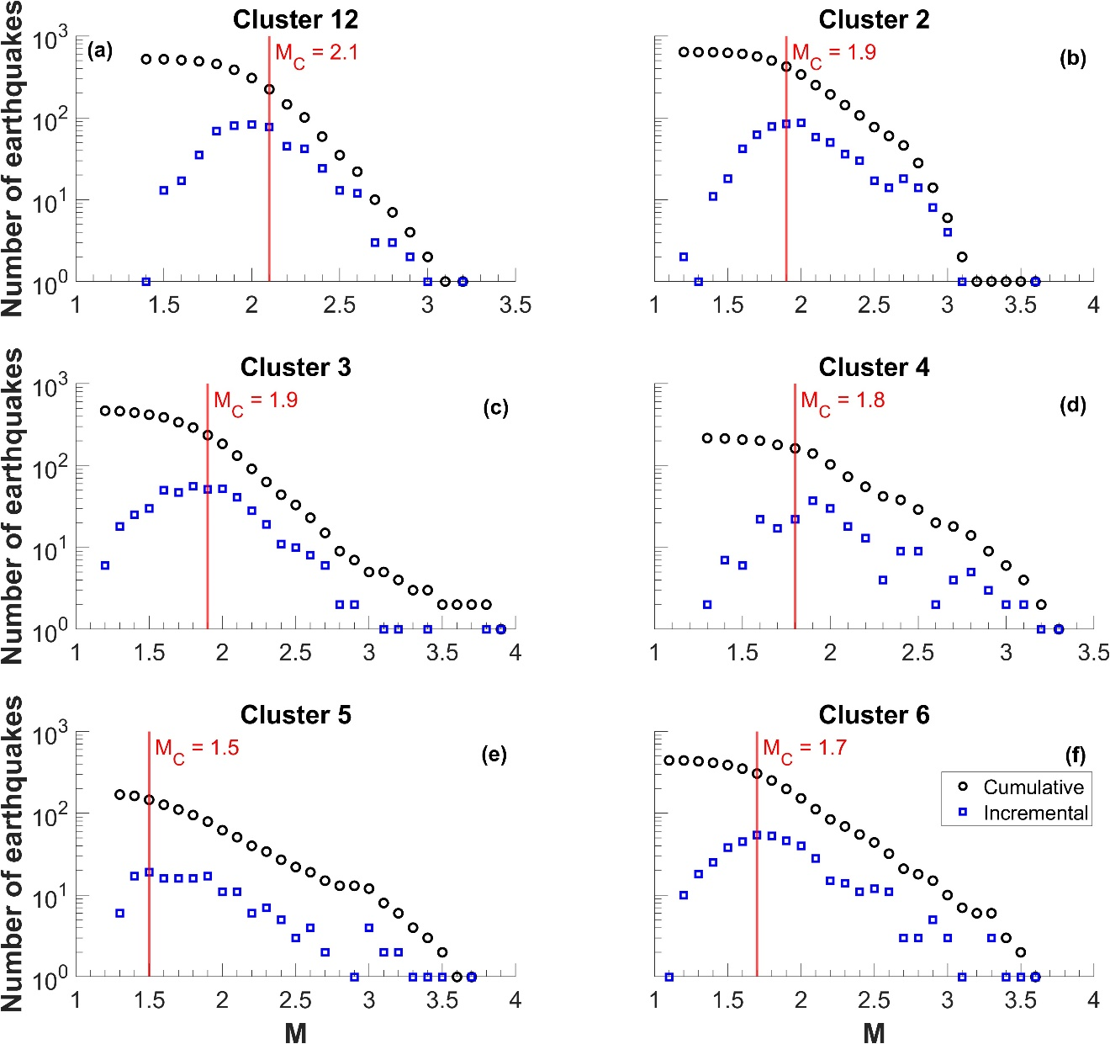

Figure S65. (a–f) Cumulative and incremental frequency magnitude distributions of Clusters 1–6. The chosen magnitude of completeness in each catalog is marked by the vertical red line.

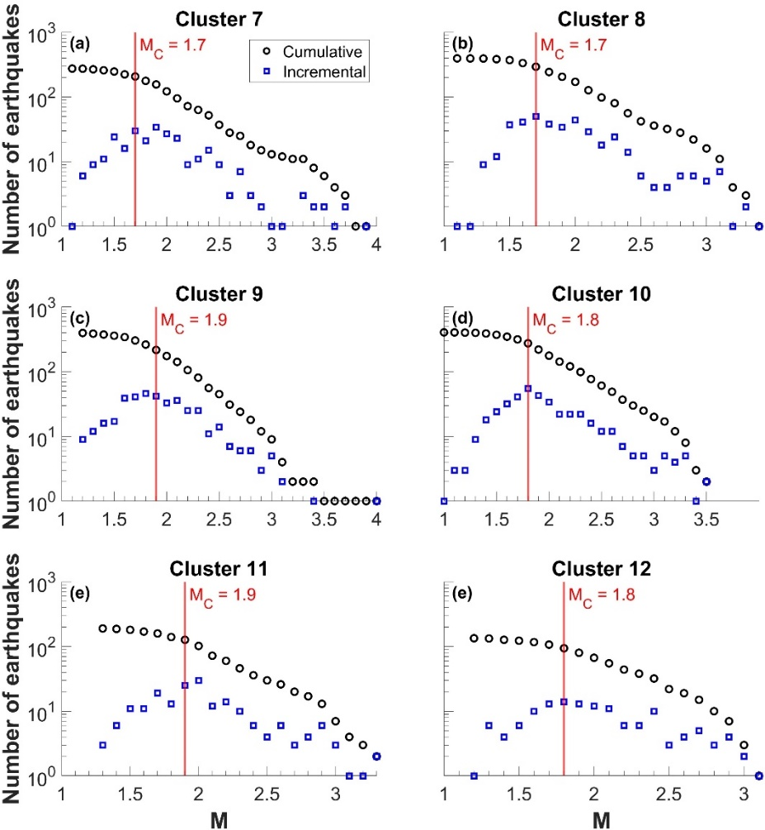

Figure S66. (a–f) Cumulative and incremental frequency magnitude distributions of Clusters 7–12. The chosen magnitude of completeness in each catalog is marked by the vertical red line.

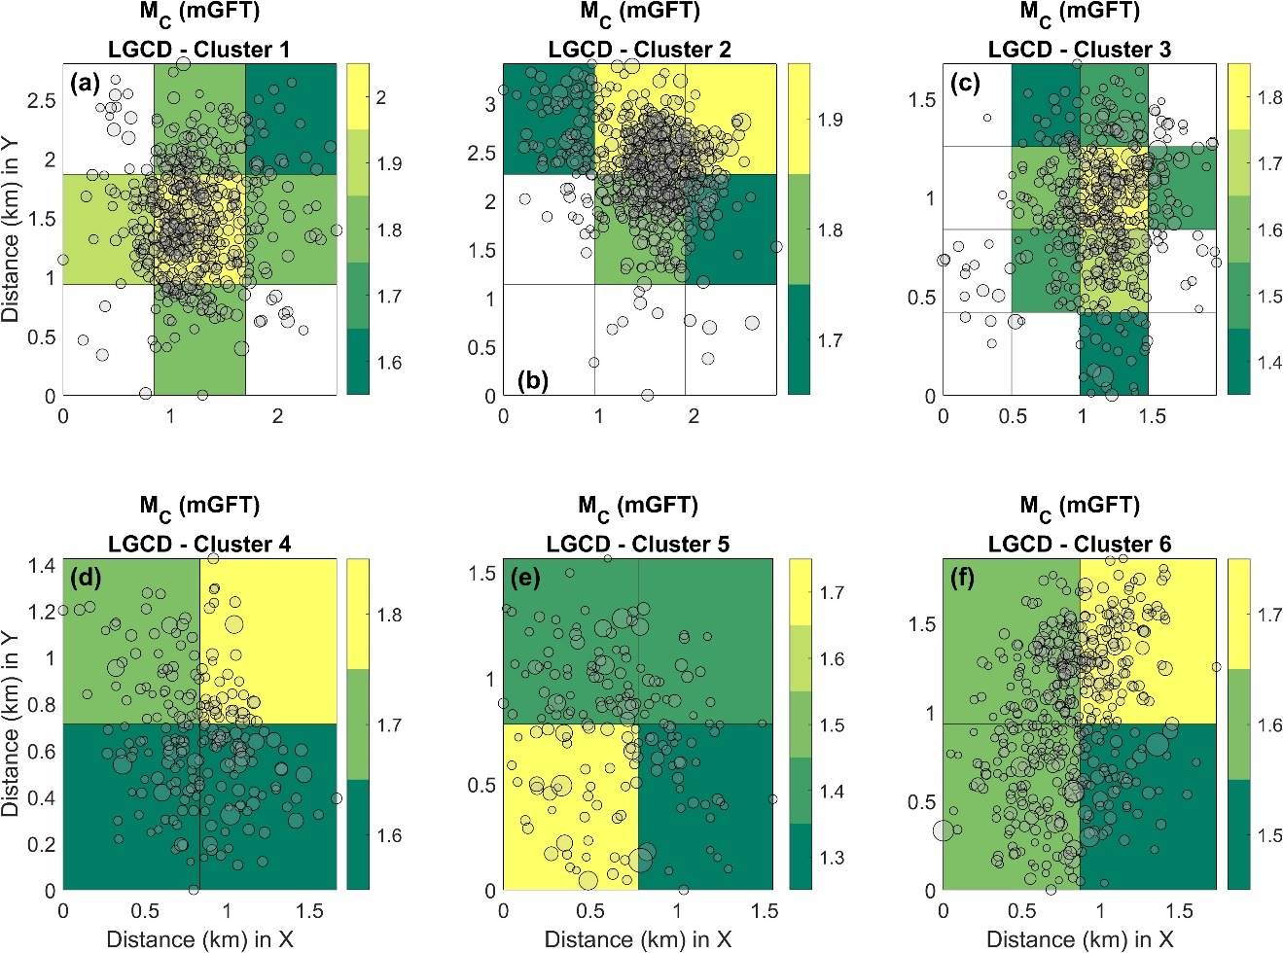

Figure S67. (a–f) Spatial distribution of the magnitude of completeness over a gridded area for Clusters 7–12 of the LGCD episode catalog.

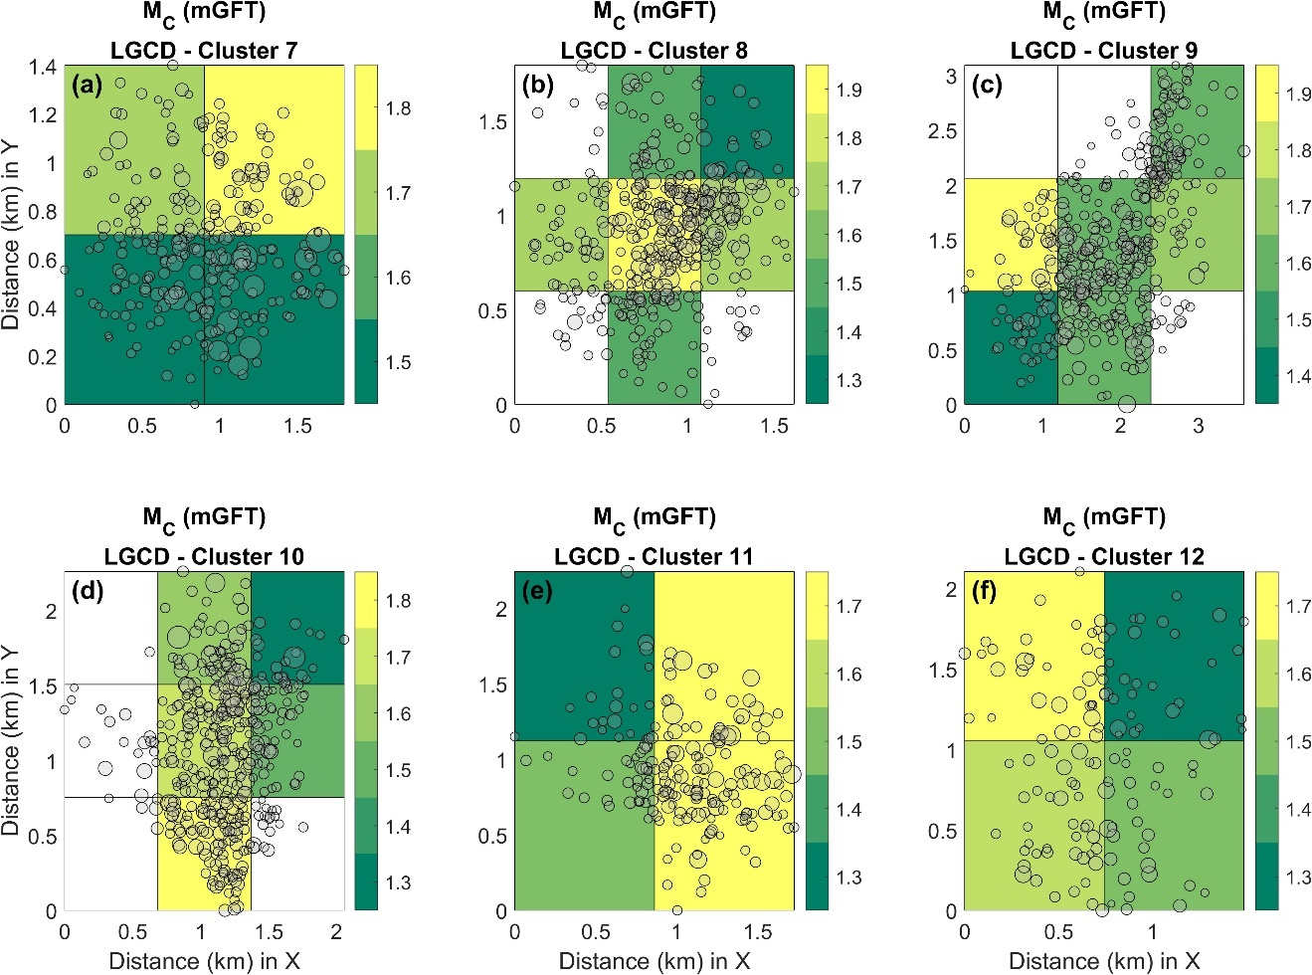

Figure S68. (a–f) Spatial distribution of the magnitude of completeness over a gridded area for Clusters 7–12 of the LGCD episode catalog.

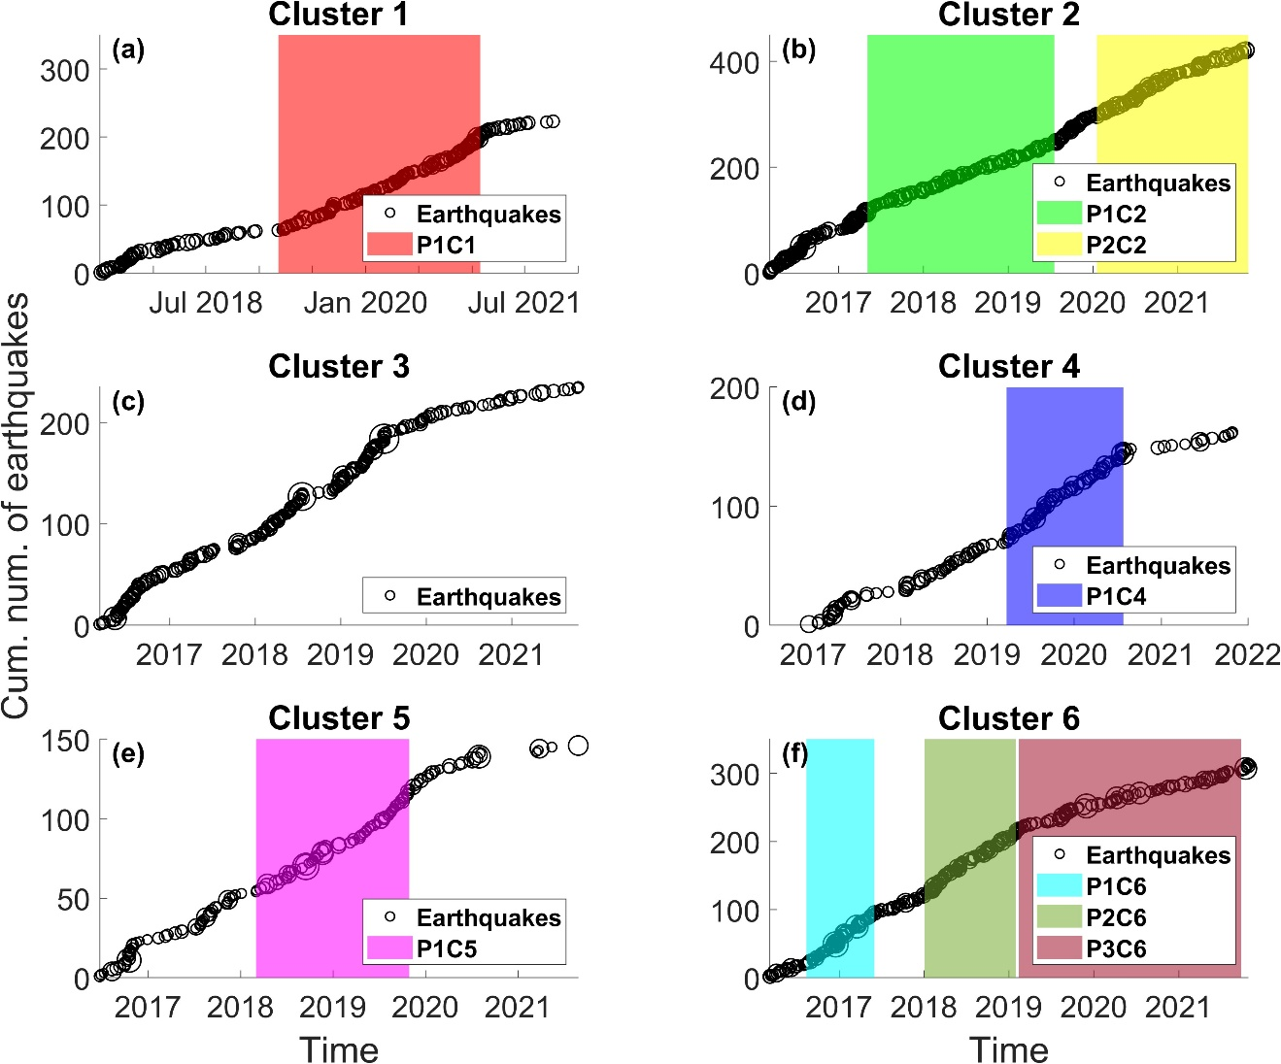

Figure S69. (a–f) Cumulative number of earthquakes with M≥Mc versus time for Clusters 1–6, represented by black circles. The stationary activity rate periods are noted with differently colored areas. The same colors are used in Fig. S71 for the epicentral distribution of events in those periods.

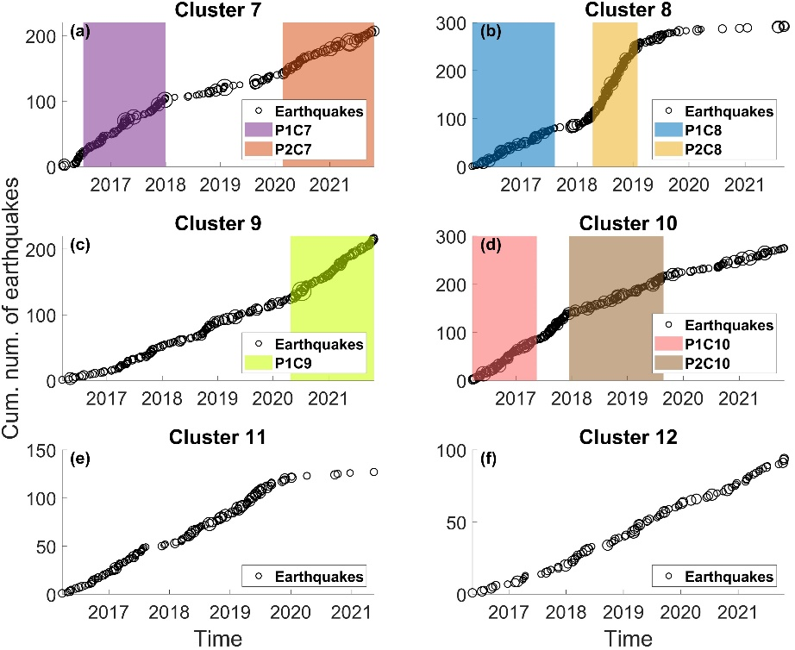

Figure S70. (a–f) Cumulative number of earthquakes with M≥Mc versus time for Clusters 7–12, represented by black circles. The stationary activity rate periods are noted with differently colored areas. The same colors are used in Fig. S71 for the epicentral distribution of events in those periods.

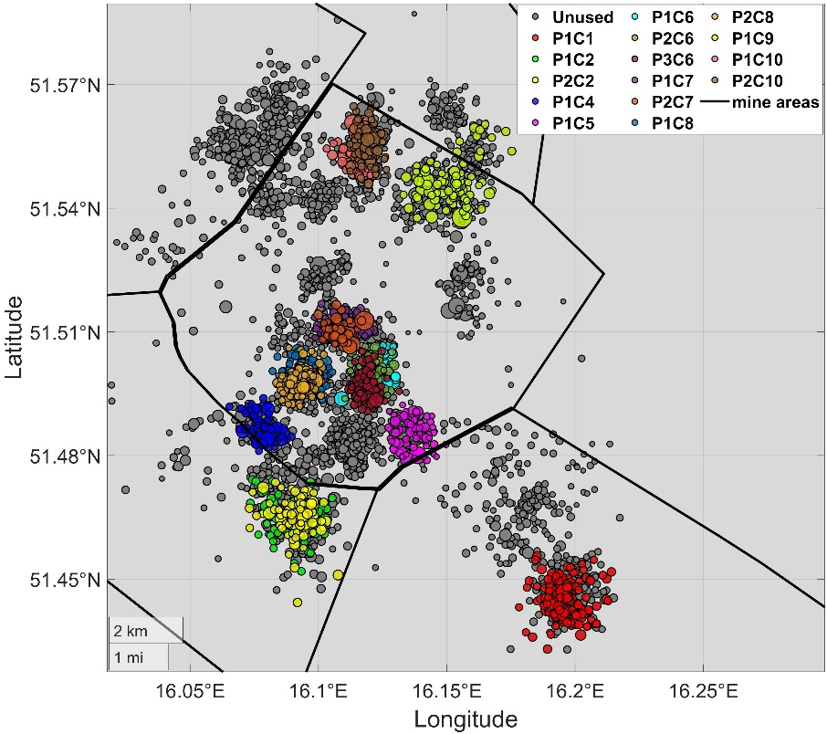

Figure S71. Epicentral distribution of the seismicity of the LGCD episode catalog after February 10, 2016. The selected stationary rate subcatalogs for complexity testing appear with different colored circles. The continuous black lines represent the mine areas.

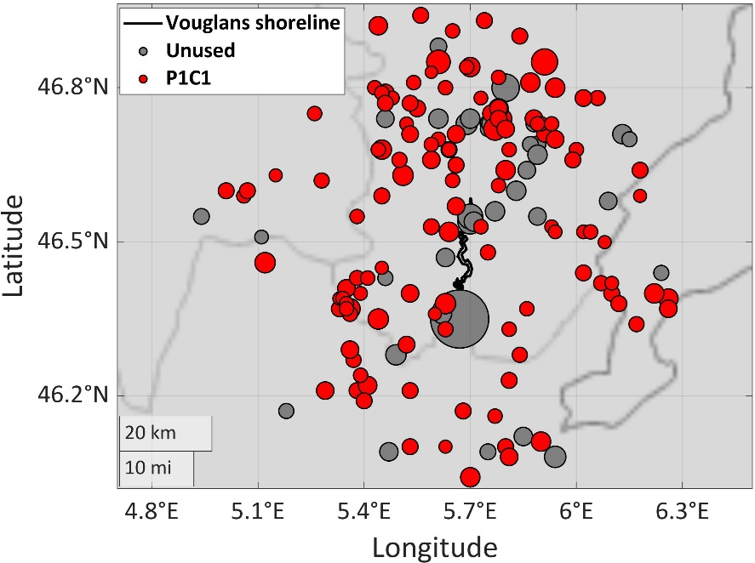

Figure S72. Epicentral distribution of the 167 earthquakes of the Vouglans episode catalog in a 50 km circle around the reservoir center. The unused earthquakes for magnitude complexity testing are depicted in gray colors. The earthquake subcatalog that was selected to assess the magnitude distribution complexity is represented by red circles.

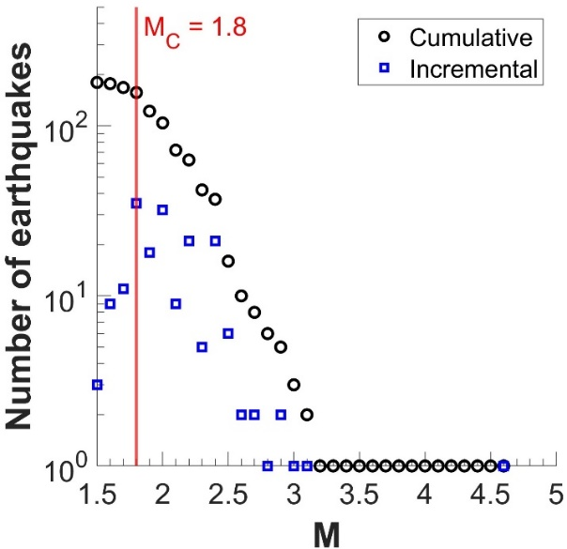

Figure S73. Cumulative and incremental frequency magnitude distributions of Vouglans reservoir catalog. The chosen magnitude of completeness is marked by the vertical red line.

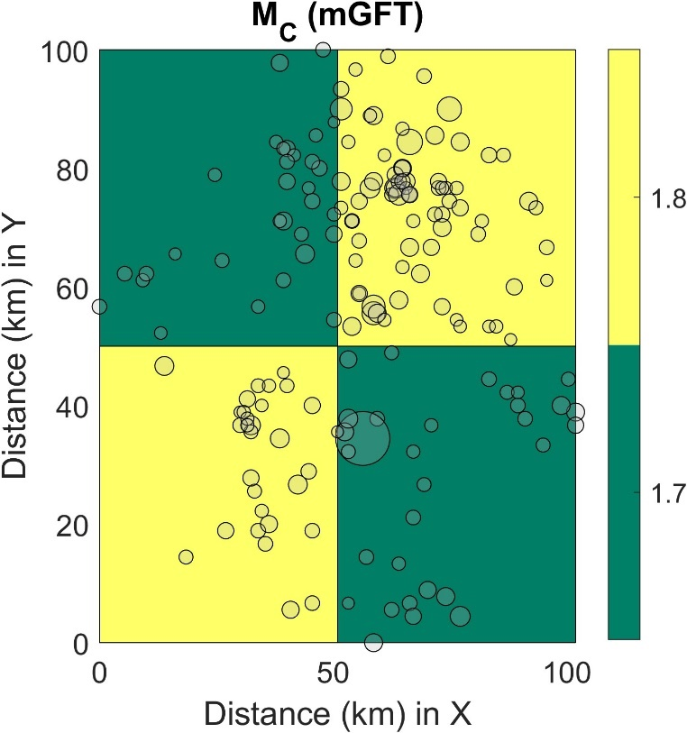

Figure S74. Spatial distribution of the magnitude of completeness over a gridded area for the Vouglans episode catalog

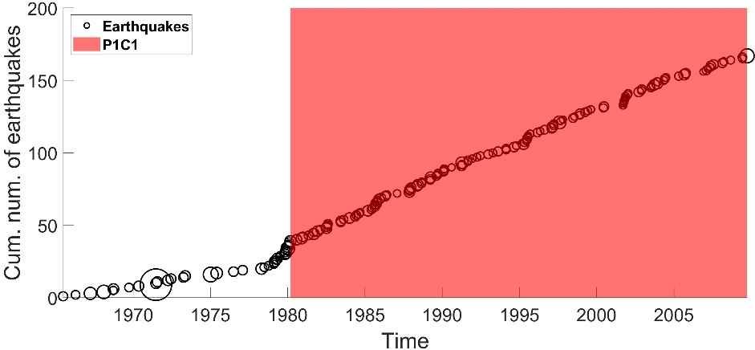

Figure S75. Cumulative number of earthquakes above Mc versus time represented with black circles. The stationary activity rate period is noted by the red colored area. The same color is used in Fig. S72 for the epicentral distribution of earthquakes in this period.

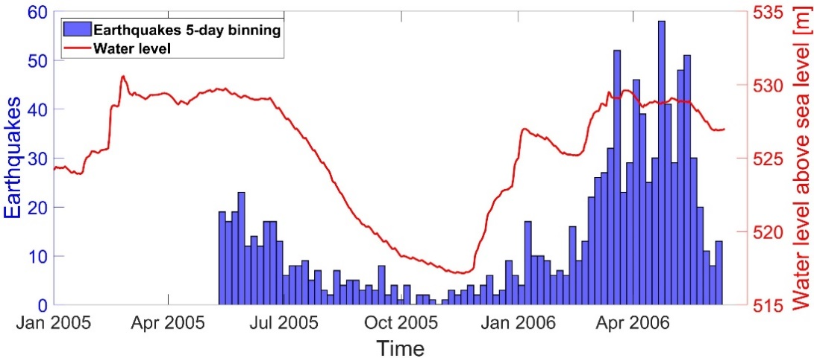

Figure S76. Earthquakes of the main cluster of 1082 earthquakes, SW of the Pertusillo lake in 5-day (left y-axis, blue histograms), along with water levels of the lake (right y-axis, red continuous line).

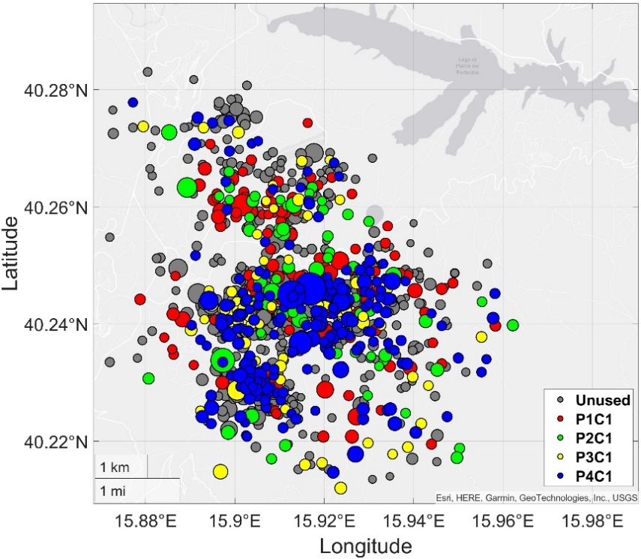

Figure S77. Epicentral distribution of the 1082 earthquakes of the main cluster of seismicity near the Petusillo lake. The unused earthquakes for magnitude distribution complexity testing are depicted in gray colors. The earthquake subcatalogs that were selected to assess the magnitude distribution complexity are represented by red, green, yellow and blue circles.

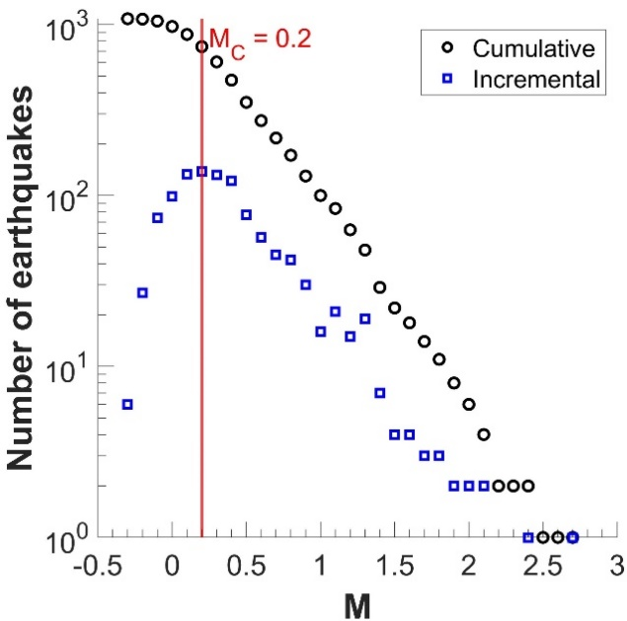

Figure S78. Cumulative and incremental frequency magnitude distributions of the main cluster of the Val D’Agri episode catalog. The chosen magnitude of completeness is marked by the vertical red line.

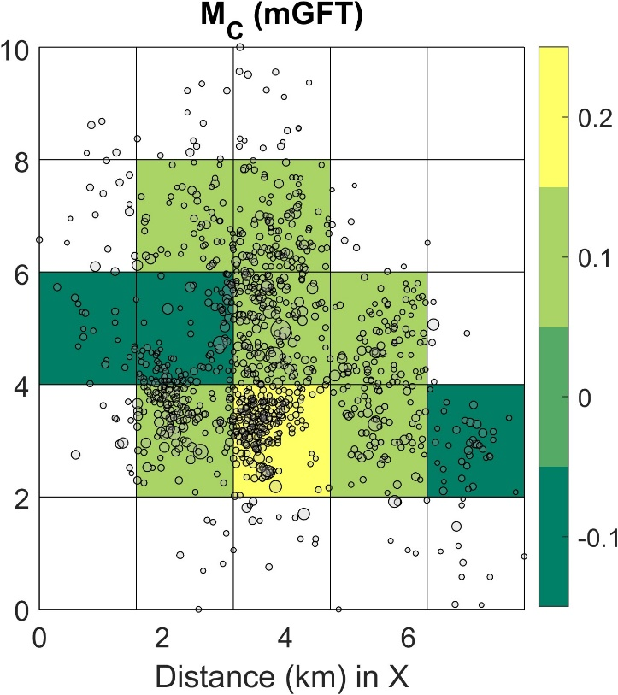

Figure S79. Spatial distribution of the magnitude of completeness over a gridded area for the Val D’Agri episode catalog

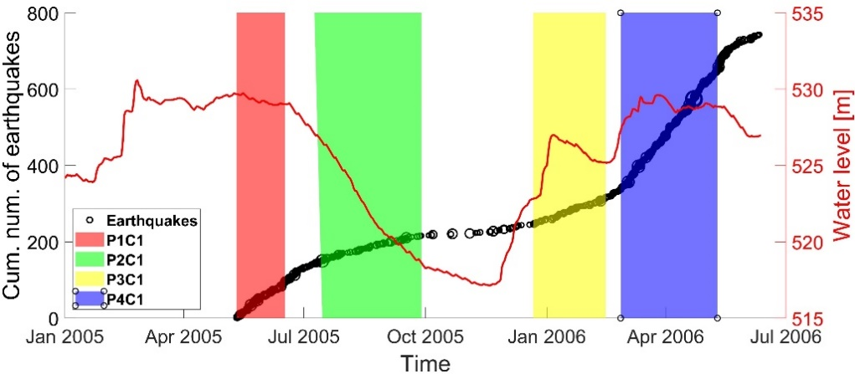

Figure S80. Cumulative number of earthquakes above Mc versus time, represented with black circles (left y-axis) along with the water level changes represented by a red continuous line (right y-axis). The stationary activity rate periods are noted by the red, green, yellow and blue colored areas. The same colors are used in Figure S77 for the epicentral distribution of earthquakes in those periods.

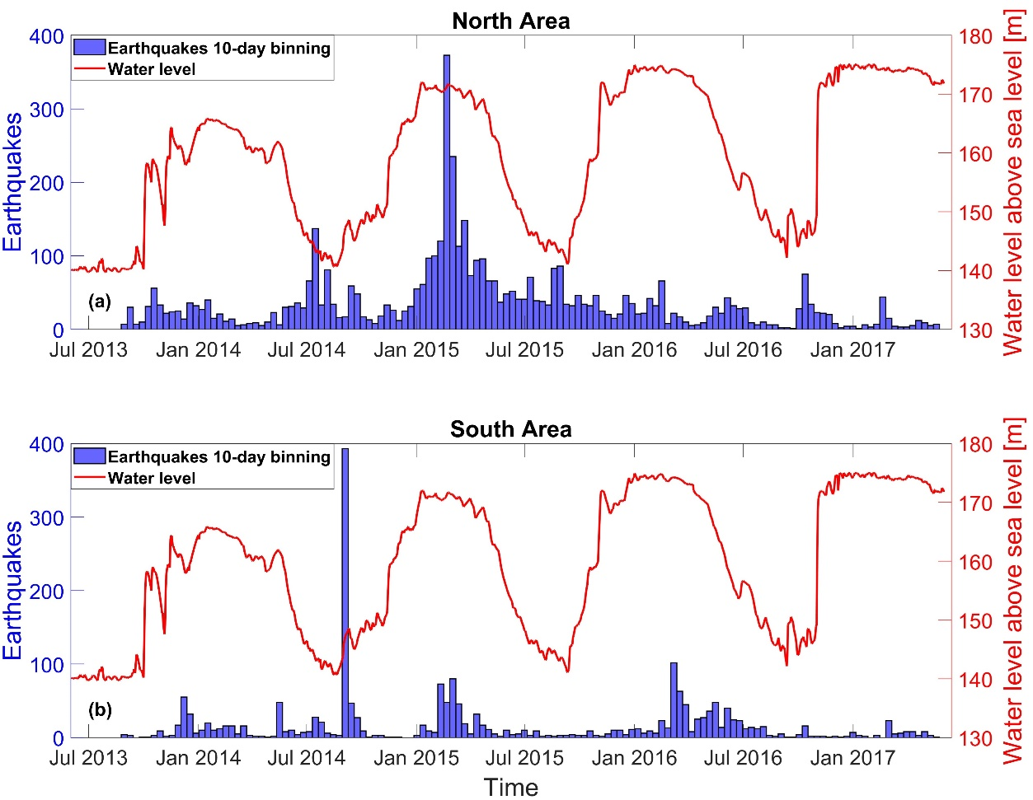

Figure S81. Earthquakes of the Song Tranh 2 reservoir, 10-day bins (left y-axis, blue histograms), along with water levels of the lake (right y-axis, red continuous line) for (a) The north and (b) South parts of the Song Trang area.

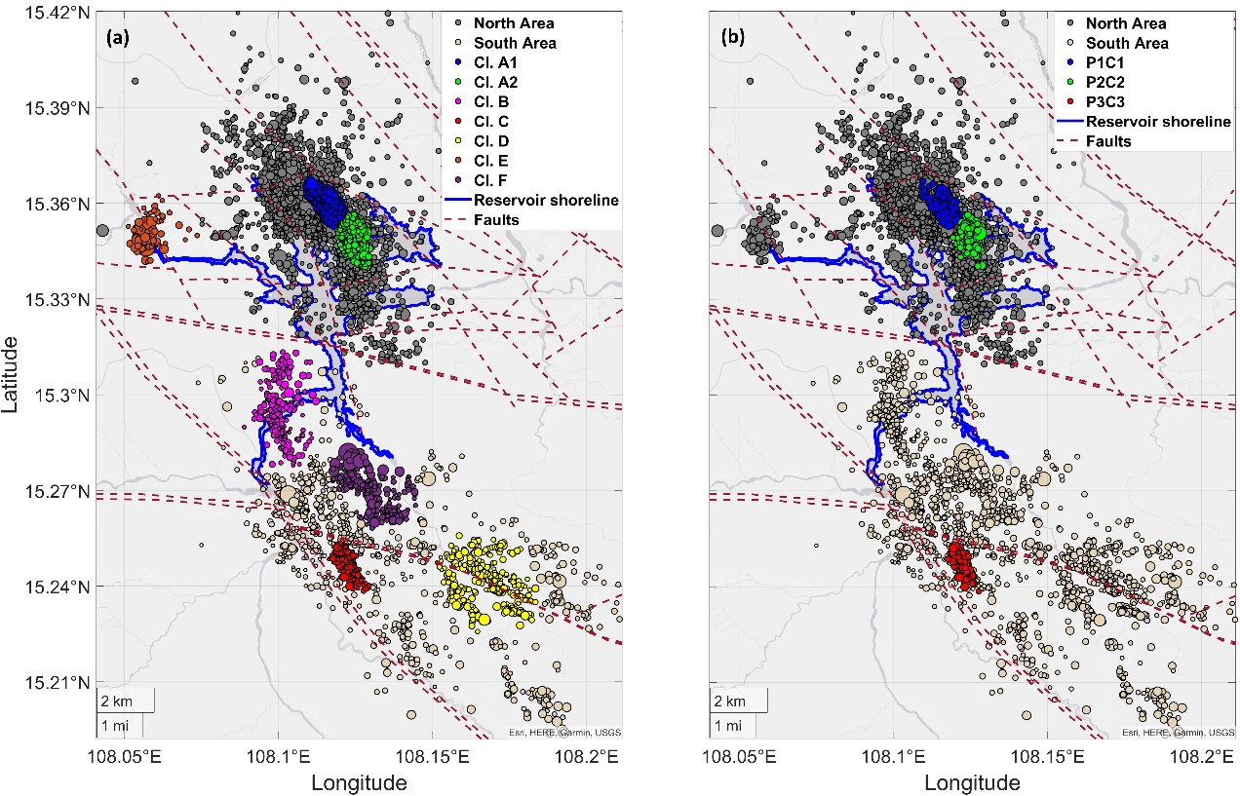

Figure S82. Epicentral distribution of the seismicity of the Song Tranh 2 basin with earthquakes of the north part represented by gray circles and those of the south part represented by beige circles. In (a) initial studied clusters appear with different colored circles and in (b) the final clusters that form subcatalogs of stationary periods appear with blue, green and red circles. The reservoir shoreline is represented by the blue continuous line and the faults are represented by the brown dashed lines.

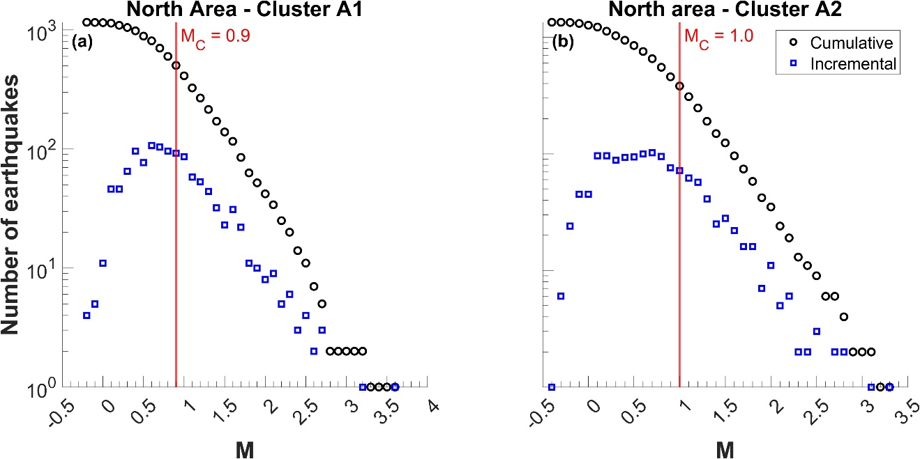

Figure S83. Cumulative and incremental frequency magnitude distributions for, (a) subcluster A1 and (b) subcluster A2 of the north part of the Song Tranh 2, episode catalog. The chosen magnitudes of completeness are marked by the vertical red lines.

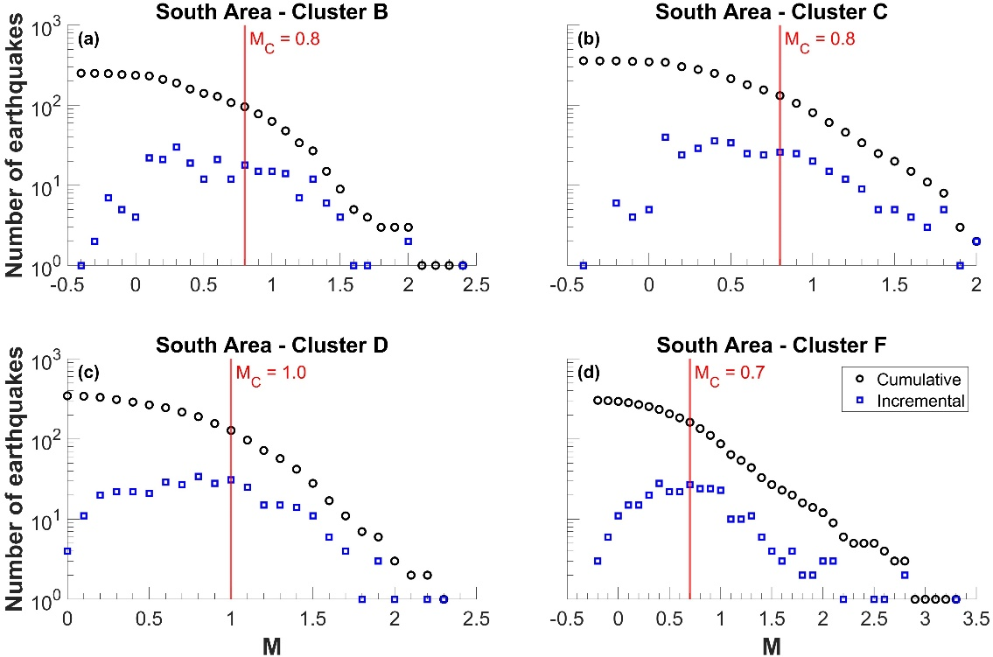

Figure S84. Cumulative and incremental frequency magnitude distributions for, (a) cluster B, (b) cluster C, (c) cluster D and (d) cluster F of the south part of the Song Tranh 2 episode catalog. The chosen magnitudes of completeness are marked by the vertical red lines.

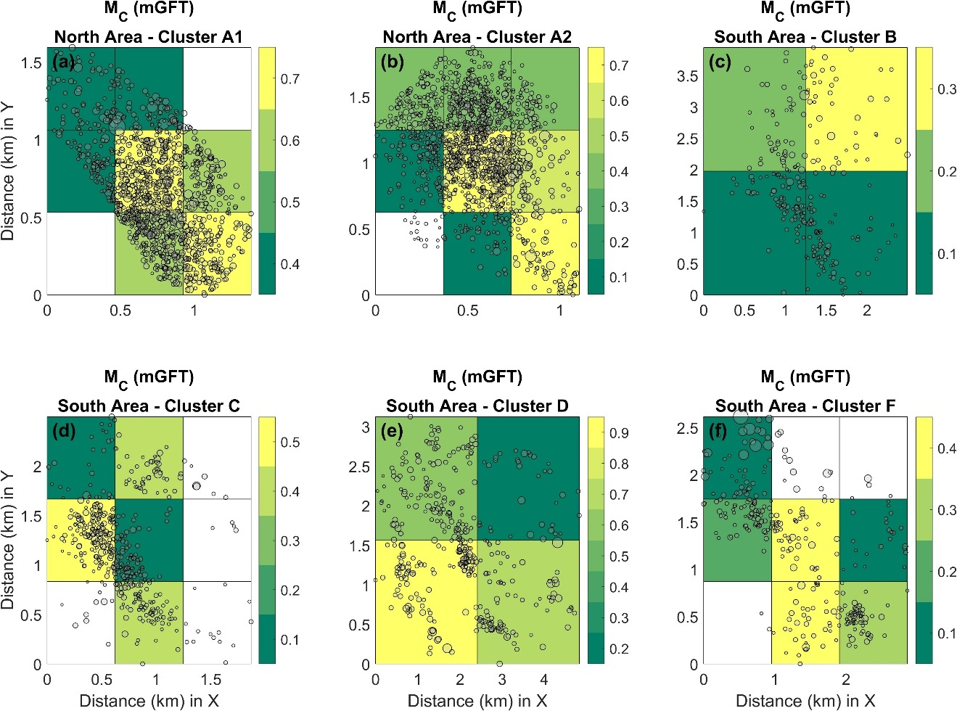

Figure S85. Spatial distribution of the magnitude of completeness over a gridded area for clusters (a) A1, (b) A2, (c) B, (d) C, (e) D and (f) F of the Song Tranh 2 episode catalog.

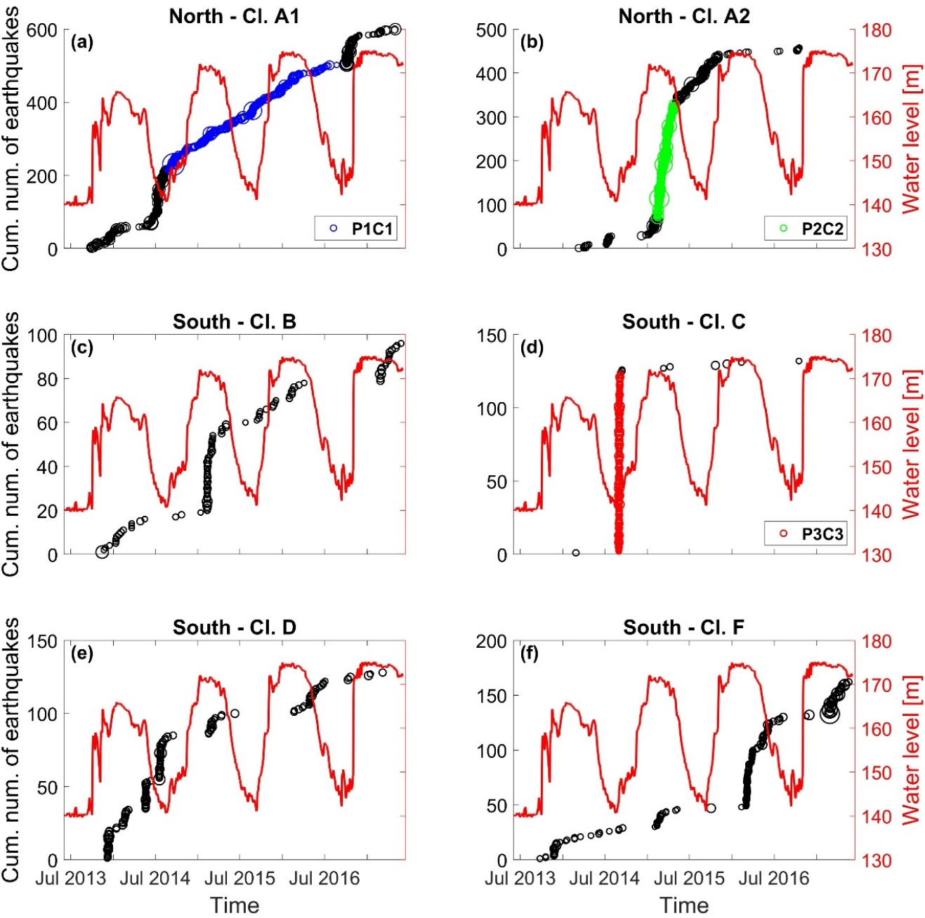

Figure S86. (a–f) Cumulative number of earthquakes above Mc versus time, represented with black circles (left y-axis) along with the water level changes represented by a red continuous line (right y-axis) for the examined clusters. The stationary activity rate periods are noted by (a) the blue colored circles, (b) the green colored circles and (d) the red colored circles. The same colors are used in Fig. S82b for the epicentral distribution of earthquakes in those periods.

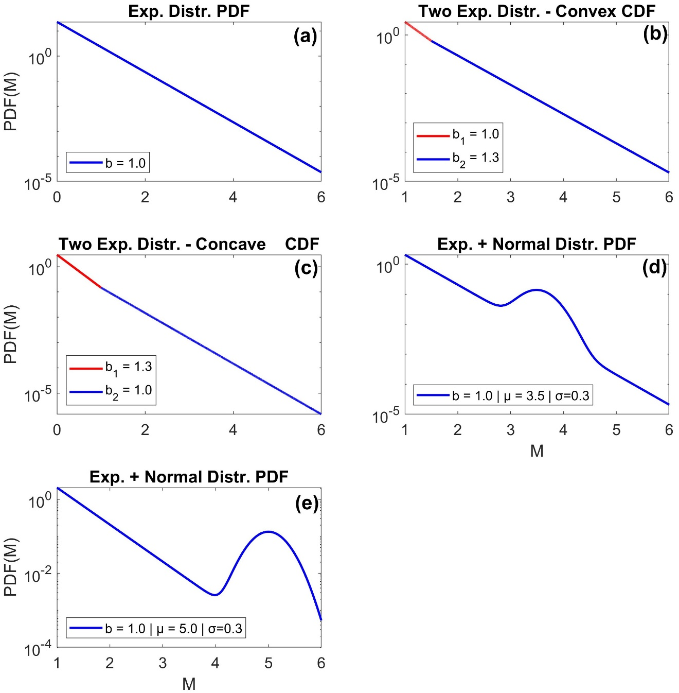

Figure S87. The five cumulative distribution functions (CDFs) used to test the power of the AD, LIL, and KS tests represented by continuous lines.

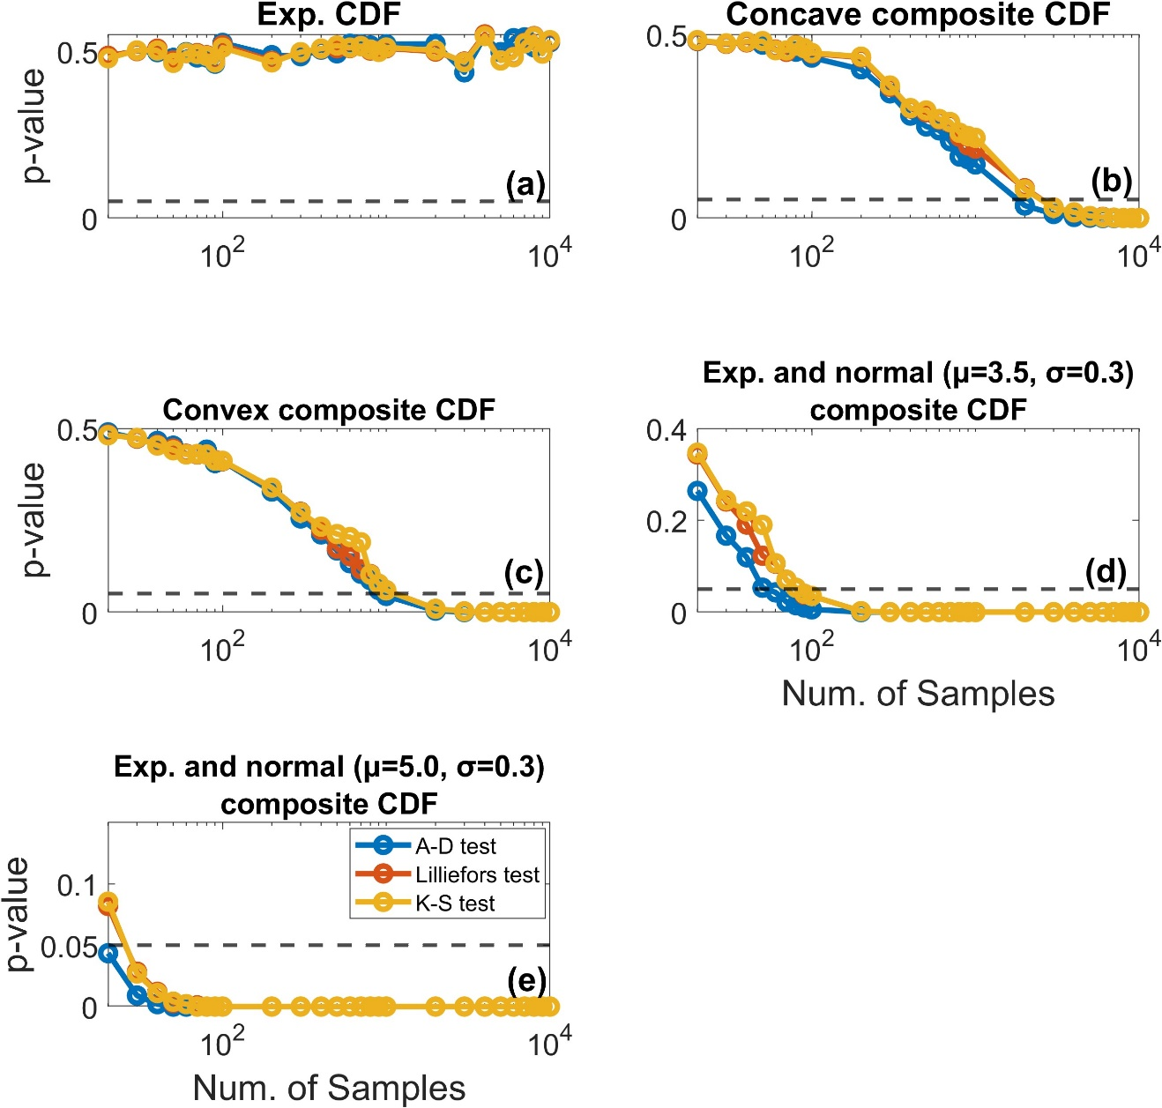

Figure S88. median p-values of the AD (blue), LIL (red) and KS (yellow) tests versus the number of samples drawn from, (a) the exponential CDF, (b) the CDF from resulting from a concave composite of two exponential PDFs, (c) the CDF from resulting from a convex composite of two exponential CDFs, (d) the CDF resulting from a composite of an exponential and normal PDF with μ=3.5 and σ=0.3, and (e) the CDF resulting from a composite of an exponential and normal PDF with μ=5.0 and σ=0.3.

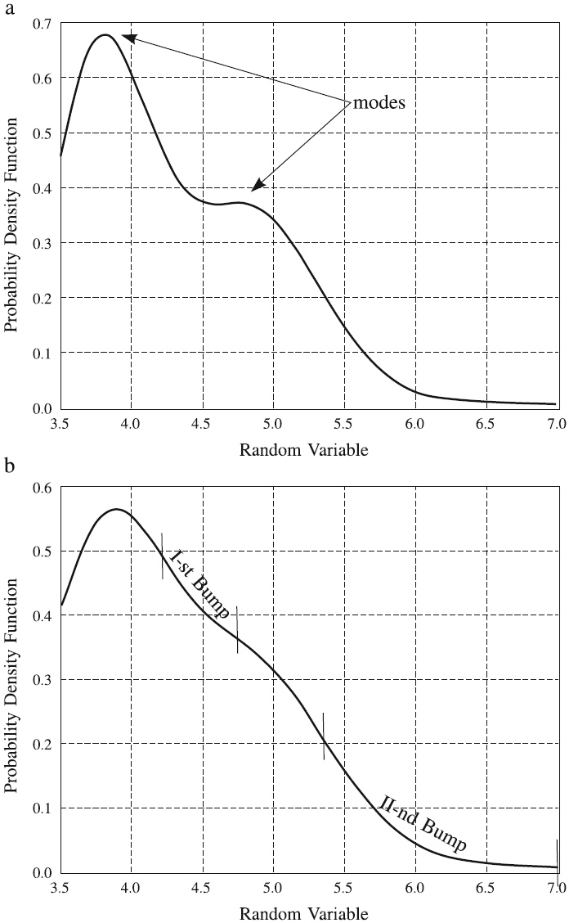

Figure S89. Examples of complex exponential-like distributions. (a) A bimodal probability density function and (b) A two-bump density function. Reproduced from Lasocki and Papadimitriou (2006).

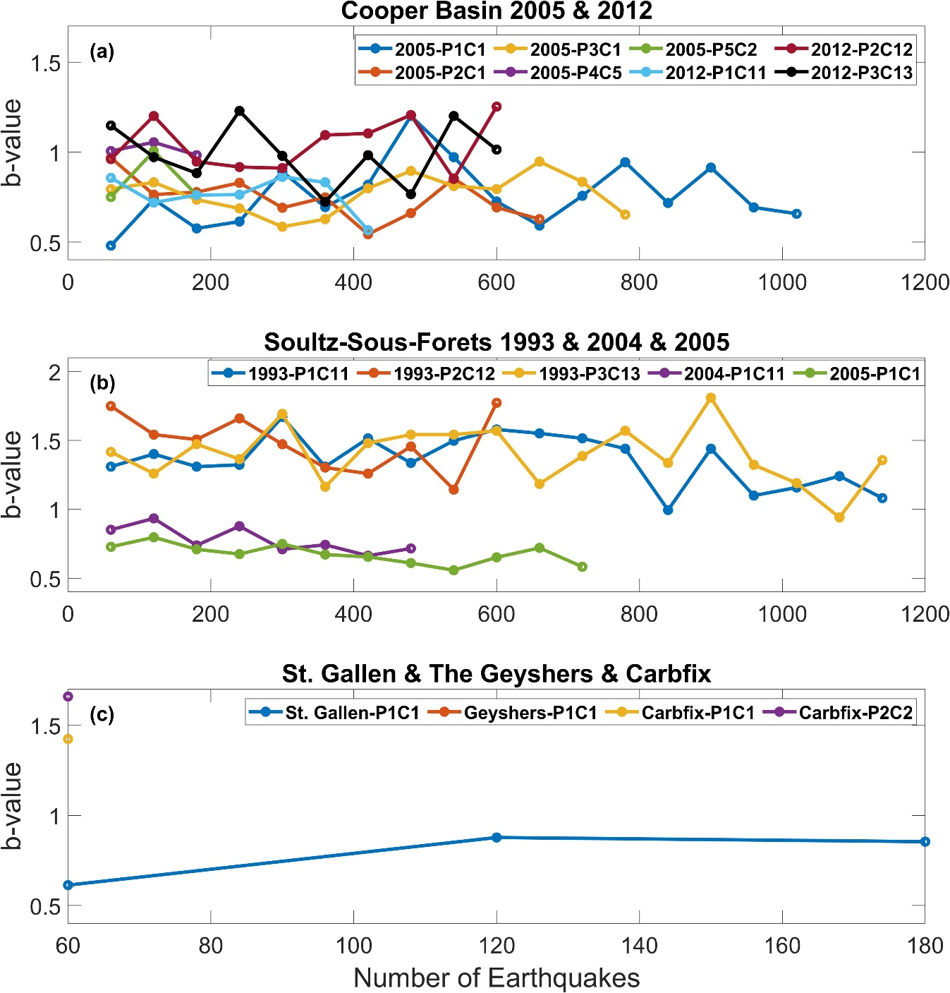

Figure S90. b-value variations calculated for 60–earthquake non-overlapping moving windows for the examined subcatalogs of (a) the 2005 and 2012 Cooper Basin injection, (b) the Soultz-sous-Forêts 1993, 2004 and 2005 injections, and (c) the Geyshers prati 9 and prati 29 injections, the Carbfix and St. Gallen episodes.

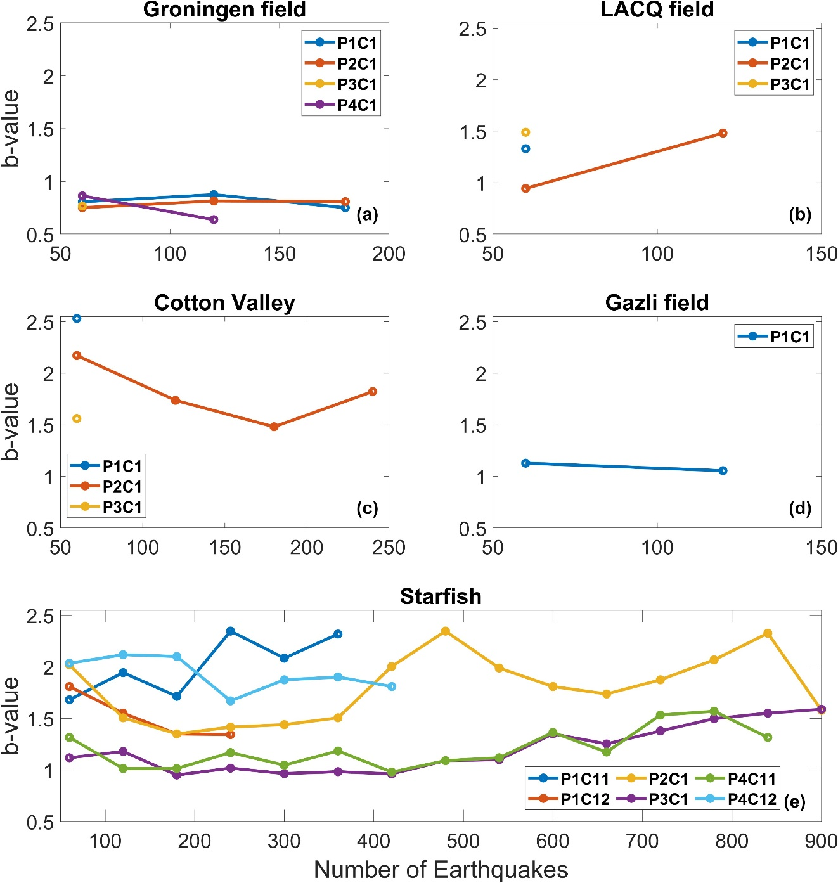

Figure S91. b-value variations calculated for 60–earthquake non-overlapping moving windows for the examined subcatalogs of (a) the Groningen field, (b) the LACQ field, and (c) the Cotton Valley episode, (d) the Gazli field, and (e) the Starfish episode.

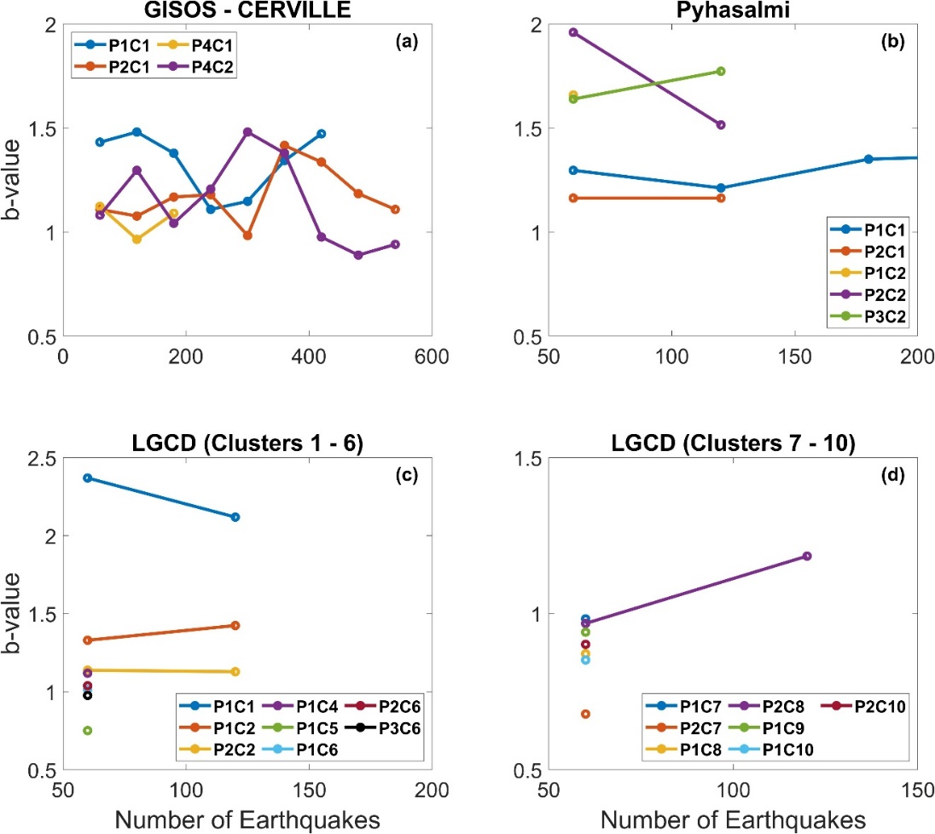

Figure S92 b-value variations calculated for 60–earthquake non-overlapping moving windows for the examined subcatalogs of (a) the GISOS–CERVILLE mine, (b) the Pyhasalmi mine, and (c) the LGCD mine, clusters 1–6, and (d) the LGCD mine, clusters 7–10.

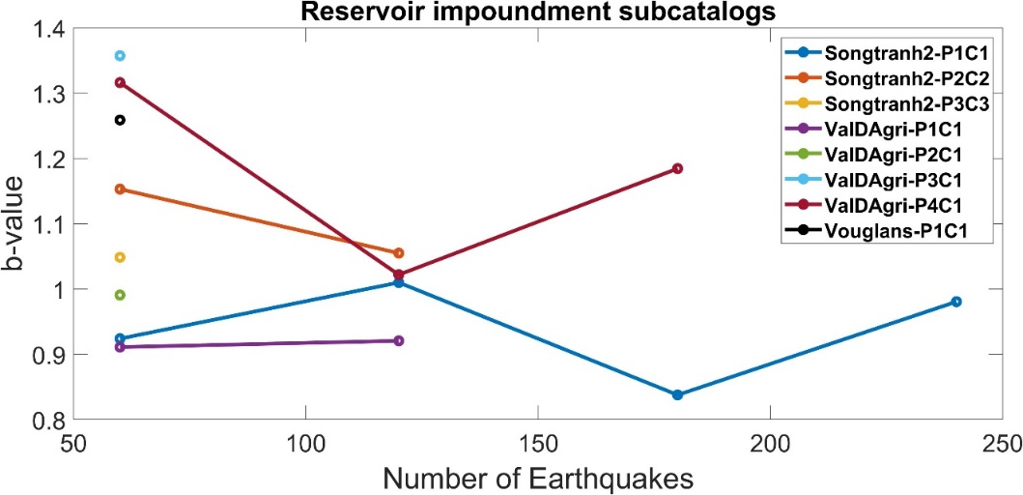

Figure S93. b-value variations calculated for 60–earthquake non-overlapping moving windows for the examined subcatalogs related to the examined Reservoir Impoundment episodes

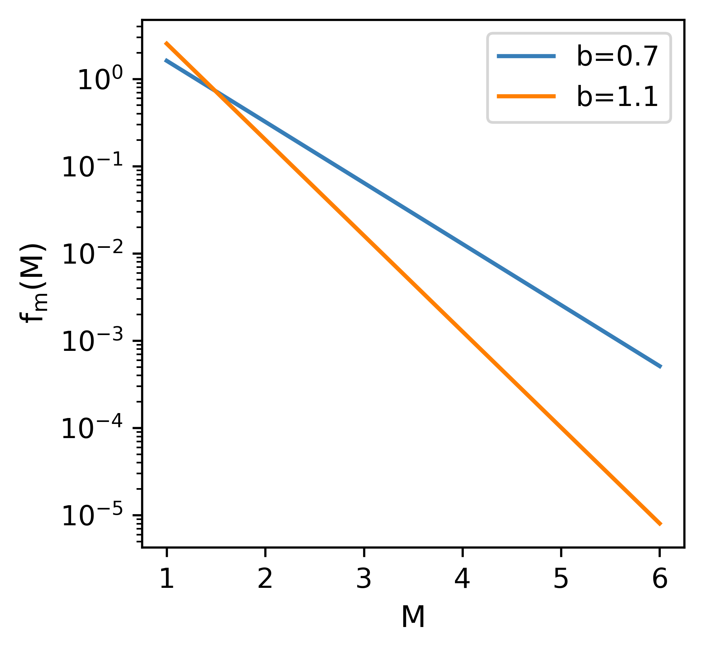

Figure S94. PDFs of two exponential distributions with b=0.7 (blue line) and b=1.1 (orange line).

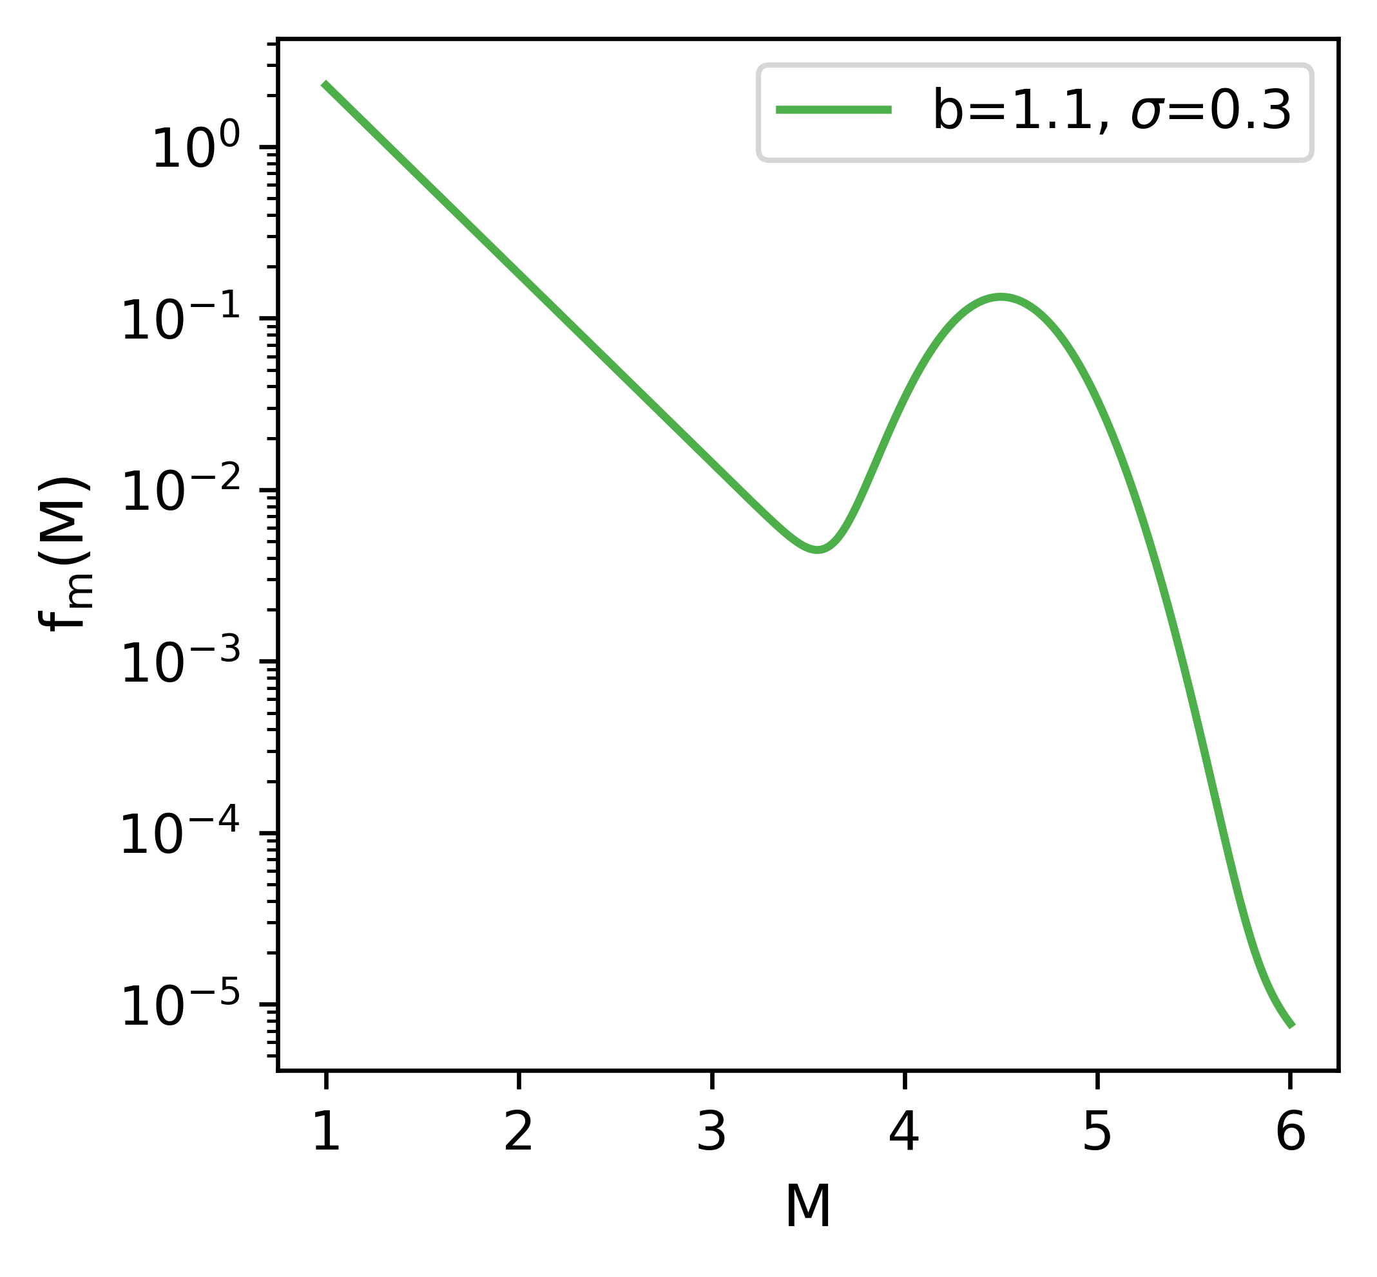

Figure S95. PDF of a combination of exponential distribution with b=0.1 and a gaussian function with a sigma of 0.3).

Table S1 Information available on the Soultz-sous-Forêts 2004 episode.
Type of episode | Geothermal energy production
Num. of events | 5861
Time range | 08/09/2004 – 24/09/2004
M_{L} | -2.3 – 2.3 (0.1 precision)
Seism. Network | Stable for the whole period
Add. Data | Inj. Rate, wellhead pressure, Flowback rate
Notes | -

Table S2 Information available on the Soultz-sous-Forêts 2005 episode.
Type of episode | Geothermal energy production
Num. of events | 3709
Time range | 04/02/2005 – 01/04/2005
M_{L} | -1.8 – 2.3 (0.1 precision)
Seism. Network | Stable for the whole period
Add. Data | Inj. Rate, wellhead pressure, Inj. volume
Notes | -

Table S3 Available information on the Cooper Basin 2005 episode.
Type of episode | Geothermal energy production
Num. of events | 8283
Time range | 11/09/2005 – 30/09/2005
M_{L} | -0.9 – 2.9 (0.1 precision)
Seism. Network | Stable for the whole period
Add. Data | Inj. Rate, Well paths, Well positions wellhead pressure
Notes | -

Table S4 Information available on The Geyshers prati 9 and prati 29 cluster episode.
Type of episode | Geothermal energy production
Num. of events | 1252
Time range | 10/12/2007 – 23/08/2014
M_{W} | 1.4 – 3.2 (0.1 precision)
Seism. Network | -
Add. Data | Inj. Rate, Well paths, Well positions
Notes | Catalog is provided after completeness calculation

Table S5 Information available on the St. Gallen episode
Type of episode | Geothermal energy production
Num. of events | 347
Time range | 14/07/2013 – 19/05/2015
M_{L} | -1.2 – 3.5 (0.1 precision)
Seism. Network | Numerous changes in network configuration
Add. Data | Well paths, Well positions, Downhole pressure
Notes | -

Table S6 Information available on the Carbfix episode.
Type of episode | Geothermal energy production and Co2 sequestration
Num. of events | 1081
Time range | 29/11/2017 – 28/02/2018
M_{L} | -0.9 – 4.3 (0.1 precision)
Seism. Network | Stable for the whole period
Add. Data | Ground water level, Well Path, Well Position
Notes | -

Table S7 Information available on the Cotton Valley episode.
Type of episode | Unconventional hydrocarbon extraction
Num. of events | 888
Time range | 14/05/1997 – 14/05/1997
M_{W} | -2.38 – -0.69 (0.01 precision)
Seism. Network | Stable
Add. Data | Fracking process parameters, well path, well position
Notes | Catalog refers to one day of the three days of injection

Table S8 Information available on the Groningen episode.
Type of episode | Conventional hydrocarbon extraction
Num. of events | 1889
Time range | 26/12/1986 – 16/07/2022
M_{W} | -0.8 – 3.4 (0.1 precision)
Seism. Network | Information only after April 2015
Add. Data | Natural gas production, production cluster position
Notes | Unknown seismic network configuration prior to 2015

Table S9 Information available on the Lacq episode.
Type of episode | Conventional hydrocarbon extraction
Num. of events | 489
Time range | 13/12/1967 – 11/12/2009
M_{W} | 1.3 – 5.2 (0.1 precision)
Seism. Network | Network changes with time
Add. Data | Injection volume, Gas field area, natural gas production
Notes | 3L catalog

Table S10 Available Information on the Gazli episode.
Type of episode | Conventional hydrocarbon extraction
Num. of events | 441
Time range | 17/05/1991 – 26/06/1991
M_{W} | 0.1 – 3.1 (0.1 precision)
Seism. Network | Stable for the whole period
Add. Data | Injected gas volume, natural gas production, Gazli field area
Notes | Local catalog, 1L, 3L and 10L catalogs contain few data

Table S11 Information available on the Starfish project episode.
Type of episode | Underground gas storage
Num. of events | 53083
Time range | 09/04/2014 – 25/02/2015
M_{L} | -6.0 – -3.0 (0.1 precision)
Seism. Network | Stable
Add. Data | In situ temperatures, in situ temperature stations
Notes | -

Table S12 Information available on the Pyhasalmi mine episode.
Type of episode | Underground mining
Num. of events | 7059
Time range | 01/10/2010 – 31/03/2011
M_{L} | -2.4 – 2.2 (0.1 precision)
Seism. Network | Stable for the whole period
Add. Data | Blasts information, ining polygon advance, mine area, well paths
Notes | Macroevents catalog exists but not used, contains very few data

Table S13 Information available on the Gisos - Cerville episode.
Type of episode | Underground mining
Num. of events | 22455
Time range | 06/03/2008 – 12/09/2009
M_{W} | -2.9 – 1.4 (0.1 precision)
Seism. Network | Stable for the whole period
Add. Data | Ground Water Level, Well Positions, Cavity roof level
Notes | -

Table S14 Information available on the LGCD episode.
Type of episode | Underground mining
Num. of events | 6986
Time range | 10/12/2013 – 31/10/2021
M_{W} | 0.9 – 4.0 (0.1 precision)
Seism. Network | Stable after 10/02/2016
Add. Data | Mine area
Notes | Used 5159 earthquakes after 10/02/2016

Table S15 Available Information on the Vouglans episode.
Type of episode | Reservoir Impoundment
Num. of events | 167
Time range | 20/06/1965 – 26/07/2009
M_{W} | 1.5 – 4.6 (0.1 precision)
Seism. Network | No information
Add. Data | Reservoir shoreline; Water Height
Notes | Catalog refers to earthquakes within a ~50 km radius from reservoir center

Table S16 Information available on the Val. D’Agri episode.
Type of episode | Reservoir Impoundment
Num. of events | 1620
Time range | 11/05/2005 – 12/06/2005
M_{L} | -0.3 – 2.7 (0.1 precision)
Seism. Network | Stable for the whole period
Add. Data | Water Level
Notes | Used 1082 earthquakes SW of the reservoir

Table S17 Information available on the Song Tranh Episode.
Type of episode | Reservoir Impoundment
Num. of events | 7165
Time range | 24/08/2013 – 02/06/2017
M_{L} | -0.6 – 3.6 (0.1 precision)
Seism. Network | One station change during the study period
Add. Data | Water Level, Shoreline
Notes | -

Table S18 Average b–values for the synthetic and real data models presented in 4.2.
Data Set | b-value
Model 1 | 0.86
Model 2 | 0.62
SSF04 | 0.55

References

Anderson, T. W., and D. A. Darling (1954). A Test of Goodness of Fit, J Am Stat Assoc 49, no. 268, 765, doi: 10.2307/2281537.
Baisch, S., R. Voros, R. Weidler, and D. Wyborn (2009). Investigation of Fault Mechanisms during Geothermal Reservoir Stimulation Experiments in the Cooper Basin, Australia, Bulletin of the Seismological Society of America 99, no. 1, 148–158, doi: 10.1785/0120080055.
Bender, B. (1983). Maximum likelihood estimation of b values for magnitude grouped data, Bulletin of the Seismological Society of America 73, no. 3, 831–851, doi: 10.1785/BSSA0730030831.
Bossu, R., J. R. Grasso, L. M. Plotnikova, B. Nurtaev, J. Fréchet, and M. Moisy (1996). Complexity of intracontinental seismic faultings: The Gazli, Uzbekistan, sequence, Bulletin of the Seismological Society of America 86, no. 4, 959–971, doi: 10.1785/BSSA0860040959.
Bourne, S. J., S. J. Oates, J. J. Bommer, B. Dost, J. van Elk, and D. Doornhof (2015). A Monte Carlo Method for Probabilistic Hazard Assessment of Induced Seismicity due to Conventional Natural Gas Production, Bulletin of the Seismological Society of America 105, no. 3, 1721–1738, doi: 10.1785/0120140302.
Cornet, F. H., J. Helm, H. Poitrenaud, and A. Etchecopar (1997). Seismic and Aseismic Slips Induced by Large-scale Fluid Injections, Pure Appl Geophys 150, no. 3–4, 563–583, doi: 10.1007/s000240050093.
Diehl, T., T. Kraft, E. Kissling, and S. Wiemer (2017). The induced earthquake sequence related to the St. Gallen deep geothermal project (Switzerland): Fault reactivation and fluid interactions imaged by microseismicity, J Geophys Res Solid Earth 122, no. 9, 7272–7290, doi: 10.1002/2017JB014473.
Dorbath, L., N. Cuenot, A. Genter, and M. Frogneux (2009). Seismic response of the fractured and faulted granite of Soultz-sous-Forêts (France) to 5 km deep massive water injections, Geophys J Int 177, no. 2, 653–675, doi: 10.1111/j.1365-246X.2009.04030.x.
Dost, B., E. Ruigrok, and J. Spetzler (2017). Development of seismicity and probabilistic hazard assessment for the Groningen gas field, Netherlands Journal of Geosciences 96, no. 5, s235–s245, doi: 10.1017/njg.2017.20.
Eaton, D. W., J. Davidsen, P. K. Pedersen, and N. Boroumand (2014). Breakdown of the Gutenberg-Richter relation for microearthquakes induced by hydraulic fracturing: Influence of stratabound fractures, Geophys Prospect 62, no. 4, 806–818, doi: 10.1111/1365-2478.12128.
Efron, B., & Tibshirani, R. J., An Introduction to the Bootstrap. New York: Chapman and Hall (1998).
Engmann, S. & Cousineau, D. Comparing distributions: the two-sample Anderson-Darling test as an alternative to the Kolmogorov-Smirnov test. Journal of Applied Quantitative Methods 6, 1–17 (2011).
EOST & GEIE EMC. (2018a). Episode: 2004 stimulation Soultz-sous-Forêts [Collection]. EOST - CDGP. https://doi.org/10.25577/SSFS2004
EOST & GEIE EMC. (2018c). Episode: 2005 stimulation Soultz-sous-Forêts [Collection]. EOST - CDGP. https://doi.org/10.25577/SSFS2005
Gahalaut, K., T. A. Tuan, and N. Purnachandra Rao (2016). Rapid and Delayed Earthquake Triggering by the Song Tranh 2 Reservoir, Vietnam, Bulletin of the Seismological Society of America 106, no. 5, 2389–2394, doi: 10.1785/0120160106.
Gunnarsson, G., A. Arnaldsson, and A. L. Oddsdóttir (2011). Model Simulations of the Hengill Area, Southwestern Iceland, Transp Porous Media 90, no. 1, 3–22, doi: 10.1007/s11242-010-9629-1.
Grasso, J. ‐R., A. Karimov, D. Amorese, C. Sue, and C. Voisin (2018). Patterns of Reservoir‐Triggered Seismicity in a Low‐Seismicity Region of France, Bulletin of the Seismological Society of America 108, no. 5B, 2967–2982, doi: 10.1785/0120180172.
Herrmann, M., and W. Marzocchi (2021). Inconsistencies and Lurking Pitfalls in the Magnitude–Frequency Distribution of High-Resolution Earthquake Catalogs, Seismological Research Letters 92, no. 2A, 909–922, doi: 10.1785/0220200337.
Herrmann, M., E. Piegari, and W. Marzocchi (2022). Revealing the spatiotemporal complexity of the magnitude distribution and b-value during an earthquake sequence, Nat Commun 13, no. 1, 1–10, doi: 10.1038/s41467-022-32755-6.
IS EPOS (2017a), Episode: THE GEYSERS Prati 9 and Prati 29 cluster, https://episodesplatform.eu/#episode:THE_GEYSERS_Prati_9_and_Prati_29_cluster, https://doi.org/10.25171/InstGeoph_PAS_ISEPOS-2017-011
IS EPOS (2017b), Episode: GRONINGEN FIELD, https://episodesplatform.eu/#episode:GRONINGEN_FIELD, https://doi.org/10.25171/InstGeoph_PAS_ISEPOS-2017-008
IS EPOS (2017c), Episode: STARFISH, https://episodesplatform.eu/#episode:STARFISH, https://doi.org/10.25171/InstGeoph_PAS_ISEPOS-2017-014
IS EPOS (2017d), Episode: PYHASALMI MINE, https://episodesplatform.eu/#episode:PYHASALMI_MINE, https://doi.org/10.25171/InstGeoph_PAS_ISEPOS-2017-015
IS EPOS (2017e), Episode: GISOS-CERVILLE, https://episodesplatform.eu/#episode:GISOS-CERVILLE, https://doi.org/10.25171/InstGeoph_PAS_ISEPOS-2017-013
IS EPOS (2017f), Episode: LGCD, https://episodesplatform.eu/#episode:LGCD, https://doi.org/10.25171/InstGeoph_PAS_ISEPOS-2017-006
IS EPOS (2017g), Episode: VAL D'AGRI, https://episodesplatform.eu/#episode:VD, https://doi.org/10.25171/InstGeoph_PAS_ISEPOS-2017-016
IS EPOS (2017h), Episode: SONG TRANH, https://episodesplatform.eu/#episode:SONG_TRANH, https://doi.org/10.25171/InstGeoph_PAS_ISEPOS-2017-002
IS EPOS (2018a), Episode: ST. GALLEN, https://episodesplatform.eu/#episode:SG, https://doi.org/10.25171/InstGeoph_PAS_ISEPOS-2018-007
IS EPOS (2018b), Episode: CARBFIX, https://episodesplatform.eu/#episode:CARBFIX, https://doi.org/10.25171/InstGeoph_PAS_ISEPOS-2018-006
IS EPOS (2018c), Episode: LACQ GAS FIELD, https://episodesplatform.eu/#episode:LGF, https://doi.org/10.25171/InstGeoph_PAS_ISEPOS-2018-005
IS EPOS (2018d), Episode: VOUGLANS, https://episodesplatform.eu/#episode:VOUGLANS, https://doi.org/10.25171/InstGeoph_PAS_ISEPOS-2018-004
IS EPOS (2019), Episode: COTTON VALLEY, https://episodesplatform.eu/#episode:COTTON_VALLEY, https://doi.org/10.25171/InstGeoph_PAS_ISEPOS-2019-003
IS-EPOS (2019b), Episode: GAZLI, https://episodesplatform.eu/#episode:GAZLI, https://doi.org/10.25171/InstGeoph_PAS_ISEPOS-2019-002
IS EPOS (2020), Episode: COOPER BASIN, https://episodesplatform.eu/#episode:COOPER_BASIN, doi:10.25171/InstGeoph_PAS_ISEPOS-2020-001
Jones R.H., Beauce A., Jupe A., Fabriol H. and Dyer B.C. (1995) Imaging induced microseismicity during the 1993 injection tests at Soultz-sous-Forêts, Proceedings, World Geothermal Congress 1995, Florence, Italy, 2265-2269
Kwiatek, G., P. Martínez‐Garzón, G. Dresen, M. Bohnhoff, H. Sone, and C. Hartline (2015). Effects of long‐term fluid injection on induced seismicity parameters and maximum magnitude in northwestern part of The Geysers geothermal field, J Geophys Res Solid Earth 120, no. 10, 7085–7101, doi: 10.1002/2015JB012362.
Kühn, D., and V. Vavryčuk (2013). Determination of full moment tensors of microseismic events in a very heterogeneous mining environment, Tectonophysics 589, 33–43, doi: 10.1016/j.tecto.2012.12.035.
Lasocki, S., Quantitative evidences of complexity of magnitude distribution in mining-induced seismicity: Implications for hazard evaluation, In Rockbursts and Seismicity in Mines: Dynamic rock mass response to mining (vanAswegen,G.,Durrheim, R.J.,Ortlepp, W.D. eds.) (SAIMM S27, Johannesburg, 2001), pp. 543-550.
Lasocki, S., and E. E. Papadimitriou (2006). Magnitude distribution complexity revealed in seismicity from Greece, J Geophys Res Solid Earth 111, no. 11, 1–18, doi: 10.1029/2005JB003794.
Lasocki, S., and B. Orlecka-Sikora (2008). Seismic hazard assessment under complex source size distribution of mining-induced seismicity, Tectonophysics 456, no. 1–2, 28–37, doi: 10.1016/j.tecto.2006.08.013.
Leptokaropoulos, K. (2020). Magnitude distribution complexity and variation at the Geysers geothermal field, Geophys J Int 222, no. 2, 893–906, doi: 10.1093/gji/ggaa208.
Lilliefors, H. W. (1967). On the Kolmogorov-Smirnov Test for Normality with Mean and Variance Unknown, J Am Stat Assoc 62, no. 318, 399, doi: 10.2307/2283970.
Lizurek, G., J. Wiszniowski, N. Van Giang, B. Plesiewicz, and D. Q. Van (2017). Clustering and Stress Inversion in the Song Tranh 2 Reservoir, Vietnam, Bulletin of the Seismological Society of America 107, no. 6, 2636–2648, doi: 10.1785/0120170042.
Massey, F. J. (1951). The Kolmogorov-Smirnov Test for Goodness of Fit, J Am Stat Assoc 46, no. 253, 68–78, doi: 10.1080/01621459.1951.10500769.
Marsaglia, G., and J. C. W. Marsaglia (2004). Evaluating the Anderson-Darling distribution, J Stat Softw 9, 1–5, doi: 10.18637/jss.v009.i02.
Mohd Razali, N., and Y. Bee Wah (2011). Power comparisons of Shapiro-Wilk, Kolmogorov-Smirnov, Lilliefors and Anderson-Darling tests.
Orlecka-Sikora, B., and S. Cielesta (2020). Evidence for subcritical rupture of injection-induced earthquakes, Sci Rep 10, no. 1, 1–15, doi: 10.1038/s41598-020-60928-0.
Pelz, M.-T., M. Schartau, C. J. Somes, V. Lampe, and T. Slawig (2023). A diffusion-based kernel density estimator (diffKDE, version 1) with optimal bandwidth approximation for the analysis of data in geoscience and ecological research, Geosci Model Dev 16, no. 22, 6609–6634, doi: 10.5194/gmd-16-6609-2023.
Pelz, M.-T., & Slawig, T. (2023). Diffusion-based kernel density estimator (diffKDE) (Version 1). Zenodo. https://doi.org/10.5281/zenodo.7594915
Plotnikova, L. M., B. S. Nurtaev, J. R. Grasso, L. M. Matasova, and R. Bossu (1996). The character and extent of seismic deformation in the focal zone of gazli earthquakes of 1976 and 1984,M&gt;7.0, Pure and Applied Geophysics PAGEOPH 147, no. 2, 377–387, doi: 10.1007/BF00877490.
Rutledge, J. T. (2004). Faulting Induced by Forced Fluid Injection and Fluid Flow Forced by Faulting: An Interpretation of Hydraulic-Fracture Microseismicity, Carthage Cotton Valley Gas Field, Texas, Bulletin of the Seismological Society of America 94, no. 5, 1817–1830, doi: 10.1785/012003257.
Saculinggan, M., and E. A. Balase (2013). Empirical Power Comparison Of Goodness of Fit Tests for Normality In The Presence of Outliers, J Phys Conf Ser 435, 012041, doi: 10.1088/1742-6596/435/1/012041.
Silverman, B. W., Density Estimation for Statistics and Data Analysis, (Chapman Hall, London 1986).
Taroni, M., J. Selva, and J. Zhuang (2021). Estimation of the Tapered Gutenberg-Richter Distribution Parameters for Catalogs with Variable Completeness: An Application to the Atlantic Ridge Seismicity, Applied Sciences 11, no. 24, 12166, doi: 10.3390/app112412166.
Urban, P., S. Lasocki, P. Blascheck, A. F. do Nascimento, N. Van Giang, and G. Kwiatek (2016). Violations of Gutenberg–Richter Relation in Anthropogenic Seismicity, Pure Appl Geophys 173, no. 5, 1517–1537, doi: 10.1007/s00024-015-1188-5.
Utsu, T. (1999). Representation and Analysis of the Earthquake Size Distribution: A Historical Review and Some New Approaches, Pure Appl Geophys 155, no. 2–4, 509–535, doi: 10.1007/s000240050276.
Valoroso, L., L. Improta, L. Chiaraluce, R. Di Stefano, L. Ferranti, A. Govoni, and C. Chiarabba (2009). Active faults and induced seismicity in the Val d’Agri area (Southern Apennines, Italy), Geophys J Int 178, no. 1, 488–502, doi: 10.1111/j.1365-246X.2009.04166.x.
Valoroso, L., L. Improta, P. De Gori, and C. Chiarabba (2011). Upper crustal structure, seismicity and pore pressure variations in an extensional seismic belt through 3-D and 4-D V _{P} and V _{P} /V _{S} models: The example of the Val d’Agri area (southern Italy), J Geophys Res 116, no. B7, B07303, doi: 10.1029/2010JB007661.
Walpersdorf, A., L. Pinget, P. Vernant, C. Sue, and A. Deprez (2018). Does Long‐Term GPS in the Western Alps Finally Confirm Earthquake Mechanisms?, Tectonics 37, no. 10, 3721–3737, doi: 10.1029/2018TC005054.

