Probabilistic Seismic Hazard Assessment for Boeotia (Central Greece) Utilizing a Complex Logic Tree Approach
Angelos Zymvragakis^{1*}, George Κaviris¹, Vasiliki Kouskouna¹, Nicholas Voulgaris¹
¹ - Section of Geophysics and Geothermics, Department of Geology and Geoenvironment, National and Kapodistrian University of Athens (NKUA), Panepistimiopolis, Zografou, 15784 Athens, Greece.
Angelos Zymvragakis*: azymvragakis@geol.uoa.gr
George Kaviris: gkaviris@geol.uoa.gr
Vasiliki Kouskouna: vkouskouna@geol.uoa.gr
Nicholas Voulgaris: voulgaris@geol.uoa.gr
*Correspondence author: Angelos Zymvragakis - Section of Geophysics and Geothermics, Department of Geology and Geoenvironment, National and Kapodistrian University of Athens (NKUA), Panepistimiopolis, Zografou, 15784 Athens, Greece – E-mail: azymvragakis@geol.uoa.gr

Appendix A
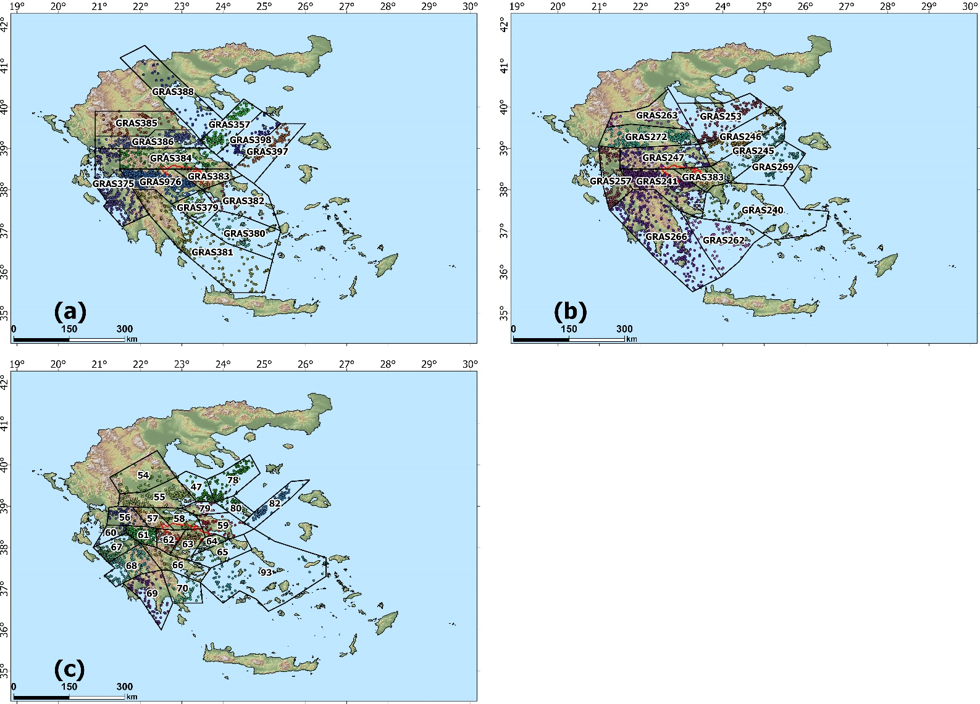
Figure S1. The area sources of (a) ESHM13, (b) ESHM20 and (c) VAM16, selected for Boeotia (red borderline) after applying the 100 km distance criterion and the spatial distribution of earthquake epicenters.

Area Source ID | NNFM | NFM | M_{c} | λ(M_{c}) | b-value | M_{uRWC} | No. events
ESHM13-GRAS398 | 0.81 | 0.19 | 4.1 | 0.72 | 0.90 | 7.0 | 88
ESHM13-GRAS397 | 0.82 | 0.18 | 4.1 | 0.96 | 1.07 | 7.2 | 118
ESHM13-GRAS388 | 0.39 | 0.61 | 4.1 | 0.50 | 0.87 | 6.6 | 62
ESHM13-GRAS386 | 0.27 | 0.73 | 4.4 | 1.18 | 0.92 | 6.6 | 204
ESHM13-GRAS385 | 0.03 | 0.97 | 4.4 | 0.54 | 0.81 | 6.1 | 87
ESHM13-GRAS384 | 0.24 | 0.76 | 4.1 | 1.23 | 1.02 | 5.7 | 151
ESHM13-GRAS383 | 0.00 | 1.00 | 4.1 | 0.83 | 0.81 | 6.4 | 102
ESHM13-GRAS382 | 0.57 | 0.43 | 4.4 | 0.06 | 0.00 | 5.6 | 16
ESHM13-GRAS381 | 0.63 | 0.37 | 4.1 | 1.36 | 0.80 | 6.8 | 167
ESHM13-GRAS380 | 0.50 | 0.50 | 4.4 | 0.24 | 1.09 | 5.9 | 45
ESHM13-GRAS379 | 0.11 | 0.89 | 4.4 | 0.15 | 0.64 | 6.0 | 29
ESHM13-GRAS375 | 0.73 | 0.27 | 4.1 | 2.41 | 1.15 | 6.6 | 297
ESHM13-GRAS357 | 0.79 | 0.21 | 4.1 | 1.16 | 1.12 | 6.8 | 143
ESHM13-GRAS976 | 0.17 | 0.84 | 4.1 | 3.63 | 0.91 | 6.4 | 446
ESHM20-GRAS272 | 0.24 | 0.76 | 4.4 | 1.29 | 0.94 | 6.6 | 221
ESHM20-GRAS269 | 0.86 | 0.14 | 4.1 | 0.55 | 0.98 | 5.8 | 68
ESHM20-GRAS266 | 0.41 | 0.59 | 4.4 | 1.63 | 0.91 | 8.0 | 308
ESHM20-GRAS263 | 0.06 | 0.94 | 4.1 | 0.47 | 0.72 | 6.1 | 58
ESHM20-GRAS262 | 0.58 | 0.42 | 4.1 | 0.51 | 0.96 | 5.8 | 63
ESHM20-GRAS257 | 0.76 | 0.25 | 4.1 | 1.28 | 1.10 | 6.6 | 157
ESHM20-GRAS253 | 0.66 | 0.33 | 4.1 | 1.55 | 0.90 | 6.8 | 191
ESHM20-GRAS247 | 0.24 | 0.75 | 4.1 | 1.20 | 1.04 | 5.7 | 147
ESHM20-GRAS246 | 0.57 | 0.43 | 4.1 | 0.92 | 0.99 | 7.0 | 113
ESHM20-GRAS245 | 0.77 | 0.23 | 4.1 | 1.02 | 1.26 | 7.2 | 126
ESHM20-GRAS241 | 0.15 | 0.84 | 4.1 | 3.80 | 0.91 | 6.4 | 468
ESHM20-GRAS240 | 0.28 | 0.71 | 4.1 | 0.26 | 1.15 | 5.4 | 32
ESHM20-GRAS383 | 0.00 | 1.00 | 4.1 | 0.80 | 0.79 | 6.4 | 99
VAM16-47 | 0.57 | 0.43 | 4.4 | 0.33 | 0.95 | 6.1 | 53
VAM16-54 | 0.00 | 1.00 | 4.1 | 0.50 | 0.90 | 6.1 | 62
VAM16-55 | 0.21 | 0.80 | 4.4 | 1.15 | 0.96 | 6.6 | 195
VAM16-56 | 0.37 | 0.63 | 4.4 | 0.36 | 1.43 | 6.0 | 64
VAM16-57 | 0.25 | 0.75 | 4.4 | 0.16 | 0.90 | 5.2 | 29
VAM16-58 | 0.20 | 0.80 | 4.1 | 0.32 | 0.84 | 5.8 | 39
VAM16-59 | 0.20 | 0.80 | 4.1 | 0.36 | 1.24 | 6.0 | 44
VAM16-60 | 0.33 | 0.67 | 4.1 | 0.18 | 0.64 | 5.5 | 22
VAM16-61 | 0.15 | 0.85 | 4.1 | 1.89 | 1.00 | 6.5 | 232
VAM16-62 | 0.11 | 0.89 | 4.4 | 0.41 | 0.82 | 6.3 | 81
VAM16-63 | 0.11 | 0.89 | 4.1 | 1.35 | 0.76 | 6.4 | 166
VAM16-64 | 0.00 | 1.00 | 4.4 | 0.11 | 0.52 | 6.0 | 24
VAM16-65 | 0.17 | 0.83 | 4.1 | 0.12 | 0.85 | 5.4 | 15
VAM16-66 | 0.67 | 0.33 | 4.1 | 0.37 | 0.93 | 6.0 | 45
VAM16-67 | 0.81 | 0.20 | 4.1 | 1.02 | 1.03 | 6.6 | 126
VAM16-68 | 0.55 | 0.45 | 4.1 | 1.24 | 1.01 | 6.0 | 152
VAM16-69 | 0.15 | 0.84 | 4.1 | 0.69 | 1.01 | 5.7 | 85
VAM16-70 | 0.31 | 0.69 | 4.4 | 0.24 | 1.21 | 6.9 | 42
VAM16-78 | 0.78 | 0.22 | 4.1 | 0.89 | 1.17 | 6.8 | 110
VAM16-79 | 0.44 | 0.56 | 4.4 | 0.14 | 0.92 | 5.5 | 25
VAM16-80 | 0.86 | 0.14 | 4.4 | 0.26 | 1.76 | 6.4 | 49
VAM16-82 | 0.64 | 0.36 | 4.1 | 0.76 | 1.24 | 7.2 | 93
VAM16-93 | 0.56 | 0.44 | 4.1 | 0.45 | 1.05 | 6.0 | 55
Table S1. All seismicity data for each area source (see Fig. S1 for ID–area source correspondence). NFM and NNFM stand for Normal Focal Mechanism and Non-Normal Focal Mechanism, respectively. λ(M_{c}) is the annual exceedance rate of M_{c}.
Appendix B – All FMD graphs
ESHM13 (see the title of each plot for Area Source ID)
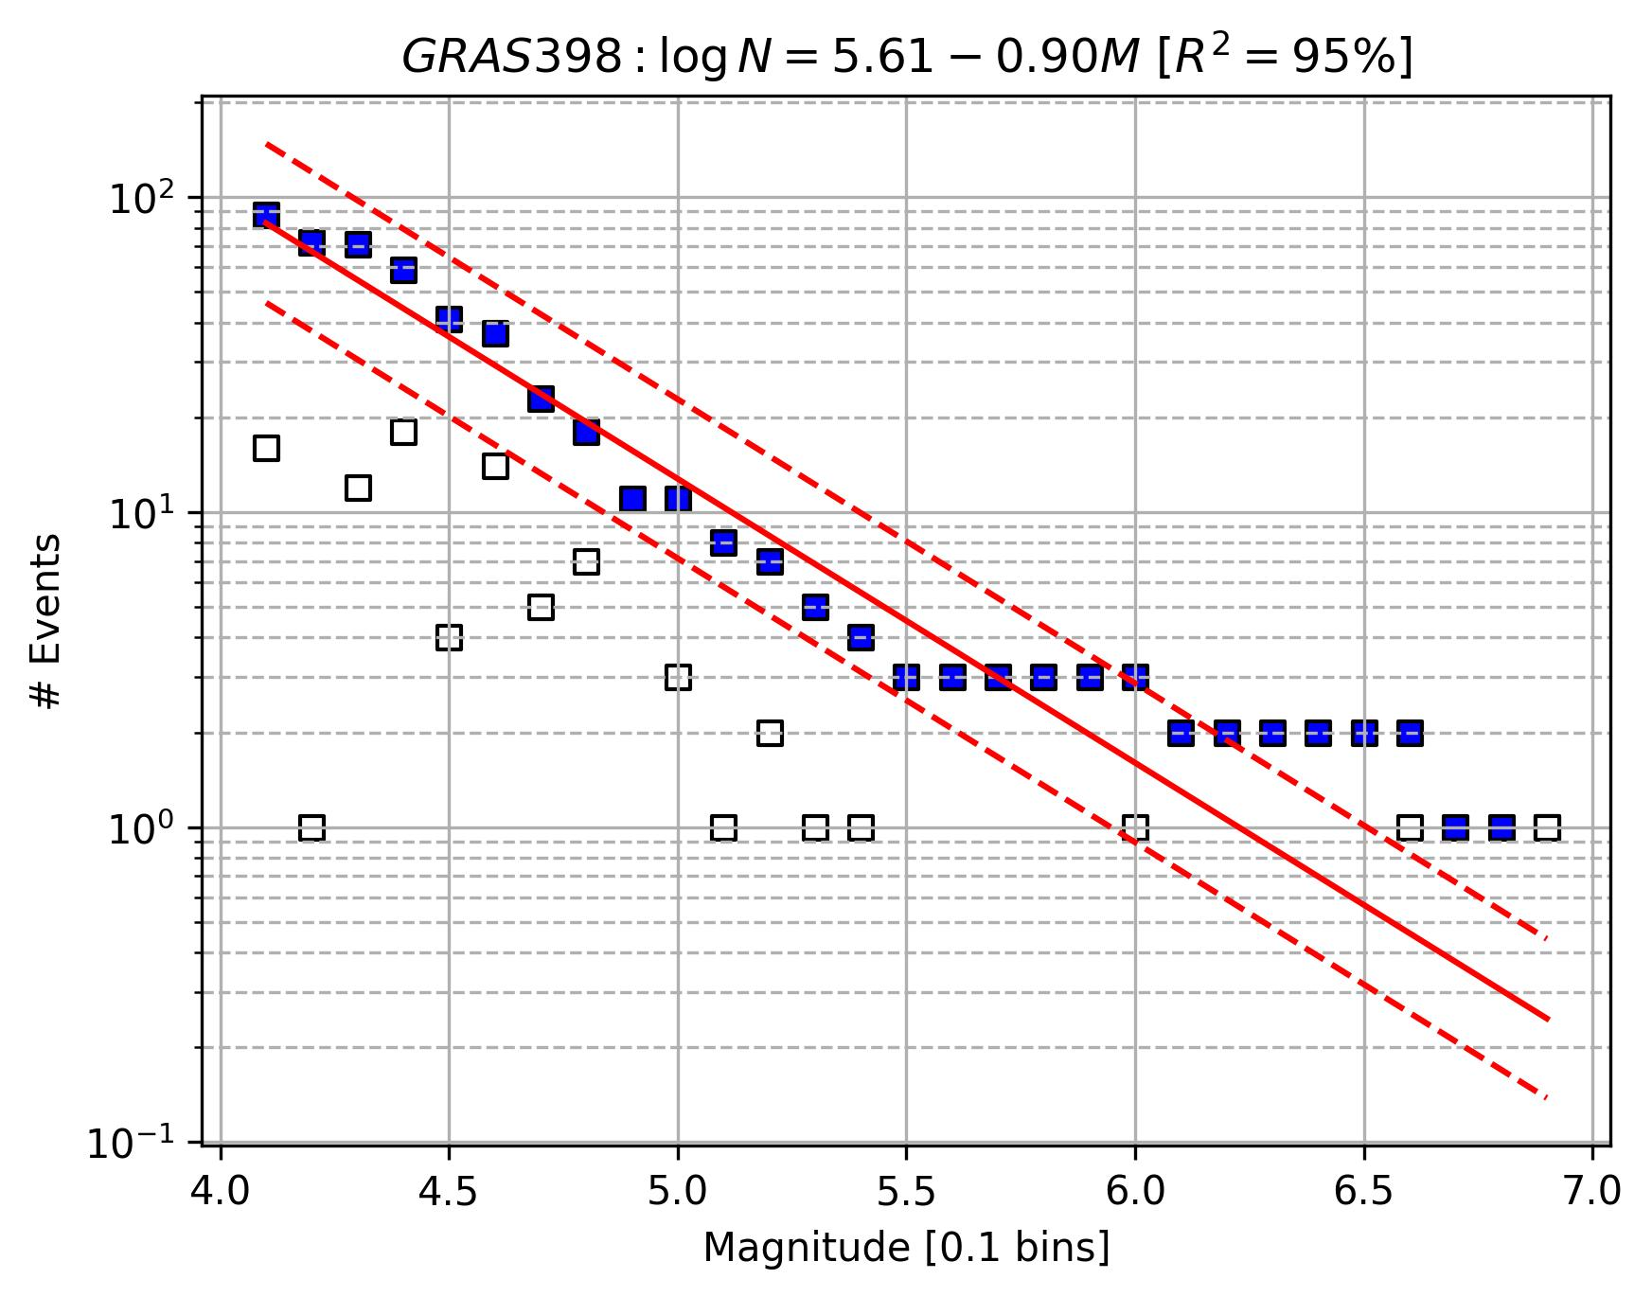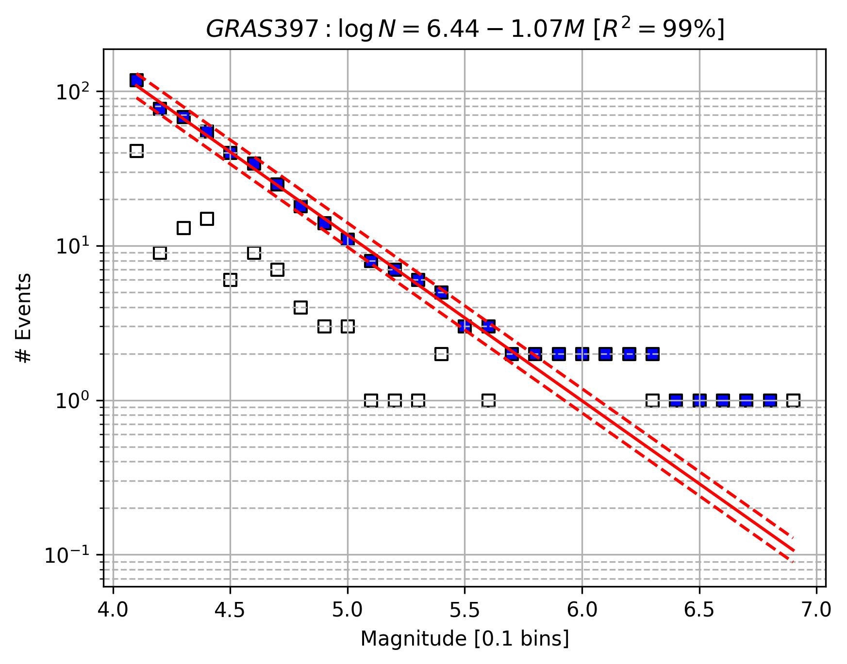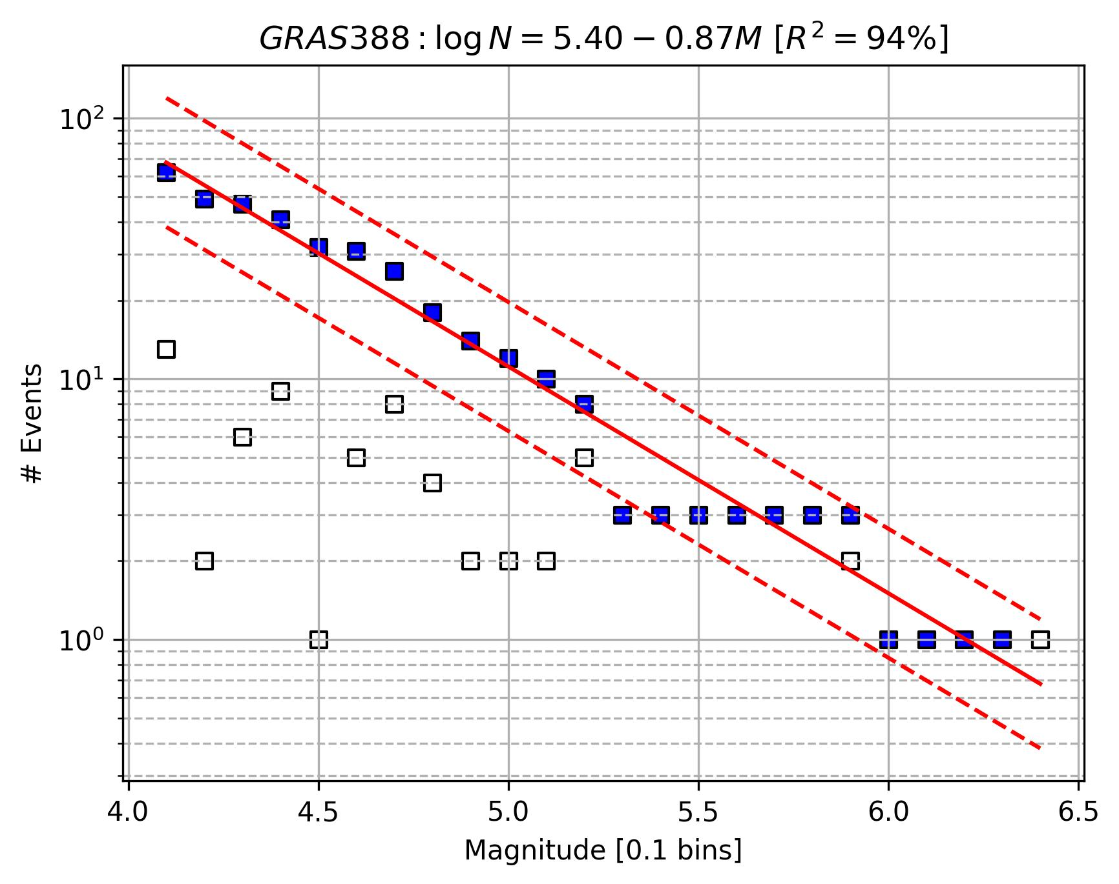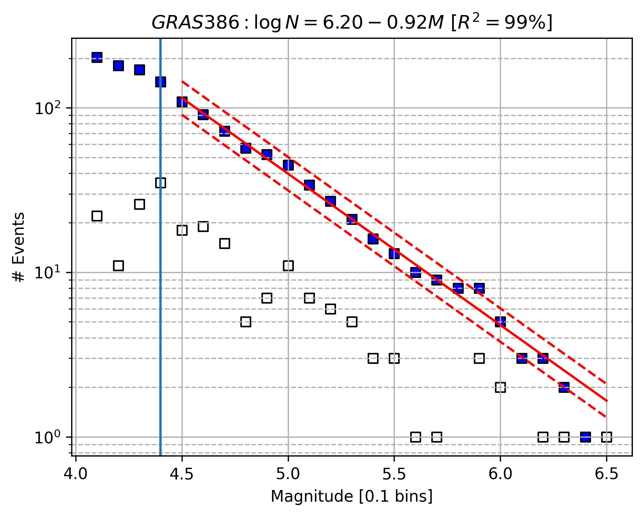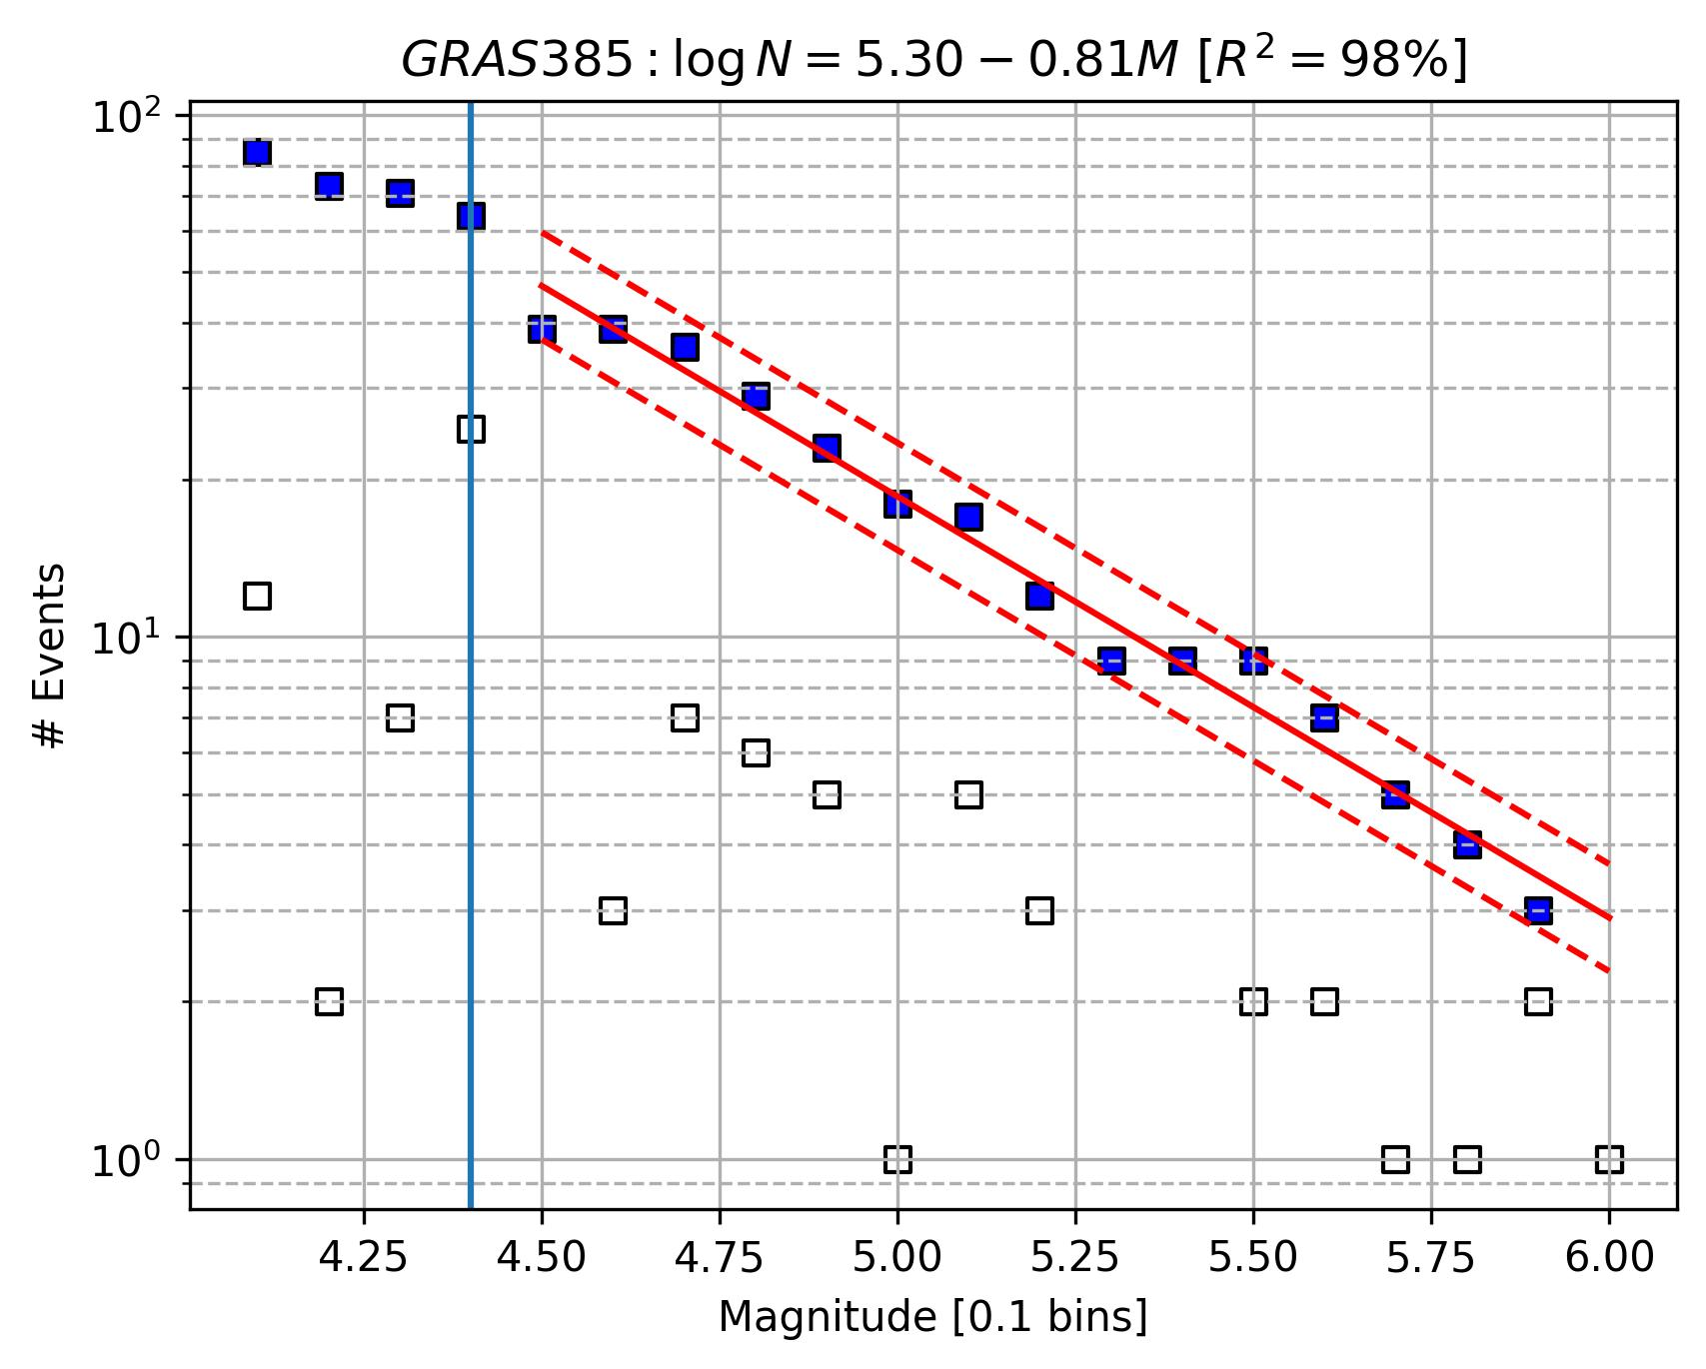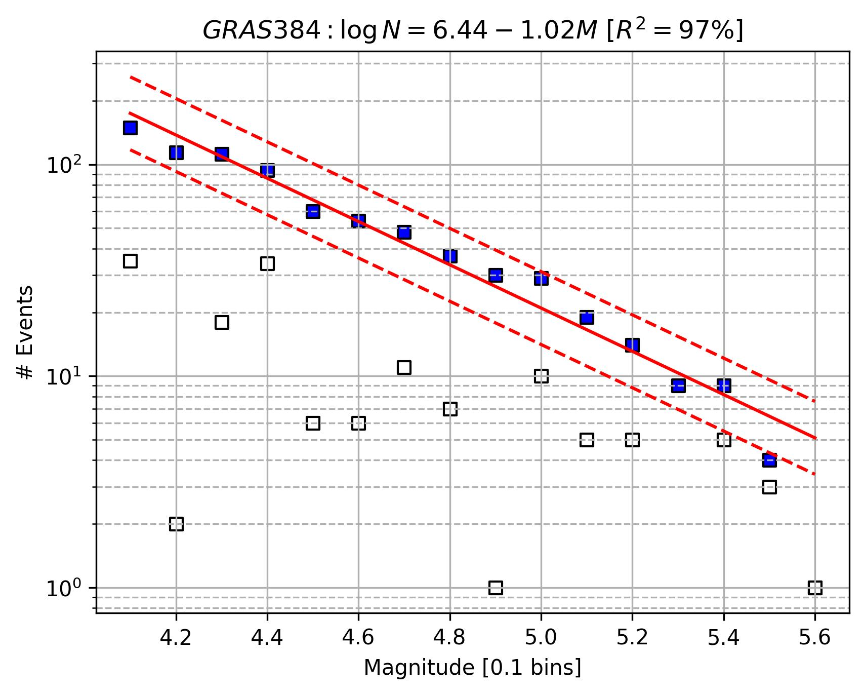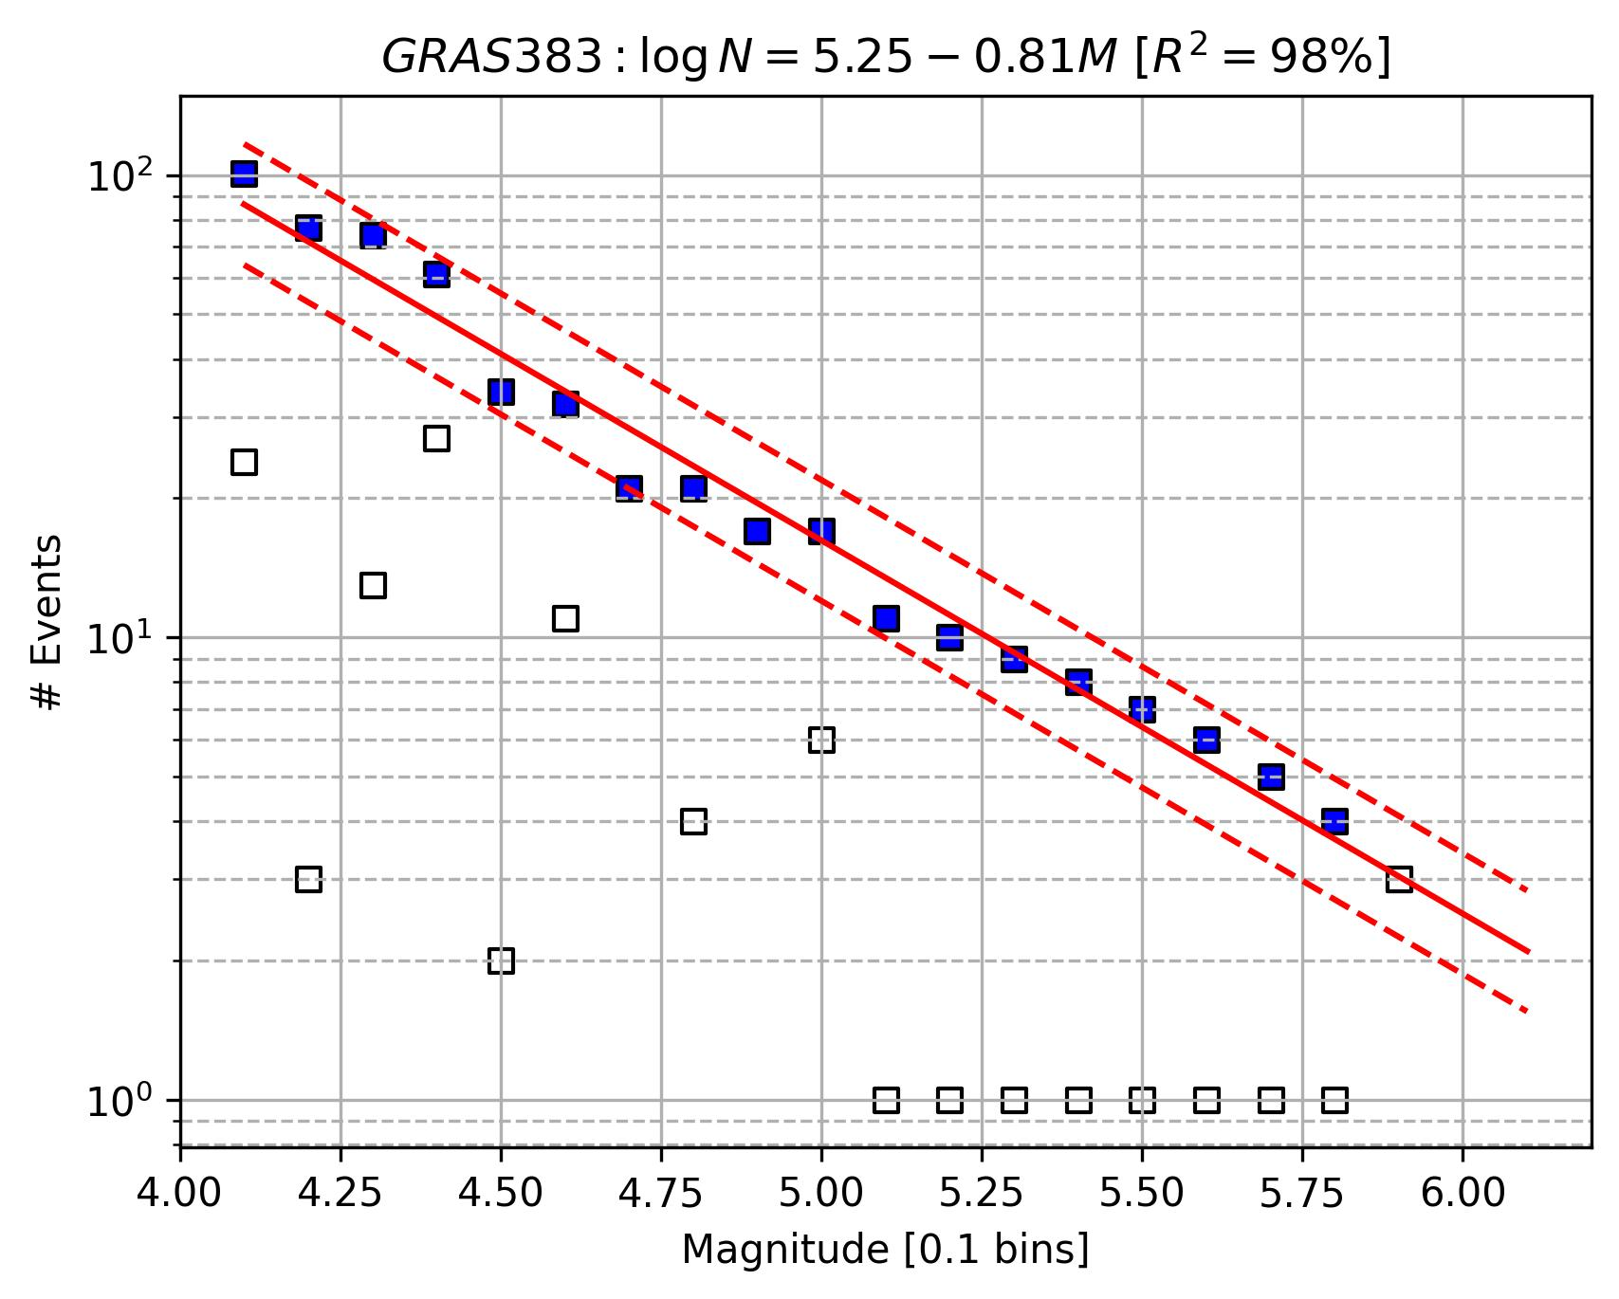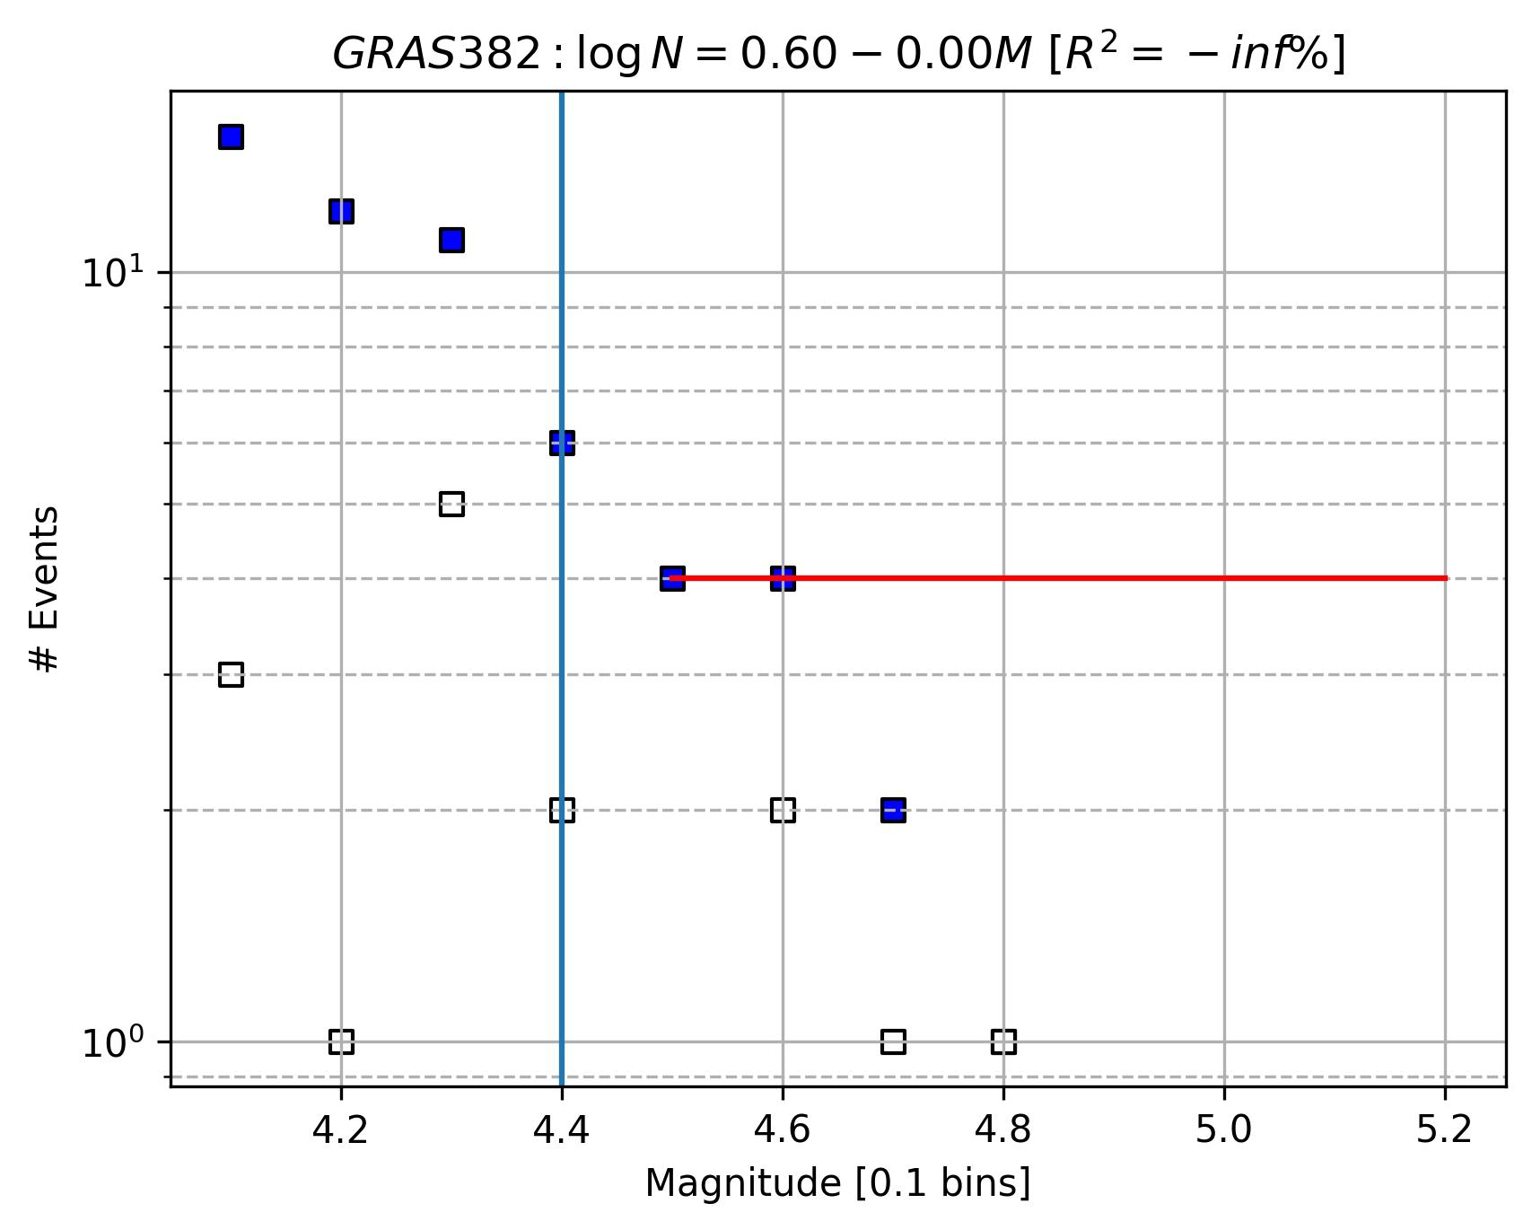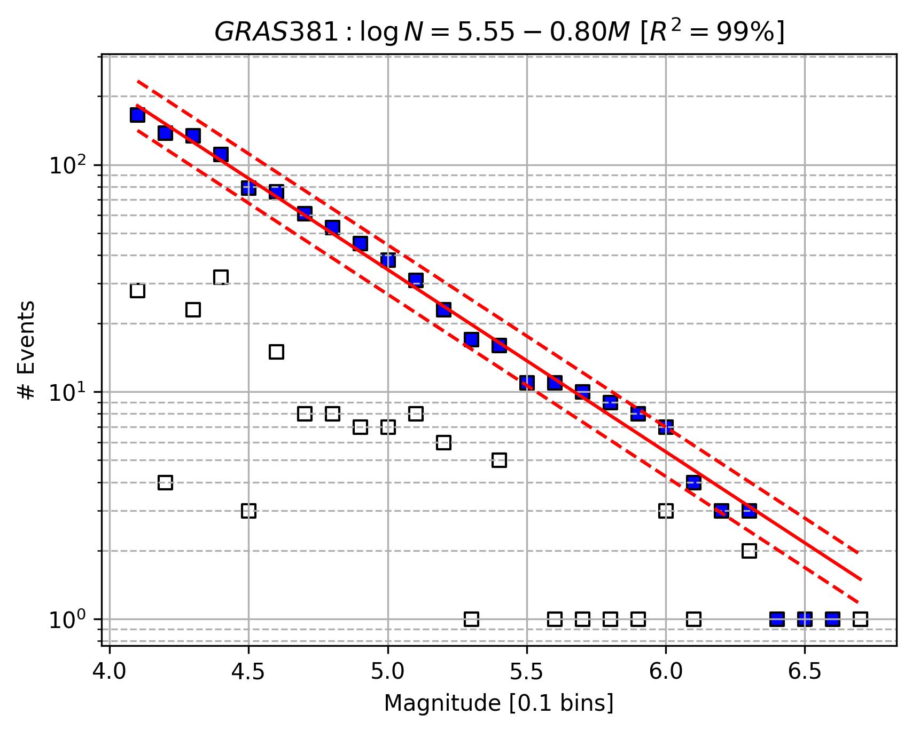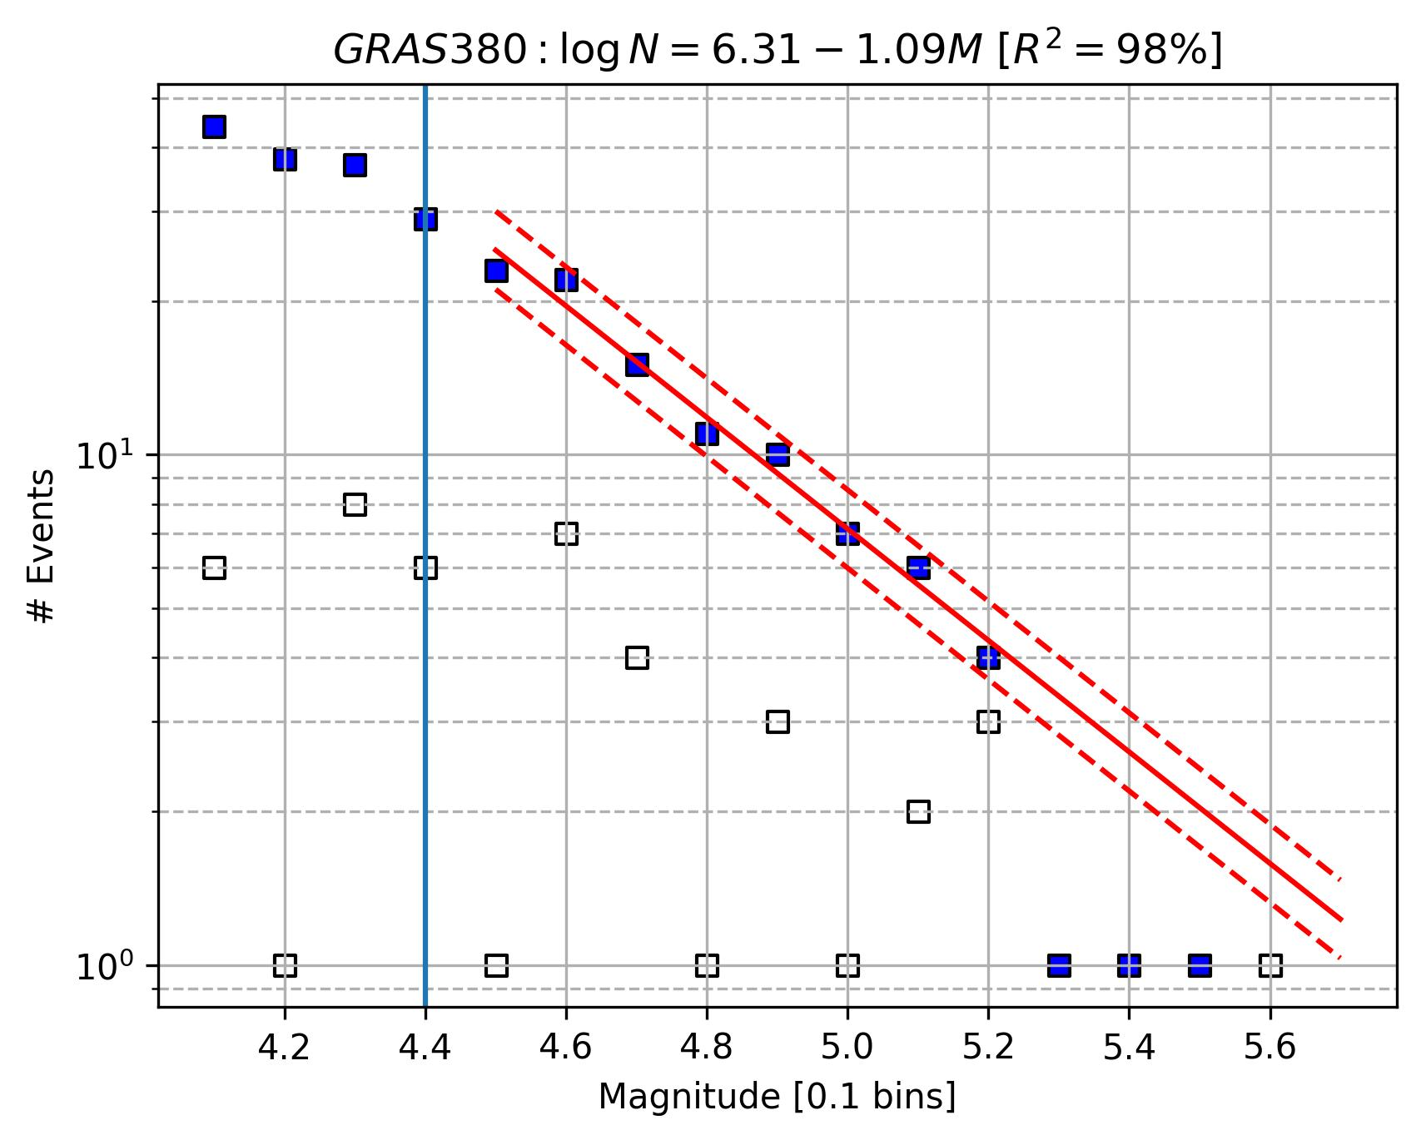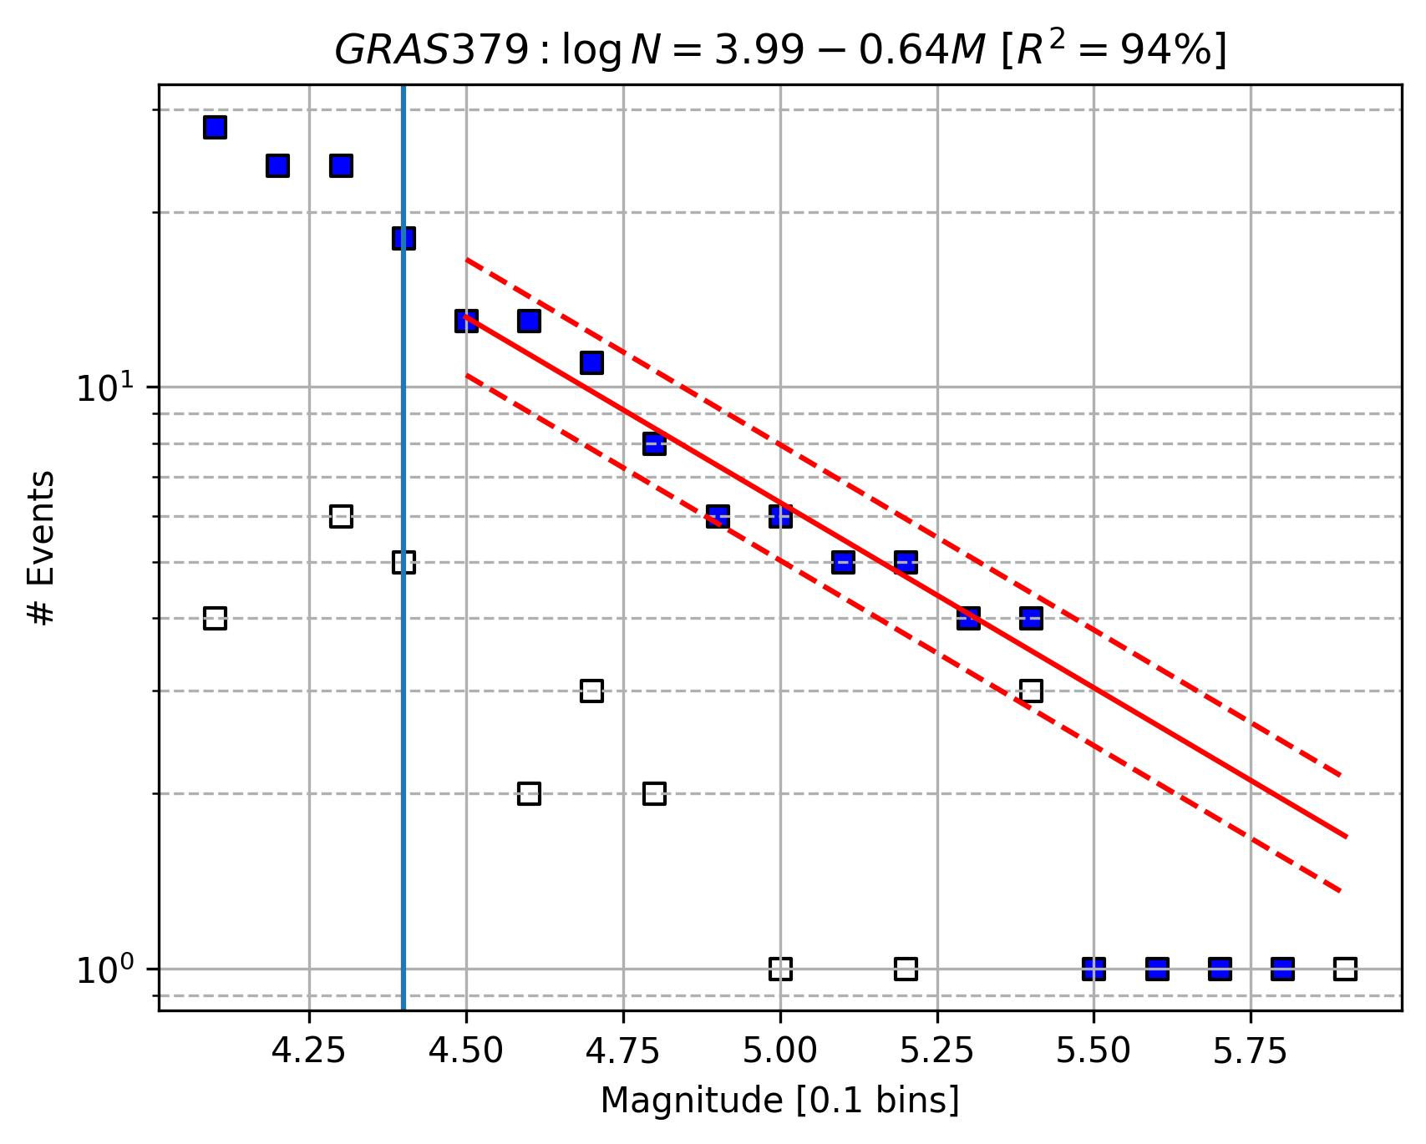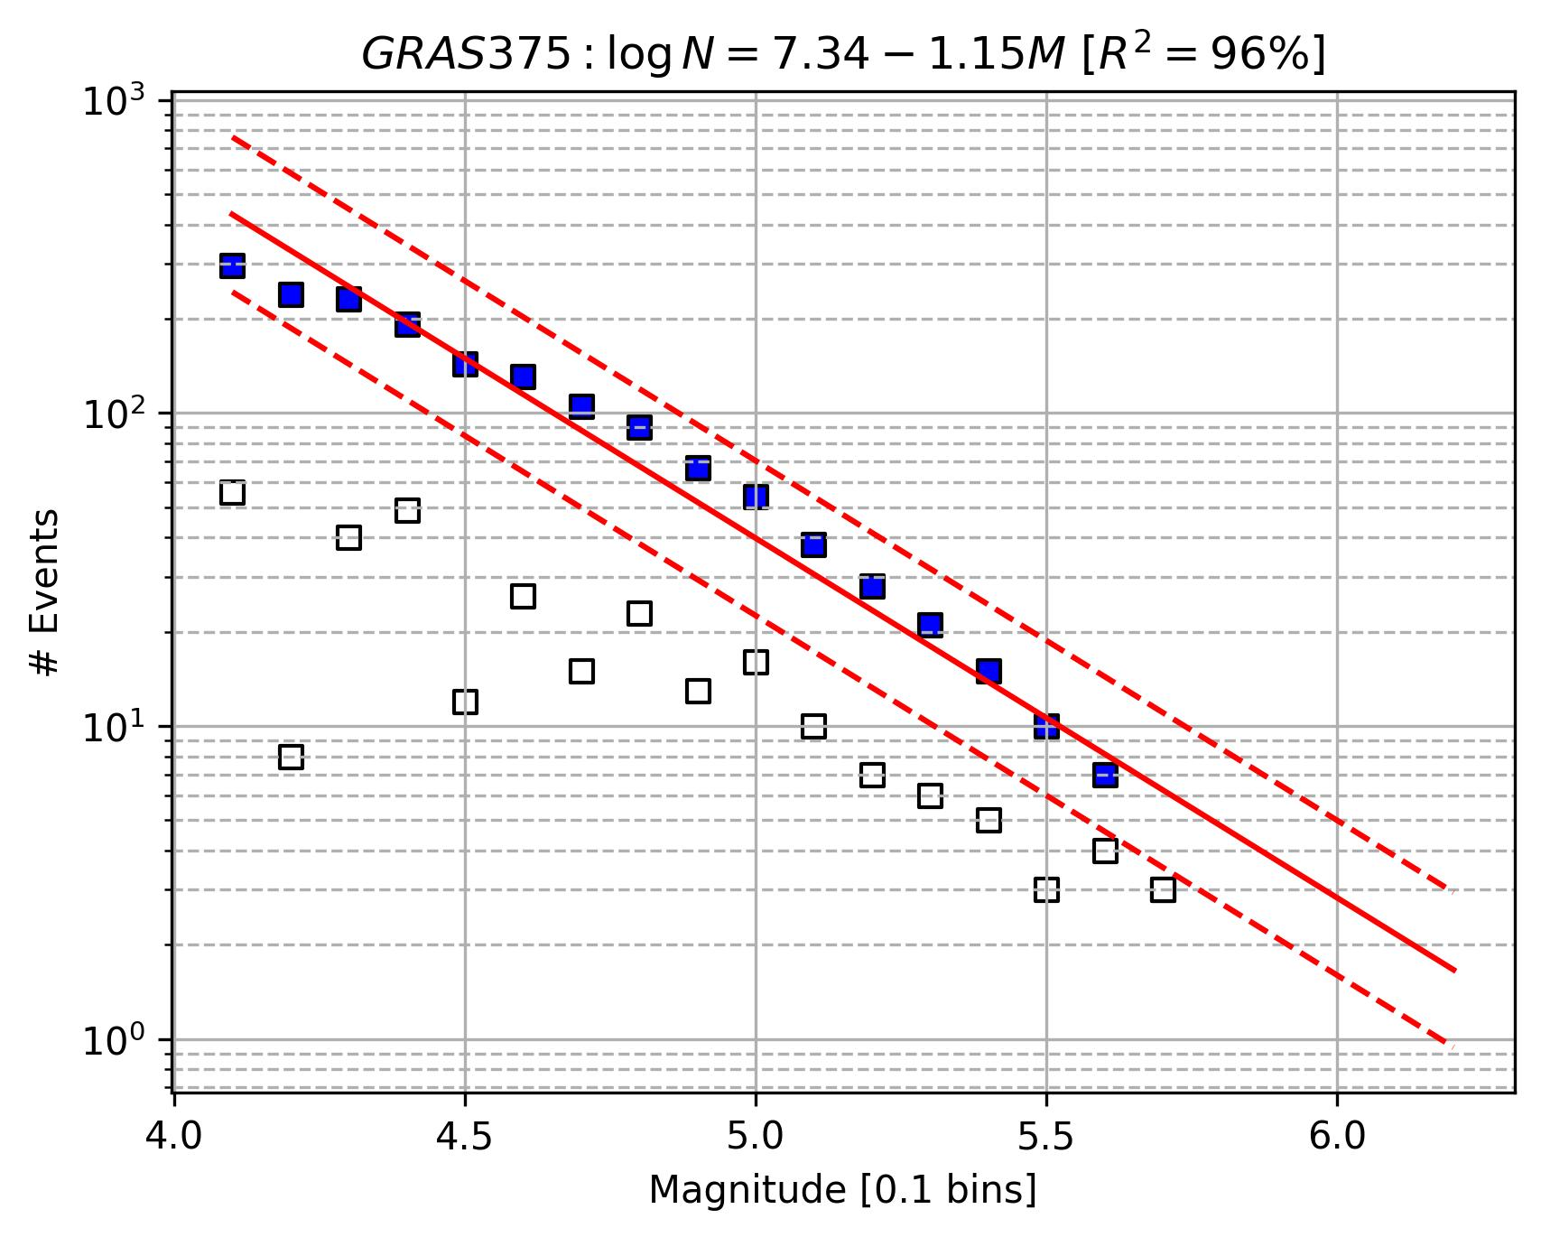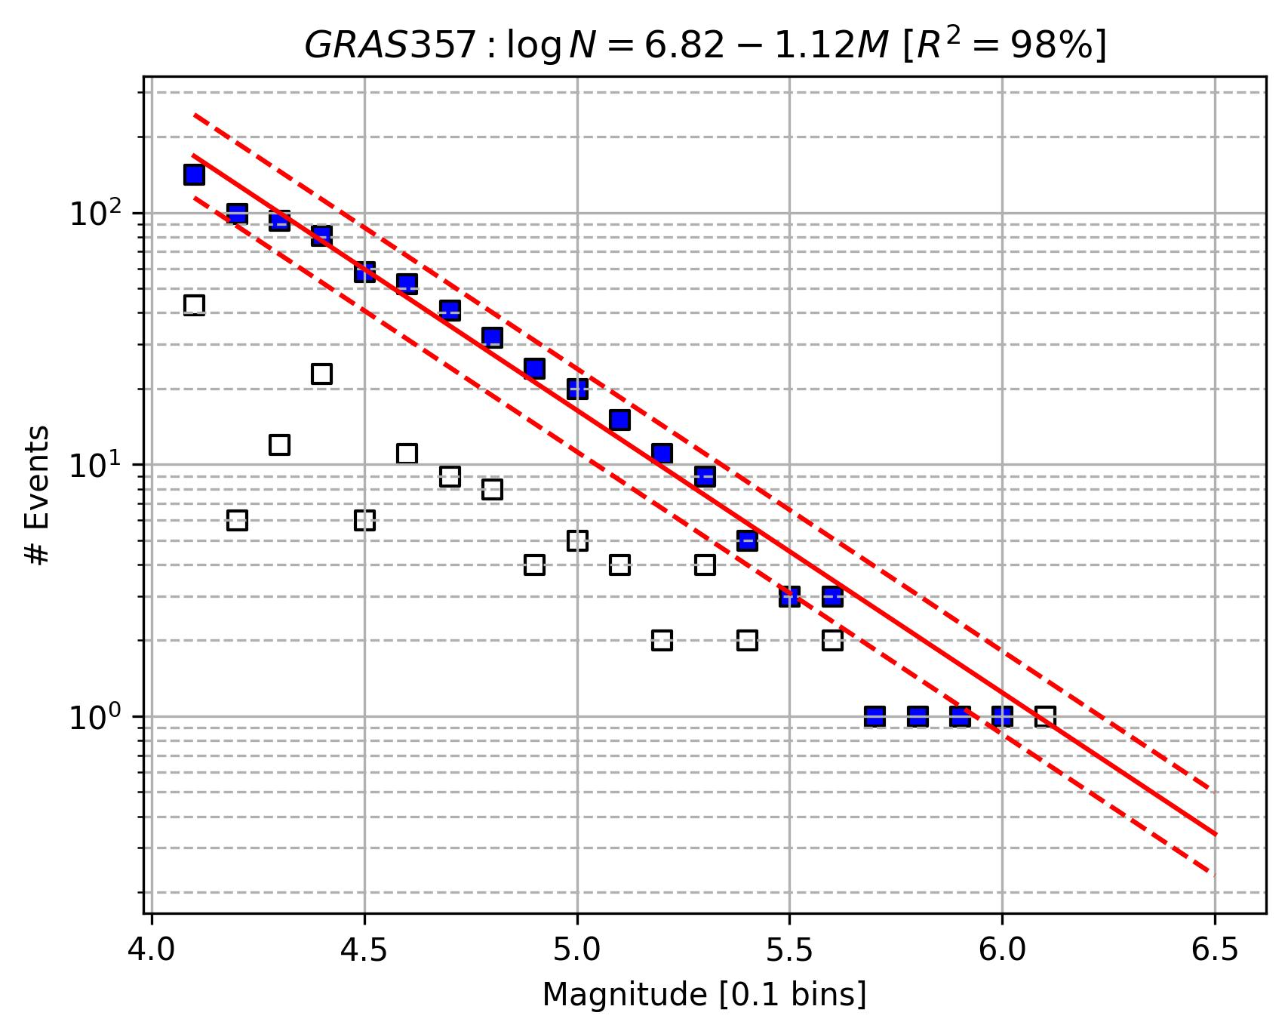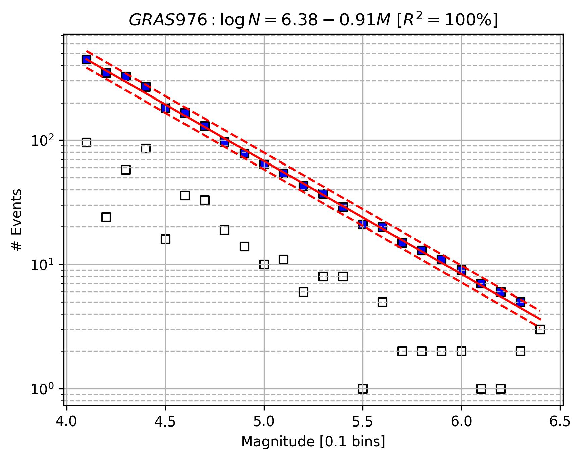

ESHM20 (see the title of each plot for Area Source ID)
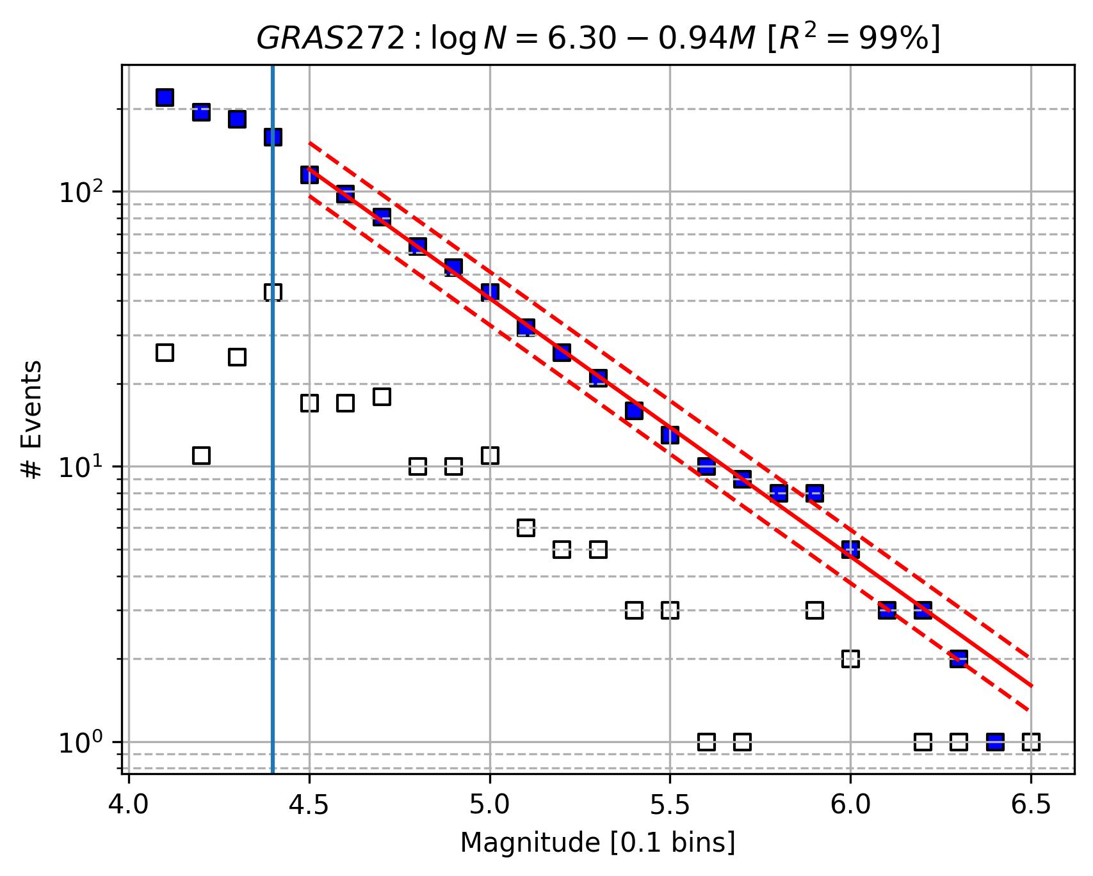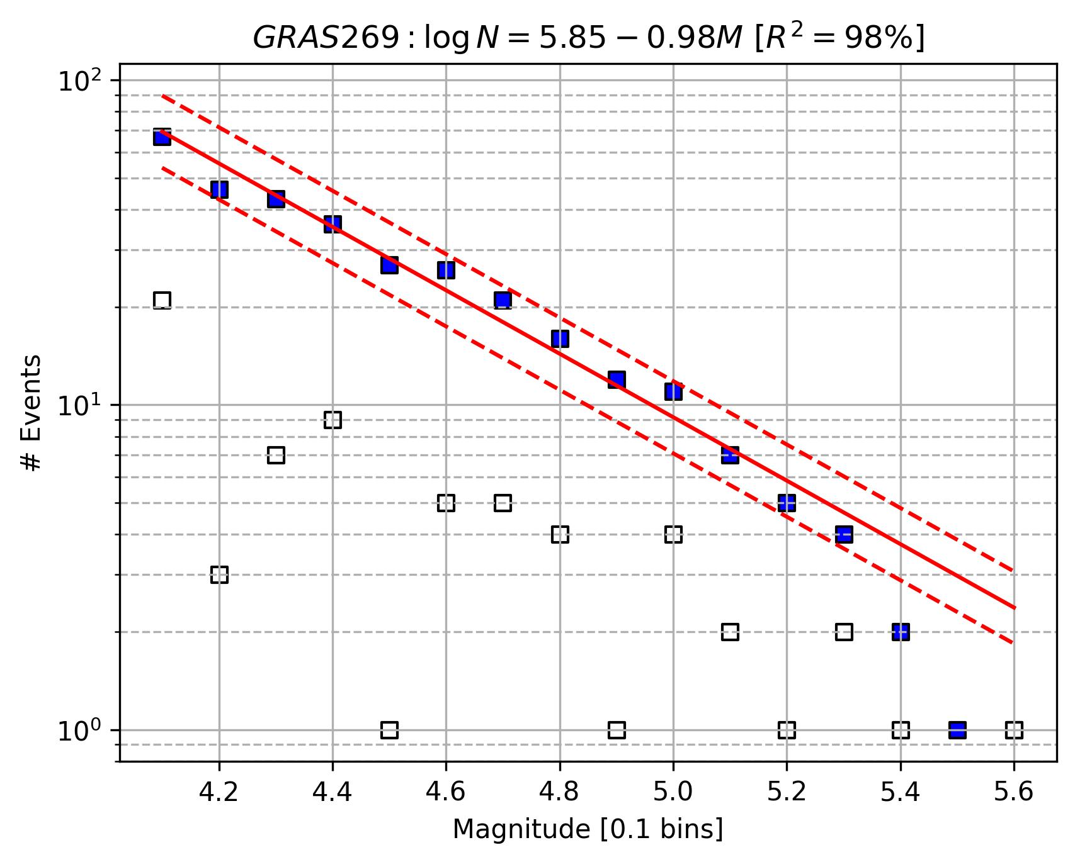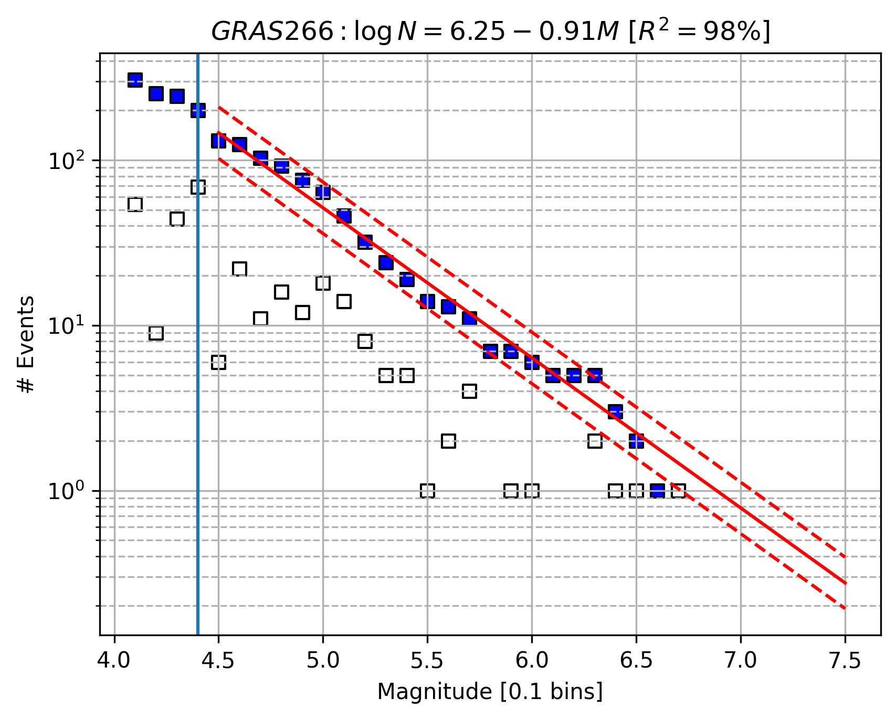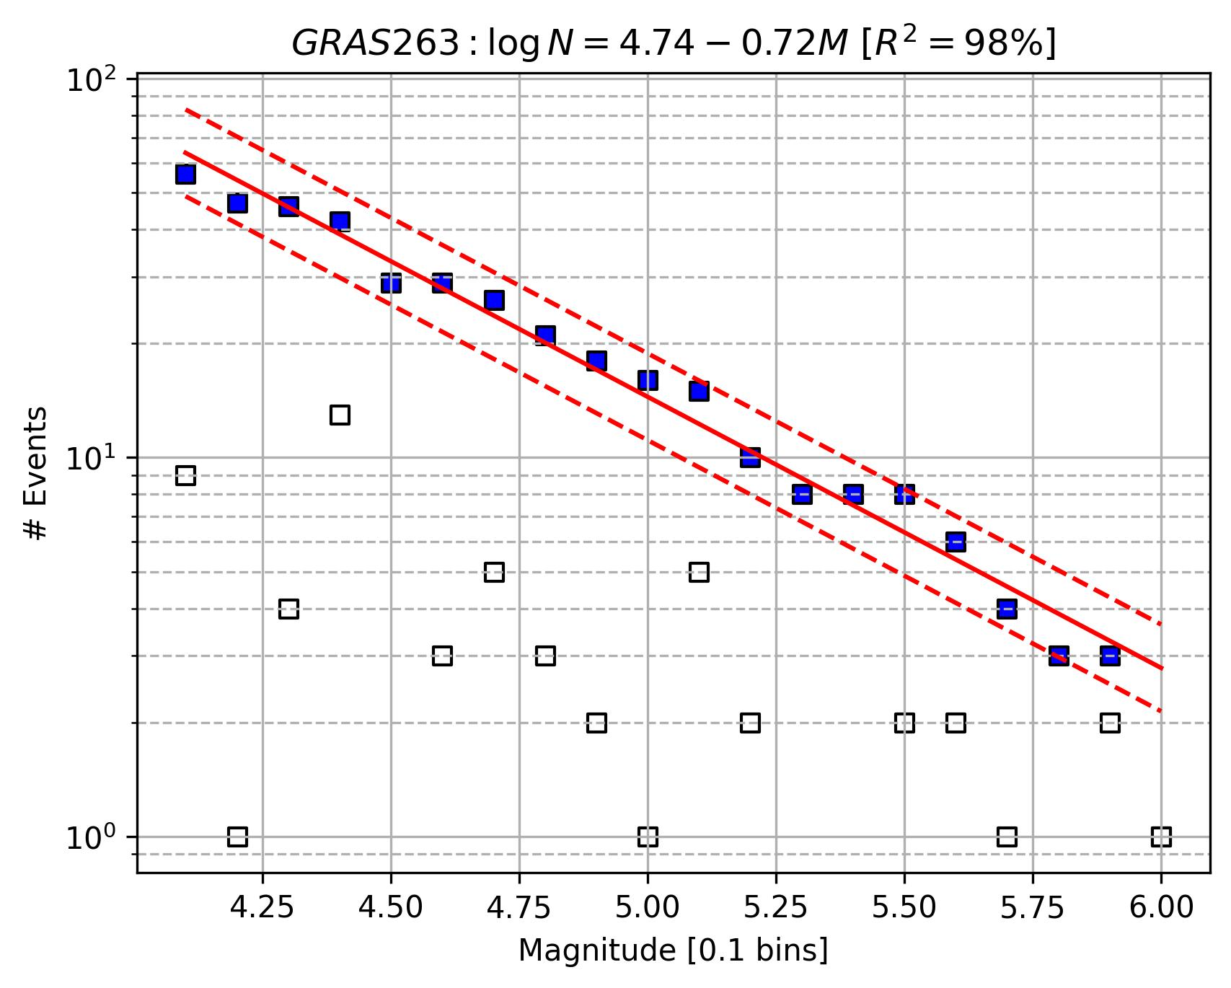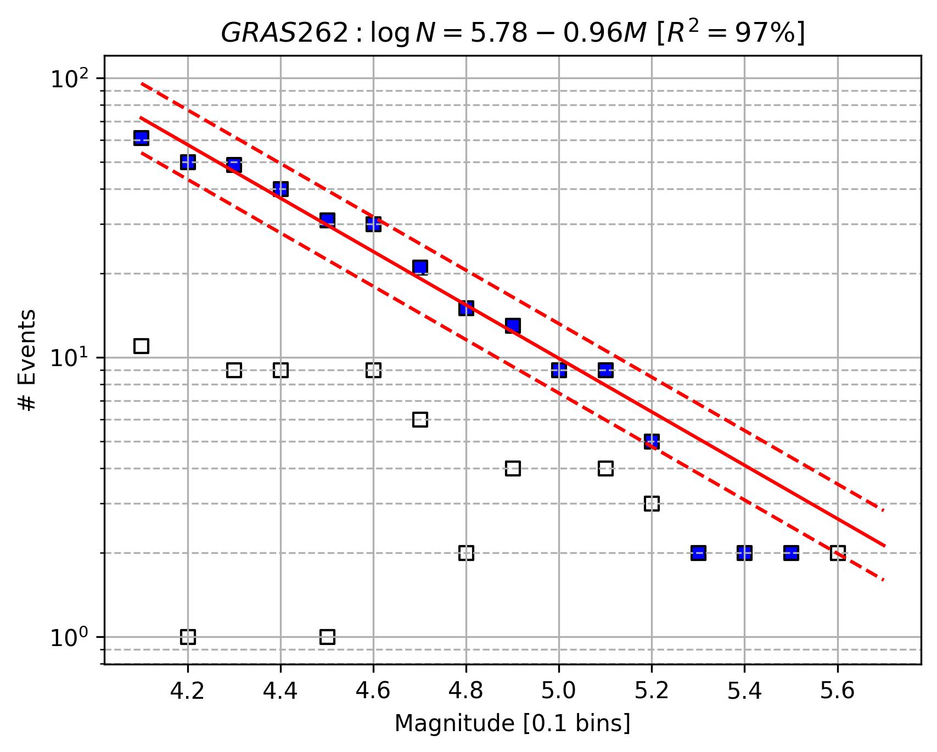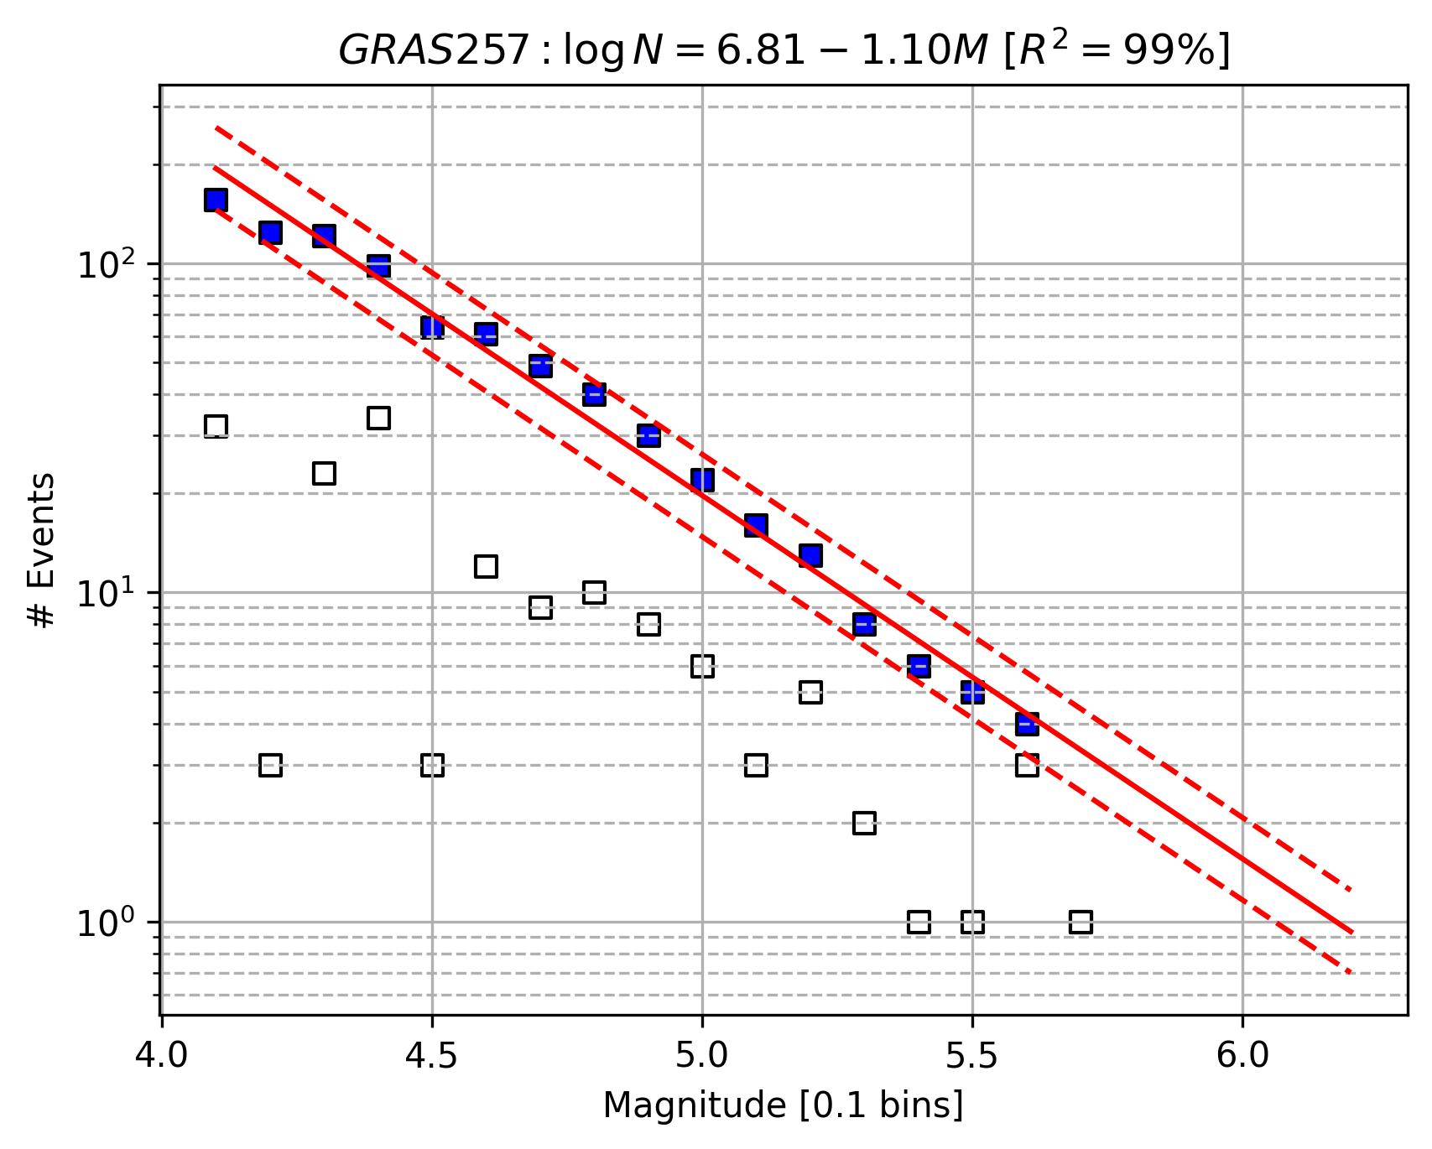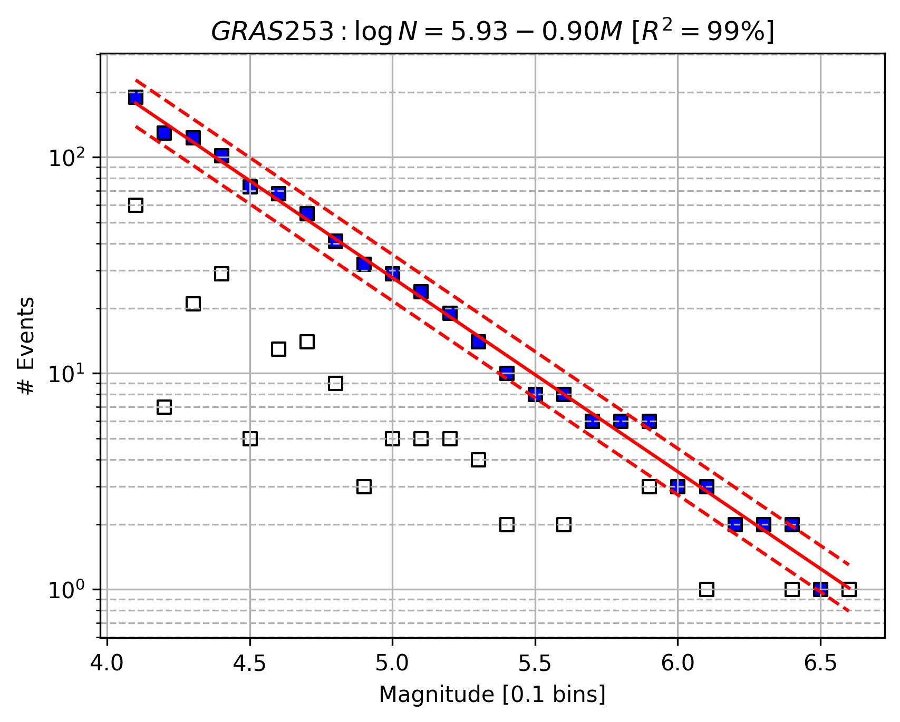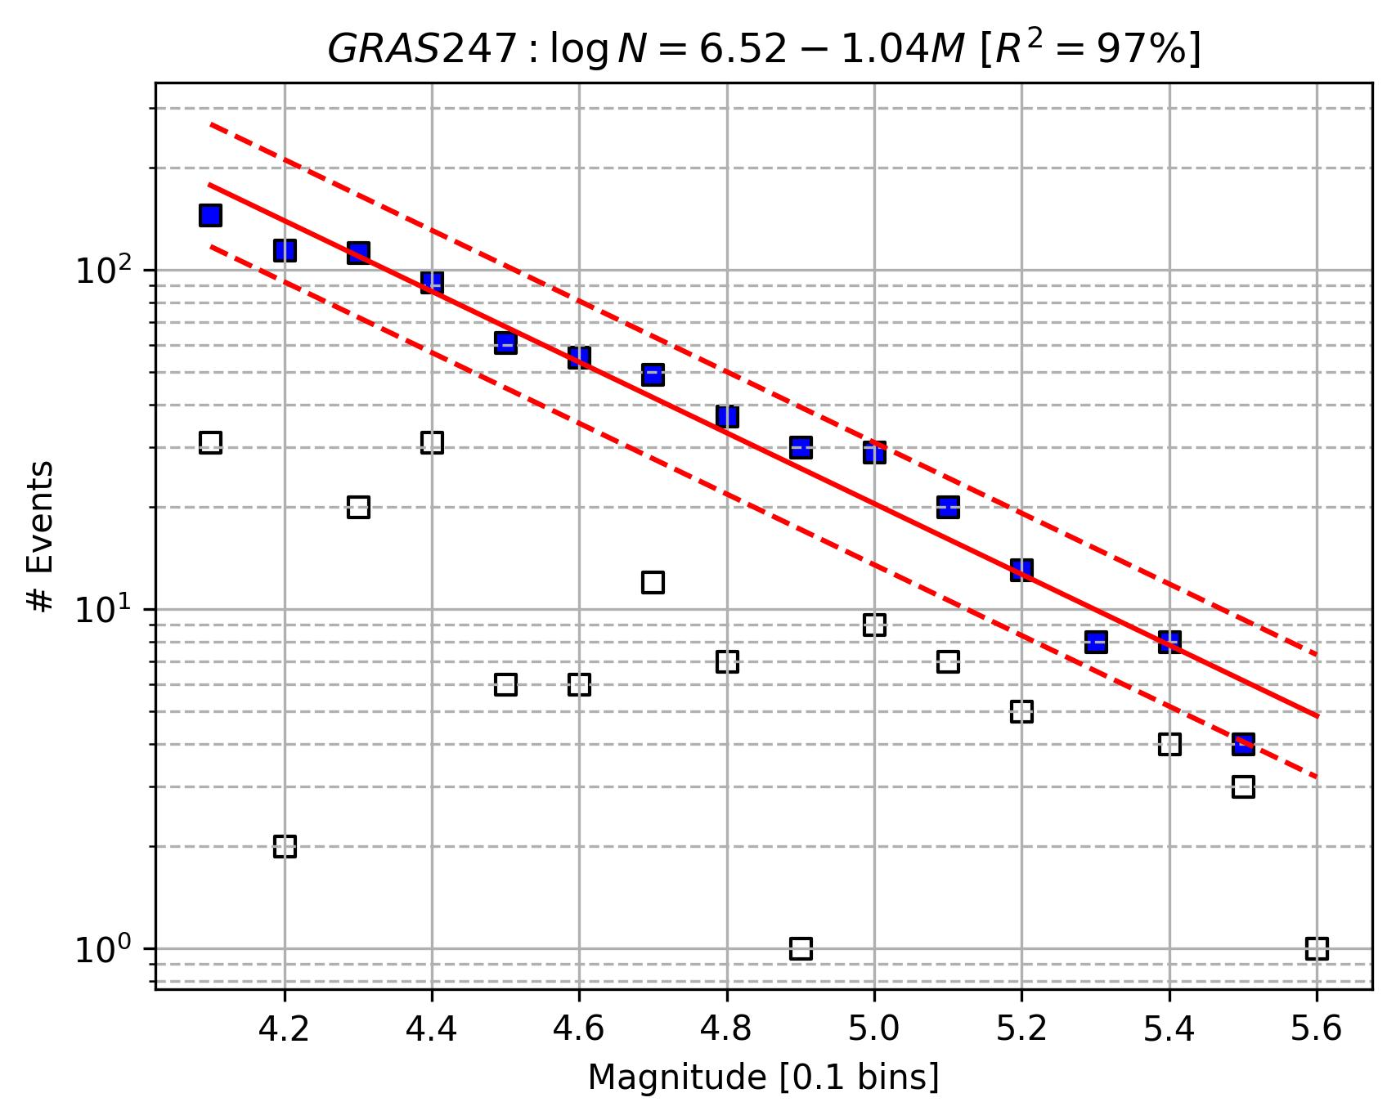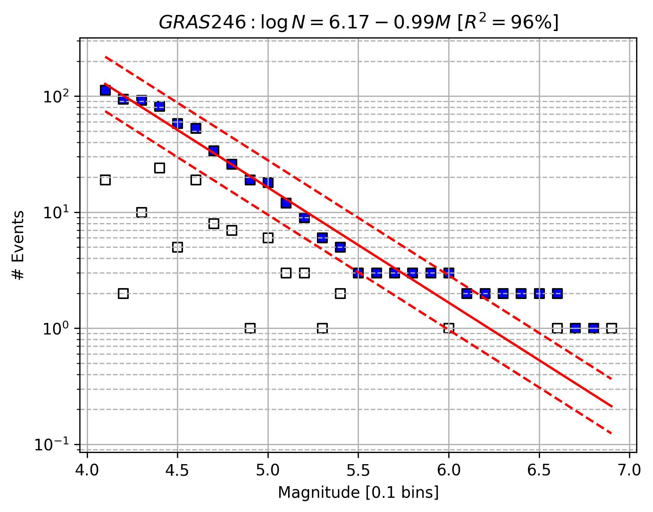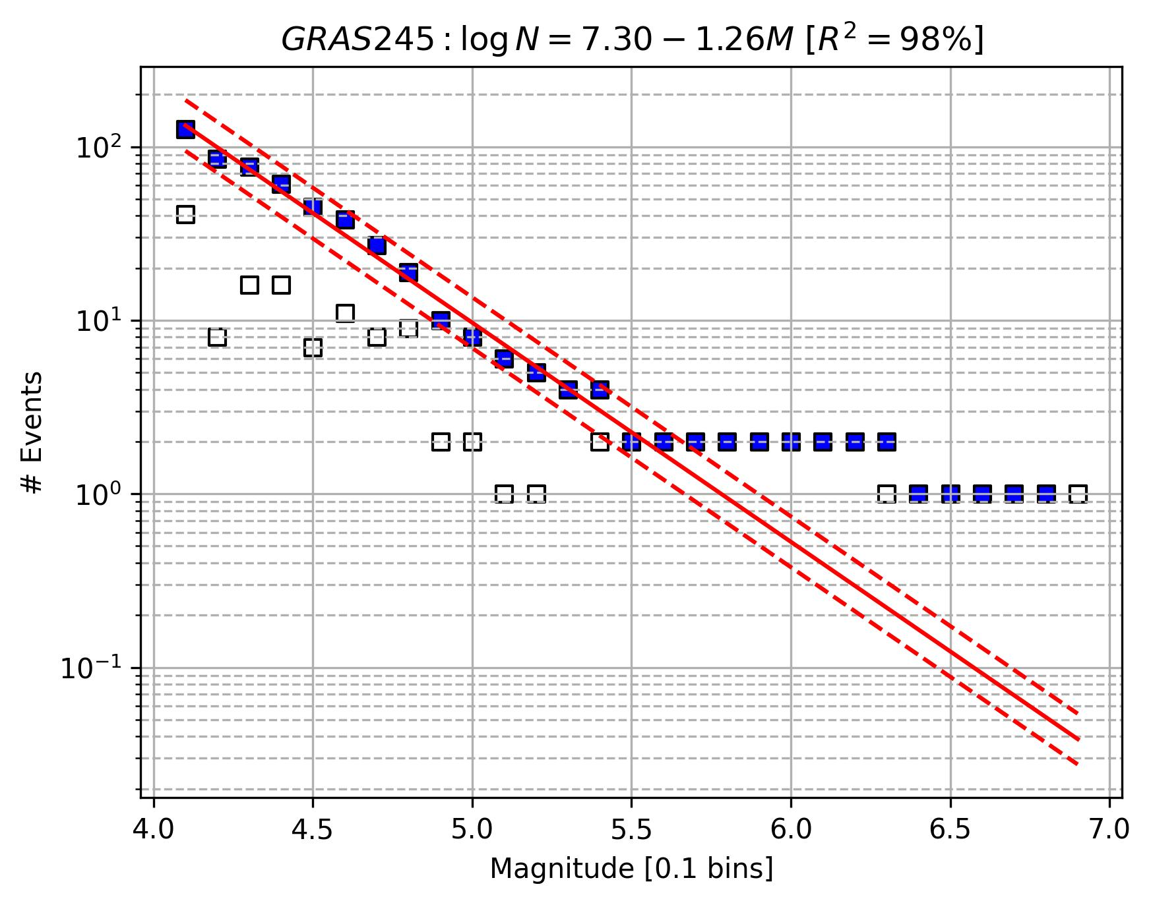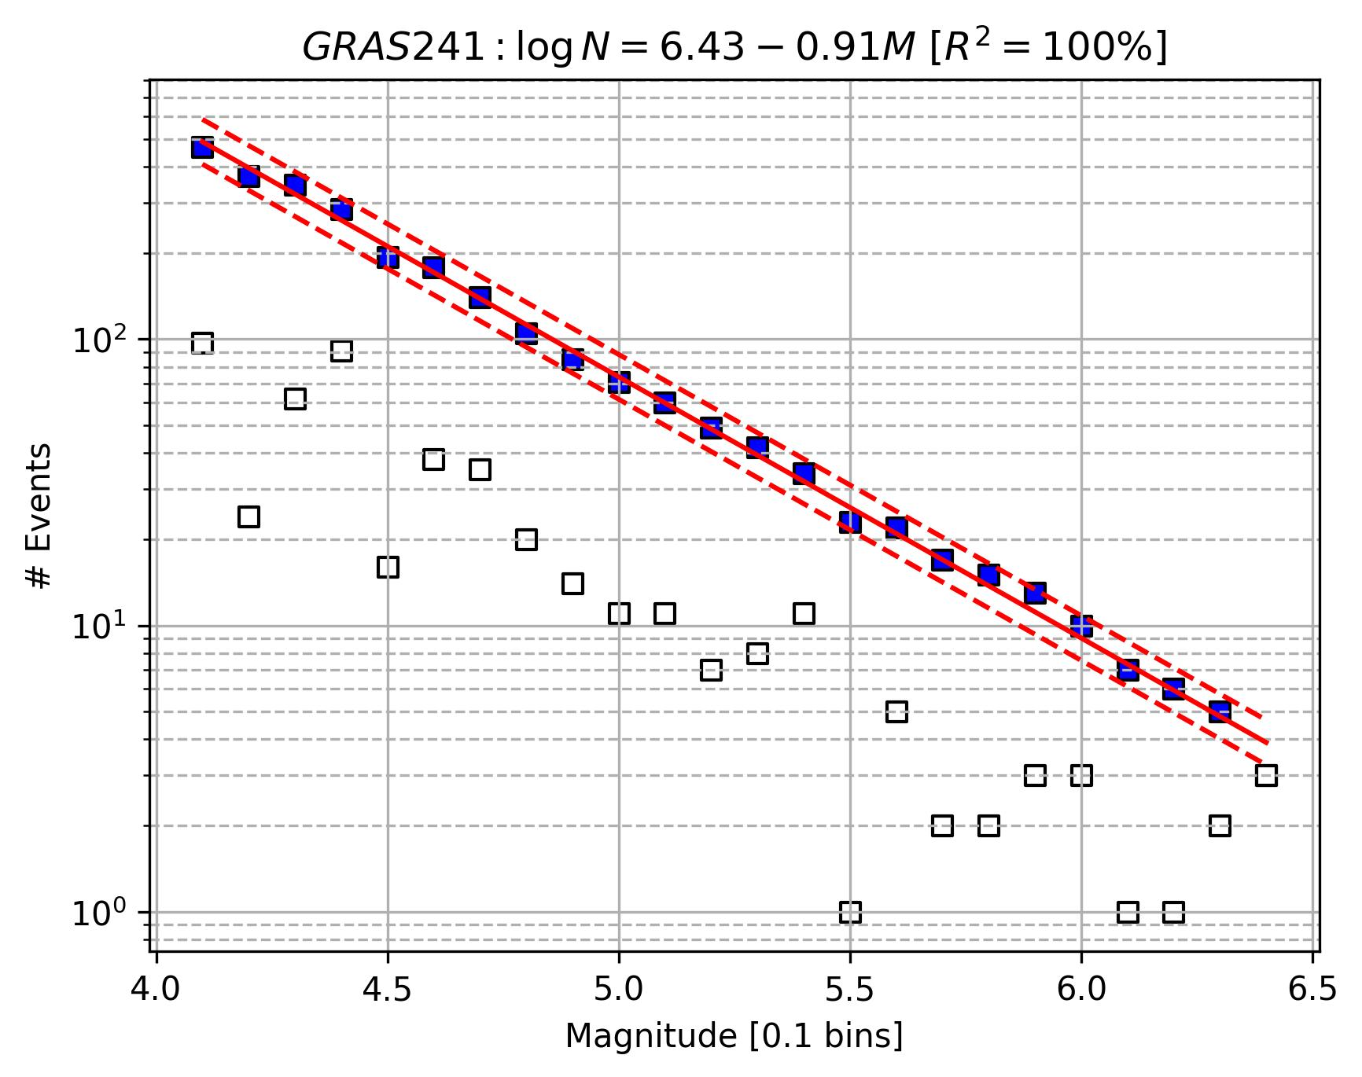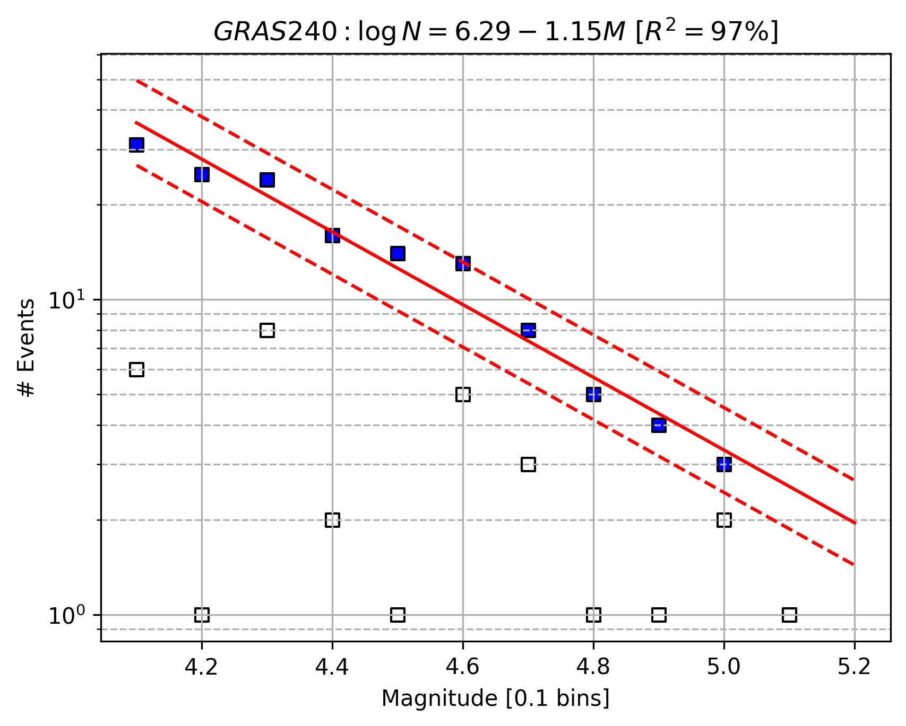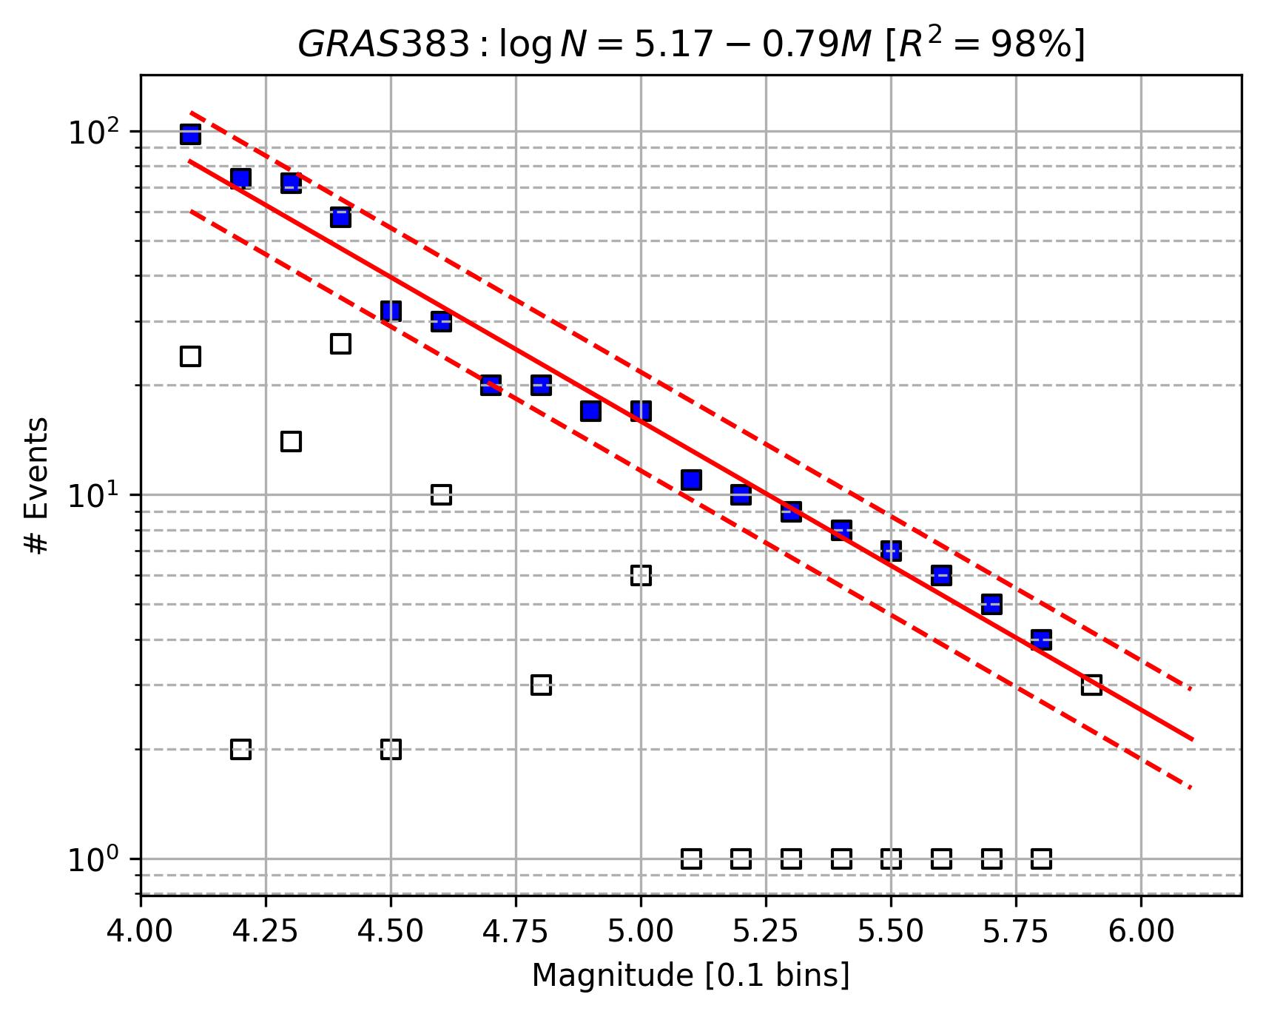

VAM16 (see the title of each plot for Area Source ID)
