Supplementary material

Population growth correlates with increased fecundity in three-spined stickleback in a human disturbed environment

Ulrika Candolin, Heinz-Rudolf Voigt

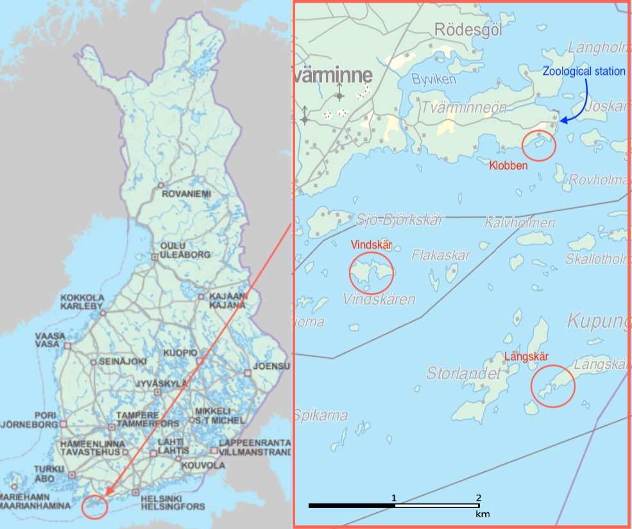

Figure S1. The investigated spawning sites in the Northern Baltic Proper, close to Tvärminne Zoological Station in Southern Finland.

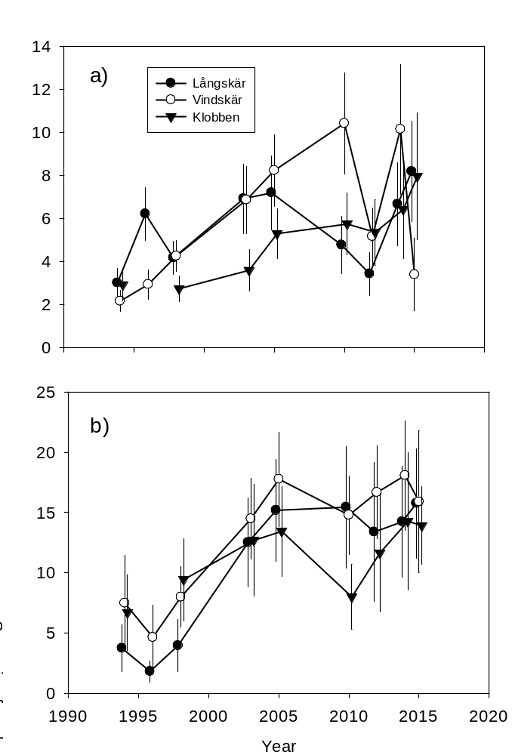

Figure S2. a) The number of adult three-spined stickleback captured from 1994 to 2015 at the three spawning sites, and b) the proportion of these that were gravid females. Data presented are pooled means and 95% confidence intervals for dates within a year.

