Supplementary Material
Variability in the duration and timing of the estuarine to freshwater transition of critically endangered European eel Anguilla anguilla.

Rose M. Boardman¹; Adrian C. Pinder¹; Adam T. Piper²; Catherine Gutmann Roberts³; Rosalind M. Wright⁴; J. Robert Britton¹

¹Department of Life and Environmental Sciences, Faculty of Science and Technology, Bournemouth University, Poole, BH12 5BB, United Kingdom
²Institute of Zoology, Zoological Society of London, Regent’s Park, NW1 4RY, London, United Kingdom
³School of Geography, Earth and Environmental Science, University of Plymouth, Drake Circus, Plymouth, PL4 8AA, United Kingdom.
⁴Environment Agency, Rivers House, Threshelfords Business Park, Inworth Road, Feering, CO5 9SE, United Kingdom

Table S1: Sample size, stage (GE: glass eel, EL: elver) and mean (± 95% CI) and range (as minimum (‘min’) and maximum (‘max’) of δ¹³C (non-corrected) and C: N ratios where data are combined for 2021 and 2022.

River | n | Stage | Mean δ¹³C ± 95% CI (min, max (‰) | C: N
Parrett | 73 | GE | -22.50 ± 0.20 (-26.88, -21.19) | 3.78 ± 0.26 (3.29,4.40)
Chelmer | 199 | EL | -23.88 ± 0.30 (-29.08, -19.82) | 3.25 ± 0.12 (3.07,3.84)
Piddle | 317 | EL | -30.55 ± 0.25 (-33.79, -21.50) | 3.25 ± 0.21 (3.14,4.12)
Frome | 39 | EL | -30.26 ± 0.25 (-32.33, -29.12) | 3.70 ± 0.06 (3.56, 3.91)

Table S2: Outputs of ANOVA testing the significance of differences in Length, δ¹³C and δ¹⁵N between sample year (2021 and 2022) for each river. * The River Frome was only sampled in 2021.
River | Length | δ¹³C | δ¹⁵N
Parrett | F_{1,71} = 3.97, P = 0.06 | F_{1,71} = 0.37, P = 0.54 | F_{1,71} = 14.09, P = 0.001
Chelmer | F_{1,197} = 1.72, P =0.18 | F_{1,197} = 1.64, P =0.20 | F_{1,197} = 4.33, P = 0.04
Piddle | F_{1,310} = 41.71, P=0.08 | F_{1,310} = 9.04, P=0.09 | F_{1,315} = 6.85, P= 0.01

Table S3: Summary of candidate generalised linear models (GLM) for (a) δ¹³C and (b) δ¹⁵N where the best fitting model has the lowest AICc
- δ¹³C
Model | Structure | AICc
Parrett
Full model | ~Length + month | 176.85
Model 1 | ~ Length | 175.07
Model 2 (best model) | ~ Month | 162.63
Chelmer
Full model | ~Length + month | 866.71
Model 1 (best model) | ~ Length | 753.20
Model 2 | ~ Month | 715.10
Piddle
Full model (best model) | ~Length + month | 1366.87
Model 1 | ~ Length | 1374.20
Model 2 | ~ Month | 1418.20
Frome
Full model (best model) | ~Length + month | 93.63
Model 1 | ~ Length | 91.63
Model 2 | ~ Month | 95.96

Model | Structure | AICc
Parrett
Full model | ~Length + month | 234.69
Model 1 | ~ Length | 264.51
Model 2 (best model) | ~ Month | 231.89
Chelmer
Full model | ~Length + month | 775.56
Model 1 | ~ Length | 942.49
Model 2 (best model) | ~ Month | 773.24
Piddle
Full model (best model) | ~Length + month | 1099.95
Model 1 | ~ Length | 1122.99
Model 2 | ~ Month | 1141.63
Frome
Full model | ~Length + month | 79.61
Model 1 (best model) | ~ Length | 77.88
Model 2 | ~ Month | 85.49
- δ¹⁵N

Table S4: Isotopic niche metrics for eel by site and groups (month) where TA: the total area of the convex hull encompassing the data points, SEA: the Standard Ellipse Area containing 90% of the data, SEA_{C}: Correction applied to SEA to account for small sample sizes, and the Bayesian estimate for SEA (SEAB) with 95% credible intervals.
Site | TA | SEA | SEA_{C} | SEA_{B} | 95% CI
Parrett
March | 3.41 | 1.05 | 1.09 | 1.02 | 0.69, 1.51
April | 1.90 | 0.86 | 0.93 | 0.82 | 0.51, 1.47
May | 1.49 | 0.67 | 0.72 | 0.65 | 0.36, 1.13
June | 5.08 | 2.31 | 2.48 | 2.98 | 1.72, 5.10
Chelmer
March | 11.52 | 3.51 | 3.73 | 3.65 | 2.22, 5.89
May | 8.64 | 2.32 | 2.37 | 2.30 | 1.73, 3.11
June | 11.51 | 3.92 | 4.16 | 4.70 | 2.86, 7.69
July | 24.45 | 5.07 | 5.18 | 5.11 | 3.79, 6.72
August | 19.07 | 4.79 | 4.90 | 4.86 | 3.57,6.39
September | 10.88 | 3.64 | 3.85 | 4.01 | 2.61, 6.45
Frome
May | 1.66 | 0.83 | 0.92 | 0.79 | 0.44, 1.59
July | 3.04 | 1.19 | 1.29 | 1.11 | 0.68, 2.01
August | 1.32 | 0.56 | 0.62 | 0.55 | 0.30, 1.04
Piddle
May | 26.98 | 7.25 | 7.46 | 8.23 | 5.94,11.42
June | 55.70 | 9.07 | 9.15 | 9.09 | 7.58,10.95
July | 26.55 | 4.44 | 4.48 | 4.47 | 3.66, 5.42
August | 10.70 | 2.58 | 2.65 | 2.63 | 1.89, 3.56
September | 9.02 | 2.86 | 3.00 | 2.81 | 1.89, 4.56

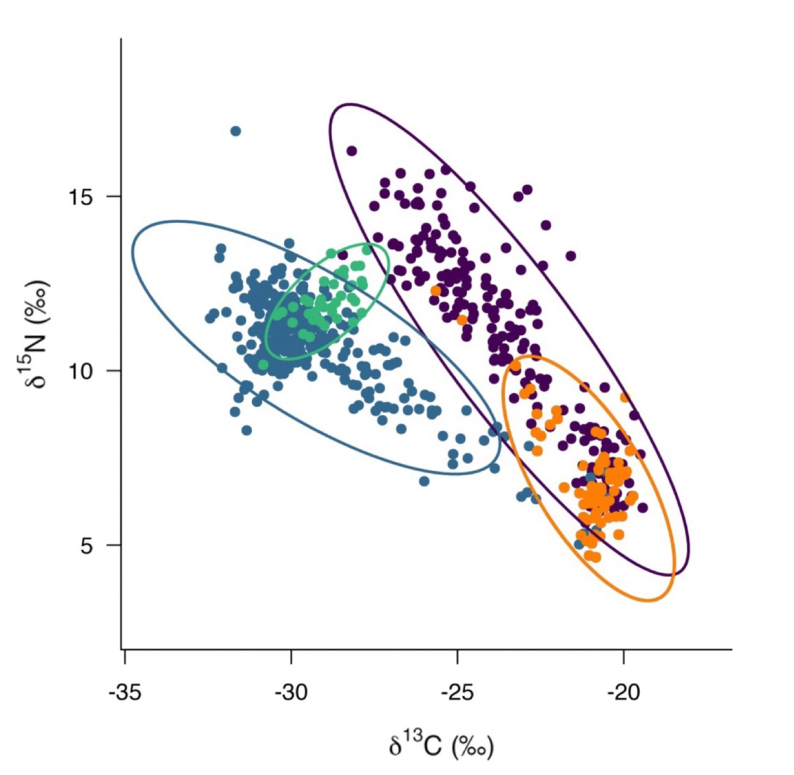

Fig. S1: Stable isotope δ¹³C and δ¹⁵N biplots for European eel by site, where standard ellipse areas (90% SEA_{c}) are shown as solid lines (Parrett •, Chelmer •, Piddle •, Frome •).

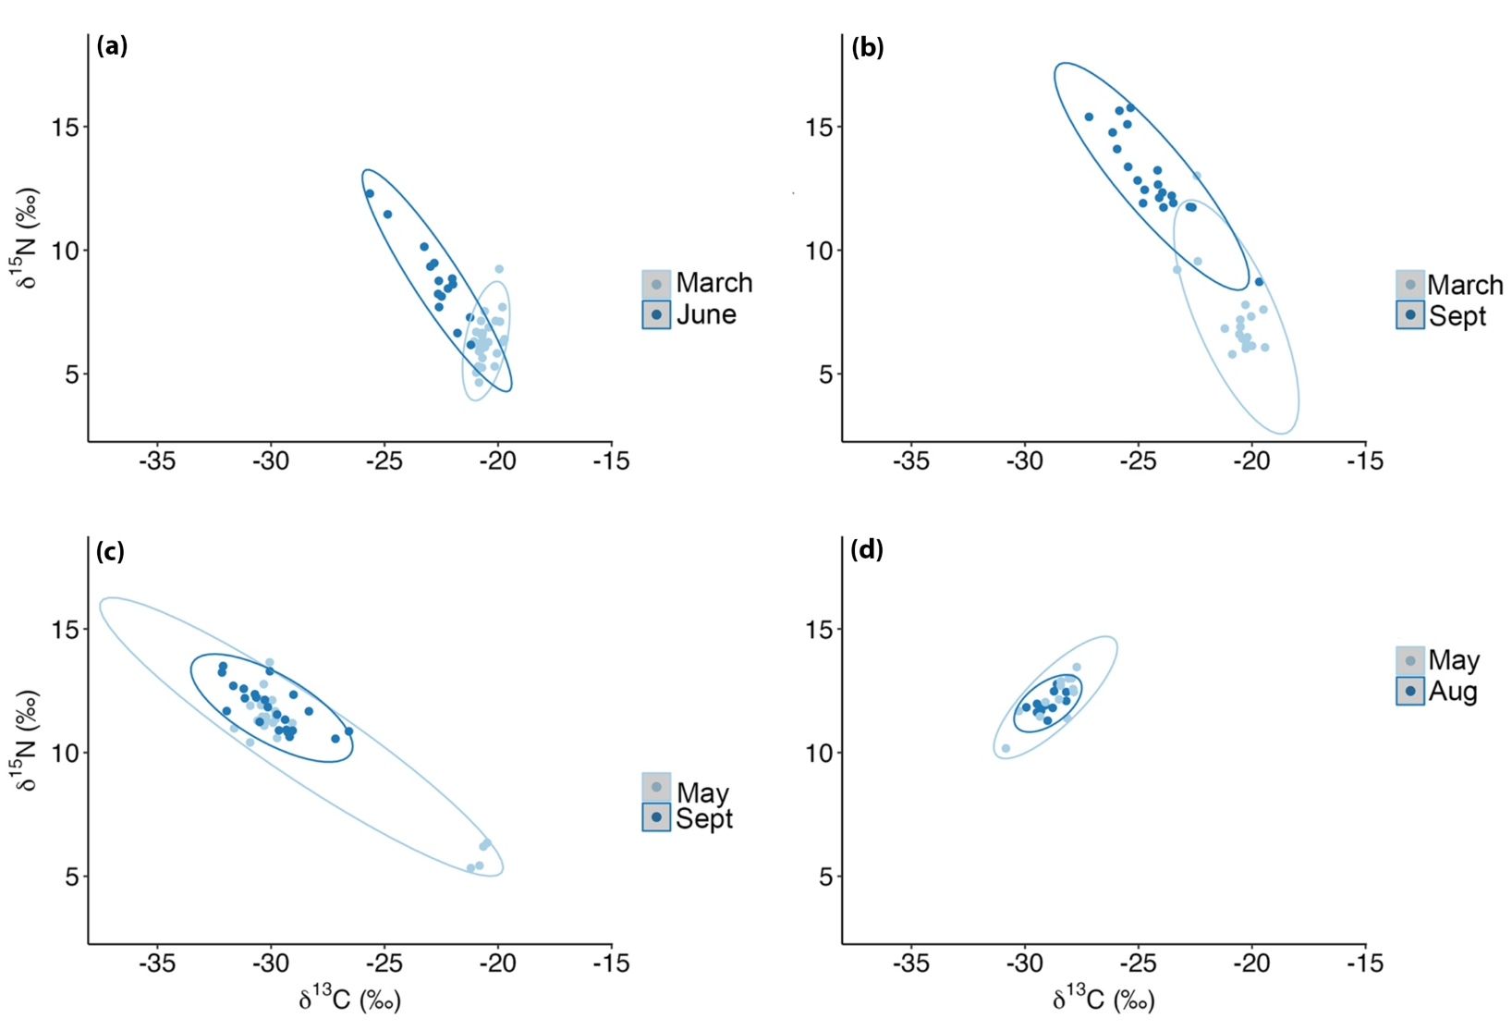

Fig. S2: Stable isotope δ¹³C and δ¹⁵N biplots for European eel by site, where standard ellipse areas (90% SEA_{c}) are shown by the start and end of the sample month. Plots are shown by location for (a) Parrett, (b) Chelmer, (c) Parrett, and (d) Frome.

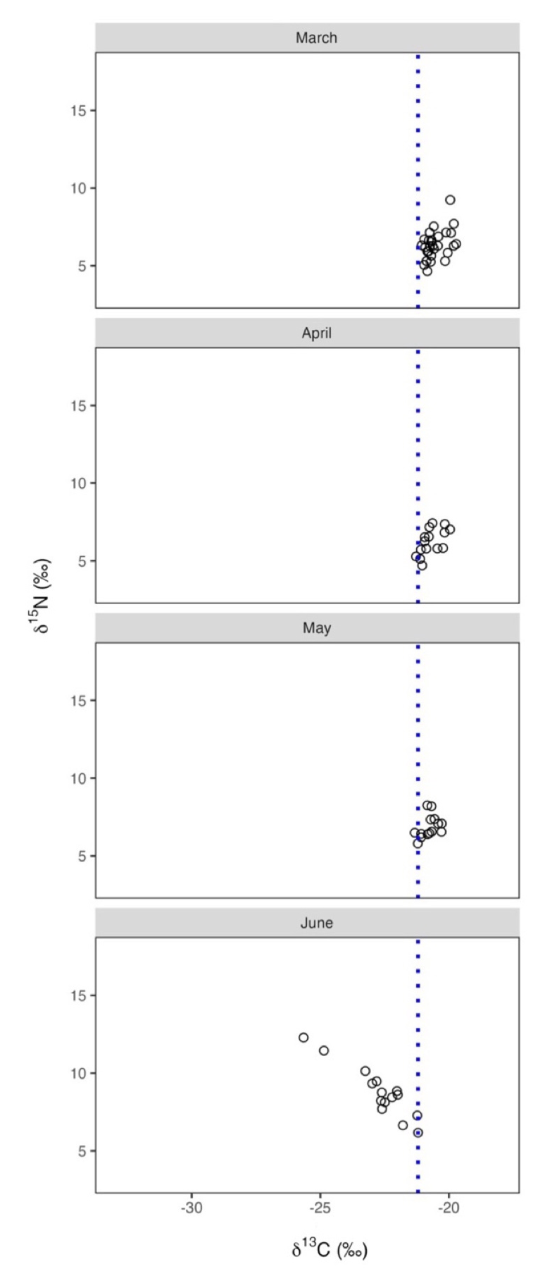

Fig. S3: Stable isotope δ¹³C and δ¹⁵N plots for eel separated into sample months for the River Parrett across the sampling period. The Blue dashed line represents values that reflect marine signatures (-21.0 ‰).

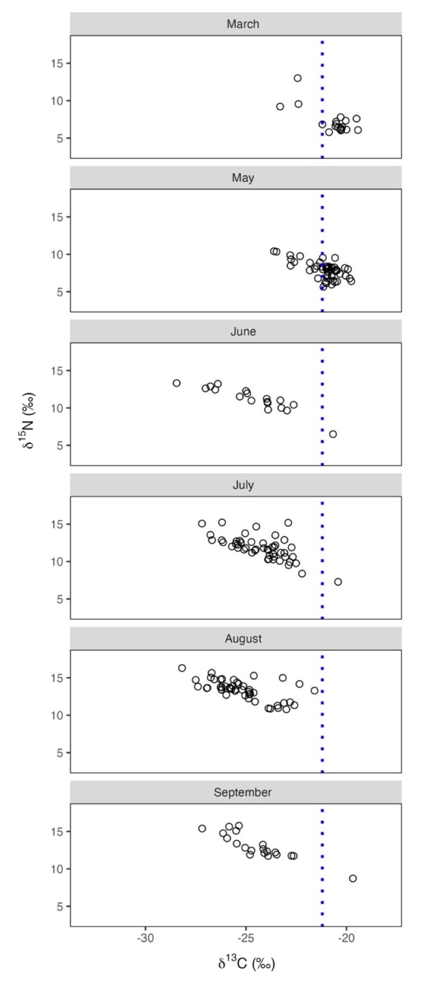

Fig.S4: Stable isotope δ¹³C and δ¹⁵N plots for eel separated into sample months for the River Chelmer across the sampling period. The Blue dashed line represents values that reflect marine signatures (-21.0 ‰).
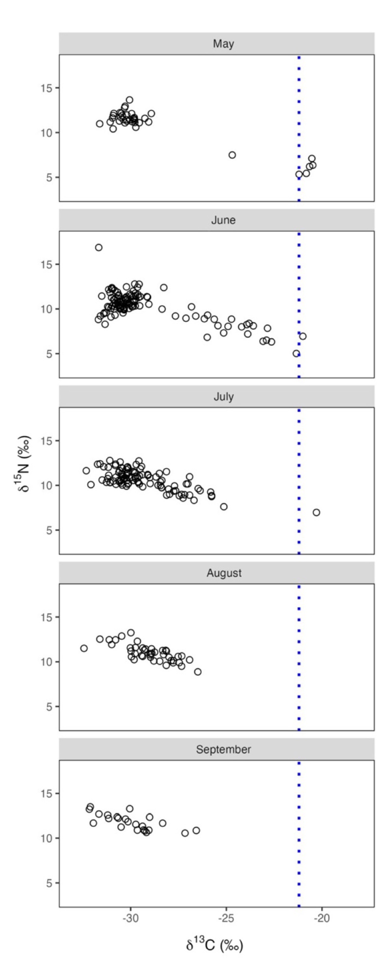

Fig.S5: Stable isotope δ¹³C and δ¹⁵N plots for eel separated into sample months for the River Piddle across the sampling period. The Blue dashed line represents values that reflect marine signatures (-21.0 ‰).
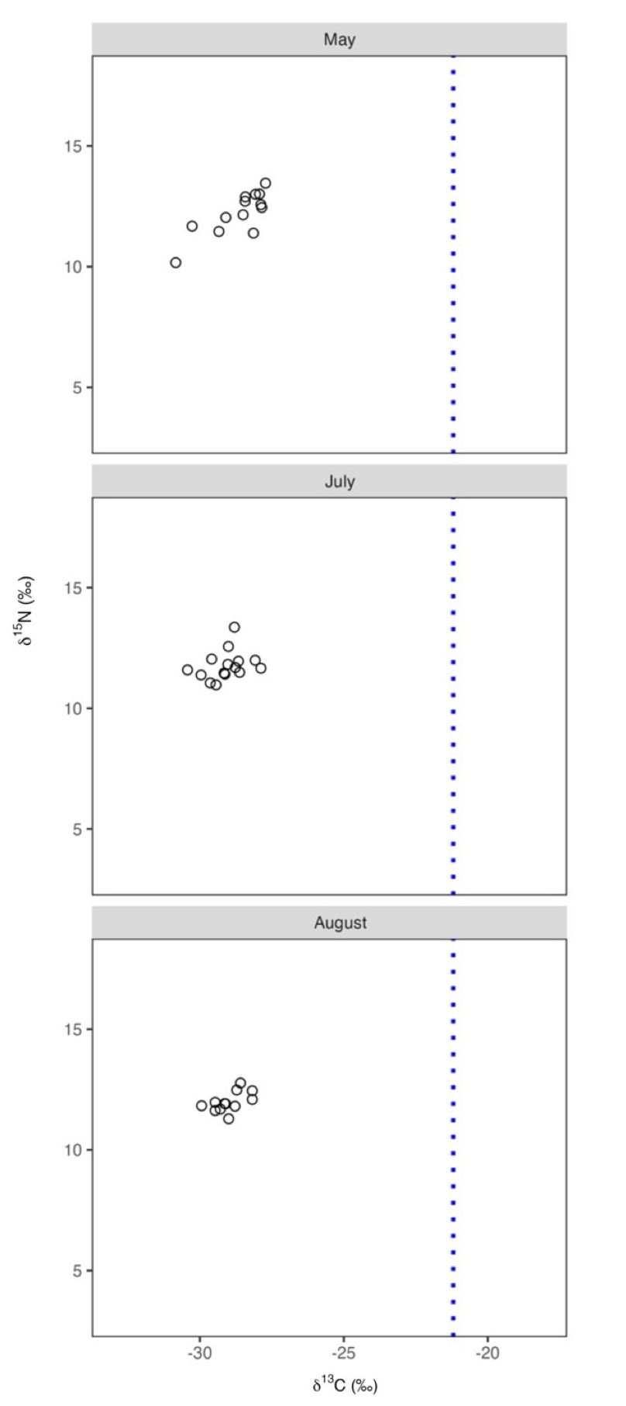

Fig.S6: Stable isotope δ¹³C and δ¹⁵N plots for eel separated into sample months for the River Frome across the sampling period. The Blue dashed line represents values that reflect marine signatures (-21.0 ‰).
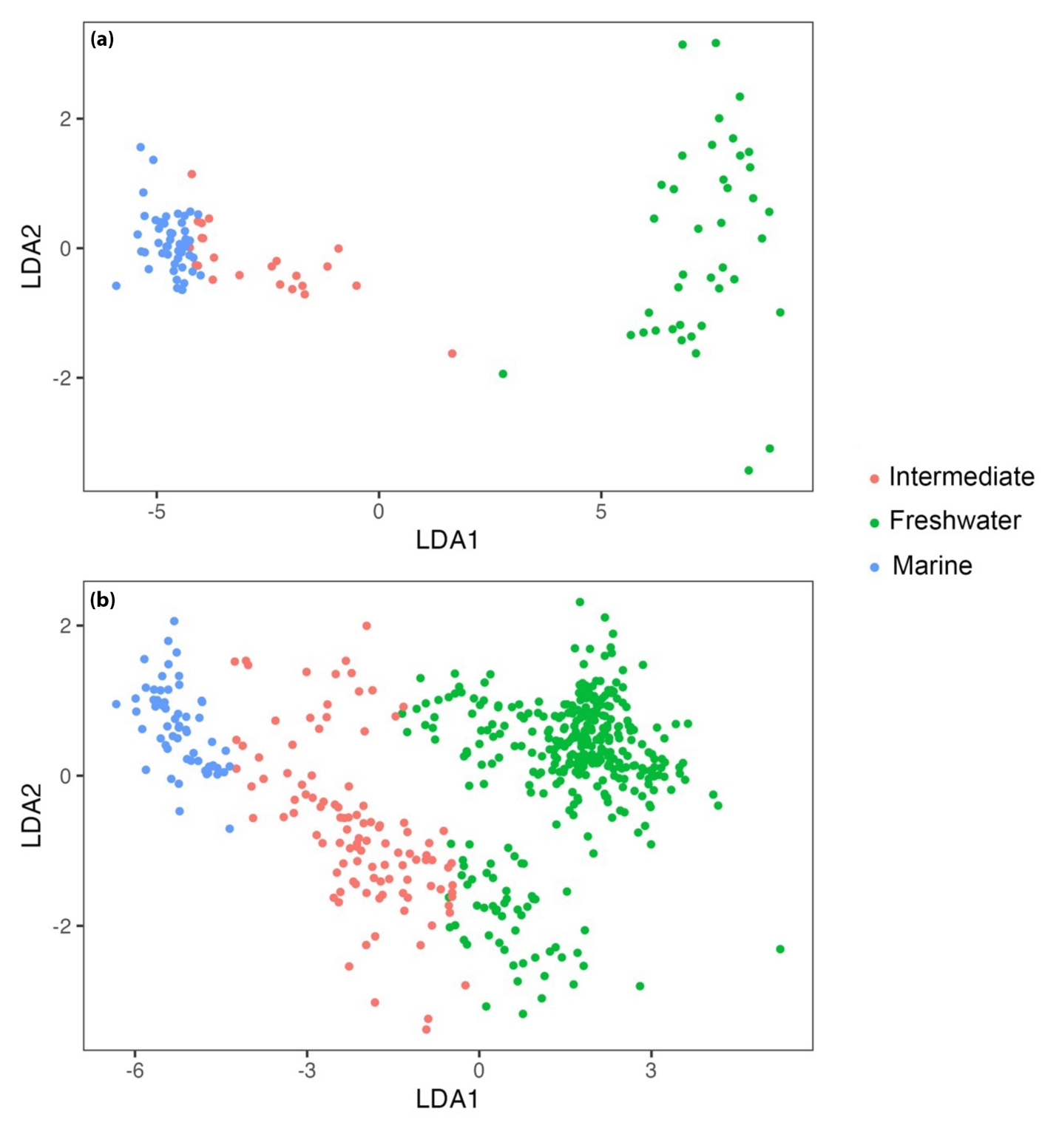

Fig.S7: Two-dimensional plot of the discriminant function analysis using Linear Discriminant (LDA1 and LDA2). (a) River Frome and Parrett outputs, (b) Piddle and Chelmer outputs.

