Supplementary materials

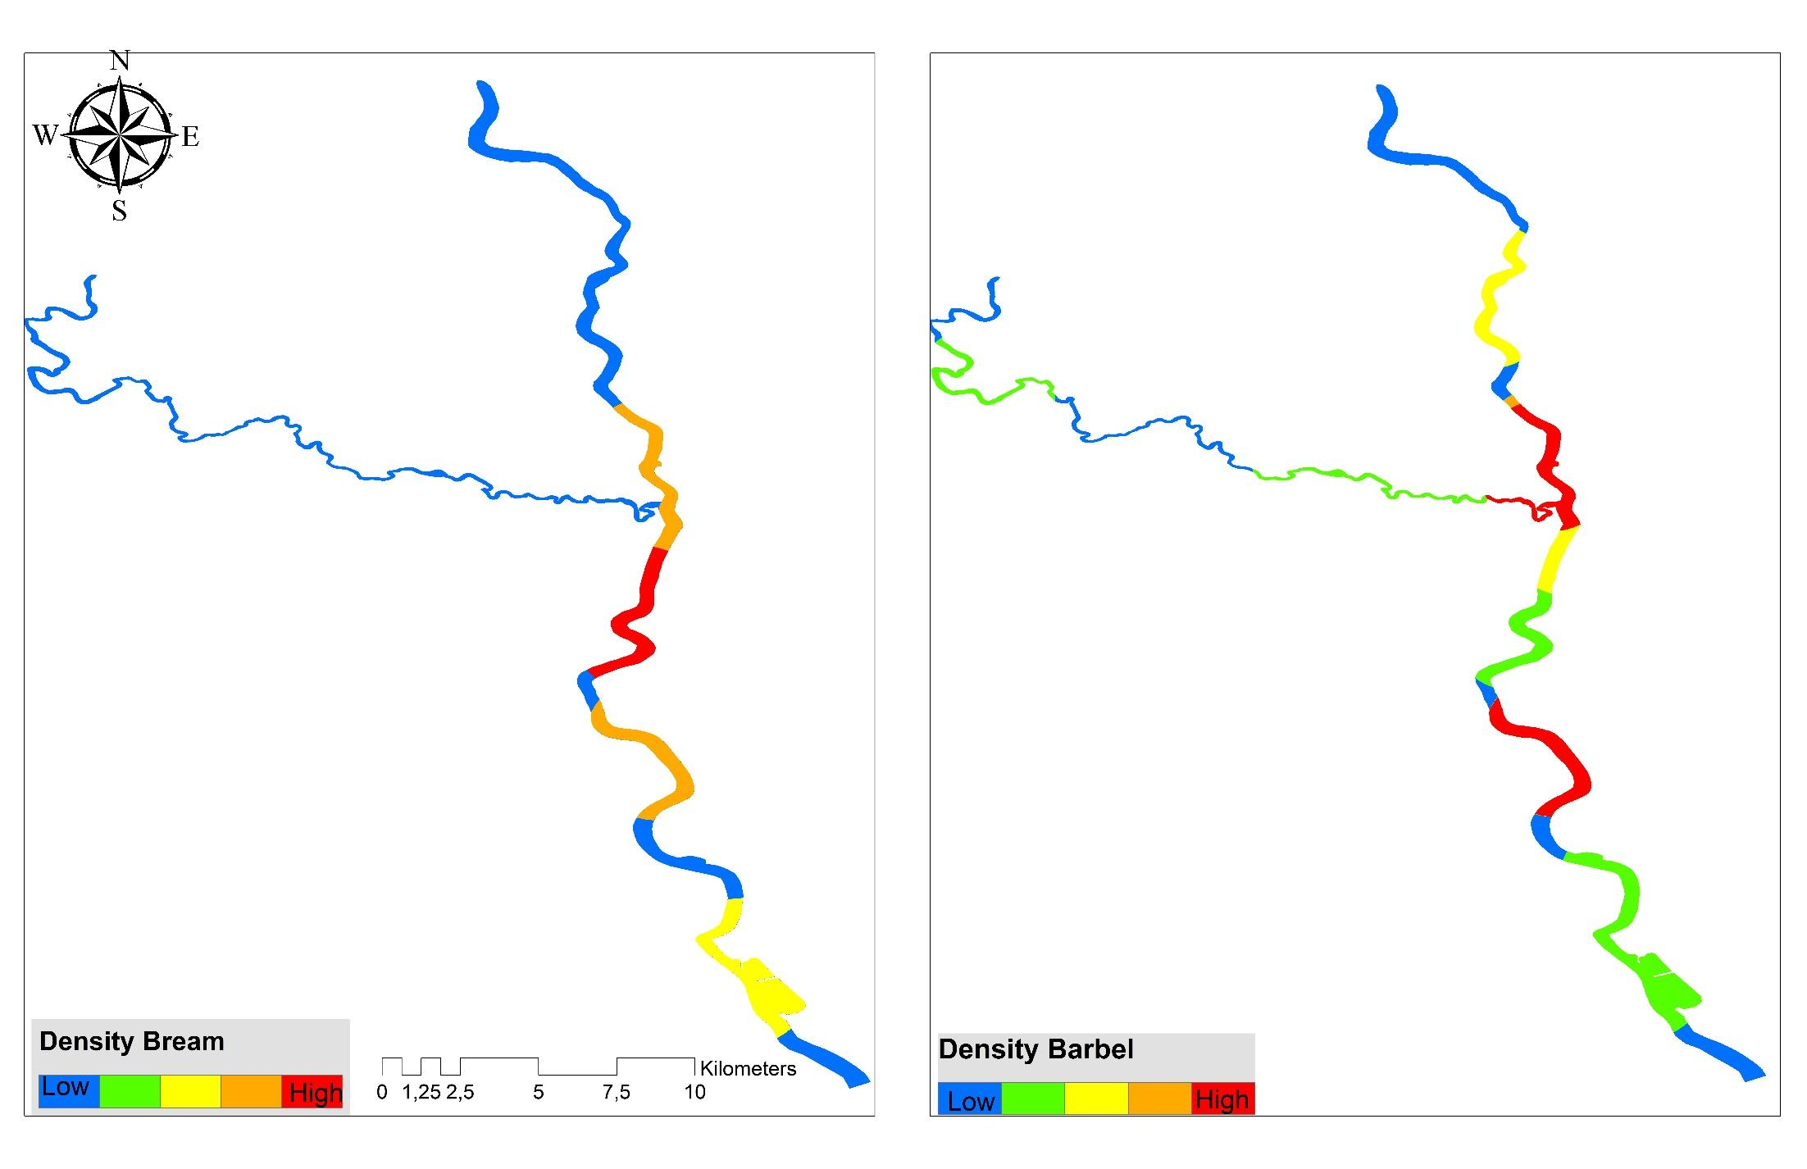

Fig. S1 Heat map showing probability of occupancy (density) of the study area (cf. Fig. 1) by common bream in summer 2022 and European barbel in summer 2021.

(A)
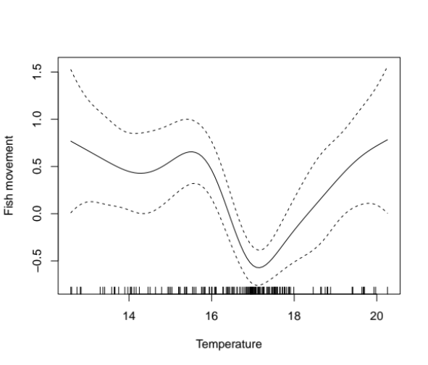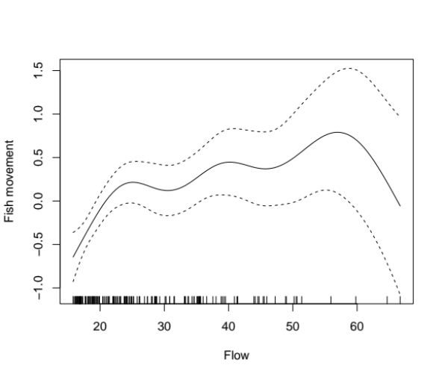
(B)
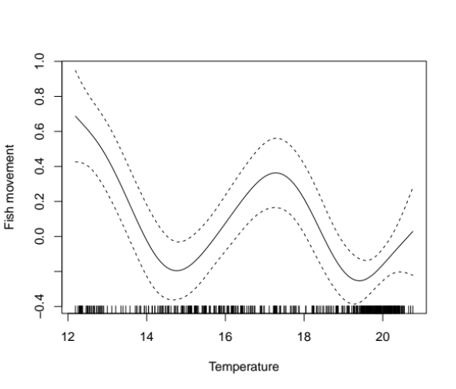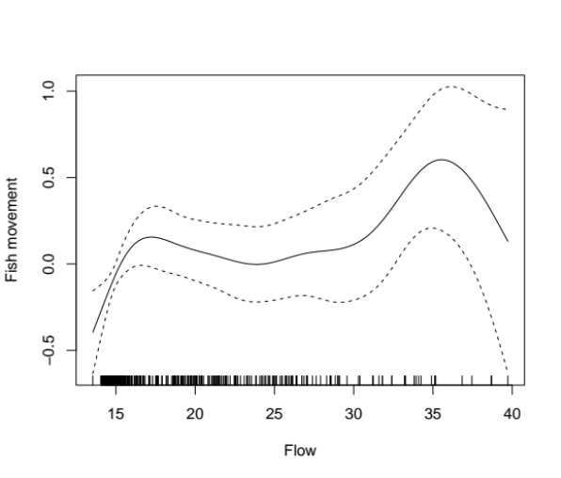
Figure S2. The generalized additive model plot depicts relationship fish movement and temperature and flow for European barbel and (B) common bream.

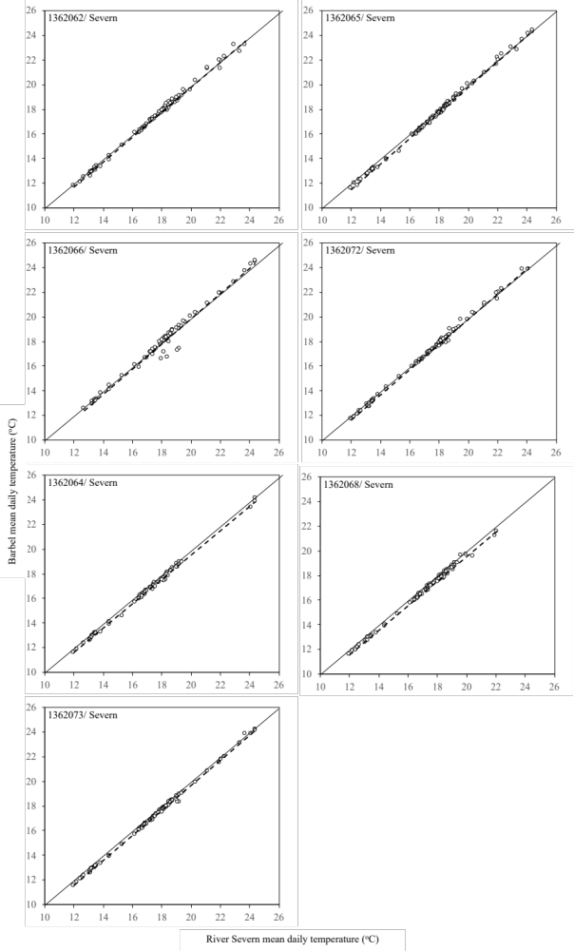
Figure S3A. Relationship between River Severn mean daily temperatures and barbel mean body temperatures on the days of detection for each individual fish (transmitter ID in top right corner).

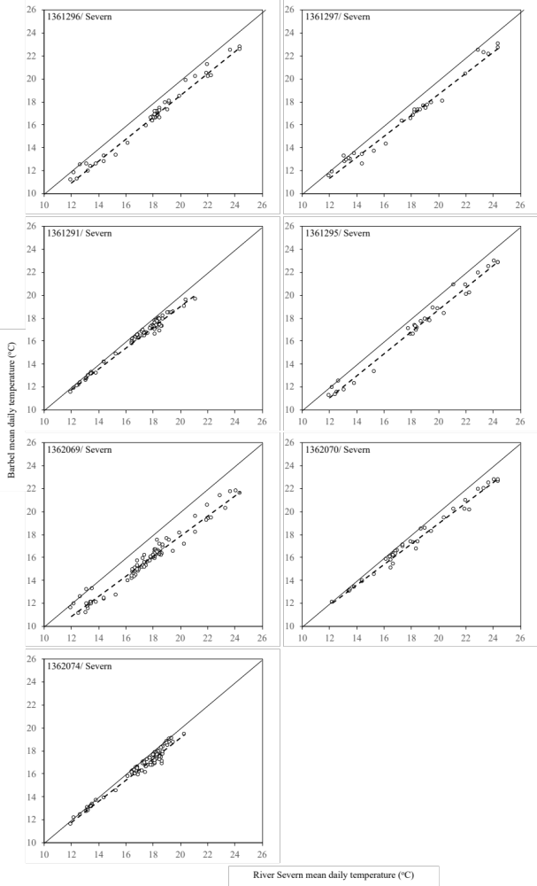

Figure S3B. Relationship between River Severn mean daily temperatures and barbel mean body temperatures on the days of detection for each individual fish (transmitter ID in top left corner).
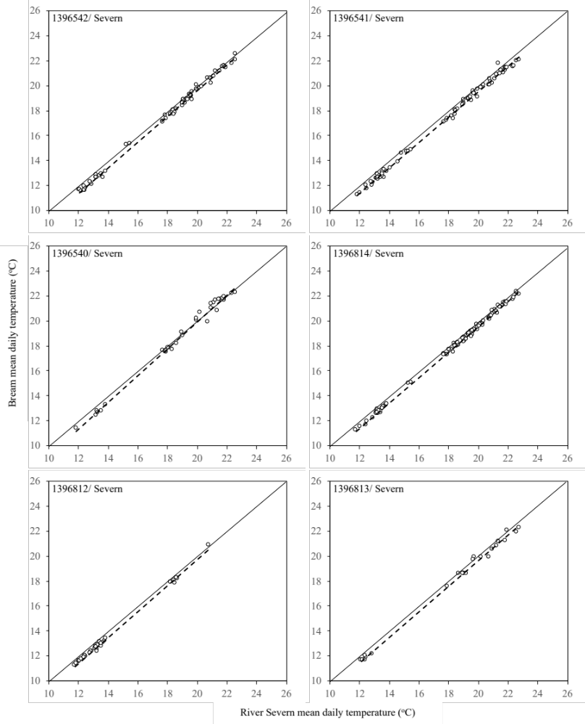

Figure S4A. Relationship between River Severn mean daily temperatures and common bream mean body temperatures on the days of detection for each individual fish (transmitter ID in top left corner).

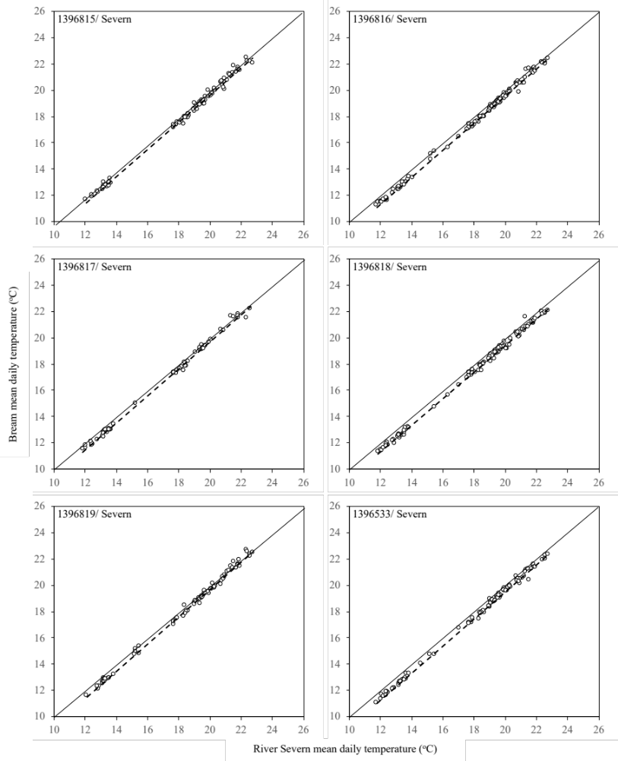
Figure S4B Relationship between River Severn mean daily temperatures and common bream mean body temperatures on the days of detection for each individual fish (transmitter ID in top left corner).

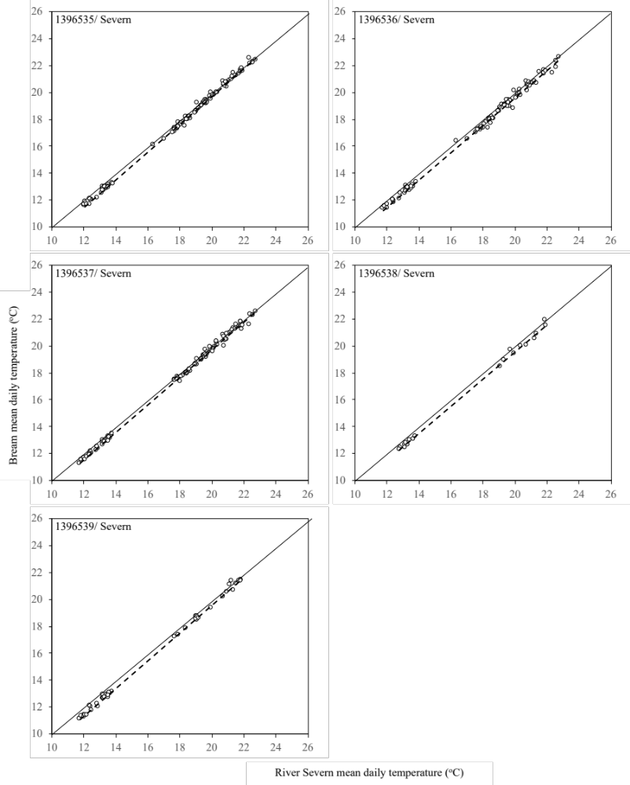

Figure S4C. Relationship between River Severn mean daily temperatures and common bream mean body temperatures on the days of detection for each individual fish (transmitter ID in top left corner).

