Cascading effects of land use on ecosystem function in Afrotropical headwater streams
Florence Nansumbi¹, Gabriele Weigelhofer¹, Robinson Odong², Thomas Hein¹
¹Institute of Hydrobiology and Aquatic Ecosystem Management; University of Natural Resources and Life Sciences, Vienna
²Department of Zoology, Entomology and Fisheries Sciences, College of Natural Sciences, Makerere University, Kampala, Uganda
*Corresponding author: Florence Nansumbi
Email: florence.nansumbi@students.boku.ac.at

Supplementary Materials
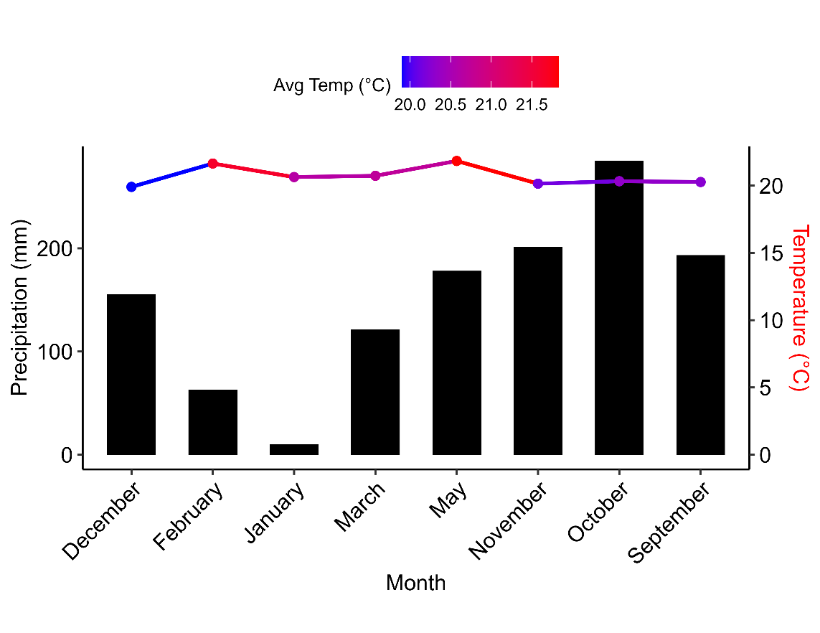
Fig. S1: Mean monthly air temperature (°C) and total precipitation (mm) recorded in Fort Portal, Uganda, during the study period (September 2022 to May 2023).
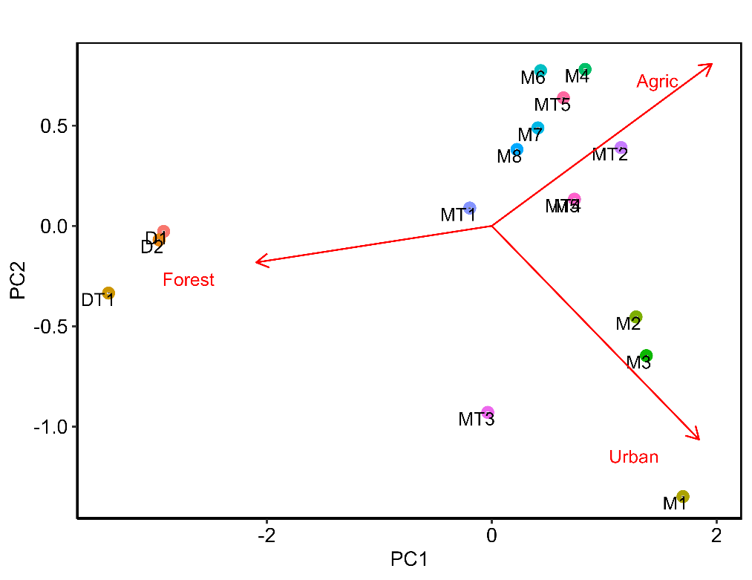
Fig S 2: Principal Component Analysis (PCA) classification of study sites, with coloured points representing individual sites and red arrows indicating the relative contributions of urban, forest, and agricultural (Agric) land use.
Table S 1: Nutrient concentrations and dissolved organic matter (DOM) composition by land use (forest, agricultural, and urban). Statistical significance was determined using the Kruskal-Wallis test, with p-values indicated by *** (p < 0.001), ** (p < 0.01), and * (p < 0.05). Values are presented as means ± standard deviations (SD), as specified.
 |  |  | Land use
Variable | Units | Forest (n=32) | Agriculture (n=64) | Urban  (n=32) | p-value
NH₄⁺ | mgL⁻¹ | 0.08 ± 0.14 | 0.08 ± 0.09 | 0.16 ± 0.36 | 0.148
NO₃⁻ | mgL⁻¹ | 0.57 ± 0.32 | 0.78 ± 0.63 | 1.54 ± 0.98 | 0.000 | ***
DIN | mgL⁻¹ | 0.64 ± 0.37 | 0.86 ± 0.66 | 1.70 ± 1.28 | 0.000 | ***
SRP | mgL⁻¹ | 0.21 ± 0.12 | 0.27 ± 0.16 | 0.30 ± 0.16 | 0.009 | **
TN | mgL⁻¹ | 1.49 ± 0.69 | 1.49 ± 0.57 | 2.40 ± 1.23 | 0.000 | ***
TP | mgL⁻¹ | 0.40 ± 0.26 | 0.52 ± 0.26 | 0.59 ± 0.27 | 0.007 | **
a254 | m⁻¹ | 71.62 ± 47.11 | 29.87 ± 13.45 | 18.04 ± 16.25 | 0.000 | ***
a280 | m⁻¹ | 57.03 ± 34.74 | 25.96 ± 9.26 | 17.17 ± 12.61 | 0.000 | ***
SR | - | 0.68 ± 0.20 | 0.67 ± 0.36 | 1.02 ± 0.94 | 0.313
E2/E3 | - | 3.05 ± 3.77 | 4.15 ± 1.74 | 6.47 ± 3.28 | 0.000 | ***
E3/E4 | - | 4.90 ± 4.03 | 5.53 ± 3.55 | 5.67 ± 5.76 | 0.096 | .
S1 | nm⁻¹ | 0.01 ± 0.01 | 0.01 ± 0.01 | 0.02 ± 0.01 | 0.205
S2 | nm⁻¹ | 0.02 ± 0.01 | 0.02 ± 0.01 | 0.02 ± 0.01 | 0.065 | .
DOC | mgL⁻¹ | 6.98 ± 1.93(n=4) | 3.7 ± 0.7(n=8) | 4.66 ± 1.18(n=4) | 0.03422 | *

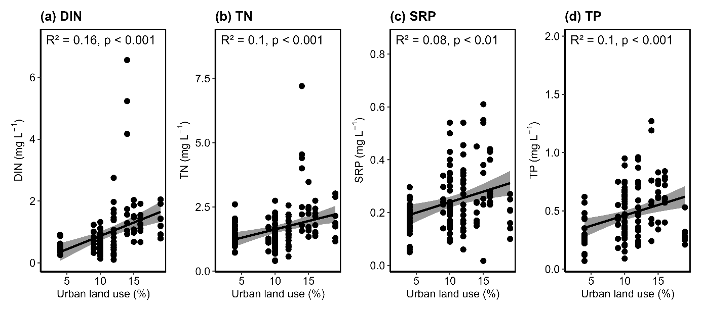
Fig S 3:Simple linear regression between Nutrient concentrations in water samples and the percentage of urban land use across sampling sites. Nutrients measured include dissolved inorganic nutrients (DIN), Soluble reactive phosphorus (SRP), Total Nitrogen (TN) and Total phosphorus (TP). Shaded areas represent 95% confidence intervals. The coefficient of determination (R²) and associated p-values are indicated within each plot. Labels a–d correspond to individual nutrients. N for each nutrient is 128.

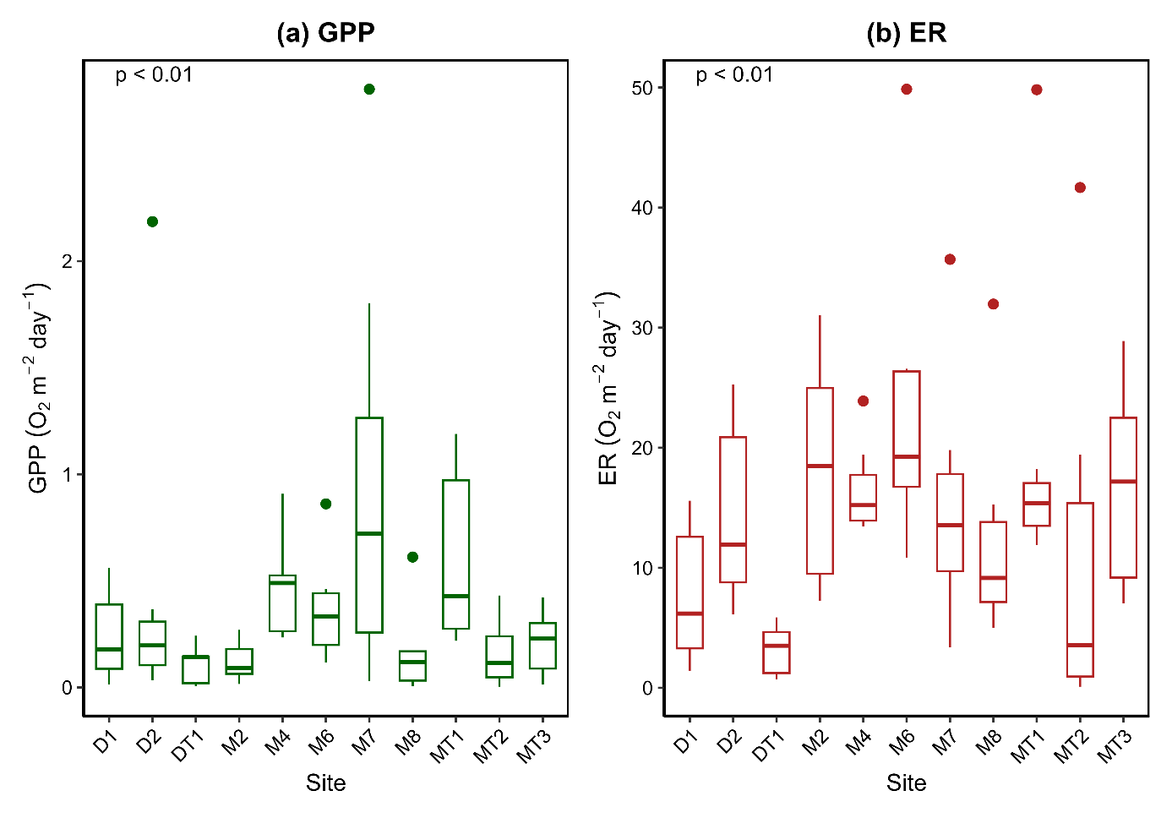
Fig S4:Boxplots of gross primary production (GPP) and ecosystem respiration (ER) across sites. Statistical differences among sites were assessed using the Kruskal–Wallis test (p < 0.05). Solid horizontal lines represent median values; dots indicate outliers.
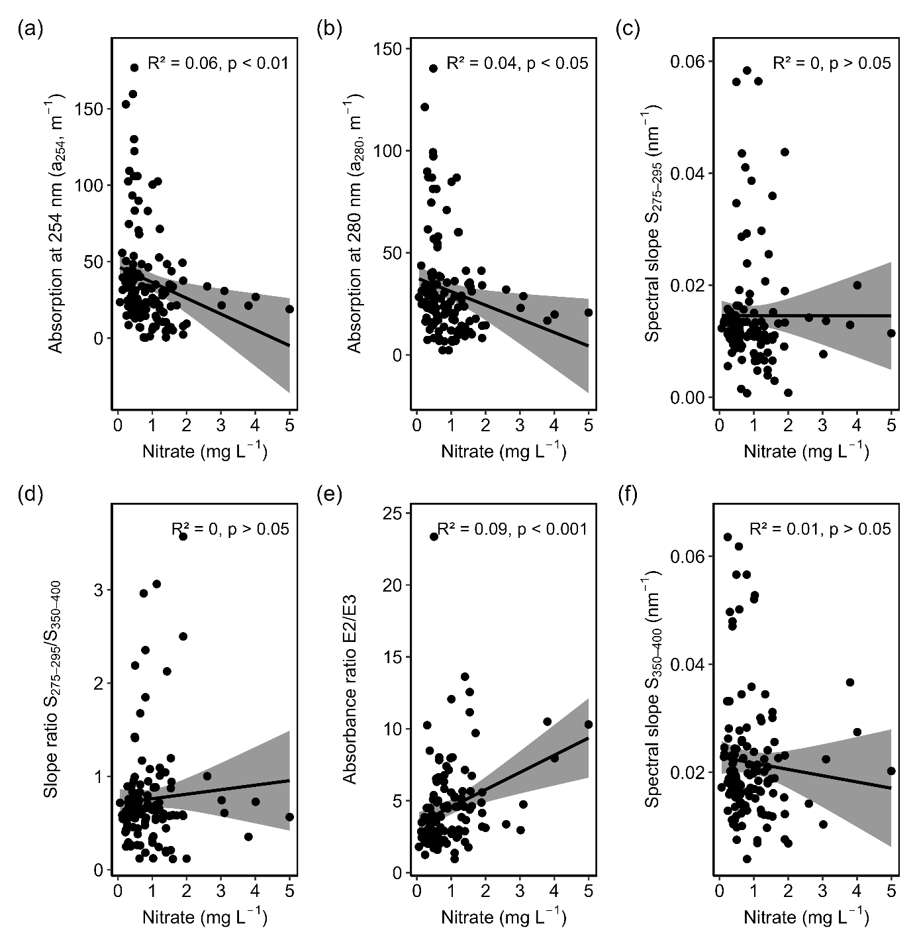
Fig S 5: Simple linear regression between DOM optical indices, a254,a280,275-295,SR,E2/E3,350-400 and nitrate concentrations throughout the study period (n=128). Shaded areas represent 95% confidence intervals. The coefficient of determination (R²) and associated p-values are indicated within each plot. Labels a–f correspond to relationships of individual DOM metrics to nitrate concentrations.

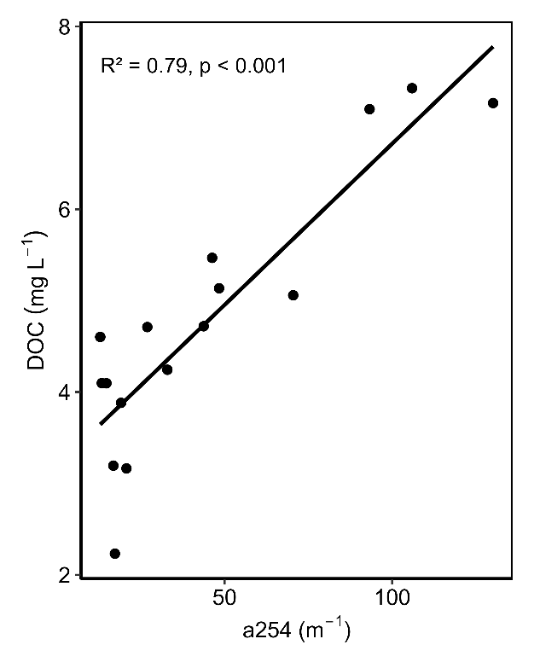
Fig S 6 : Relationship between absorbance at 254 nm (a254) and dissolved organic carbon (DOC) concentrations measured across sampling sites in May 2023. The solid line represents the linear regression fit, with the coefficient of determination (R²) and associated p-value shown on the plot.

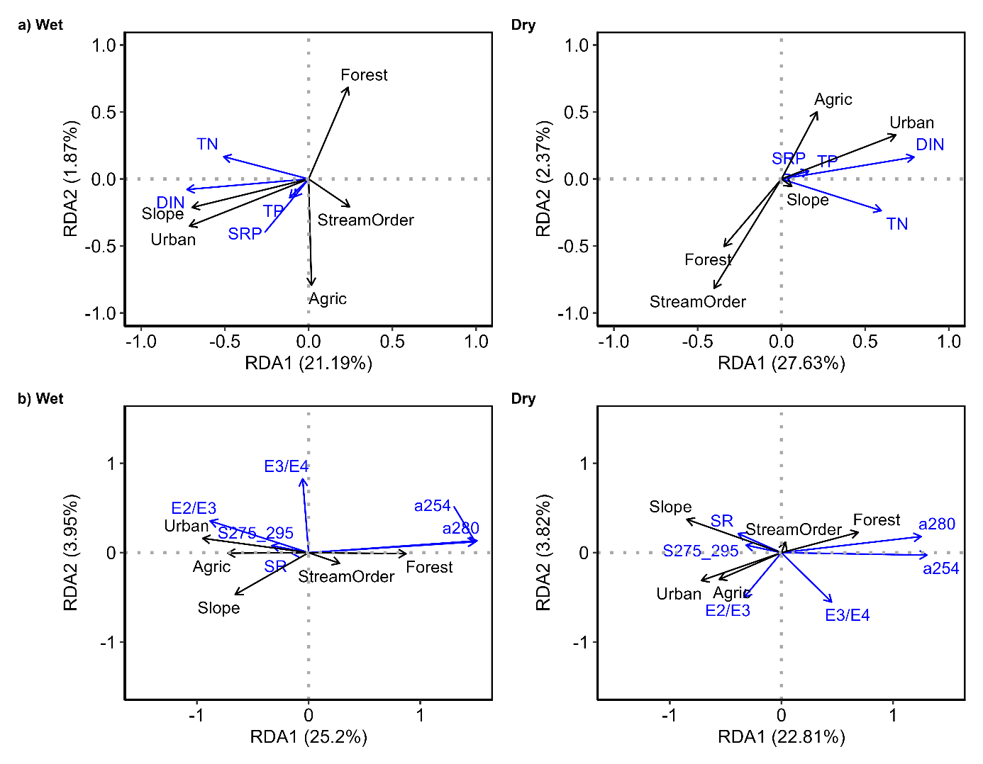
Fig S 7: Redundancy analysis biplots showing the relationships between land use and catchment variables (black arrows) and nutrient (a) and DOM composition indices (b) in the wet and dry seasons. Black arrows represent explanatory variables while blue arrows represent response variables (DOM and nutrients). The direction of the arrows indicates the direction of correlation and the arrow length the magnitude of contribution of the variables.

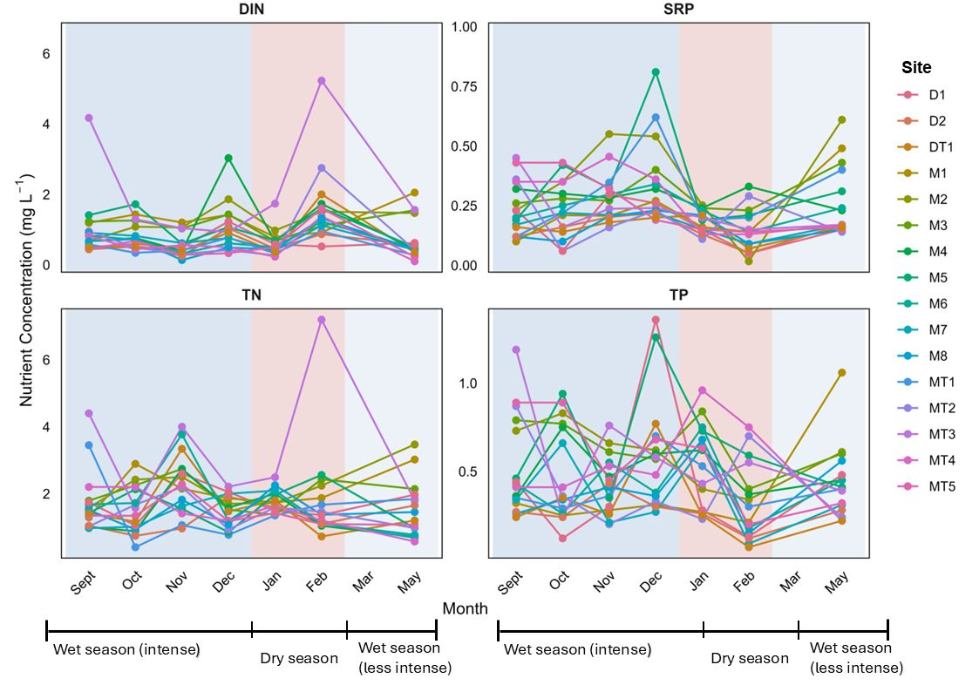
Fig S 8: Monthly concentrations of nutrients: Dissolved Inorganic Nitrogen (DIN), Soluble Reactive Phosphorus (SRP), Total Nitrogen (TN), and Total Phosphorus (TP) measured at each sampling site.
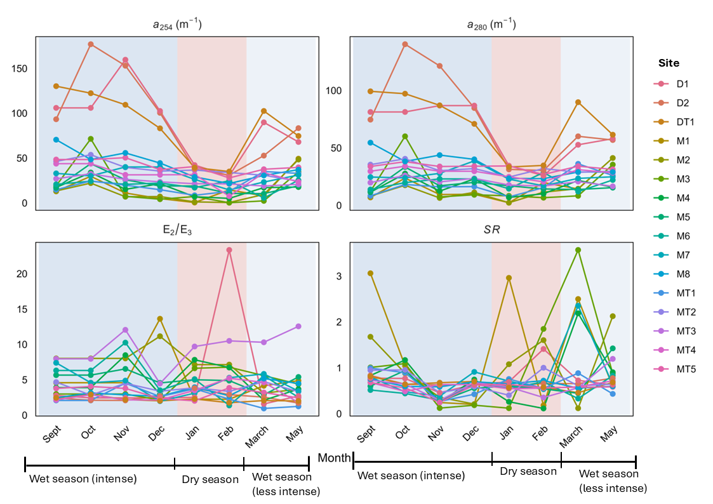
Fig S 9: Monthly concentrations of DOM composition indices a254,A280,E2/E3 and SR at measured at each sampling site.

Table S 2:Stream metabolism deployment information, model input data and model outputs.
Deployment information |  |  |  |  |  | Input data |  |  |  |  | Model Outputs
Site | Month | Year | Days deployed | Days Removed | Days used | Mean Temp  (°C) | Mean DO (mgL⁻¹) | Mean PAR (µmol m⁻²s⁻¹) | Total PAR (µmol m-2s-1) | Depth (m) | Mean GPP± sd | Mean ER ± sd | Mean K.600 ± sd
M2 | October | 2022 | 4 | 3 | 1 | 19.2 | 7.07 | 9.2 | 1855.7 | 0.50 | 0.2 ± NA | -31. ± NA | 84.6 ± NA
 | November | 2022 | 3 | 2 | 1 | 18.8 | 7.11 | 9.1 | 1228.9 | 1.2 | 0.016 ± NA | -28.4±NA | 99.3 ± NA
 | December | 2022 | 3 | 1 | 2 | 18.47 | 6.48 | 3.8 | 378.7 | 0.59 | 0.092± NA | -21.5 ± NA | 72.20± NA
 | January | 2023 | 4 | 2 | 2 | 19.37 | 6.73 | 1.1 | 125.5 | 0.14 | 0.070 ± 0.015 | -10.9 ± 0.5 | 34.4 ± 1.6
 | February | 2023 | 3 | 1 | 2 | 19.49 | 5.22 | 24.3 | 13142.6 | 0.23 | 0.14 ± 0.019 | -7.5 ± 0.35 | 46.02 ± 2.1
 | March | 2023 | 3 | 3 | 0 | 19.67 | 6.66 | 3.0 | 775.8 | 0.22 | 0.046 ± 0.033 | -8.5 ± 0.94 | 34.2 ± 3.4
 | May | 2023 | 5 | 3 | 2 | 20.40 | 6.33 | 7.9 | 854.5 | 1.1 | 0.27 ± 0.060 | -18.5 ± 1.7 | 47.9± 4.9
MT1 | October | 2022 | 7 | 2 | 5 | 19.12 | 6.85 | 2.5 | 298.1 | 1 | 0.22 ± 0.23 | -14.6 ± 3.1 | 17.9 ± 2.9
 | November | 2022 | 3 | 0 | 3 | 18.76 | 7.17 | 7.5 | 1265.7 | 0.6 | 0.25 ± 0.0092 | -11.9 ± 1.0 | 4.3 ± 0.32
 | December | 2022 | 3 | 2 | 1 | 18.47 | 7.11 | 3.8 | 688.6 | 0.56 | 1.2 ± 0.16 | -49.8 ± 15.4 | 20.8± 6.1
 | January | 2023 | 4 | 0 | 4 | 19.50 | 6.9 | 5.7 | 1058.4 | 0.46 | 0.43 ± 0.084 | -15.4 ± 1.3 | 13.05 ± 0.96
 | February | 2023 | 3 | 2 | 1 | 19.61 | 6.69 | 14.4 | 7490.0 | 0.2 | 1.0036 ± NA | -18.2 ± NA | 27.5 ± NA
 | March | 2023 | 4 | 4 | 0 | 19.76 | 1.62 | 1.2 | 110.1 | 0.55 | 0.30 ± 0.14 | -12.3 ± 2.7 | 12.9 ± 2.9
 | May | 2023 | 5 | 0 | 5 | 20.33 | 6.57 | 2.1 | 367.8 | 1.4 | 0.94 ± 0.26 | -15.9 ± 4.6 | 17.1 ± 4.4
M4 | October | 2022 | 4 | 1 | 3 | 19.33 | 4.00 | 2.7 | 494.9 | 0.3 | 0.51 ± 0.10 | -14.1 ± 6.3 | 6.9 ± 2.9
 | November | 2022 | 3 | 2 | 1 | 18.69 | 5.04 | 1.0 | 137.2 | 0.47 | 0.2659 ± NA | -19.4± NA | 9.2± NA
 | December | 2022 | 3 | 1 | 2 | 18.18 | 5.86 | 3.4 | 673.1 | 0.17 | 0.2341 ± NA | -13.4 ± NA | 7.01± NA
 | January | 2023 | 4 | 1 | 3 | 19.28 | 6.07 | 194. | 40157.2 | 0.04 | 0.49 ± 0.21 | -23.9 ± 11.3 | 15.3± 7.3
 | February | 2023 | 3 | 1 | 2 | 19.50 | 5.68 | 216.8 | 116209.9 | 0.08 | 0.29 ± 0.048 | -14.6 ± 0.9 | 9.2 ± 0.62
 | March | 2023 | 3 | 1 | 2 | 19.80 | 5.69 | 131.9 | 43116.93 | 0.23 | 0.54 ± NA | -13.8 ± NA | 3.3± NA
 | May | 2023 | 5 | 0 | 5 | 20.40 | 5.92 | 279.4 | 95259.8 | 0.3 | 0.94 ± 0.26 | -15.9 ± 4.6 | 17.1 ± 4.4
MT2 | October | 2022 | 3 | 2 | 1 | 16.84 | 7.11 | 7.1 | 3464.8 | 0.5 | 0.25 ± NA | -7.4± NA | 7.9 ± NA
 | November | 2022 | 5 | 2 | 3 | 16.54 | 7.17 | 5.9 | 804.5 | 0.4 | 0.039 ± 0.018 | -3.6 ± 2.0 | 11.2 ± 6.8
 | December | 2022 | 4 | 1 | 3 | 16.47 | 7.21 | 1.2 | 136.6 | 0.36 | 0.78 ± NA | -87.3 ± NA | 44.9 ± NA
 | January | 2023 | 5 | 2 | 3 | 16.73 | 6.95 | 0.7 | 120.3 | 0.3 | 0.43± 0.10 | -19.4± 3.4 | 27.5 ± 5.4
 | February | 2023 | 5 | 4 | 1 | 16.97 | 6.89 | 14.0 | 1988.4 | 0.15 | 0.0552 ± NA | -11.3 ± NA | 10.1± NA
 | March | 2023 | 3 | 1 | 2 | 17.41 | 6.95 | 15.1 | 2351.2 | 0.3 | 0.0031 ± NA | -0.85± NA | 0.37 ± NA
 | May | 2023 | 3 | 2 | 1 | 18.24 | 6.74 | 182.1 | 53899.4 | 0.37 | 0.12 ± NA | -0.09 ± NA | -1.1± NA
MT3 | October | 2022 | 5 | 3 | 2 | 18.86 | 5.21 | 2.4 | 529.8 | 0.7 | 0.079 ± 0.013 | -7.5 ± 0.043 | 14.4 ± 0.003
 | November | 2022 | 3 | 2 | 1 | 18.96 | 5.75 | 0.3 | 2.0 | 1 | 0.42± NA | -17.2 ± NA | 17.8 ± NA
 | December | 2022 | 3 | 1 | 2 | 18.67 | 5.82 | 5.8 | 2399.4 | 0.91 | 0.29 ± NA | -20.9 ± NA | 14.2± NA
 | January | 2023 | 5 | 4 | 1 | 18.74 | 6.10 | 10.2 | 2482.4 | 0.86 | 0.23 ± NA | -28.9 ± NA | 20.1± NA
 | February | 2023 | 3 | 2 | 1 | 19.10 | 5.85 | 8.2 | 1157.6 | 0.8 | 1.45 ± NA | -89.2 ± NA | 35.6± NA
 | March | 2023 | 4 | 2 | 1 | 20.60 | 2.02 | 30.0 | 6447.4 | 0.53 | 0.31± 0.11 | -24.1 ± 15.9 | 23.9± 19.7
 | May | 2023 | 3 | 1 | 2 | 20.30 | 5.67 | 25.5 | 4584.3 | 0.84 | 0.098 ± 0.043 | -7.04 ± 2.6 | 9.8 ± 1.0
M6 | October | 2022 | 3 | 2 | 1 | 18.62 | 6.05 | 3.8 | 165.7 | 1.2 | 0.42± NA | -26.14 ± NA | 12.1 ± NA
 | November | 2022 | 5 | 2 | 3 | 18.80 | 5.26 | 7.24 | 1317.3 | 1.84 | 0.14 ± 0.10 | -25.6 ± 3.5 | 5.2 ± 0.88
 | December | 2022 | 4 | 2 | 2 | 18.35 | 6.69 | 13.5 | 2777.1 | 1.7 | 0.86± 0.029 | -49.9± 18.4 | 23.4 ± 9.2
 | January | 2023 | 5 | 0 | 5 | 18.08 | 6.59 | 36.6 | 9667.1 | 1.2 | 0.12 ± 0.051 | -17.7 ± 3.7 | 10.8 ± 2.10
 | February | 2023 | 5 | 0 | 5 | 18.91 | 6.44 | 8.7 | 2382.7 | 0.7 | 0.44 ± 0.12 | -10.4 ± 0.98 | 10.3± 0.96
 | March | 2023 | 3 | 3 | 0 | 19.72 | 6.29 | 39.9 | 6868.3 | 0.55 | 0.33 ± 0.01 | -19.3± 2.4 | 24.9 ± 3.3
 | May | 2023 | 5 | 2 | 3 | 20.67 | 6.31 | 38.3 | 4830.2 | 0.84 | 0.27 ± 0.28 | -15.6 ± 3.4 | 13.4 ± 2.7
M7 | October | 2022 | 3 | 2 | 1 | 19.59 | 6.46 | 398.5 | 74123.2 | 1.2 | 0.72 ± NA | -11.27 ± NA | 6.03 ± NA
 | November | 2022 | 5 | 4 | 1 | 19.09 | 6.11 | 0.5 | 48.6 | 1.88 | 0.7211 ± NA | -15.8 ± NA | 4.4 ± NA
 | December | 2022 | 4 | 2 | 2 | 18.57 | 6.28 | 12.3 | 1841.0 | 2.5 | 2.8 ± 1.5 | -43.2 ± 29.10 | 7.0± 5.3
 | January | 2023 | 4 | 1 | 3 | 18.58 | 0.03 | 3.5 | 806.9 | 0.73 | 0.04 ± 0.03 | -4.2 ± 3.4 | 0.67 ± 0.56
 | February | 2023 | 3 | 1 | 2 | 18.96 | 5.11 | 1.0 | 54.4 | 0.4 | 1.38 ± 0.6 | -12.5 ± 4.4 | 19.2± 4.8
 | March | 2023 | 6 | 6 | 0 | 19.03 | 6.21 | 3.9 | 760.1 | 0.7 | 0.25 ± 0.35 | -14.1 ± 12.1 | 11.3 ± 9.2
 | May | 2023 | 3 | 0 | 3 | 20.27 | 6.47 | 4.8 | 747.6 | 1.3 | 0.14 ± 0.029 | -19.8 ± 2.3 | 12.8± 1.4
M8 | October | 2022 | 3 | 2 | 1 | 19.57 | 7.08 | 365.8 | 74623.0 | 1.1 | 0.011 ± NA | -9.2± NA | 13.1 ± NA
 | November | 2022 | 5 | 4 | 1 | 19.05 | 7.08 | 63.5 | 18221.3 | 1.4 | 0.0053 ± NA | -6.5 ± NA | 5.8 ± NA
 | December | 2022 | 3 | 1 | 2 | 18.47 | 7.00 | 136.0 | 22984.4 | 1.37 | 0.17 ± NA | -32.0 ± NA | 23.6 ± NA
 | January | 2023 | 7 | 0 | 7 | 18.27 | 7.28 | 2.5 | 393.5 | 0.69 | 0.15 ± 0.13 | -13.4 ± 7.2 | 28.0 ± 16.1
 | February | 2023 | 3 | 1 | 2 | 19.02 | 6.92 | 1.3 | 102.8 | 0.5 | 0.61± 0.16 | -7.8± 0.95 | 15.03± 1.1
 | March | 2023 | 5 | 1 | 4 | 18.81 | 6.99 | 7.2 | 2051.7 | 0.86 | 0.12 ± NA | -5.01 ± NA | 6.01± NA
 | May | 2023 | 3 | 2 | 1 | 20.18 | 6.86 | 3.9 | 566.9 | 1 | 0.053 ± NA | -12.3± NA | 15.6 ± NA
D1 | October | 2022 | 3 | 2 | 1 | 17.23 | 6.62 | 10.0 | 4455.7 | 0.6 | 0.37 ± NA | -12.1 ± NA | 29.6 ± NA
 | November | 2022 | 4 | 3 | 1 | 17.76 | 6.37 | 1.4 | 158.3 | 1.77 | 0.013 ± NA | -15.6 ± NA | 14.7± NA
 | December | 2022 | 4 | 2 | 2 | 17.07 | 6.80 | 3.6 | 645.0 | 1.65 | 0.56± 0.066 | -1.4 ± 1.06 | -0.65 ± 1.8
 | January | 2023 | 3 | 1 | 2 | 16.03 | 6.94 | 59.0 | 15629.8 | 0.8 | 0.074 ± 0.012 | -2.8 ± 0.51 | 15.7 ± 2.9
 | February | 2023 | 9 | 0 | 8 | 17.28 | 6.54 | 2.6 | 323.8 | 0.4 | 0.34± 0.607 | -3.4 ± 1.4 | 8.7 ± 5.0
 | March | 2023 | 4 | 4 | 0 | 17.74 | 6.31 | 3.1 | 563.4 | 0.52 | 0.17 ± 0.089 | -7.09 ± 1.9 | 28.2 ± 8.0
 | May | 2023 | 5 | 3 | 2 | 19.41 | 6.74 | 93.1 | 25514.2 | 0.9 | 0.10 ± 0.10 | -13.0 ± 10.8 | 11.3 ± 9.6
D2 | October | 2022 | 4 | 1 | 3 | 18.61 | 4.06 | 4.9 | 579.1 | 0.3 | 0.092 ± 0.066 | -20.9 ± 7.3 | 17.0 ± 5.7
 | November | 2022 | 3 | 1 | 2 | 18.92 | 6.44 | 4.4 | 897.1 | 0.23 | 0.25 ± 0.19 | -17.4± 2.2 | 31.9± 5.2
 | December | 2022 | 3 | 1 | 2 | 17.78 | 5.74 | 102.9 | 25403.6 | 0.76 | 0.046 ± NA | -6.1 ± NA | 9.5± NA
 | January | 2023 | 3 | 2 | 1 | 17.19 | 5.50 | 14.7 | 3721.2 | 0.23 | 0.20 ± NA | -9.4 ± NA | 18.0 ± NA
 | February | 2023 | 10 | 0 | 10 | 17.19 | 4.19 | 14.7 | 3721.2 | 0.23 | 0.45 ± 0.27 | -11.9 ± 6.3 | 44.2± 23.3
 | March | 2023 | 5 | 1 | 4 | 19.00 | 0.07 | 9.6 | 1553.1 | 0.29 | 2.20± NA | -8.2 ± NA | 0.65 ± NA
 | May | 2023 | 3 | 0 | 3 | 19.71 | 2.35 | 29.8 | 5090.8 | 0.38 | 0.035 ± 0.03 | -24.3 ± 3.4 | 13.0± 1.3
DT1 | October | 2022 | 3 | 2 | 1 | 18.55 | 5.39 | 15.0 | 3900.3 | 0.2 | 0.24 ± NA | -3.5 ± NA | 2.4 ± NA
 | November | 2022 | 4 | 3 | 1 | 18.24 | 5.49 | 0.65 | 21.51 | 0.4 | 0.14 ± NA | -3.5± NA | 2.3± NA
 | December | 2022 | 3 | 1 | 2 | 18.65 | 5.14 | 11.37 | 1353.31 | 0.52 | 0.0072 ± NA | -1.7± NA | 4.3± NA
 | January | 2023 | 3 | 0 | 3 | 17.80 | 5.02 | 2.36 | 134.24 | 0.4 | 0.009 ± 0.0065 | -0.8 ± 0.051 | 9.6 ± 0.65
 | February | 2023 | 8 | 5 | 3 | 18.74 | 1.85 | 1.54 | 130.89 | 0.37 | 0.030 ± 0.010 | -0.69 ± 0.22 | 3.5 ± 1.06
 | March | 2023 | 6 | 3 | 3 | 19.14 | 2.35 | 2.01 | 241.35 | 0.23 | 0.15 ± 0.045 | -4.6± 2.04 | 8.3 ± 4.0
 | May | 2023 | 6 | 3 | 3 | 20.15 | 4.39 | 22.51 | 3466.32 | 0.19 | 0.14 ± 0.039 | -5.9± 2.04 | 10.4 ± 3.4
Mean environmental and metabolic parameters are reported for each deployment across study sites. Input data (e.g., temperature, DO, PAR) represent averages over the full deployment period, while output values (GPP, ER, K600) reflect averages from days with valid and realistic model outputs and are reported as means ± standard deviation. . "Days used" indicates the number of days retained after quality control. "NA" denotes cases where standard deviations could not be calculated due to limited data. Temp, temperature; DO, dissolved oxygen; PAR ,photosynthetically active radiation; GPP ,gross primary productivity; ER, ecosystem respiration; K600, reaeration coefficient standardized to a Schmidt number of 600

