Ecomorphological Variation in the Corfu Killifish and Trait Overlap with the Invasive Mosquitofish: Conservation Implications
Yiannis Kapakos1,2*, Anthi Oikonomou¹, Kostas Vlachopoulos¹, Nafsika Karakatsouli² & Eleni Kalogianni¹
1 Institute of Marine Biological Resources and Inland Waters, Hellenic Centre for Marine Research, 46.7km Athens-Sounio ave., Anavyssos 19013, Greece
2 Laboratory of Applied Hydrobiology, Department of Animal Science, Agricultural University of Athens, Iera Odos 75, Athens 11855, Greece

*Correspondence: Yiannis Kapakos, ykapakos@hcmr.gr

SUPPLEMENTARY MATERIAL

SUPPLEMENTARY TABLES

Table S1 Number of individuals of the Corfu killifish and its sympatrics per location that were photographed and subsequently analysed with ImageproPLus software. F: Female, M: Male (sexual dimorphism was evident in the Corfu killifish and the alien mosquitofish).

 | V. letourneuxi | G. holbrooki | T. pleurobipunctatus | P.thesproticus
Sidari | 12F/18M | absent | 6 | 0
Chohla | 10F/9M | absent | absent | 2
Vlychos | 9F/13M/6Juv | 14F/13M | absent | 15

Table S2 Physicochemical, hydrological and habitat characteristics of the three killifish habitats studied; Coarse substrate (>63 mm, %)

Habitat | Chocha | Vlychos | Sidari
Date | 10/07/2020 | 11/7/2019 | 11/7/2020
Conductivity (μS/m) | 656 | 5200 | 961
pH | 7.22 | 7.48 | 7.6
T ⁰C | 17.2 | 20.3 | 21.7
Width (mean, m) | 7 | 1.5 | 3
Depth (mean, m) | 1.2 | 0.9 | 0.5
Velocity (m/sec) | <0.1 | <0.1 | 0.1-025
Coarse substrate | 15 | 0 | 20
Shadiness (%) | 20 | 0 | 25
Helophytes/bottom vegetation | Rich/Rich | Rich/Rich | Rich/Rich
Habitat type (%) | Pool 80%; Glide 20% | Pool 100% | Pool 25%; Glide 50%; Run 20%; Riffle 5%

Table 3 Traits with statistically significant differences between killifish populations based on the Dunn test.
Habitat | Sidari | Vlychos
Chochla | Condition factor, Body Mass, Throt, Gape position, Ratio fin caudal | Pect fin posit, Ratio fin pect, Eye posit
Sidari |  | Condition factor, Body Mass, Throt, Gape position, Pect fin posit, Ratio fin pect, Eye posit, Fins surface

SUPPLEMENTARY FIGURES

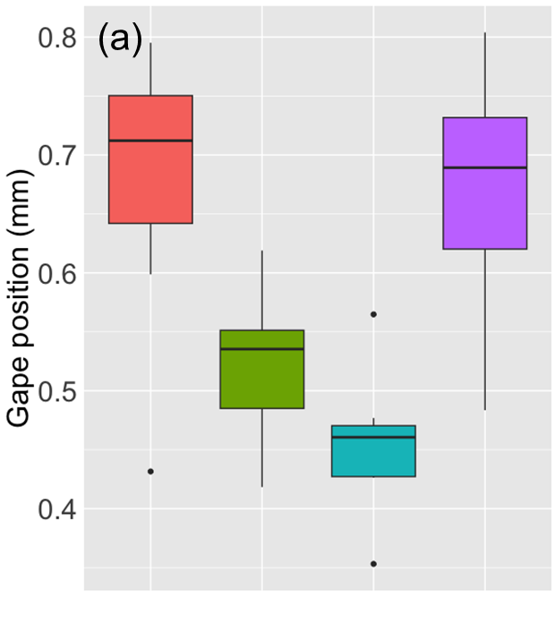 | 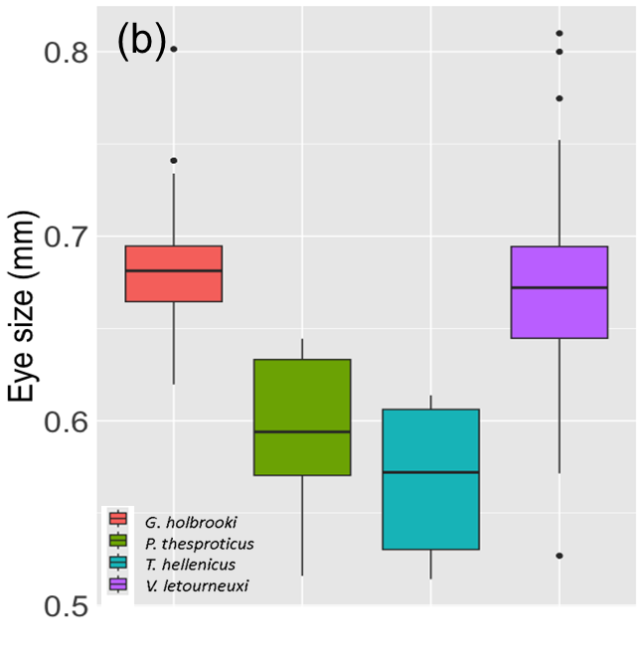
Fig.S1 Boxplots representing the variation in gape position (a) and eye size (b) among the four species (killifish data pooled).

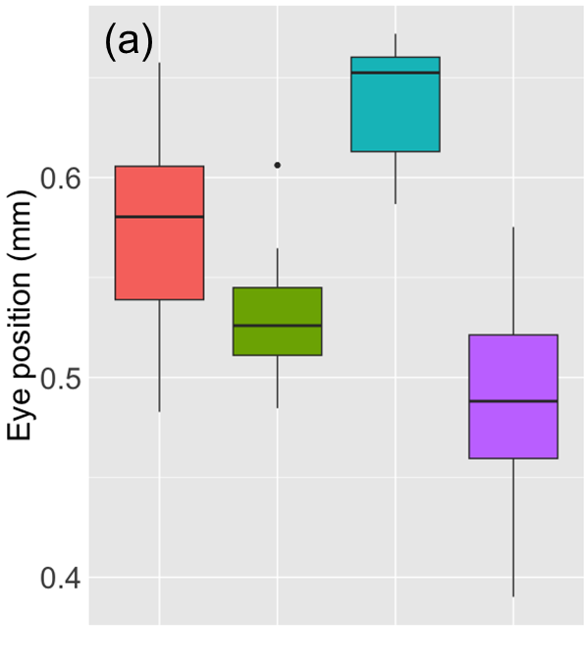 |  |  | 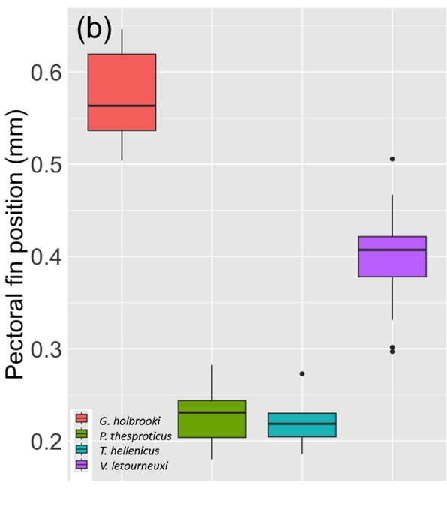
Fig. S2 Boxplots representing the variation in eye position (a) and in pectoral fin position (b) among the four species (killifish data pooled).
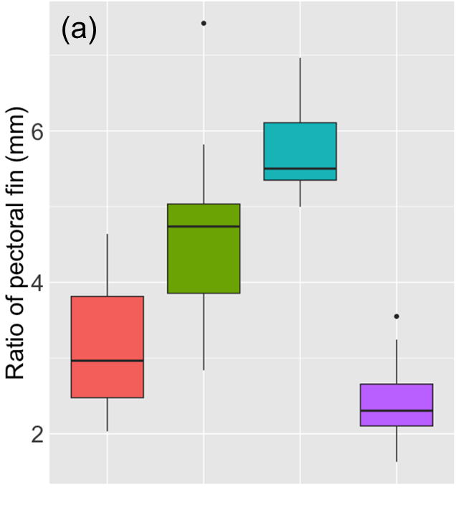 |  | 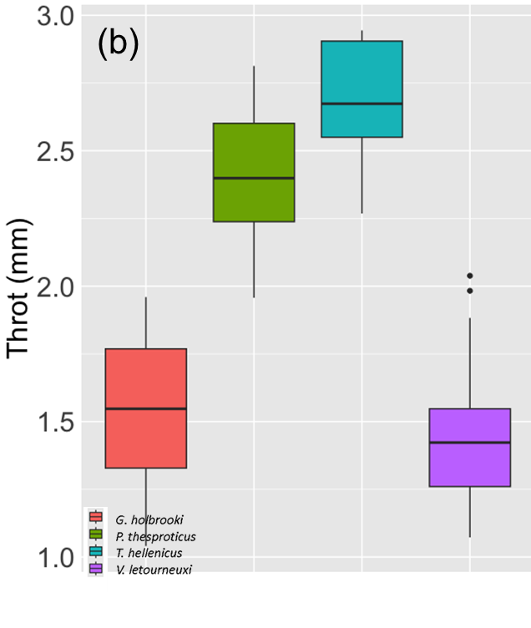
Fig. S3 Boxplots representing the variation in ratio fin pectoral (a) and in throt (b) among the four species (killifish data pooled).
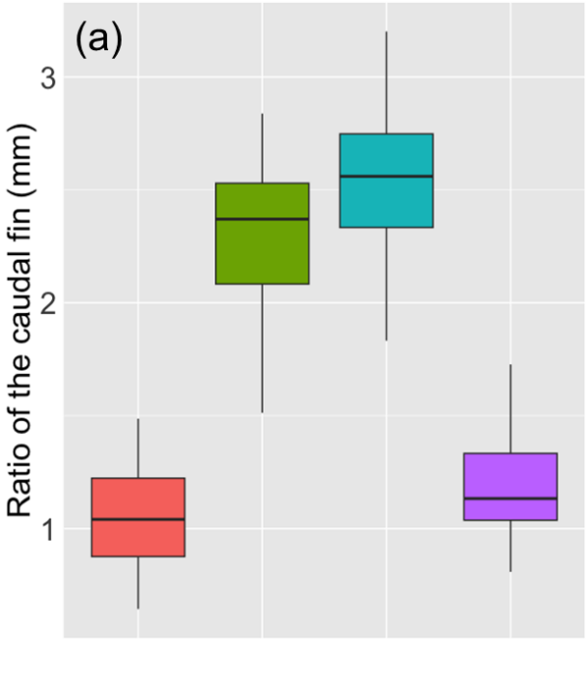 | 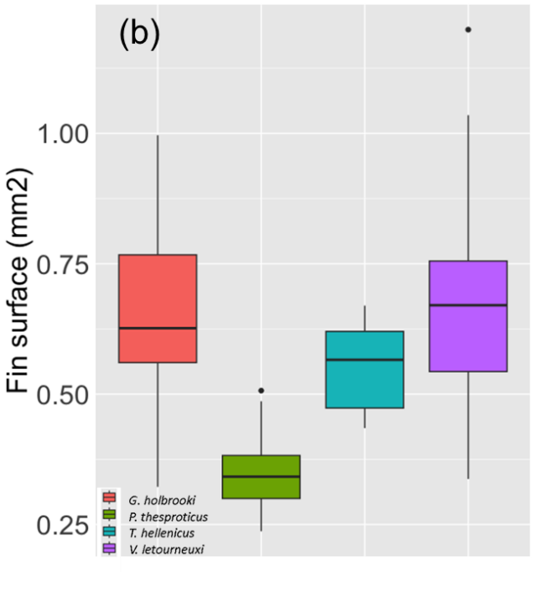
Fig. S4 Boxplots representing the variation in ratio fin caudal (a) and in fin surface (b) among the four species (killifish data pooled).

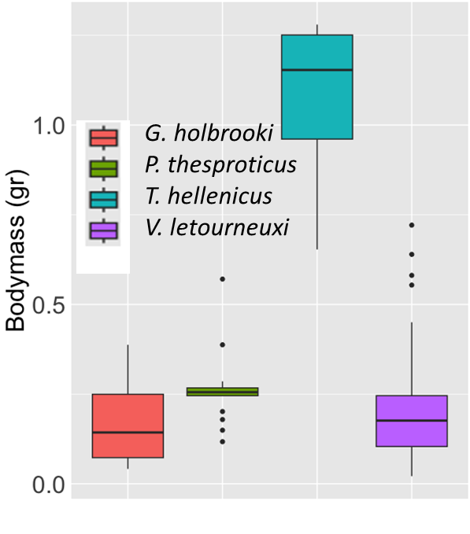
Fig S5 Boxplot representing the variation in in body mass (among the four species (killifish data pooled).

