Supplementary Material
Climate drivers of thermal dynamics and ecosystem changes in Lake Terra Alta: a moderate deep tropical lake
Barroso, G.F. ^{1*}; Guerner, L. ²; Carvalho, R.S. ²; Garcia F.C.²
Aquatic Sciences
Gilberto Fonseca Barroso, e-mail: gilberto.barroso@ufes.br, corresponding author
Letícia Guerner, e-mail: leticiaguarnier.geo@gmail.com
Roger Carvalho da Silva, e-mail: roger.c.silva@ufes.br
Fábio da Cunha Garcia, e-mail: garciafc2007@gmail.com
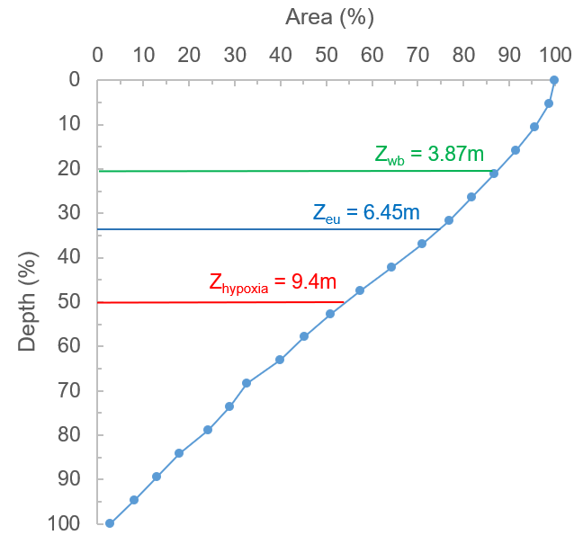
Supplementary Figure 1: LTA percentage area curve with wave base (Z_{wb}), euphotic (Z_{eu}), and hypoxia depths (Z_{hypoxia}).

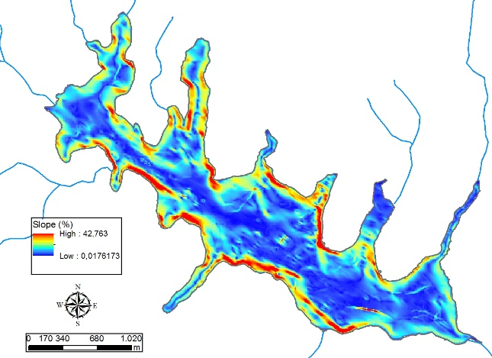  a) | 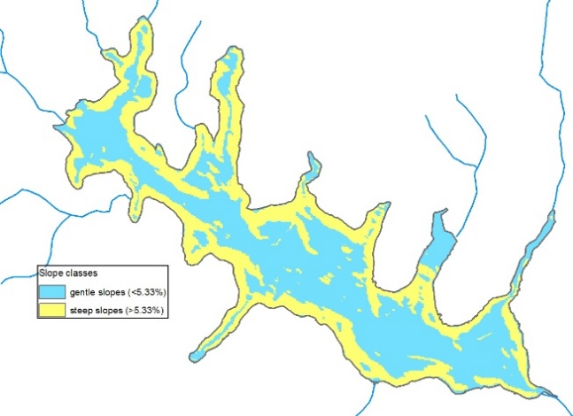  b)
Supplementary Figure 2: Lake bottom slope (%): a) Slope gradient in percentage; b) Reclassified slopes: gentle (<5.33%) and steep (>5.33%) slopes.

Supplementary Table 1: Spearman correlations (p < 0.05) of climate and thermal variables. Correlations ≥ 0.5 are bolded, and those >0.8 are highlighted.

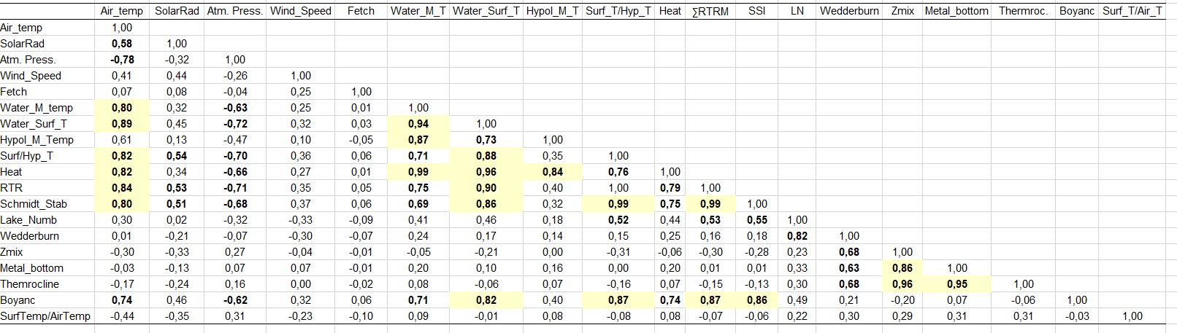
Air_temp: air temperature (°C); SolarRad: solar radiation (W.m⁻²); Atm. Press: atmospheric pressure (hPA); Wind_Speed: wind speed (m.s); Fetch (km); Water_M_Temp: water column mean temperature (°C); Water_Surf_T: water surface temperature (°C); Hypol_M_Temp: hypolimnion mean temperature (°C); Surf_T/Hyp_T: surface and hypolimnion temperature ratio; Heat (x10⁶ J.m⁻²); ∑RTRM: sum of Relative Thermal Resistance to Mixing; SSI: Schmidt Stability Index (J.m⁻²); LN: lake number (dimensionless); Wedderburn: Wedderburn number (dimensionless); Zmix: mixing depth (m); Metal_bottom: metalimnion bottom depth (m); Thermoc.: thermocline depth (m); Buoy: buoyancy frequency (s⁻²); Surf_T/Ait_T: surface and air temperature ratio.

Supplementary Table 2: LTA morphometric data corrected for lake level at the meteorological station site (17.21 m for the bathymetric model, 15.59 m for the mean water level, 12.89 for the shallower level, and 18.43m for the deeper level).
 | Area  (km²) | Volume  (x10⁷m³) | Z_{max}  (m) | Z_{mean}  (m) | Z_{rel}  (%) | V_{d} | D_{R} | Z_{wb}  (m)
Bathymetric model | 3.91 | 3.90 | 24.22 | 9.99 | 1.08 | 1.24 | 0.20 | 3.87
Mean water level | 3,64 | 3,30 | 22,60 | 9,07 | 1,05 | 1,20 | 0,21 | 3,74
Lower water level | 3,19 | 2,37 | 19,90 | 7,42 | 0,99 | 1,12 | 0,24 | 3,52
Higher water level | 4,36 | 4,36 | 25,40 | 11,58 | 1,16 | 1,37 | 0,17 | 3,80
Z_{max}: maximum depth; Z_{mean}: mean depth; Z_{rel}: relative depth; V_{d}: volume development; DR: dynamic ratio; Z_{wb}: depth of wave base.

Supplementary Table 3: Spearman correlations (p < 0.05) of dissolved oxygen, phytoplankton indicators, and selected climate and thermal variables during the mixing and stratification seasons. Correlations ≥ 0.5 are bolded, and those >0.8 are highlighted.
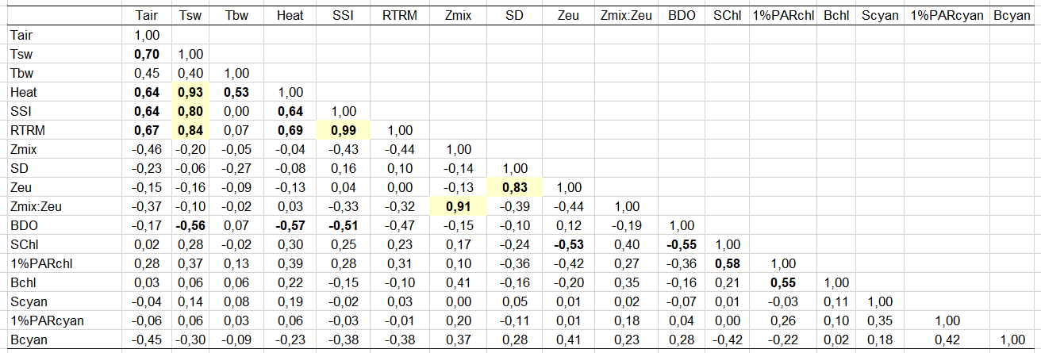
Air temperature (T_{air)}), surface water temperature (T_{sw}), bottom water temperature (T_{bw}), ∑RTRM (sum of relative thermal resistance to mixing), Z_{mix} (mixing depth), bottom dissolved oxygen (BDO), surface chlorophyll (Schl), chlorophyll-a at 1% PAR (1%PARchl), chlorophyll-a at bottom water (Bchl), surface cyanobacteria (Scyan), cyanobacteria at 1% PAR (1%PARcyan), and bottom cyanobacteria (Bcyan)..

Supplementary Table 4: Spearman correlations (p < 0.05) of climate and thermal variables during heat wave events (day 3). Correlations ≥ 0.5 are bolded, and those >0.8 are highlighted.
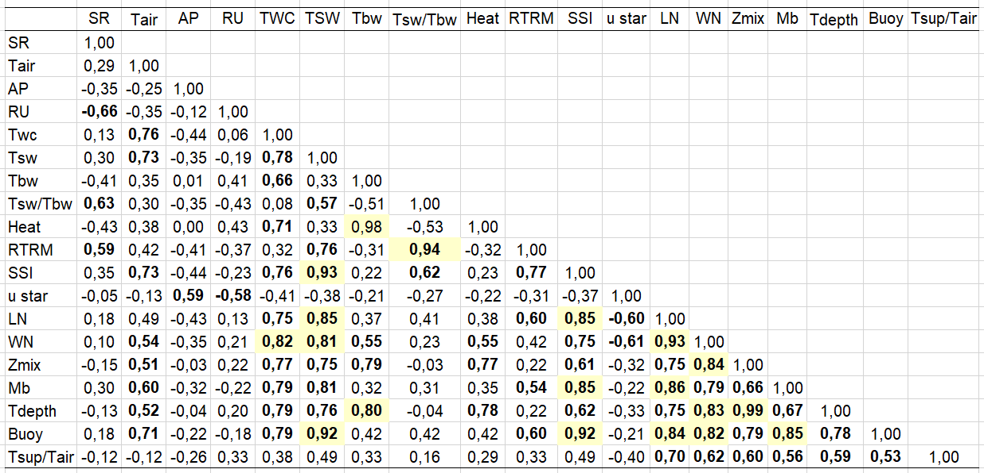
Solar radiation (SR); Air temperature (Tair); Atmosphere pressure (AP); water column temperature (T_{wc}), surface water temperature (T_{sw}), bottom water temperature (T_{bw}), ∑RTRM (sum of relative thermal resistance to mixing), lake number (LN), Wedderburn number (WN); mixing depth (Z_{mix}), metalimnion bottom depth (Mb), thermocline depth (Tdepth), Buoyancy frequency (Buoy); temperature difference between water surface and air (Tsup/Tair).

Supplementary Table 5: Morphometry data of LDRV deep lakes.
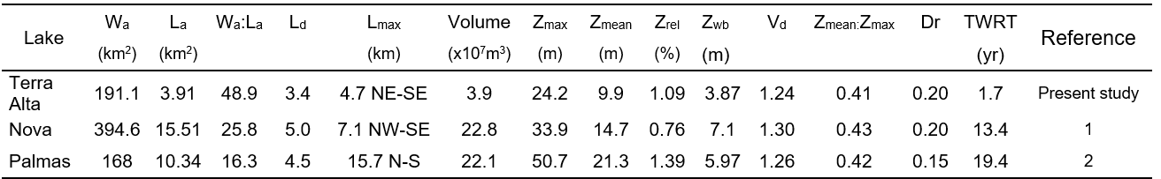
W_{a}: watershed area; L_{a}: lake surface area; L_{d}: Shoreline development index; L_{max}: maximum length; Z_{max}: maximum depth; Z_{mean}: mean depth; Z_{wb}: wave base depth; V_{d}: volume development; Dr: dynamic ratio; TWRT: theoretical water retention time. 1: Gonçalves et al. (2016); 2: Barroso et al., (2014).

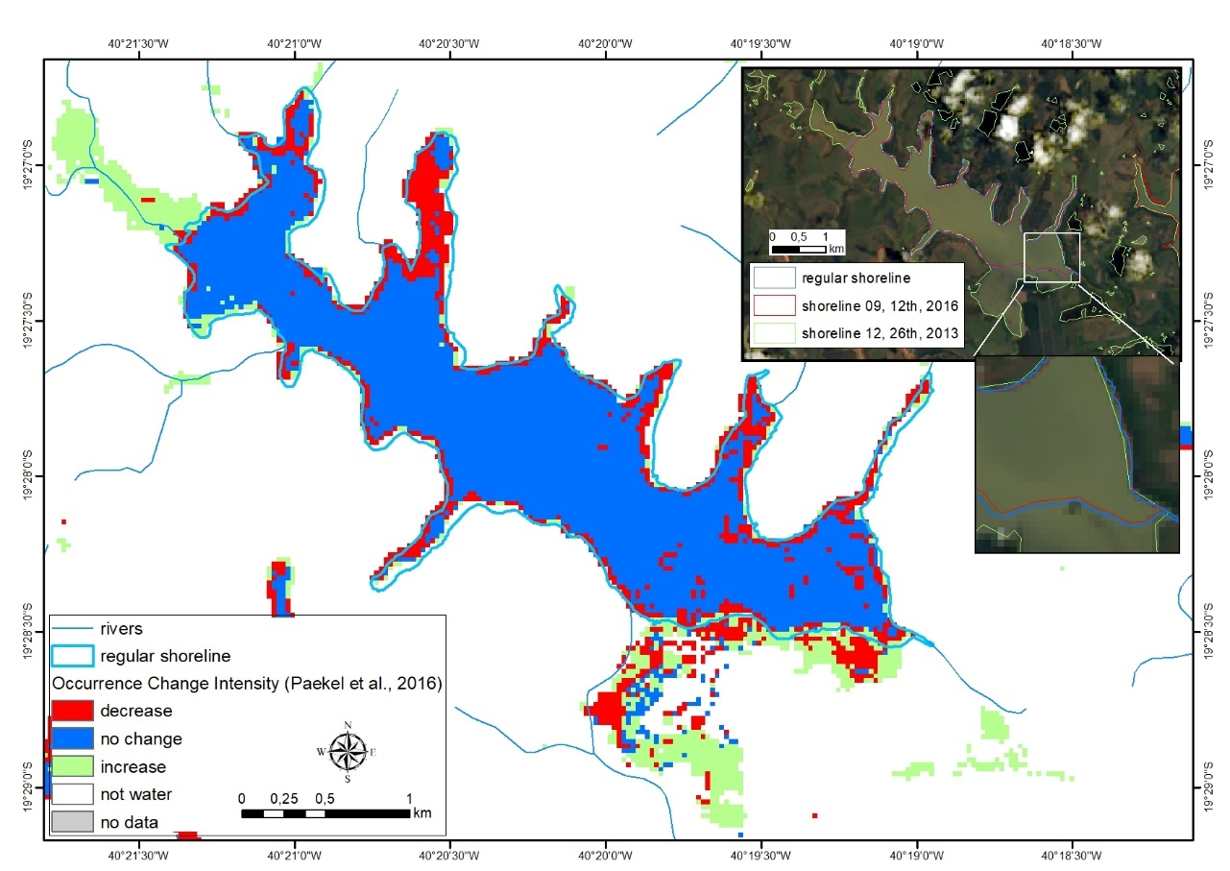
Supplementary Figure 3: Lake surface changes according to the Global Surface Water Database (1984 to 2021, Pekel et al., 2016). The inset shows shoreline changes: the regular shoreline, the shoreline at the end of the 2016 dry season (composition of CBERS 4 PAN bands 432, 10 m spatial resolution, acquired on 09, 12th, 2016), and the shoreline at the flood of December 2013 (composition of Landsat 8 OLI bands 752, 30 m spatial acquired on 12, 26th, 2013).

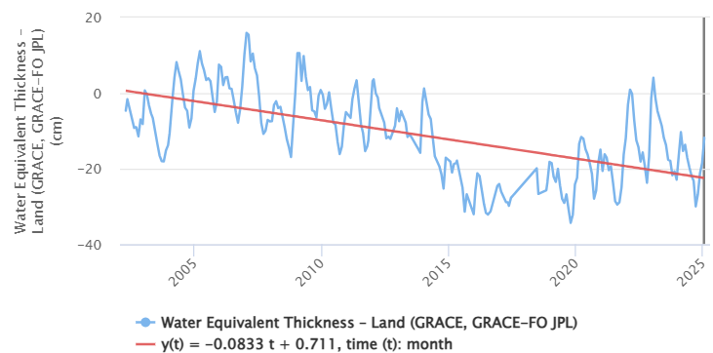
Supplementary Figure 4: Terrestrial water storage as water equivalent thickness in LTA region (GRACE analysis tool available at https://grace.jpl.nasa.gov/data/data-analysis-tool/ Landerer and Cooley, 2021).

