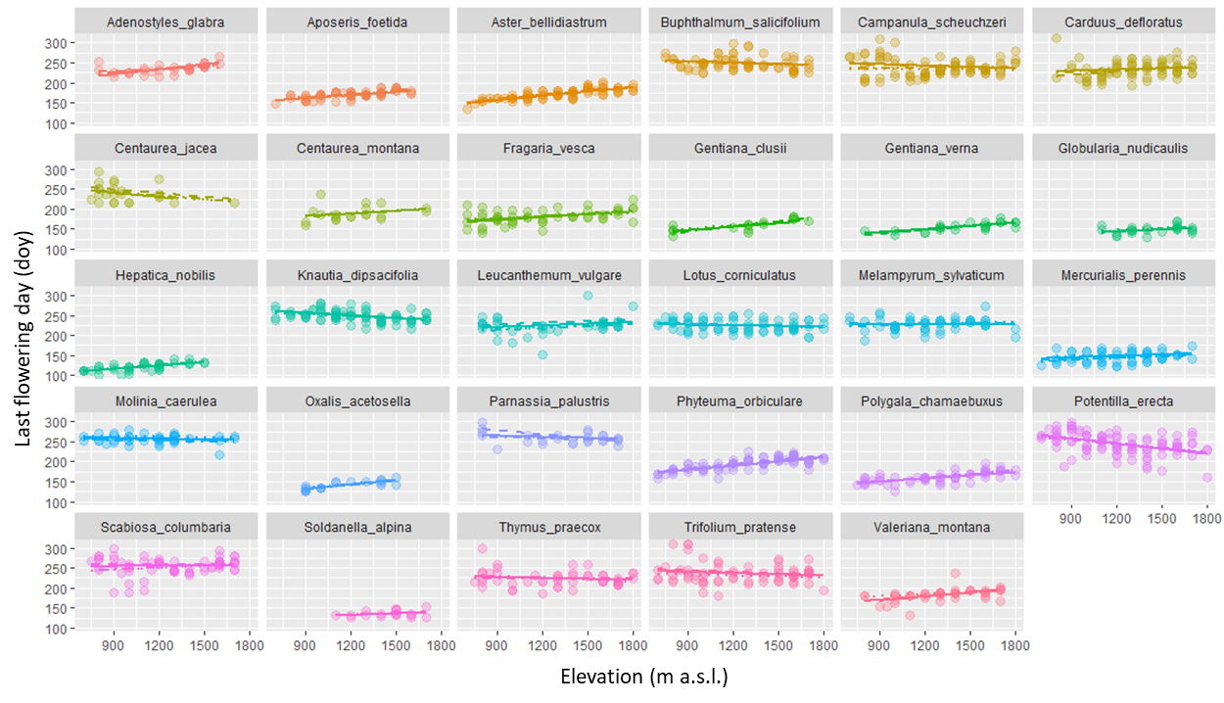Fig. S3 Changes in last flowering day (LFD) along the elevational gradient as dependent on species. Colours represent species. Solid lines indicate the slope on Kramer in 2012, dashed lines indicate the slope on Kramer in 2013, dotted lines indicate the slope on Kreuzeck in 2012 and dotdahed lines indicate the slope on Kreuzeck in 2013.

