Supplementary figure material

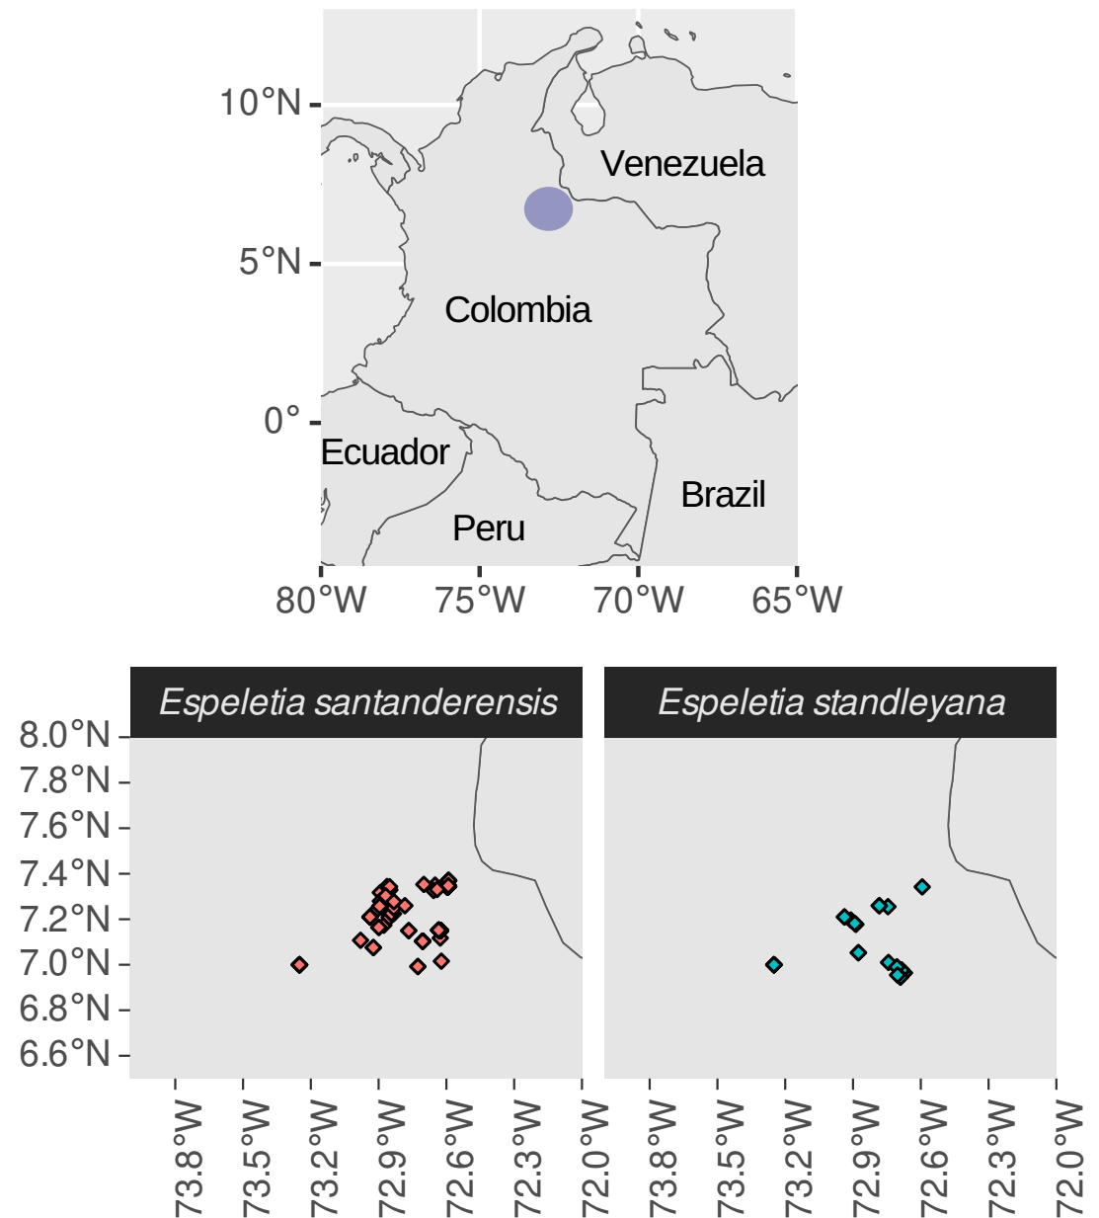
Figure S1: Distribution area of ​​Espeletia standleyana and Espeletia santanderensis populations according to the Global Biodiversity Information Facility (GBIF). This larger area which includes many smaller paramos, including Paramo de Garcia, is known as Paramo de Santurban.

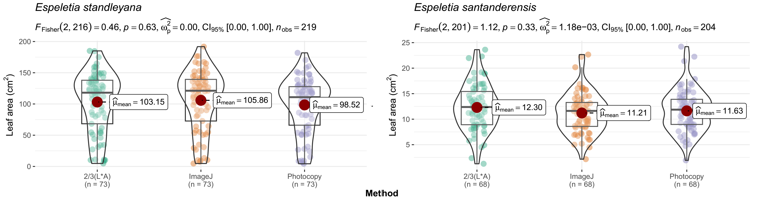
Figure S2: Leaf area methods comparisons

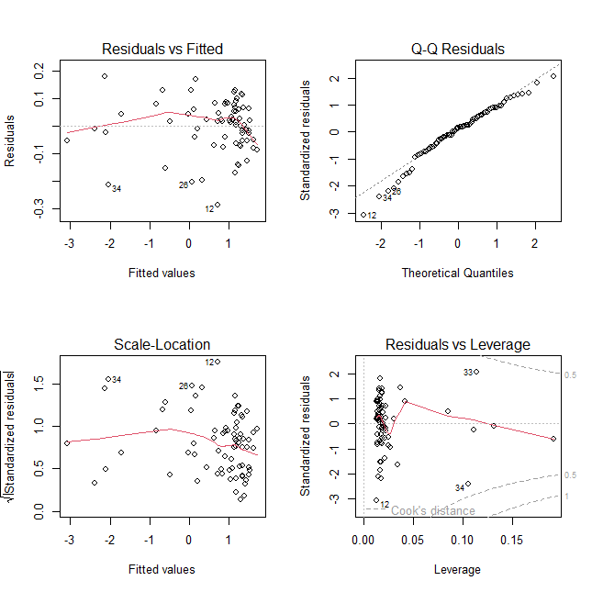
Figure S3: Graphical representation of the validations leaf dry weight vs leaf area model for E. standleyana

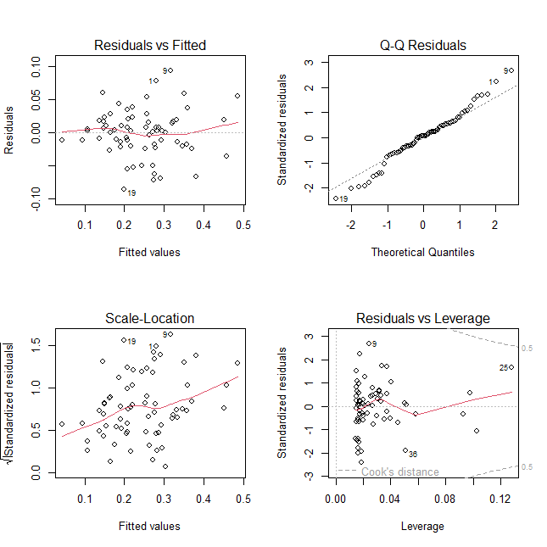
Figure S4: Graphical representation of the validations leaf dry weight vs leaf area model for E. santanderensis

