Variation in the effectiveness of nonnative plant removal along elevation gradients in Switzerland
Authors: Georg V. Flückiger¹, Sascha Gregori², Jake M. Alexander¹
Corresponding Author: J.M. Alexander, jake.alexander@usys.ethz.ch
Affiliations:
- Institute of Integrative Biology, ETH Zurich, 8092 Zurich, Switzerland
- Department of Nature and Environment of the Canton Grisons, ANU, 7000 Chur, Switzerland.
Journal name: Alpine Botany

Supplementary Material
Table S1 | Analysis of deviance tables of the full GLMM models used to analyze the effectiveness of mechanical removal on the cover of our three focal nonnative species. The degrees of freedom (d.f.) for each predictor were always equal to one (d.f.=1), except for the polynomial and its interaction terms in the Lupinus model, where in each case d.f.=2. Site ID and Plot ID were included as random effects (not shown). Significant relationships with a significance threshold of α=0.05 are indicated in bold.
Erigeron annuus
 | Chi-square | P
Year | 91.6 | < 0.001 | ***
Removal Treatment | 0.3 | 0.594
Elevation | 8.3 | 0.004 | **
Background management | 0.5 | 0.491
Year x Removal Treatment | 7.2 | 0.007 | **
Year x Elevation | 21.9 | 0.003 | ***
Removal Treatment x Elevation | 0.0 | 0.868
Year x Removal Treatment x Elevation | 0.5 | 0.498
Solidago canadensis
Variable | Chi-square | P
Year | 23.0 | < 0.001 | ***
Removal Treatment | 7.9 | 0.005 | **
Elevation | 0.0 | 0.940
Background management | 0.0 | 0.865
Year x Removal Treatment | 32.2 | < 0.001 | ***
Year x Elevation | 1.1 | 0.304
Removal Treatment x Elevation | 0.5 | 0.466
Year x Removal Treatment x Elevation | 0.5 | 0.490
Lupinus polyphyllus
Variable | Chi-square | P
Year | 55.2 | < 0.001 | ***
Removal Treatment | 17.5 | 0.030 | ***
poly(Elevation, 2) | 2.6 | 0.268
Background management | 8.4 | 0.004 | **
Year x Removal Treatment | 79.4 | < 0.001 | ***
Year x poly(Elevation, 2) | 11.5 | 0.003 | **
Removal Treatment x poly(Elevation, 2) | 1.7 | 0.429
Year x Removal Treatment x poly(Elevation, 2) | 1.3 | 0.513

Table S2 | Analysis of deviance tables of GLMM models used to relate the observed changes in cover with the mechanical removal treatment and the elevation of managed sites. The first four model outputs represent summary statistics for Erigeron sites, the middle ones for Solidago sites and the last four show those of Lupinus sites. The degrees of freedom (d.f.) for each predictor were always equal to one (d.f.=1), except for polynomial and its interaction terms, where in each case d.f.=2. Significant relationships of predictors with the response variable (indicated above summary tables) are shown in bold. The significance threshold used is α = 0.05.
Erigeron annuus
Response variable: Forbs cover
Variable | Chi-square | P
Year | 1.172 | 0.279
Treatment | 0.519 | 0.471
Elevation | 3.154 | 0.076 | .
Year:Treatment | 0.471 | 0.492
Year:Elevation | 0.358 | 0.549
Treatment:Elevation | 0.094 | 0.759
Year:Treatment:Elevation | 0.012 | 0.912
Response variable: Graminoids cover
Variable | Chi-square | P
Year | 4.326 | 0.038 | *
Treatment | 0.726 | 0.394
Elevation | 7.848 | 0.005 | **
Year:Treatment | 0.932 | 0.334
Year:Elevation | 3.981 | 0.046 | *
Treatment:Elevation | 0.164 | 0.685
Year:Treatment:Elevation | 0.007 | 0.935
Response variable: Legumes cover
Variable | Chi-square | P
Year | 3.571 | 0.059 | .
Treatment | 1.305 | 0.253
Elevation | 0.205 | 0.651
Year:Treatment | 0.041 | 0.839
Year:Elevation | 6.760 | 0.009 | **
Treatment:Elevation | 0.104 | 0.748
Year:Treatment:Elevation | 0.253 | 0.615
Response variable: Bare ground cover
Variable | Chi-square | P
Year | 8.258 | 0.004 | **
Treatment | 0.002 | 0.961
Elevation | 0.925 | 0.336
Year:Treatment | 0.222 | 0.638
Year:Elevation | 5.938 | 0.015 | *
Treatment:Elevation | 0.169 | 0.681
Year:Treatment:Elevation | 0.002 | 0.962
Solidago canadensis
Response variable: Forbs cover
Variable | Chi-square |  | P
Year |  | 1.029 | 0.310
Treatment |  | 0.020 | 0.886
poly(Elevation, 2) |  | 3.169 | 0.205
Year:Treatment |  | 0.061 | 0.805
Year:poly(Elevation, 2) |  | 9.955 | 0.007 | **
Treatment:poly(Elevation, 2) |  | 2.894 | 0.235
Year:Treatment:poly(Elevation, 2) |  | 3.633 | 0.163
Response variable: Graminoids cover
Variable | Chi-square |  | P
Year |  | 7.573 | 0.006 | **
Treatment |  | 1.965 | 0.161
poly(Elevation, 2) |  | 14.071 | < 0.001 | ***
Year:Treatment |  | 0.067 | 0.796
Year:poly(Elevation, 2) |  | 16.200 | < 0.001 | ***
Treatment:poly(Elevation, 2) |  | 1.121 | 0.571
Year:Treatment:poly(Elevation, 2) |  | 1.531 | 0.465
Response variable: Legumes cover
Variable | Chi-square |  | P
Year |  | 0.036 | 0.850
Treatment |  | 0.900 | 0.343
Elevation |  | 3.217 | 0.073 | .
Year:Treatment |  | 1.396 | 0.237
Year:Elevation |  | 2.482 | 0.115
Treatment:Elevation |  | 0.531 | 0.466
Year:Treatment:Elevation |  | 1.357 | 0.244
Response variable: Bare ground cover
Variable | Chi-square |  | P
Year |  | 6.372 | 0.012 | *
Treatment |  | 0.418 | 0.518
Elevation |  | 4.403 | 0.036 | *
Year:Treatment |  | 9.360 | 0.002 | **
Year:Elevation |  | 0.562 | 0.453
Treatment:Elevation |  | 5.938 | 0.015 | *
Year:Treatment:Elevation |  | 0.483 | 0.487

Lupinus polyphyllus
Response variable: Forbs cover
Variable | Chi-square |  | P
Year |  | 2.080 | 0.149
Treatment |  | 3.603 | 0.058 | .
poly(Elevation, 2) |  | 2.777 | 0.249
Year:Treatment |  | 3.289 | 0.070 | .
Year:poly(Elevation, 2) |  | 17.115 | < 0.001 | ***
Treatment:poly(Elevation, 2) |  | 2.009 | 0.366
Year:Treatment:poly(Elevation, 2) |  | 0.453 | 0.797
Response variable: Graminoids cover
Variable | Chi-square |  | P
Year |  | 3.083 | 0.079 | .
Treatment |  | 0.945 | 0.331
Elevation |  | 0.610 | 0.435
Year:Treatment |  | 3.954 | 0.047 | *
Year:Elevation |  | 0.452 | 0.501
Treatment:Elevation |  | 0.340 | 0.560
Year:Treatment:Elevation |  | 1.126 | 0.289
Response variable: Legumes cover
Variable | Chi-square |  | P
Year |  | 15.114 | < 0.001 | ***
Treatment |  | 1.974 | 0.160
Elevation |  | 5.411 | 0.020 | *
Year:Treatment |  | 0.312 | 0.577
Year:Elevation |  | 13.854 | < 0.001 | ***
Treatment:Elevation |  | 0.739 | 0.390
Year:Treatment:Elevation |  | 0.016 | 0.898
Response variable: Bare ground cover
Variable | Chi-square |  | P
Year |  | 25.473 | < 0.001 | ***
Treatment |  | 19.842 | 0.008 | **
Elevation |  | 2.496 | 0.114
Year:Treatment |  | 32.208 | < 0.001 | ***
Year:Elevation |  | 2.830 | 0.093 | .
Treatment:Elevation |  | 1.398 | 0.237
Year:Treatment:Elevation |  | 1.074 | 0.300

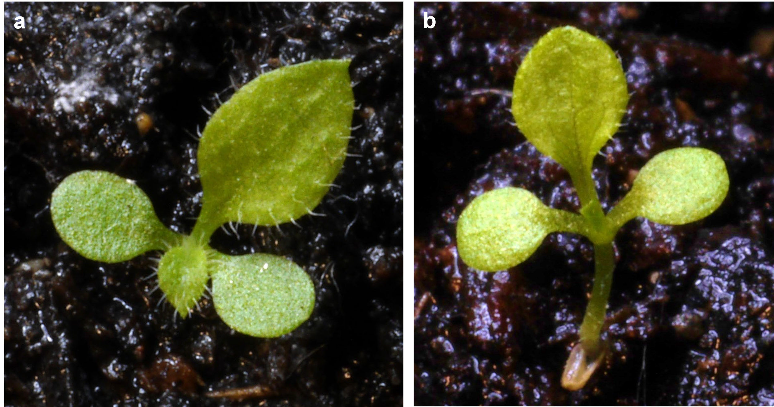
Fig. S1 | Pictures (© Georg Flückiger) depict the growth habit of seedlings of Erigeron (a) and Solidago (b). Seedlings of Erigeron have ovate-round cotyledons, short stalks and leaves covered with simple white hairs (Hanf, 1970), while those of Solidago have club-shaped cotyledons and spatulate-round leaves with toothed margins (Muller, 1978).

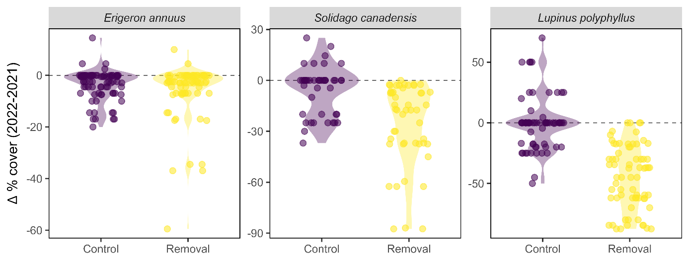
Fig. S2 | Change in percentage cover (Δ-% cover) for Erigeron (a), Solidago (b) and Lupinus (c) in removal and control plots. Each point represents the change observed in an individual plot over the two-year period (2021-2022), with distributions visualised by violin shapes. Colours indicate treatment type (purple = Control, yellow = Removal). Positive values denote an increase in cover from 2021 to 2022, negative values a decrease. Violin widths reflect the relative density of values, and points are jittered horizontally to reduce overlap.

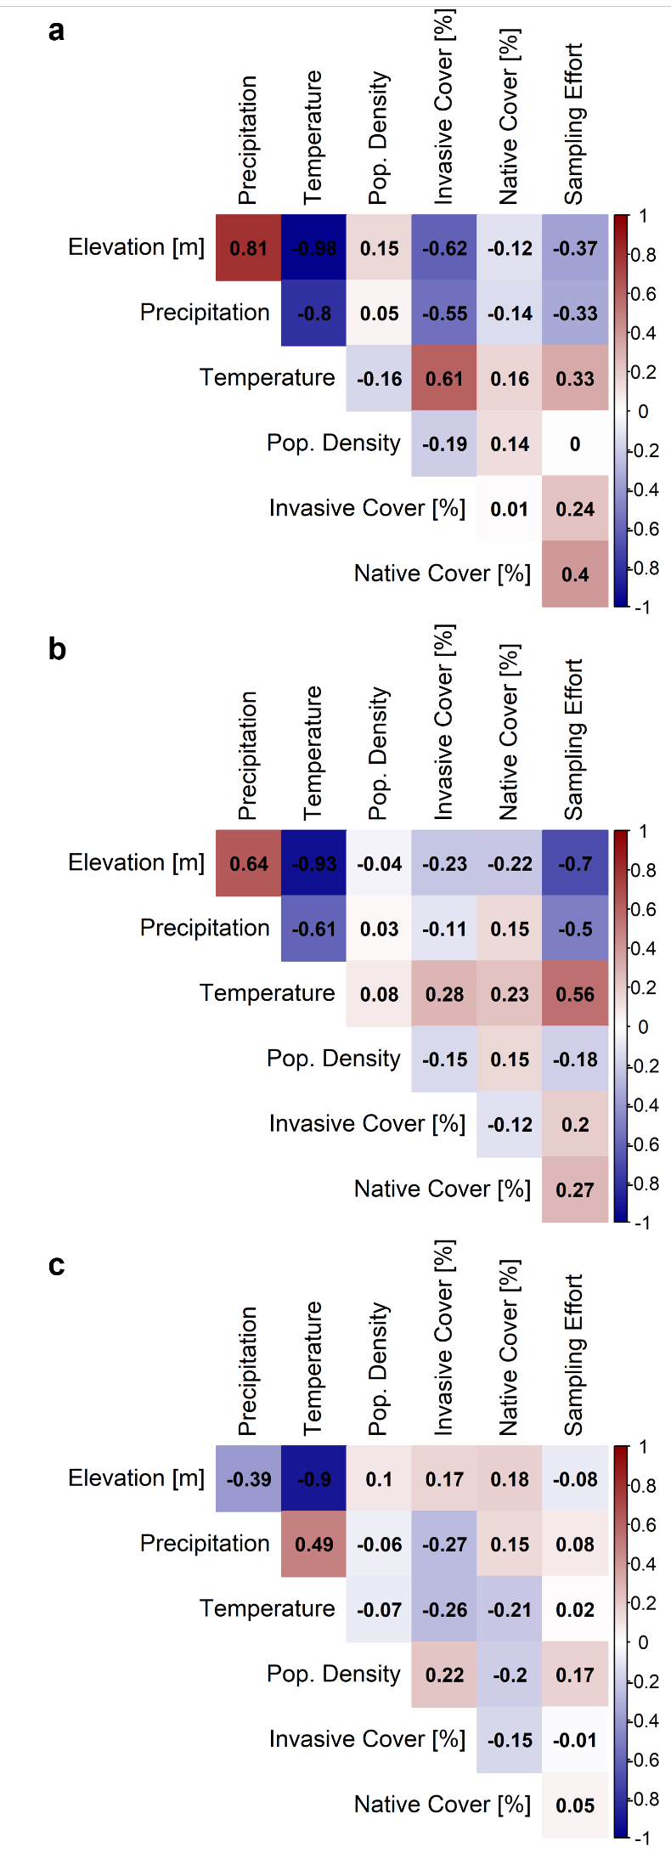
Fig. S3 | Pearson correlation matrices for Erigeron (a), Solidago (b) and Lupinus (c) study sites. Site-level correlations are shown between elevation (m a.s.l.), annual mean temperature (Bio1), annual precipitation (Bio12), human population density, mean invasive cover, mean native vegetation cover, and sampling effort (number of plots per site). All environmental variables and human population density were extracted at 25 × 25 m resolution from the SWECO25 database (Külling et al., 2024). Shading indicates strength and direction of the correlations.

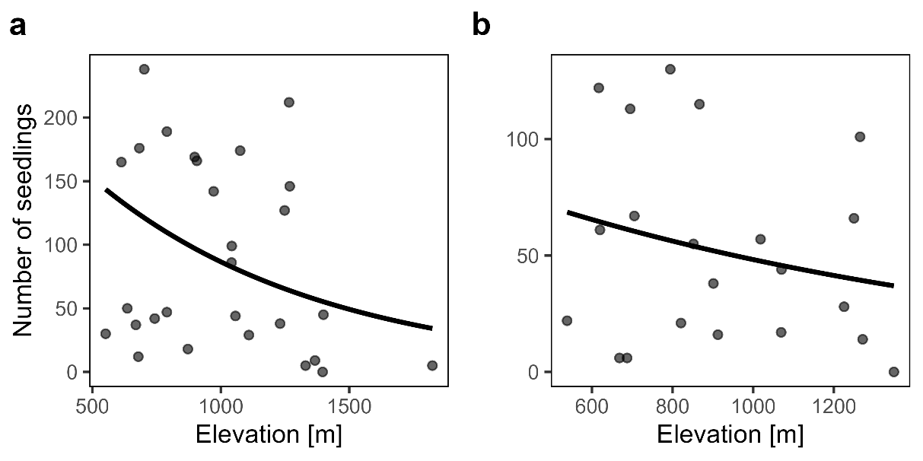
Fig. S4 | Scatterplots depicting the relationship between elevation and the total number of seedlings (i.e. of focal and non-focal species) emerging from soil samples taken from sites of Erigeron (a) and Solidago (b). The regression lines were fitted using Negative Binomial Regression Models (NBRMs) based on simulated elevation data while holding all other predictors constant at their mean values. Both relationships shown are non-significant, although samples of Erigeron sites showed a trend towards reduced total emergence at higher elevation (P = 0.06).

References
Külling, N., Adde, A., Fopp, F., Schweiger, A. K., Broennimann, O., Rey, P. L., ... & Guisan, A. (2024). SWECO25: a cross-thematic raster database for ecological research in Switzerland. Scientific Data, 11(1), 21. https://doi.org/10.1038/s41597-023-02899-1

