SUPPLEMENTARY TABLE AND FIGURES
Supplementary Table I Queen collection sites
Site name | Grid reference | Collection dates
Mount Caburn | TQ4443908915 | 28th, 30th, 31st March 2017  5th, 6th April 2017
Ditchling Common | TQ334192 | 25th, 27th 29th March 2017  1st, 4th April 2017

Supplementary Figure 1
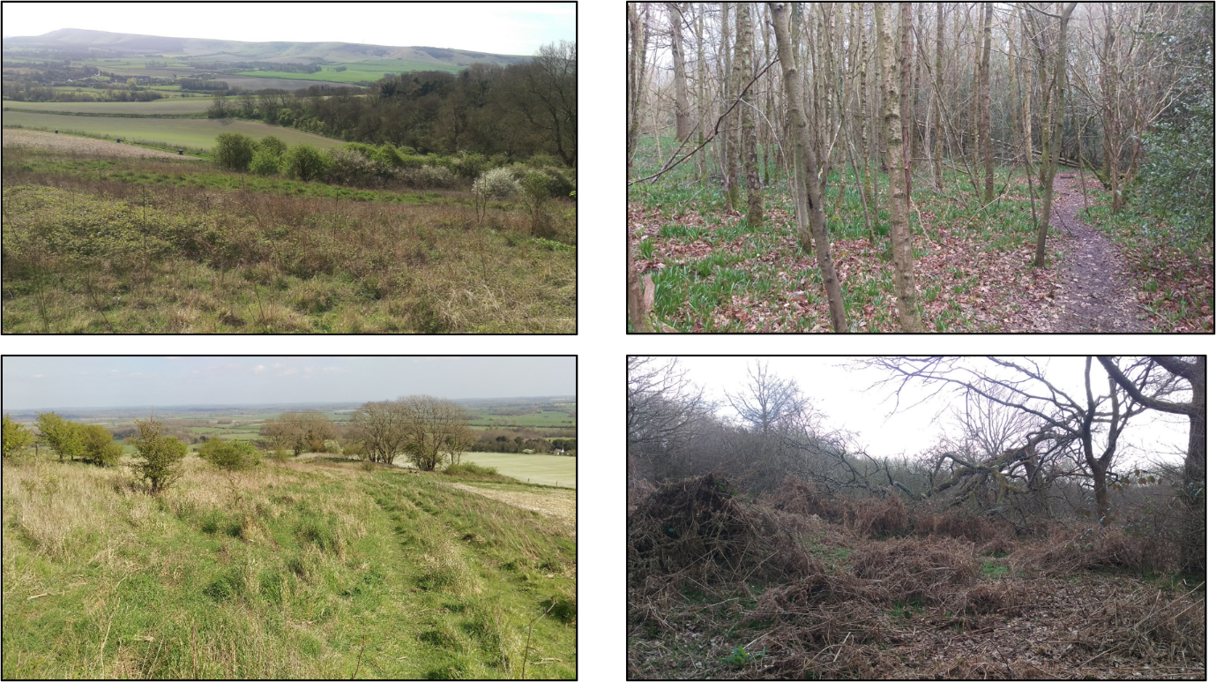
Field sites (left) Mount Caburn and (right) Ditchling Common (East Sussex) used to collect B. pascuorum and B. hortorum queens. Queens that were not carrying pollen (and so were still nest searching) were hand netted and stored in cooled and aerated 120 ml round collection pots for transport back to the laboratory. B. pascuorum queens were more common (62 caught) than B. hortorum queens (20 caught). Sites were each visited five times between 25th March-4th April 2017.

