Title: Bee-Ing Positive About Wasp-Negative Media Reporting: The Opinions of Scientists and their Influence on The Media
- Cintia Akemi Oi^{1*}, Robert L. Brown², Seirian Sumner¹
¹ Centre for Biodiversity & Environment Research, Department of Genetics, Evolution & Environment, University College London, London, U.K
² Manaaki Whenua-Landcare Research, P.O. Box 69040, Lincoln 7640, New Zealand
* Correspondence:
Cintia Akemi Oi
cintiaakemioi@gmail.com
ORCID: 0000-0002-3682-8219 (CAO); 0000-0002-2294-5721 (RLB); 0000-0003-0213-2018 (SS)

Supplementary Material

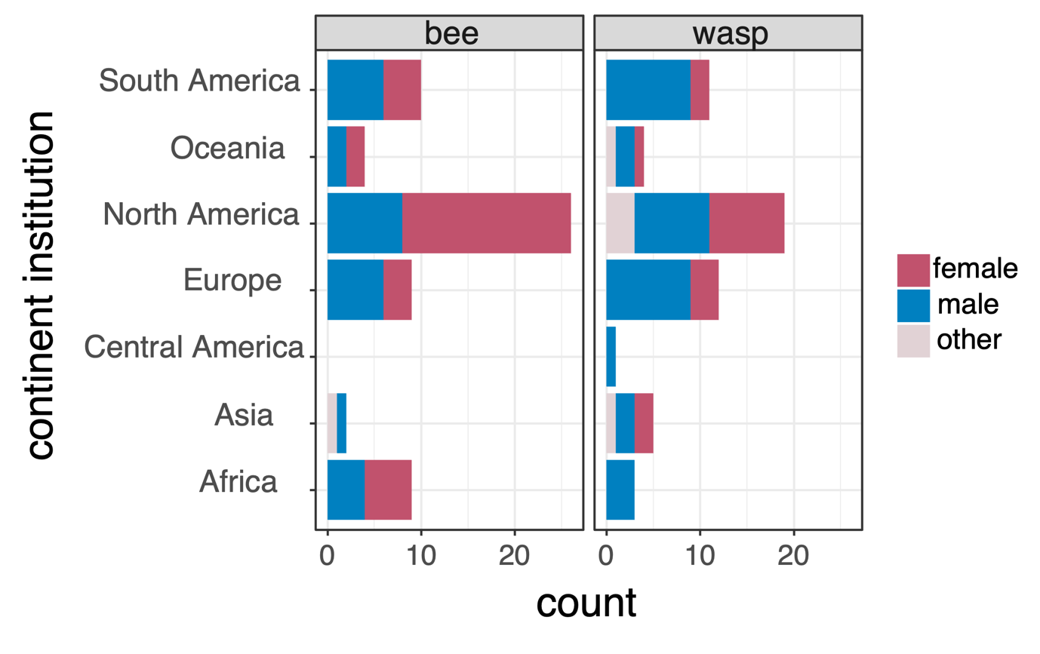
Figure S1: Number of bee and wasp scientists who took part in our survey, their reported gender identity, and the country in which they work. North America and South America dominated our sample.

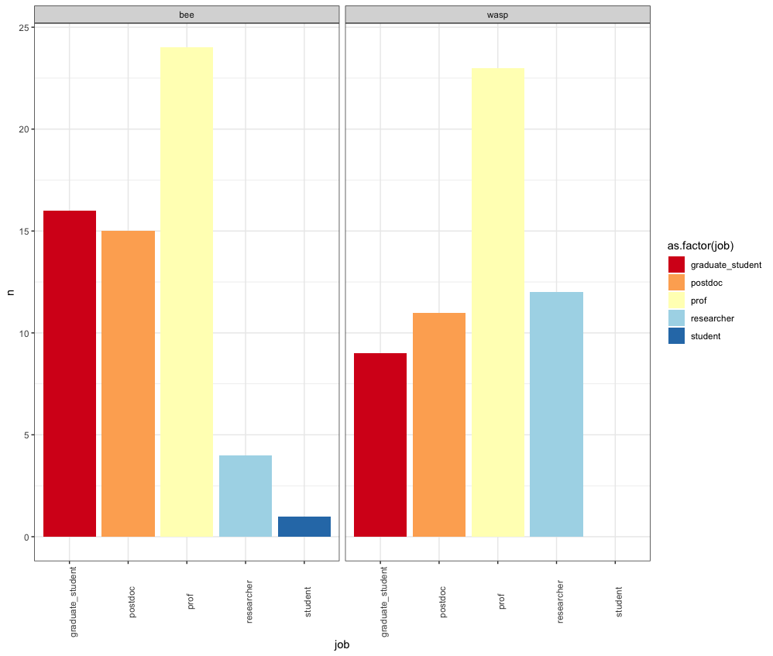
Figure S2: Career stage of respondents.

Table S1: Binomial GLM of the researcher’s survey choice (bee or wasp) and their career stage, gender and country of study. Estimates, Standard Errors (SE), Lower and Upper 95% Confidence Levels (CL), Z value and p-values are shown. (model: glm(formula = survey_type ~ job + gender + continent_institution + time, family = binomial, data = data).
 | survey_type
Predictors | Estimate | std. Error | CI | Z value | p
(Intercept) | -1.416e+00 | 8.168e-01 | 0.04 – 1.09 | -1.73 | 0.083
job [postdoc] | -1.394e-01 | 6.750e-01 | 0.23 – 3.30 | -0.21 | 0.836
job [prof] | 7.556e-03 | 6.769e-01 | 0.27 – 3.86 | 0.01 | 0.991
job [researcher] | 1.075e+00 | 8.550e-01 | 0.57 – 16.93 | 1.26 | 0.209
job [student] | -1.558e+01 | 1.455e+03 | NA | -0.01 | 0.991
gender [male] | 5.419e-01 | 4.626e-01 | 0.69 – 4.30 | 1.17 | 0.241
gender [other] | 1.994e+00 | 1.227e+00 | 0.85 – 162.58 | 1.63 | 0.104
continent institution  [Asia] | 1.573e+00 | 1.144e+00 | 0.55 – 55.67 | 1.37 | 0.169
continent institution  [Central_America] | 1.610e+01 | 1.455e+03 | 0.00 – NA | 0.01 | 0.991
continent institution  [Europe] | 1.136e+00 | 8.465e-01 | 0.63 – 18.67 | 1.34 | 0.180
continent institution  [North_America] | 5.929e-01 | 7.802e-01 | 0.42 – 9.71 | 0.76 | 0.447
continent institution  [Oceania] | 6.492e-01 | 1.039e+00 | 0.25 – 16.02 | 0.63 | 0.532
continent institution  [South_America] | 1.139e+00 | 8.325e-01 | 0.65 – 18.31 | 1.37 | 0.171
time [linear] | 4.287e-01 | 5.504e-01 | 0.52 – 4.61 | 0.78 | 0.436
time [quadratic] | 7.481e-02 | 4.487e-01 | 0.44 – 2.60 | 0.17 | 0.868
time [cubic] | 2.463e-02 | 4.244e-01 | 0.44 – 2.35 | 0.06 | 0.954
Observations | 115
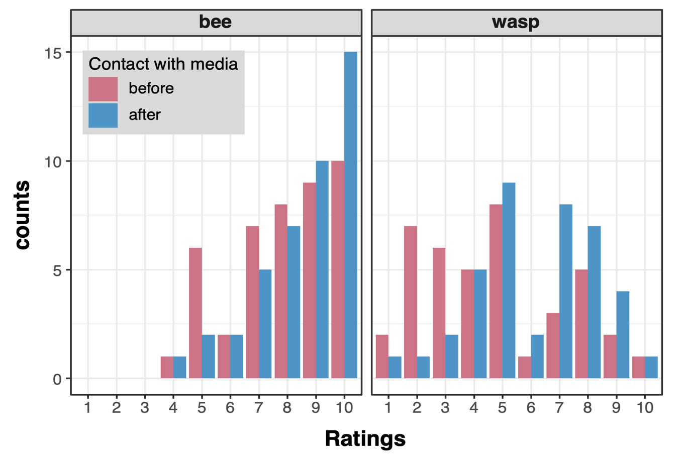
Figure S3: Comparisons of how bee (left panel) and wasp (right panel) scientists rated the angle of the media story on initial interaction with the media (‘before’) and the angle of the final story after the interview with the scientist (‘after’, post-interview). Ratings indicate the angle of the story on a scale of 1 to 10, where a score of 1 indicates a strongly negative angle, 5 and 6 indicate neither positive nor negative (i.e. neutral) and 10 indicates strongly positive.

Table S2: Binomial GLM of the number of searches and the organisms. Estimates, Standard Errors (SE), Lower and Upper 95% Confidence Levels (CL), Z value and p-values are shown.
 | searches
Predictors | Estimate | std. Error | CI | zvalue | p
(Intercept) | 7.93 | 0.12 | 7.70 – 8.16 | 140.79 | <0.001
organism [wasp] | 0.23 | 0.00 | 0.22 – 0.23 | -94.37 | <0.001
media [web] | 2.69 | 0.04 | 2.62 – 2.77 | 71.95 | <0.001
country [USA] | 1.87 | 0.02 | 1.82 – 1.91 | 48.61 | <0.001
Observations | 2080

Table S3: Open comments from the scientists regarding the portray of wasps/bee by the media from question 17 (Full questionary on Supplemental Material). These comments were voluntary, and did not have many responses. From question 15: “Continuing from the previous question, select the topics that you're thinking of when rating the media's portrayal of wasps/bees (above)”. Question 17: “If you have any comments, you'd like to add with respect to any of your answers in this Section, please add them in this free-text box”.
wasps and the media | bees and the media
our narrative tries to focus on hornet species in general, but we cannot avoid the native-exotic discourse when talking to the media. The arrival and expansion of the Asian hornet imo also provides opportunity to communicate about the ecological significance of social wasps and their fascinating behaviours. Also, it is a good case for creating awareness about biological invasions and the ecological and socio-economic impacts they can exert. | As I see it, the media generally portrays bees as a single species. I’ve lost count of how many times I've seen articles talking about the importance of bees and showing invasive Apis melifera photos to illustrate that.
Despite working with the popularization of knowledge about wasps for the lay public, the view of wasps as malefic agents is very strong. | Honey bees are often conflated as "conservation" organisms, instead of managed livestock.
Public perception is human nuisance/danger balanced with ecosystem services ("we hate em but we gotta live with em.") | Depends on the species. Most media is centered around honey bees, with native bee species receiving much less attention. Not even negative attention, no attention - the general public is not even aware that other species exist majority of the time.
Media outlets use photos of incorrect species about 50% of the time | I see positive portrayal of bees, but not as much nuance among kinds of bees (e.g., Apis vs wild bees)
In Europe - I think perception of wasps is trending towards being more positive in recent years (ecosystem services), or highlight non-native wasps (eg Vespa velutina) in a more neutral/informative manner. Tabloid media tends to use wasps as an alarmist filler piece/clickbait, pictures of Vespa mandarinia when discussing V. velutina, Vespula pestering picnic goers, etc. In Southeast Asia - I have not noticed much media about wasps, perception seems quite neutral. | There is more than honey bees to portray
Periodically I get interviewed, and the story becomes less negative, hence the rating of "3" out of 10. | Media portrays the bees losses - here in NZ we have too many bees !
Newspaper articles often describe wasps as a threat to humans | I feel the media portrays them as a vacuum-sealed necessity...that we need bees (mainly honey bees), but we don't need a shift in our perception of bees. The idea seems to be that we need bees as long as they're not in our personal space. I do believe public perception is better than it was 10 years ago and is currently improving though.
Luckily there are little press-concerns towards invasive hornet (Vespa velutina) and leaving wasps and hornets has gron acceptance. Still there are years with press releases towards wasp annoying people. It is getting better accepting insects in Germany. | I'm trying to teach about the ecological effects of non-native bees (Apis and Bombus are both introduced to NZ). It's starting to gain some traction.
 | I think bees (especially honey bees) are portraited as only good, media rarely talks about problems arising from commercial bee breeding for example

Table S4: Summary of survey mailing list, message content, and social media platforms used to request participation of wasp and bee scientists.
Email content | Mail lists | Social media
Dear Hymenoptera *bee & wasp* researchers,  We are conducting a survey about bee & wasp researchers, why you study them and how (in your experience) bees and/or wasps are portrayed by the media. Whether you work with social, solitary, or parasitoid Hymenoptera, your opinions and experiences are valuable and important to us.  Please contribute to our survey. It's anonymous and won't take more than 10 minutes. This survey will be available until 26th November!  Please share this email with other bee & wasp researchers in your network in case we have missed them. The links to the survey forms are below.  Wasp: https://forms.gle/gLdvbzgH49S2kQHM6 Bee: https://forms.gle/cEYrbrAoak3y1j4z7 Thank you in advance for taking part in the survey.  Best regards, |  | Twitter; Facebook
  africaniussi@up.ac.za;
  iussi.secbras@gmail.com;
  africaniussi@up.ac.za;
  iussi.nas@gmail.com;
  polist-serve@googlegroups.com;
  INSECTS@bio.ku.dk;
  worldwidebeeproject@gmail.com;
  vworkshopiussi@gmail.com

1 Survey questionnaire provided through Google Forms. (In brackets and underlined, we included the questions from a-j that are displayed in the Likert plot of Figure 3 at the main text).

Global survey of wasp researchers and perceptions of wasps/bees in the media - closes 26th Nov 2022

Do you study/work with wasps/bees? Are you based at an academic, research or conservation organisation? If so, this survey is for you!

We are conducting a survey about wasp/bee researchers, why you study them and how (in your experience wasps/bees are portrayed by the media. Whether you work with social, solitary, or parasitoid wasps/bees, your opinions and experiences are valuable and important to us. Please contribute to our survey. It's anonymous and won't take more than 10 minutes.
If you do not study/work with wasps/bees, then please do not complete this survey.
If you study bees/wasps, then please ﬁll in this survey instead: URL from other survey.

Thank you and please share among other relevant researchers around the world. The surveys will remain open until 26th November 2022.
* Indicates required question

About you - the wasp/bee researcher
In this Section, we would like to collect some demographic data.
- What is your current role/job description? *
If 'other', specify: _______________

Check all that apply:
Prof/Assistant Prof/Lecturer Postdoctoral assistant/fellow
Predoctoral research assistant/technician Graduate student (Master, PhD etc.) Undergraduate student
Other, please specify, under 'Job description' above

2. Job description
_______________

3. How would you describe your gender?
Check all that apply:
Female Male
Non-binary Gender-ﬂuid Agender Transgender Prefer not to say
Other: _______________

4. What is your ethnicity?
Check all that apply:
Asian Black White
Mixed heritage - Asian & Black Mixed heritage - Black & White
Mixed heritage - other ethnic backgrounds Mixed heritage - Asian & White
Prefer not to say
Other: _______________

5. Which country is your institution based in? *
_______________

6. Where do your wasp study organisms live? List the countries. *
_______________

7. List the wasp genera you work with most. *
_______________

8. How long have you been studying wasps/bees? *
Mark only one:
<5 years
5 - 10 years
11 to 20 years
>20 years

In this Section we'd like to learn about your own perception of wasps/bees and about why you study them
9. Tell us how you feel about wasps/bees. (Question c, Fig 3)
Please rate your feelings on a scale from 1 (strongly dislike) to 10 (strongly like), with 5 indicating neutral (i.e. neither like nor dislike).
Mark only one:
1 2 3 4 5 6 7 8 9 10

10. What is your scientiﬁc motivation/interest in wasps/bees? Choose your main research areas. *
Check all that apply:
Ecology Evolution Conservation Biocontrol Natural History Biodiversity
Molecular Biology
Other: _______________

11. If you chose "other" for the previous question, please use the free-text box below
to specify the scientiﬁc motivation for you in your wasp/bee research.
_______________

12. If you have any comments you'd like to add with respect to any of your answers in this Section, please add them in this free-text box.
_______________

In this Section, we are keen to hear how you think media (i.e. communications that target the general public) portray wasps/bees, and what role you think they have/had in shaping the public's perceptions of wasps/bees. Media types include: websites, newspapers, TV, magazines, books, social media etc.
13. In your opinion, how does the media portray wasps? (Question a, Fig 3)
Please rate your perception of the media's angle on a scale from 1 (strongly negative) to 10 (strongly positive), with 5 indicating neutral (i.e. neither positive nor negative).
Mark only one:
1 2 3 4 5 6 7 8 9 10

14. What kind of media sources are you thinking of in your answer to the last question? (e.g. websites, newspapers, TV, magazines, books, social media etc.)
_______________

15. Continuing from the previous question, select the topics that you're thinking of when rating the media's portrayal of wasps/bees (above).
Check all that apply:
Wasps/Bees as a risk to human health (e.g. stings)
Wasps/bees and their beneﬁts to human health (e.g. medicines, food) Wasps/Bees as non-native species
Wasps/Bees and their ecosystem services (e.g. pest-control, pollination, recycling) Fundamental science topics involving wasps/bees (e.g. evolution, sensory ecology, genomics) Nuisance (e.g. bothering people at BBQs; wasps/bees in people's houses)
Other: _______________

16. If you answered 'Other' to the above question, please use this free-text box to specify.
_______________

17. If you have any comments you'd like to add with respect to any of your answers in this Section, please add them in this free-text box.
_______________

In this Section, we are interested to hear about any interactions (e.g. interviews, consultation, advice, opinions, research (your own or others)) you've had with the media, regarding wasps/bees. Please answer the below questions only if you've interacted with the media in this way. If no interactions, please skip this section.
18. Why did the media contact you?
Mark only one:
About a paper I (co)authored
About a paper I wasn't involved with but I am an expert in the topic
About a seasonal news story to do with wasps/bees (i.e. due to their life cycle) About wasps/bees and human health
About wasps/bees and their role in the environment About wasps/bees as a non-native species
Other: _______________

19. If you answered 'Other' to the above question, please use this free-text box to specify.
_______________

20. What type of media outlet contacted you, for the above question? (e.g.websites, newspapers TV, magazines, books, social media etc.)
_______________

21. Specify the wasp/bee genus/genera in which the media were interested.
_______________

22. We are interested in the nature of the questions that the media initially asked you about wasps/bees. Did these initial inquiries have a positive, negative or neutral angle with respect to wasps/bees? (Question d, Fig 3)
Please rate your perception of the nature of their inquiry on a scale from 1 (strongly negative to 10 (strongly positive), with 5 indicating neutral (i.e. neither positive nor negative).
If you have mixed experiences, then please use the most recent example you can think of.
Mark only one:
1 2 3 4 5 6 7 8 9 10

23. Continuing with the media interaction(s) you are thinking of in the previous question, we are now interested in the nature of the ﬁnal article/news story that was written/broadcast, after your interaction with the media.
To what extent did it present wasps in a positive, negative or neutral light? Please rate your perception of this on a scale from 1 (strongly negative) to 10 (strongly positive), with 5 indicating neutral (i.e. neither positive nor negative). (Question e, Fig 3)
Mark only one:
1 2 3 4 5 6 7 8 9 10

24. To what extent do you think your interaction with the media inﬂuenced the nature of article/broadcast, regarding the portrayal of wasps/bees? (Question f, Fig 3)
Please rate your perception of this on a scale from 1 (my interaction had no impact at all on the story/the media ignored what I had to say) to 10 (my interaction had an enormous impact on the story/my interaction completely changed the angle of the article).
Mark only one:
1 2 3 4 5 6 7 8 9 10

25. If you have any comments you'd like to add with respect to any of your answers in this Section please add them in this free-text box.
_______________

We are interested in your opinions about how the general public perceive wasps/bees in your institution's country and the countries you study wasps/bees in (if different)

26. This question is about the country in which your study institution is based.
If you stopped a random member of the public in the street in your institution's town, and ask them how they feel about wasps/bees, what do you think they would say? (Question b, Fig 3)
Please rate their putative response on a scale from 1 (strongly negative) to 10 (strongly positive), with 5 indicating neutral (i.e. neither positive nor negative).
Mark only one:
1 2 3 4 5 6 7 8 9 10

27. Continuing from the previous question, please conﬁrm the country you are thinking of.
_______________

28. If the country in which you study wasps/bees is the same as that of your home institution, then please skip this question, and go to the next section.
This question is about the country in which you study wasps, if different from your home institution.
If you stopped a random member of the public in the street in a town of the country in which you study wasps/bees, and asked them how they feel about wasps/bees, what do you think they would say? Please rate their response on a scale from 1 (strongly negative) to 10 (strongly positive with 5 indicating neutral (i.e. neither positive nor negative).
Mark only one:
1 2 3 4 5 6 7 8 9 10

29. Continuing from the previous question, please specify the country you are thinking of.
_______________

This section is about conservation attitudes to wasps/bees
We are interested to hear of any wasp/bee conservation work that you know of in any country, your opinion on whether wasp/bee conservation initiatives are required, and any role the media may play in wasp/bee conservation.
30. Thinking about any country, please list/describe any initiatives you know of that seek to promote/conserve wasp/bee populations?
Please specify the types of wasps (if known) and include website url if possible/relevant. Enter ''None" if you don't know of any.
_______________

31. We are interested to hear whether you think more conservation effort is required to conserve/promote wasp/bee populations. (Question g, Fig 3)
When answering this question consider any country and any wasp species/genus.
Please rate your response on a scale from 1 (deﬁnitely not needed) to 10 (deﬁnitely needed) with 5 indicating neutral (i.e. I have no opinion).
Mark only one:
1 2 3 4 5 6 7 8 9 10
32. Continuing from the previous question, please specify the country and wasp/bee species you are thinking of (e.g. Vespula vulgaris in Argentina, Bumble bees in South America).
_______________

33. How important do you think the media is in promoting wasp /bee conservation, e.g. by encourage people to promote wasp/bee populations, create wasp/bee-friendly habitats? (Question h, Fig 3)
Please rate your response on a scale from 1 (not important at all) to 10 (extremely importan with 5 indicating neutral (i.e. neither important or unimportant).
Mark only one:
1 2 3 4 5 6 7 8 9 10

This last section is about attitudes to controlling/killing wasps/bees and wasp/bee populations
We are interested to hear of any wasp/bee control measures that you know of in any country, your opinions on whether wasp/bee population control measures are required, and any role the media may play in the control of wasp/bee.
34. We are interested to hear whether you think more effort is required to control wasp/bee populations. (Question i, Fig 3)
When answering this question consider any country and any wasp/bee species/genus.
Please rate your response on a scale from 1 (deﬁnitely not needed) to 10 (deﬁnitely needed) with 5 indicating neutral (i.e. I have no opinion).
Mark only one:
1 2 3 4 5 6 7 8 9 10

35. Continuing from the previous question, please specify the country and wasp/bee species you are thinking of (e.g. Vespula vulgaris in Argentina).
_______________

36. How important do you think the media are in promoting wasp/bee control, e.g. by encouraging people to remove/kill wasps/bees, clearing wasp/bee-friendly habitats? (Question j, Fig 3)
Please rate your response on a scale from 1 (not important at all) to 10 (extremely important with 5 indicating neutral (i.e. neither important or unimportant).
Mark only one:
1 2 3 4 5 6 7 8 9 10

Congratulations! You've completed the survey and can now press Submit. Thanks for taking part. We really appreciate you taking the time to share your thoughts and experiences. If you also work with bees, then please ﬁll in our twin survey here: URL.
And please share both surveys with other relevant researchers around the world. The surveys will remain open until 26th November 2022.

Raw data in excel format and R scripts of data analyses

