Supplementary materials for: Top-heaviness of ant nests is related to soil properties

Lexi Schroeder*, Sean O’Fallon*, Noa Pinter-Wollman

Supplementary figures relating nest top heaviness to number of nest chambers an nest depth.
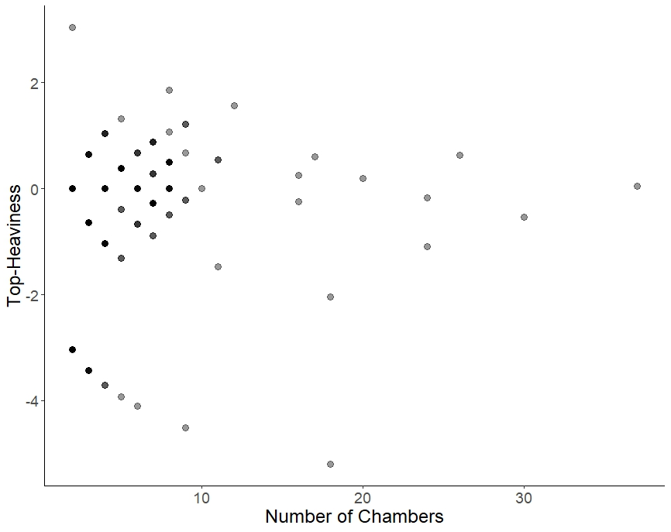

Figure S1: Nest top-heaviness in relation to the number of chambers in the nest. Each point represents a nest in the dataset. Darker points represent cases in which multiple nests overlap, having identical top-heaviness and number of chambers (especially prevalent at low chamber numbers). We did not find a significant relationship between number of chambers and top-heaviness (Linear model: t = 1.501, p = 0.135).

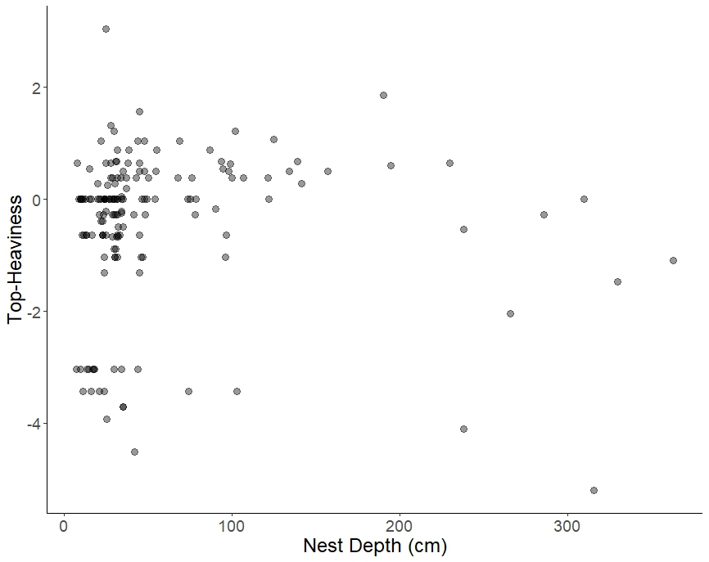

Figure S2: Nest top-heaviness in relation to nest depth (in centimeters). Each point represents a nest in the dataset. We did not find a significant relationship between nest depth and top-heaviness (Linear model: t = -0.538, p = 0.591).

Table S1. Species included in the analysis, with information about subfamily, number of nests available for each species, the coordinates (long/lat) of the nests when available (NA when location information was not available), the biome of the location, and the reference (including doi when available) from which data about the nests was obtained.
Subfamily | Species | Number of nests | Sampling location | Biome* | Reference for nest cast
Myrmicinae | Acromyrmex balzani | 8 | -22.2211, -54.8056 | Tropical & Subtropical Grasslands, Savannas & Shrublands | Caldato et al 2016: 10.1080/00222933.2016.1166529
Myrmicinae | Aphaenogaster ashmeadi | 11 | 30.0998, -84.7316 | Temperate Grasslands, Savannas & Shrublands | Tschinkel 2011; https://doi.org/10.1673/031.011.10501
Myrmicinae | Aphaenogaster floridana | 24 | 30.0998, -84.7316 | Temperate Grasslands, Savannas & Shrublands | Tschinkel 2011; https://doi.org/10.1673/031.011.10501
Myrmicinae | Aphaenogaster treatae | 11 | 30.0998, -84.7316 | Temperate Grasslands, Savannas & Shrublands | Tschinkel 2011; https://doi.org/10.1673/031.011.10501
Formicinae | Camponotus socius | 13 | 30.0998, -84.7316 | Temperate Grasslands, Savannas & Shrublands | Tschinkel 2005: https://doi.org/10.1093/jis/5.1.9
Dolichoderinae | Dorymyrmex elegans | 1 | NA |  | O’Fallon et al. 2023: https://doi.org/10.1098/rstb.2022.0146
Ectatomminae | Ectatomma opaciventre | 9 | -22.4108, -47.5596 | Tropical & Subtropical Moist Broadleaf Forests | Antonialli 1997: Journal of Advanced Zoology, v. 18, n. 2, p. 64-71, 1997
Ectatomminae | Ectatomma ruidum | 24 | 3.376, -76.5299 | Tropical & Subtropical Moist Broadleaf Forests | Santamaria 2022: https://doi.org/10.1371/journal.pone.0263382
Formicinae | Formica archboldi | 1 | 30.0998, -84.7316 | Temperate Grasslands, Savannas & Shrublands | Tschinkel 2015: https://doi.org/10.1007/s10818-015-9203-6; King 2007: https://doi.org/10.1673/031.007.4201
Formicinae | Formica dolosa | 1 | 30.0998, -84.7316 | Temperate Grasslands, Savannas & Shrublands | King 2007: https://doi.org/10.1673/031.007.4201
Formicinae | Formica pallidefulva | 1 | 30.0998, -84.7316 | Temperate Grasslands, Savannas & Shrublands | Tschinkel 2003: https://doi.org/10.1016/S0031-0182(02)00690-9; King 2007: https://doi.org/10.1673/031.007.4201; Williams 1988
Ponerinae | Harpegnathos venator | 1 | 17.3975, 98.3661 | Tropical & Subtropical Moist Broadleaf Forests | Aupanun 2022: https://doi.org/10.1007/s00040-022-00857-5
Myrmicinae | Monomorium viridum | 1 | NA |  | Williams DF, Lofgren CS, Trager JC. 1988. Nest casting of some grounddwelling Florida ant species using dental labstone. Advances in Myrmecology. 433
Myrmicinae | Mycetagroicus inflatus | 4 | -8.7539, -49.5454  -8.8016, -49.5737 | Tropical & Subtropical Grasslands, Savannas & Shrublands | Jasovnik 2013: DOI 10.1007/s00040-013-0320-8
Myrmicinae | Mycetarotes parallelus | 2 | -25.7136, -54.4617 | Tropical & Subtropical Moist Broadleaf Forests | Solomon 2004: https://doi.org/10.1007/s00040-004-0742-4
Myrmicinae | Mycetophylax simplex | 7 | -29.3333, -49.7167 | Tropical & Subtropical Moist Broadleaf Forests | Diehl-Fleig and Diehl 2007; https://doi.org/10.1007/s00040-007-0936-7
Myrmicinae | Mycocepurus smithii | 1 | -2.8833, -59.9833 | Tropical & Subtropical Moist Broadleaf Forests | Rabeling et al 2007: https://doi.org/10.1673/031.007.4001
Ponerinae | Odontomachus brunneus | 16 | 30.3787, -84.3223 | Temperate Grasslands, Savannas & Shrublands | Tschinkel 2010; https://doi.org/10.1673/031.010.6401
Ponerinae | Odontomachus chelifer | 1 | -22.2211, -54.8056 | Tropical & Subtropical Moist Broadleaf Forests | Guimaraes 2018; https://doi.org/10.1371/journal.pone.0189896
Ponerinae | Pachycondyla striata | 4 | -22.5444, -47.5456 | Tropical & Subtropical Moist Broadleaf Forests | da Silva-Melo 2010; https://doi.org/10.1007/s00040-009-0043-z
Myrmicinae | Pheidole adrianoi | 1 | NA |  | Tschinkel WR. 2021. Ant Architecture: The Wonder, Beauty, and Science of Underground Nests. Princeton University Press.
Myrmicinae | Pheidole dentata | 1 | NA |  | Williams DF, Lofgren CS, Trager JC. 1988. Nest casting of some grounddwelling Florida ant species using dental labstone. Advances in Myrmecology. 433
Formicinae | Prenolepis imparis | 7 | 30.0998, -84.7316 | Temperate Grasslands, Savannas & Shrublands | Dennis 1941; https://doi.org/10.1093/aesa/34.1.82 and Tschinkel 1987; https://doi.org/10.1007/BF02224081
Myrmicinae | Sericomyrmex amabilis | 1 | 18.587, -95.078 | Tropical & Subtropical Moist Broadleaf Forests | Jesovnik 2018: https://par.nsf.gov/biblio/10106155
Myrmicinae | Sericomyrmex bondari | 1 | -6.063, -50.057 | Tropical & Subtropical Moist Broadleaf Forests | Jesovnik 2018: https://par.nsf.gov/biblio/10106155
Myrmicinae | Sericomyrmex mayri | 4 | -12.819, -69.364  3.513, -58.235 | Tropical & Subtropical Moist Broadleaf Forests | Jesovnik 2018: https://par.nsf.gov/biblio/10106155
Myrmicinae | Sericomyrmex parvulus | 2 | -12.819, -69.364  -20.755, -42.887 | Tropical & Subtropical Moist Broadleaf Forests | Jesovnik 2018: https://par.nsf.gov/biblio/10106155
Myrmicinae | Trachymyrmex septentrionalis | 3 | 30.0998, -84.7316 | Temperate Grasslands, Savannas & Shrublands | Tschinkel 2002, 2005; Williams 1988
Myrmicinae | Veromessor pergandei | 1 | NA |  | Tschinkel 2015; https://doi.org/10.1007/s10818-015-9203-6

* Biome information obtained from: Dinerstein E. et al. 2017. An ecoregion-based approach to protecting half the terrestrial realm, BioScience, 67(6):534-545. https://doi.org/10.1093/biosci/bix014

