SUPPORTING DATA 2

3.3.1 (E)-N-(4-(3-(3-fluorophenyl)acryloyl)phenyl)-2-(methylamino)benzamide (K1)

H NMR

C NMR

FTIR

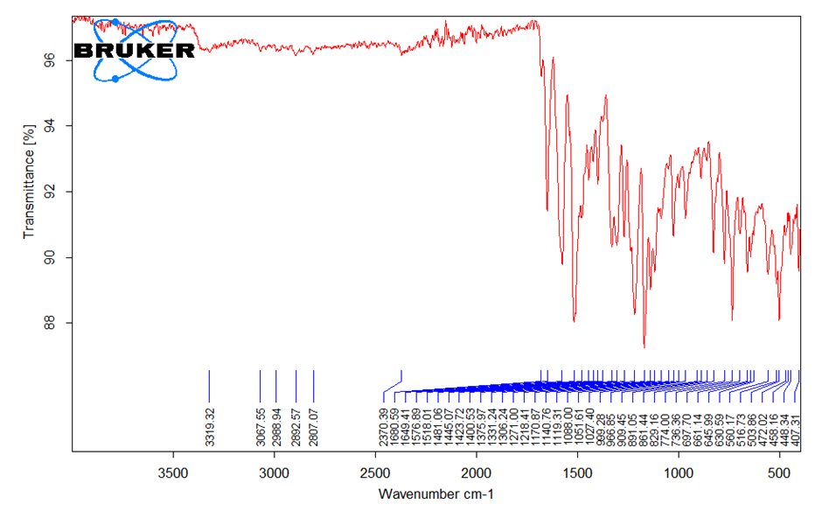

HRMS

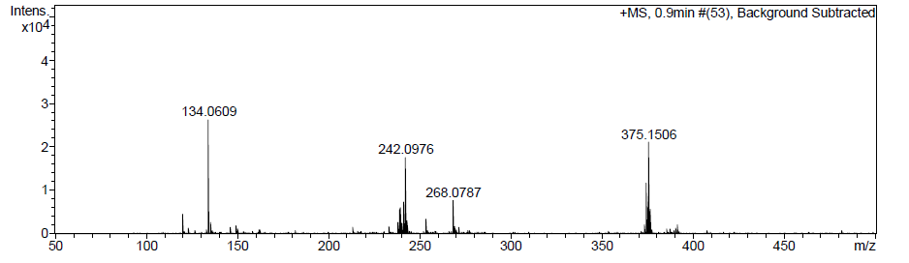

HPLC

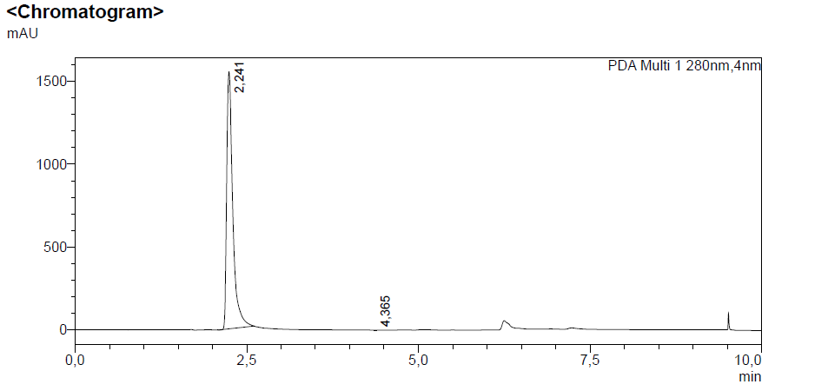

(E)-2-(methylamino)-N-(4-(3-(4-nitrophenyl)acryloyl)phenyl)benzamide (K3)

H NMR

C NMR

FTIR
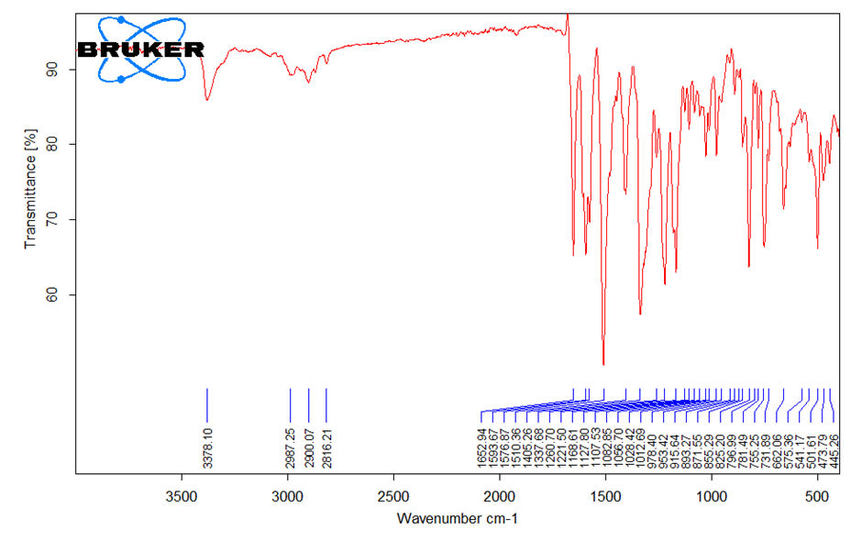

HRMS

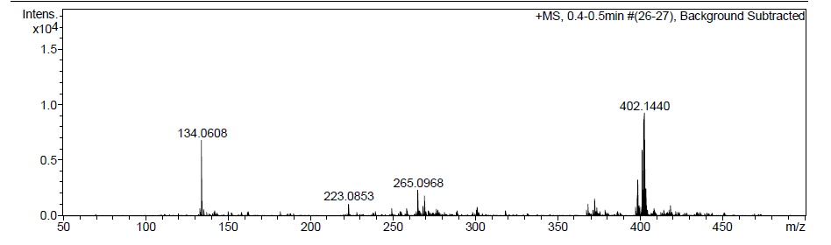

HPLC

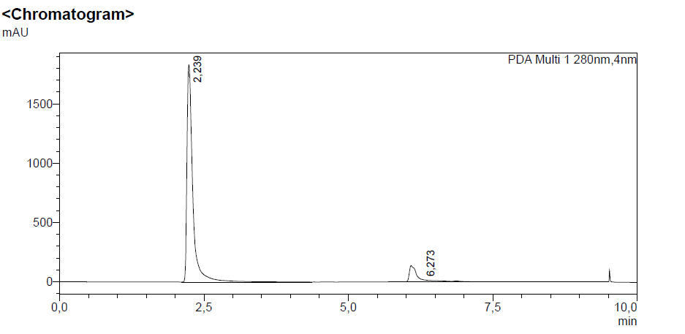

(E)-2-(methylamino)-N-(4-(3-(3-nitrophenyl)acryloyl)phenyl)benzamide (K4)

H NMR

C NMR

FTIR
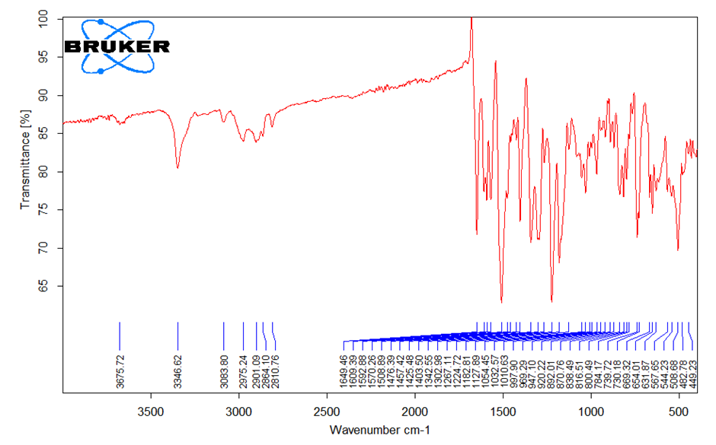

HRMS
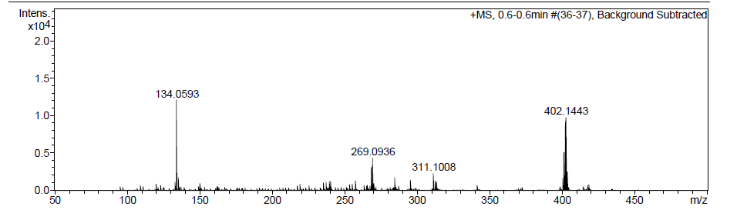

HPLC
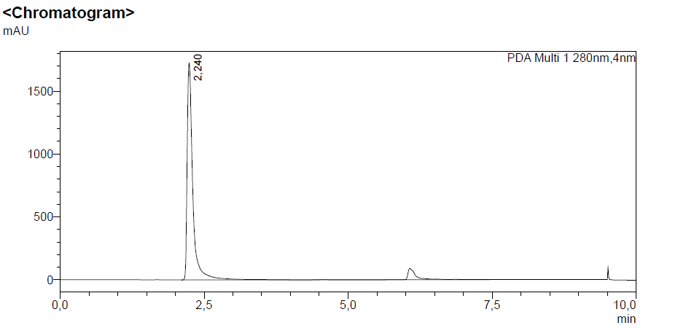
(E)-N-(4-(3-(4-fluorophenyl)acryloyl)phenyl)-2-(methylamino)benzamide (K5)

H NMR

C NMR

FTIR
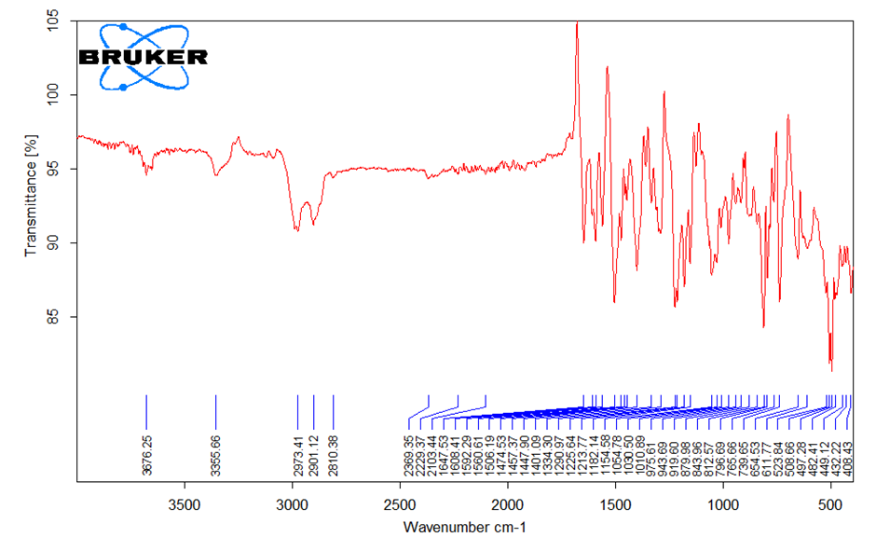
HRMS
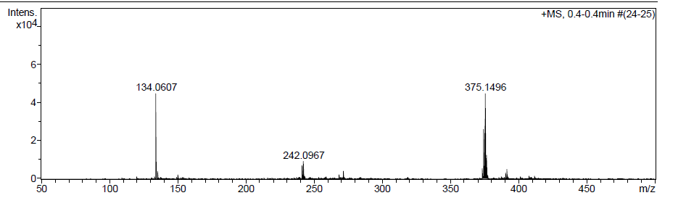

HPLC
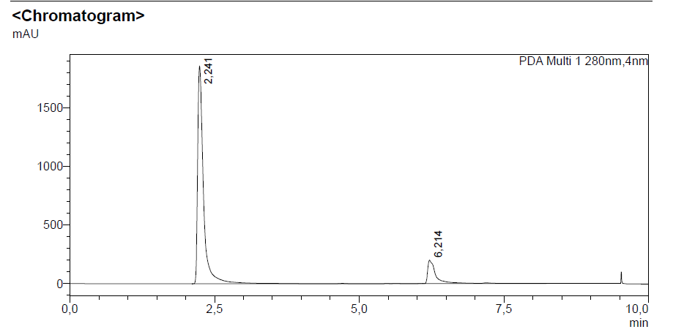
(E)-N-(4-(3-(3-chlorophenyl)acryloyl)phenyl)-2-(methylamino)benzamide (K6)

H NMR

C NMR

FTIR
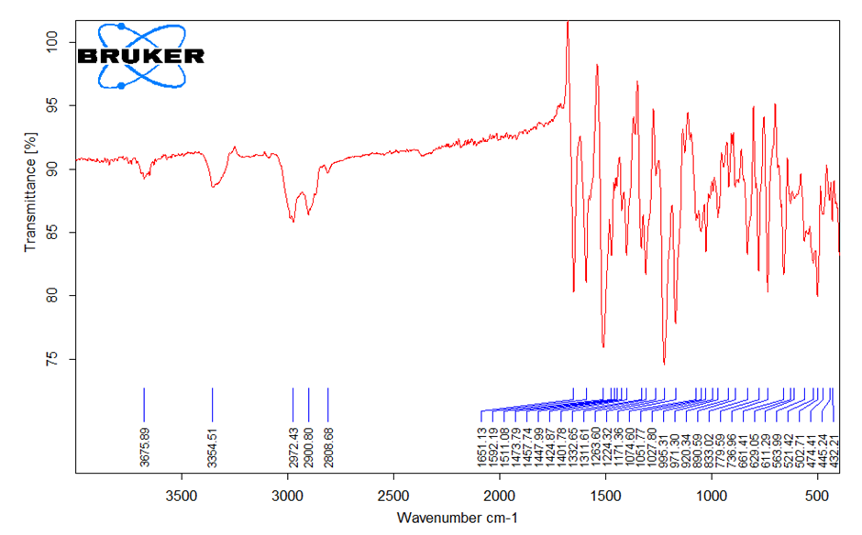

HRMS
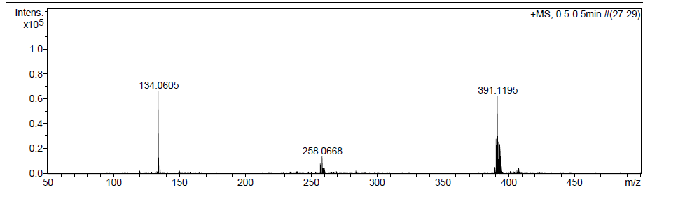

HPLC
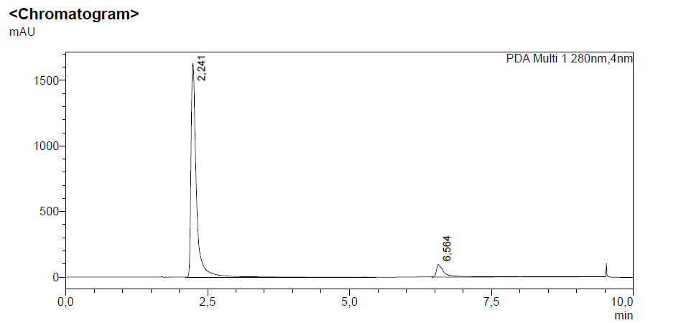

(E)-2-(methylamino)-N-(4-(3-(o-tolyl)acryloyl)phenyl)benzamide (K7)

H NMR
C NMR

FTIR
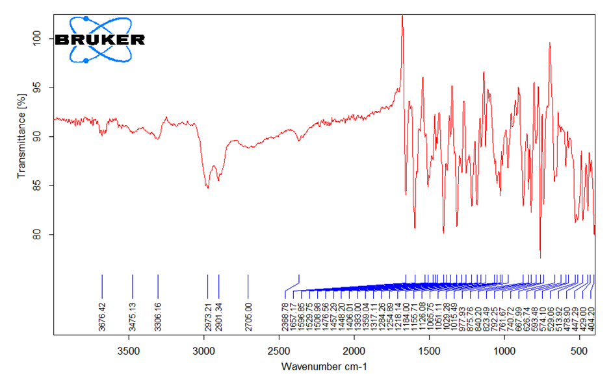
HRMS
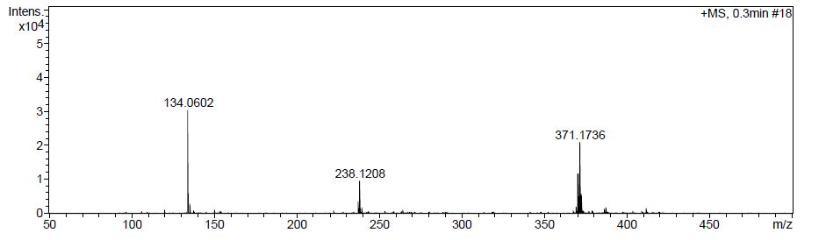

HPLC
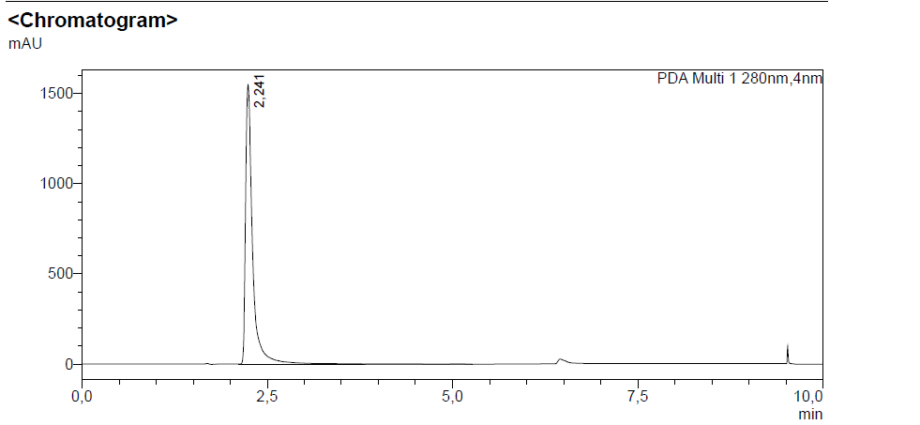
(E)-N-(4-(3-(4-bromophenyl)acryloyl)phenyl)-2-(methylamino)benzamide (K8)

H NMR

C NMR

FTIR
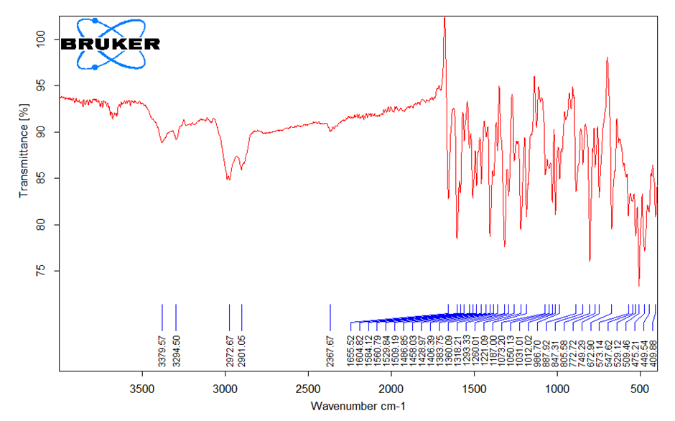

HRMS
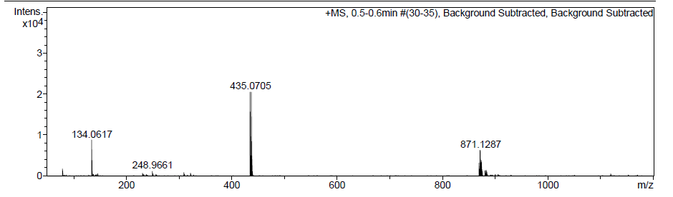

HPLC
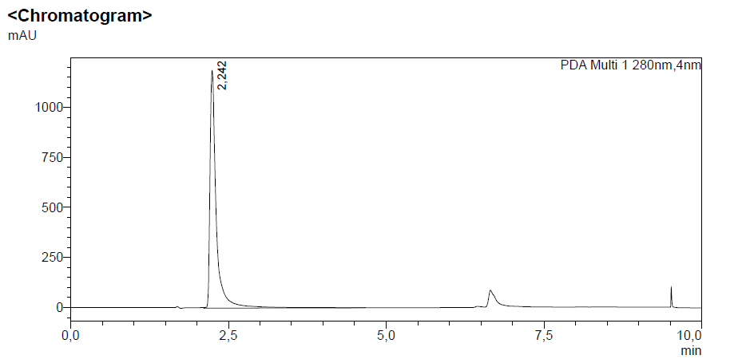

(E)-N-(4-(3-(4-chlorophenyl)acryloyl)phenyl)-2-(methylamino)benzamide (K9)

H NMR
C NMR

FTIR
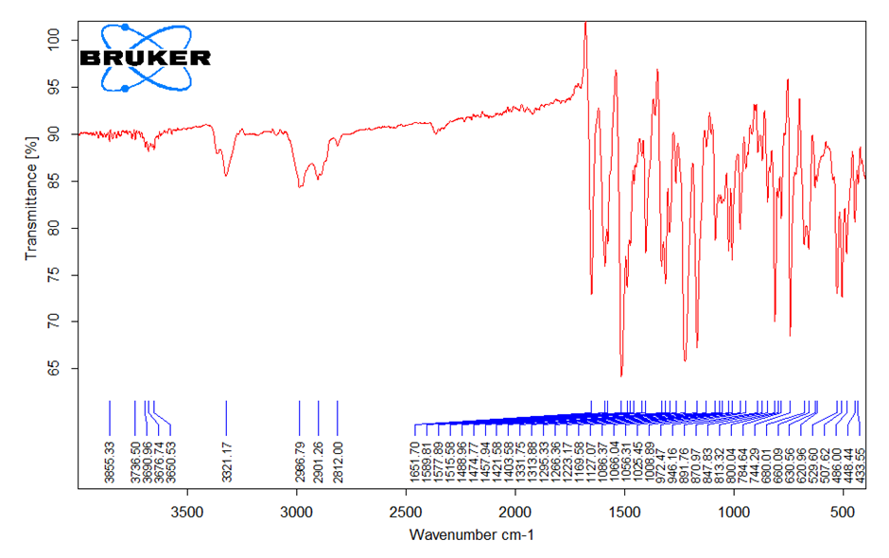
HRMS
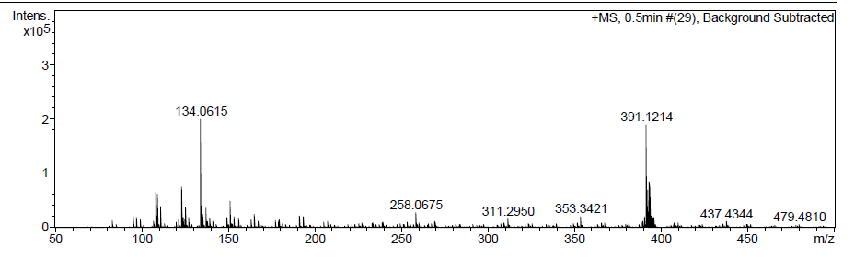

HPLC
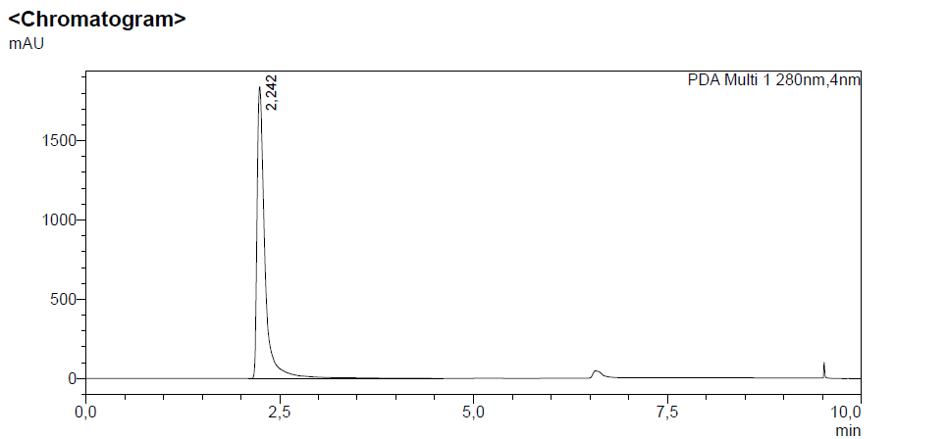

(E)-N-(4-(3-(2-chlorophenyl)acryloyl)phenyl)-2-(methylamino)benzamide (K10)

H NMR

C NMR

FTIR
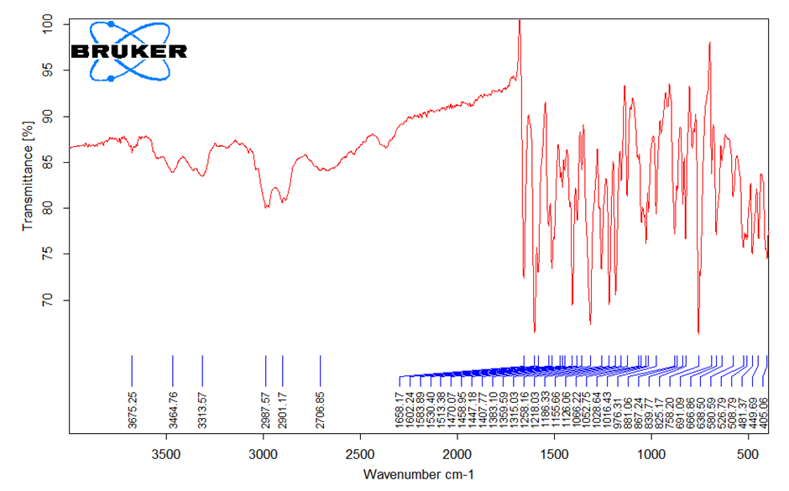

HRMS
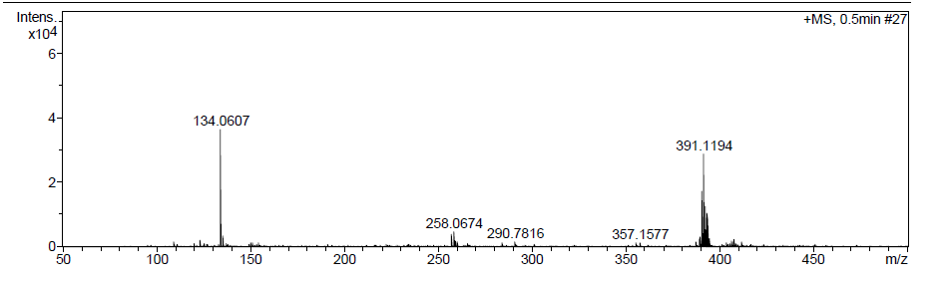

HPLC
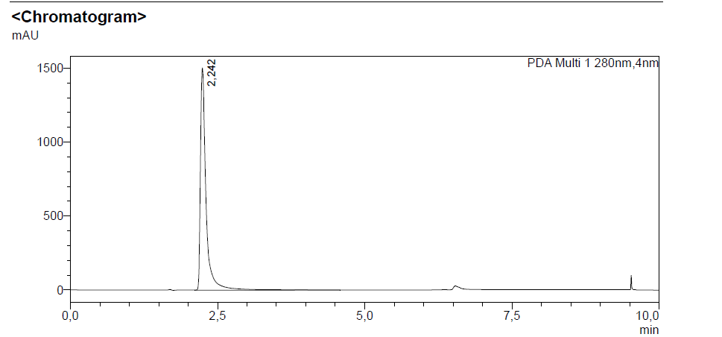

(E)-N-(4-(3-(3,4-dimethoxyphenyl)acryloyl)phenyl)-2-(methylamino)benzamide (K11)

H NMR
C NMR

FTIR
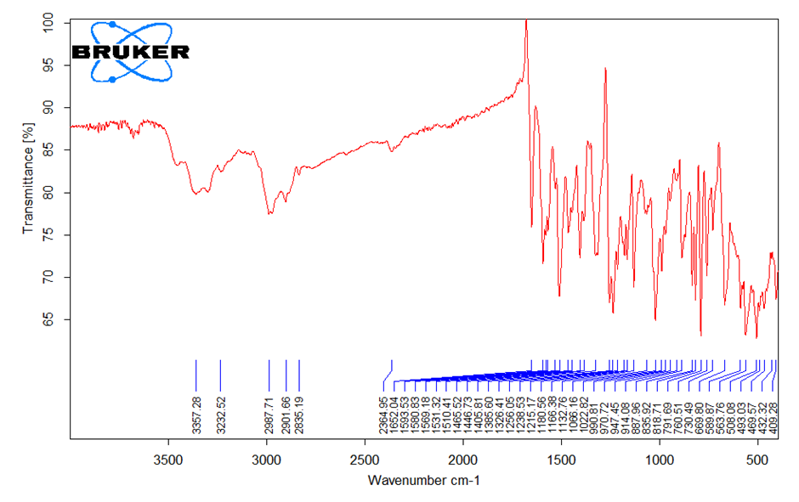
HRMS
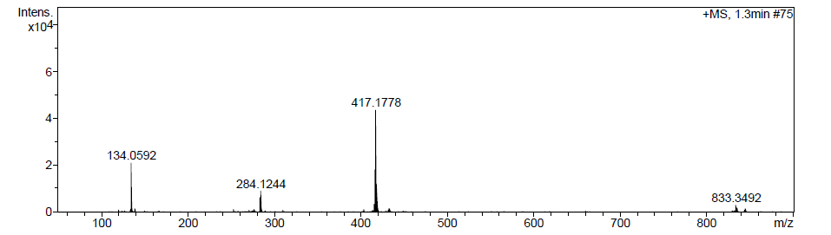

HPLC
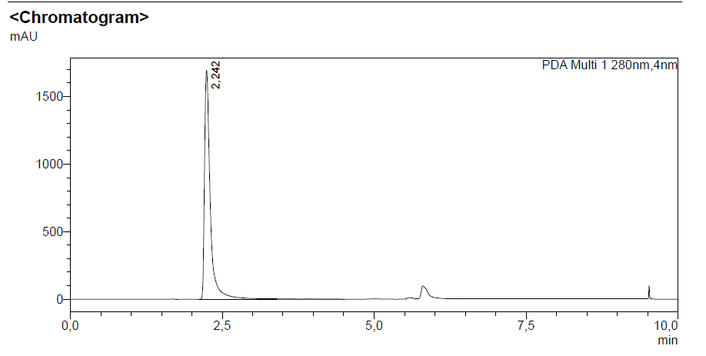
(E)-N-(4-(3-(3,4-dichlorophenyl)acryloyl)phenyl)-2-(methylamino)benzamide (K12)

H NMR

C NMR

FTIR
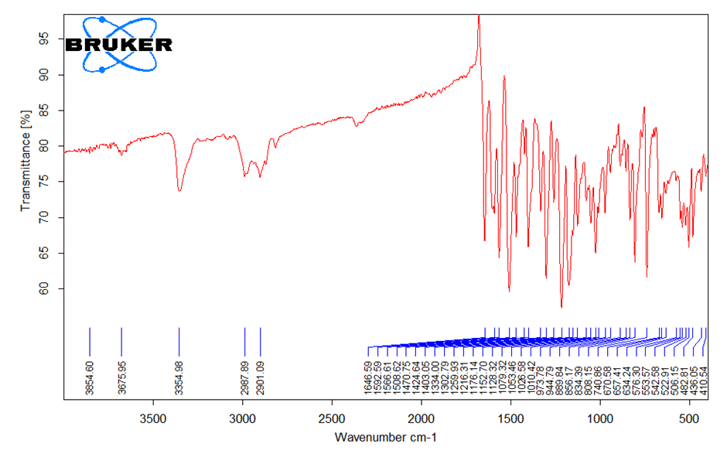

HRMS
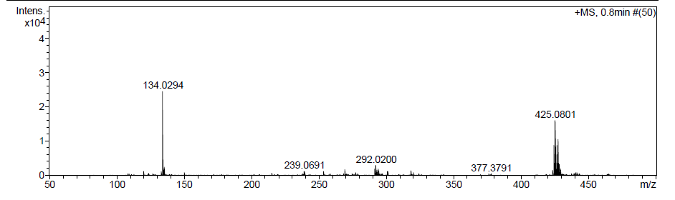

HPLC
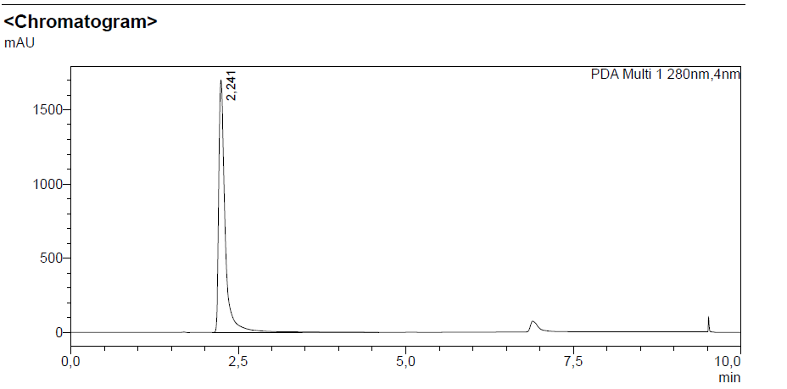

E)-2-(methylamino)-N-(4-(3-(4-(trifluoromethyl)phenyl)acryloyl)phenyl)benzamide
(K15)

H NMR
C NMR

FTIR
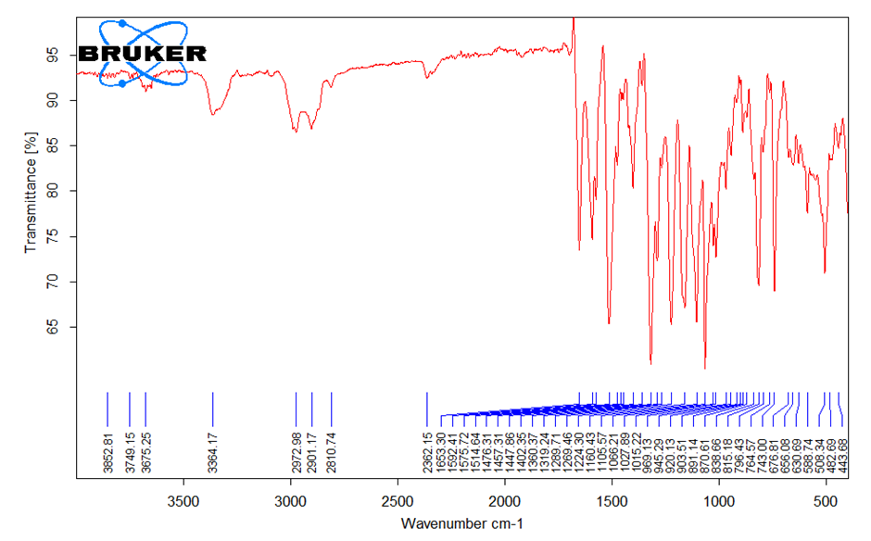

HRMS
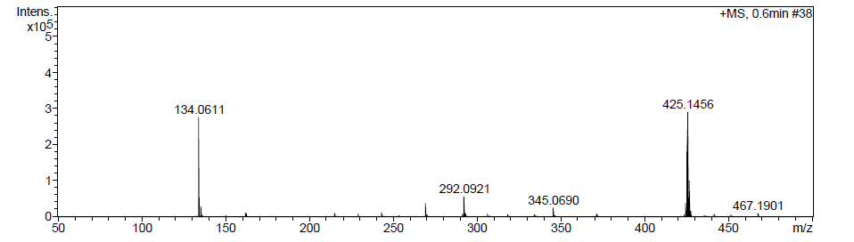

HPLC
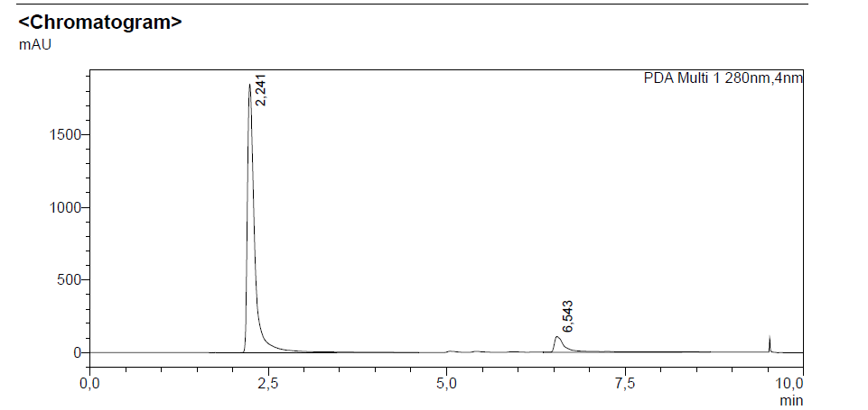
(E)-2-(methylamino)-N-(4-(3-(2,4,6-trimethoxyphenyl)acryloyl)phenyl)benzamide (K16)

H NMR

C NMR

FTIR
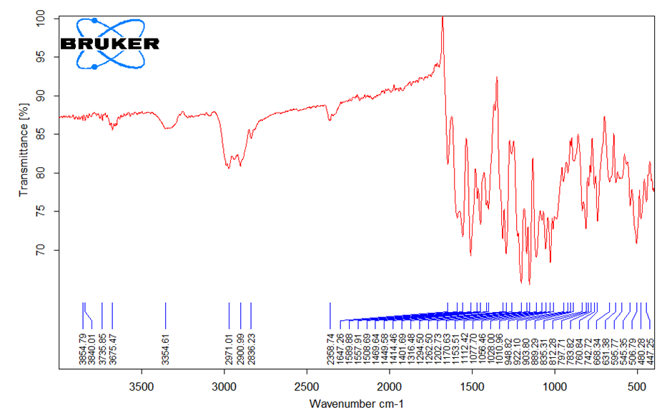

HRMS
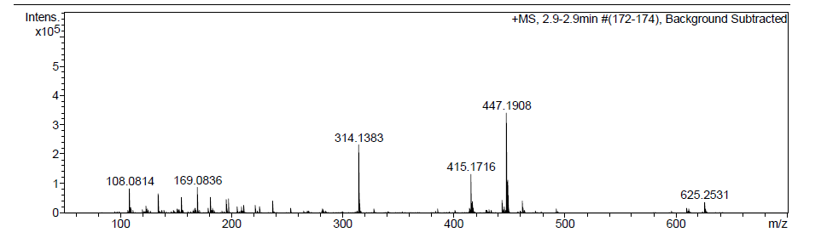

HPLC
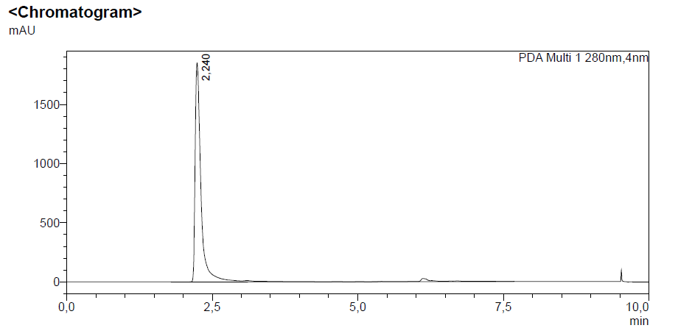

(E)-N-(4-(3-(3-methoxyphenyl)acryloyl)phenyl)-2-(methylamino)benzamide (K17)

H NMR

C NMR
FTIR

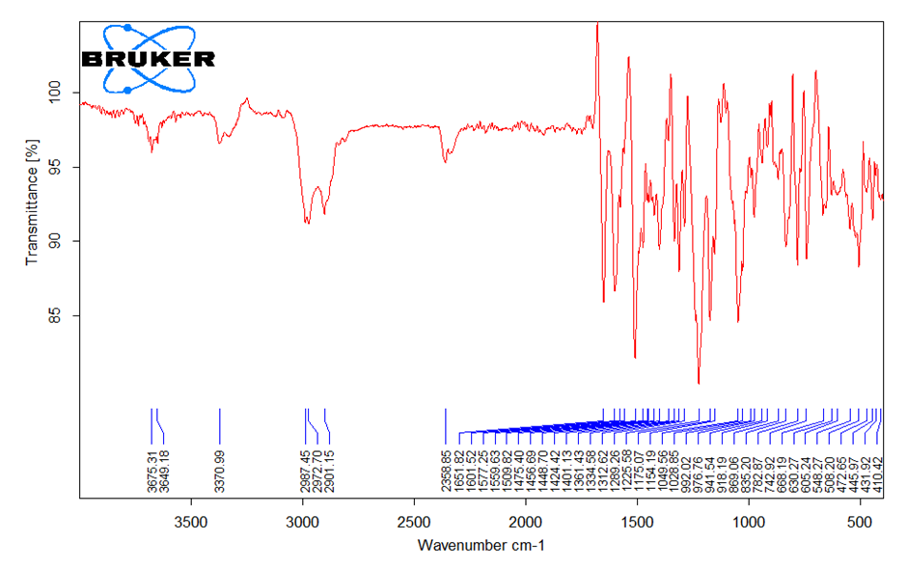
HRMS
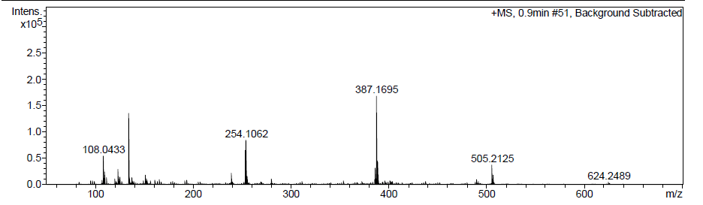

HPLC
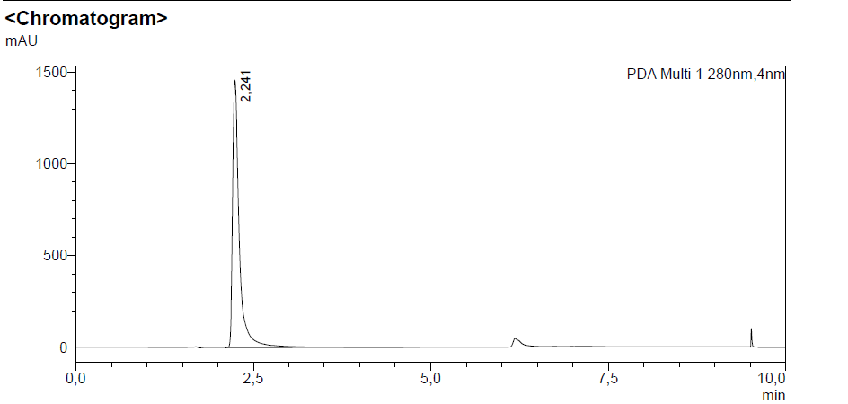

(E)-N-(4-(3-(2-bromophenyl)acryloyl)phenyl)-2-(methylamino)benzamide (K18)

H NMR
C NMR

FTIR
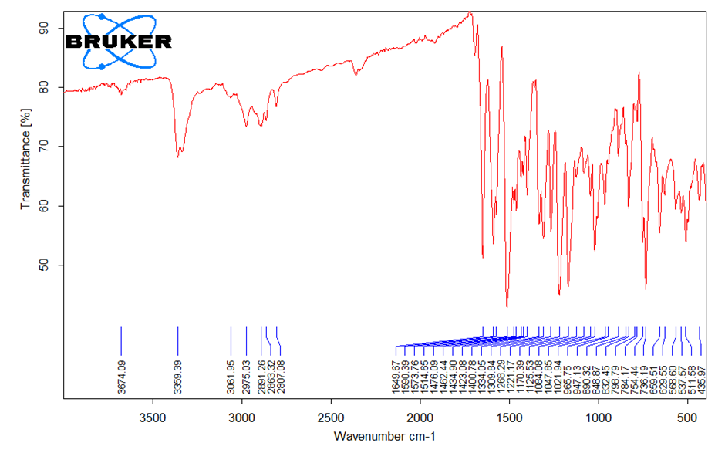

HRMS
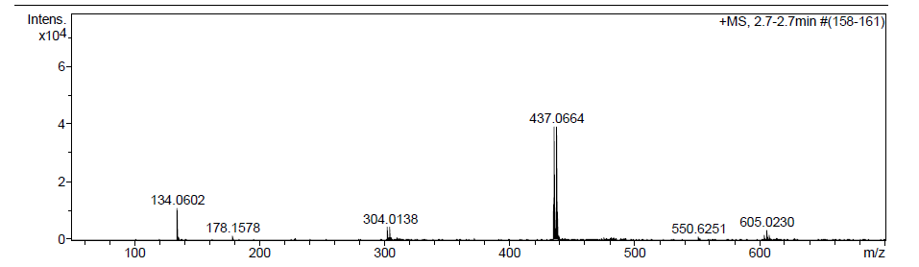

HPLC
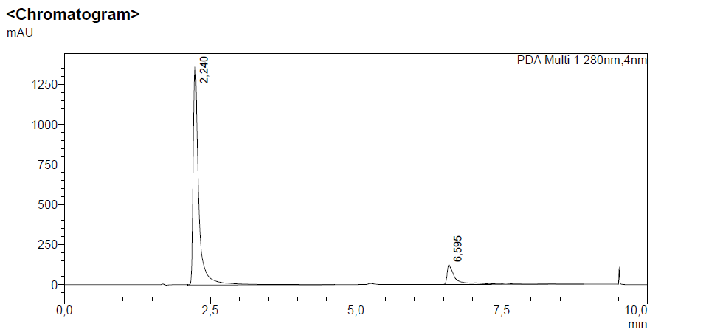

(E)-N-(4-(3-(2,5-dimethoxyphenyl)acryloyl)phenyl)-2-(methylamino)benzamide (K19)

H NMR

C NMR

FTIR
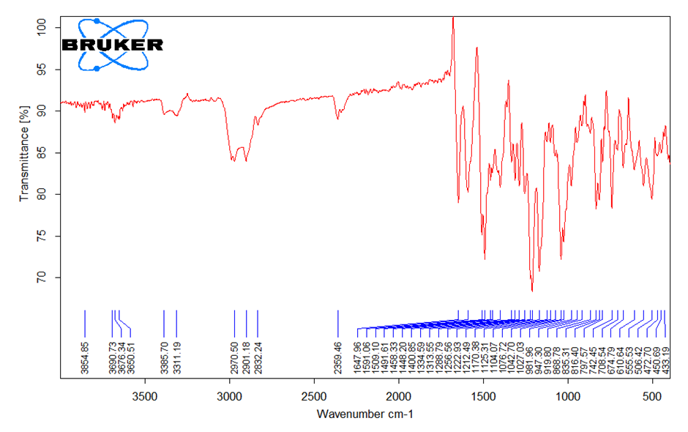
HRMS
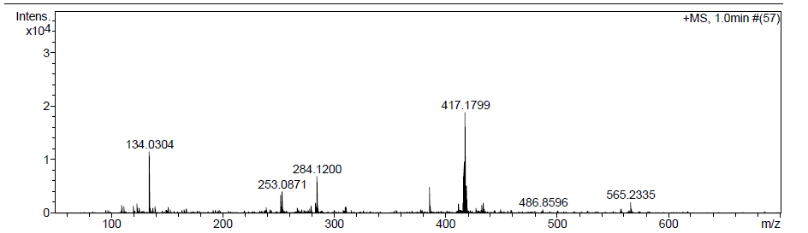

HPLC
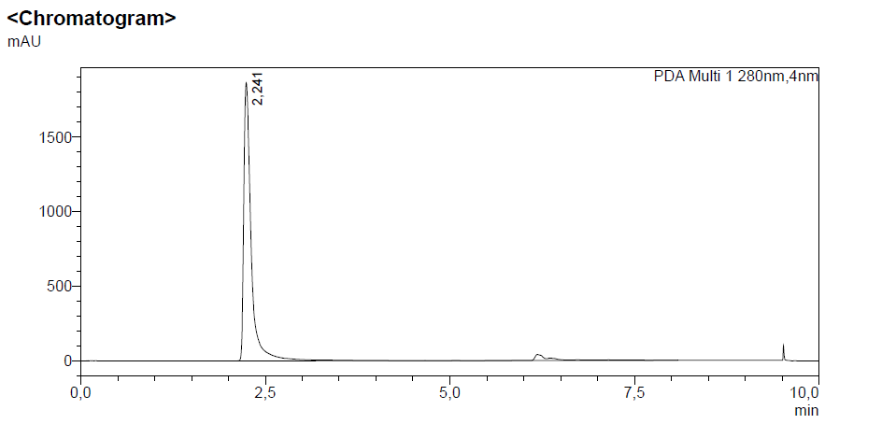

(E)-2-(methylamino)-N-(4-(3-(thiophen-3-yl)acryloyl)phenyl)benzamide (K20)

H NMR

C NMR

FTIR
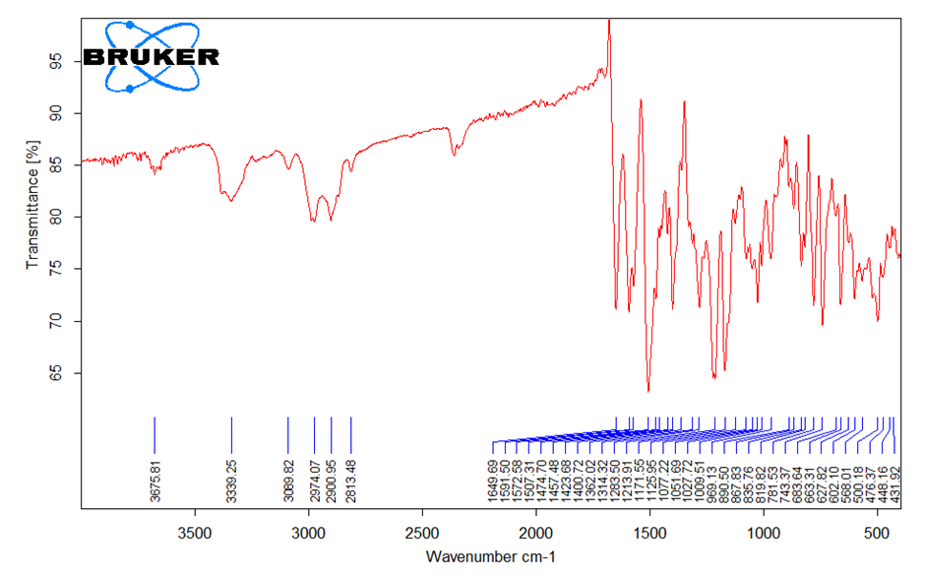

HRMS
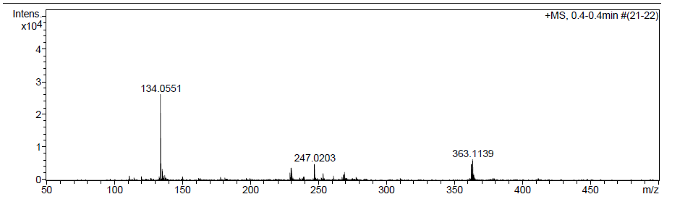

HPLC
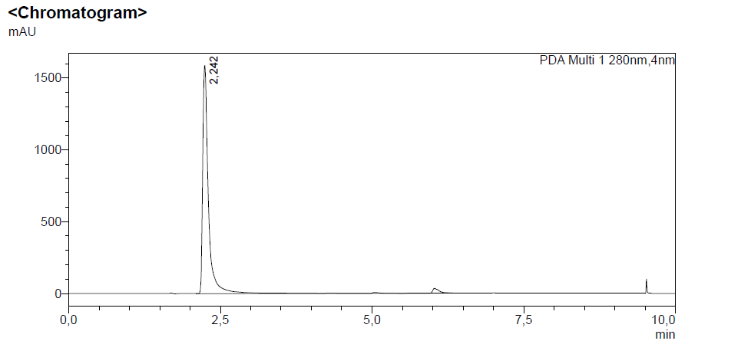

(E)-2-(methylamino)-N-(4-(3-(thiophen-2-yl)acryloyl)phenyl)benzamide (K21)

H NMR
C NMR

FTIR
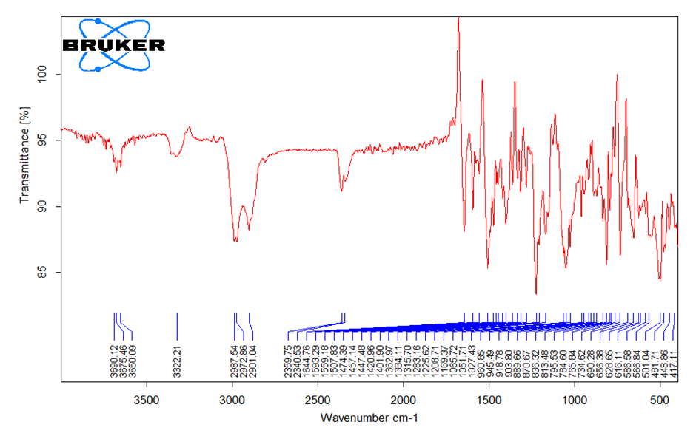
HRMS
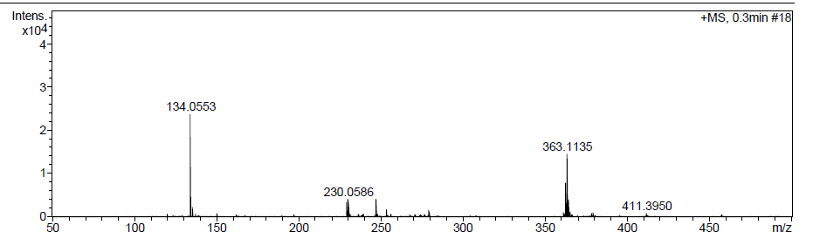

HPLC
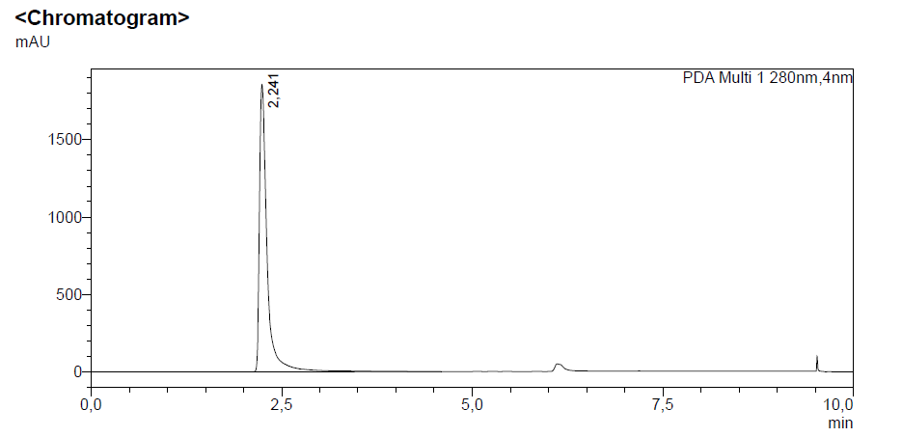
(E)-N-(4-(3-(benzo[d][1,3]dioxol-5-yl)acryloyl)phenyl)-2-(methylamino)benzamide (K22)

H NMR

C NMR

FTIR
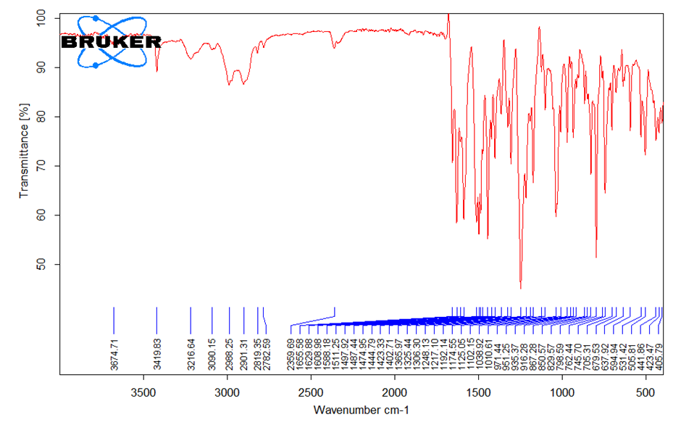

HRMS
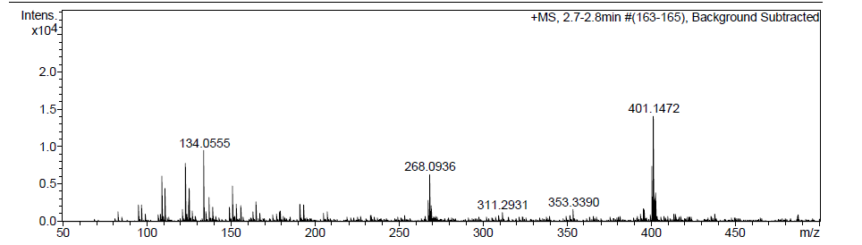

HPLC
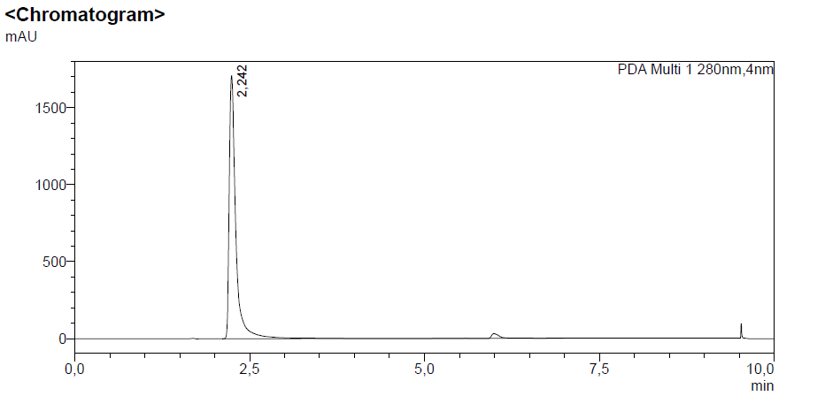

(E)-2-(methylamino)-N-(4-(3-(2,4,5-trimethoxyphenyl)acryloyl)phenyl)benzamide (K23)

H NMR

C NMR

FTIR
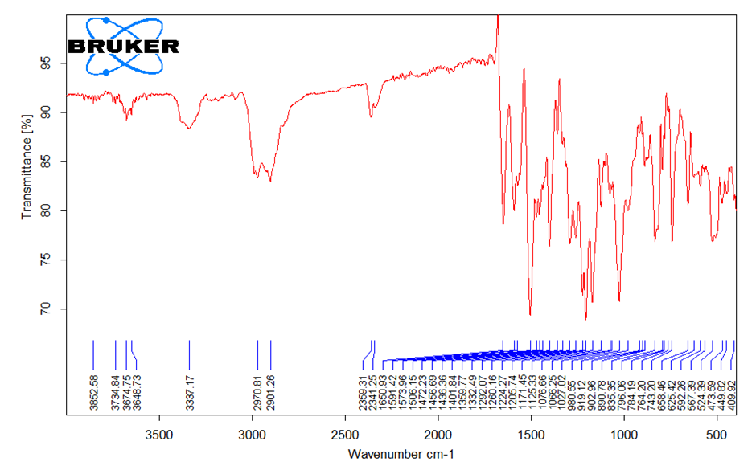
HRMS
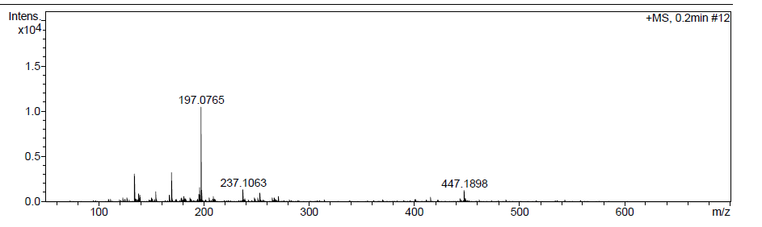

HPLC
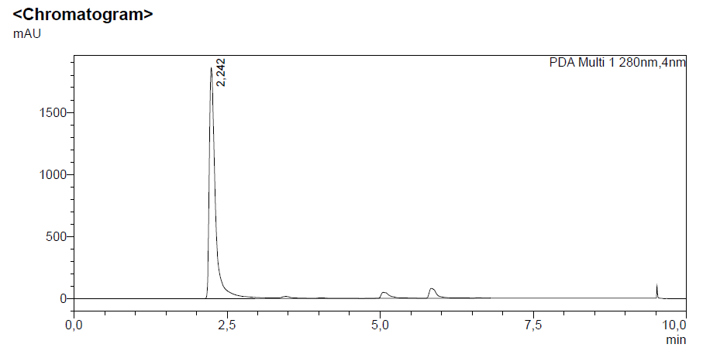
(E)-N-(4-(3-(2-methoxyphenyl)acryloyl)phenyl)-2-(methylamino)benzamide (K25)

H NMR

C NMR
FTIR
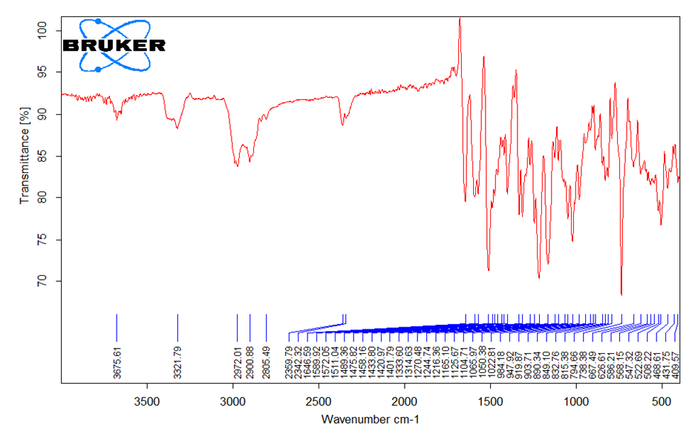

HRMS
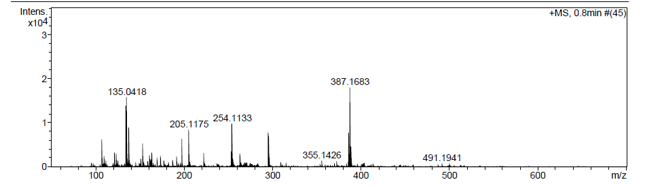

HPLC
