Synthesis of 6-dialkylaminopyrimidine carboxamide analogues and their anti-tubercular properties
Ronewa Tshinavhe,¹ Nashied Peton^{2,3}, Sandile B. Simelane⁴, Paseka T. Moshapo¹

¹Research Centre for Synthesis and Catalysis, Department of Chemical Sciences, University of Johannesburg, Kingsway Campus, Auckland Park 2006, South Africa.

²Holistic Drug Discovery & Development Centre (H3D), University of Cape Town, Rondebosch, Cape Town, South Africa.

³Infectious Diseases and Immune Defence Division, The Walter & Eliza Hall Institute of Medical Research, Parkville, Victoria, Australia.

⁴Department of Chemistry, University of Eswatini, Private Bag 4, Kwaluseni M201, Eswatini.

Corresponding author
Paseka T. Moshapo
pasekam@uj.ac.za

Contents
1. Abbreviations 2
2. Proton and Carbon NMR Spectra 3
3. Biological Assays 68
3.1 In vitro antimycobacterial assay 68
3.2 Bioluminescence Assays 68
3.2.1 Lux assay 68
3.2.2 Charcoal agar resazurin assay (CARA) 72

Abbreviations

AIDS | Acquired Immunodeficiency Syndrome
CARA | Charcoal agar resazurin assay
DCM | Dichloromethane
DIPEA | N,N-Diisopropylethylamine
DMAP | 4-Dimethylaminopyridine
DMF | N,N-Dimethylformamide
DNA | Deoxyribonucleic acid
EtOAc | Ethyl acetate
HATU | Hexafluorophosphate azabenzotriazole tetramethyl uronium
HIV | Human immunodeficiency virus
HRMS | High-resolution mass spectrometry
IR | Infrared
LHS | Left-hand side
Mtb | Mycobacterium tuberculosis
NMR | Nuclear magnetic resonance
RHS | Right-hand side
TB | Tuberculosis
TEA | Triethylamine
THF | Tetrahydrofuran
TLC | Thin layer chromatography
WHO | World Health Organization

Proton and Carbon NMR Spectra

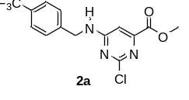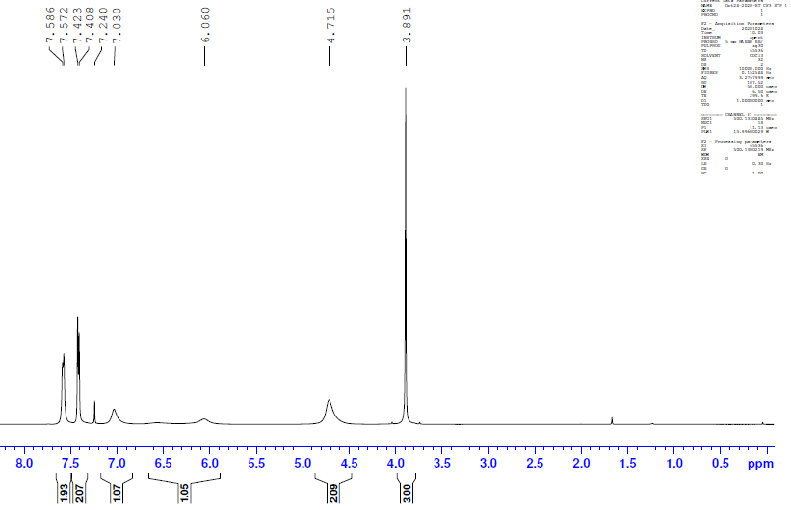

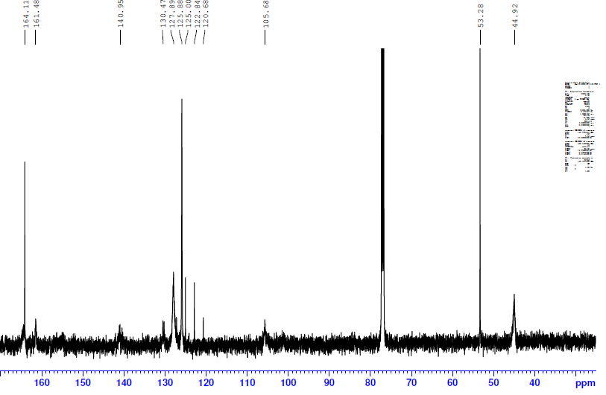
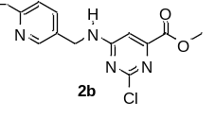
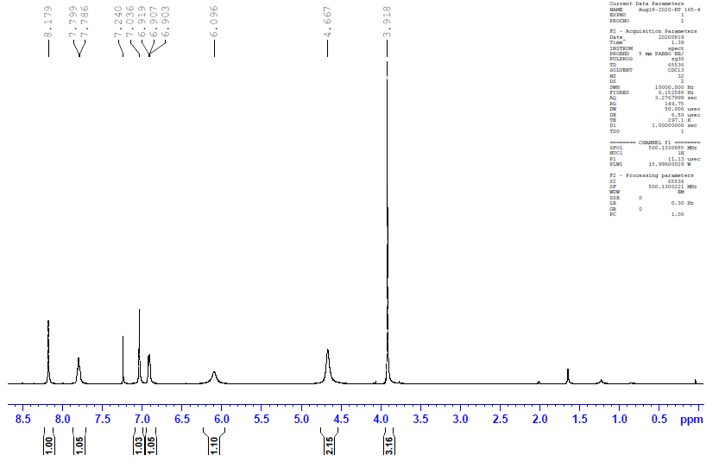

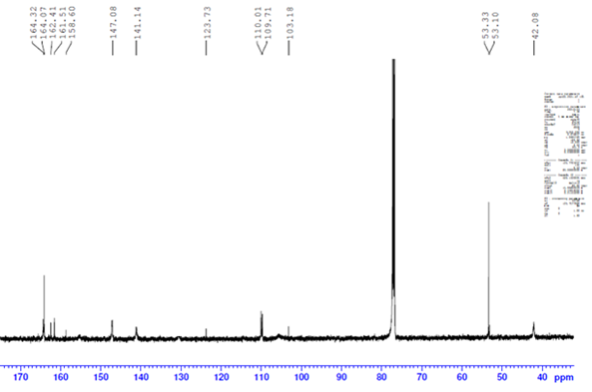

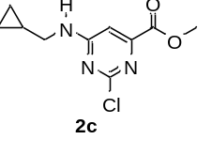
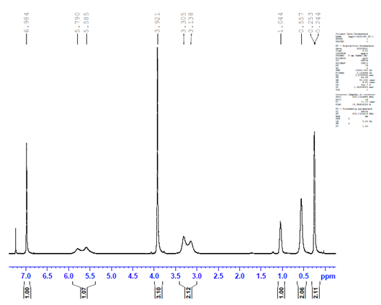

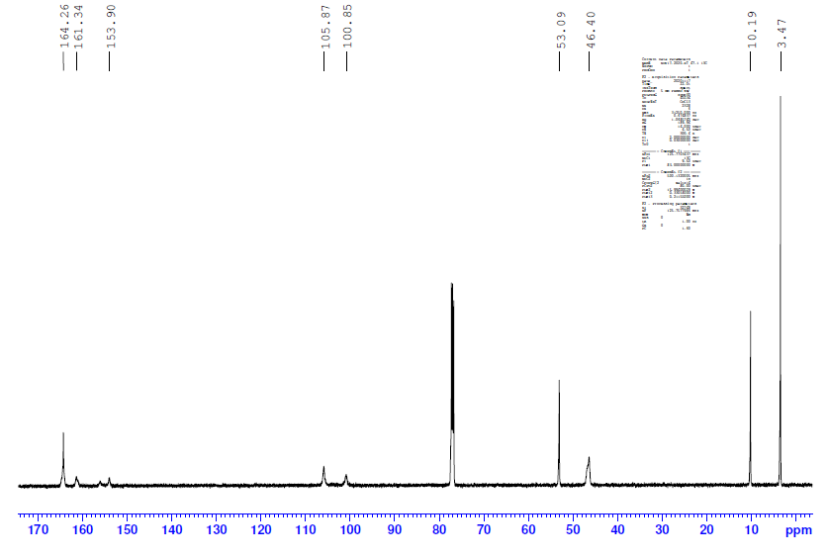
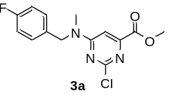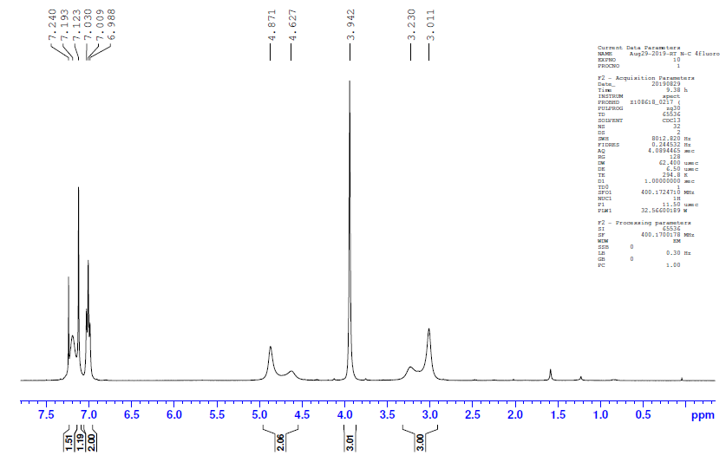

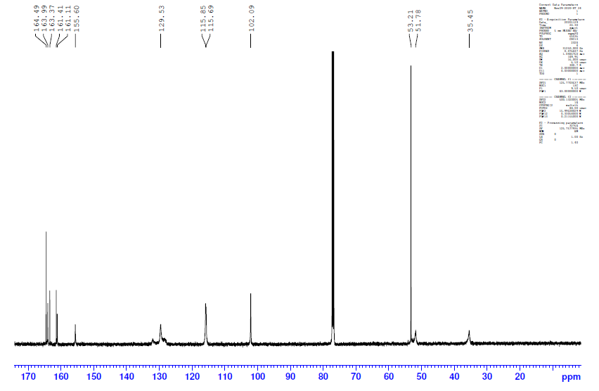

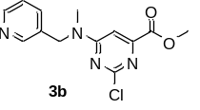
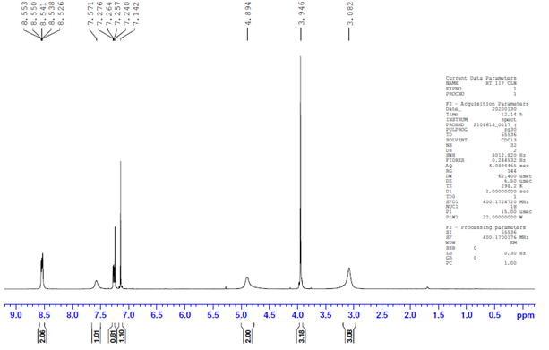

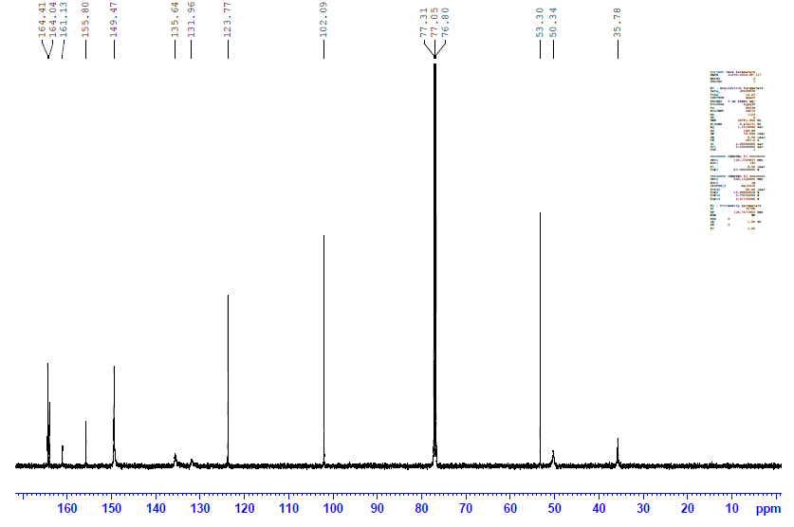

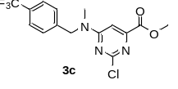
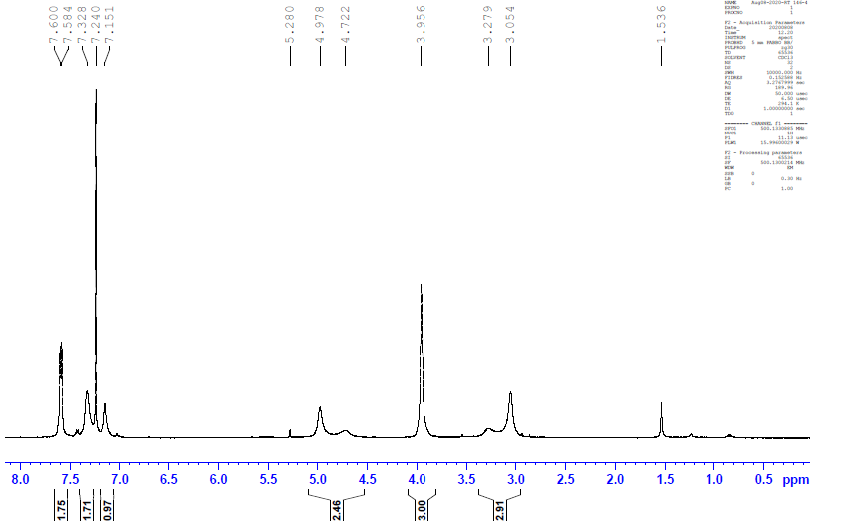

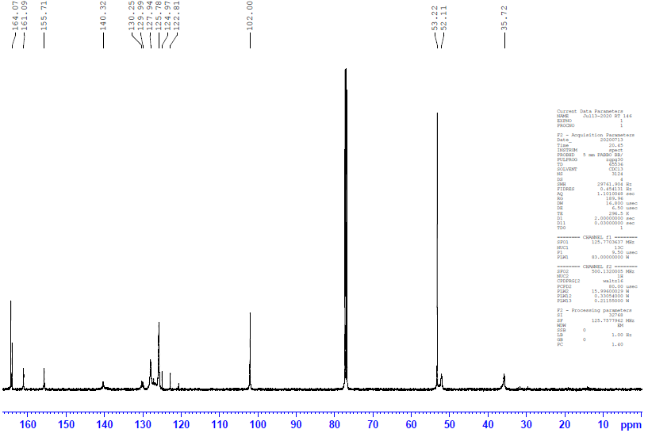

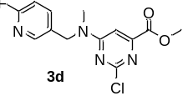
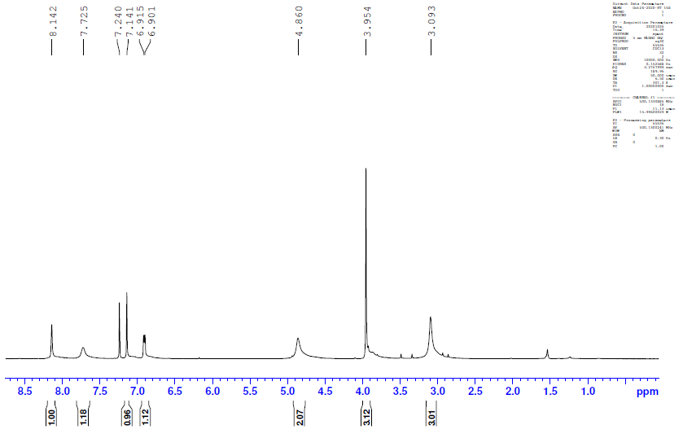

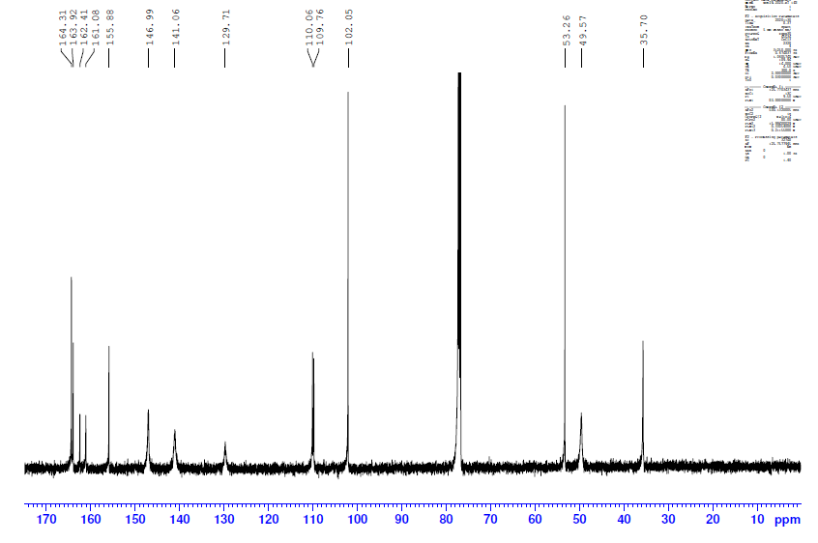

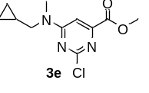
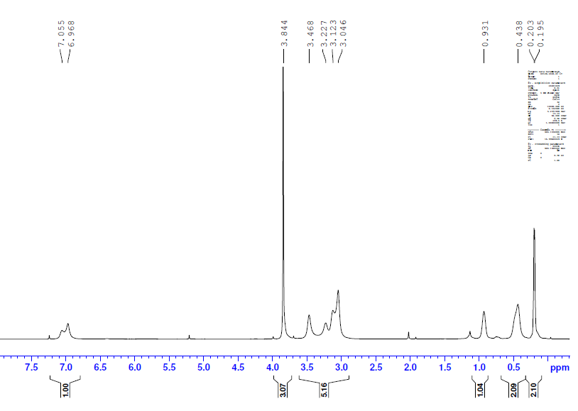

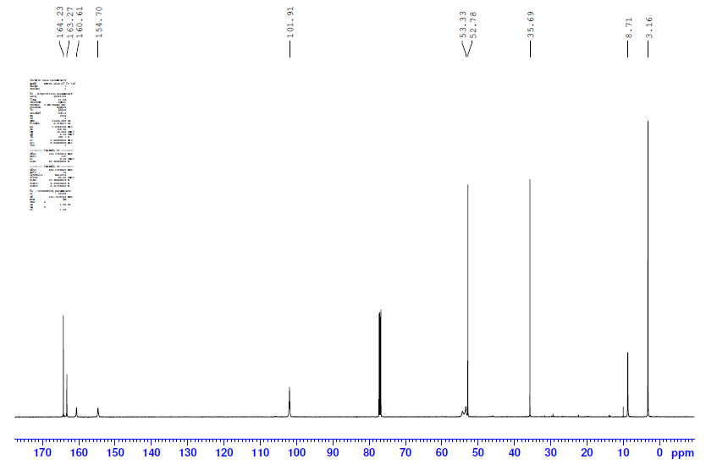
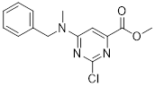
3f

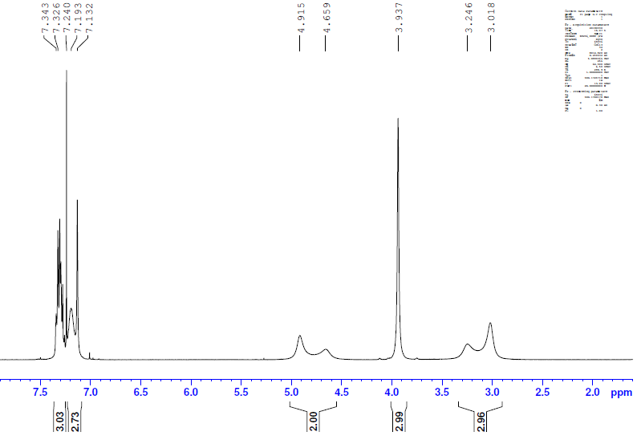

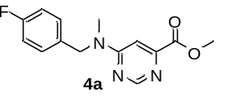
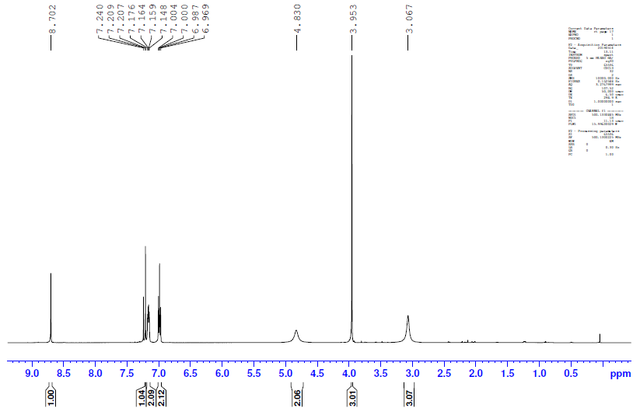

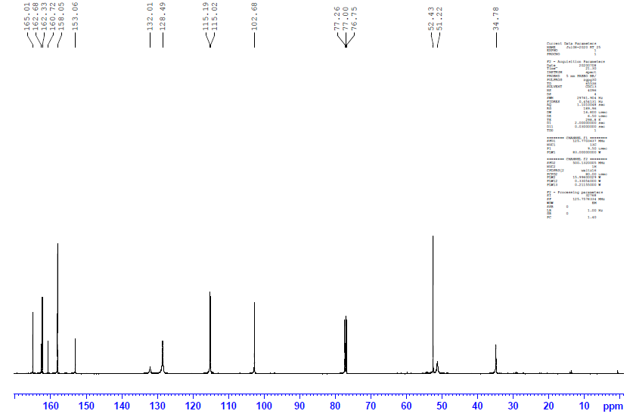

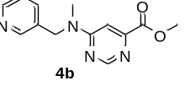
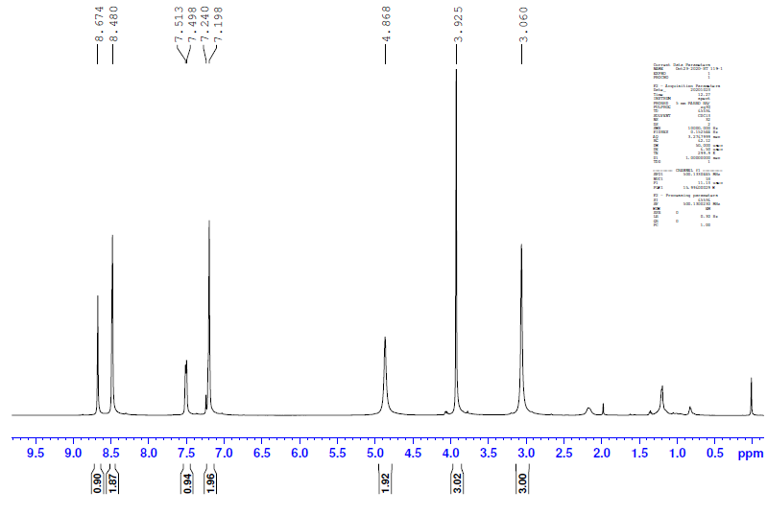

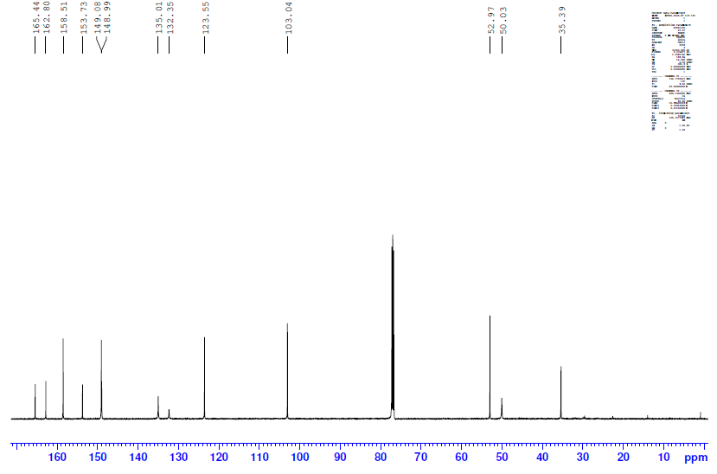

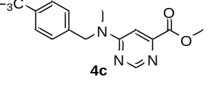
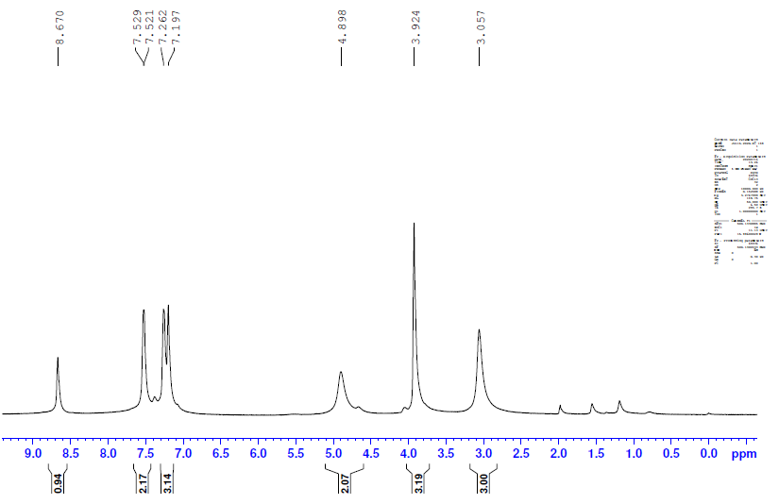

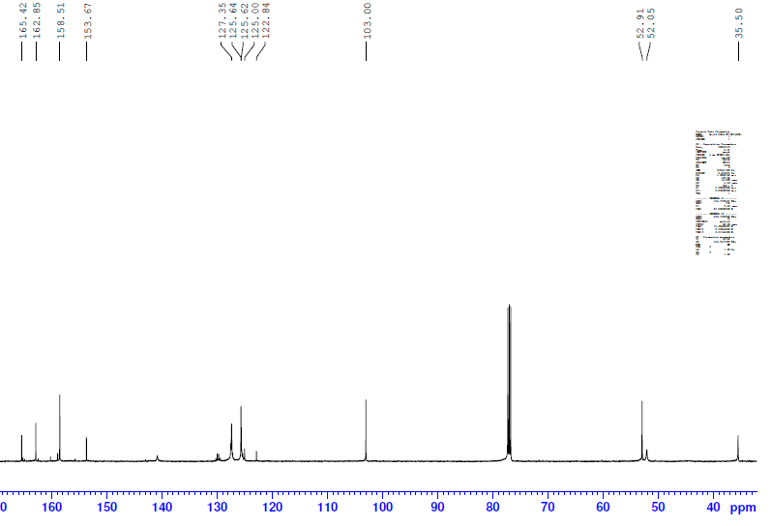

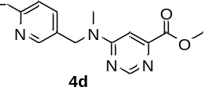
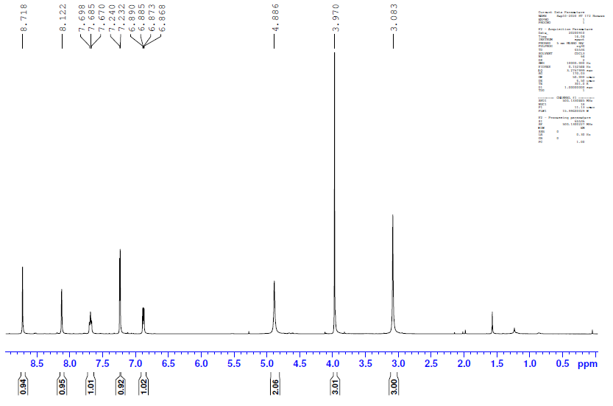

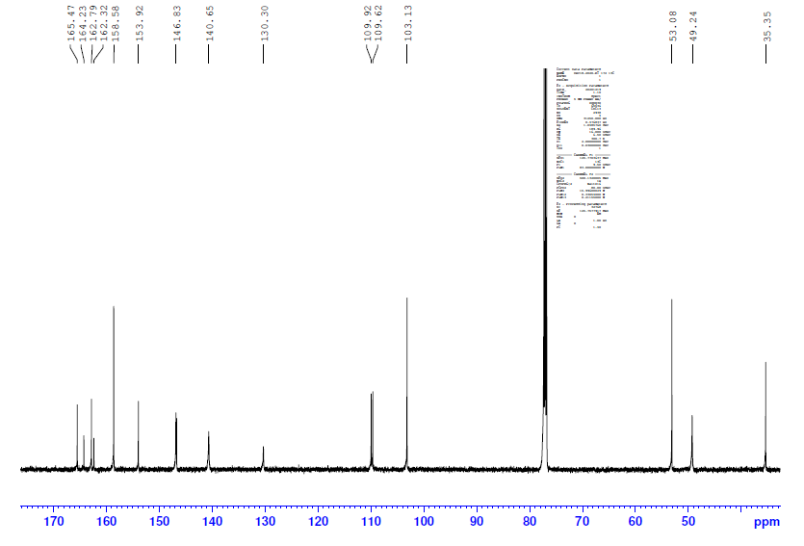

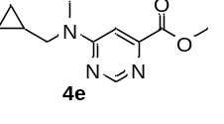
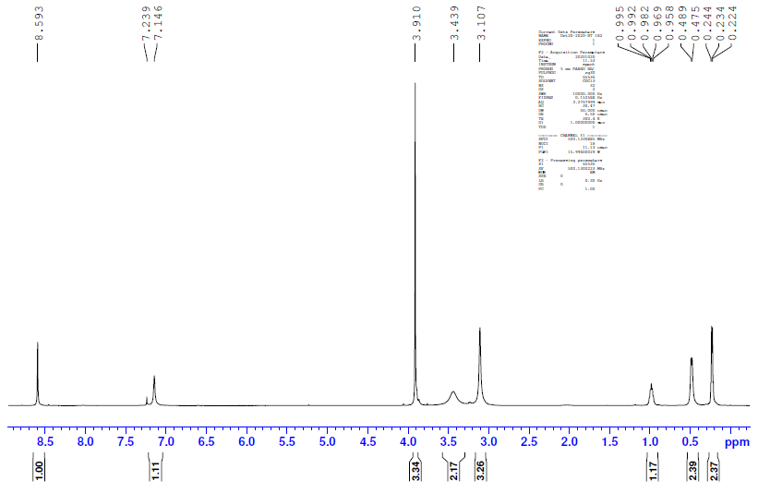

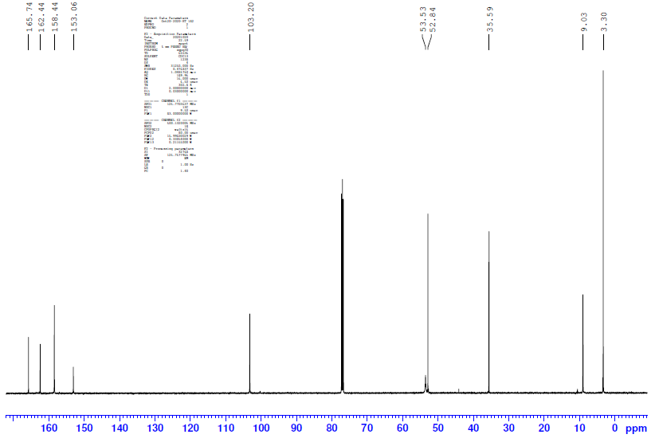

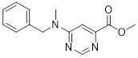
4f
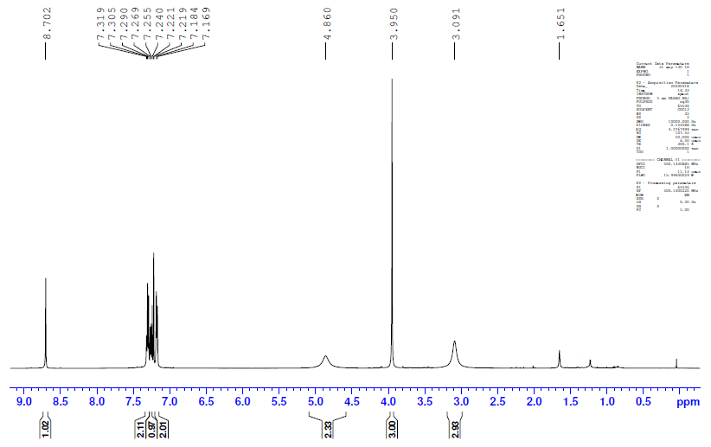

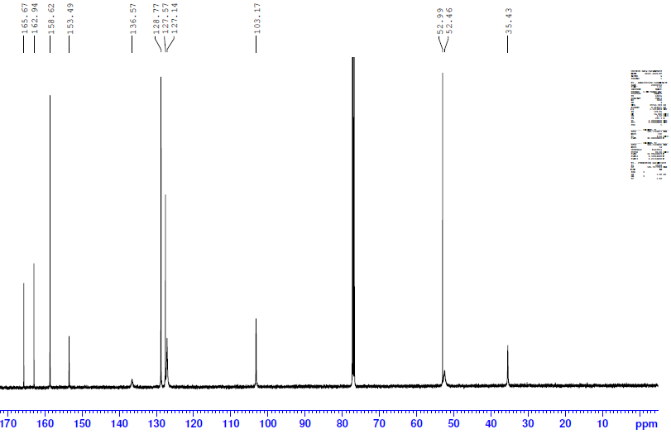

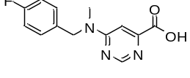
5a
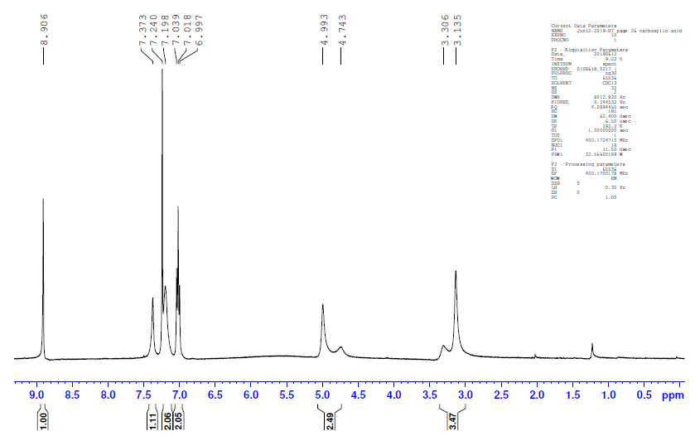

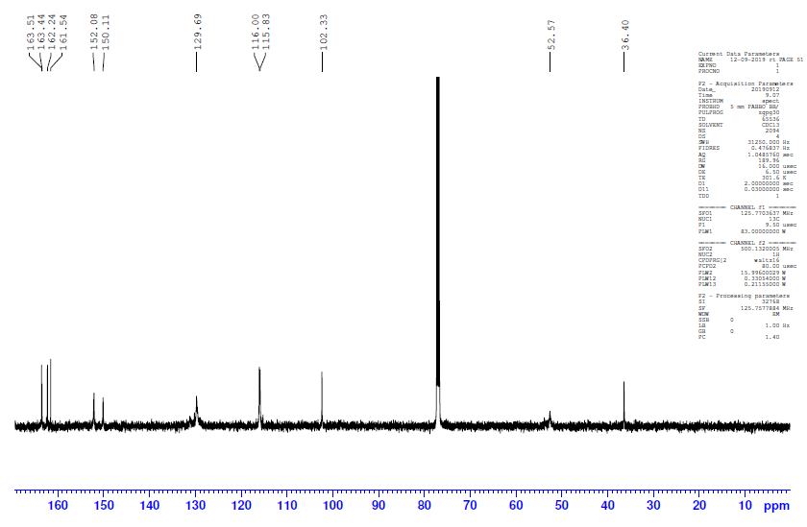

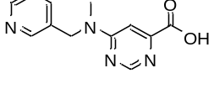
5b
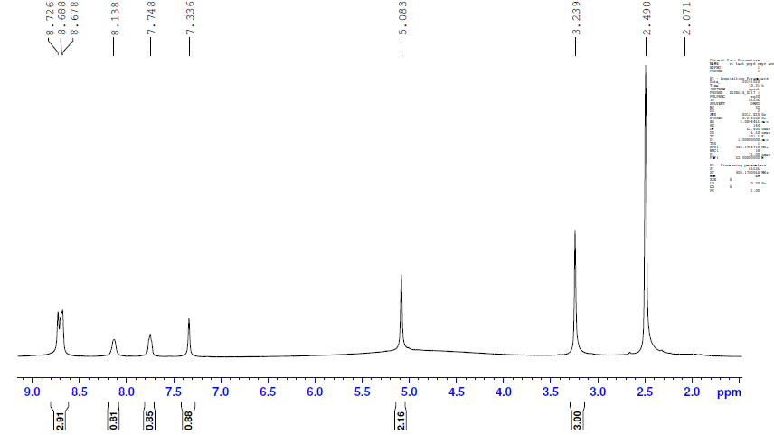

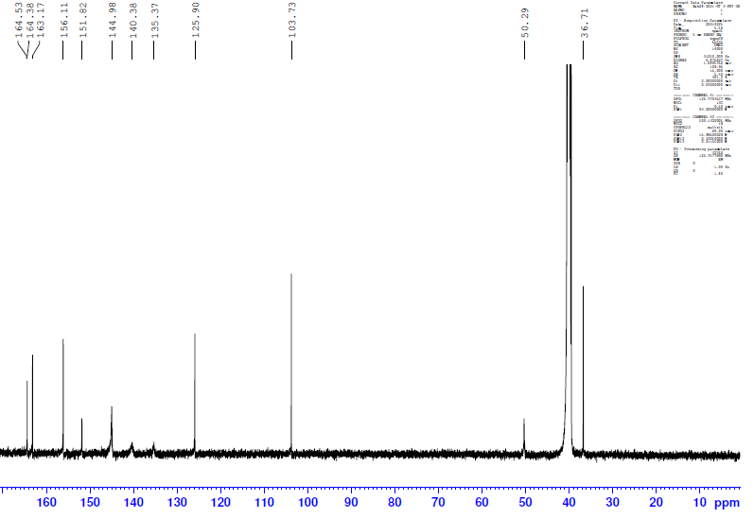

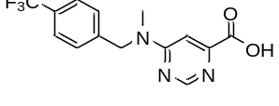
5c
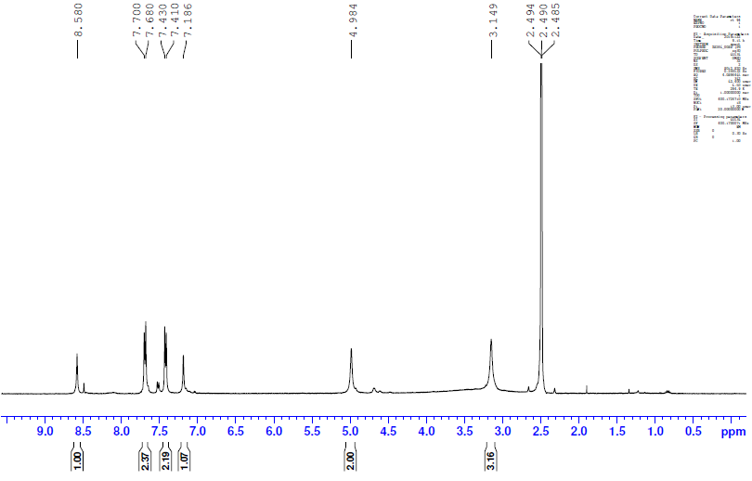

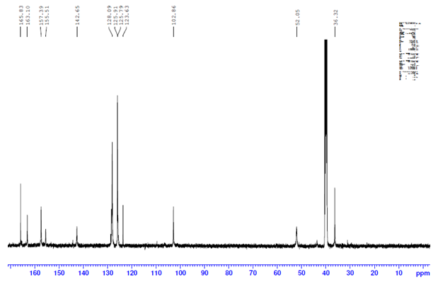

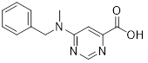
5d
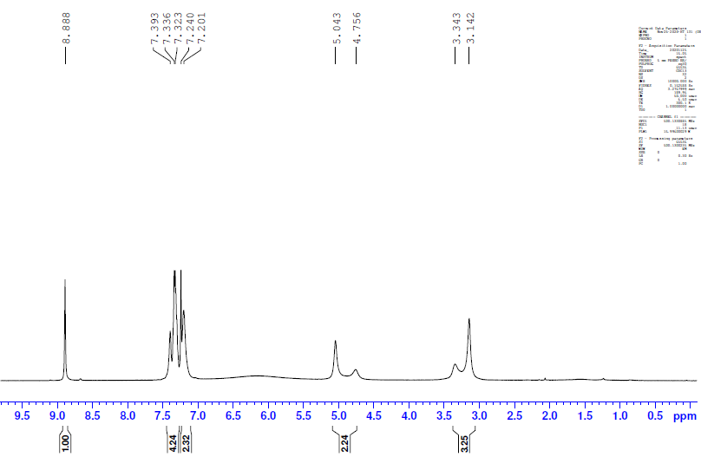
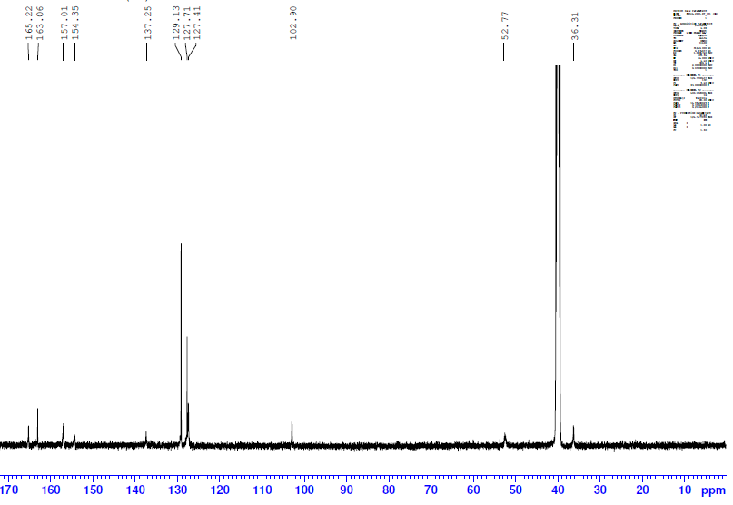
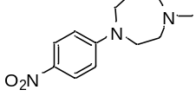
6a
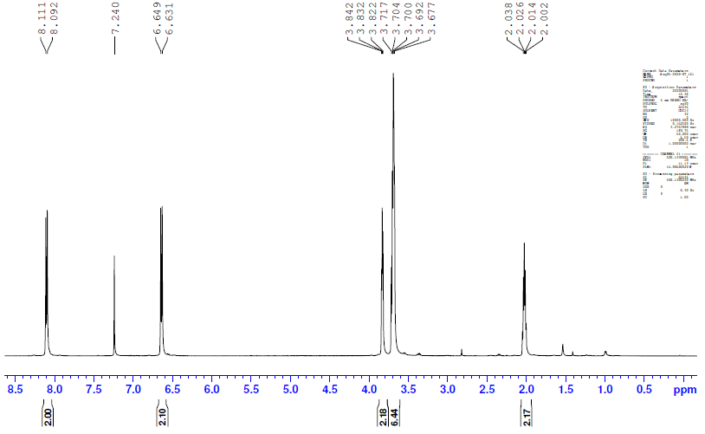

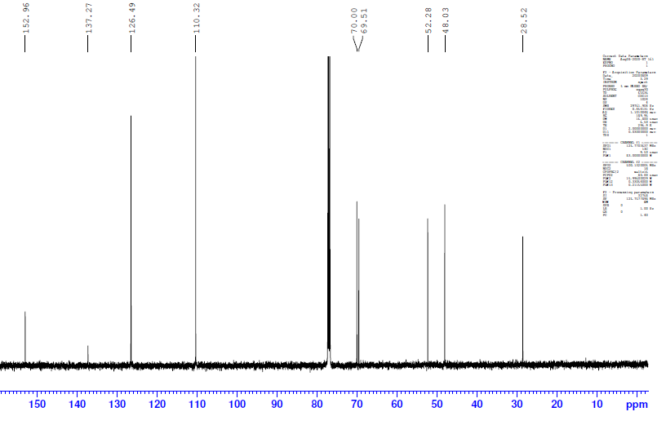

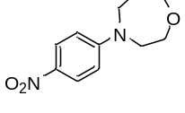
6b
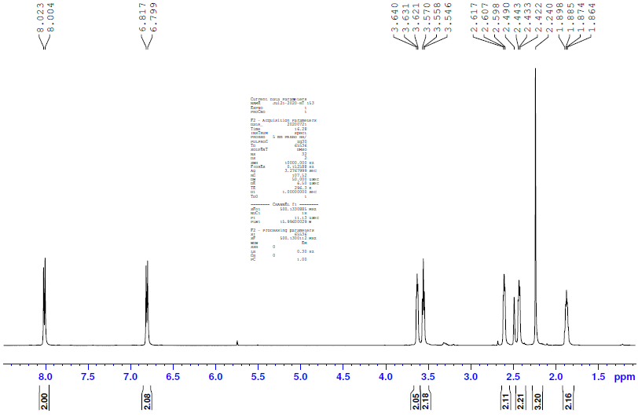

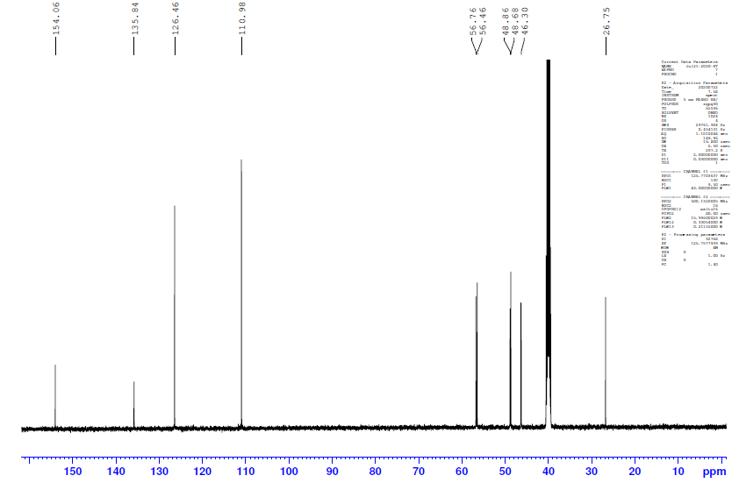

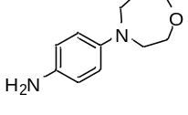
6c
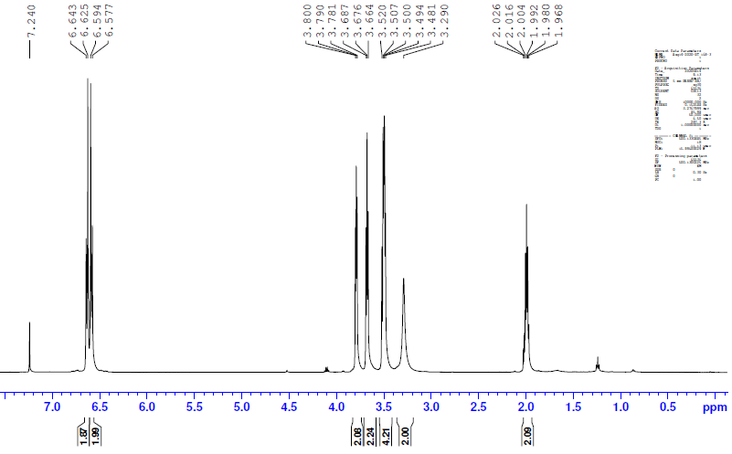

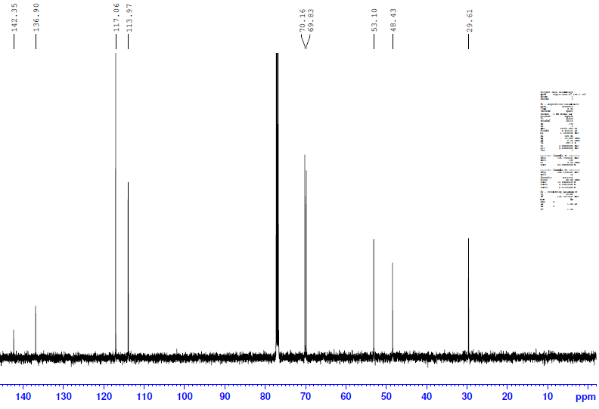

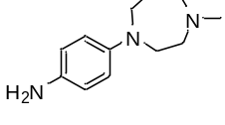
6d
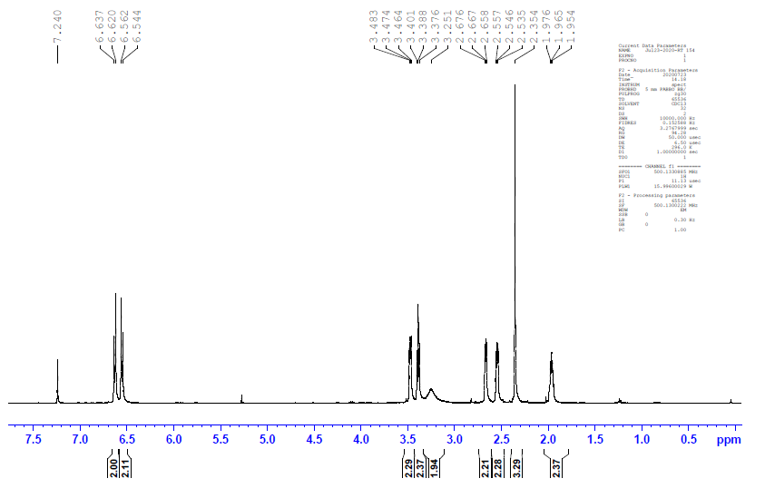

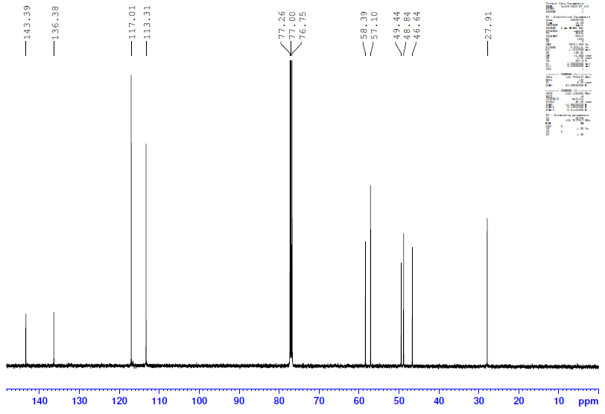
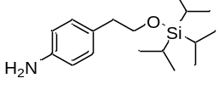
6e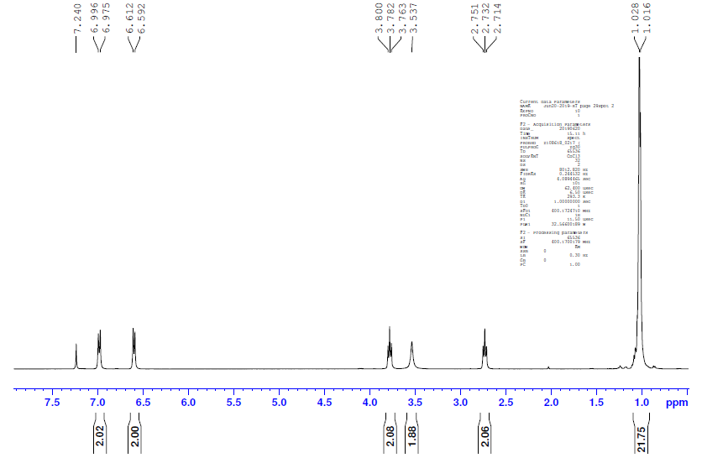

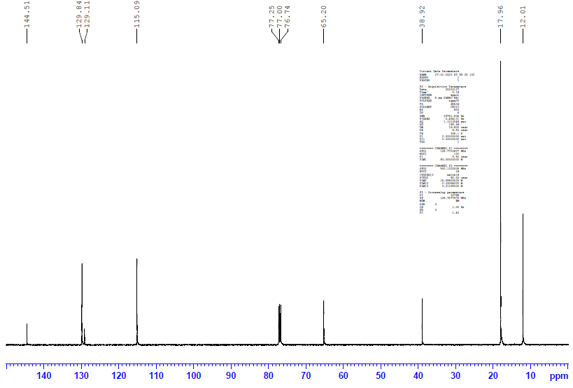

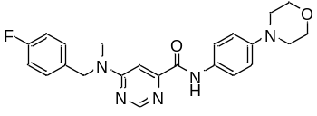
7a
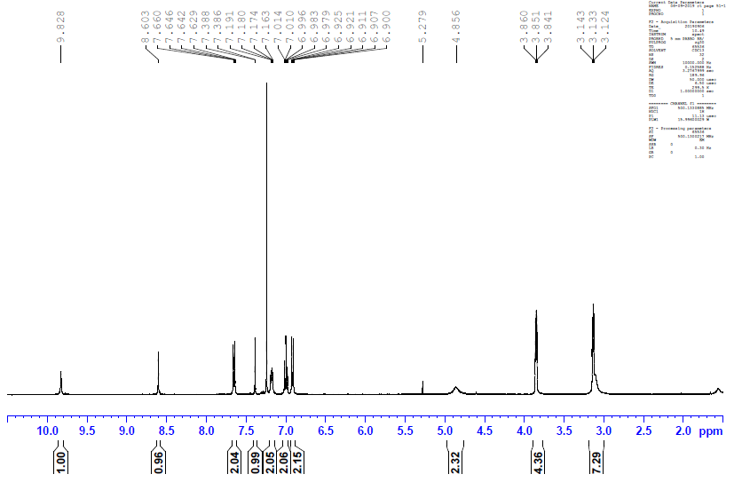

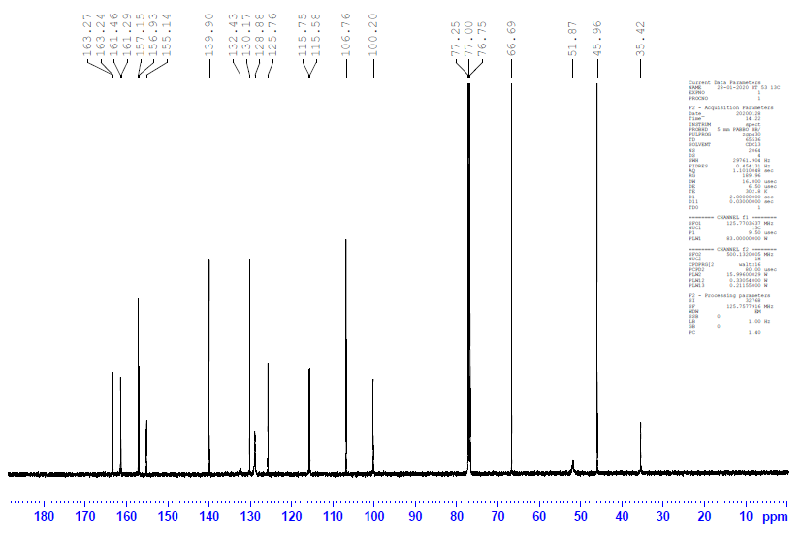

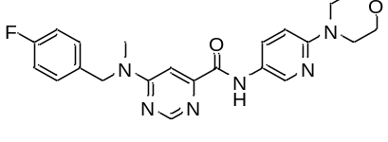
7b
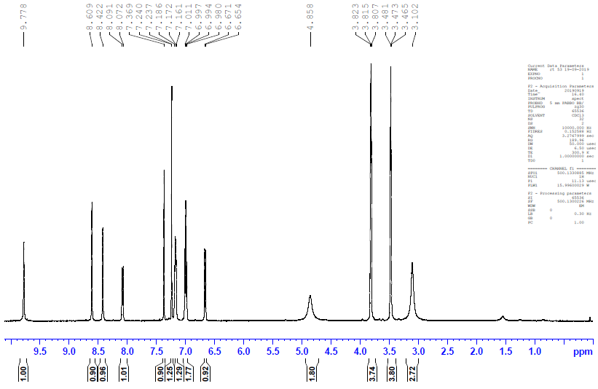

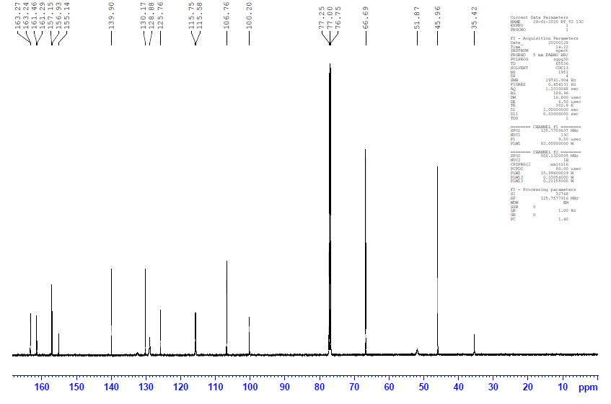

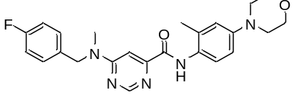
7c
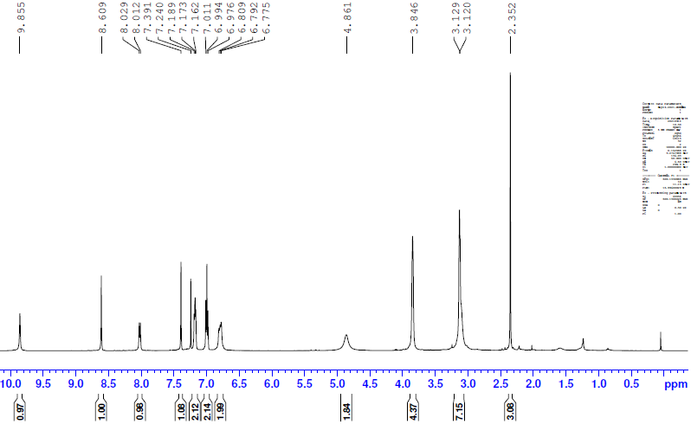

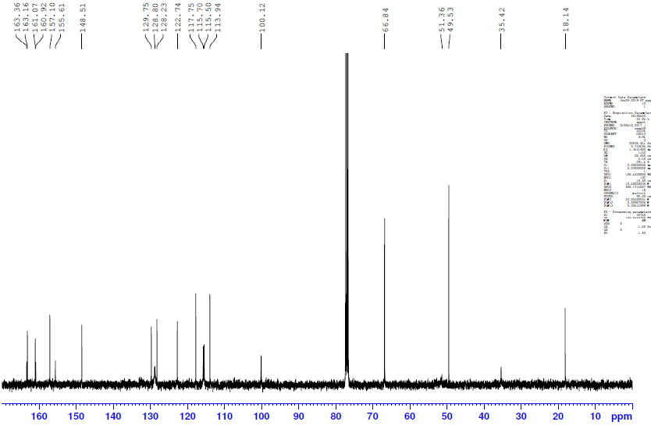

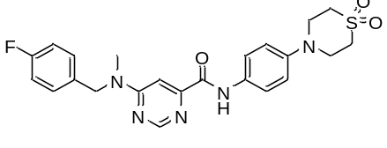
7d
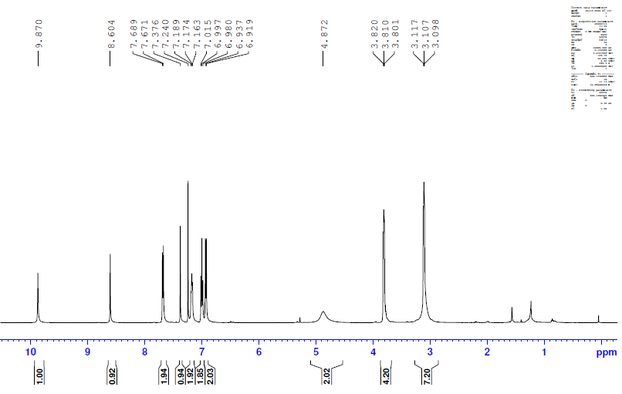

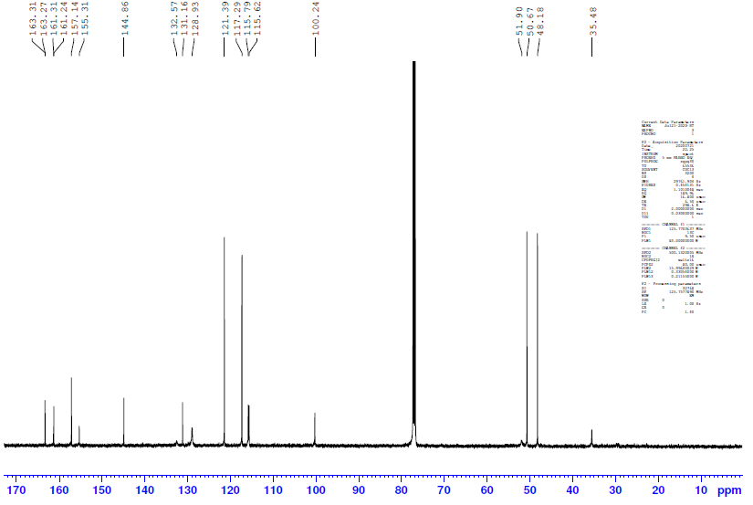

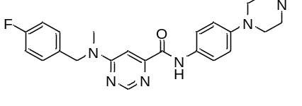
7e
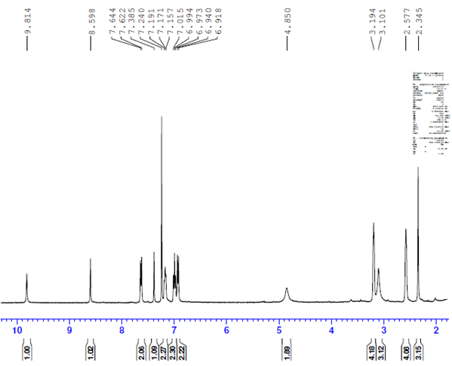

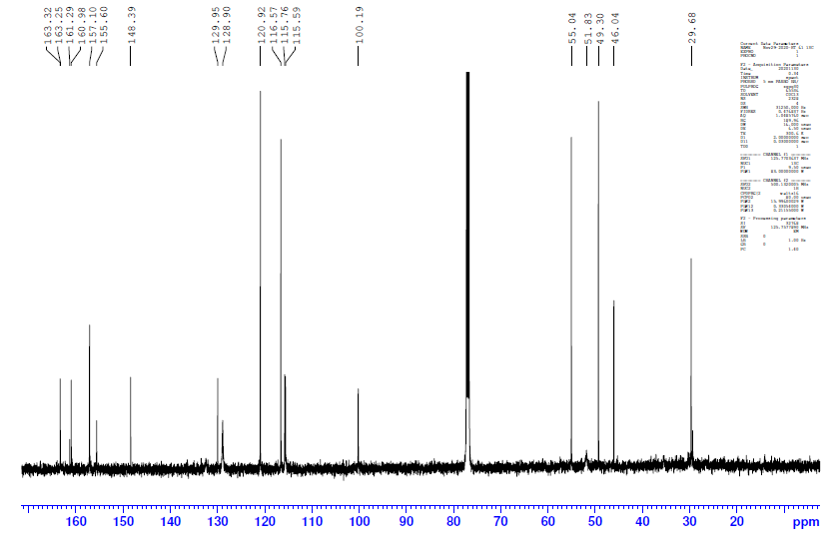
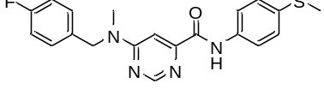
7f
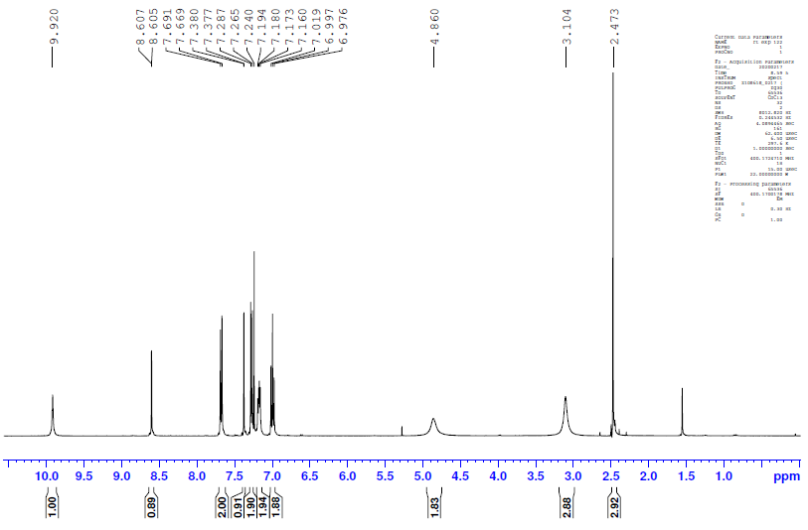

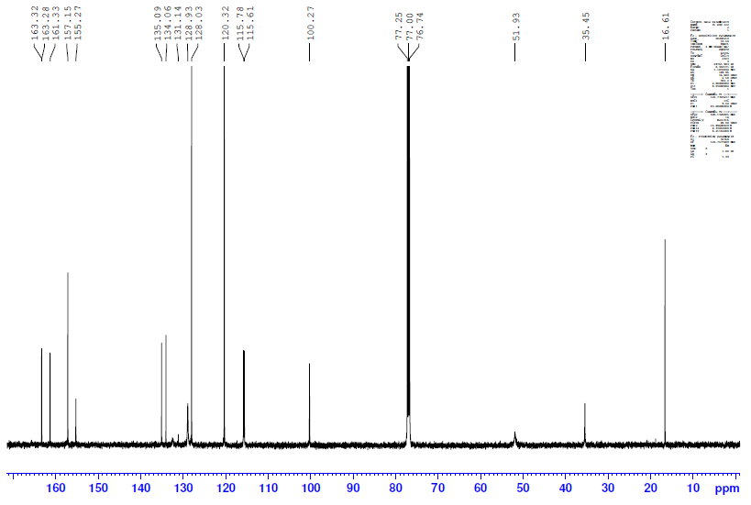

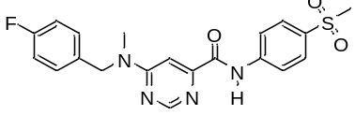
7g
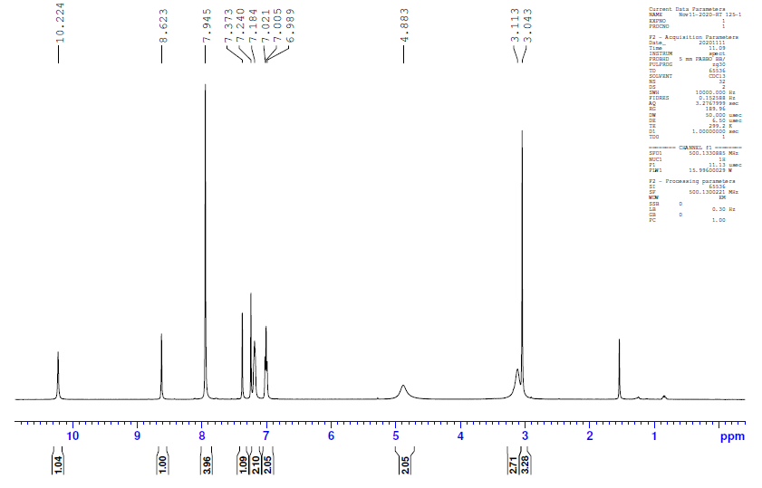

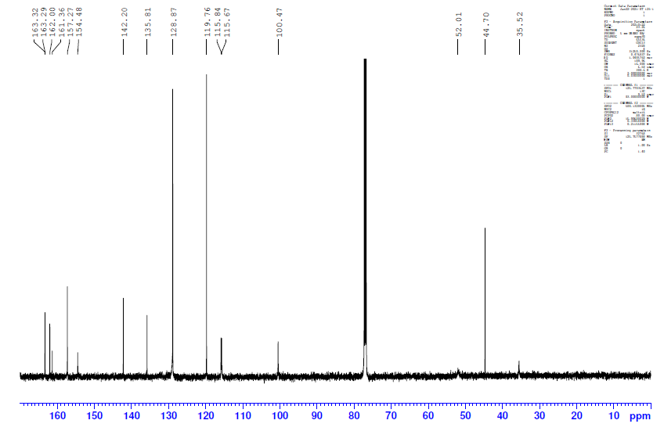

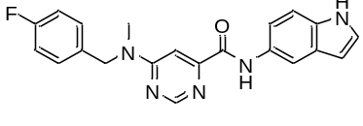
7h
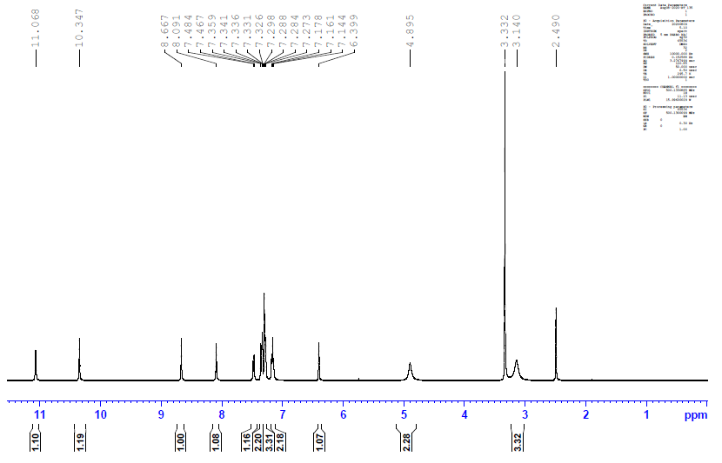

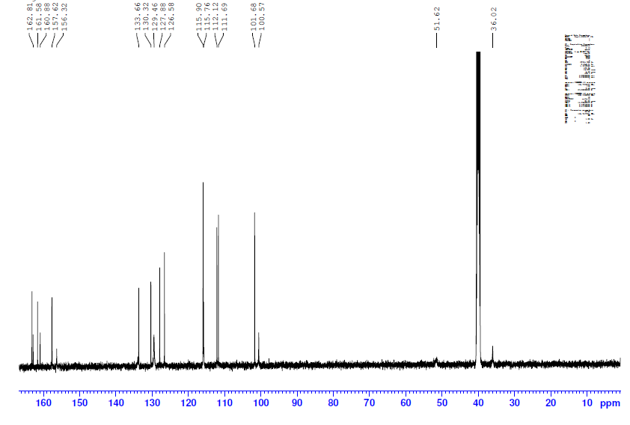
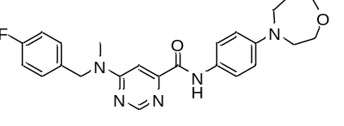
7i
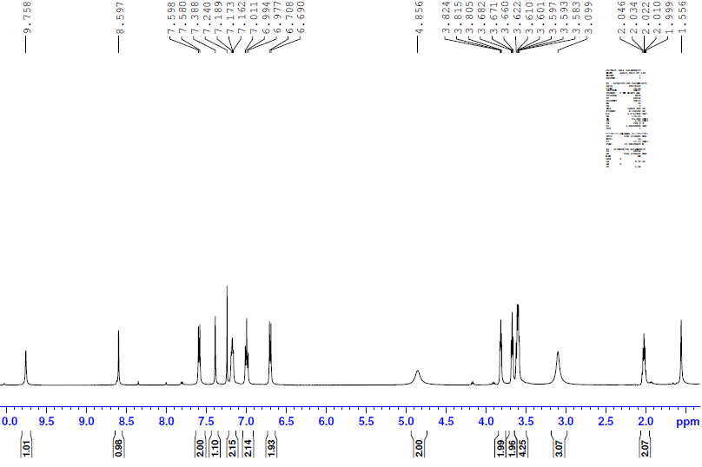

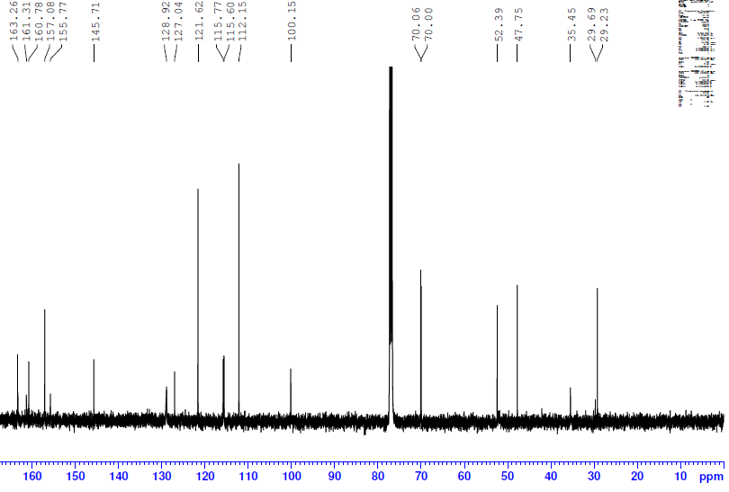
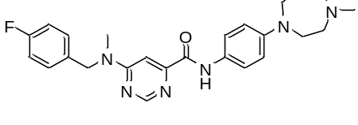
7j
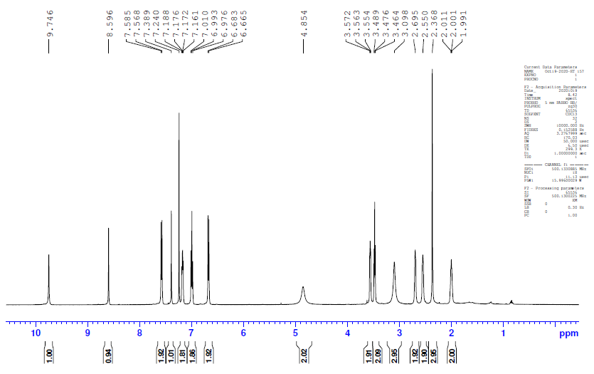

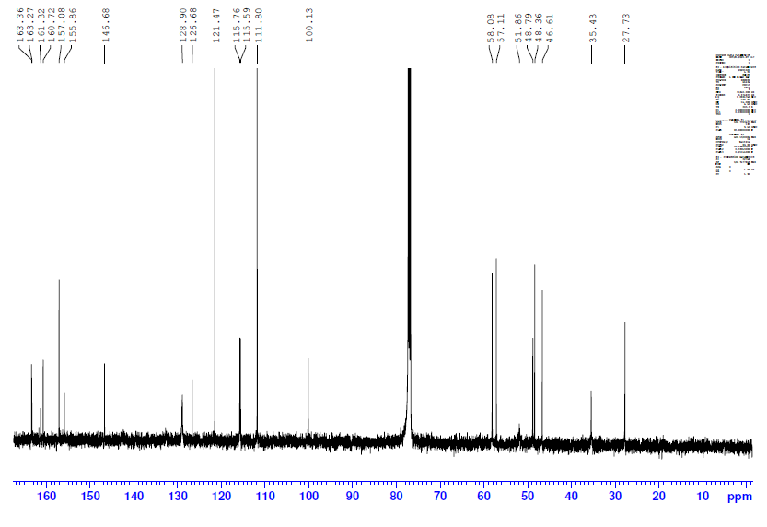

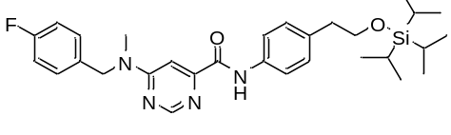
A
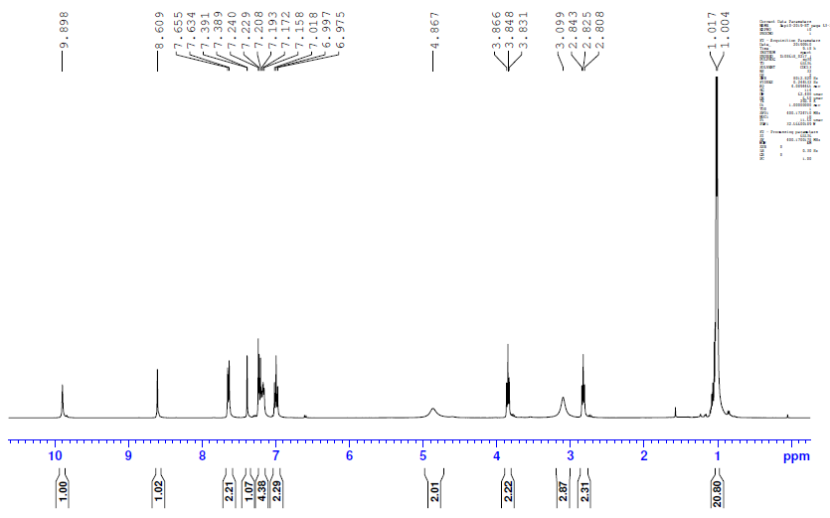

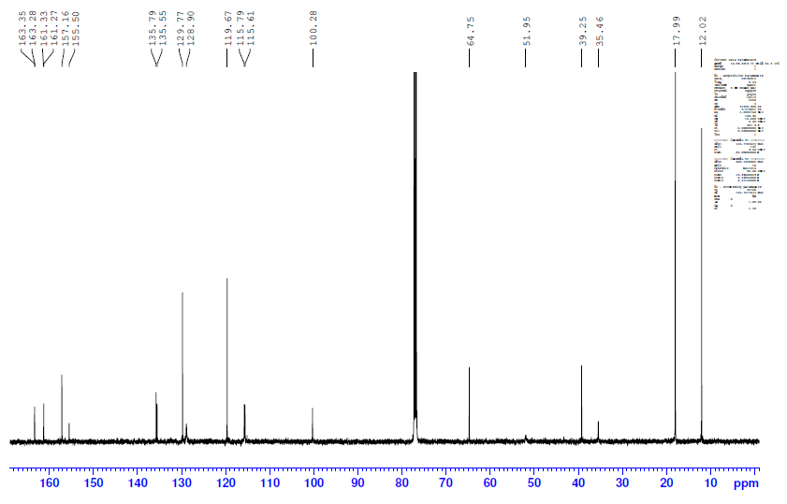

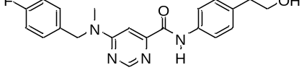
7k
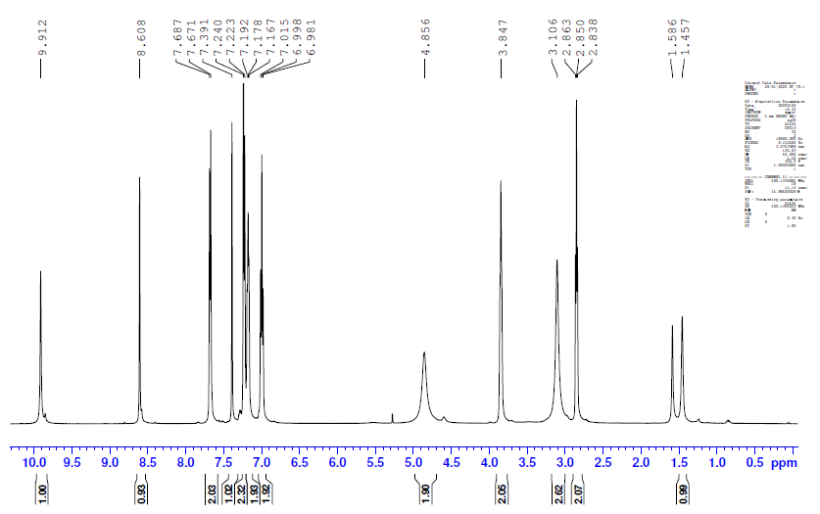

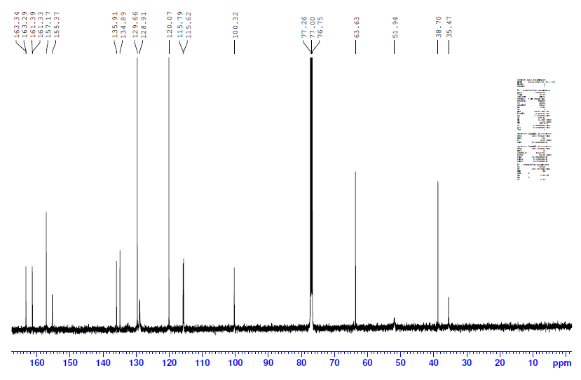

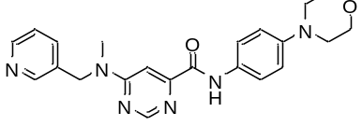
7l
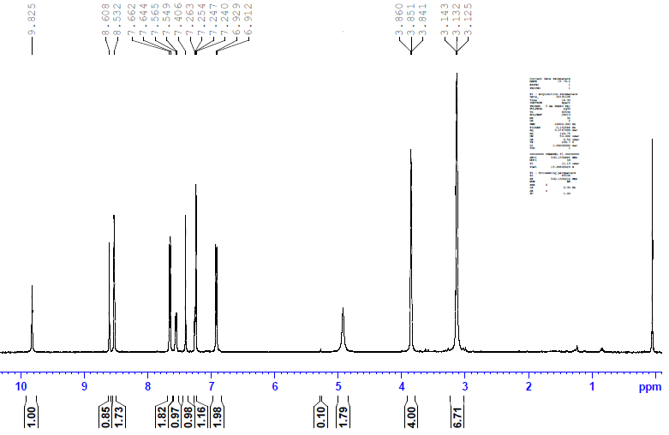

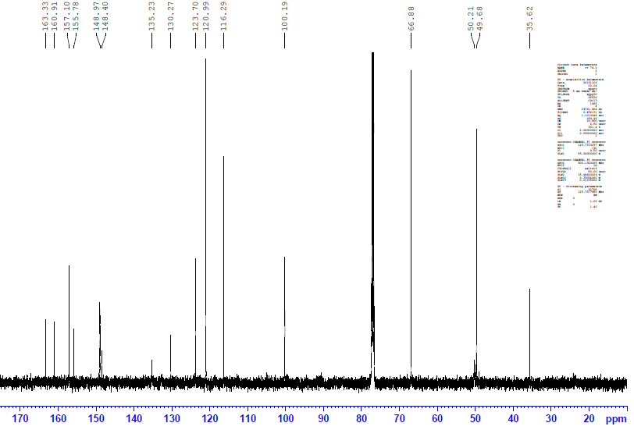

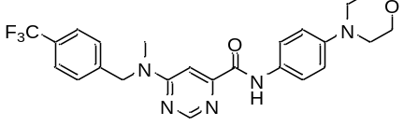
7m
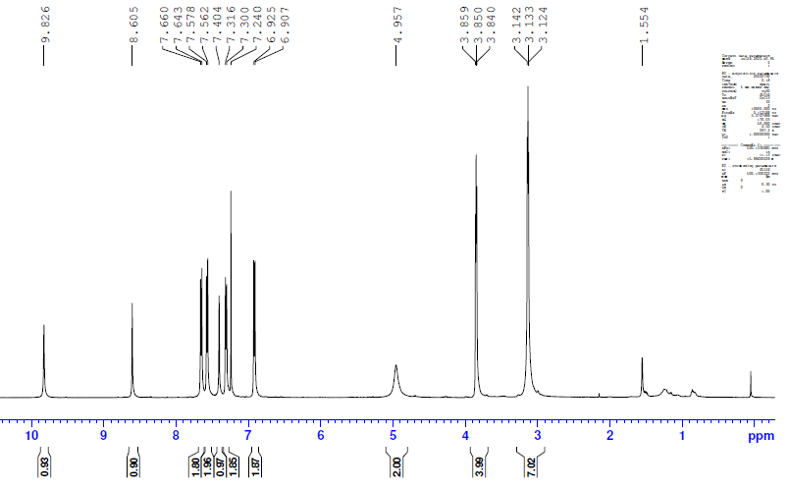

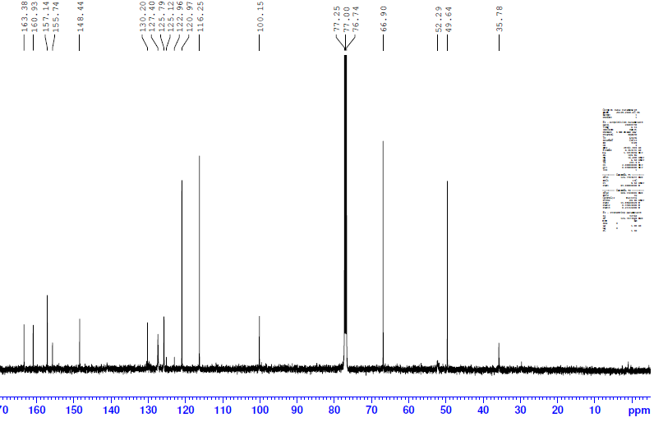

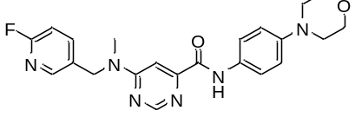
7n
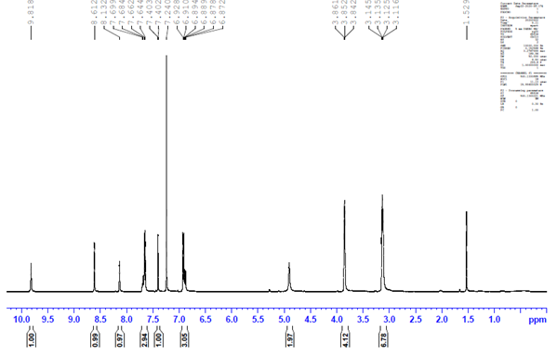

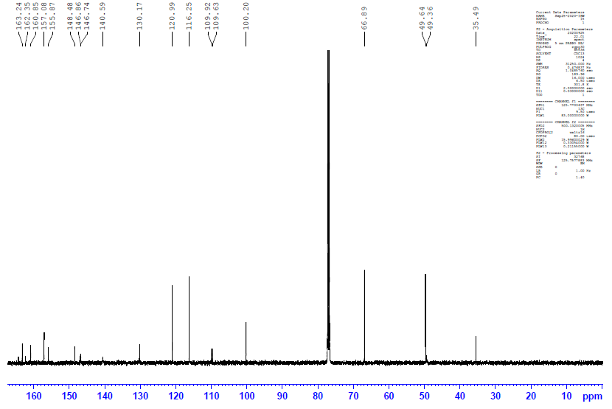

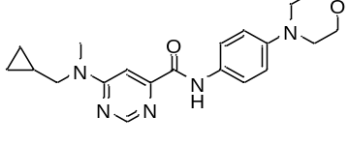
7o
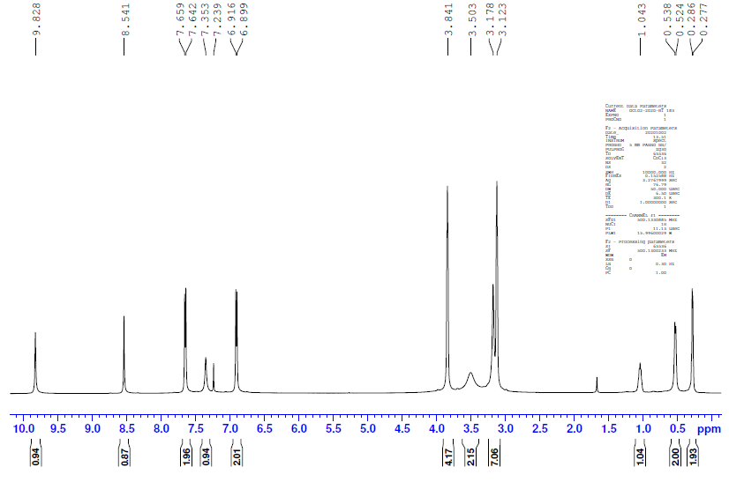

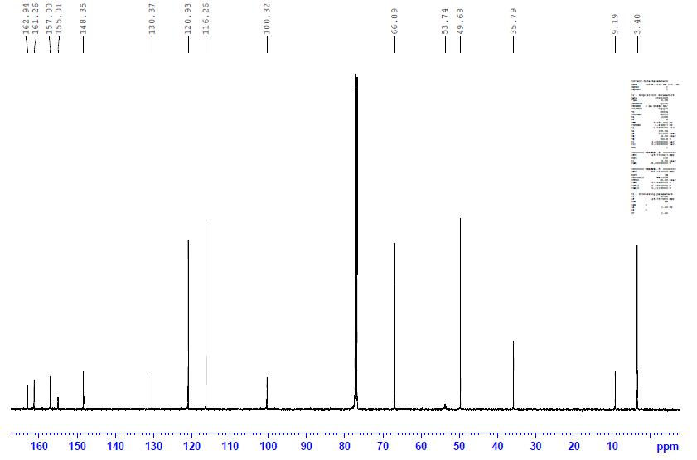

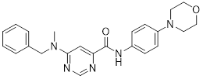
7p
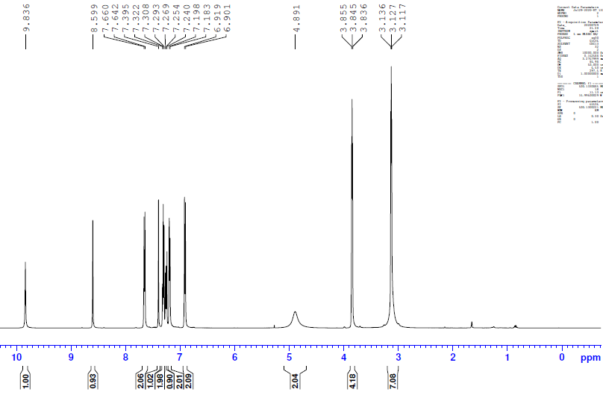
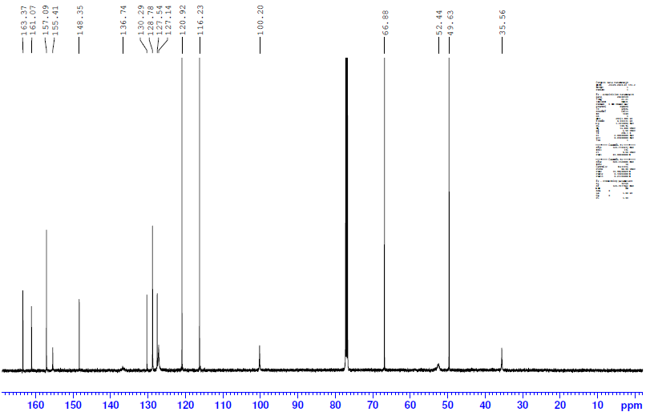
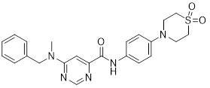
7q
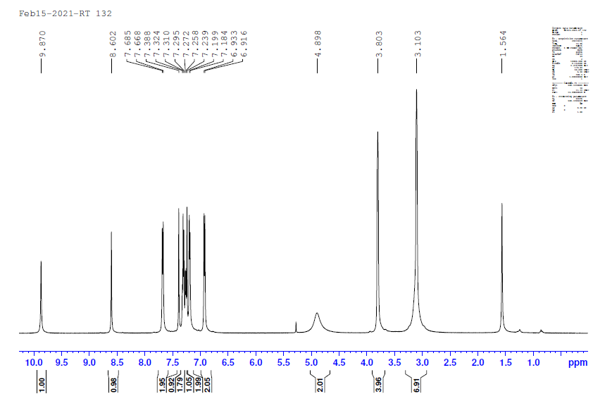

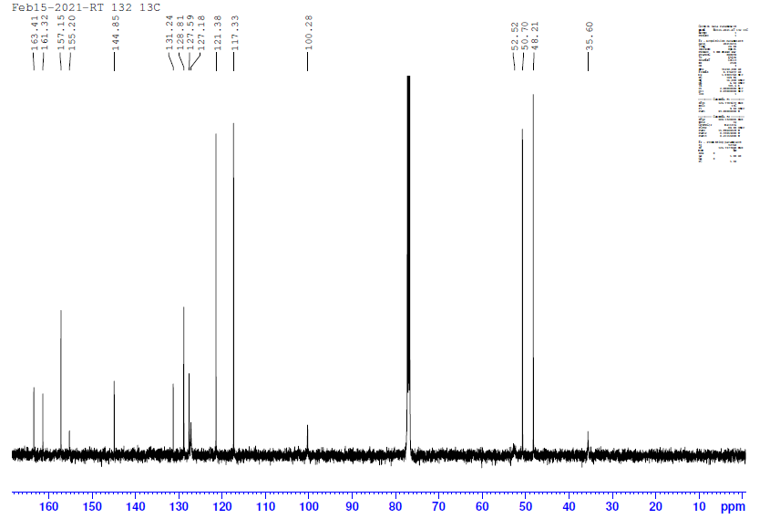
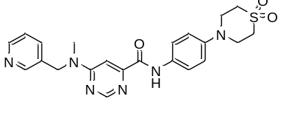
7r
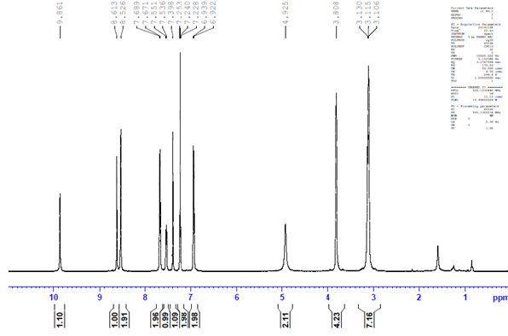

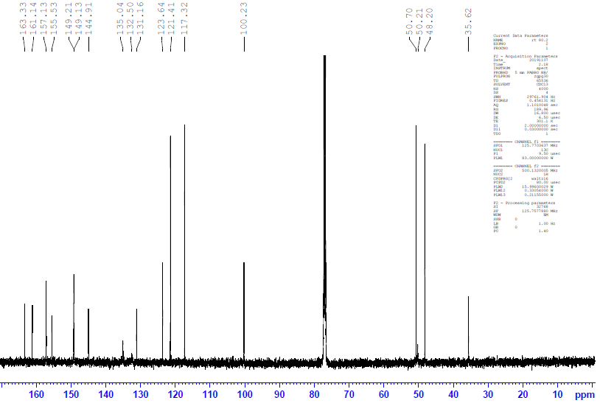

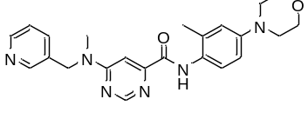
7s
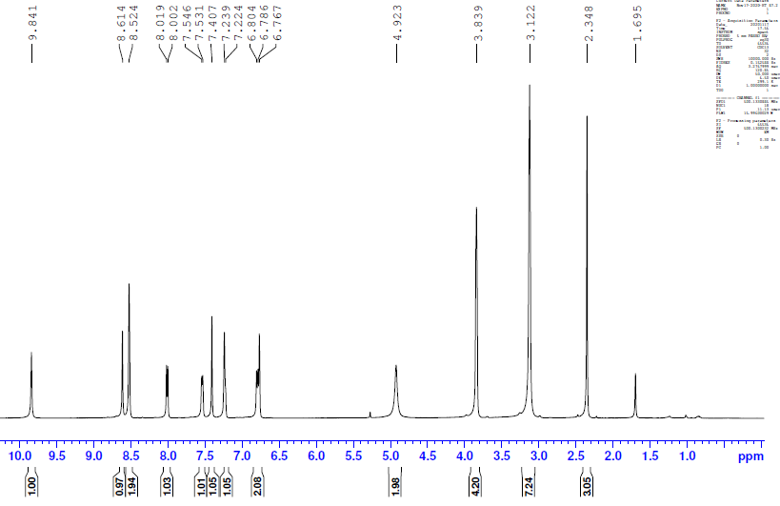

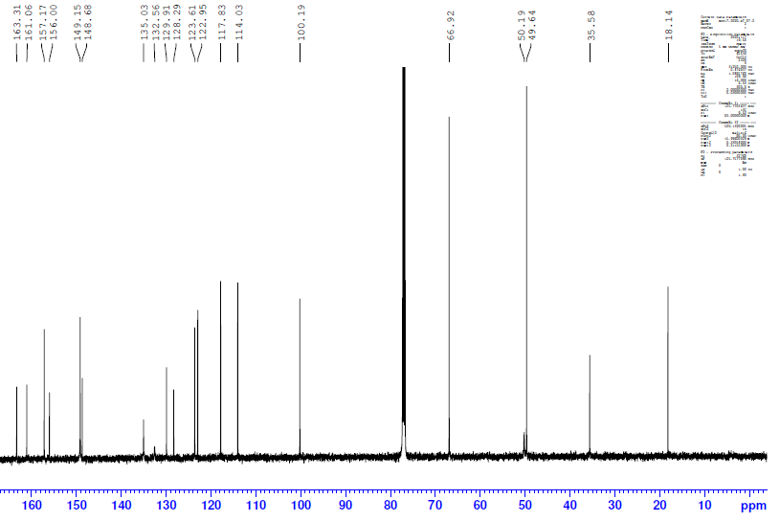

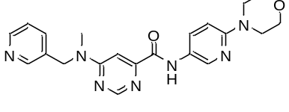
7t
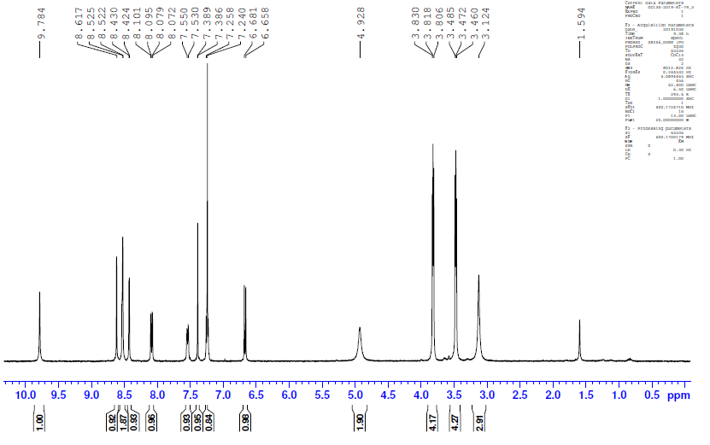

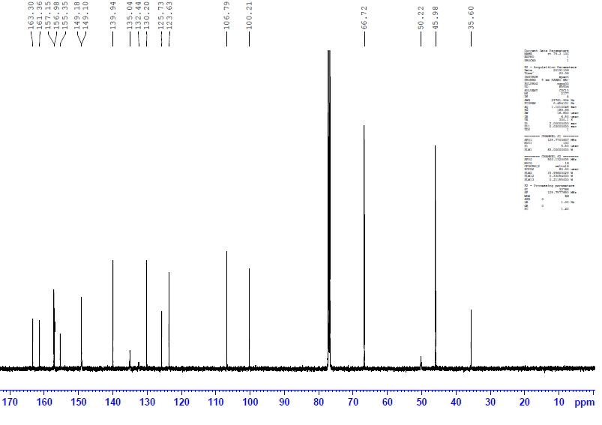

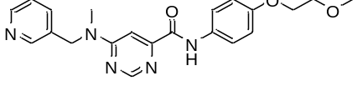
7u
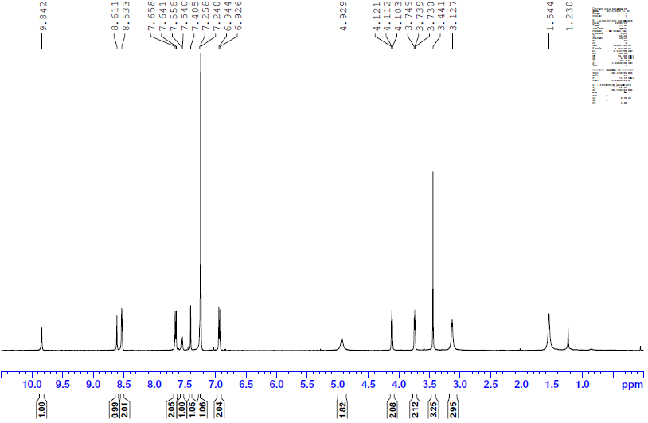

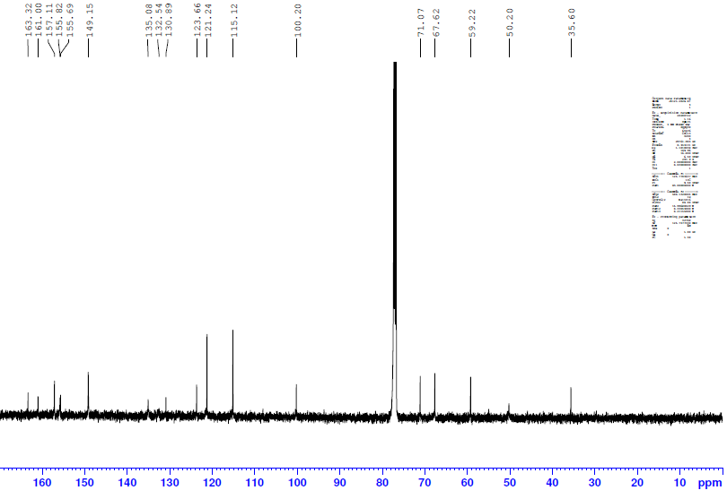

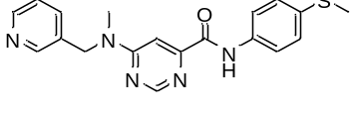
7v
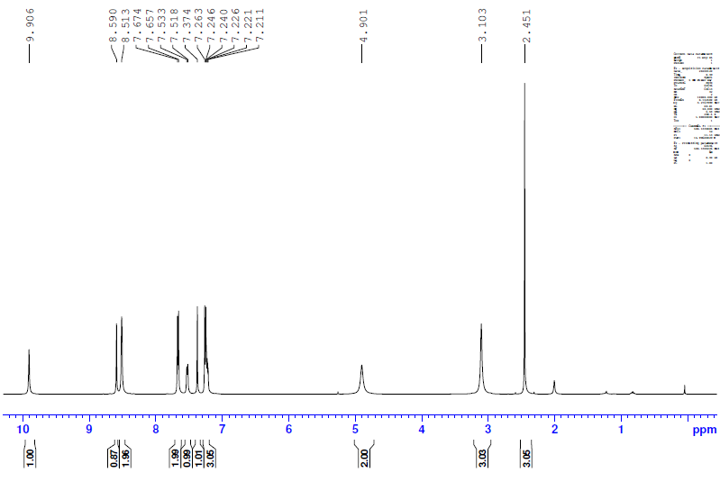

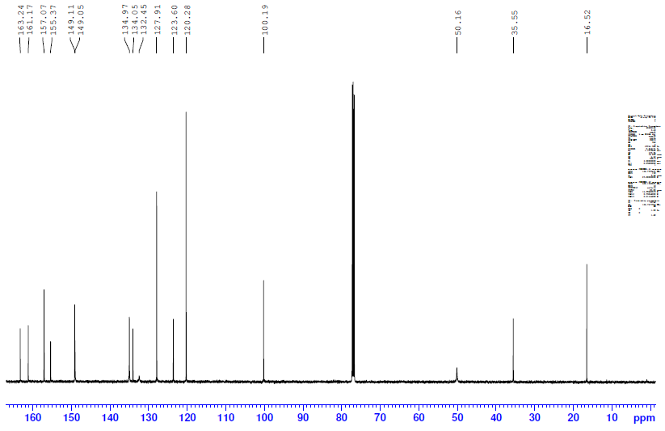

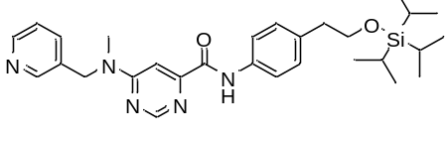
B
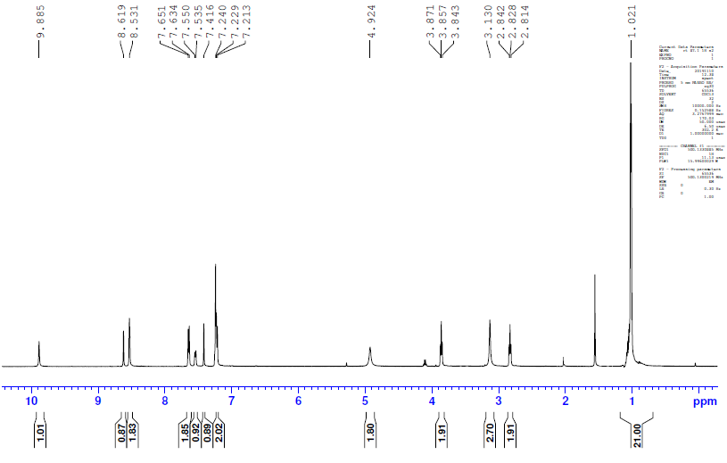

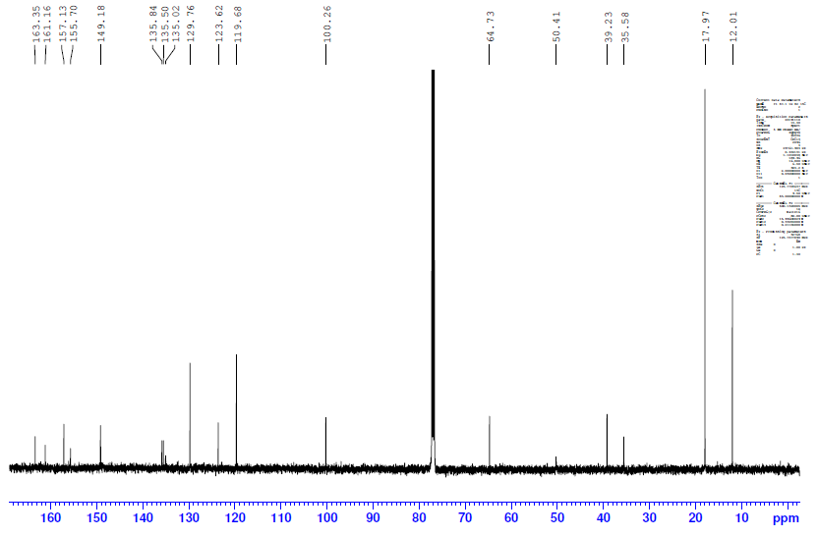

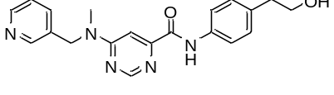
7w
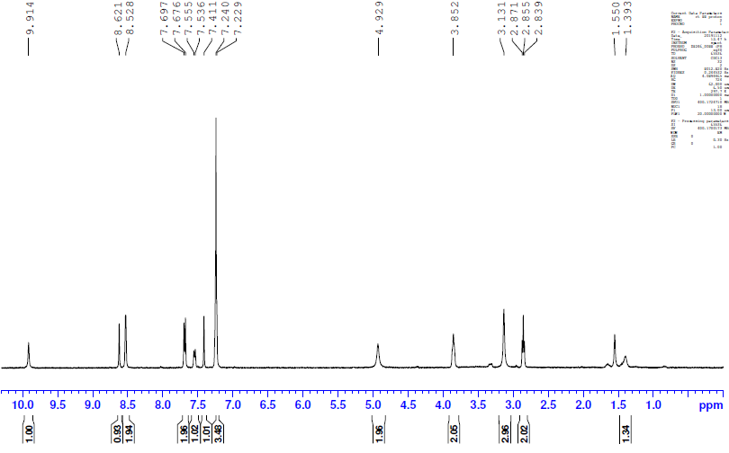

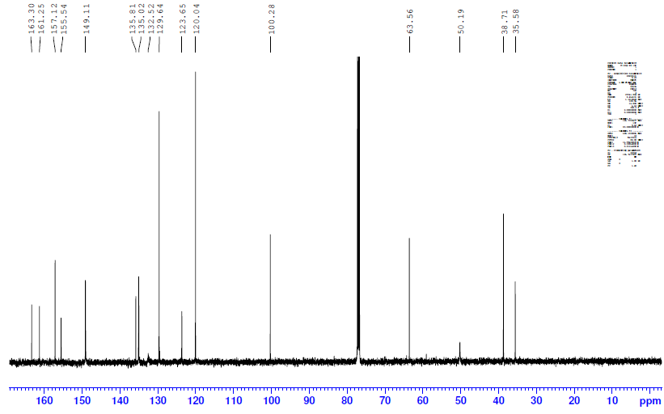

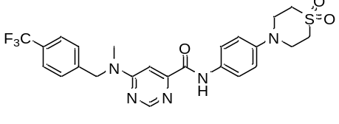
7x
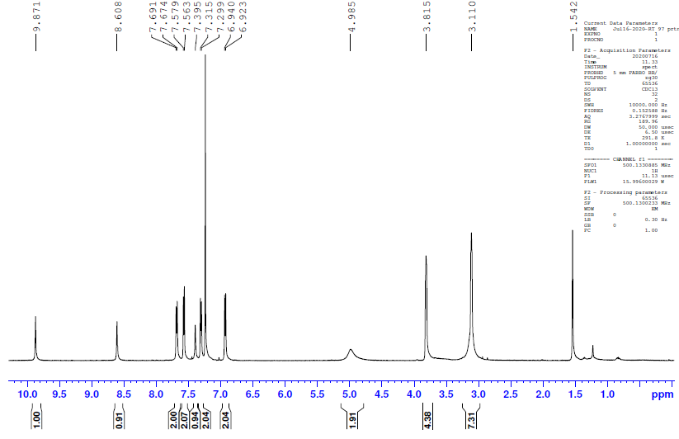

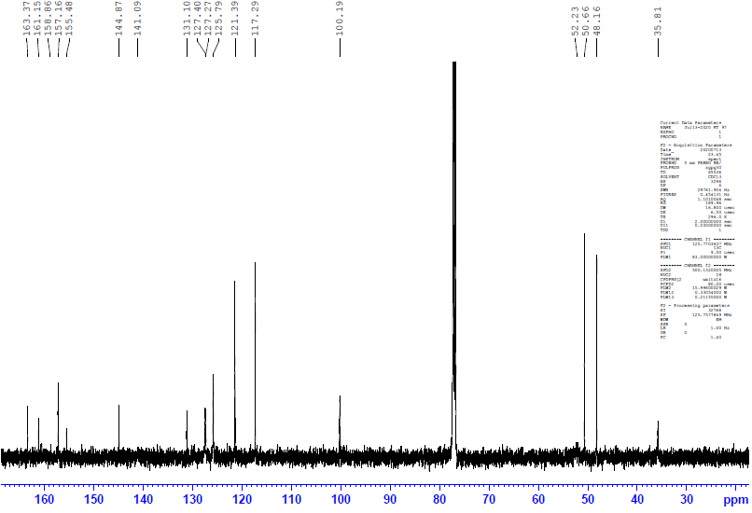

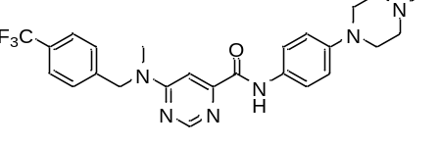
7y
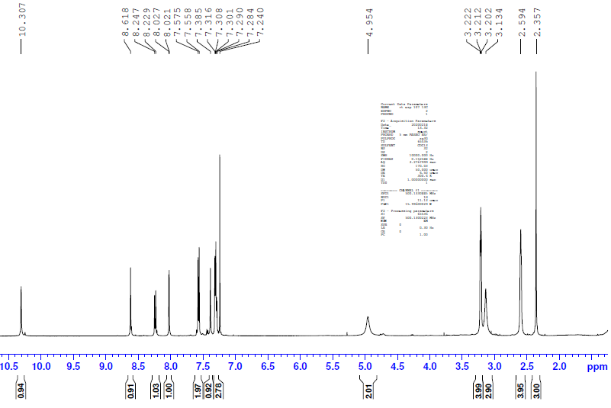

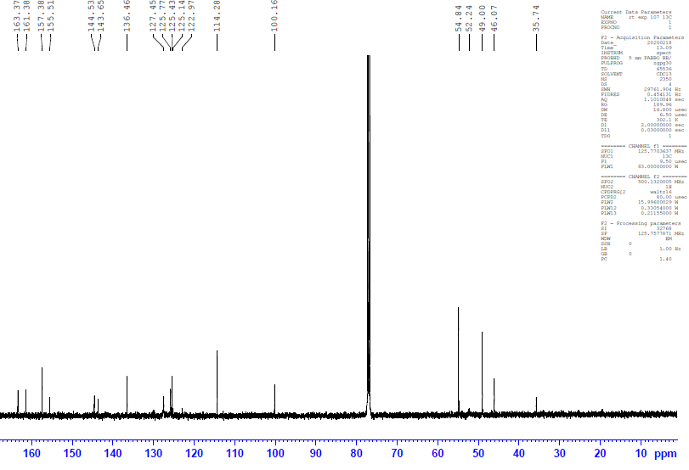
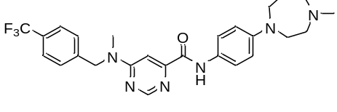
7z
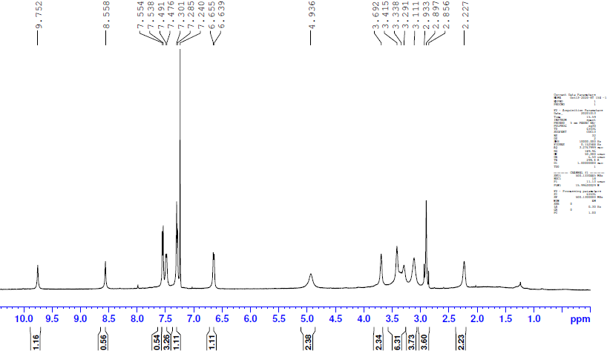

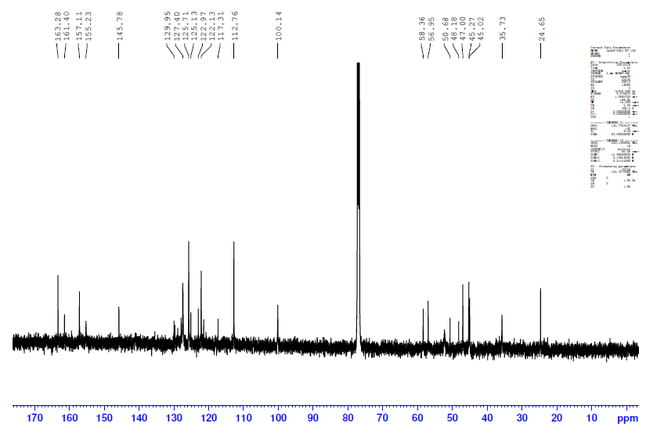

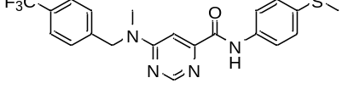
7aa
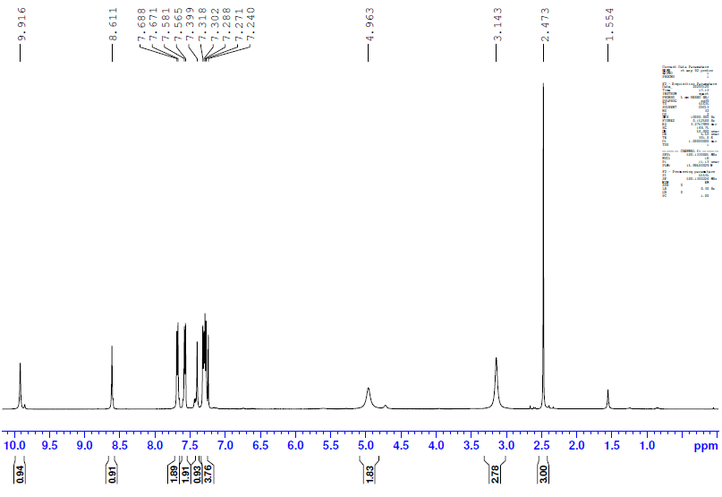

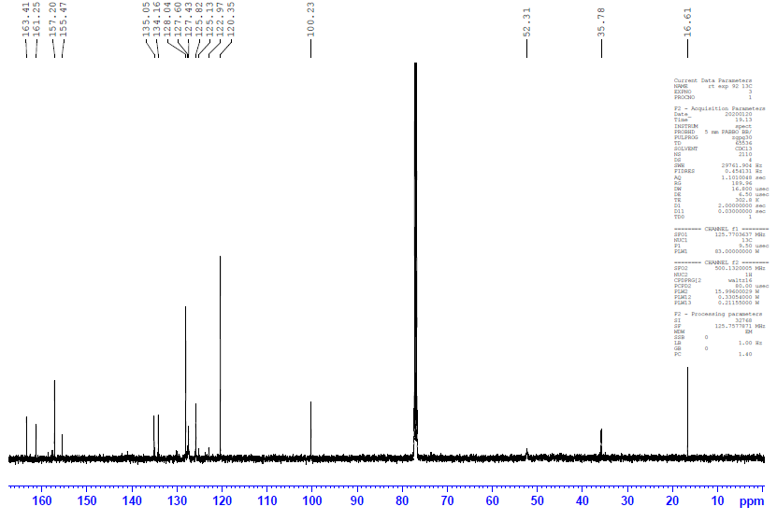

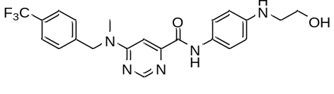
7ab
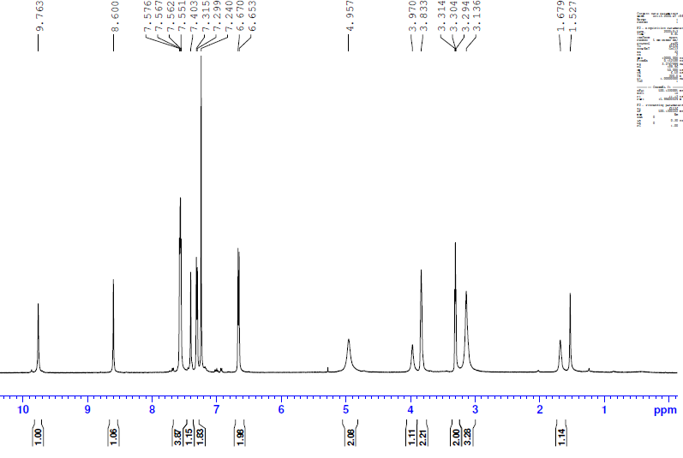

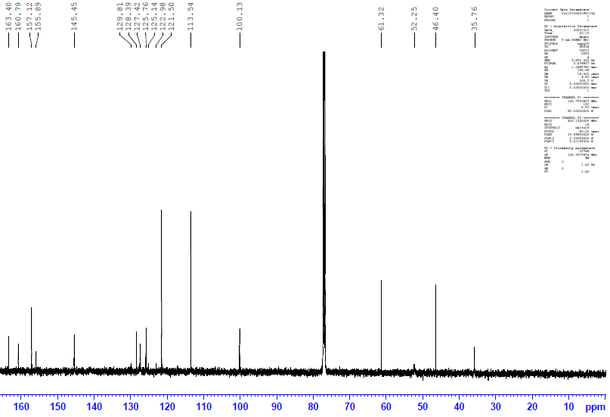

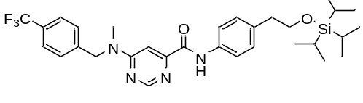
C
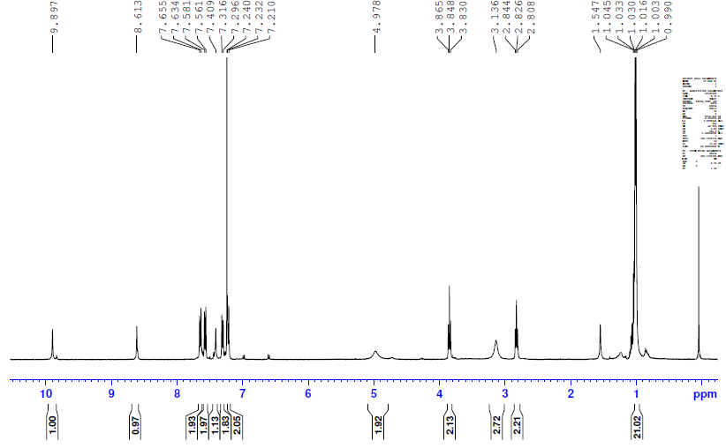

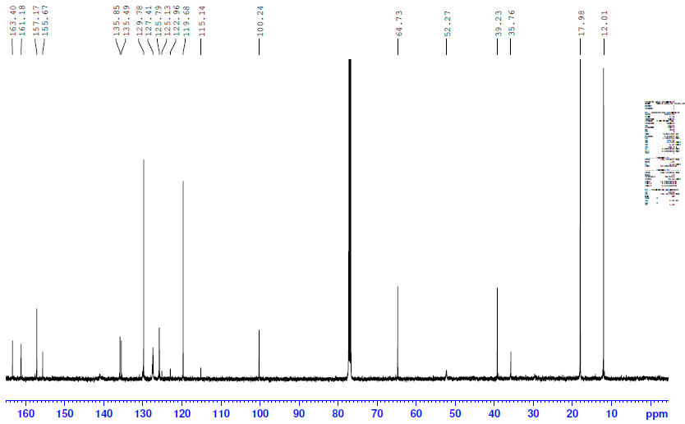

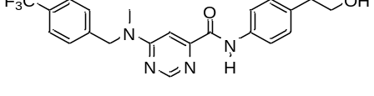
7ac
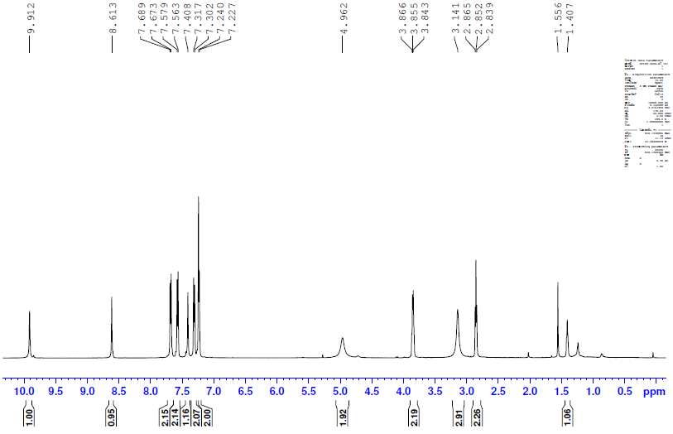

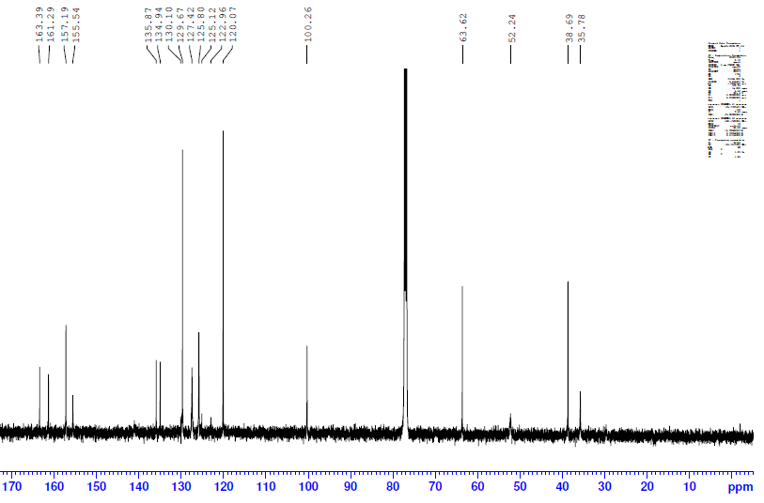

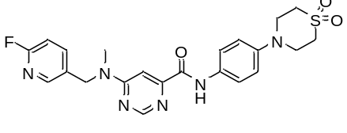
7ad
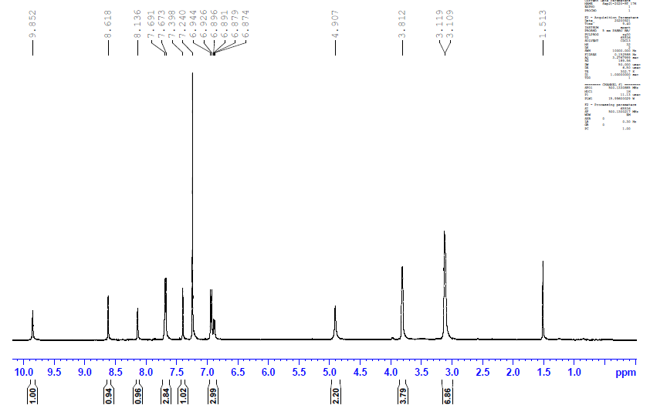

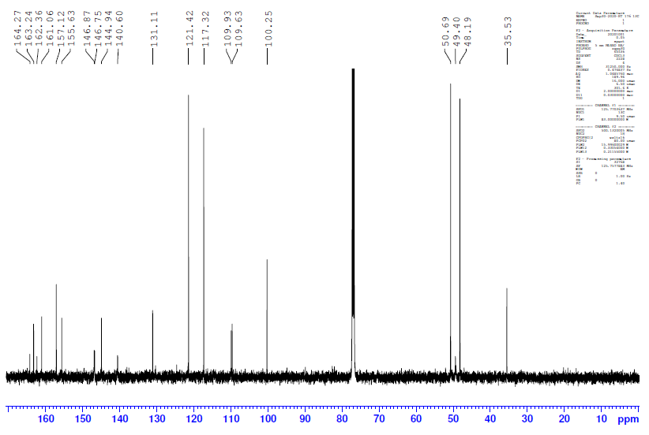

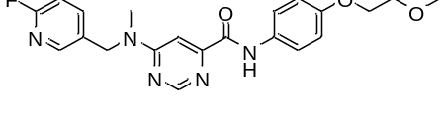
7ae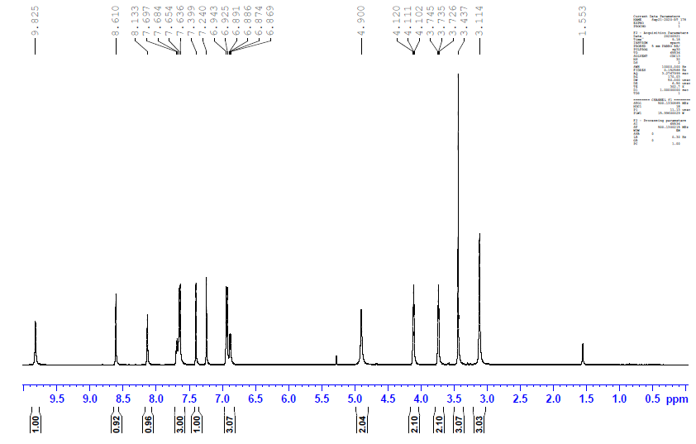

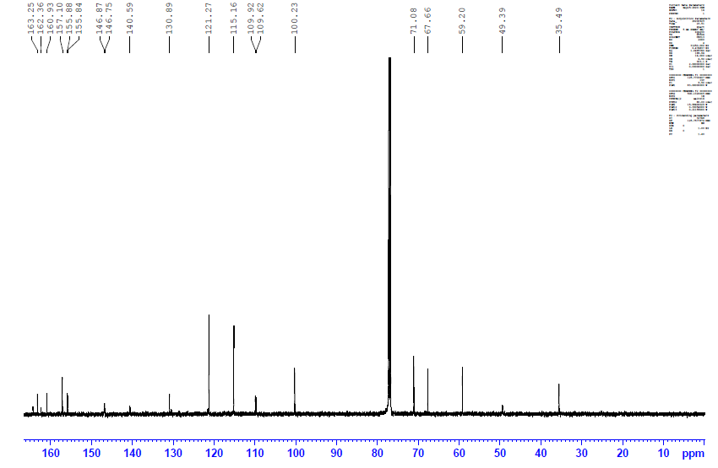

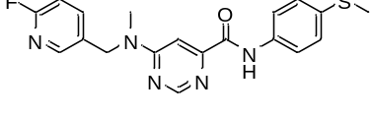
7af
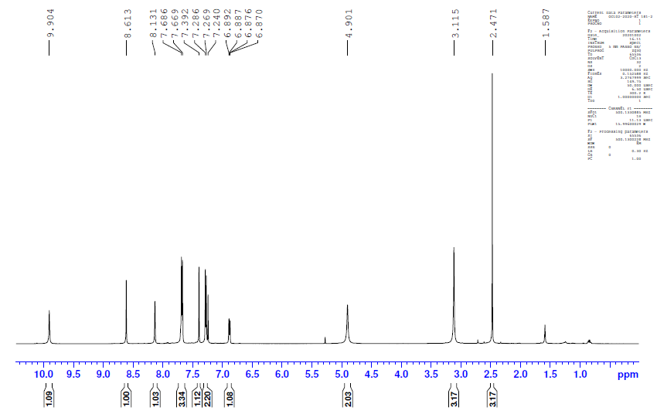

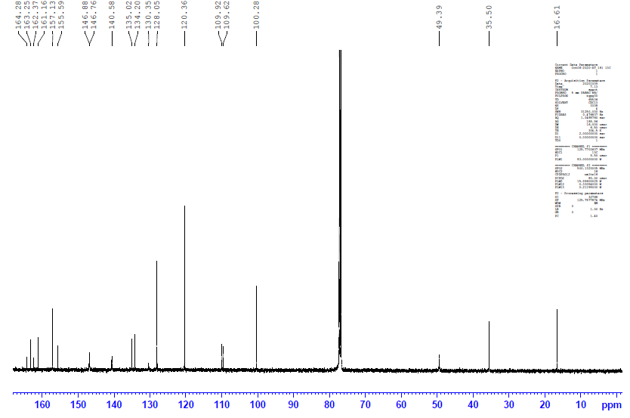

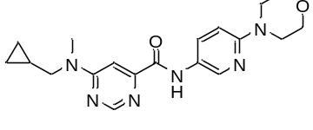
7ag
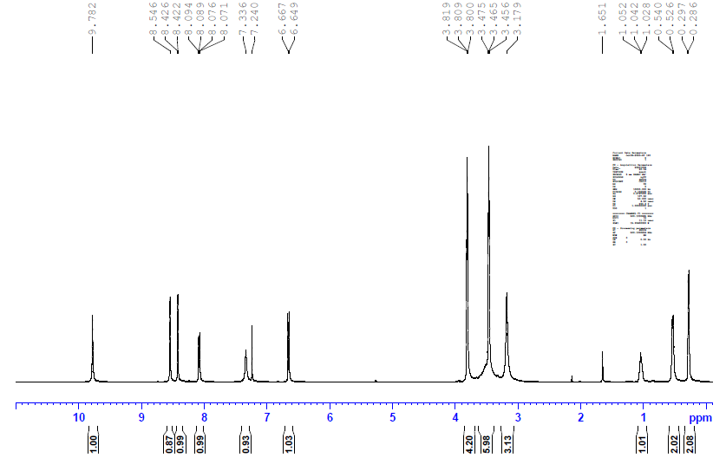

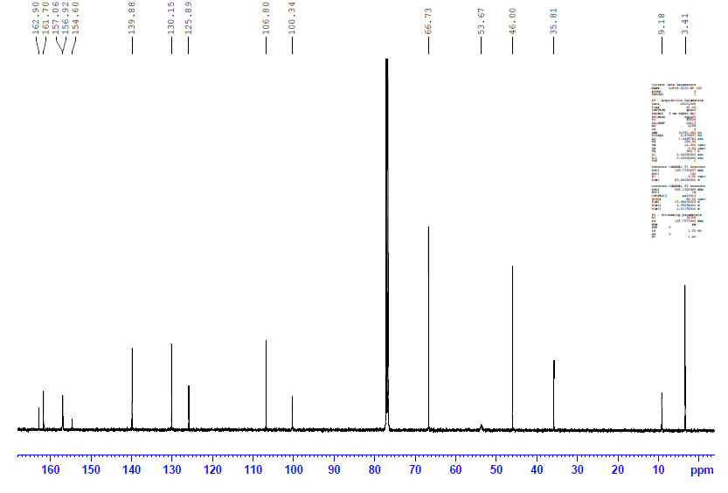

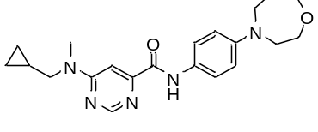
7ah
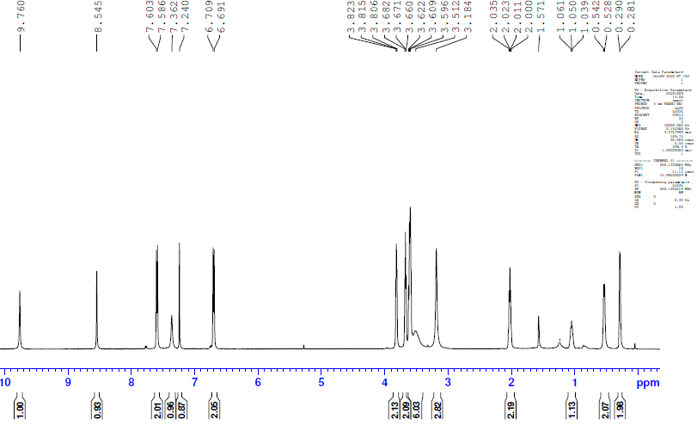

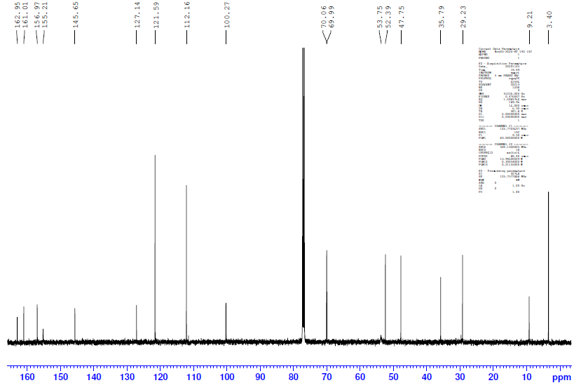

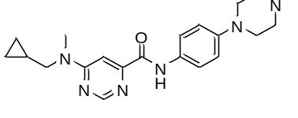
7ai
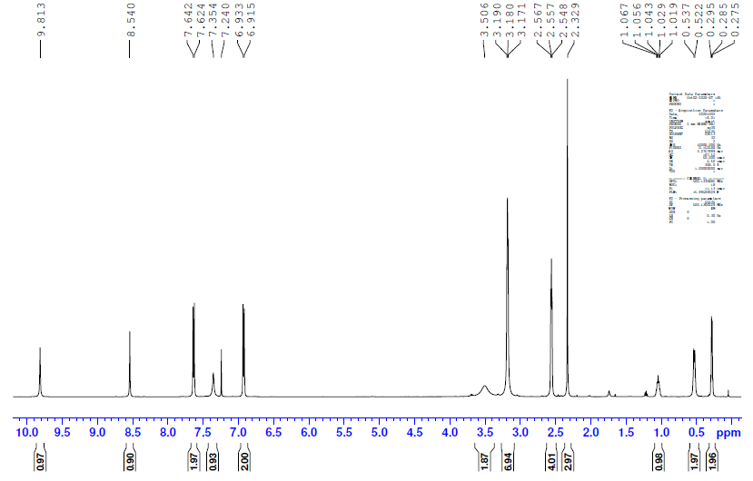

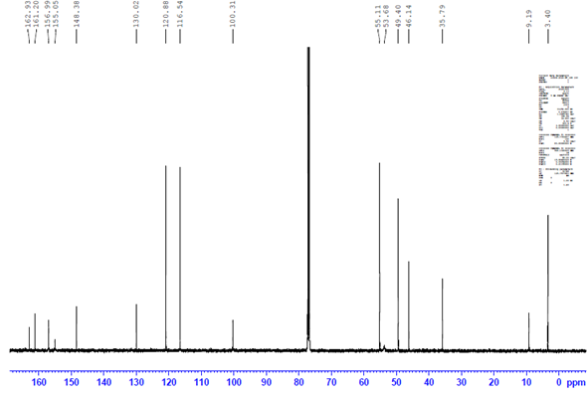

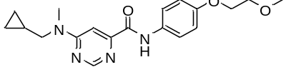
7aj
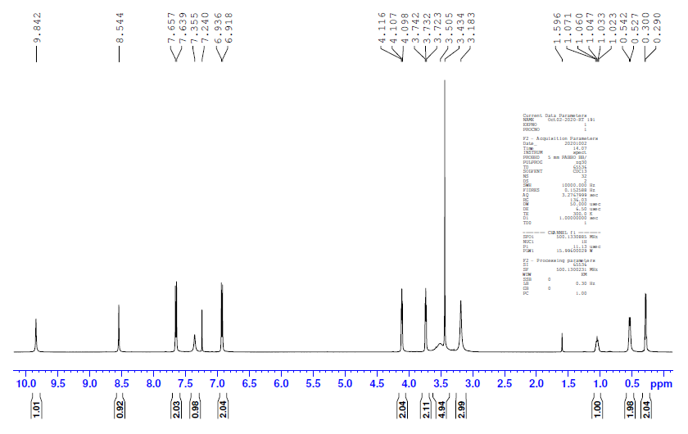

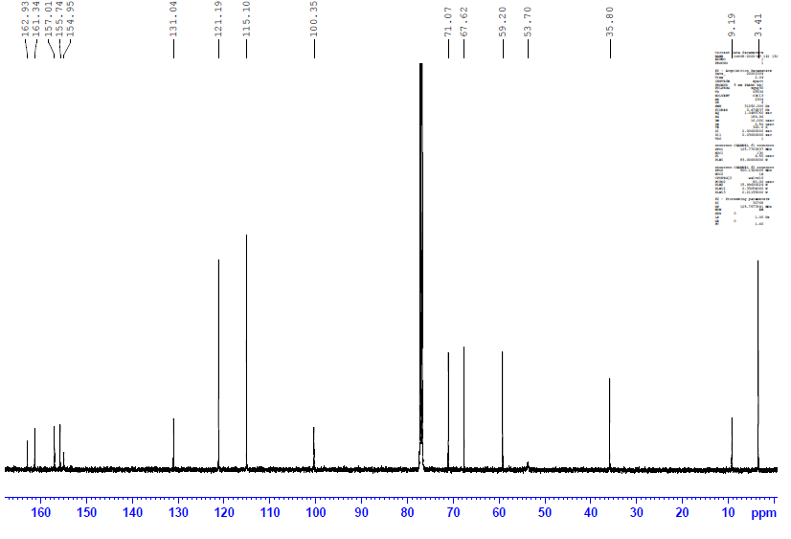

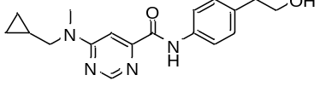
7ak
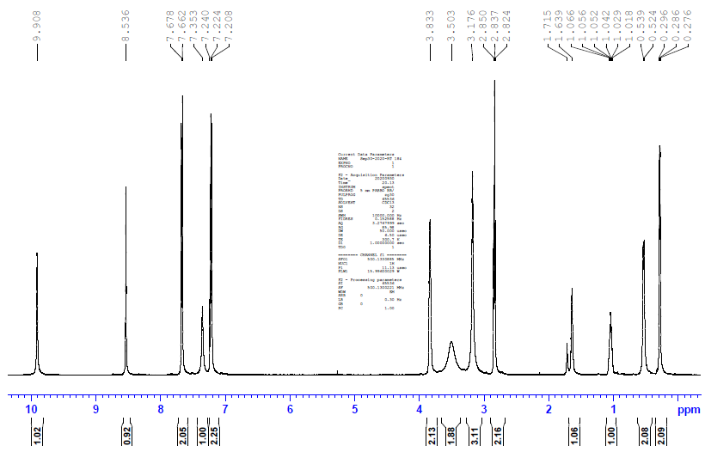

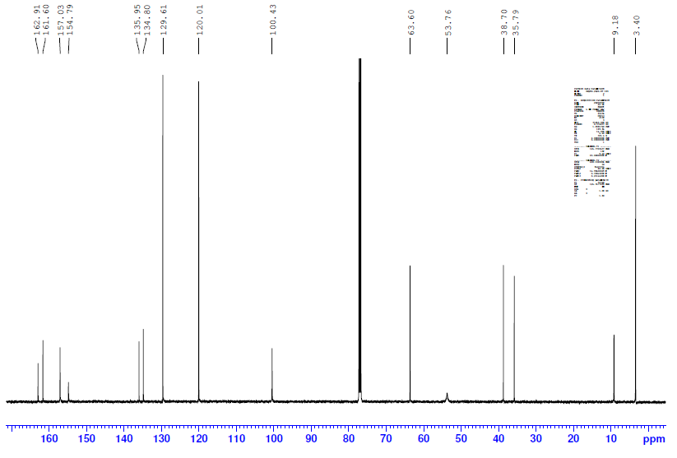

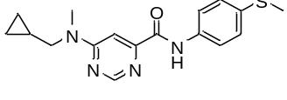
7al
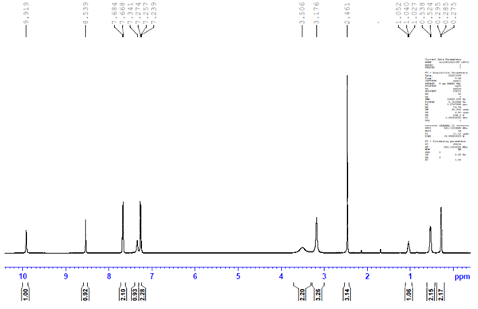

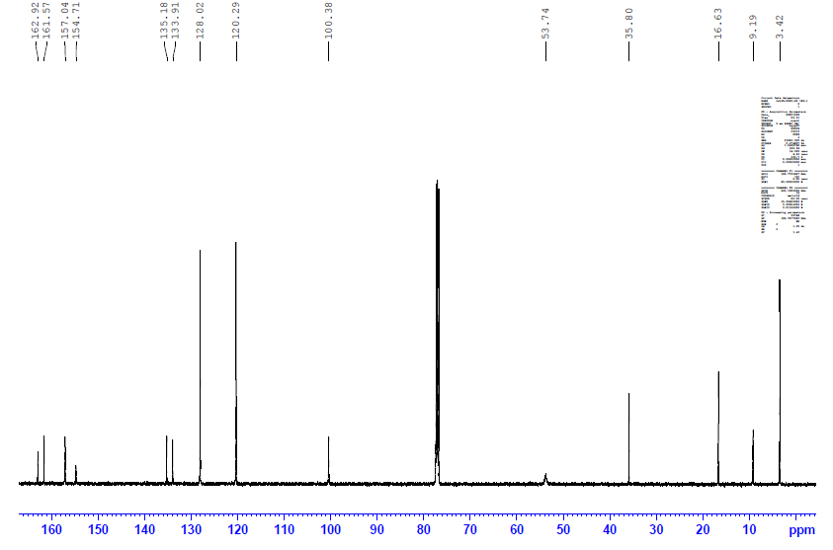

Biological Assays

3.1 In vitro antimycobacterial assay

Biological assays were conducted by the Drug Discovery and Development Center (H3D), University of Cape Town, South Africa. The test samples were prepared in 100% DMSO (Sigma Aldrich) at a stock concentration of 10mM. Further 2-fold serial dilutions were prepared in growth medium in 96-well round bottom plates on the day of the experiment. A concentration range of 62.5 μM – 0.122 μM was tested for each sample. Isoniazid (INH) and Moxifloxacin (Moxi) were included as the reference drugs in all experiments at concentration ranges of 0.15 – 0.0002 μM and 125 – 0.244 μM, respectively. A minimum growth control (INH at 2X MIC: 0.150 μM) and a maximum growth control (5 % DMSO) was included on each test plate. A culture of M. tuberculosis H37RvMA, in 7H9_ADC_GLU_TW (or alternative media), was grown to an optical density (OD600) of 0.5- 0.7 and a 500-fold dilution was prepared in each media composition. A volume of 50 μl of the diluted culture (~ 1 X 10⁴ bacilli) was added to each well of each test plate, for a final volume of 100 μl per well. Each compound was tested in duplicate.

The assay plates were incubated at 37 $℃$ with 5% CO₂ and humidification. The assay was scored visually at day 7, and the Visual MIC was recorded as the lowest concentration at which no bacterial pellet was observed. Alamar blue reagent was then added to each well of the assay plate and re-incubated for 24 h. The relative fluorescence units (RFU) (excitation 540 nm; emission 590 nm) of each well was measured using a SpecraMax i3x Plate reader at day 8 (Serial no. 36370 3271, Molecular Devices Corporation 1311 Orleans Drive Sunnyvale, California).

Media used:
7H9_ADC_GLU_ TW: Middlebrook 7H9 media (Difco) supplemented with 0.4 % Glucose, Middlebrook albumin-dextrose- catalase (ADC) enrichment (Difco) and 0.05 % Tween 80.
7H9_ADC_GLY_TW: Middlebrook 7H9 media (Difco) supplemented with 0.4% Glycerol, Middlebrook albumin-dextrose- catalase (ADC) enrichment (Difco) and 0.05 % Tween 80.
7H9_ADC_GLU_TX: Middlebrook 7H9 media (Difco) supplemented with 0.2% Glucose, Middlebrook albumin-dextrose- catalase (ADC) enrichment (Difco) and 0.05% Tyloxapol.
7H9_CAS_GLU_TX: Middlebrook 7H9 media (Difco) supplemented with 0.4% Glucose, 0.03% Casitone (Gibco Bacto) and 0.05% Tyloxapol.

3.2 Bioluminescence Assays

3.2.1 Lux assay

To determine whether a compound promotes DNA damage or inhibits cell wall synthesis in Mtb H37Rv in vitro, its activity is assessed in a bioluminescence assay where H37Rv contains either a:
A) RecA promoter cloned upstream of the bacterial luciferase luxCDABE operon (termed PrecA-LUX). Here, the recA promoter is upregulated in response DNA damage resulting in an enhanced bioluminescent signal in the assay. Controls employed for the RecA strain are Moxifloxacin and Ciprofloxacin (positive controls) and Isoniazid (Negative controls).
B) IniB promoter cloned upstream of the bacterial luciferase luxCDABE operon (termed PiniB-LUX). Here, the iniB promoter is upregulated in response to disruption of peptidoglycan, arabinogalactan, and mycolic acid biosynthesis resulting in an enhanced bioluminescent signal in the assay. Controls employed for the IniB strain are Isoniazid (positive control) and Moxifloxacin and Ciprofloxacin (negative controls).

Data summary:
All 4 compounds tested showed no positive signal against both the PiniB- & PrecA-Lux strains indicating the compound may not be targeting the cell wall of Mycobacterium nor are they involved in DNA damage, with all controls for this assay behaving as expected. It is noted however that a slightly higher non-specific signal for 7m and negative control Ciprofloxacin is observed against the PiniB strain and therefore may require a repeat.

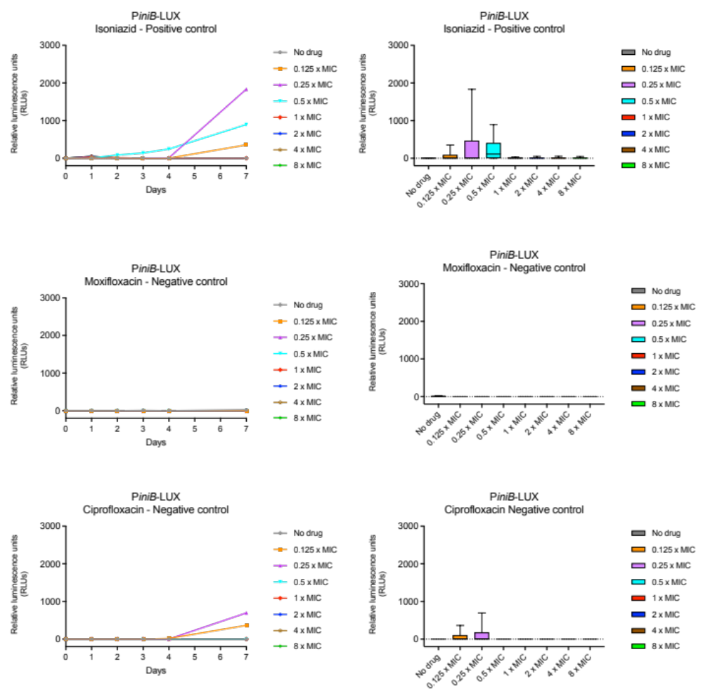
Figure S1: PiniB-LUX graphs for controls.

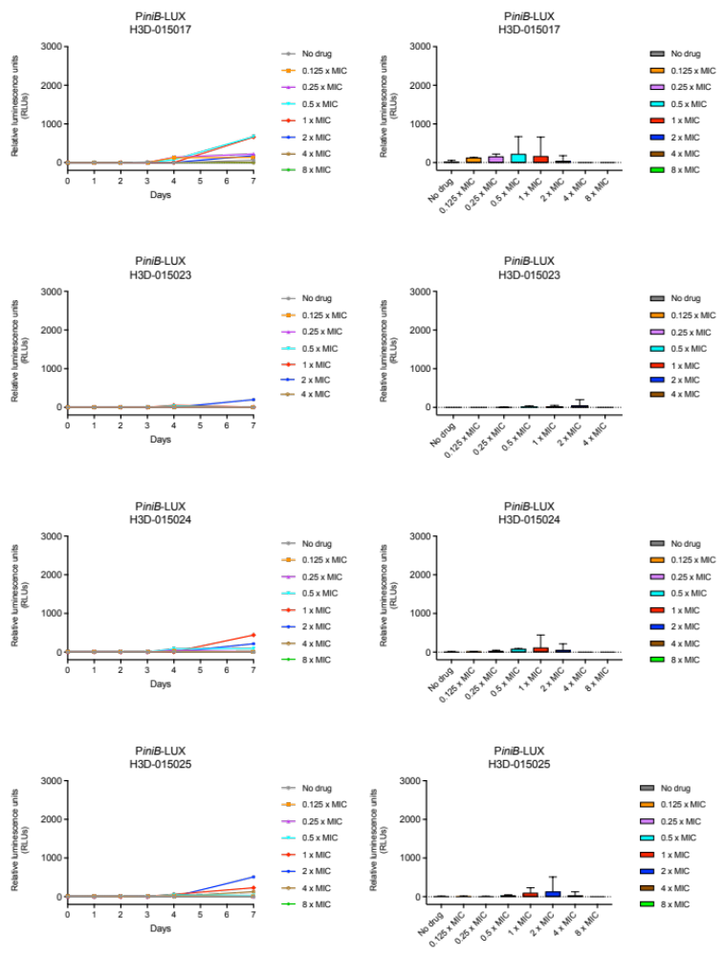
7q
7q
7p
7p
7d
7d
7m
7m

Figure S2: PiniB-LUX graphs for compounds 7m, 7d, 7p and 7q.

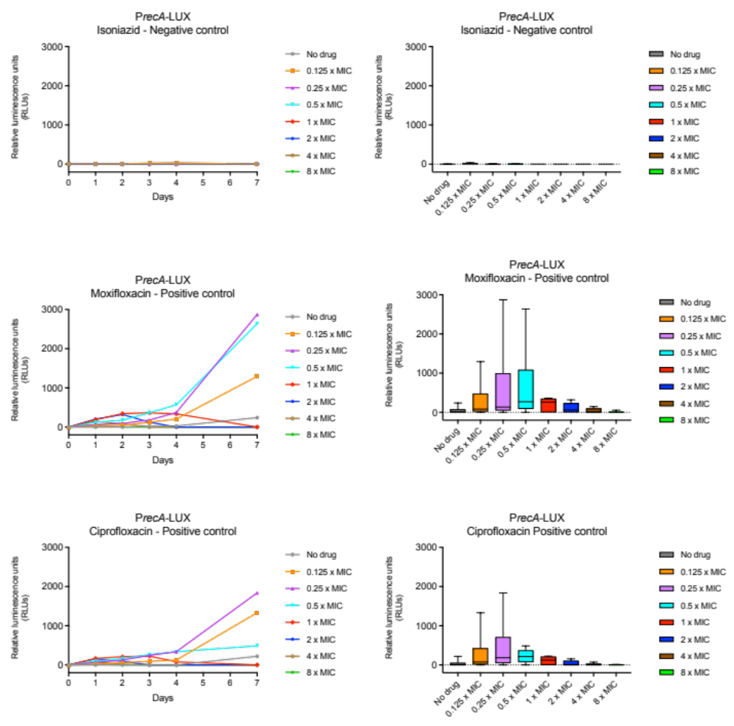
Figure S3: PrecA-LUX graphs for controls.

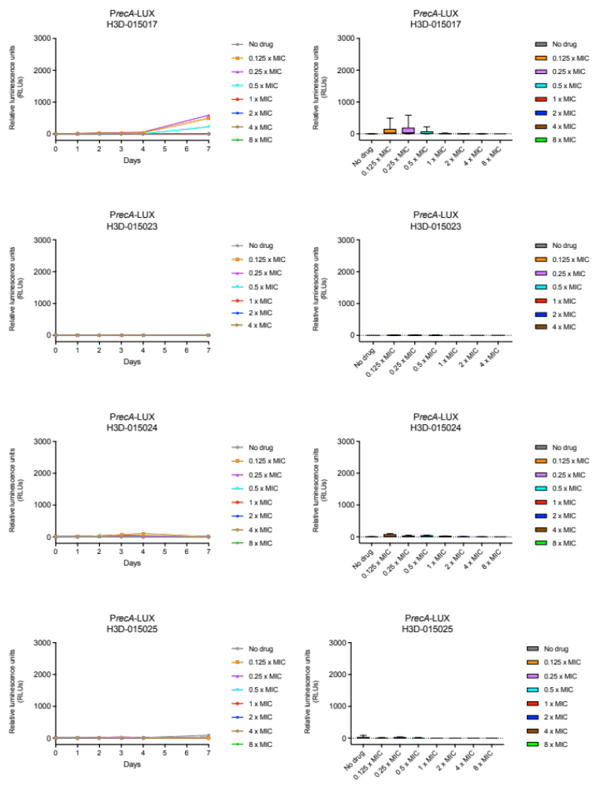
7q
7q
7p
7p
7d
7d
7m
7m
Figure S4: PrecA-LUX graphs for compounds 7m, 7d, 7p and 7q.

3.2.2 Charcoal agar resazurin assay (CARA)

To determine whether a compound exhibits bactericidal or bacteriostatic activity against replicating Mtb H37Rv in vitro, its activity is assessed in a charcoal agar resazurin assay (CARA). Here, culture from a 7-day dose-response MIC broth assay is transferred to agar media containing activated charcoal to remove drug pressure. Cell growth is then measured after an additional 7-day incubation to determine the minimum bactericidal concentration (MBC). Under replicating conditions, a compound is considered:
A) Bactericidal if the minimal bactericidal concentration (MBC _{≥99} ) is < 4-fold that of the compound’s MIC_{90.}
B) Bacteriostatic if the minimal bactericidal concentration (MBC) is ≥ 4-fold that of the compound’s MIC₉₀
C) Positive controls for this assay consist of isoniazid as a bactericidal control and Linezolid as a bacteriostatic control.
Data summary:
All compounds tested were bactericidal against replicating H37Rv, as the MBC_{≥99} was < 4-fold that of each compound’s MIC90, with both bactericidal and bacteriostatic controls behaving as expected.

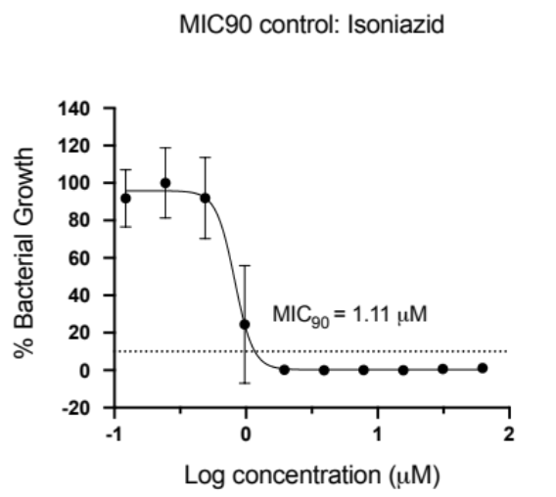
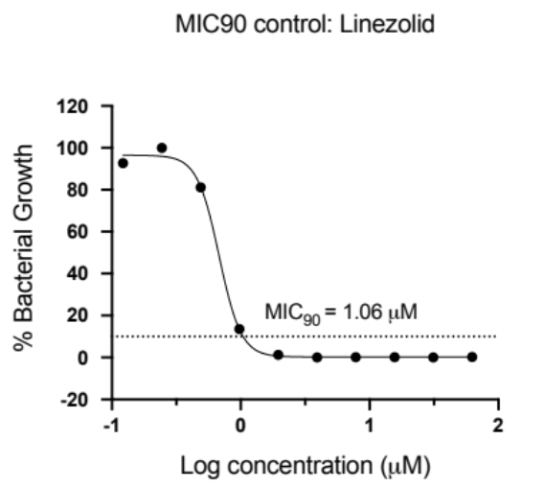

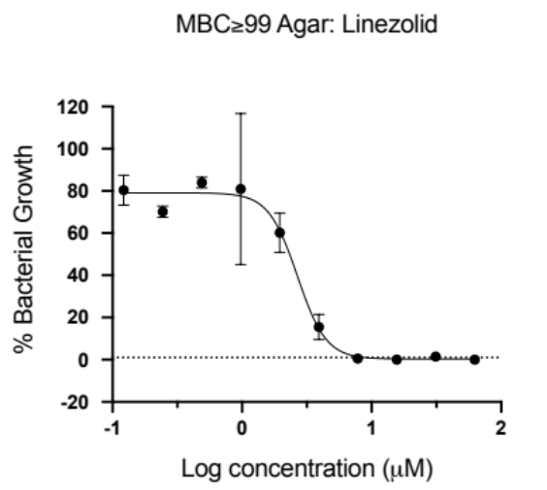
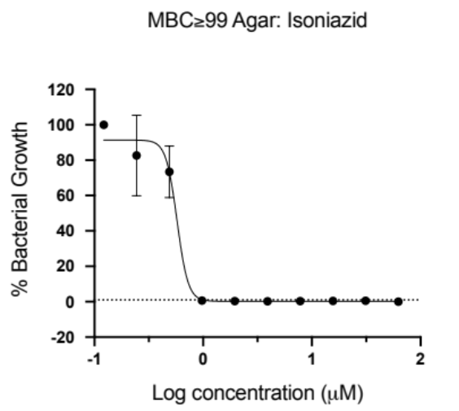
MBC≧99 ~ 7.8 µM
MBC≧99 ~ 0.9 µM

Figure S5: Control CARA assay graphs.

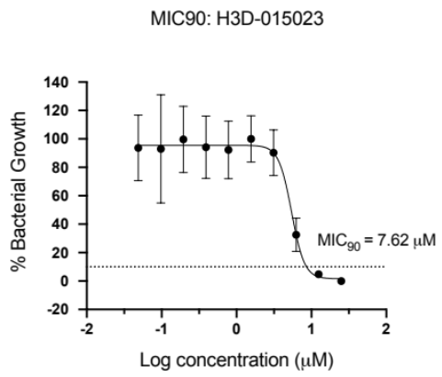
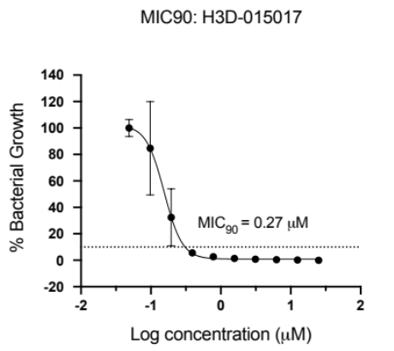
7d
7m

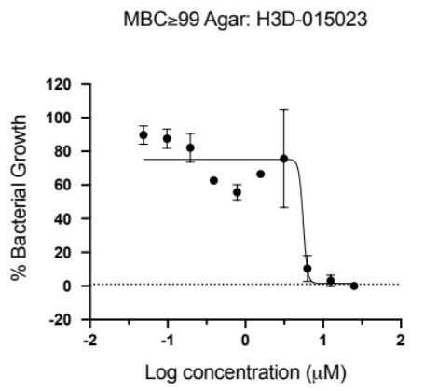
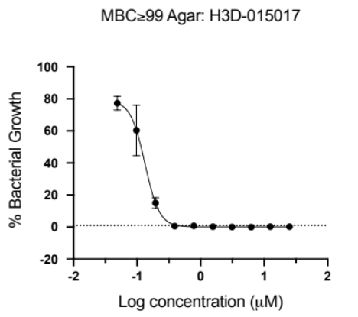
7d
7m

MBC≧99 ~ 0.39 µM
MBC≧99 ~ 12.5 µM

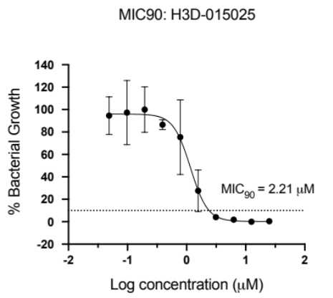
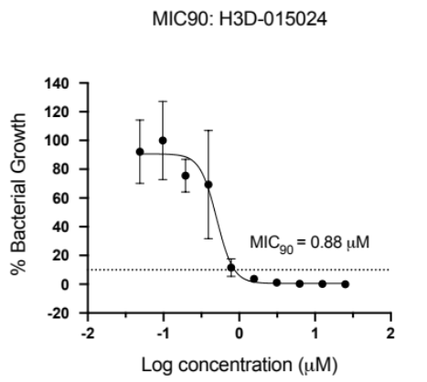
7p
7q

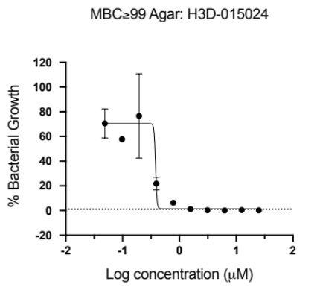
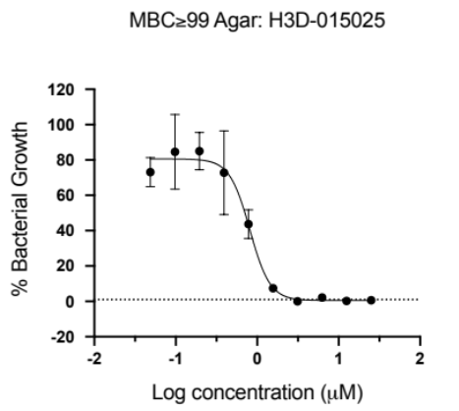
7p
7q

MBC≧99 ~ 3.12 µM
MBC≧99 ~ 1.56 µM

Figure S6: Compounds 7m, 7d, 7p and 7q CARA graphs.

