6-Phenoxyl-4-aminoquinoline: Synthesis and preliminary antitubercular-structure activity relationship analyses
Richard M. Beteck^{a*}, Lesetja J. Legoabeª, Phelelisiwe S. Dubeª, Audrey Jordaan^{b}, Digby F. Warner^{b}.

ª Centre of Excellence for Pharmaceutical Sciences, North-West University, Potchefstroom 2520, South Africa
^{b} Molecular Mycobacteriology Research Unit, Department of Pathology and Institute of Infectious Disease and Molecular Medicine, University of Cape Town, Observatory 7925, South Africa
^{c} Faculty of Science, Department of Chemistry, Rhodes University, Grahamstown 6140, South Africa
^{d} Wellcome Centre for Infectious Diseases Research in Africa (CIDRI-Africa), Institute of Infectious Disease and Molecular Medicine, Faculty of Health Sciences, University of Cape Town, Observatory 7925, South Africa

*Corresponding Author: RMB- email; 25159194@nwu.ac.za or richmbi1@yahoo.com.

Ethyl 4-((2-(dimethylamino)ethyl)amino)-6-phenoxyquinoline-3-carboxylate, 4a.

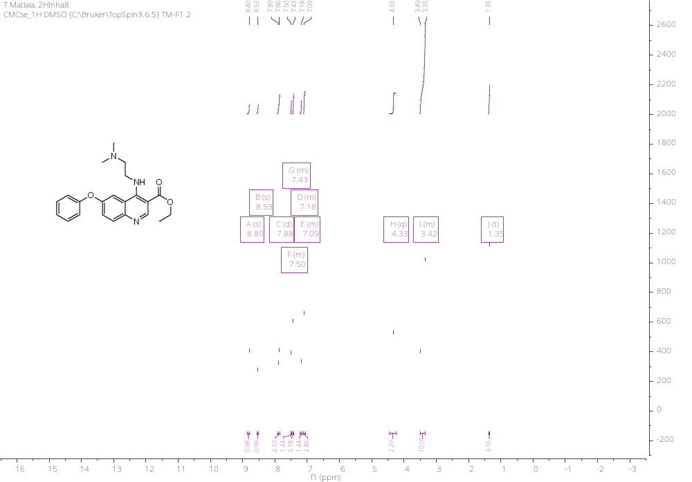
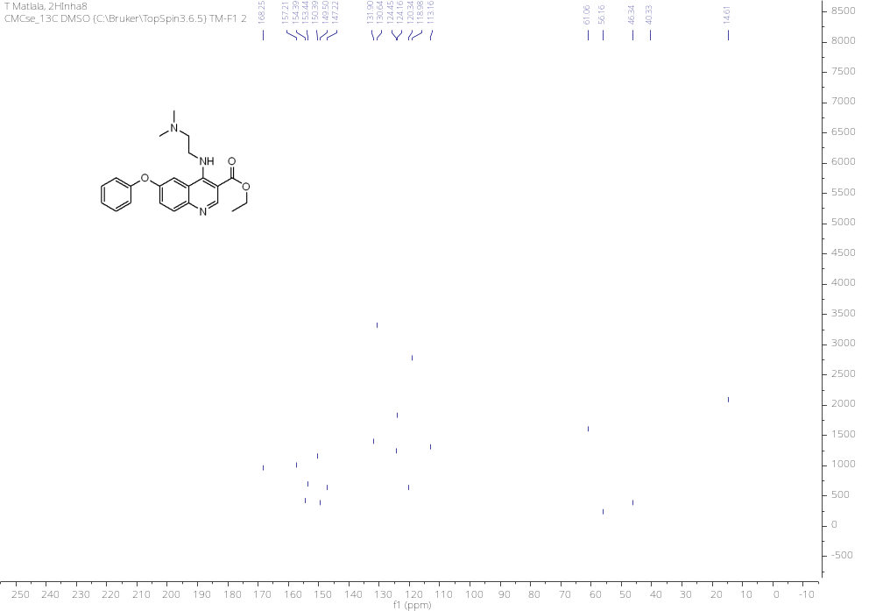
HRMS
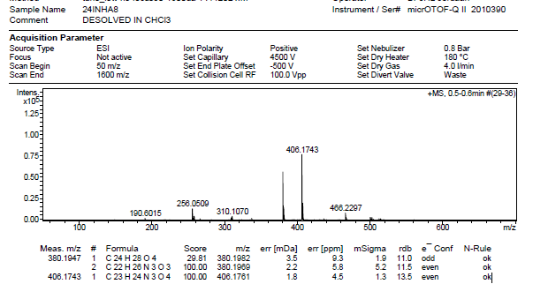

IR
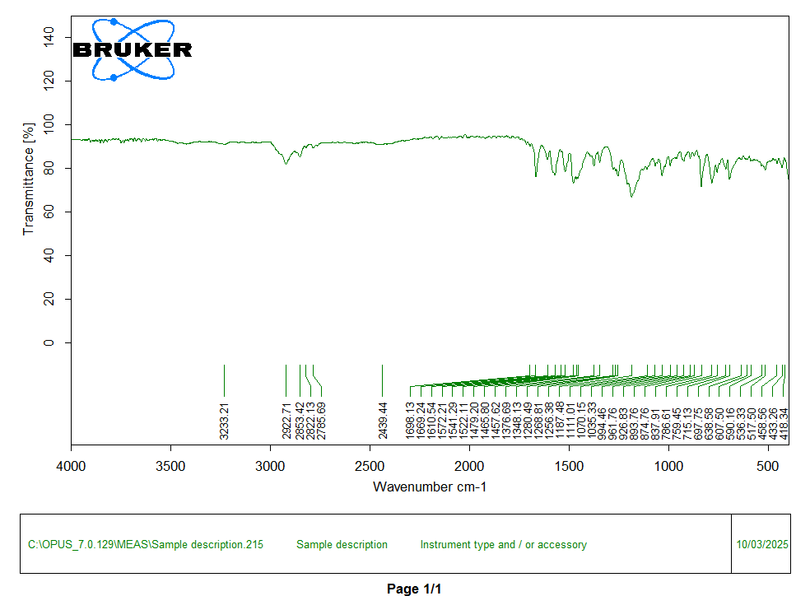

Ethyl 4-((3-(dimethylamino)propyl)amino)-6-phenoxyquinoline-3-carboxylate, 4b.
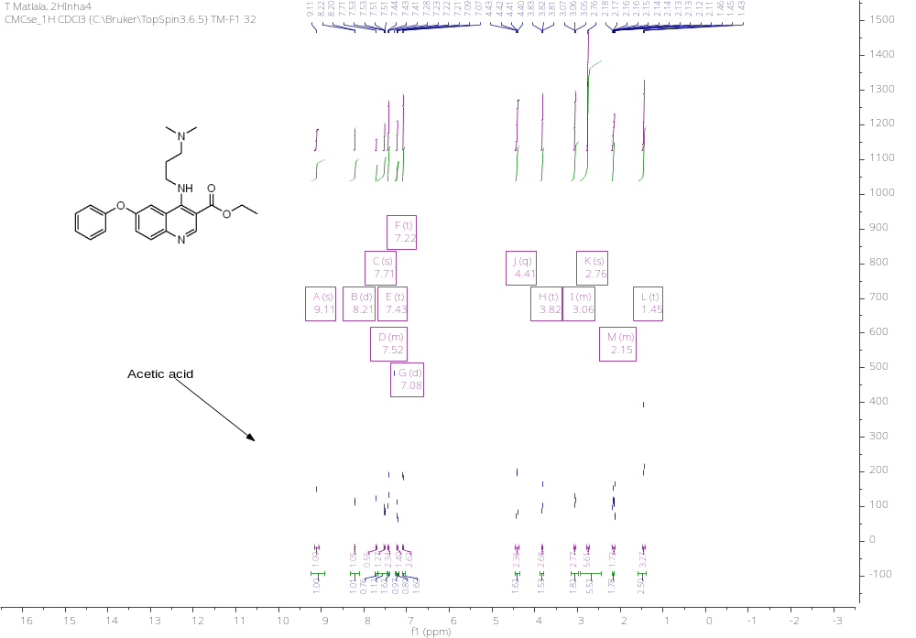
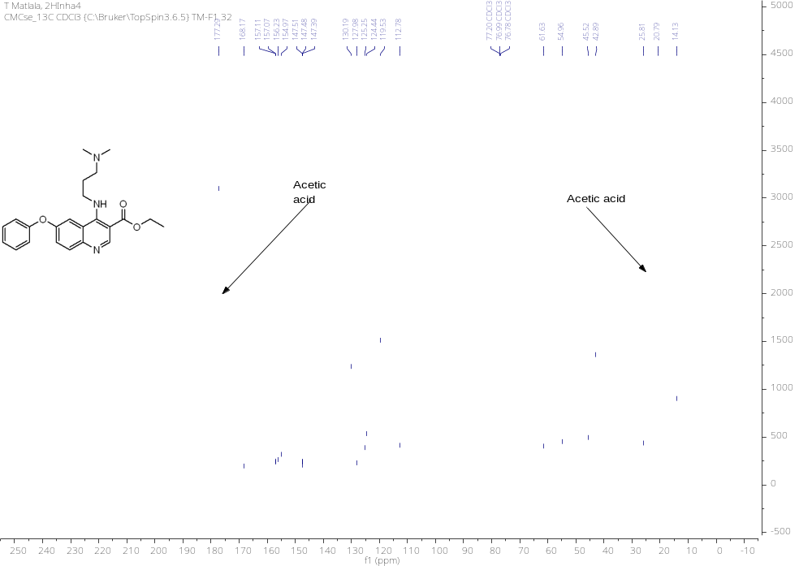

HRMS
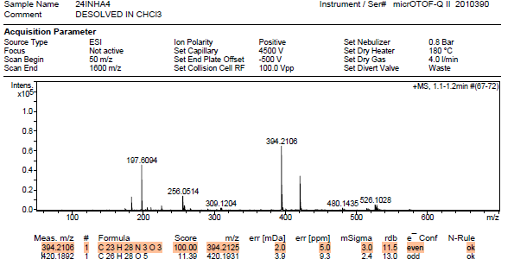
IR
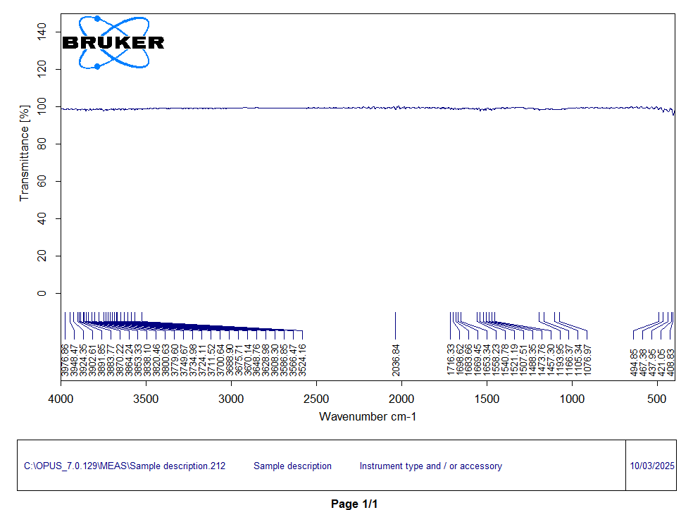

Ethyl 6-phenoxy-4-((3-(pyrrolidin-1-yl)propyl)amino)quinoline-3-carboxylate, 4c.
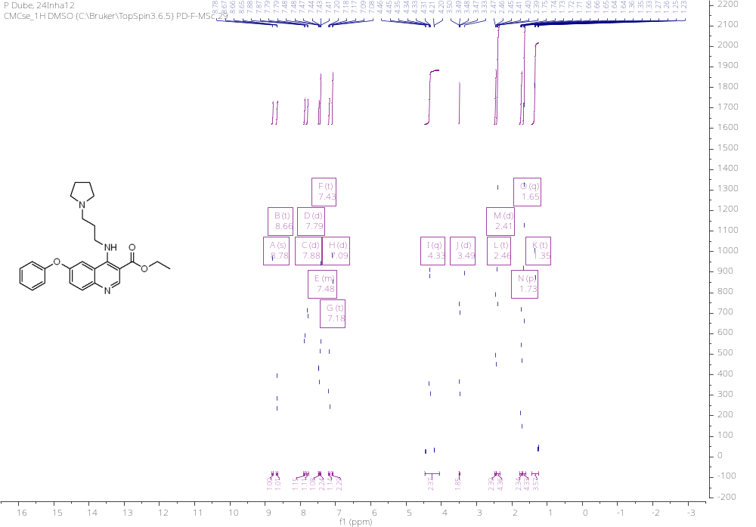

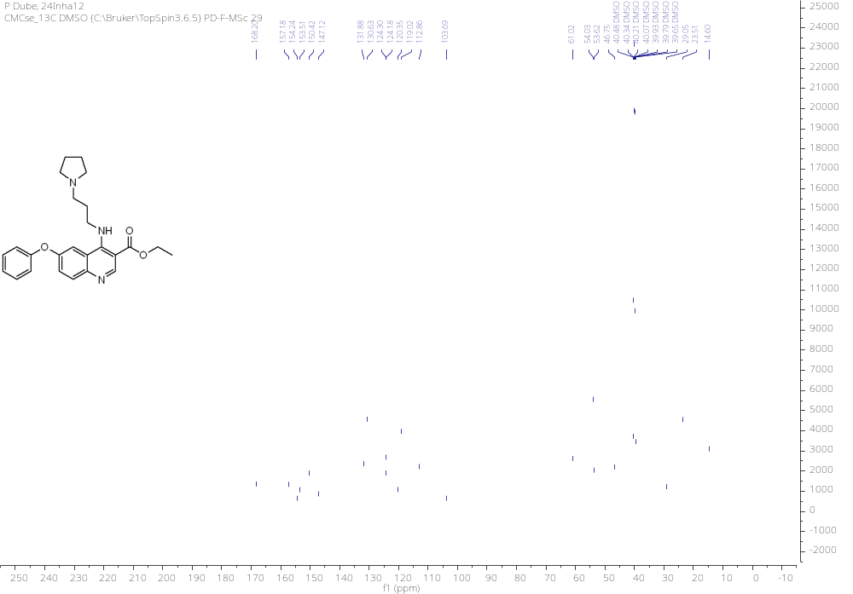
HRMS
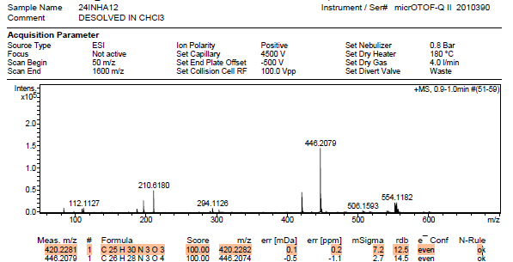

IR
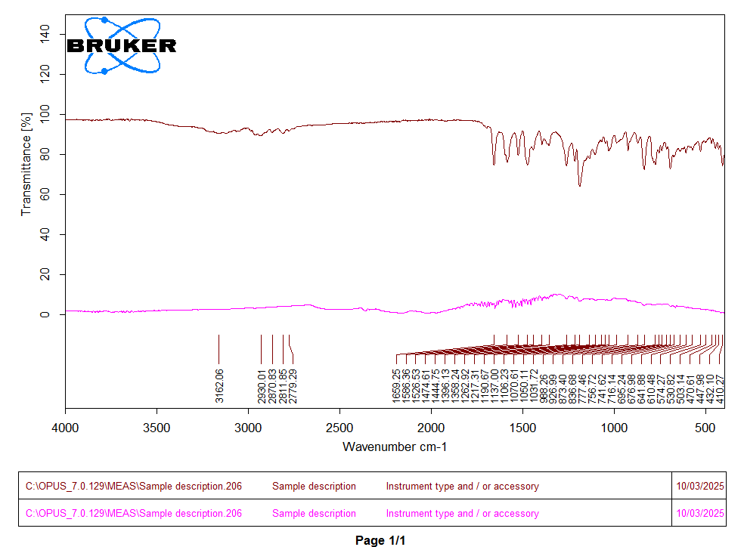
Ethyl 4-((3-(2-oxopyrrolidin-1-yl)propyl)amino)-6-phenoxyquinoline-3-carboxylate, 4d.
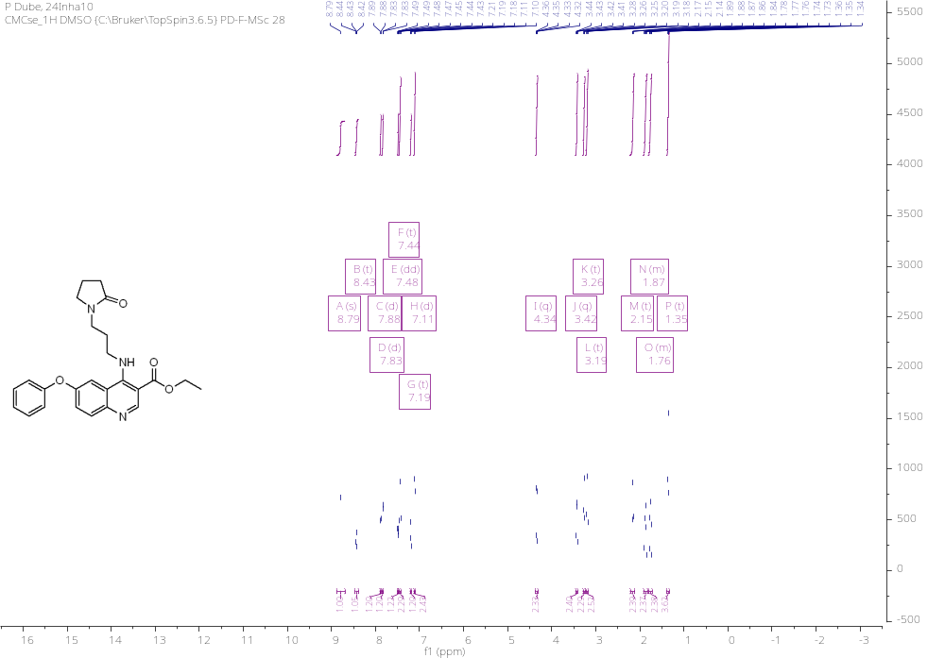
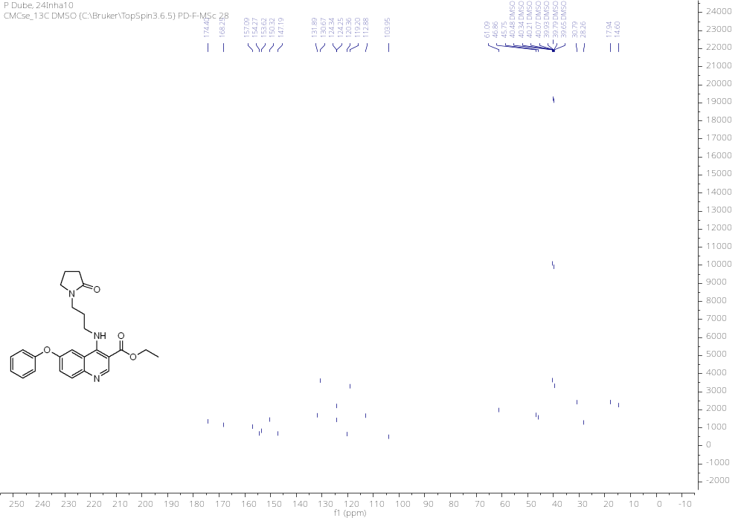
HRMS
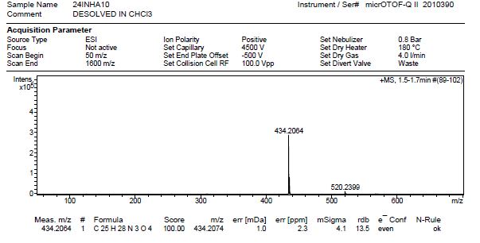

IR
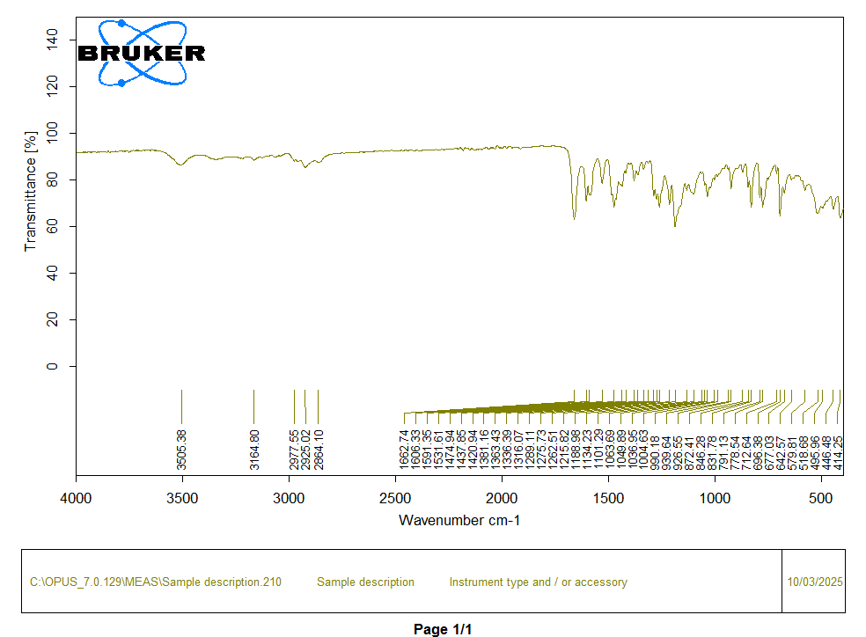
Ethyl 6-phenoxy-4-((3-(piperidin-1-yl)propyl)amino)quinoline-3-carboxylate, 4e.
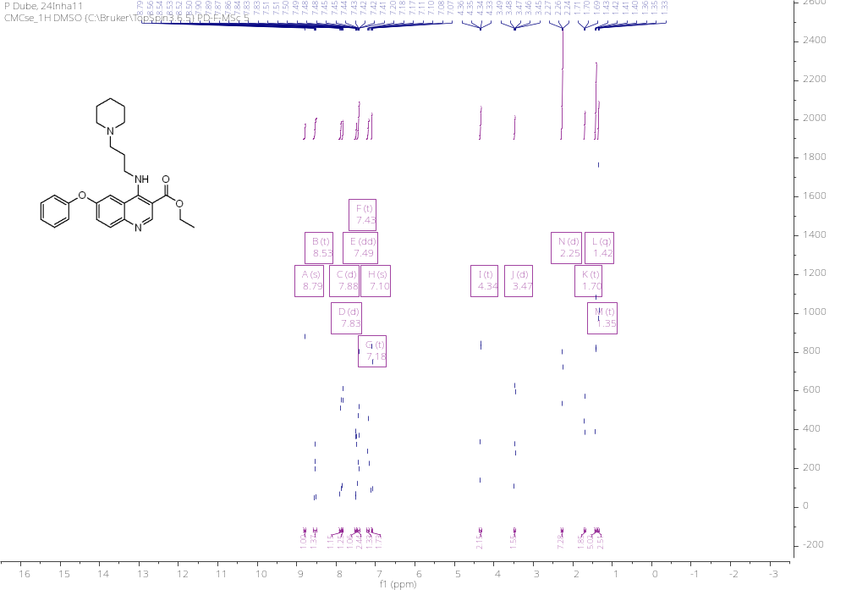
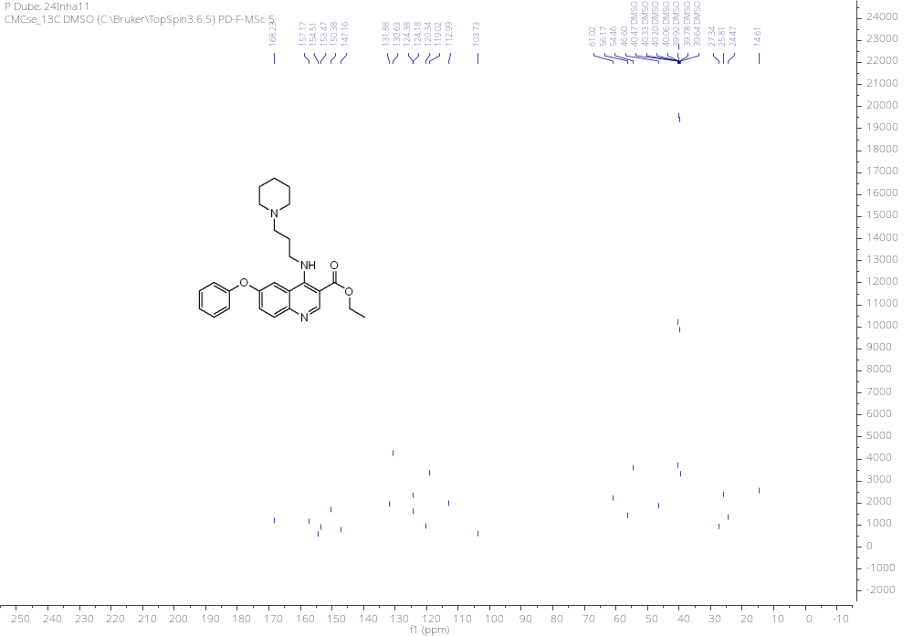

HRMS
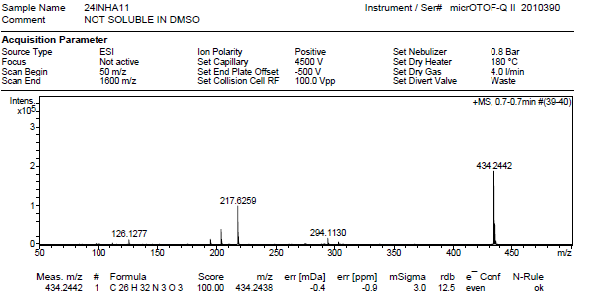

IR
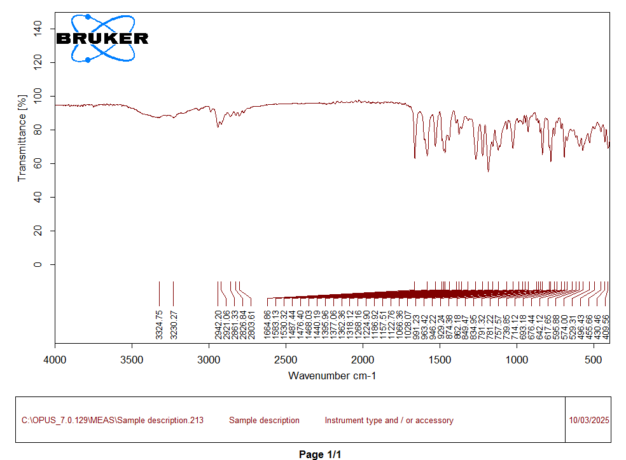
HPLC Purity
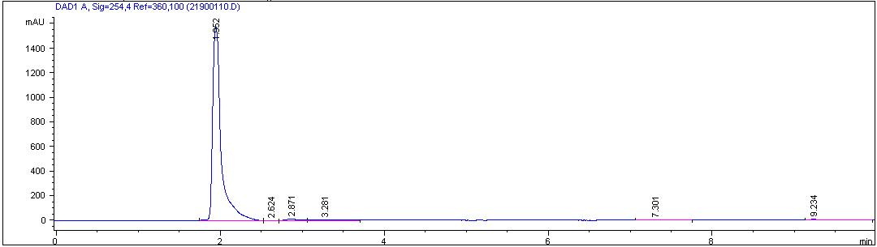

Ethyl 4-((3-(2-methylpiperidin-1-yl)propyl)amino)-6-phenoxyquinoline-3-carboxylate, 4f
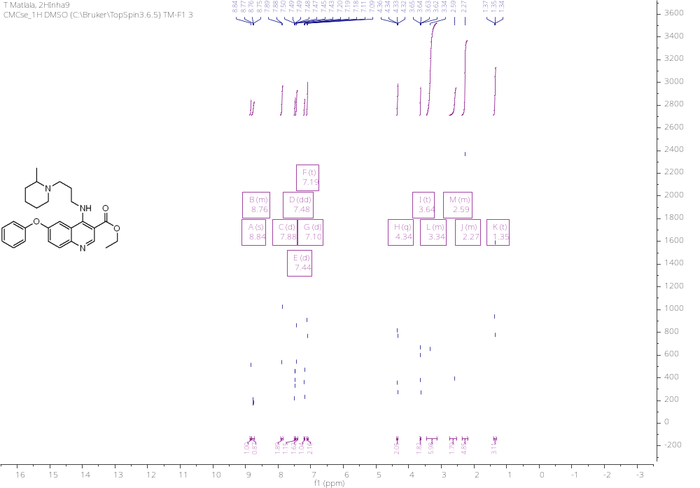

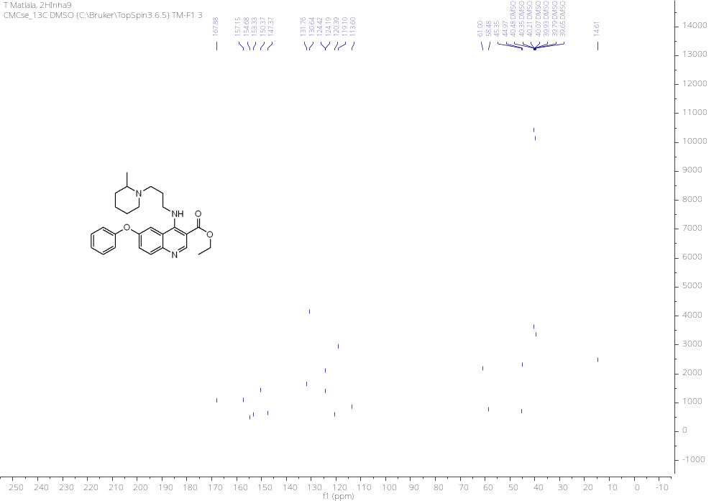

HRMS
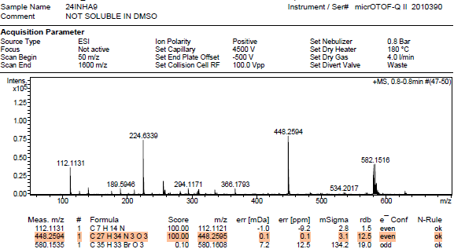

IR
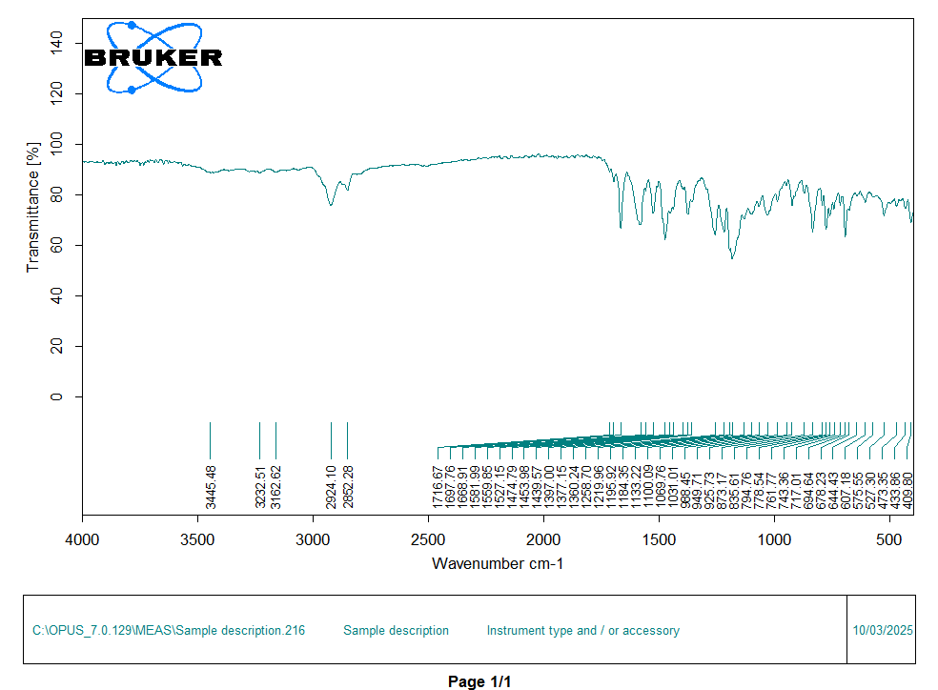
Ethyl 4-((3-morpholinopropyl)amino)-6-phenoxyquinoline-3-carboxylate, 4g.
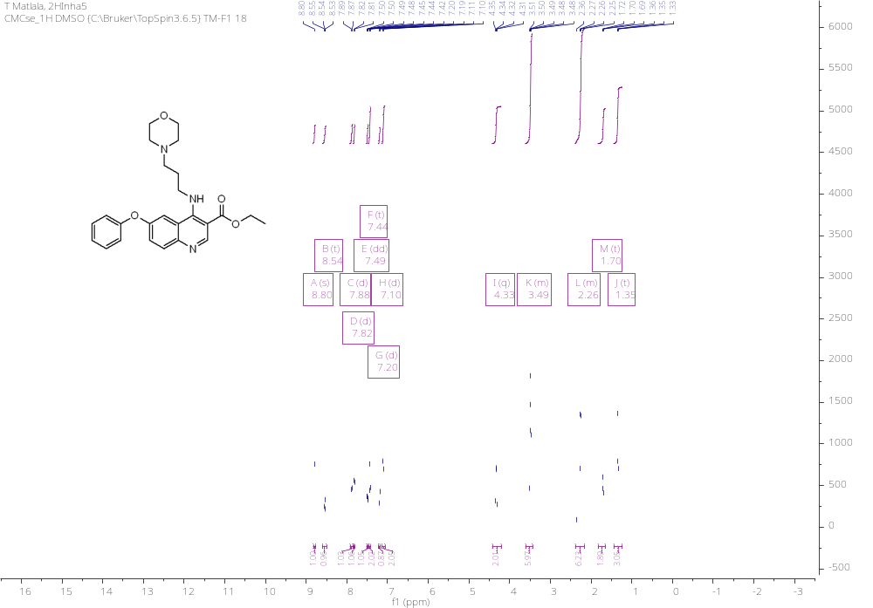
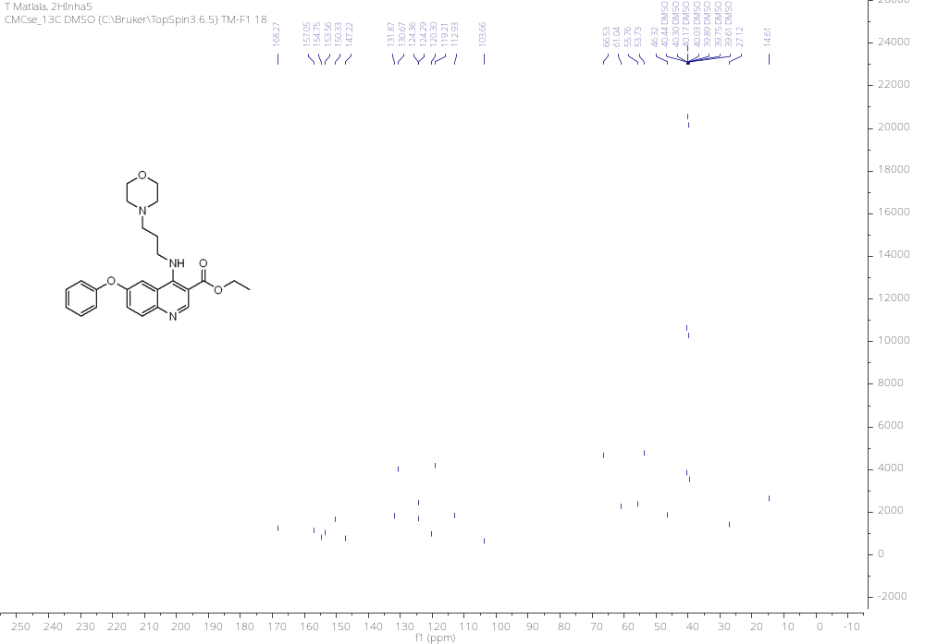
HRMS
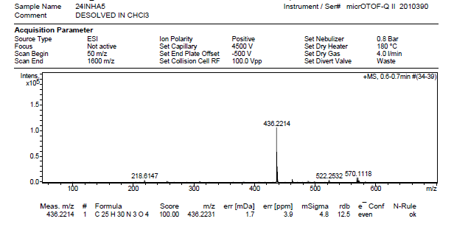

IR
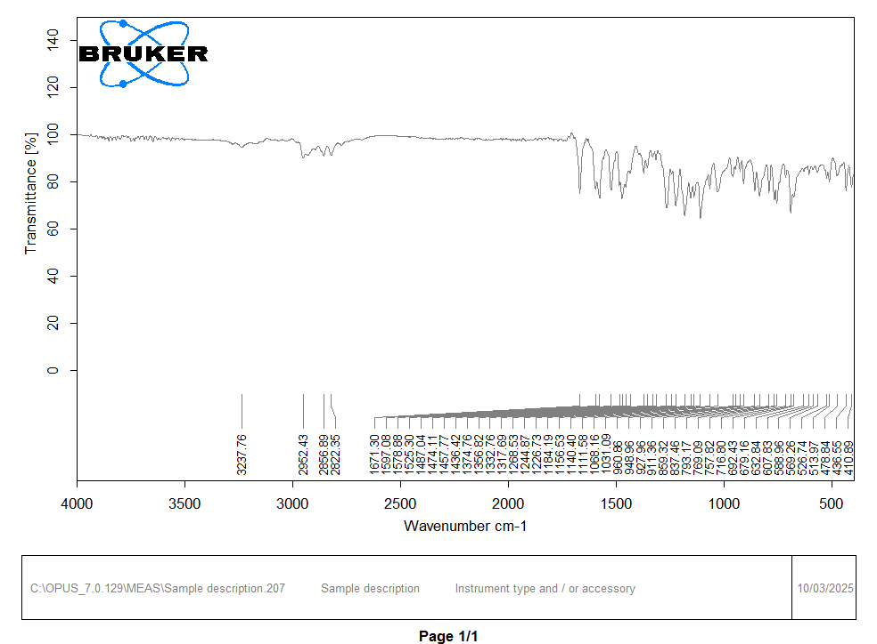
4-((3-Isopropoxypropyl)amino)-6-phenoxyquinoline-3-carboxylic acid, 5.
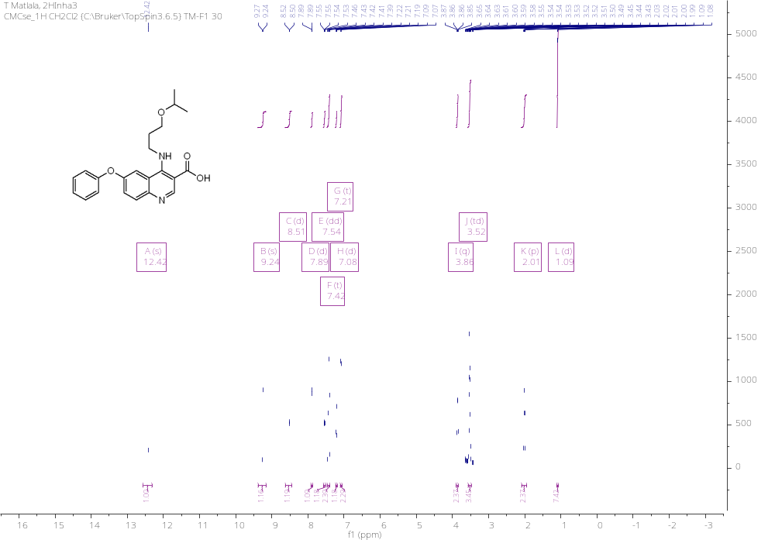
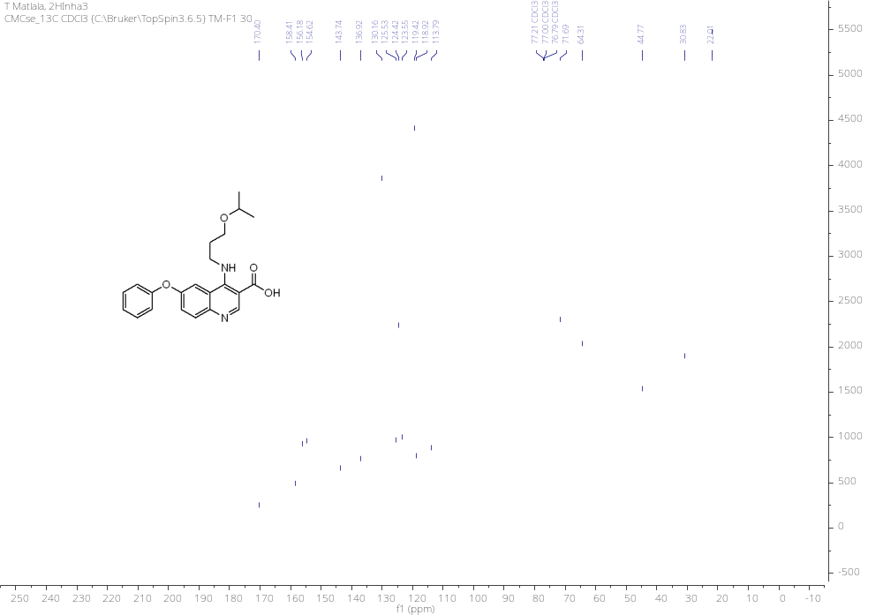
HRMS
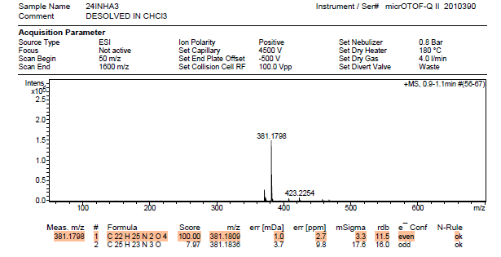

IR
