Supplementary 1
Figures S1a. Representative Electroantennogram responses for 1,8-cineole standard and mineral oil control.
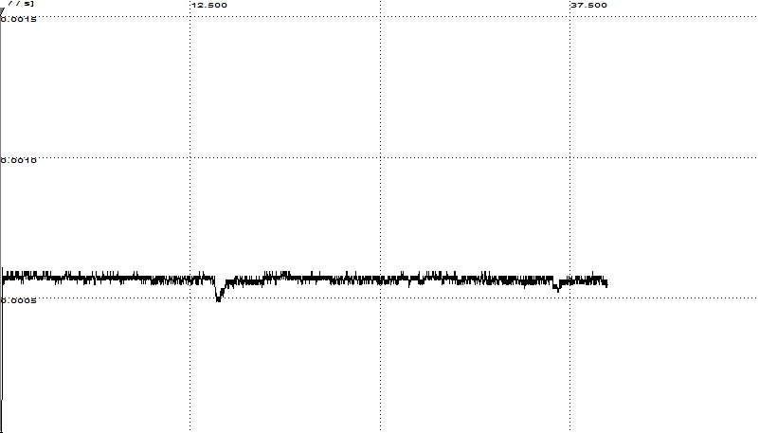
Mineral oil control
1,8-cineole

Figures S1b. Representative Electroantennogram responses for 1,8-cineole standard and (S)-limonene.
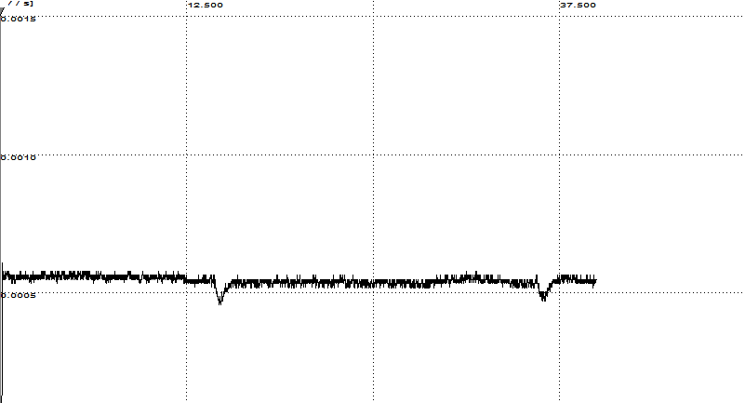
1,8-cineole
(S)-limonene

Figures S1c. Representative Electroantennogram responses for 1,8-cineole standard and (R)-limonene.
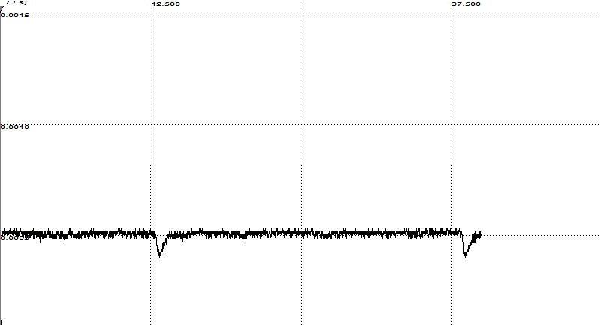
(R)-limonene
1,8-cineole

Figures S1d. Representative Electroantennogram responses for 1,8-cineole standard and cis-3-hexen-1-ol.
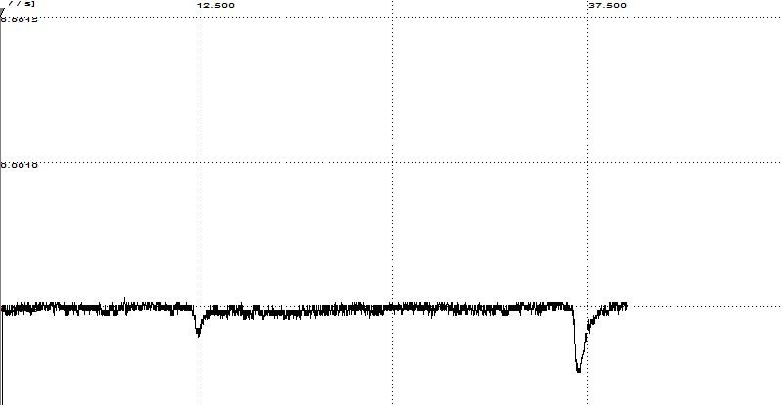
1,8-cineole
cis-3-hexen-1-ol

Figures S1e. Representative Electroantennogram responses for 1,8-cineole standard and trans-3-hexen-1-ol.
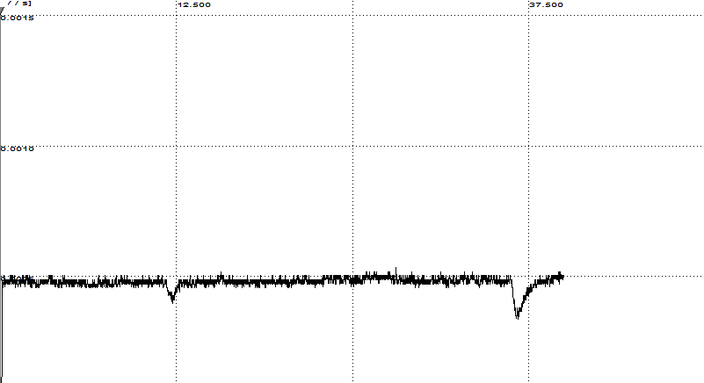
1,8-cineole
trans-3-hexen-1-ol

Figures S1f. Representative Electroantennogram responses for 1,8-cineole standard and (+)-borneol.
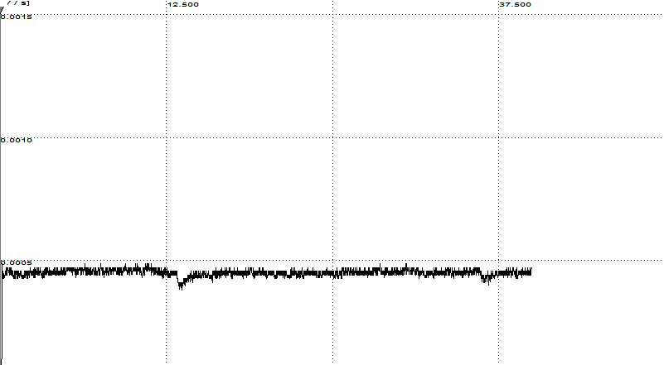
1,8-cineole
(+)-borneol

Figures S1g. Representative Electroantennogram responses for 1,8-cineole standard and (-)-borneol.
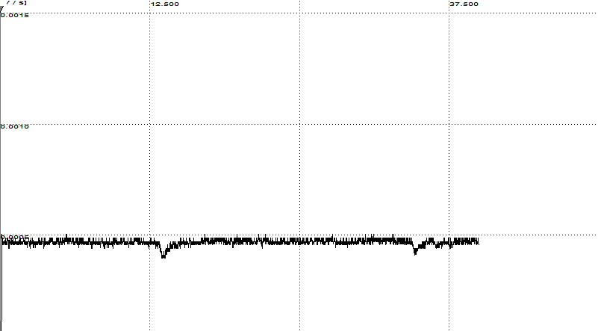
1,8-cineole
(-)-borneol

Figures S1h. Representative Electroantennogram responses for 1,8-cineole standard and (+)-terpinen-4-ol.
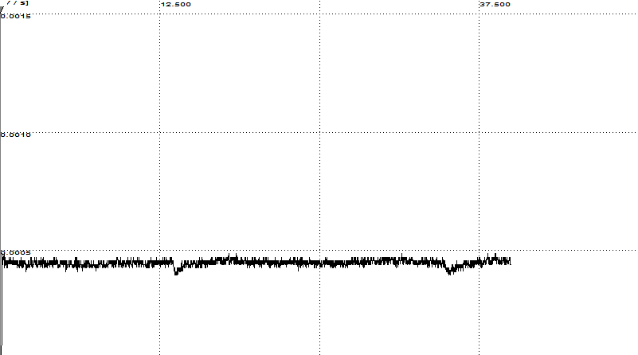
1,8-cineole
(+)-terpinen-4-ol

Figures S1i. Representative Electroantennogram responses for 1,8-cineole standard and (-)-terpinen-4-ol.
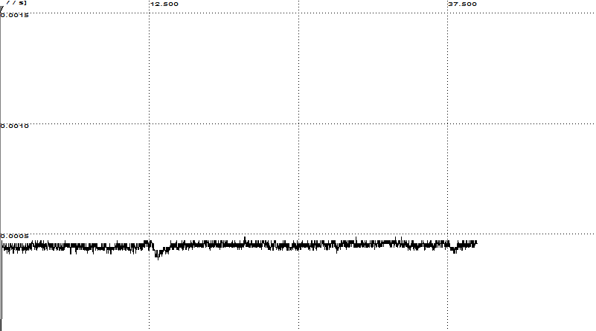
(-)-terpinen-4-ol
1,8-cineole

Figures S1j. Standard at end of insect block replicate and fresh standard check.
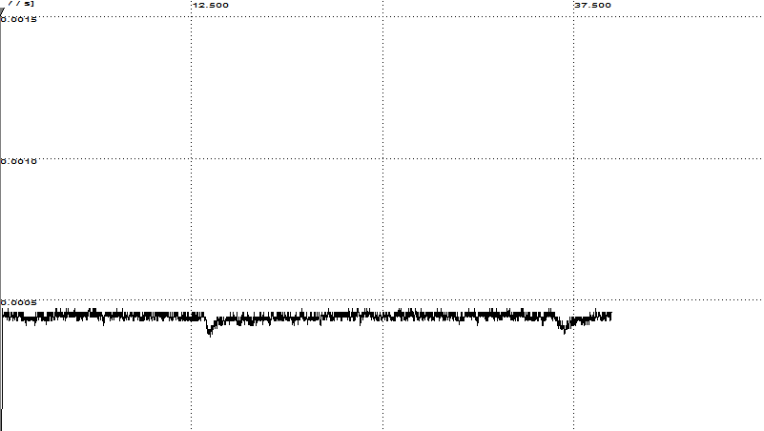
Reponse to freshly applied 1,8-cineole
Respone to 1,8-cineole at end of insect block replicate

