Supplementary material S2 – additional analyses

Interactions of ants with native and invasive ladybeetles and the role of chemical cues in intraguild interference

Roman Bucher^{1,*}, Laura M. Japke^{1,2}, Ayse Gül Ünlü^{1,3}, Florian Menzel⁴

¹ Philipps-Universität Marburg, Conservation Ecology, Karl-von-Frisch-Str. 8, 35043 Marburg, Germany
² Westfälische Wilhelms-Universität Münster, Institute for Evolution and Biodiversity, Hüfferstr. 1, 48149 Münster, Germany
³ Swedish University of Agricultural Sciences, Department of Ecology, Ulls väg 16, 75007 Uppsala, Sweden
⁴ Johannes Gutenberg-Universität Mainz, Institute of Organismic and Molecular Evolution, Hanns-Dieter-Hüsch-Weg 15, 55128 Mainz, Germany

* Corresponding author: R. Bucher (ORCID 0000-0002-3001-2876), email: bucher@uni-marburg.de

Ant aggression towards living ladybeetles – based on the aggression score proposed by Finlayson et al. 2009¹

For L. niger, the aggression score differed between ladybeetle species (Fig. S2a; ꭕ²_{4,96} = 19.95, p < 0.001). Here, the strength of ant aggression was higher towards C. septempunctata (z = 4.08, p < 0.001), P. quatuordecimpunctata (z = 3.67, p = 0.002), and tended to be higher in A. bipunctata (z = 2.54, p = 0.08) compared to H. axyridis. In contrast, the aggression score did not differ between ladybeetle species for M. rubra assays (Fig. S2a; ꭕ²_{4,100} = 4.36, p = 0.36).
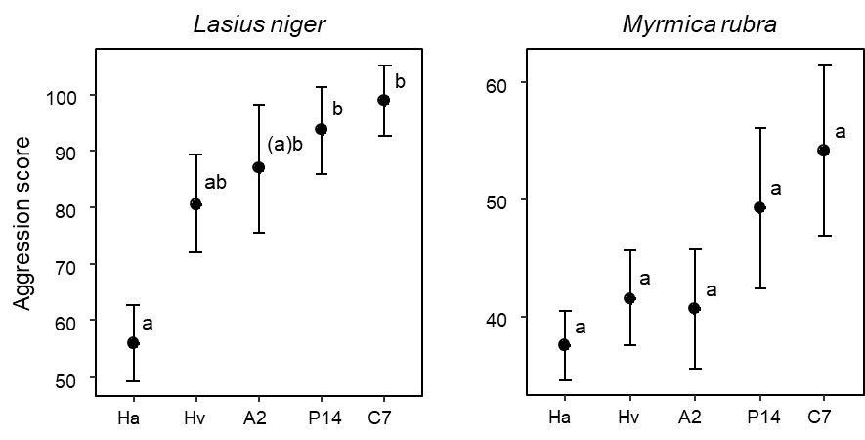
Figure S2a: Aggression score of L. niger and M. rubra towards the studied ladybeetle species (Ha: H. axyridis, Hv: H. variegata, A2: A. bipunctata, P14: P. quatuordecimpunctata, C7: C. septempunctata); mean ± SE. Different lowercase letters indicate statistical differences (α < 0.05). Letters in brackets indicate statistical trends (α < 0.1). Note that y-axes are on different scales.

Ant aggression towards living ladybeetles – based on the proportion of strong aggression²

For L. niger, the proportion of strong aggression differed between ladybeetle species (Fig. S2b; ꭕ²_{4,96} = 10.61, p = 0.031). The proportion of strong aggression tended to be higher towards C. septempunctata compared to H. axyridis (z = 2.67, p = 0.06) and A. bipunctata (z = 2.56, p = 0.08). Also for M. rubra, the proportion of strong aggression differed between ladybeetle species (Fig. S2b; ꭕ²_{4,100} = 13.94, p = 0.007). Here, the proportion of strong aggression was higher towards P. quatuordecimpunctata (z = 3.30, p = 0.009) and tended to be higher towards C. sepetempunctata (z = 2.47, p = 0.098) compared to A. bipunctata. We found no further differences in the proportion of strong aggression among the remaining pair-wise comparisons.
___
¹ Finlayson CJ, Alyokhin AV, Porter EW (2009) Interactions of native and non-native lady beetle species (Coleoptera: Coccinellidae) with aphid-tending ants in laboratory arenas. Environ. Entomol. 38:846–855. For congruence between the different behavioral elements and the letter used in the formula by Finlayson et al. 2009 see behavioral data in supplementary material S1. The statistical approach is identical to the one described in the main text.

² For a definition of strong interactions see method section in the main text and separation strong vs. weak interactions in the supplementary material S1. The statistical approach is as described in the main text except that errors of the models were assumed to follow binomial distribution.
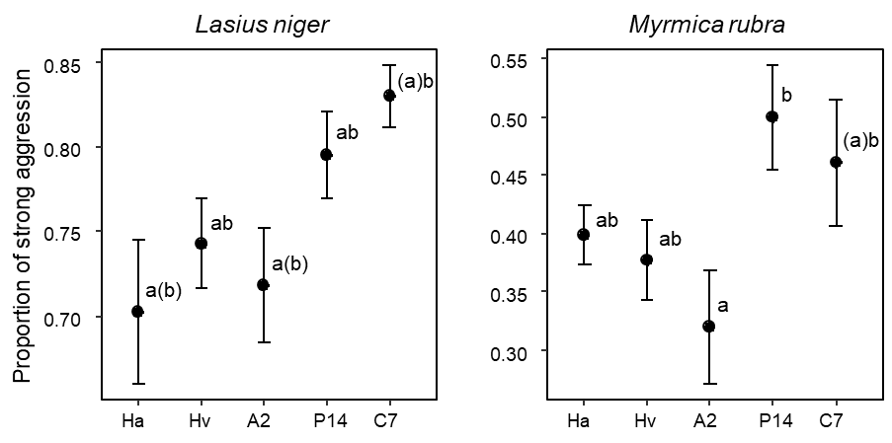
Figure S2b: Proportion of strong aggression of L. niger and M. rubra towards the studied ladybeetle species (Ha: H. axyridis, Hv: H. variegata, A2: A. bipunctata, P14: P. quatuordecimpunctata, C7: C. septempunctata); mean ± SE. Different lowercase letters indicate statistical differences (α < 0.05). Letters in brackets indicate statistical trends (α < 0.1). Note that y-axes are on different scales.

Reaction of ladybeetles to ant encounters – based on the reaction score proposed by Finlayson et al. 2009

Upon contact with L. niger, the reaction score differed between ladybeetle species (Fig. S2c; ꭕ²_{4,96} = 20.09, p < 0.001). Here, C. septempunctata had a higher reaction score confronted with L. niger compared to H. axyridis (z = 3.63, p = 0.003) and H. variegata (z = 2.82, p = 0.038). In addition, the reaction score was higher in P. quatuordecimpunctata compared to H. axyridis (z = 3.43, p = 0.006) and tended to be higher in P. quatuordecimpunctata compared to H. variegata (z = 2.60, p = 0.07). For encounters with M. rubra, reaction scores did not differ between ladybeetle species (Fig. S2c; ꭕ²_{4,100} = 7.65, p = 0.11).
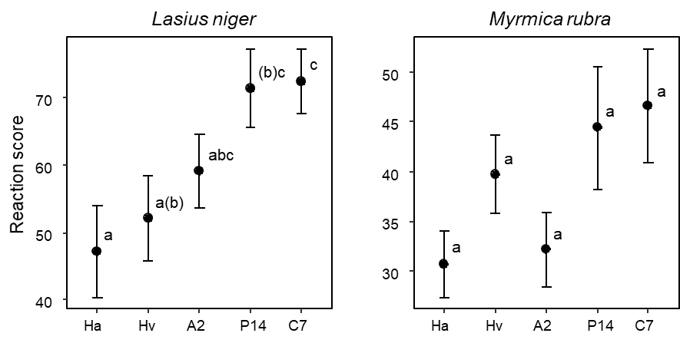
Figure S2c: Reaction scores of the studied ladybeetle species (Ha: H. axyridis, Hv: H. variegata, A2: A. bipunctata, P14: P. quatuordecimpunctata, C7: C. septempunctata) confronted with L. niger or M. rubra; mean ± SE. Different lowercase letters indicate statistical differences (α < 0.05). Letters in brackets indicate statistical trends (α < 0.1). Note that y-axes are on different scales.
Reaction of ladybeetles to ant encounters – based on the proportion of strong reactions

Upon contact with L. niger, the proportion of strong reaction differed between ladybeetle species (Fig. S2d; ꭕ²_{4,96} = 24.96, p < 0.001). Here, C. septempunctata showed a higher proportion of strong reactions confronted with L. niger compared to all other ladybeetle species H. axyridis (z = 4.03, p < 0.001), H. variegata (z = 3.60, p = 0.003), A. bipuctata (z = 3.85, p = 0.001), and P. quatuordecimpunctata (z = 4.14, p < 0.001). For encounters with M. rubra, the proportion of strong reactions differed between ladybeetle species (Fig. S2d; ꭕ²_{4,100} = 24.17, p < 0.001). Here, C. septempunctata showed a higher proportion of strong reactions compared to H. axyridis (z = 3.84, p = 0.001), A, bipunctata (z = 4.32, p < 0.001), and P. quatuordecimpunctata (z = 3.18, p = 0.013). In addition, the proportion of strong reactions tended to be higher in H. variegata compared to A. bipunctata (z = 2.48, p = 0.095) if confronted with M. rubra.
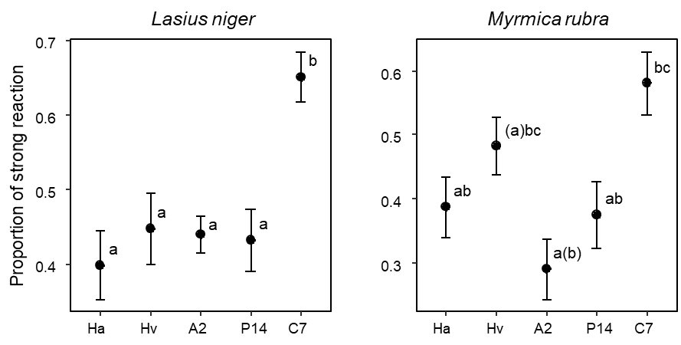
Figure S2d: Proportion of strong reaction of the studied ladybeetle species (Ha: H. axyridis, Hv: H. variegata, A2: A. bipunctata, P14: P. quatuordecimpunctata, C7: C. septempunctata) confronted with L. niger or M. rubra; mean ± SE. Different lowercase letters indicate statistical differences (α < 0.05). Letters in brackets indicate statistical trends (α < 0.1). Note that y-axes are on different scales.

Aggression towards ladybeetle CHCs – control elytra only

When we restricted our analysis on control elytra (i.e. confronting ants with one untreated elytron of the respective ladybeetle species), we found no differences in the frequency of strong ant aggression between the ladybeetle species (Fig. S2e; ꭕ²_{4,190} = 5.26, p = 0.26). L. niger tended to show more strong aggressions towards control elytra compared to M. rubra (ꭕ²_{1,190} = 2.71, p = 0.10). We found a marginally significant interaction between ladybeetle and ant species identity (ꭕ²_{4,190} = 9.32, p = 0.05). L. niger exhibited relatively more aggression than M. rubra against elytra of most ladybeetle species but not A. bipunctata. M. rubra showed more strong aggressions towards elytra of A. bipunctata compared to P. quatuordecimpunctata (z = 3.08, p = 0.02). We found no further pair-wise differences in aggression among the elytra of the different ladybeetle species for both ant species separately.

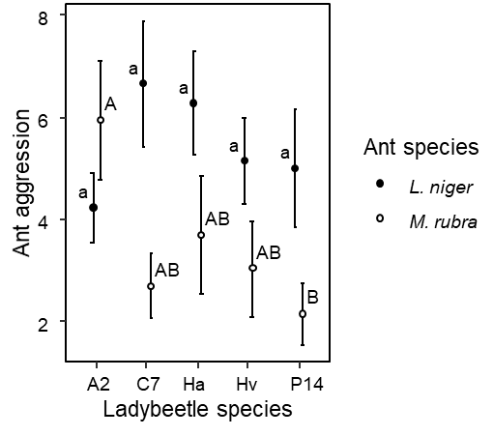
Figure S2e: The frequency of strong aggression against elytra of the tested ladybeetle species (A2 Adalia bipunctata, C7 Coccinella septempunctata, Ha Harmonia axyridis, Hv Hippodamia variegata, P14 Propylea quatuordecimpunctata). Different lowercase letters indicate statistical differences for L. niger aggression, different capital letters indicate statistical differences for M. rubra aggression (α < 0.05).

Aggression towards ladybeetle CHCs – species-wise analyses

For A. bipunctata, the aggression of ants differed between the treatments of the elytra (Fig. S2f; ꭕ²_{2,114} = 21.03, p < 0.001). We found no differences in the frequency of ant aggression between the two ant species (ꭕ²_{1,114} = 0.19, p = 0.66) and no treatment/ant species interaction (ꭕ²_{2,114} = 0.93, p = 0.63). L. niger aggression was less frequent against washed elytra compared to control elytra (z = 3.04, p < 0.01) and the treatment of washed elytra with A. bipunctata cues tended to increase the frequency of ant aggression (z = 2.12, p = 0.08). Elytra with artificially applied A. bipunctata cues induced a similar frequency of ant aggression compared with control elytra (z = 1.05, p = 0.54). M. rubra aggression was less frequent against washed elytra compared to control elytra (z = 3.46, p < 0.01). The treatment of washed elytra with A. bipunctata cues had no effect on the frequency of ant aggression (z = 1.20, p = 0.45). Elytra with artificially applied A. bipunctata cues tended to induced fewer M. rubra aggression compared to control elytra (z = 2.26, p = 0.06).

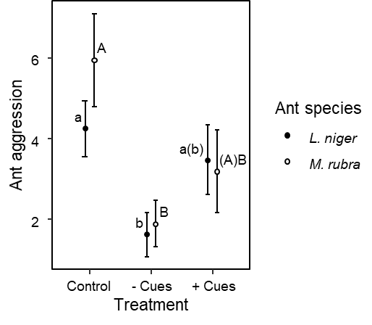
Figure S2f: The frequency of strong ant aggression against control elytra of A. bipunctata (Control), washed H. axyridis elytra (- Cues), and washed H. axyridis elytra treated with A. bipunctata cues (+ Cues). Different lowercase letters indicate statistical differences for L. niger aggression, different capital letters indicate statistical differences for M. rubra aggression (α < 0.05).

For C. septempunctata, the aggression of ants differed between the treatments of the elytra (Fig. S2g; ꭕ²_{2,113} = 14.80, p < 0.001) and L. niger tended to exhibit more strong aggressions against elytra of C. septempunctata compared to M. rubra (ꭕ²_{1,113} = 3.82, p = 0.05). We found no treatment/ant species interaction (ꭕ²_{1,113} = 0.52, p = 0.77). L. niger aggression was less frequent against washed elytra compared to control elytra (z = 3.15, p < 0.01). Elytra with artificially applied C. septempunctata cues received less aggression compared to control elytra (z = 2.70, p = 0.02). We found no pair-wise differences in M. rubra aggression between treatments.

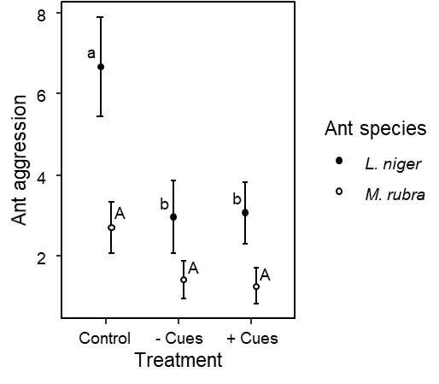
Figure S2g: The frequency of strong ant aggression against control elytra of C. septempunctata (Control), washed H. axyridis elytra (- Cues), and washed H. axyridis elytra treated with C. septempunctata cues (+ Cues). Different lowercase letters indicate statistical differences for L. niger aggression, different capital letters indicate statistical differences for M. rubra aggression (α < 0.05).

For H. axyridis, the aggression of ants differed between the treatments of the elytra (Fig. S2h; ꭕ²_{2,114} = 13.00, p < 0.01) and L. niger exhibited more strong aggressions against elytra of H. axyridis compared to M. rubra (ꭕ²_{1,114} = 12.15, p < 0.001). We found no treatment/ant species interaction (ꭕ²_{2,114} = 3.80, p = 0.15). L. niger aggression was less frequent against washed elytra compared to control elytra (z = 3.38, p < 0.01) and washed elytra treated with H. axyridis cues received more aggression than washed elytra (z = 3.27, p < 0.01). We found no pair-wise differences in M. rubra aggression between treatments.

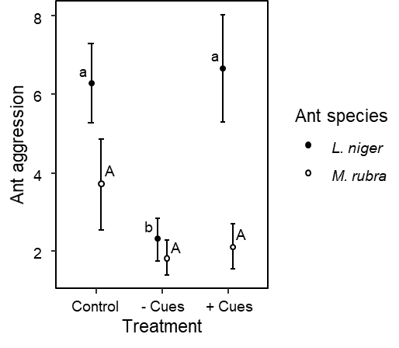
Figure S2h: The frequency of strong ant aggression against control elytra of H. axyridis (Control), washed H. axyridis elytra (- Cues), and washed H. axyridis elytra treated with H. axyridis cues (+ Cues). Different lowercase letters indicate statistical differences for L. niger aggression, different capital letters indicate statistical differences for M. rubra aggression (α < 0.05).

For H. variegata, the aggression of ants differed between the treatments of the elytra (Fig. S2i; ꭕ²_{2,112} = 16.34, p < 0.001) and L. niger tended to exhibit more strong aggressions against elytra of H. variegata compared to M. rubra (ꭕ²_{1,112} = 3.18, p = 0.07). We found no treatment/ant species interaction (ꭕ²_{2,112} = 0.38, p = 0.83). L. niger aggression was less frequent against washed elytra compared to control elytra (z = 2.46, p = 0.04) and washed elytra treated with H. variegata cues received more aggression than washed elytra (z = 2.70, p = 0.02). M. rubra aggression was less frequent against washed elytra compared to control elytra (z = 2.45, p = 0.04). We found no further pair-wise treatment differences in M. rubra aggression.
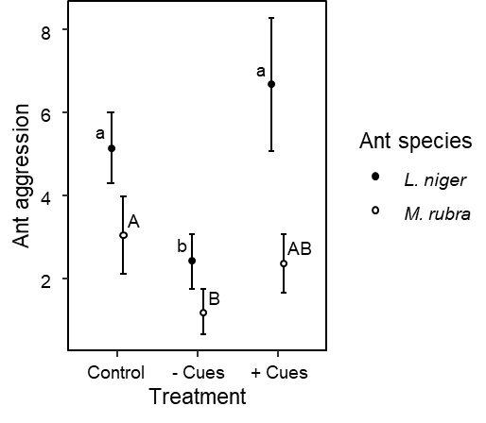
Figure S2i: The frequency of strong ant aggression against control elytra of H. variegata (Control), washed H. axyridis elytra (- Cues), and washed H. axyridis elytra treated with H. variegata cues (+ Cues). Different lowercase letters indicate statistical differences for L. niger aggression, different capital letters indicate statistical differences for M. rubra aggression (α < 0.05).

For P. quatuordecimpunctata, the aggression of ants tended to differ between the treatments of the elytra (Fig. S2j; ꭕ²_{2,115} = 5.42, p = 0.07) and L. niger exhibited more strong aggressions against elytra of P. quatuordecimpunctata compared to M. rubra (ꭕ²_{1,115} = 8.71, p < 0.01). We found no treatment/ant species interaction (ꭕ²_{2,115} = 1.83, p = 0.40). L. niger aggression tended to be less frequent against washed elytra compared to control elytra (z = 2.37, p = 0.05) and washed elytra treated with P. quatuordecimpunctata cues received more aggression than washed elytra (z = 2.53, p = 0.03). We found no pair-wise differences in M. rubra aggression between treatments.

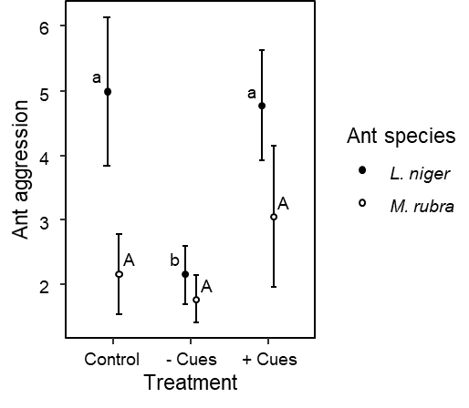
Figure S2j: The frequency of strong ant aggression against control elytra of P. quatuordecimpunctata (Control), washed H. axyridis elytra (- Cues), and washed H. axyridis elytra treated with P. quatuordecimpunctata cues (+ Cues). Different lowercase letters indicate statistical differences for L. niger aggression, different capital letters indicate statistical differences for M. rubra aggression (α < 0.05).

