Supplementary Information

Identification of sex-specific compounds in the invasive four-eyed fir bark beetle Polygraphus proximus

Lina Viklund, Yuri Baranchikov, Martin Schroeder, Anton Efremenko, Denis Demidko, Erik Hedenström

Corresponding author: Erik Hedenström, Eco-Chemistry, Department of Chemical Engineering, Mid Sweden University, SE-851 70 Sundsvall, Sweden. erik.hedenstrom@miun.se ORCID:0000-0002-5543-2041

Identification of sex-specific compounds by SPME-GC-MS

Volatile compounds emitted from males and females of Polygraphus proximus boring in the bark of Abies sibirica were collected with SPME and analyzed with GC-MS. The GC column was an HP5-MS and the temperature program started at 50 °C for 2 min, increased by 10 °C/min up to 230 °C and then increased by 15 °C/min to 280 °C, where it was held for 5 min. A VF23-MS column was also used with a temperature program of 50 °C for 2 min which increased by 5 °C/min up to 250 °C, where it was held for 10 min. More details relating to these analytical methods can be found in the main article.

Compound A (rt 2.64 min) matched well with 3-methyl-3-buten-1-ol (F match 919, R match 938) in the NIST 14 library. Compound B (rt 3.17 min) matched 3-methyl-2-buten-1-ol (F match 926, R match 934) and compound C (rt 3.32 min) matched 3-methyl-2-butenal (F match 910, R match 938). The retention times and mass spectra of the synthetic references confirmed the identities of these compounds. Compound D (rt 7.36) matched the mass spectrum of benzyl alcohol (F match 880, R match 915) and again, a synthetic reference was run and both retention time and mass spectrum matched the male specific compound.

Compound E (rt 10.22 min) had a mass spectrum that matched well with grandisol in the NIST 14 library (F match 906, R match 908). As the mass spectra of grandisol and fragranol are practically identical, we ran synthetic references of both grandisol and fragranol and as the retention times differed, we could conclude that the insect specific compound was fragranol. Compound F (rt 10.25 min) was the second largest male-specific GC peak. Its mass spectrum matched 7-methyl-3-methylene-6-octen-1-ol (γ-isogeraniol) (F match 910, R match 935). We could synthesize this compound at our laboratory (Yong et al. 2001, Viklund et al. 2021) and when the reference was run, both retention time and mass spectrum confirmed that it was indeed compound F.

The major male-specific compound, G (10.39 min), was suggested to be (Z)-2-(3,3-dimethylcyclohexylidene)-ethanol [(Z)-DMCHE] according to the NIST 14 library (F match 961, R match 962). As we know from previous studies that (E)-DMCHE has a similar mass spectrum and retention time on an HP5-MS column, the Vf23-MS column was also used and it became clear that the male-specific compound was (Z)-DMCHE. No (E)-DMCHE was seen in P. proximus males, unlike in P. subopacus males which we have previously analysed (Viklund et al. 2021).

Compound H (10.75 min) matched geraniol in the NIST 14 library and this identity was confirmed when a reference was run (F match 860, R match 908). Compounds I (10.80 min) and J (10.92 min) matched (Z)-2-(3,3-dimethylcyclohexylidene)-acetaldehyde (F match 900, R match 905) and (E)-2-(3,3-dimethylcyclohexylidene)-acetaldehyde (F match 834, R match 848). A reference of a 1:1 mixture of these compounds confirmed that both were present in the insects.

Compound K (10.97 min) did not generate any good suggestions from the library. The best match was 3-cyano-4-ethoxyfurazan (F match 707, R match 832) which seemed unlikely. There was an m/z fragment of 155 which appeared to be the M+ ion. However, when searching the literature for other insects which produce similar sex-specific compounds as P. proximus, a compound with a similar mass spectrum - papayanol - was eventually found (Zarbin et al. 2010). Papayanol could be synthesized at our laboratory and when run on the GC-MS, mass spectrum and retention times matched the compound found in samples from P. proximus. Compound L (11.01 min) co-eluted partially with compound K on the HP5-MS column, however a good match was found with citral (F match 874, R match 882). A reference of citral (containing both neral and geranial) showed that compound L was indeed geranial.

One female-specific compound, compound M, was found at 4.57 min. The best match in the MS library was 1-hexanol (F match 868, R match 912) and a reference could easily be run, confirming the identity of this compound.

Benzaldehyde (rt. 6.15 min), which was previously detected in males of P. subopacus, was also seen in males of P. proximus, but similar fragments were found in the females and in the fir background. As in P. subopacus, it coeluted with other compounds from the fir background and in combination with the small number of replicates in this study, it was not possible to determine whether the GC peak of benzaldehyde was larger in males than in females.

References
Viklund L, Bång J, Schroeder M, Hedenström E (2021) Identification of male produced compounds in the bark beetle Polygraphus subopacus and establishment of (Z)-2-(3,3-dimethylcyclohexylidene)-ethanol as an aggregation pheromone component. Chemoecology 31:367–376. https://doi.org/10.1007/s00049-021-00358-0
Yong KH, Lotoski JA, Chong M (2001) Studies on the alkylation of 3-methyl-3-buten-1-ol dianion: an efficient synthesis of 3-methylene-1-alkanols including a San Jose scale sex pheromone. J Org Chem 66:8248–8251. https://doi.org/10.1021/jo015940w
Zarbin PHG, Moreira MAB, Haftmann J, Tröger A, Franke S, Kopf J, Mori K, Francke W (2010) (1R,2S,6R)-2-Hydroxymethyl-2,6-dimethyl-3- oxabicyclo[4.2.0]octane, a new volatile released by males of the papaya borer Pseudopiazurus obesus (Col.: Curculionidae). Org Lett 12:2447–2449. https://doi.org/10.1021/ol100074q

Chromatograms and MS spectra of compounds A-M and their corresponding synthetic references

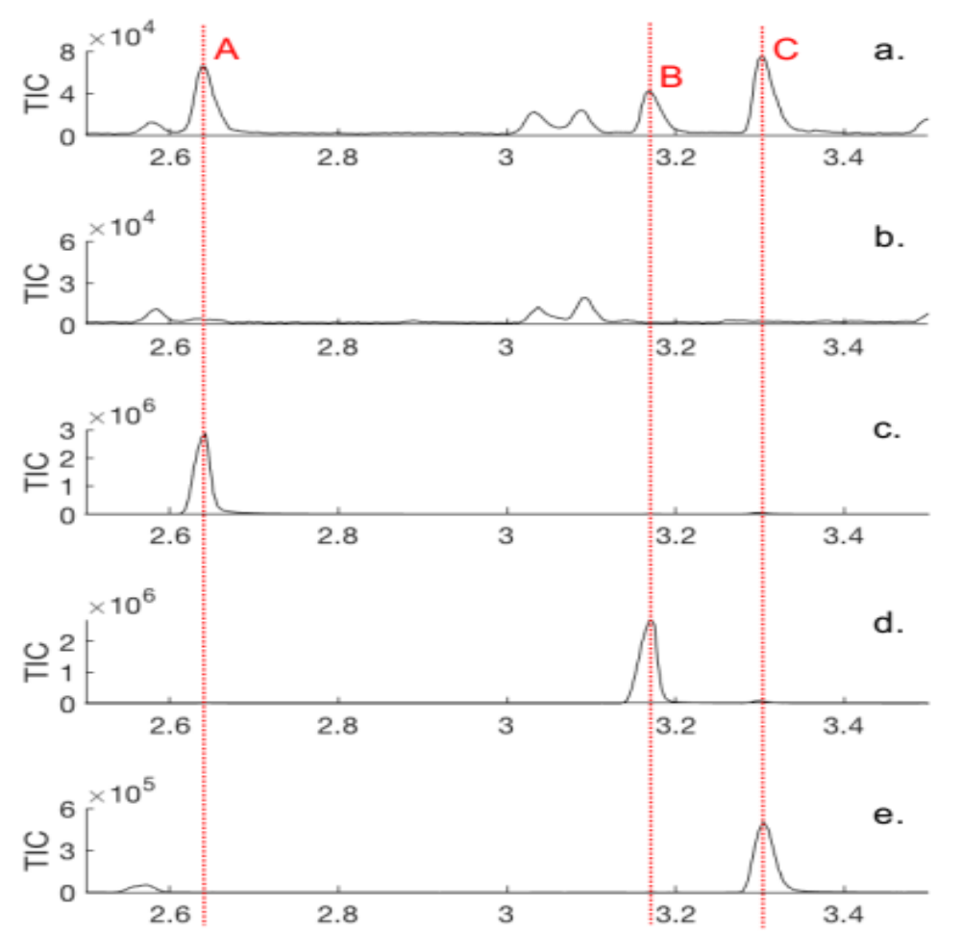
Fig. S1 GC chromatograms showing a) male specific compounds A, B and C, b) the absence of these compounds in the female, c) a synthetic reference of 3-methyl-3-buten-1-ol, d) a synthetic reference of 3-methyl-2-buten-1-ol and e) a synthetic reference of 3-methyl-2-butenal. A pink SPME fiber was used and the column was an HP5-MS

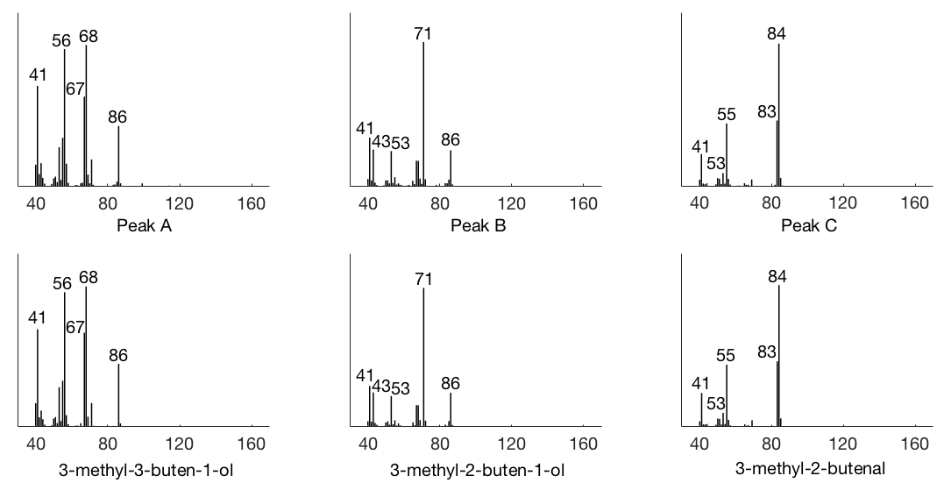

Fig. S2 Mass spectra of the male specific compounds A, B and C with corresponding synthetic references. A pink SPME fiber was used and the column was an HP5-MS.

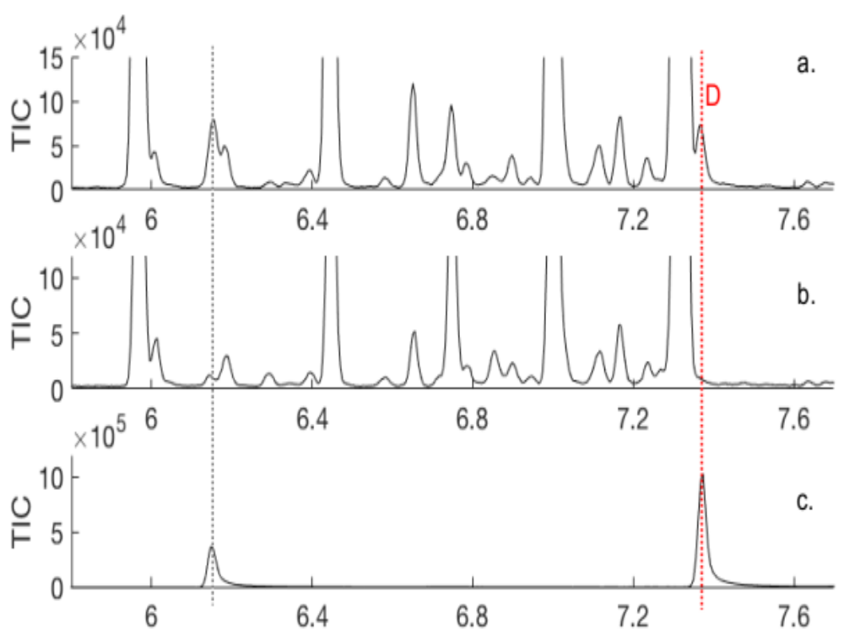

Fig. S3 GC chromatograms showing a) the male specific compound D, b) the absence of this compound in the female and c) a synthetic reference of benzyl alcohol. Benzaldehyde (marked with a grey line) is also present in the reference sample, as well as in the male and female of P. proximus. A pink SPME fiber was used and the column was an HP5-MS

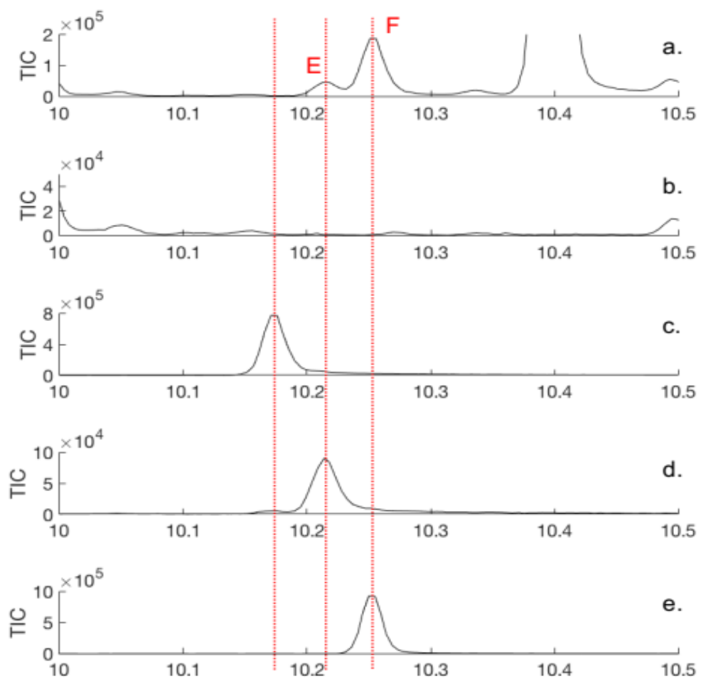

Fig. S4 GC chromatograms showing a) male specific compounds E and F, b) the absence of these compounds in the female, and synthetic references of c) grandisol, d) fragranol and e) gamma-isogeraniol. An orange SPME fiber was used and the column was an HP5-MS

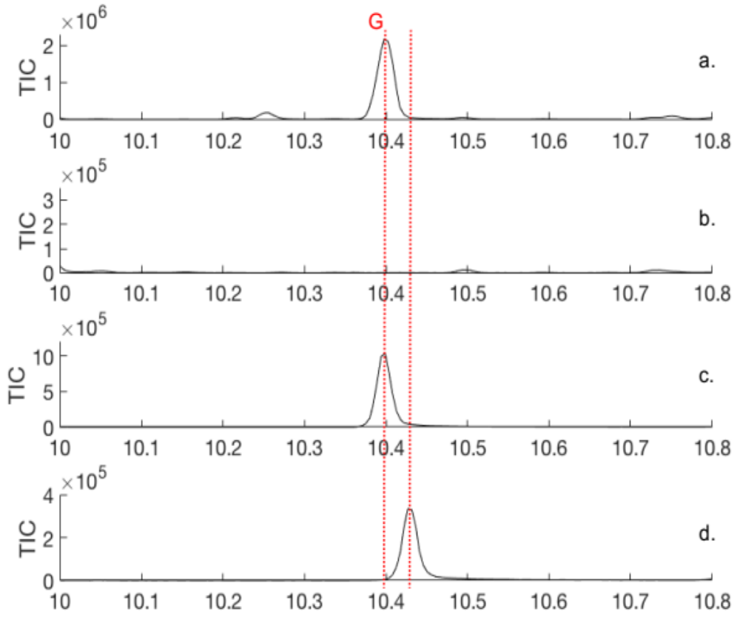

Fig. S5 GC chromatograms showing a) the major male specific compound G, b) the absence of this compound in the female, and synthetic references of c) (Z)-DMCHE and d) (E)-DMCHE. An orange SPME fiber was used and the column was an HP5-MS

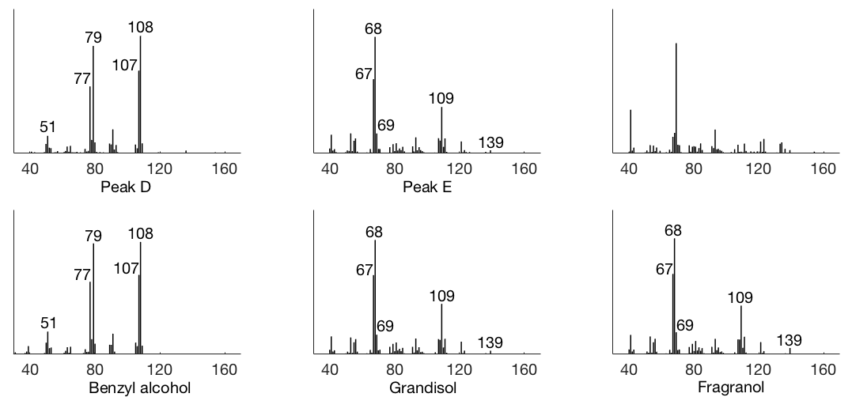
Fig. S6 Mass spectra of the male specific compounds D and E with corresponding synthetic references. A pink SPME fiber was used for compound D and an orange fiber was used for compound E. The column was an HP5-MS

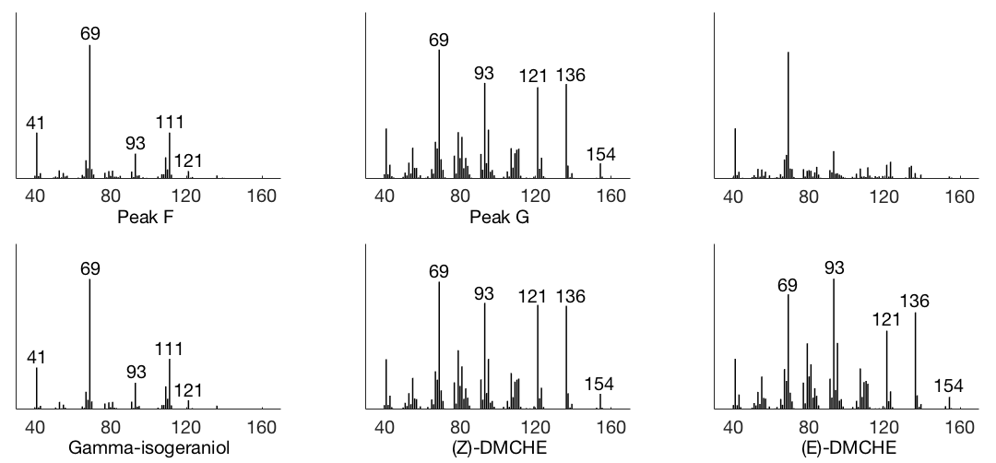

Fig. S7 Mass spectra of the male specific compounds F and G with corresponding synthetic references. An orange SPME fiber was used and the column was an HP5-MS

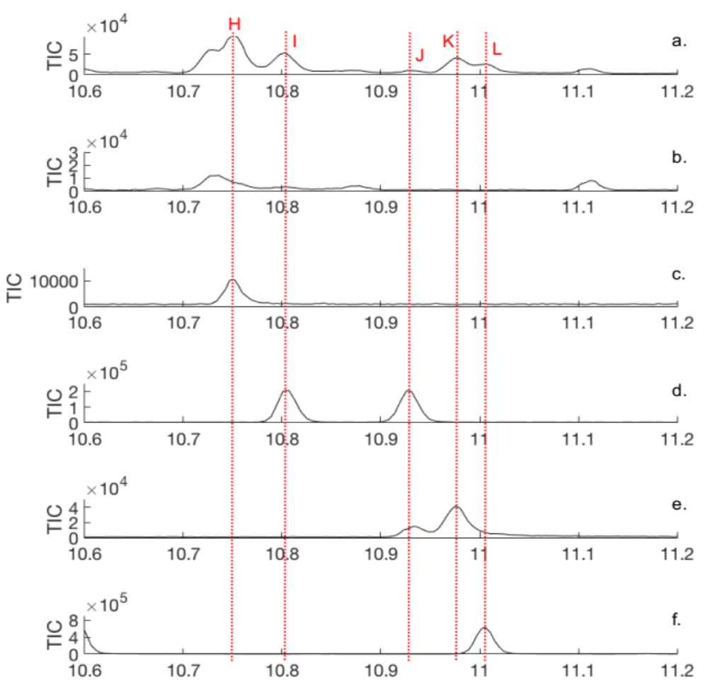
Fig. S8 GC chromatograms showing a) male-specific compounds H, I, J, K and L, b) the absence of these compounds in the female, synthetic references of c) geraniol, d) (Z)- and (E)-DMCHA, e) two isomers of papayanol and f) citral (geranial at 11.02 min and neral is barely visible at 10.59 min). An orange SPME fiber was used and the column was an HP5-MS

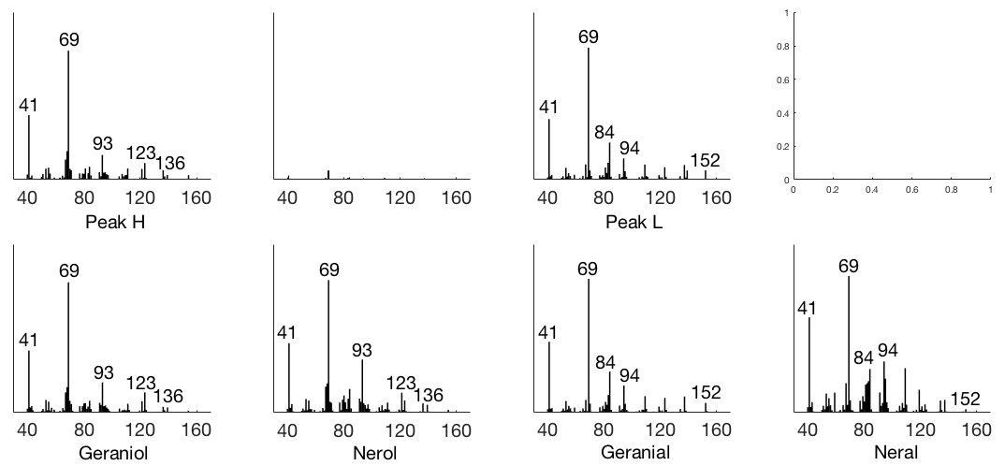

Fig. S9 Mass spectra of the male-specific compounds H and L with corresponding, synthetic references. A pink SPME fiber was used. The column was a VF23-MS for compound H, and an HP5-MS for compound L

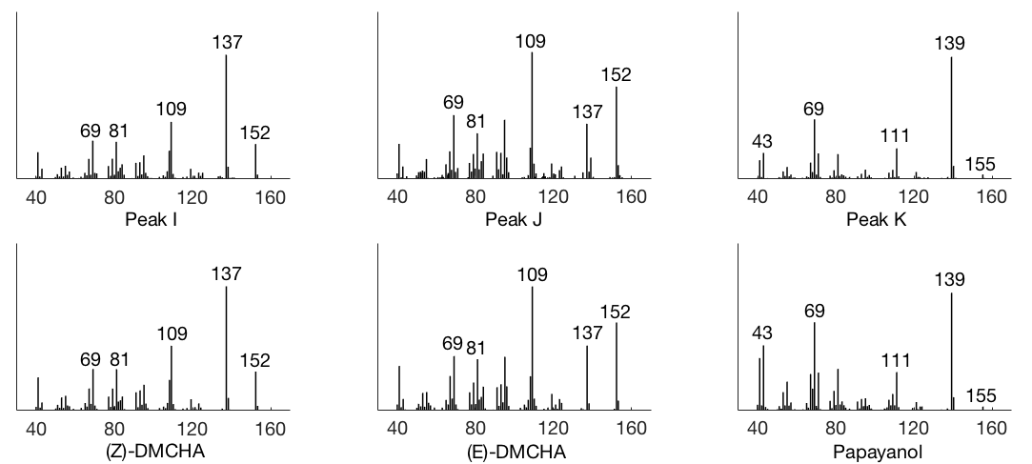

Fig. S10 Mass spectra of the male specific compounds I, J and K with corresponding synthetic references. A pink SPME fiber was used and the column was an HP5-MS

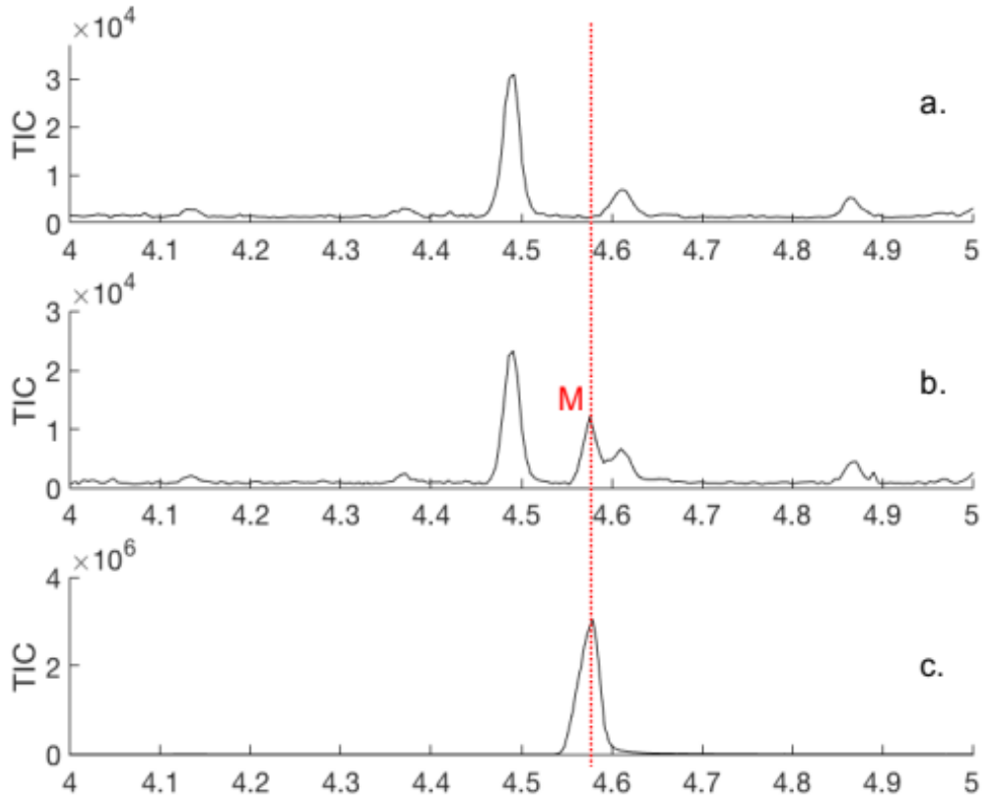

Fig. S11 GC chromatograms showing a) a representative male, b) the female-specific compound M and c) a synthetic reference of 1-hexanol. An orange SPME fiber was used and the column was an HP5-MS

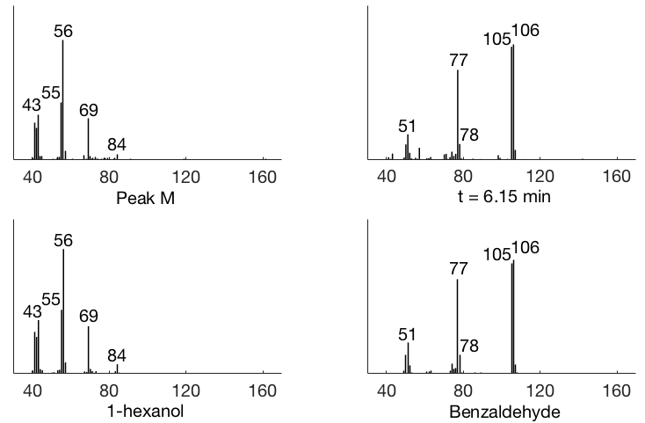

Fig. S12 Mass spectra of the female-specific compound M and the compound at retention time 6.15 min which was found in both sexes, with their corresponding synthetic references. A pink SPME fiber was used and the column was an HP5-MS

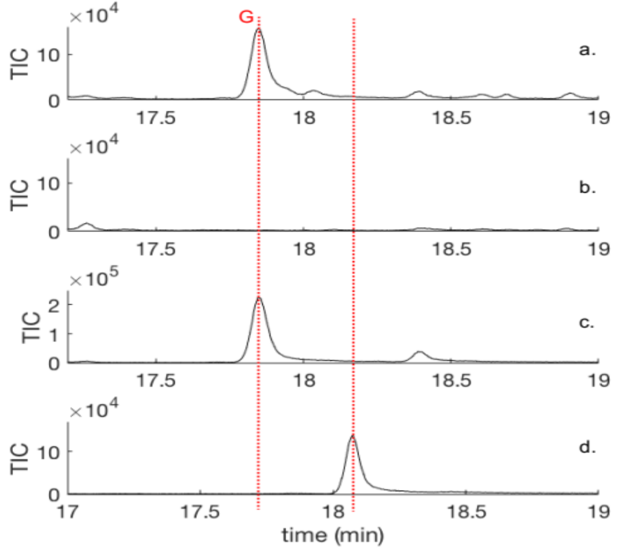

Fig. S13 GC chromatograms showing a) the major male-specific compound G, b) the absence of this compound in the female and c) a synthetic reference of (Z)-DMCHE and d) (E)-DMCHE. A pink SPME fiber was used and the column was a VF23-MS

Statistics

The proportions of beetles caught by each treatment in each replicate were summarized and the results are illustrated below (Fig. S14−S23). Note that the arcsine square root transformation was used on these proportions before statistical analysis with Welch’s ANOVA followed by Games-Howell post hoc test. Proportions are shown instead of the transformed values, for illustrative purposes.

P. proximus

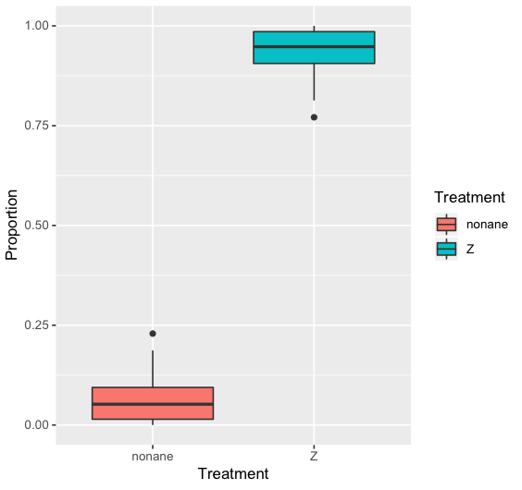

Fig. S14 Experiment 1. Catches of P. proximus. (Z)-DMCHE caught more beetles than n-nonane

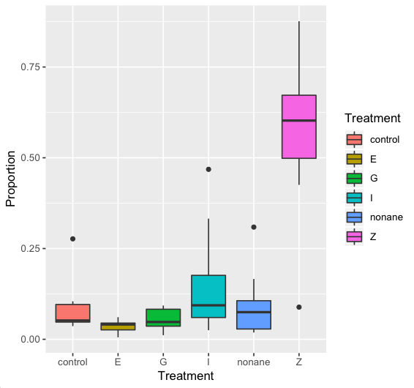

Fig. S15 Experiment 2, part 1. Catches of P. proximus. (Z)-DMCHE, (Z), was compared to (E)-DMCHE (E), grandisol (G), γ-isogeraniol (I), n-nonane and unbaited control traps

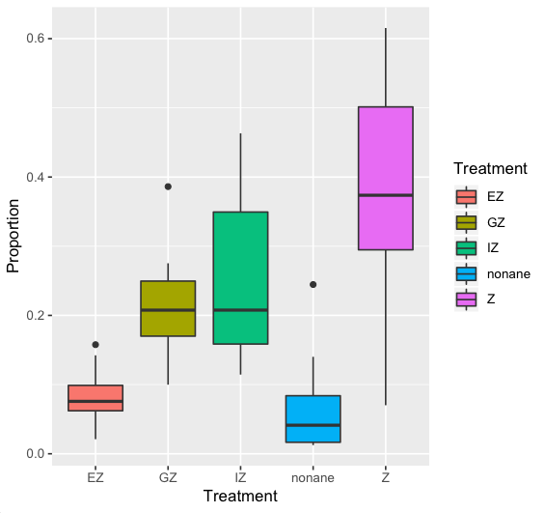

Fig. S16 Experiment 2, part 2. Catches of P. proximus. (Z)-DMCHE, (Z), was combined with (E)-DMCHE (E), grandisol (G) and γ-isogeraniol (I)

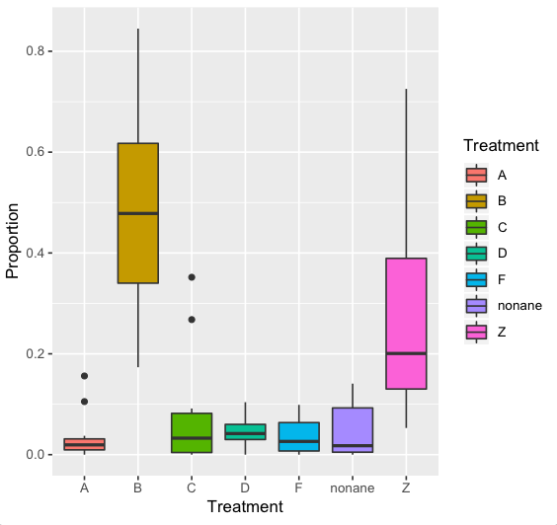

Fig. S17 Experiment 3, part 1. Catches of P. proximus. 3-Methyl-3-buten-1-ol (A), 3-methyl-2-buten-1-ol (B), 3-methyl-2-butenal (C), geraniol (D) and citral (F) were compared to (Z)-DMCHE (Z) and n-nonane

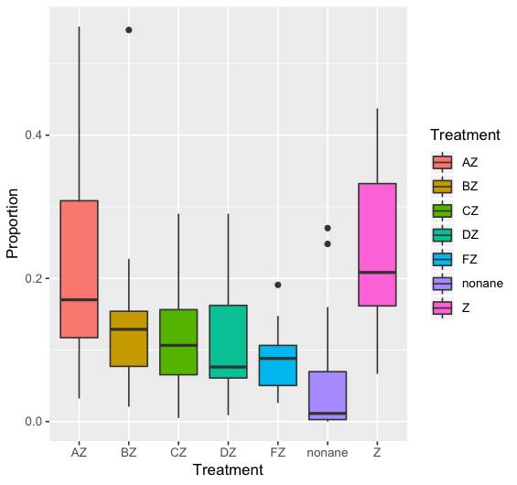

Fig. S18 Experiment 3, part 2. Catches of P. proximus. (Z)-DMCHE (Z) was combined with 3-methyl-3-
buten-1-ol (A), 3-methyl-2-buten-1-ol (B), 3-methyl-2-butenal (C), geraniol (D) and citral (F)

P. subopacus

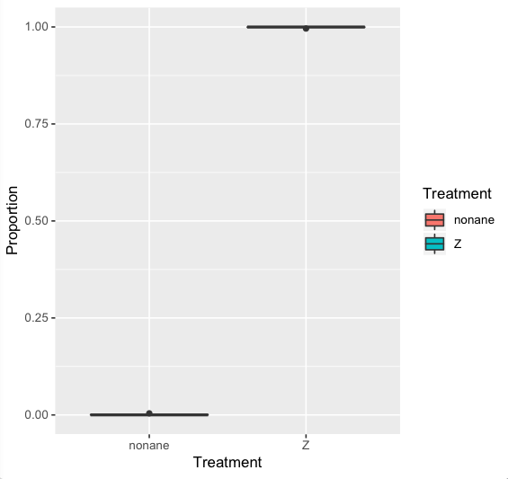

Fig. S19 Experiment 1. Catches of P. subopacus. (Z)-DMCHE caught more beetles than n-nonane

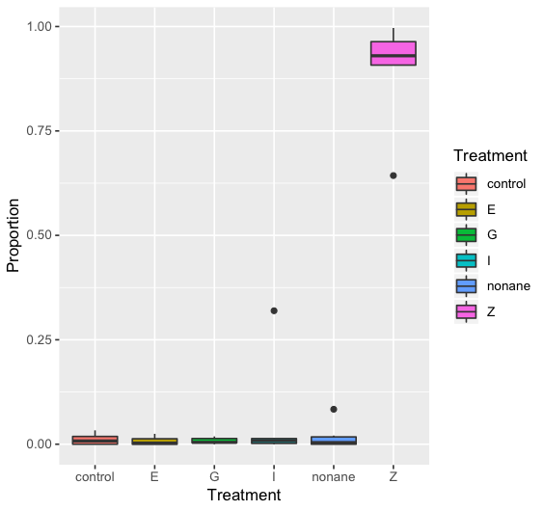

Fig. S20 Experiment 2, part 1. Catches of P. subopacus. (Z)-DMCHE (Z), was compared to (E)-DMCHE (E), grandisol (G), γ-isogeraniol (I), n-nonane and unbaited control traps

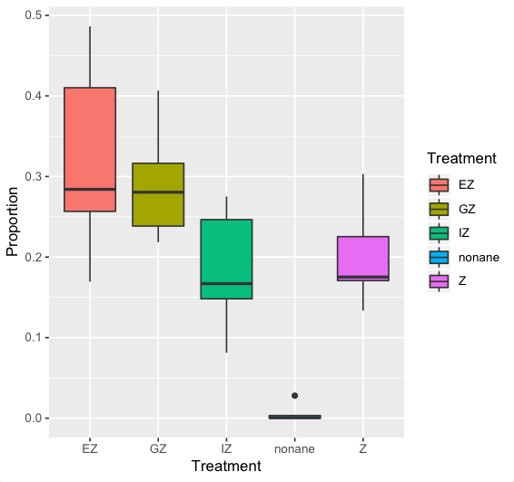

Fig. S21 Experiment 2, part 2. Catches of P. subopacus. (Z)-DMCHE, (Z), was combined with (E)-DMCHE (E), grandisol (G) and γ-isogeraniol (I)

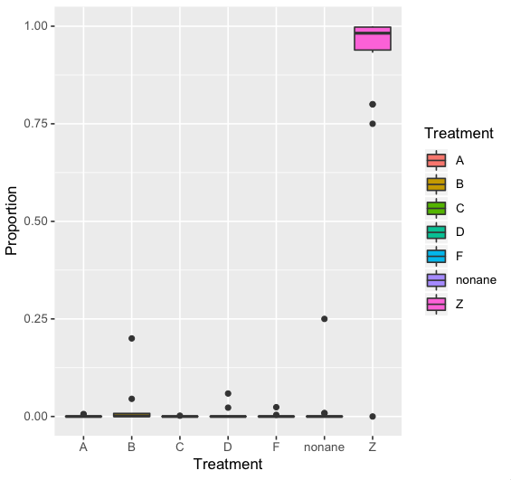

Fig. S22 Experiment 3, part 1. Catches of P. subopacus. 3-Methyl-3-buten-1-ol (A), 3-methyl-2-buten-1-ol (B), 3-methyl-2-butenal (C), geraniol (D) and citral (F) were compared to (Z)-DMCHE (Z) and n-nonane

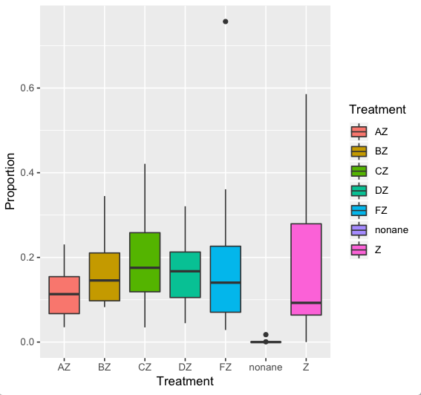

Fig. S23 Experiment 3, part 2. Catches of P. subopacus. (Z)-DMCHE (Z) was combined with 3-methyl-3-buten-1-ol (A), 3-methyl-2-buten-1-ol (B), 3-methyl-2-butenal (C), geraniol (D) and citral (F)

P. proximus compared to P. subopacus

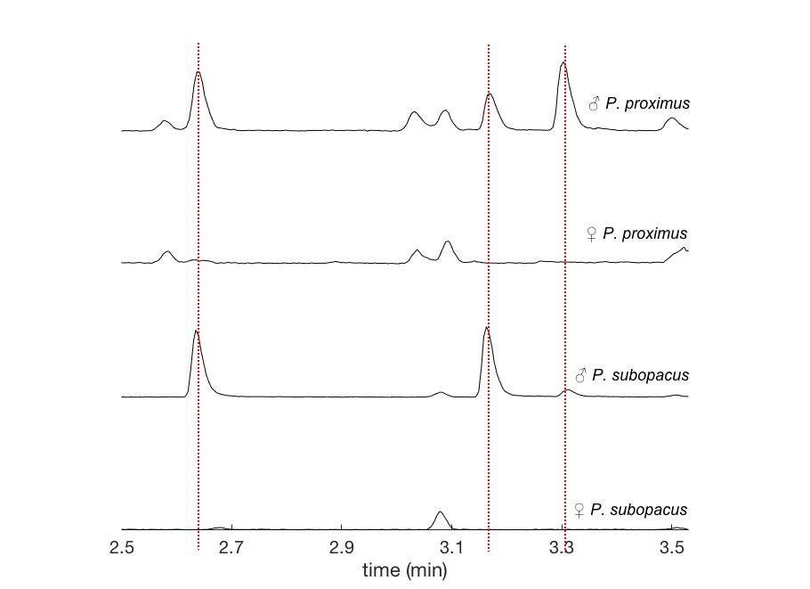

Fig. S24 GC chromatograms of P. proximus and P. subopacus males and females, zoomed in on 2.5−3.6 min. A pink SPME fiber was used with an HP5-MS GC column.

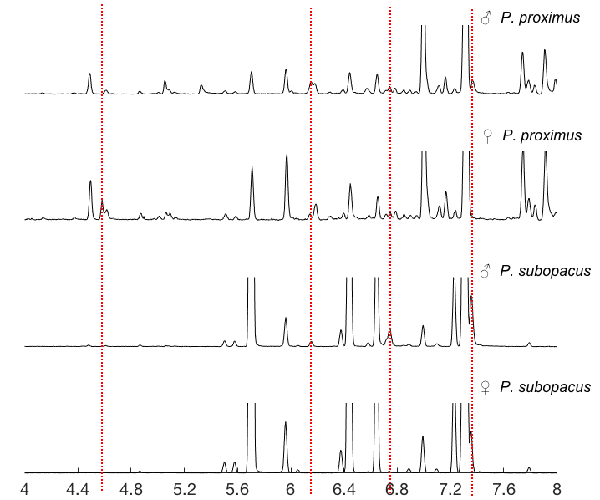

Fig. S25 GC chromatograms of P. proximus and P. subopacus males and females, zoomed in on 4.0−8.0 min. A pink SPME fiber was used with an HP5-MS GC column

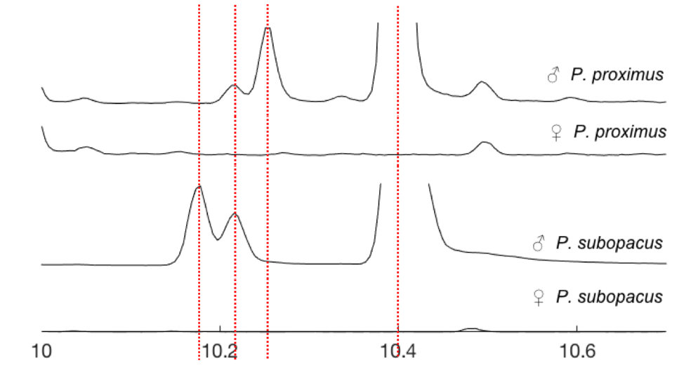

Fig. S26 GC chromatograms of P. proximus and P. subopacus males and females, zoomed in on 10.0−10.7 min. An orange fiber was used for P. proximus and a pink SPME fiber was used for P. subopcaus. The column was an HP5-MS GC column

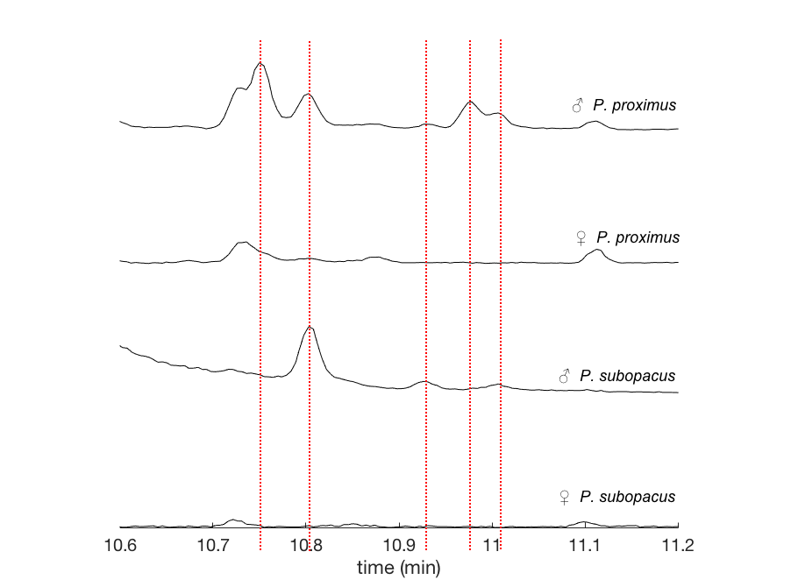

Fig. S27 GC chromatograms of P. proximus and P. subopacus males and females, zoomed in on 10.6−11.2 min. An orange fiber was used for P. proximus and a pink SPME fiber was used for P. subopcaus. The column was an HP5-MS GC column

