Supplemental information
Figure S1

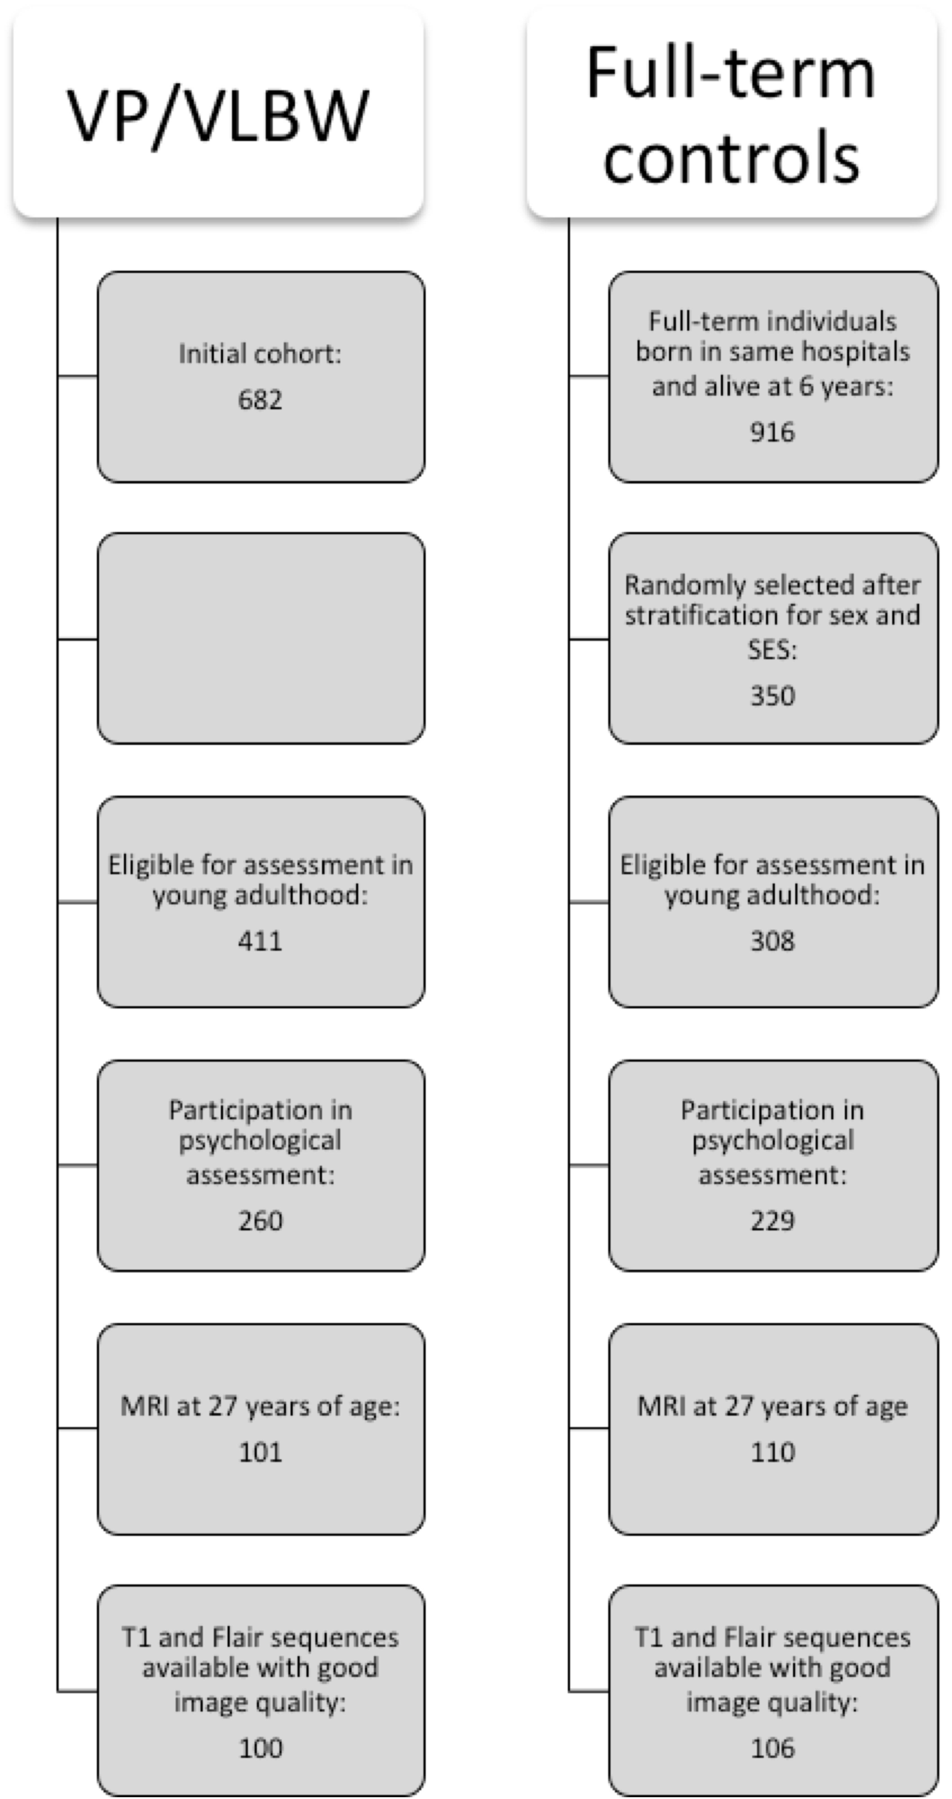

Figure S1: Flow diagram of study participants.
Abbreviations: SES: socioeconomic status, VP/VLBW: very preterm and/or very low birth weight

Table S1: Scanner distribution and sequence specifications

 | Center | Bonn |  | Munich
 | Scanner | Achieva 3T | Ingenia 3T | Achieva 3T | Ingenia 3T
 | Subjects (VP/VLBW/ FT) | 5 / 10 | 33 / 17 | 60 / 64 | 2 / 15
T1-weighted | TI | 1300 ms | 1300 ms | 1300 ms | 1300 ms
T1-weighted | TR | 7.7 ms | 7.7 ms | 7.7 ms | 7.7 ms
T1-weighted | TE | 3.9 ms | 3.9 ms | 3.9 ms | 3.9 ms
T1-weighted | Flip angle | 15° | 15° | 15° | 15°
T1-weighted | Field of view | 256 mm x 256 mm | 256 mm x 256 mm | 256 mm x 256 mm | 256 mm x 256 mm
T1-weighted | Reconstructed voxel size | 1 mm³ | 1 mm³ | 1 mm³ | 1 mm³
FLAIR-weighted | TI | 1600 ms | 1600 ms | 1600 ms | 1600 ms
FLAIR-weighted | TR | 4800 ms | 4800 ms | 4800 ms | 4800 ms
FLAIR-weighted | TE | 320 ms | 320 ms | 320 ms | 320 ms
FLAIR-weighted | Flip angle | 90° | 90° | 90° | 90°
FLAIR-weighted | Field of view | 256 mm x 256 mm | 256 mm x 256 mm | 256 mm x 256 mm | 256 mm x 256 mm
FLAIR-weighted | Reconstructed voxel size | 0.5 mm³ | 0.5 mm³ | 0.5 mm³ | 0.5 mm³

Table S1: Scanner distribution and sequence specifications.
Abbreviations: FLAIR: Fluid-attenuated inversion recovery; TE: Time to echo; TI: Time to inversion; TR: Time to repetition; VP/VLBW: very preterm and/or very low birth weight

