Supplement

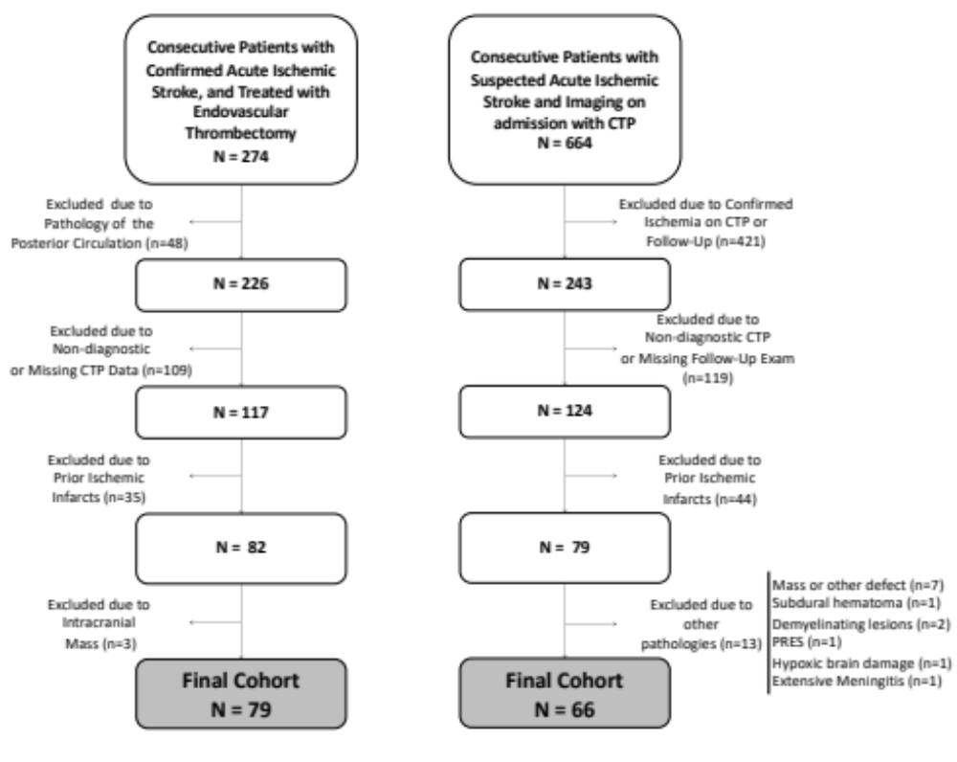
Supplemental Figure I. Flow chart of patient selection. CTP indicates CT perfusion; PRES, posterior reversible encephalopathy syndrome.

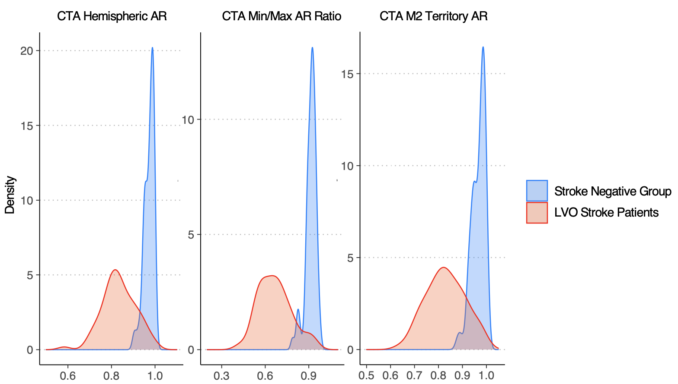
Supplemental Figure II. Density plot for the distribution of the indicated parameters in the stroke negative group (blue) and LVO stroke group (red). The x-axis displays the values of the respective parameters, the y-axis the kernel density estimate. LVO indicates, large vessel occlusion; CTA, CT Angiography, M2 segment of the middle cerebral artery.

Supplemental Table I. Linear regression analysis for the association of white matter changes and automated CTA measurements (N=145)
Independent variable | Beta (95% CI) |  | P Value
CTA Hemispheric AR | 0.061 | (-0.012-0.025) | 0.47
CTA Min/Max AR Ratio | 0.019 | (-0.027-0.034) | 0.82
CTA M2 Territory AR | 0.053 | (-0.013-0.025) | 0.53
CTA ASPECTS M5 Region AR | 0.066 | (-0.006-0.014) | 0.43
Univariate linear regression analyses were performed for the indicated imaging parameters as independent variables and the age-related white matter changes score (1) as dependent variable. CTA indicates CT angiography; AR, asymmetry ratio; ASPECTS, Alberta Stroke Program Early CT Score. P values <0.05 indicate statistical significance.

Supplemental References:
1. Wahlund, L. O., et al. (2001). "A new rating scale for age-related white matter changes applicable to MRI and CT." Stroke 32(6): 1318-1322

