SUPPLEMENTARY MATERIAL
Segment | Modality | Delineation | P-value | Signal | P-value | Contrast | P-value
Aortic arch/ | CE-MRA | 4 [2-5] | .141 | 4 [2-5] | <.0001 | 4 [2-5] | .391
adjacent branches | REACT | 4 [2-5] |  | 4 [2-5] |  | 4 [2-5]
Common | CE-MRA | 5 [2-5] | .048 | 4 [3-5] | .663 | 4 [2-5] | .582
carotid artery | REACT | 4 [3-5] |  | 4 [3-5] |  | 4 [3-5]
ICA | CE-MRA | 5 [2-5] | .049 | 4 [3-5] | .004 | 4 [2-5] | .346
(C1 segment) | REACT | 4 [3-5] |  | 5 [3-5] |  | 5 [3-5]
ICA | CE-MRA | 5 [2-5] | .003 | 4 [3-5] | .06 | 4 [2-5] | .88
(C2 segment) | REACT | 4 [3-5] |  | 4.5 [3-5] |  | 5 [3-5]
Proximal external | CE-MRA | 5 [2-5] | <.0001 | 4 [2-5] | .248 | 4 [2-5] | <.0001
carotid artery | REACT | 4 [3-5] |  | 4 [2-5] |  | 4 [2-5]
Distal external | CE-MRA | 4 [2-5] | <.0001 | 4 [2-5] | <.0001 | 4 [2-5] | <.0001
carotid artery | REACT | 4 [1-5] |  | 4 [1-5] |  | 4 [1-5]
Vertebral artery | CE-MRA | 4 [2-5] | <.0001 | 4 [3-5] | .258 | 4 [2-5] | .008
(V1 segment) | REACT | 4 [3-5] |  | 4 [2-5] |  | 4 [3-5]
Vertebral artery | CE-MRA | 4 [2-5] | <.0001 | 4 [3-5] | .302 | 4 [2-5] | .002
(V2 segment) | REACT | 4 [3-5] |  | 4 [3-5] |  | 4 [2-5]
Vertebral artery | CE-MRA | 4 [2-5] | .003 | 4 [3-5] | .608 | 4 [2-5] | .398
(V3 segment) | REACT | 4 [3-5] |  | 4 [3-5] |  | 4 [2-5]
Supplementary tables

Table 1: Median subjective scores regarding vessel delineation, signal, and contrast averaged as indicated by all readers for CE-MRA (contrast-enhanced magnetic resonance angiography) and REACT (Relaxation-Enhanced Angiography without Contrast and Triggering). The Wilcoxon rank-sum test was used with P<.05 indicating statistical significance. ICA=internal carotid artery.

Criterion | CE-MRA | REACT
Delineation | 0.43 | 0.46
Signal | 0.45 | 0.44
Contrast | 0.44 | 0.47
Artifacts | 0.29 | 0.26
Noise | 0.48 | 0.36

Table 2: Interobserver agreement for CE-MRA (contrast-enhanced magnetic resonance angiography) and REACT (Relaxation-Enhanced Angiography without Contrast and Triggering) for each subjective criterion of image quality assessed by Kendall’s W.

Supplementary figures
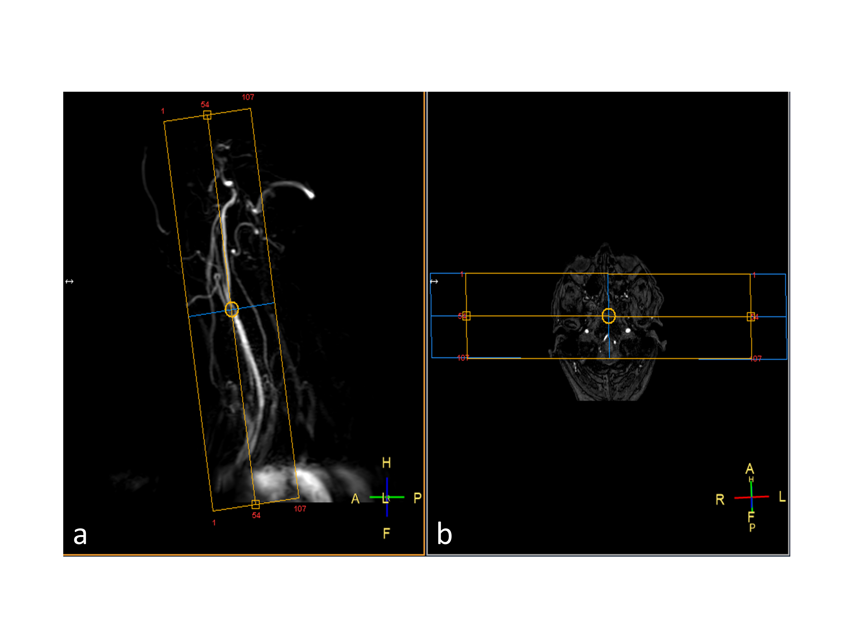Figure 1: Sagittal tilted scout image based on phase-contrast angiography (a) and axial orientation based on prior acquired TOF-MRA (b) for the acquisition of extracranial MRAs.

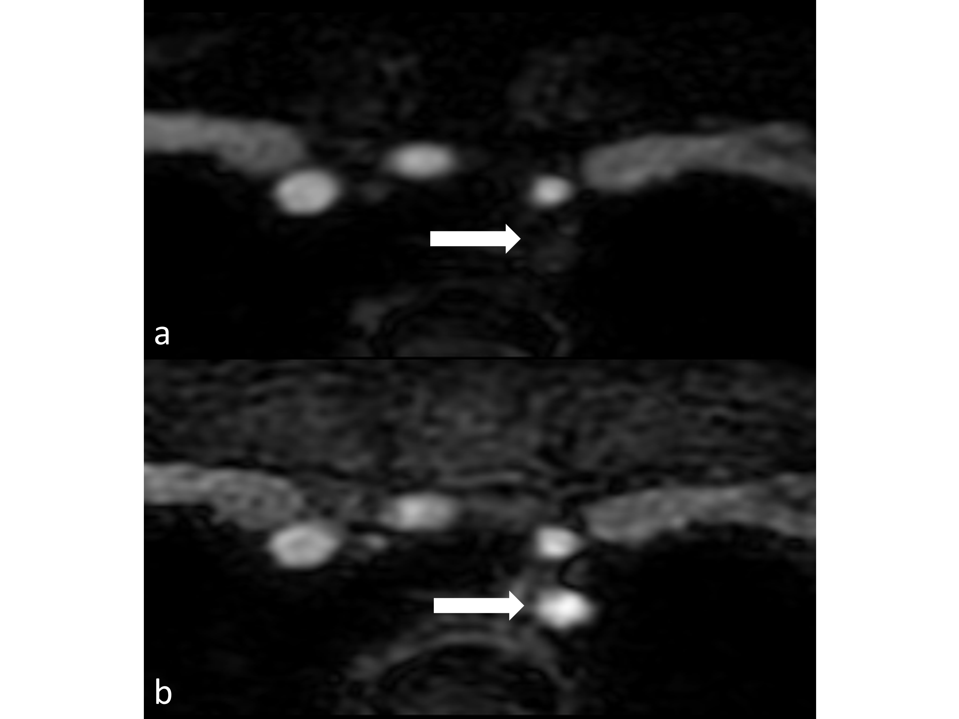
Figure 2: Example of a signal loss in water-only weighting (a) of mDIXON XD readout in axial source images from REACT with strong signal of the corresponding in-phase image (b; arrows) in the left proximal subclavian artery (1 cm distal of its origin, over a length of 2.5 cm) in a 75-year-old female patient with acute right hemispheric watershed cerebral infarction.

