Supplementary Information

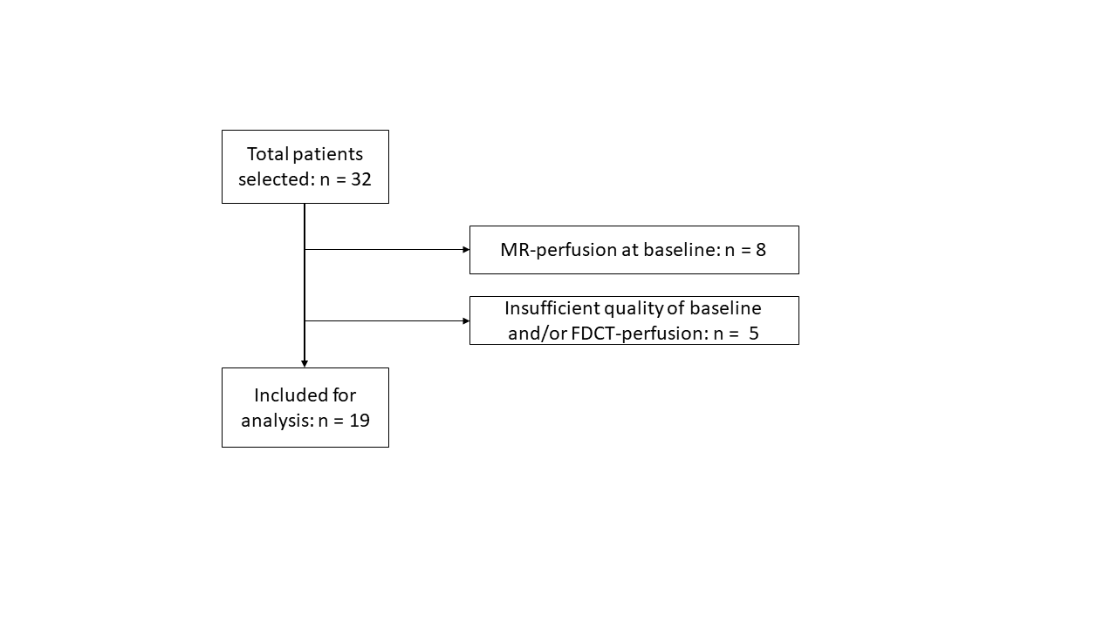
Supplementary Fig. 1 Flowchart depicting the patient selection

Supplementary Table 1 Acquisition parameters used for multidetector computed tomography perfusion

Patients (n) | Acquisition parameters
14 | 350 mA, 80 kV, 570 ms, a matrix size of 512 × 512, a field of view of 20 cm, a spiral pitch factor of 0.5, a single collimation width of 1.2 mm, and H20f kernel. A total of 30 contrast phases were acquired.
2 | 180 mA, 70 kV, 500 ms, a matrix size of 512 × 512, a field of view of 20 cm, a spiral pitch factor of 0.5, a single collimation width of 1.2 mm, and Hr36f kernel. A total of 28 contrast phases were acquired.
1 | 273 mA, 80 kV, 660 ms, a matrix size of 512 × 512, a field of view of 20 cm, a spiral pitch factor of 0.5, a single collimation width of 1.2 mm, and H20f kernel. A total of 29 contrast phases were acquired.
1 | 304 mA, 80 kV, 660 ms, a matrix size of 512 × 512, a field of view of 20 cm, a spiral pitch factor of 0.5, a single collimation width of 1.2 mm, and H20f kernel. A total of 30 contrast phases were acquired.
1 | 120 mA, 80 kV, 350 ms, a matrix size of 512 × 512, a field of view of 22 cm, axial acquisition, a single collimation width of 0.625 mm, and standard kernel. A total of 25 contrast phases were acquired.

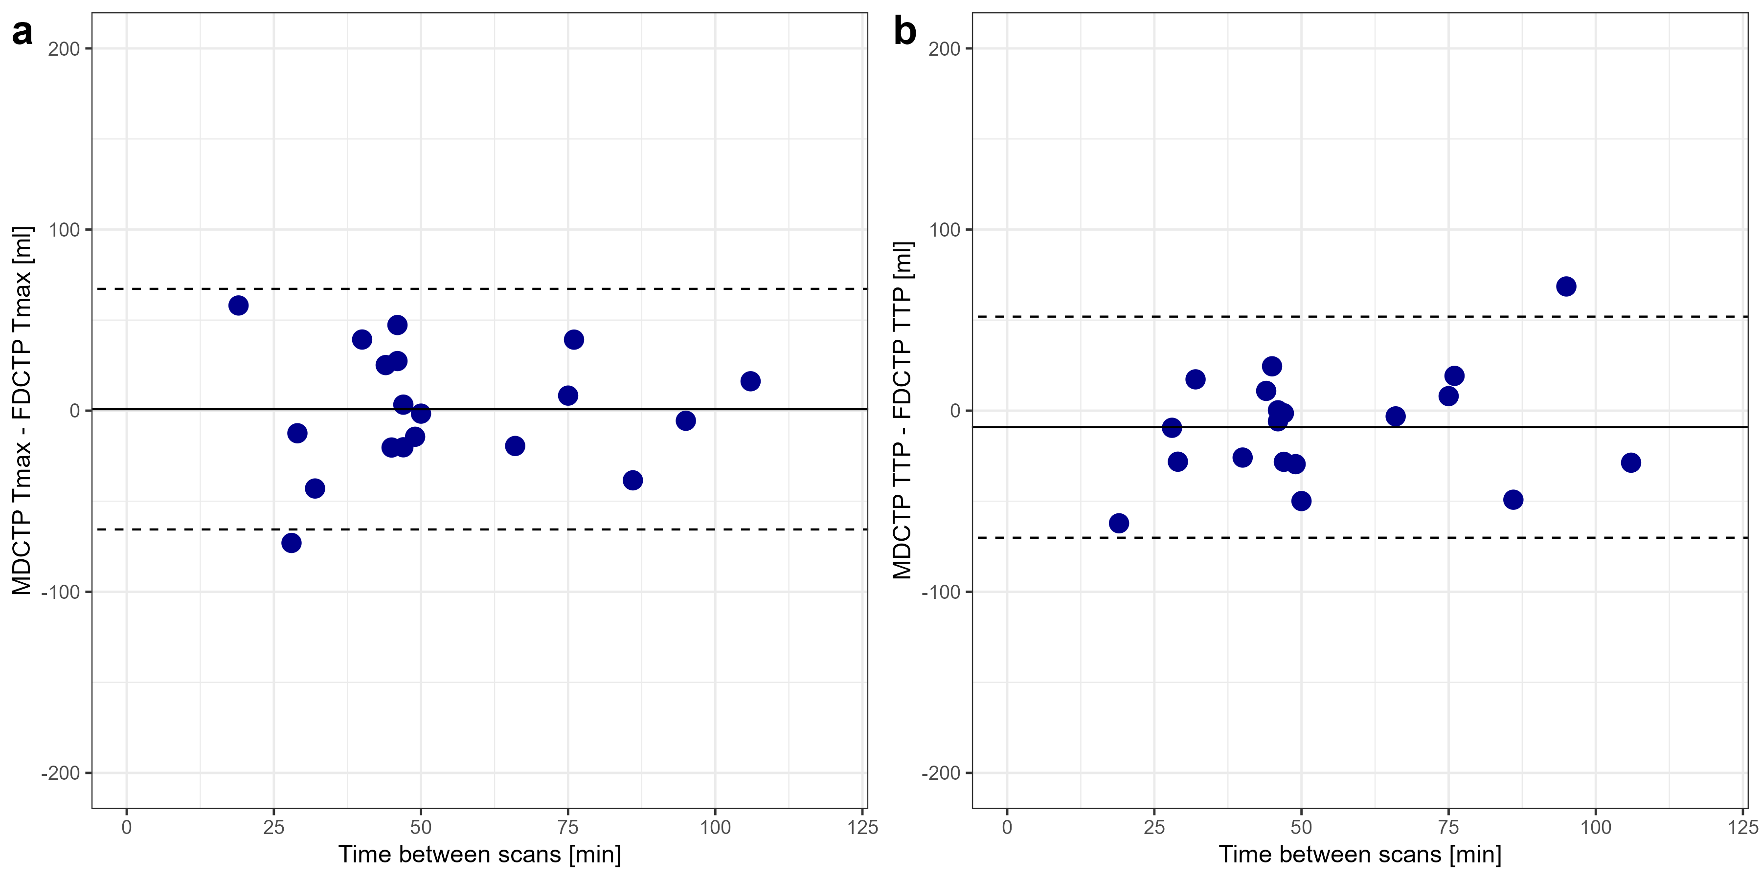
Supplementary Fig. 2 Differences of volumes for multidetector computed tomography perfusion (MDCTP) and flat-panel detector computed tomography perfusion (FDCTP) in correlation with the corresponding time between the scans. (a) For time to maximum (Tmax), and (b) for time to peak (TTP). Mean of differences (solid line) and limits of agreement are shown (dashed lines).

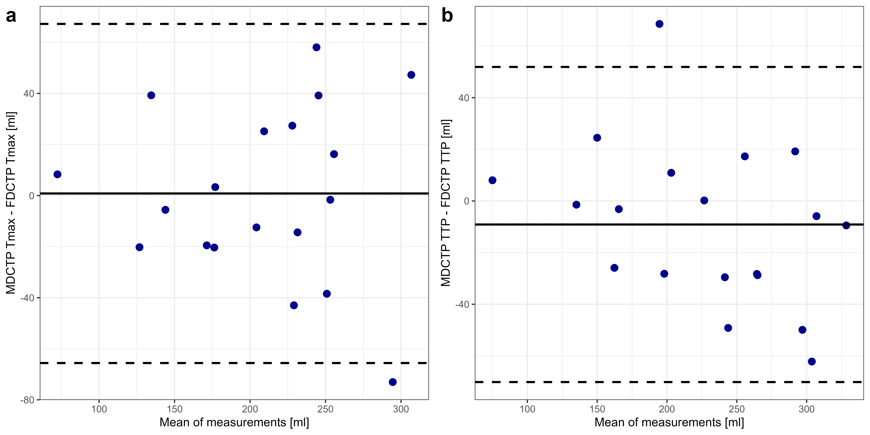
Supplementary Fig. 3 Bland-Altman plots showing the differences in volumes of maximum visible extent obtained on multidetector computed tomography perfusion (MDCTP) and flat-panel detector computed tomography perfusion (FDCTP) for (a) time to maximum (Tmax) and (b) time to peak (TTP). The mean difference (bias, solid line) and 95% CI of agreement (dashed lines) are shown.

