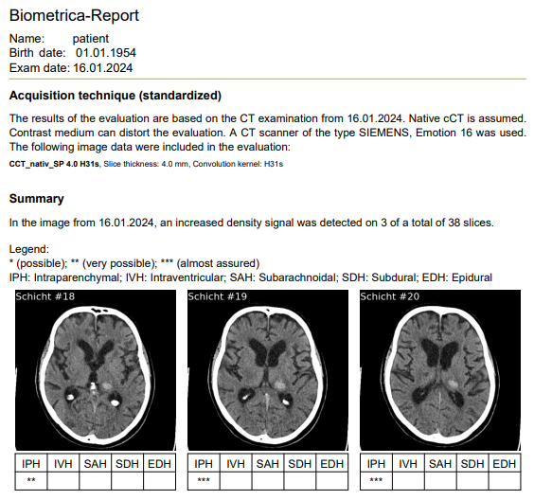
Figure 5: Example findings of the AI

