Supplementary Figure 2: Boxplot of highest radiation exposure by body part
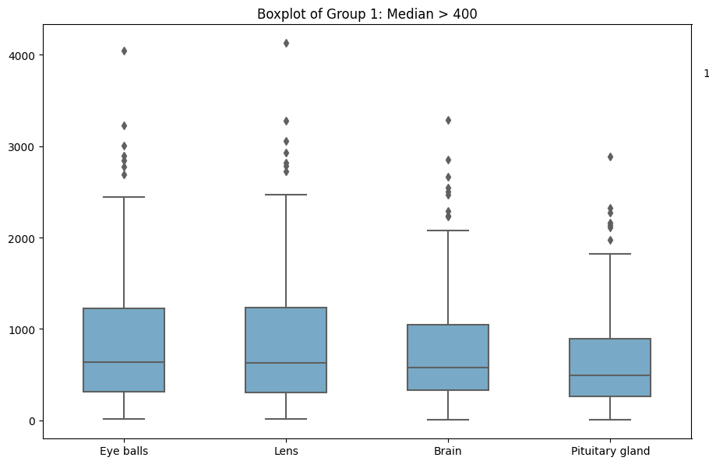
Median > 400 = body parts with median radiation exposure > 400 millisieverts
Y axis = median radiation exposure, x axis = body part exposed

