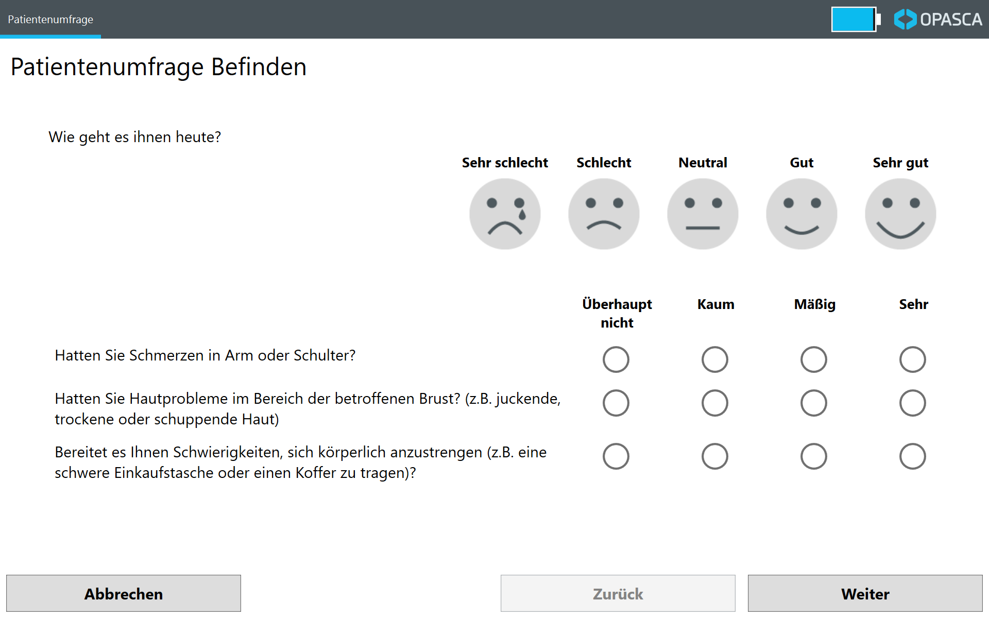
Multimedia Appendix 1: sample screenshot of the OPASCA app surface¹
¹Translation: How are you feeling today? – very bad, bad, neutral, good, very good
Have you had any pain in your arm or shoulder? / Have you had skin problems on or in the area of your affected breast (e.g., itchy, dry, flaky)? / Have you had problems with bodily exertion (e.g., carrying a heavy shopping bag or suitcase)? – not at all, a little, quite a bit, very much

