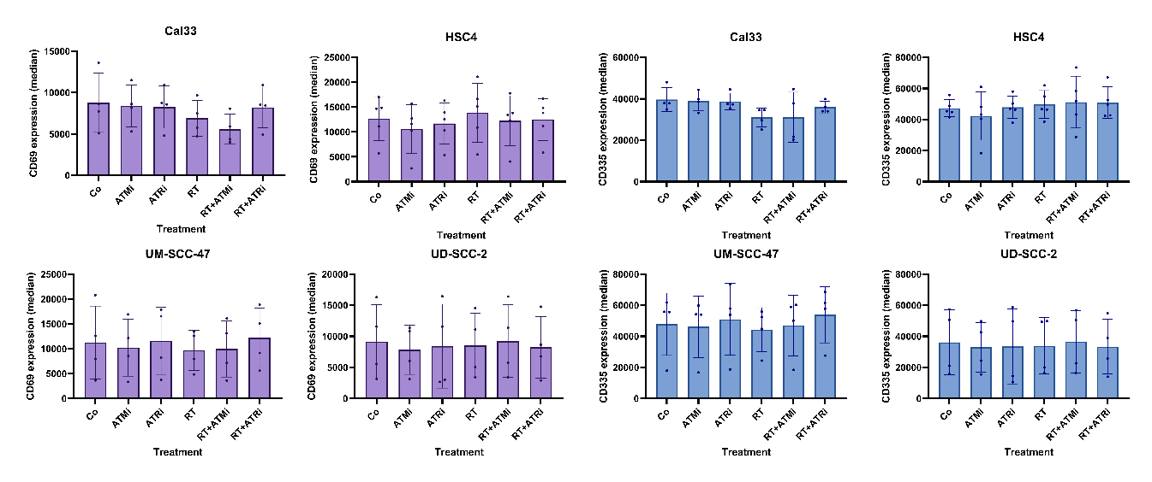
Supplementary Figure S1: Analysis of NK cell activation markers after co-cultivation with pre-treated HNSCC for 24 hours. The HNSCC cell lines Cal33, HSC4, UM-SCC-47 and UD-SCC-2 were pretreated with either 1 µM of the ATM-inhibitor AZD0156, 0.1 µM of the ATR-inhibitor VE-822, RT of 2 x 5 Gy or a combination of smKI and RT and DMSO as a vehicle control.
Expression of CD69 and CD335 on the NK cell surface: expression was measured using multicolor flow-cytometry. Each value shows mean ± SD (Cal33, n = 4; HSC4, n = 5; UM-SCC-47, n = 4; UD-SCC-2, n = 4).

Supplementary material
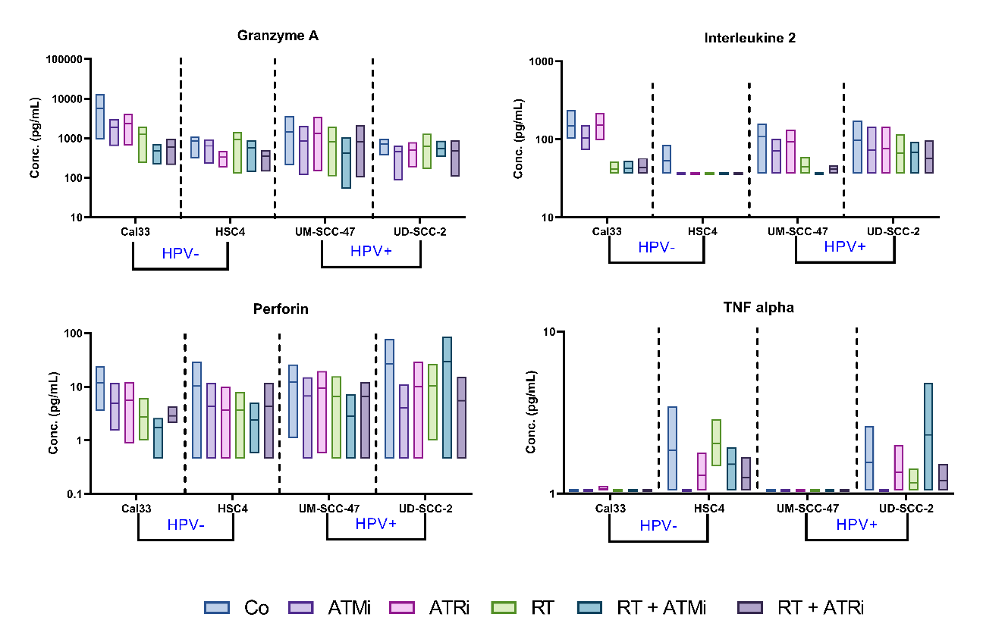
Supplementary Figure S2: Secretion of NK cell related molecules after co-cultivation with pre-treated HNSCC for 24 hours. The HNSCC cell lines Cal33, HSC4, UM-SCC-47 and UD-SCC-2 were pretreated with either 1 µM of the ATM-inhibitor AZD0156, 0.1 µM of the ATR-inhibitor VE-822, RT of 2 x 5 Gy or a combination of smKI and RT and DMSO as a vehicle control. Secretion Granzyme A, IL-2, Perforin and TNF-α was analysed using a bead-based Multiplex Assay. Each value shows mean ± SD (n = 3).
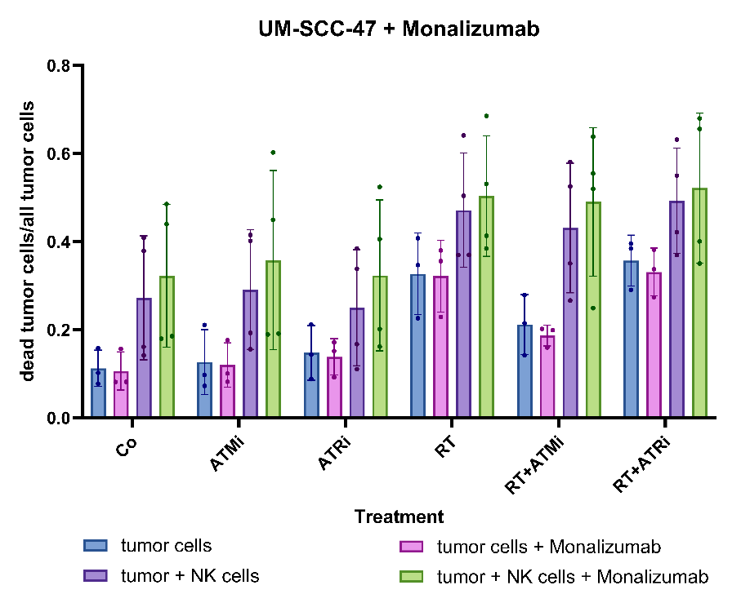
Supplementary Figure S3: Effect of the immune-checkpoint-inhibitor Monalizumab on the co-culture of pre-treated UM-SCC-47 tumor cells and primary human NK cells: the UM-SCC-47 tumor cells were pretreated with either 1 µM of the ATM-inhibitor AZD0156, 0.1 µM of the ATR-inhibitor VE-822, RT of 2 x 5 Gy or a combination. DMSO exposed cell cultures served as control (Co). Additionally, NKG2A-inhibitor Monalizumab (conc. 7.72 mg / mL) was added. Cell death rates were measured in each treatment group by using multicolor flow-cytometry as described in Figure 2A.

