Supplemental Figure S1: Search string for systematic literature review

Medline Ovid: (exp "Myocardial Contusions"/ OR (((heart OR cardiac OR myocard* OR cordis) ADJ6 (contusio* OR commotio* OR concussion*)) OR ((blunt* OR Nonpenetrat* OR Non-penetrat*) ADJ6 (heart OR cardiac*) ADJ6 (trauma* OR injur*))).ab,ti,kf.) NOT (exp animals/ NOT humans/) NOT ((letter OR news OR comment OR editorial OR congresses OR abstracts).pt.) AND english.la

Medline Ovid: (exp "Myocardial Contusions"/ OR (((heart OR cardiac OR myocard* OR cordis) ADJ6 (contusio* OR commotio* OR concussion*)) OR ((blunt* OR Nonpenetrat* OR Non-penetrat*) ADJ6 (heart OR cardiac*) ADJ6 (trauma* OR injur*))).ab,ti,kf.) NOT (exp animals/ NOT humans/) NOT ((letter OR news OR comment OR editorial OR congresses OR abstracts).pt.) AND english.la.

Embase.com: ('heart contusion'/exp OR 'commotio cordis'/de OR (((heart OR cardiac OR myocard* OR cordis) NEAR/6 (contusio* OR commotio* OR concussion*)) OR ((blunt* OR Nonpenetrat* OR Non-penetrat*) NEAR/6 (heart OR cardiac*) NEAR/6 (trauma* OR injur*))):ab,ti) NOT ([animals]/lim NOT [humans]/lim) NOT ([Conference Abstract]/lim OR [Letter]/lim OR [Note]/lim OR [Editorial]/lim) AND [english]/lim

Cochrane CENTRAL: ((((heart OR cardiac OR myocard* OR cordis) NEAR/6 (contusio* OR commotio* OR concussion*)) OR ((blunt* OR Nonpenetrat* OR Non-penetrat*) NEAR/6 (heart OR cardiac*) NEAR/6 (trauma* OR injur*))):ab,ti)

Web of science: TS=(((((heart OR cardiac OR myocard* OR cordis) NEAR/5 (contusio* OR commotio* OR concussion*)) OR ((blunt* OR Nonpenetrat* OR Non-penetrat*) NEAR/5 (heart OR cardiac*) NEAR/5 (trauma* OR injur*)))) ) AND DT=(article) AND LA=(english)

Google scholar: "heart|cardiac|myocardial contusion|concussion"|"commotio cordis"|"blunt|Nonpenetrating heart|cardiac trauma|injury|injuries" diagnosis|diagnostic

Supplemental Figure S2: Sensitivity, specificity, and summary receiver operating curves (SROC) of electrocardiography, echocardiography, and laboratory tests for identifying myocardial contusion

A: Electrocardiography
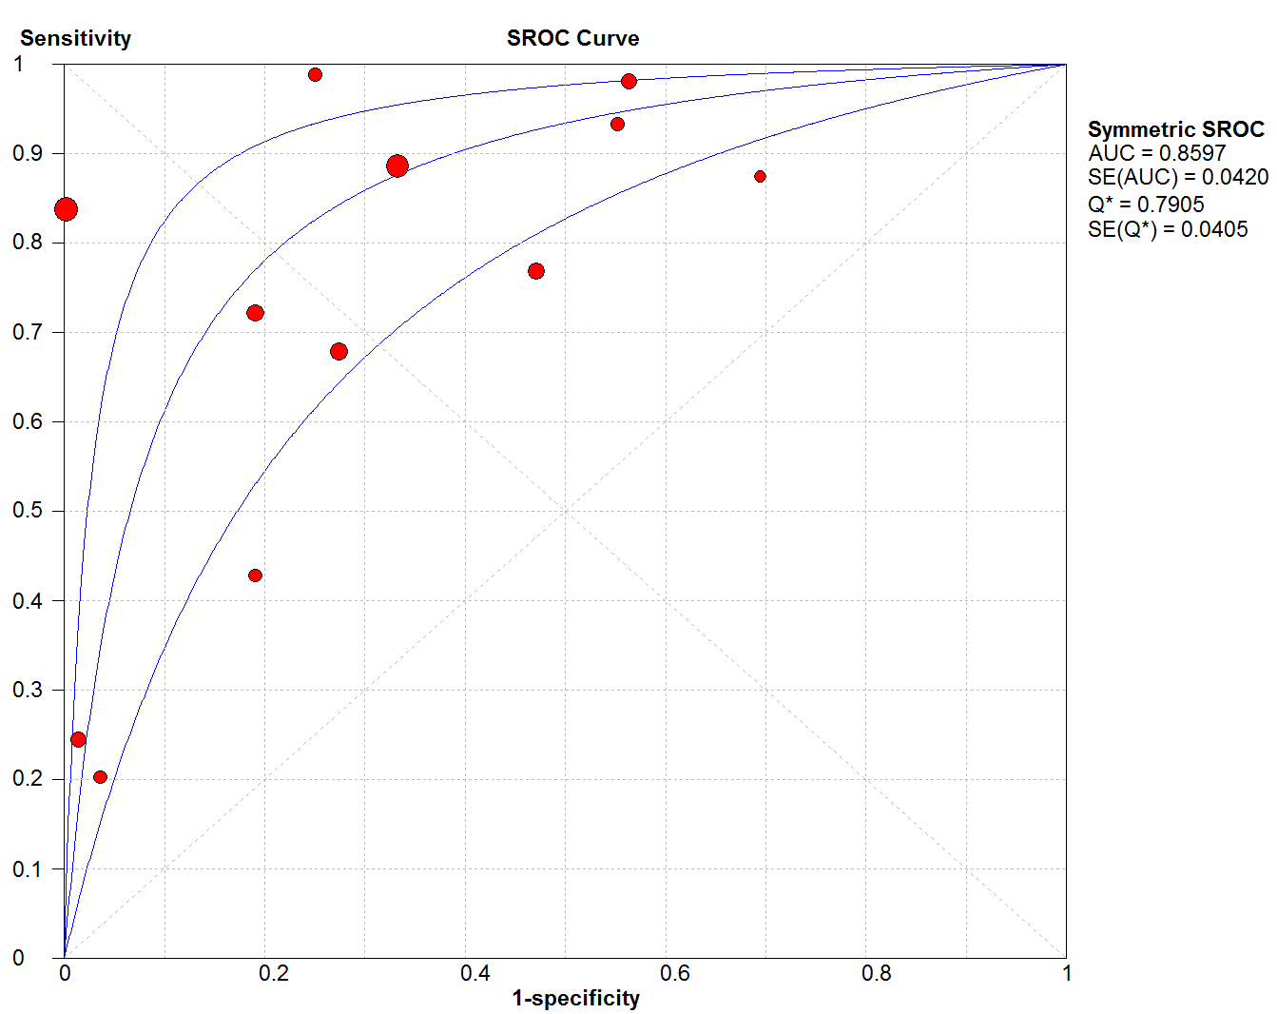

B: Echocardiography
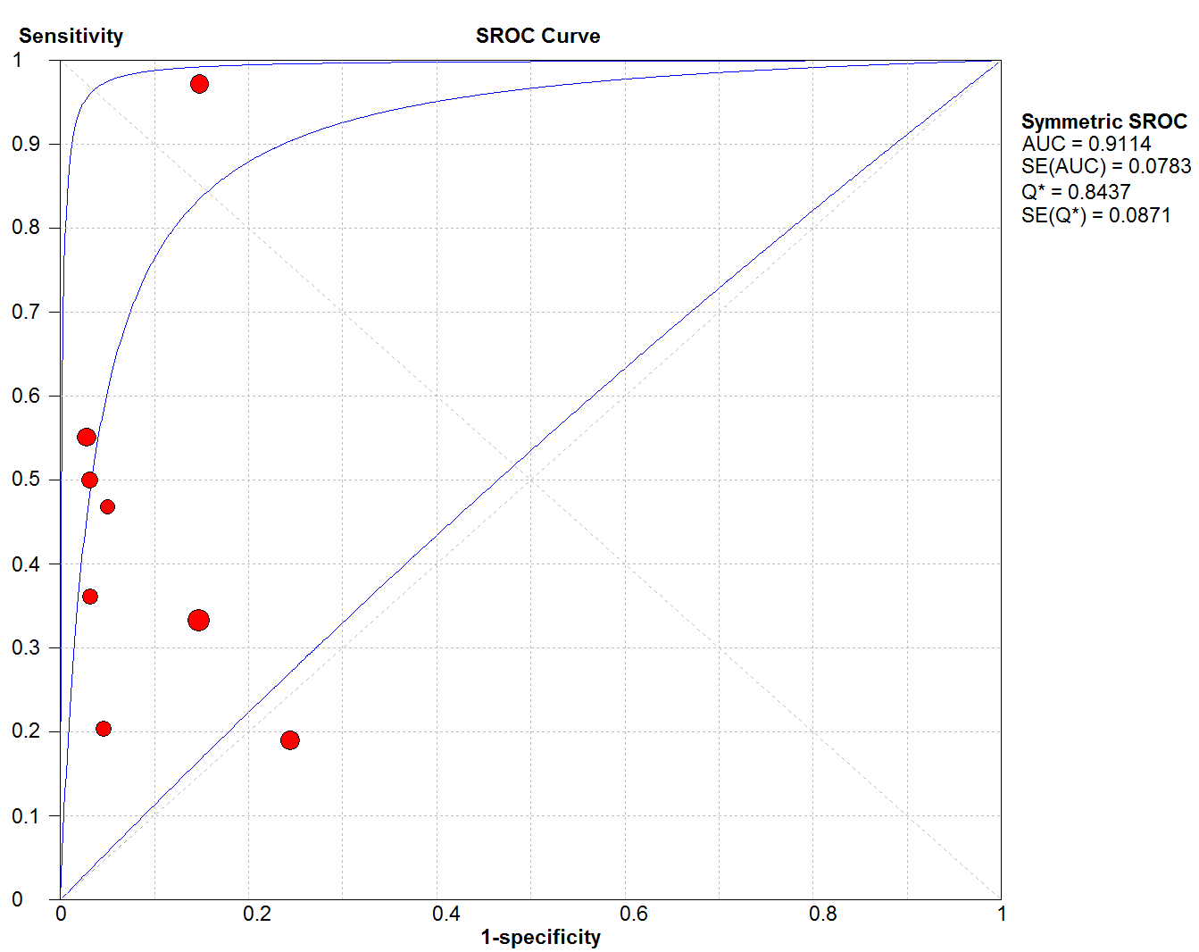

C: Troponin T
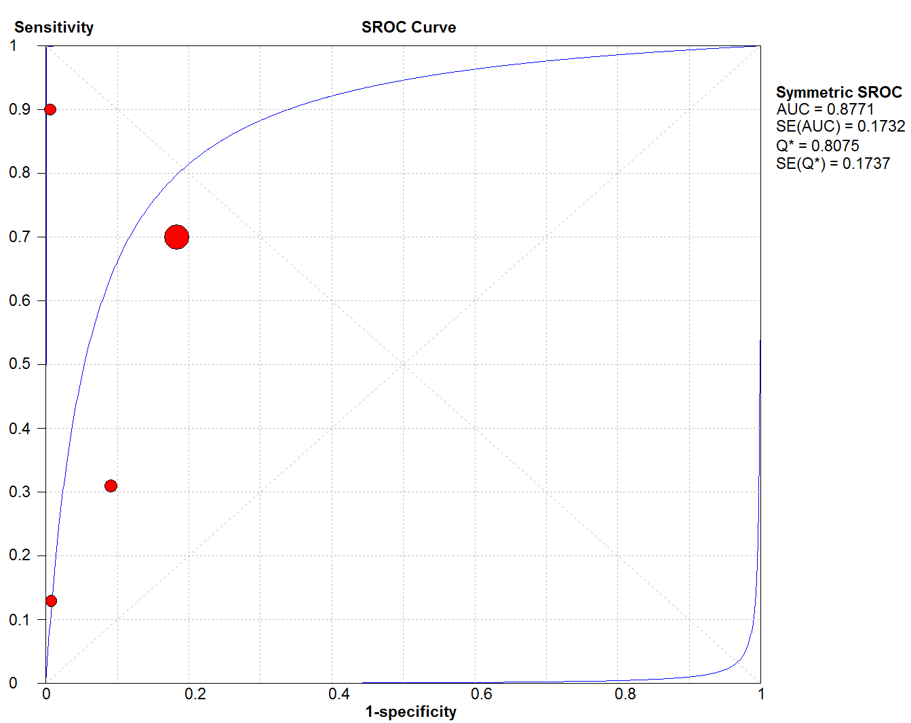

D: Troponin I
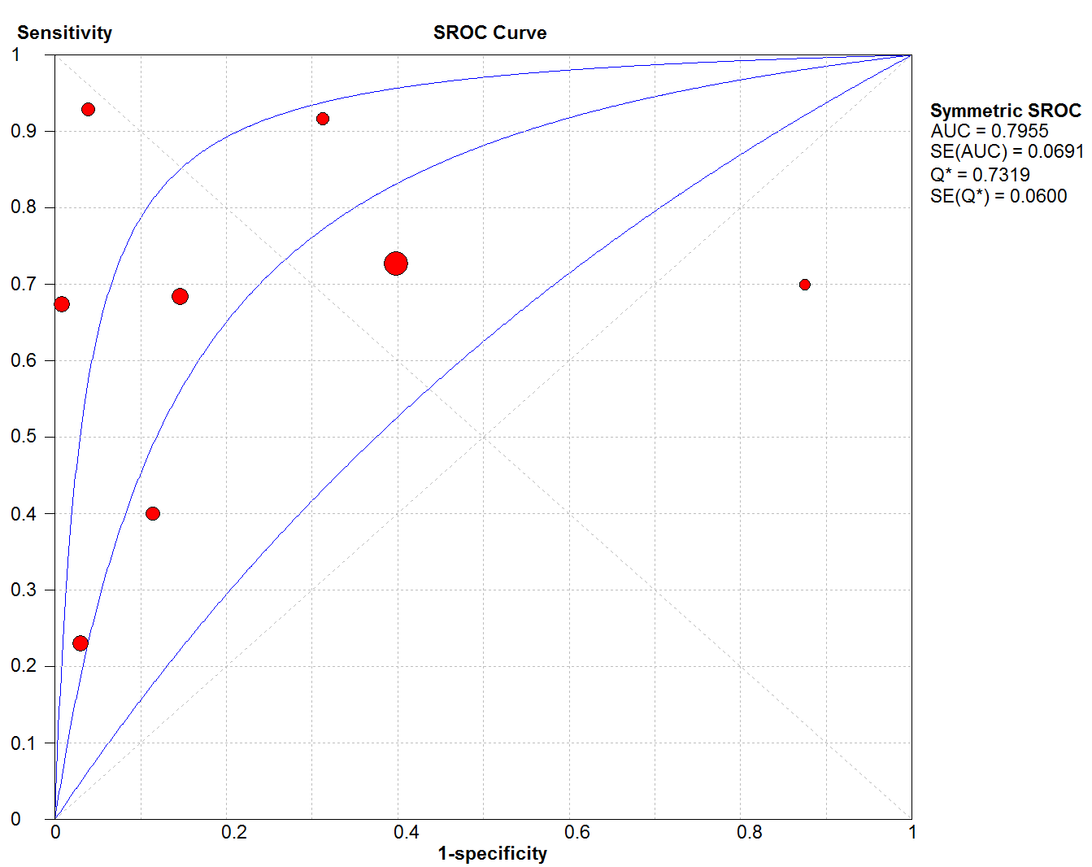

E: CK-MB
