Supplement 2: PMN-cell surface receptor alterations pre- and post-instrumentation
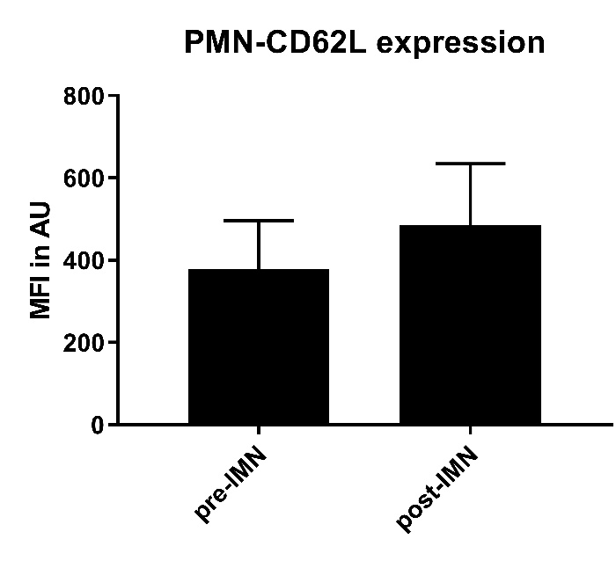
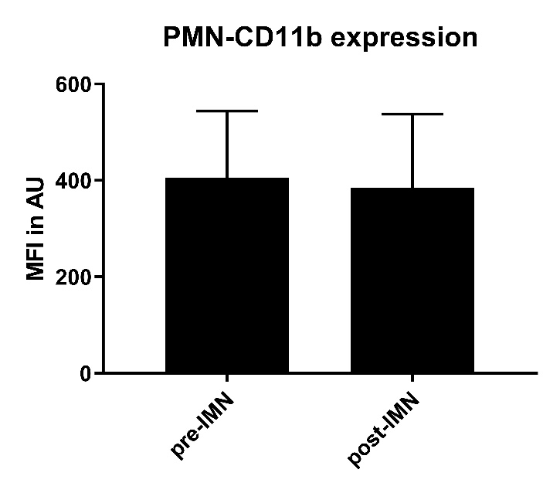

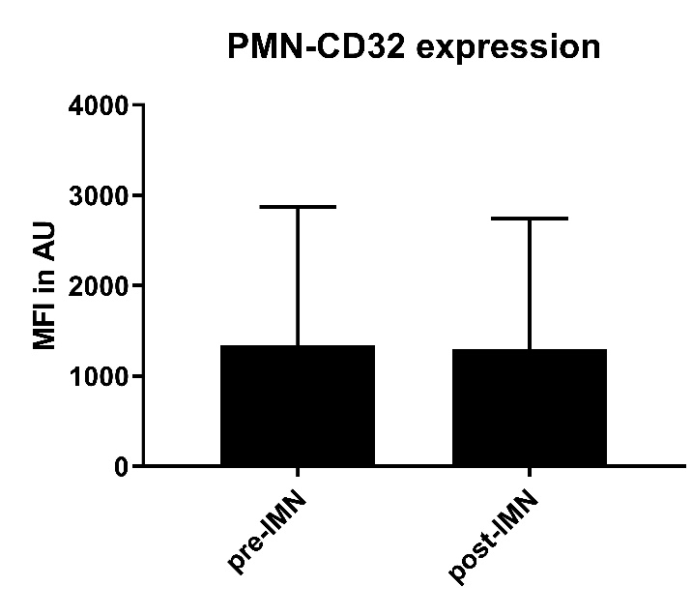
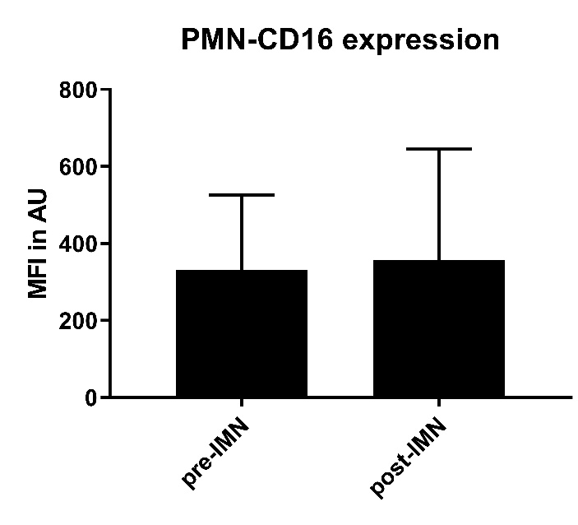

Receptor expression on PMNs prior to operative intervention (pre-IMN) and 2hrs after operative intervention (post-IMN). Data in mean (SD). No significant differences were seen between conditions

