Supplementary Digital Content

Table 1 - National and Regional declarations of survey respondents
 | Overall (N=58)
Country
Spain | 10 (17.2%)
UK | 6 (10.3%)
Italy | 4 (6.9%)
Sweden | 5 (8.6%)
Finland | 3 (5.2%)
Norway | 3 (5.2%)
Belgium | 3 (5.2%)
USA | 3 (5.2%)
Denmark | 3 (5.2%)
Ireland | 3 (5.2%)
Switzerland | 2 (3.4%)
Brazil | 2 (3.4%)
Malta | 1 (1.7%)
Latvia | 1 (1.7%)
Romania | 1 (1.7%)
Czech Republic | 1 (1.7%)
Slovenia | 1 (1.7%)
Qatar | 1 (1.7%)
Netherlands | 1 (1.7%)
France | 1 (1.7%)
Poland | 1 (1.7%)
Cyprus | 1 (1.7%)
Oman | 1 (1.7%)
Regional Grouping
Nordic | 14 (24.1%)
Central/Western Europe | 14 (24.1%)
Spain | 10 (17.2%)
UK/Ireland | 9 (15.5%)
Italy | 4 (6.9%)
USA | 3 (5.2%)
Brazil | 2 (3.4%)
Middle East | 2 (3.4%)

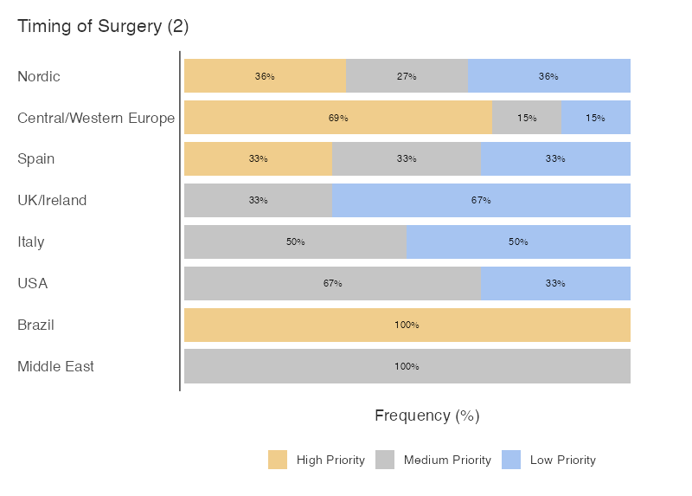
Figure 1 - Timing of Surgery. Survey responses, grouped by geographic practice location of respondents, and categorizeded into high-, medium- and low- priority for future research.
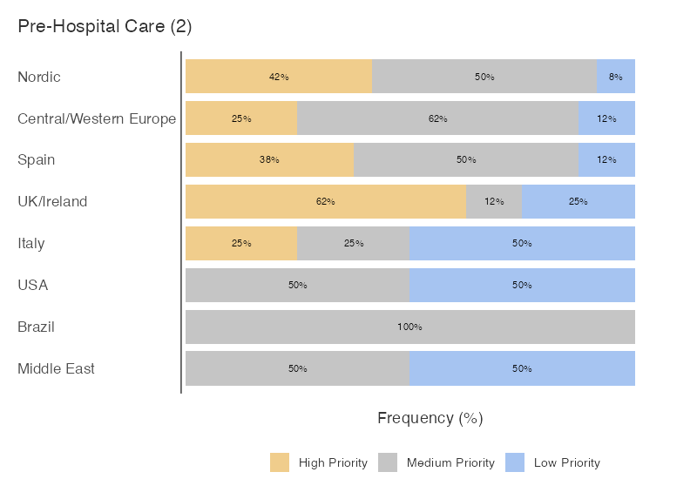
Figure 2 – Pre-hospital care and Inter-Hospital Transfer. Survey responses, grouped by geographic practice location of respondents, and categorizeded into high-, medium- and low- priority for future research.

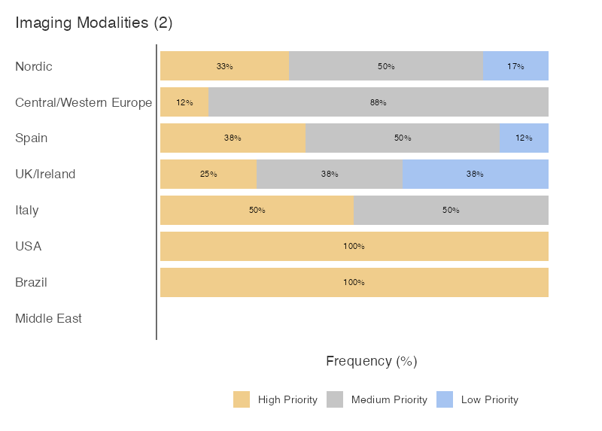
Figure 3 - Imaging in Surgial Decision Making. Survey responses, grouped by geographic practice location of respondents, and categorizeded into high-, medium- and low- priority for future research.
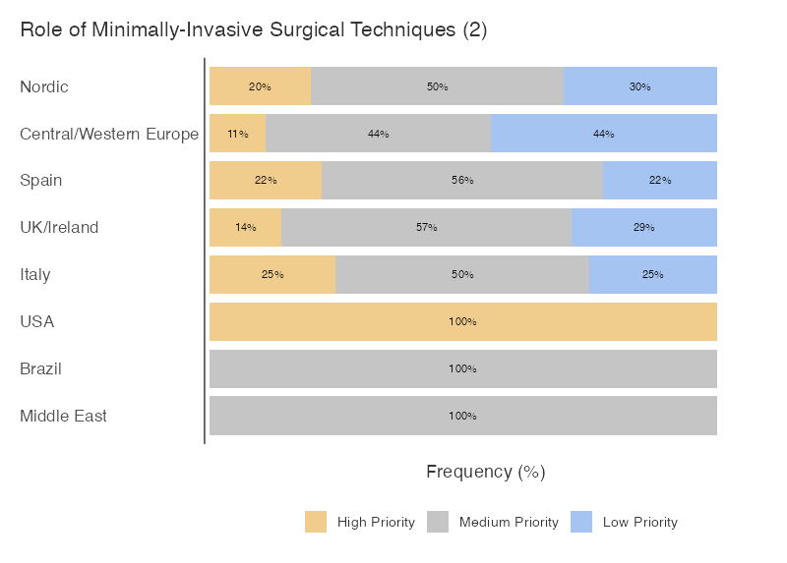
Figure 4 – Minimally-Invasive Surgery and new technologies. Survey responses, grouped by geographic practice location of respondents, and categorizeded into high-, medium- and low- priority for future research.
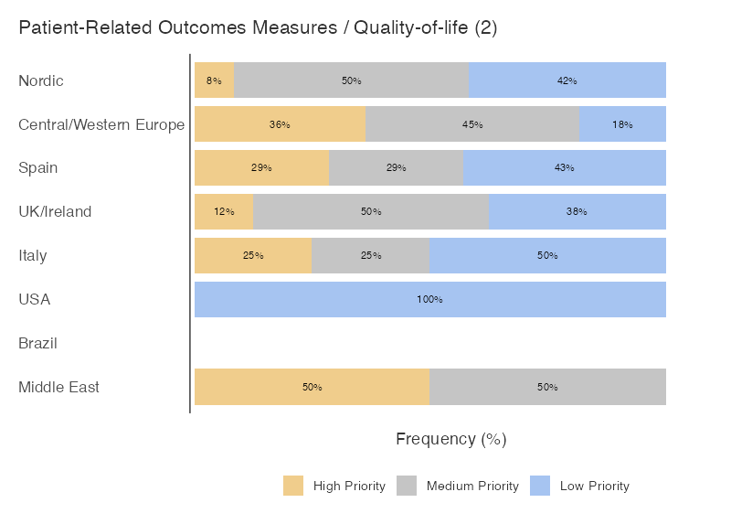
Figure 5 – Patient-reported Outcome Measures of Quality of Life.. Survey responses, grouped by geographic practice location of respondents, and categorizeded into high-, medium- and low- priority for future research.
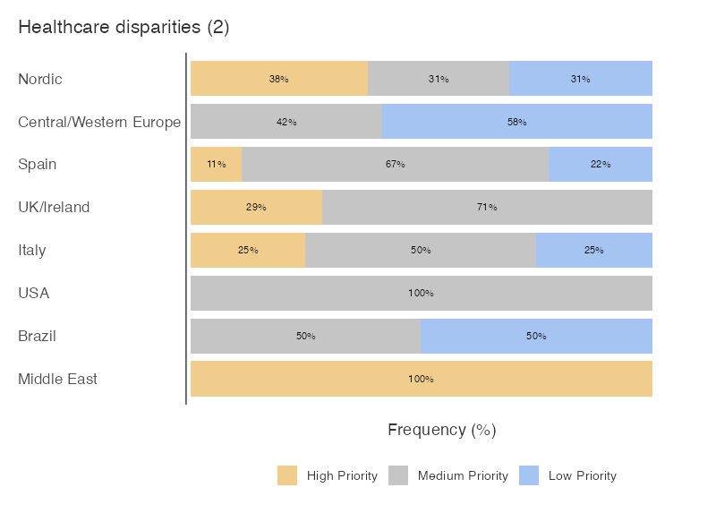
Figure 6 – Disparities in access to healthcare. Survey responses, grouped by geographic practice location of respondents, and categorizeded into high-, medium- and low- priority for future research.
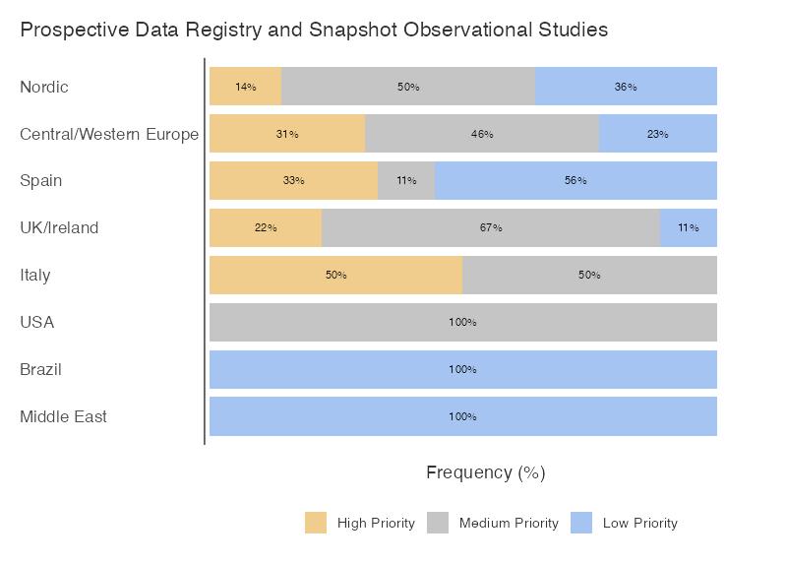
Figure 7 – Data Registry and Prospective Observational Cohort Studies. Survey responses, grouped by geographic practice location of respondents, and categorizeded into high-, medium- and low- priority for future research.

