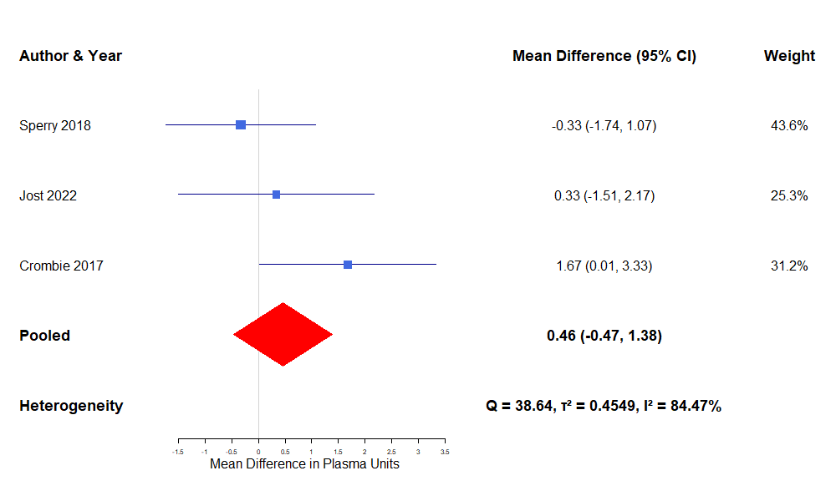
Suppl 1: forest plot for 24-hour Plasma transfusion used
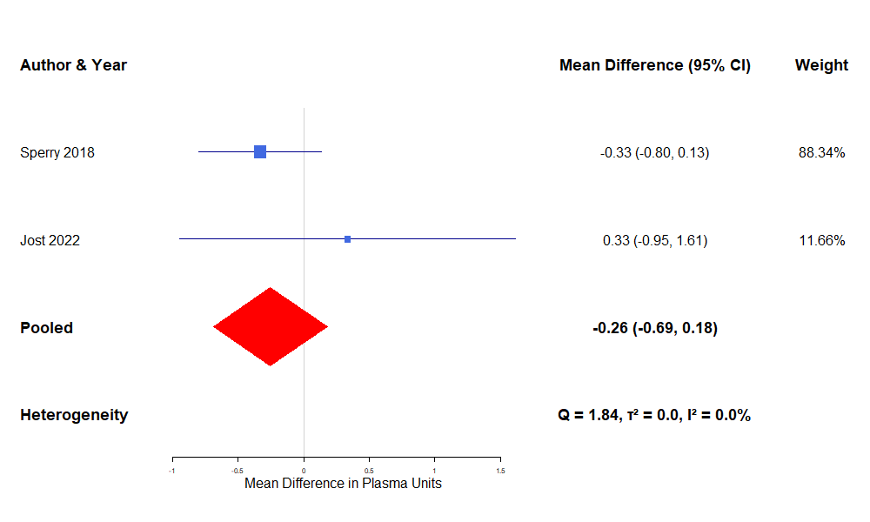
Suppl 1b : forest plot for 24-hour Plasma transfusion used- sensitivity analysis
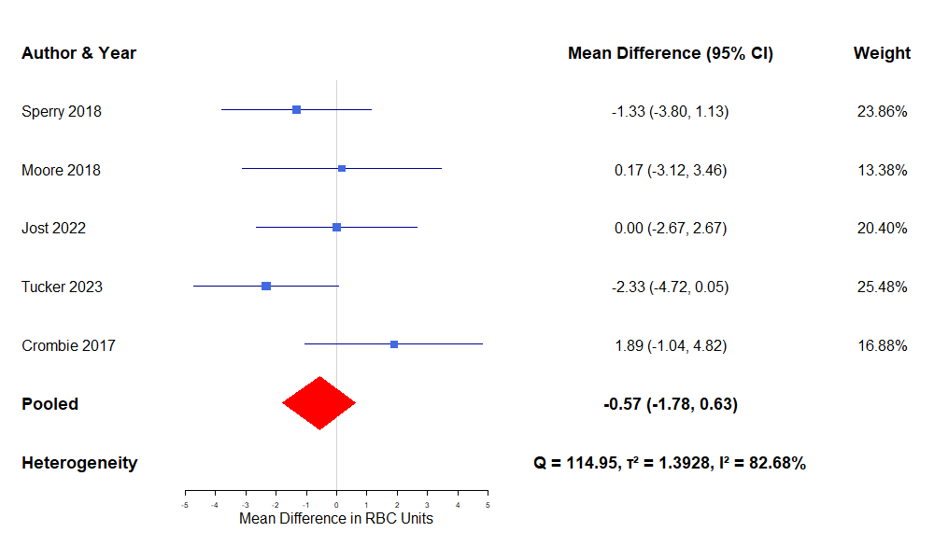
Suppl 2: forest plot for 24-hour RBC transfusion
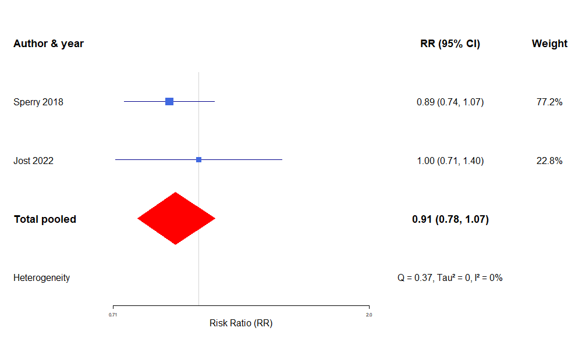
Suppl 3: Forest plot for Vasopressors received
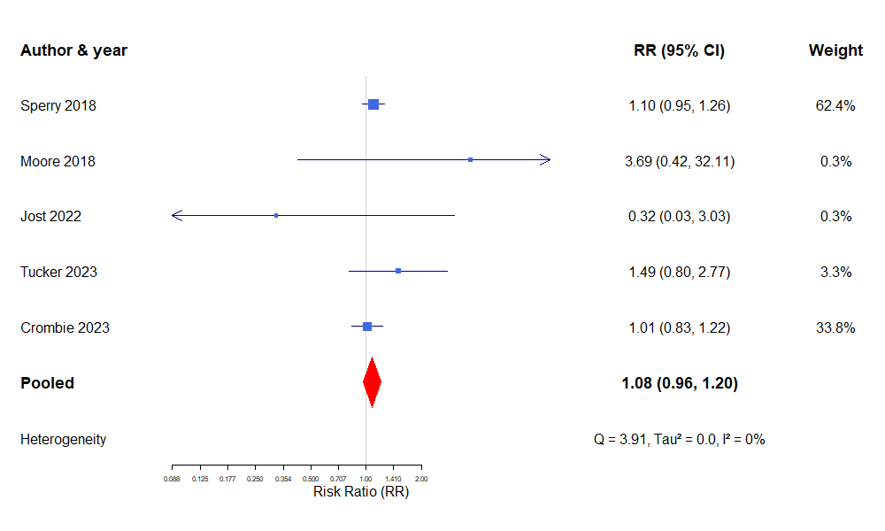
Suppl 4: Forest plot for MOF
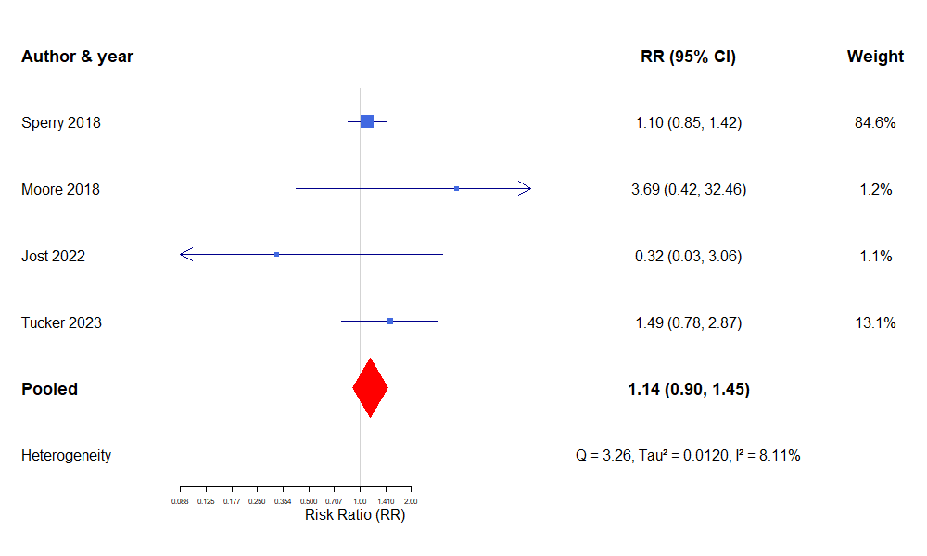
Suppl 4 b: Forest plot for MOF- sensitivity analysis

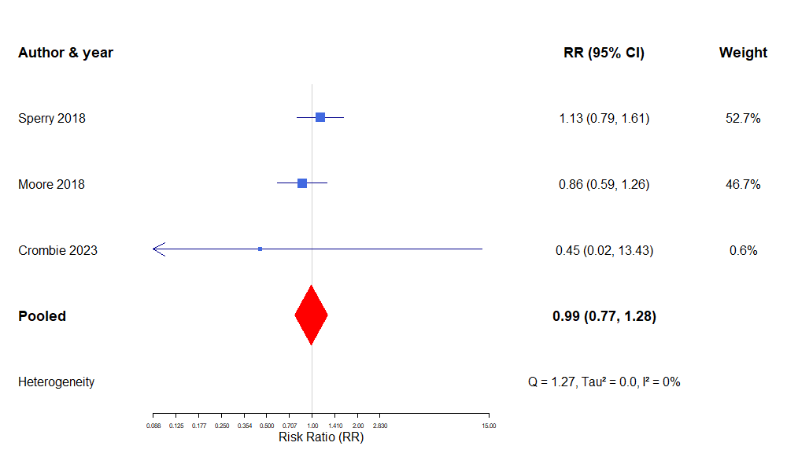
Suppl 5: Forest plot for Acute lung injury
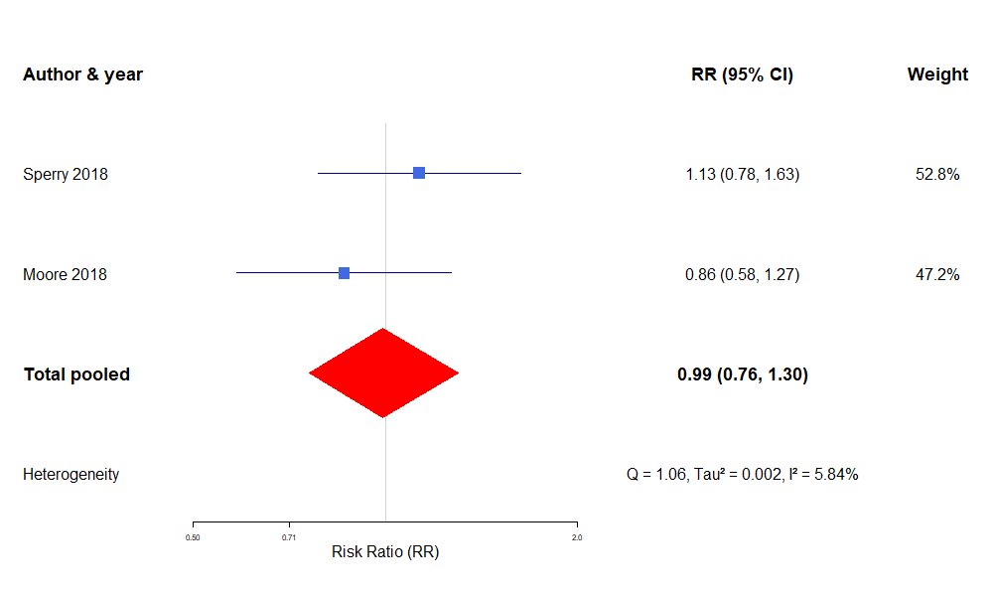
Suppl 5 b: Forest plot for Acute lung injury- sensitivity analysis

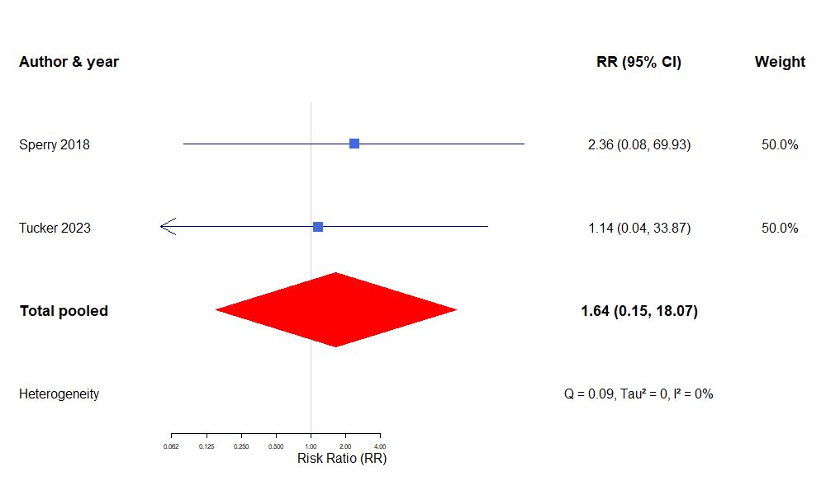
Suppl 6: Forest plot for transfusion reaction
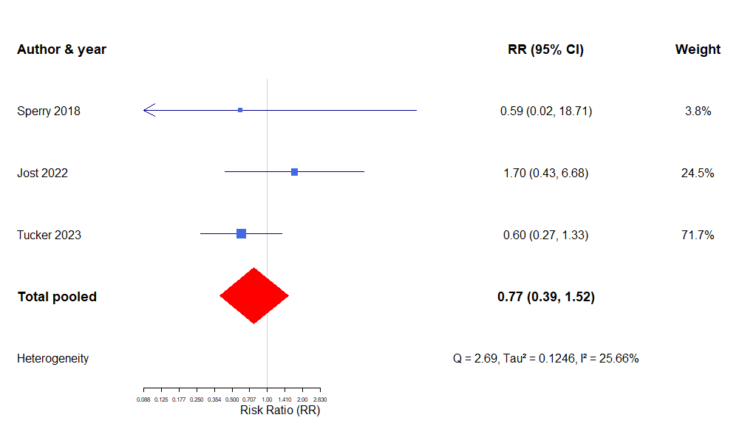
Suppl 7: Forest plot for sepsis

