Supplemental Figures
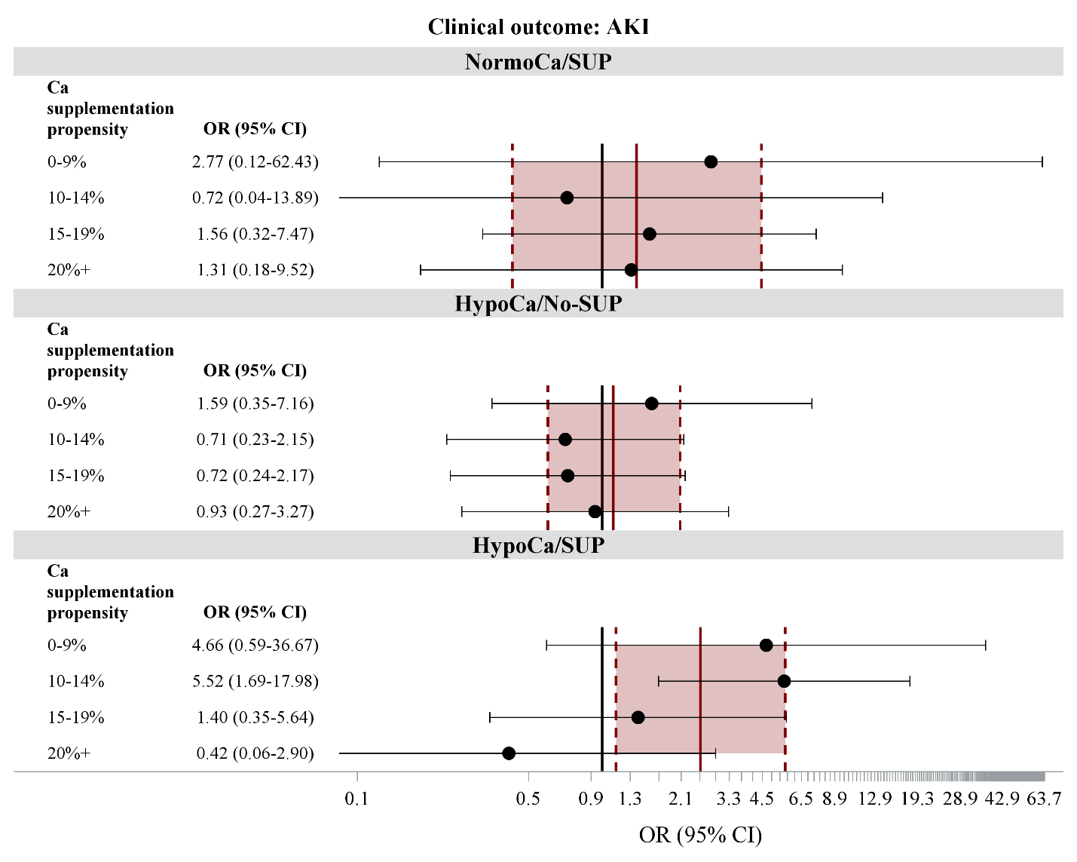
Figure S1. Odds ratios (ORs) and 95% confidence intervals for the association between calcium status (hypocalcemic [HypoCa] and normocalcemic [NormoCa]) and calcium supplementation (SUP) status and acute kidney injury (AKI) stratified by calcium supplementation propensity score.

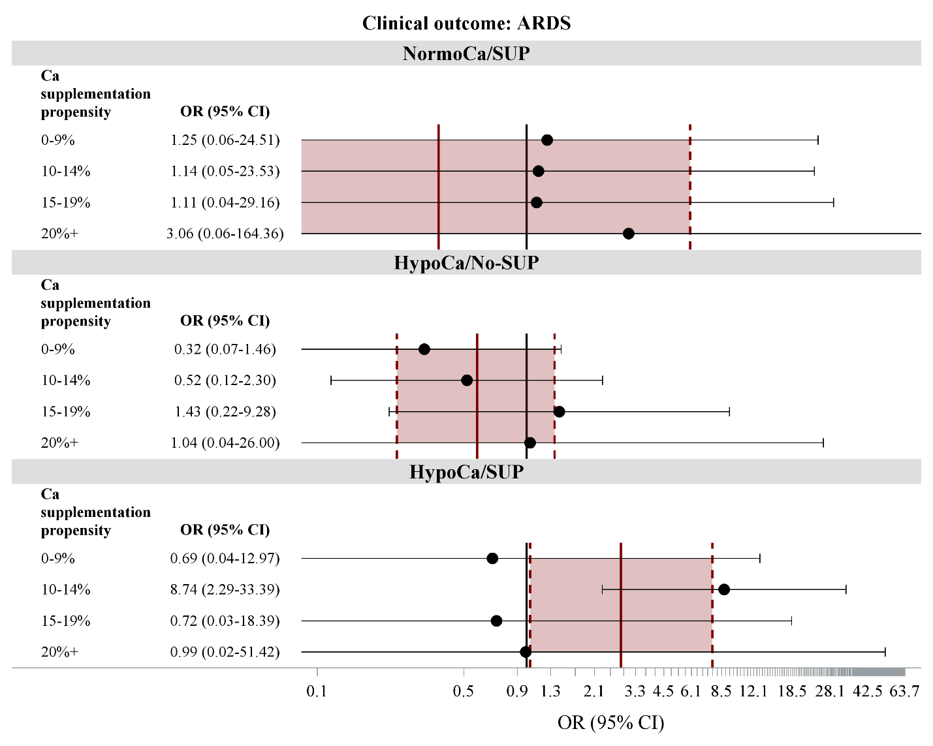
Figure S2. Odds ratios (ORs) and 95% confidence intervals for the association between calcium status (hypocalcemic [HypoCa] and normocalcemic [NormoCa]) and calcium supplementation (SUP) status and acute respiratory distress syndrome (ARDS) stratified by calcium supplementation propensity score.

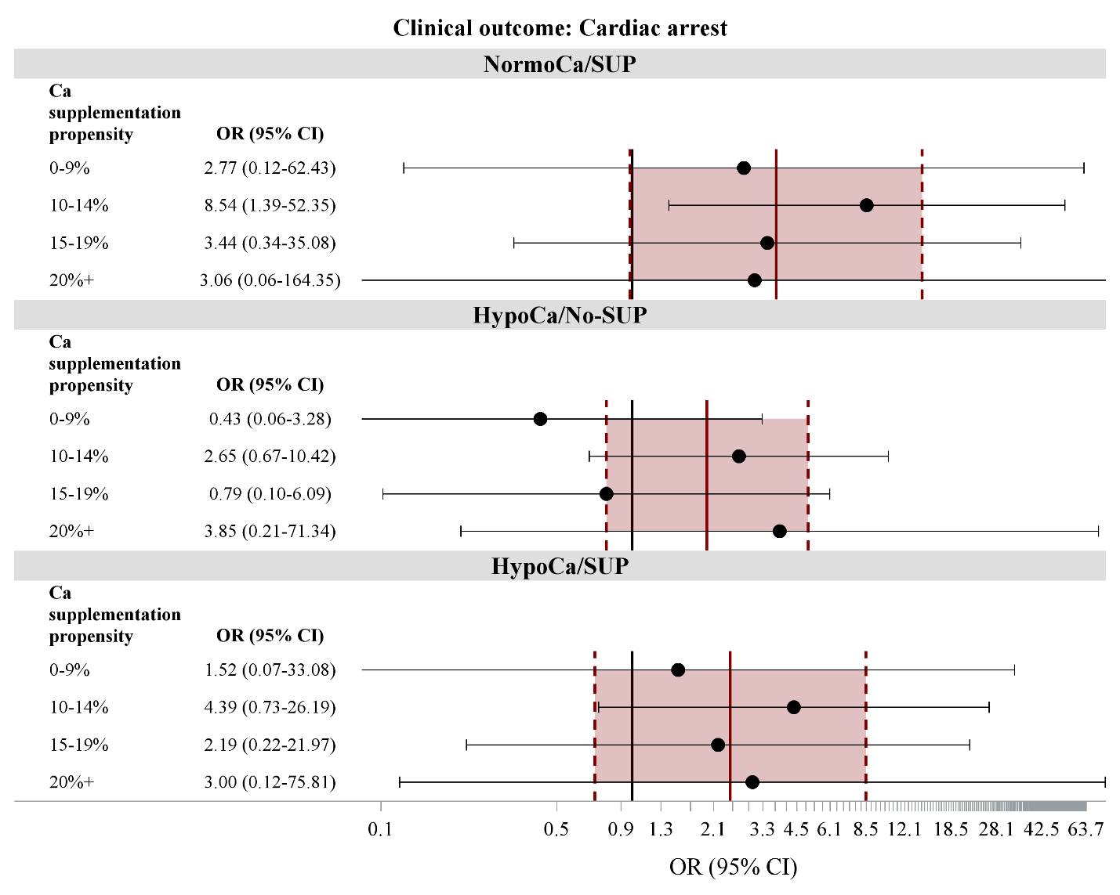
Figure S3. Odds ratios (ORs) and 95% confidence intervals for the association between calcium status (hypocalcemic [HypoCa] and normocalcemic [NormoCa]) and calcium supplementation (SUP) status and cardiac arrest stratified by calcium supplementation propensity score.

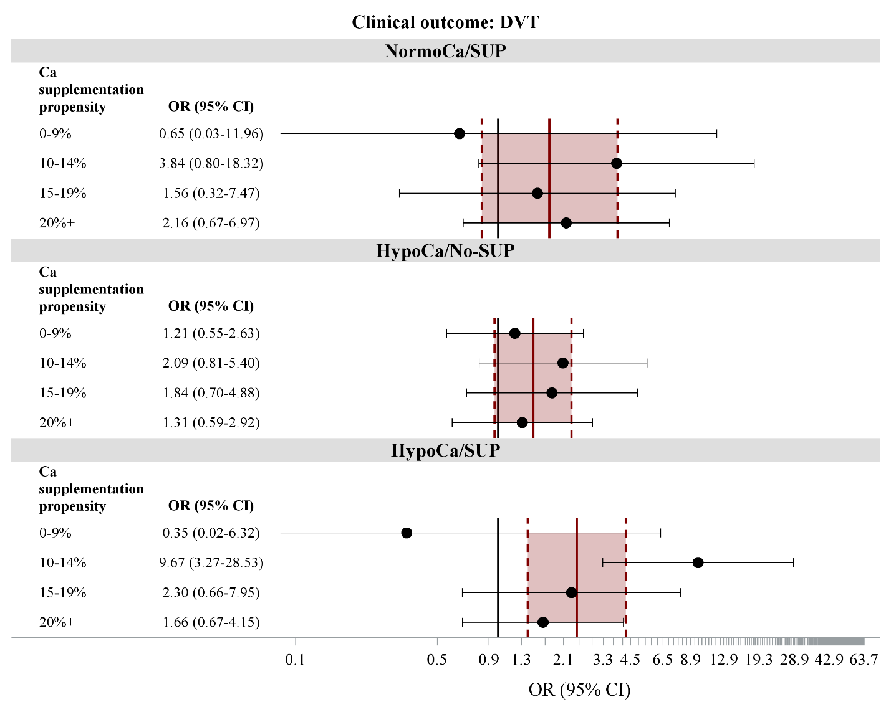
Figure S4. Odds ratios (ORs) and 95% confidence intervals for the association between calcium status (hypocalcemic [HypoCa] and normocalcemic [NormoCa]) and calcium supplementation (SUP) status and deep vein thrombosis (DVT) stratified by calcium supplementation propensity score.

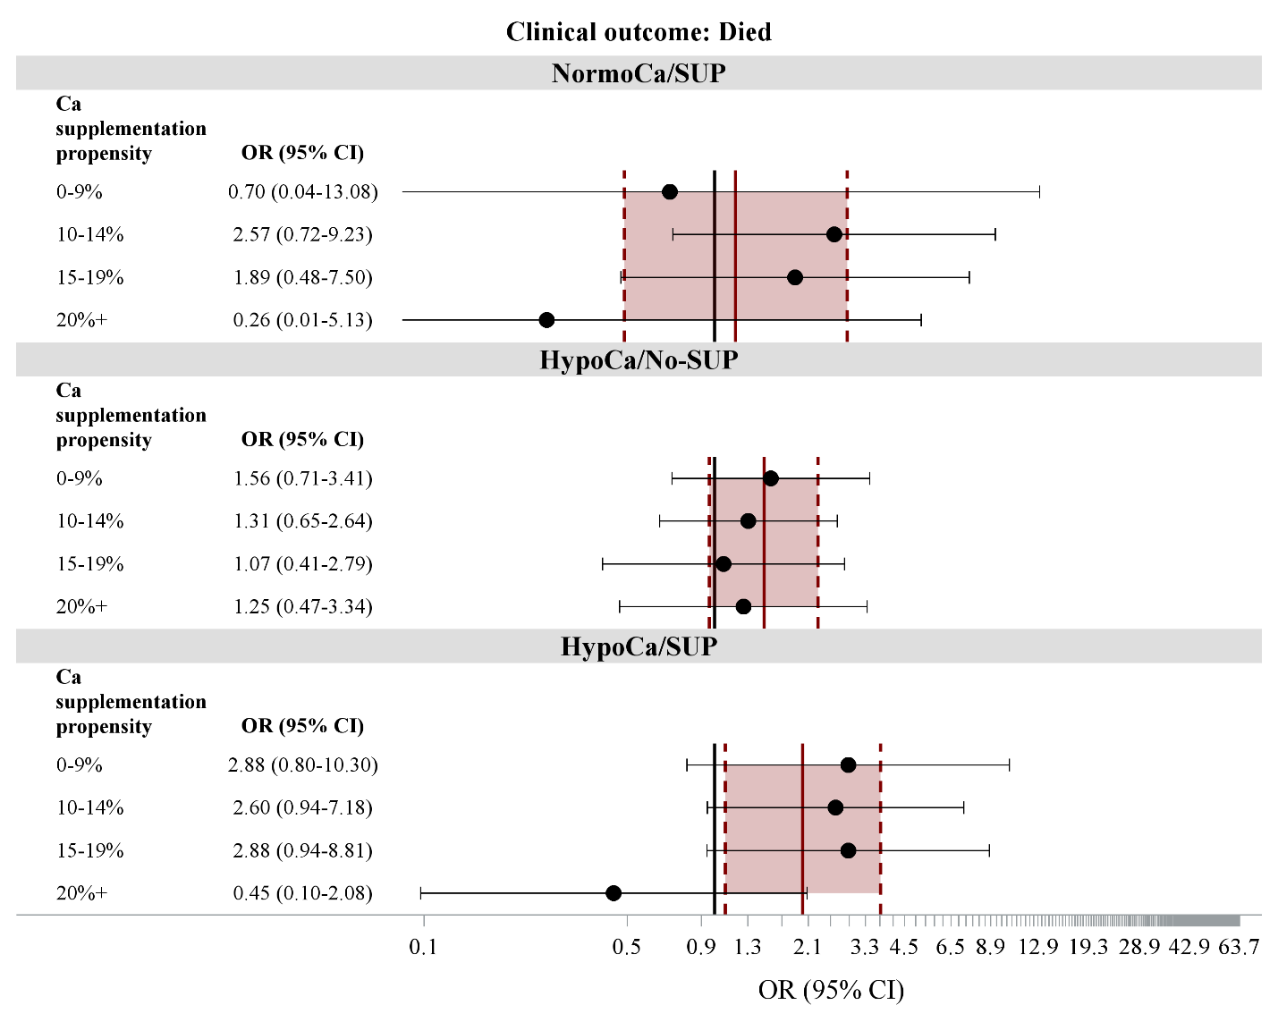
Figure S5. Odds ratios (ORs) and 95% confidence intervals for the association between calcium status (hypocalcemic [HypoCa] and normocalcemic [NormoCa]) and calcium supplementation (SUP) status and death stratified by calcium supplementation propensity score.

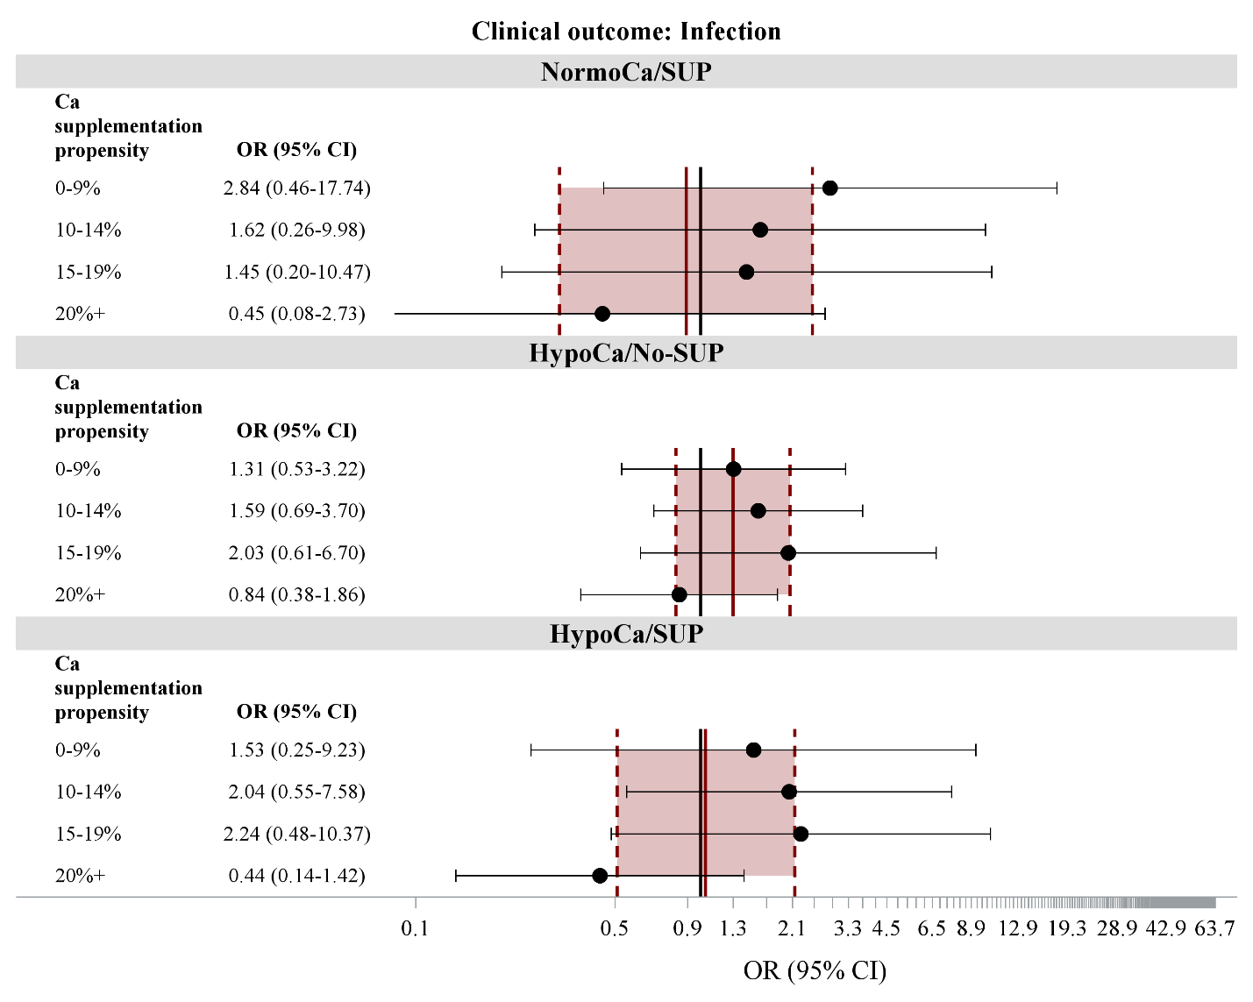
Figure S6. Odds ratios (ORs) and 95% confidence intervals for the association between calcium status (hypocalcemic [HypoCa] and normocalcemic [NormoCa]) and calcium supplementation (SUP) status and infection stratified by calcium supplementation propensity score.

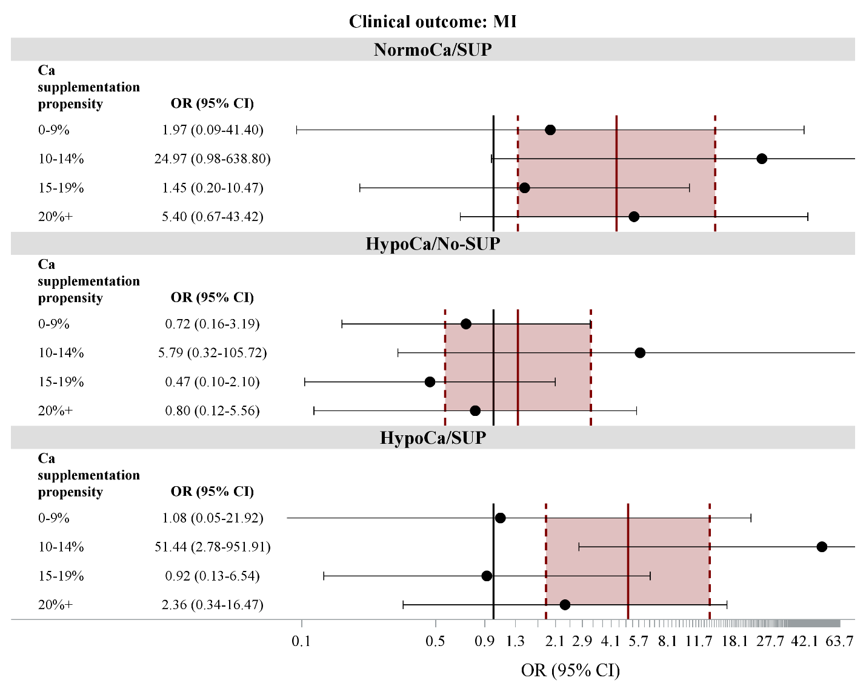
Figure S7. Odds ratios (ORs) and 95% confidence intervals for the association between calcium status (hypocalcemic [HypoCa] and normocalcemic [NormoCa]) and calcium supplementation (SUP) status and myocardial infarction (MI) stratified by calcium supplementation propensity score.

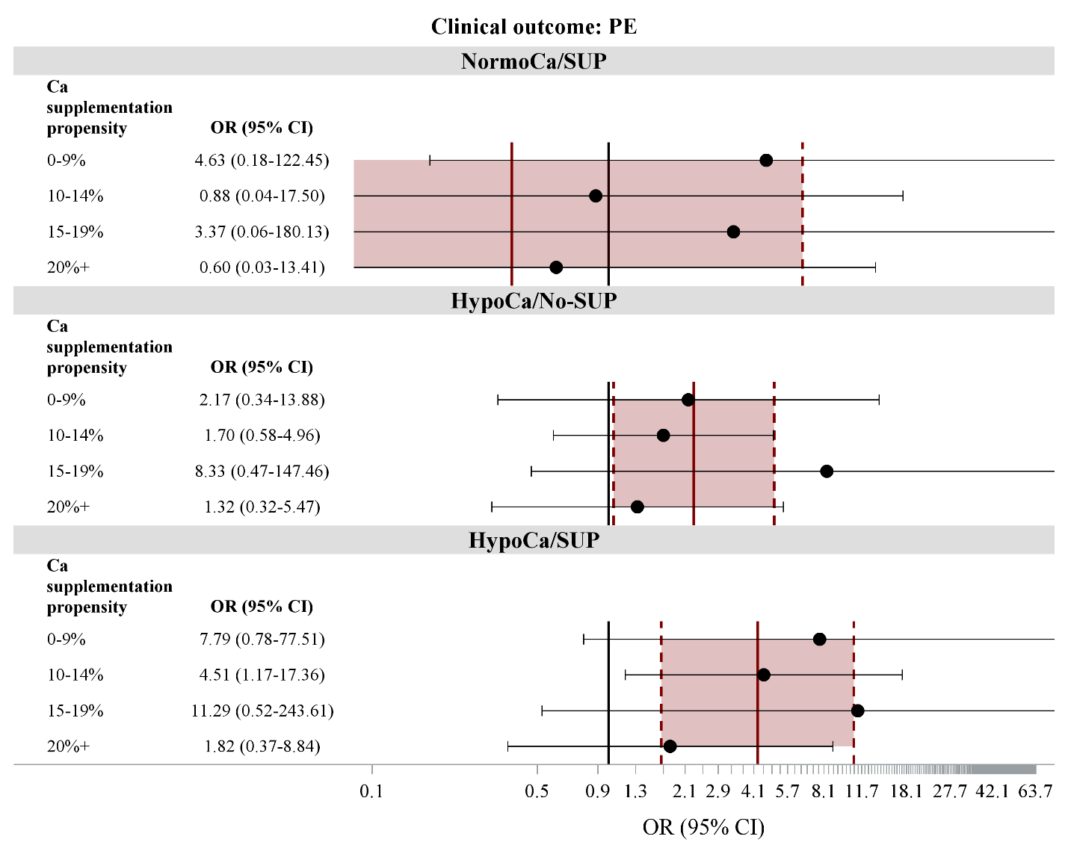
Figure S8. Odds ratios (ORs) and 95% confidence intervals for the association between calcium status (hypocalcemic [HypoCa] and normocalcemic [NormoCa]) and calcium supplementation (SUP) status and symptomatic pulmonary embolism (PE) stratified by calcium supplementation propensity score.

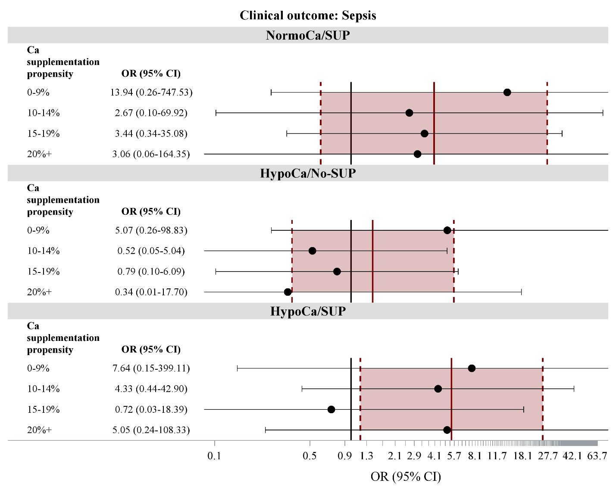
Figure S9. Odds ratios (ORs) and 95% confidence intervals for the association between calcium status (hypocalcemic [HypoCa] and normocalcemic [NormoCa]) and calcium supplementation (SUP) status and sepsis stratified by calcium supplementation propensity score.

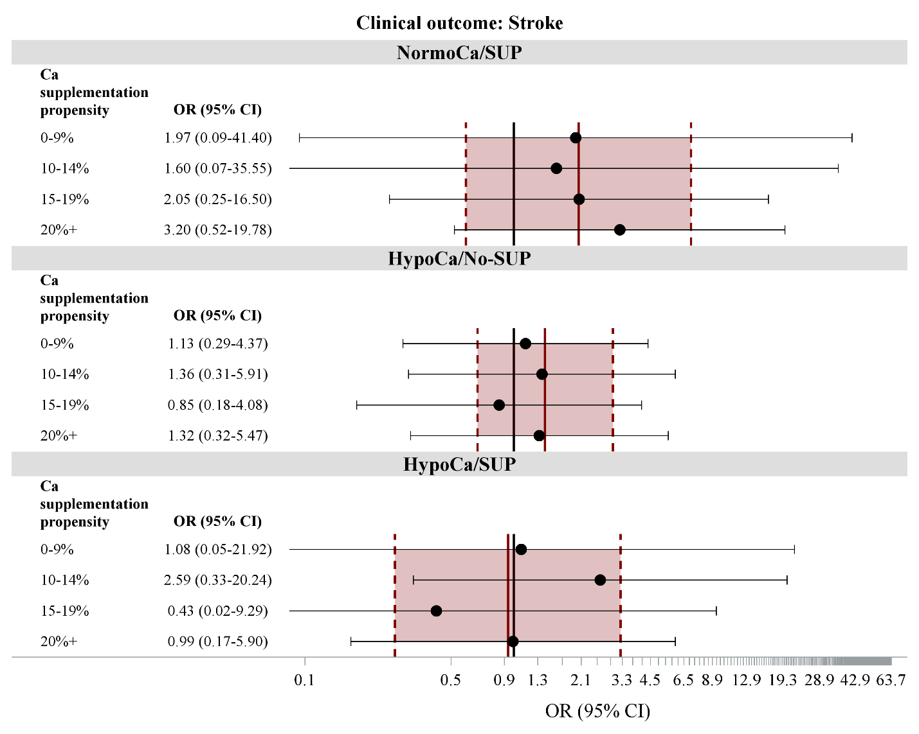
Figure S10. Odds ratios (ORs) and 95% confidence intervals for the association between calcium status (hypocalcemic [HypoCa] and normocalcemic [NormoCa]) and calcium supplementation (SUP) status and stroke stratified by calcium supplementation propensity score.

