Supplementary material

Wood modification with phenol urea formaldehyde (PUF) resin: The influence of wood species selection on the dimensional stability.

Carlo Kupfernagel^{1*}, Morwenna J. Spear¹, Andrew J. Pitman², Graham A. Ormondroyd¹

¹ BioComposites Centre, Bangor University, Deiniol Road, Bangor, Wales, UK
*crk20scf@bangor.ac.uk
m.j.spear@bangor.ac.uk
g.ormondroyd@bangor.ac.uk

² BM Trada, Chiltern House, Stocking Lane, Hughenden Valley High Wycombe, Buckinghamshire HP14 4ND, United Kingdom
Andy.Pitman@bmtrada.com

Fig. S 1 The relationship between Bulking and Swelling Coefficient within treated Beech wood. A linear regression model is shown for each wood species by a dotted line

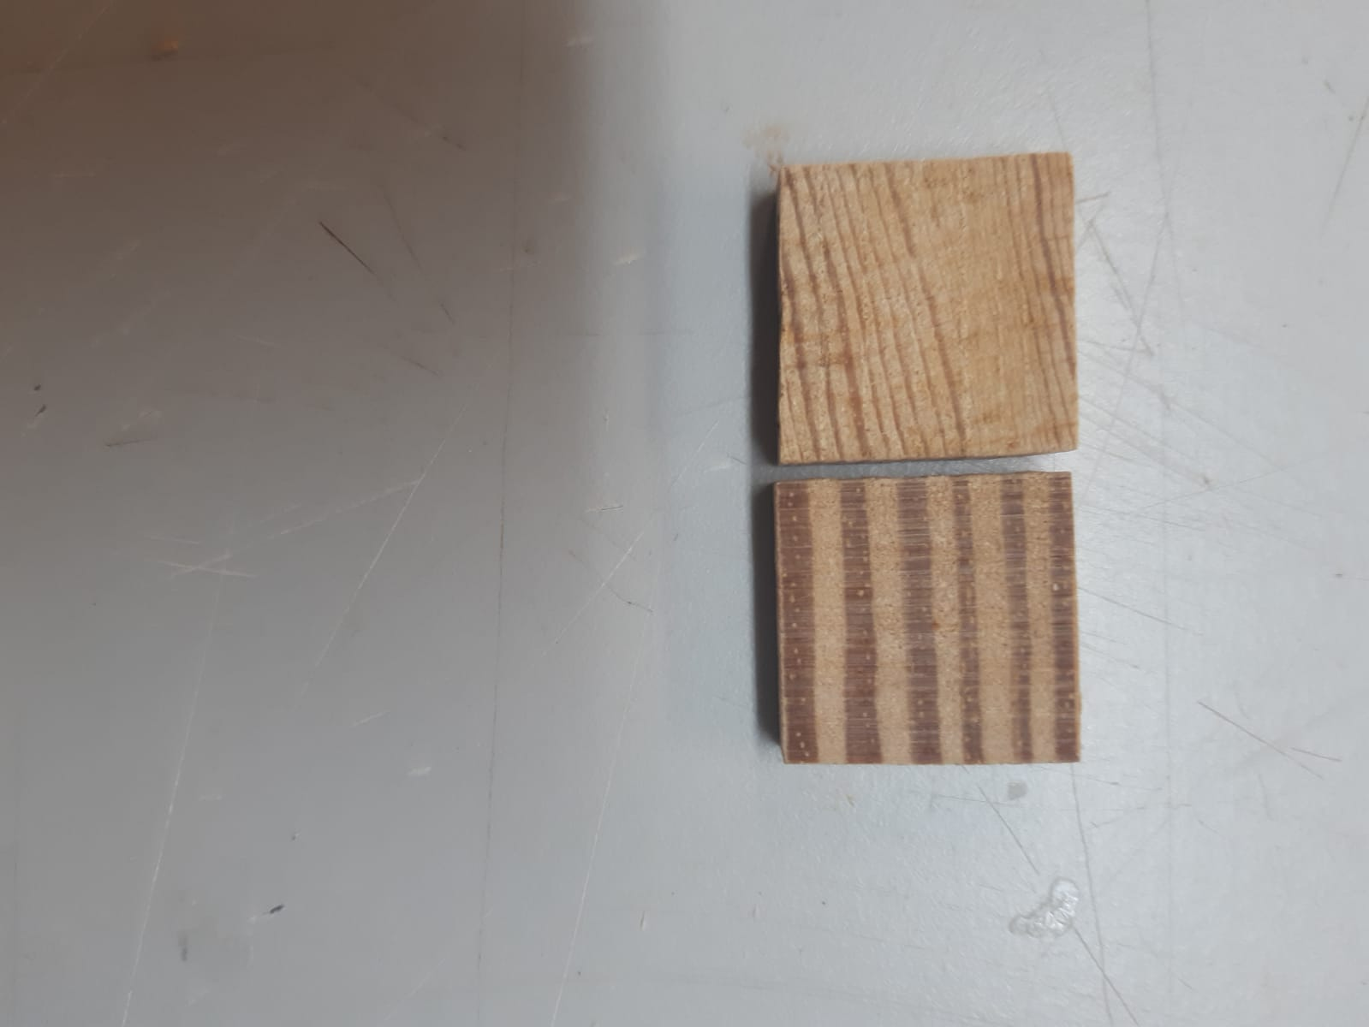
Fig. S 2 Differences in annual ring width in SYP and Scots pine in this study. Scots pine (left) and SYP (right)
Fig. S. 3 Evolution of the relative volume over the course of the ASE experiment for all observed timbers. The top row shows the modified test groups and bottom row the unmodified control groups. Boxplots at top of each sub-plot represent the water-soaked volume and boxplots at the bottom represent the oven dry volume. Note that the y-axes are customised for every sub-plot. The observed trends are therefore relative and not absolute.

Fig. S. 4 water uptake in modified and unmodified control groups during the second soak cycle. The additional weight of resin in modified timbers is excluded showing that the water uptake per wood mass is higher for modified specimens.
Table S. 1 – Results of two-way ANOVA test showing the correlation between treating fluid, wood species, their interaction, and the swelling coefficient. Asterisks indicate statistical significance. The treating fluid has no significant effect on the swelling coefficient (p > 0.05).
Df Sum Sq Mean Sq F value p-value
Treating_fluid 1 0 0.1 0.160 0.69004
Species 10 4809 480.9 579.372 < 2e-16 ***
Treating_fluid:Species 10 21 2.1 2.475 0.00823 **
Residuals 194 161 0.8
---
Signif. codes: 0 ‘***’ 0.001 ‘**’ 0.01 ‘*’ 0.05 ‘.’ 0.1 ‘ ’ 1

Table S. 2 Results of Tukey test showing the pairwise comparison of treating fluid within each species. P-values lower than 0.95 indicate a statically significant effect of the treating fluid on swelling coefficient after impregnation.
Test groups compared | diff | lwr | upr | p-value
In_water:Willow-In_resin:Willow | 0.206739 | -1.27826 | 1.691735 | 1
In_water:Poplar-In_resin:Poplar | -0.687 | -2.17199 | 0.798001 | 0.986827
In_water:Tulipwood-In_resin:Tulipwood | 0.903728 | -0.62196 | 2.429417 | 0.856265
In_water:Radiata Pine-In_resin:Radiata Pine | -0.82186 | -2.30686 | 0.663133 | 0.917768
In_water:Pinus taeda-In_resin:Pinus taeda | 0.142302 | -1.34269 | 1.627298 | 1
In_water:Scots Pine-In_resin:Scots Pine | 0.292096 | -1.15876 | 1.74295 | 1
In_water:Lime-In_resin:Lime | 0.295274 | -1.27005 | 1.860598 | 1
In_water:Sycamore-In_resin:Sycamore | 1.448317 | -0.07737 | 2.974006 | 0.086776
In_water:SYP-In_resin:SYP | -0.22376 | -1.70875 | 1.26124 | 1
In_water:Birch-In_resin:Birch | -0.22483 | -1.70983 | 1.260164 | 1
In_water:Beech-In_resin:Beech | -0.00592 | -1.53161 | 1.519766 | 1

Table S. 3 – Results of two-way ANOVA test showing the effect of modification on the total swelling coefficient (bulking + swelling in water). Asterisks indicate statistical significance. Modified and unmodified groups have significantly different total swelling values (p < 0.05).
Df Sum Sq Mean Sq F value p-value
Control_Modified 1 423 423.4 606.16 < 2e-16 ***
Species 10 4862 486.2 696.01 < 2e-16 ***
Control_Modified:Species 10 17 1.7 2.44 0.00922 **
Residuals 193 135 0.7
---
Signif. codes: 0 ‘***’ 0.001 ‘**’ 0.01 ‘*’ 0.05 ‘.’ 0.1 ‘ ’ 1

Table S. 4 - Results of Tukey test showing the effect of modification on total swelling for every species. P-values lower than 0.95 indicate a statically significant effect of modification of modification on total swelling coefficient.
Test groups compared | diff | lwr | upr | p-value
control:Willow-modified:Willow | -2.55155 | -3.91396 | -1.18914 | 2.5E-08
control:Poplar-modified:Poplar | -3.48818 | -4.85059 | -2.12577 | 2.37E-13
control:Tulipwood-modified:Tulipwood | -2.79121 | -4.19096 | -1.39147 | 2.01E-09
control:Radiata Pine-modified:Radiata Pine | -2.96906 | -4.33147 | -1.60665 | 3.64E-11
control:Pinus taeda-modified:Pinus taeda | -2.31291 | -3.67533 | -0.9505 | 8.08E-07
control:Scots Pine-modified:Scots Pine | -2.70428 | -4.06669 | -1.34187 | 2.43E-09
control:Lime-modified:Lime | -1.43505 | -2.83479 | -0.0353 | 0.03737
control:Sycamore-modified:Sycamore | -2.22021 | -3.61995 | -0.82046 | 6.55E-06
control:SYP-modified:SYP | -2.92862 | -4.29104 | -1.56621 | 6.98E-11
control:Birch-modified:Birch | -3.12716 | -4.48957 | -1.76475 | 2.91E-12
control:Beech-modified:Beech | -3.48269 | -4.88244 | -2.08295 | 2.52E-13

Table S. 5 – Results of two-way ANOVA test showing the effect of modification on the total mass loss. Asterisks indicate statistical significance. Modified and unmodified groups have a significantly different mass loss overall (p < 0.05).
Df Sum Sq Mean Sq F value p-value
Control_Modified 1 19.784 19.784 850.74 <2e-16 ***
Species 10 23.029 2.303 99.03 <2e-16 ***
Control_Modified:Species 10 16.489 1.649 70.91 <2e-16 ***
Residuals 184 4.279 0.023
---
Signif. codes: 0 ‘***’ 0.001 ‘**’ 0.01 ‘*’ 0.05 ‘.’ 0.1 ‘ ’ 1
Table S. 6 - Results of Tukey test showing the effect of modification on total mass loss for every species. P-values lower than 0.95 indicate a statically significant effect of modification on the total mass during water soaking.
Test groups compared | diff | lwr | upr | p-value
control:Willow-modified:Willow | -0.0904794 | -0.3392308 | 0.15827195 | 0.99943328
control:Poplar-modified:Poplar | -0.0350763 | -0.61845 | 0.54829734 | 1
control:Tulipwood-modified:Tulipwood | 1.45994847 | 1.2111971 | 1.70869985 | 9.2149E-15
control:Radiata Pine-modified:Radiata Pine | 0.94092228 | 0.67871531 | 1.20312925 | 9.6589E-15
control:Pinus taeda-modified:Pinus taeda | 1.5313272 | 1.28257583 | 1.78007858 | 9.2149E-15
control:Scots Pine-modified:Scots Pine | 0.6412605 | 0.39250913 | 0.89001188 | 2.2449E-13
control:Lime-modified:Lime | -0.0640576 | -0.312809 | 0.18469373 | 0.99999789
control:Sycamore-modified:Sycamore | -0.1026007 | -0.3664414 | 0.16123998 | 0.99853375
control:SYP-modified:SYP | 0.30563015 | 0.05687878 | 0.55438153 | 0.00252389
control:Birch-modified:Birch | 0.76084917 | 0.51209779 | 1.00960054 | 1.0814E-13
control:Beech-modified:Beech | 0.36566945 | 0.11010171 | 0.62123719 | 0.00010411

Table S. 7 ASE solution data separated into wood species and soaking cycle. The tables show the pH value, the solid residue after evaporating, and the UV absorbance at 272nm of the diluted ASE solution.
pH | Cycle No. | Radiata Pine | Beech | SYP | Tulip-wood | Birch | Lime | Willow | Poplar | Syca- more | Scots Pine | Pinus taeda
control groups | 1 | 6.14 | 4.75 | 5.91 | 6.94 | 6.74 | 5.16 | 5.35 | 6.62 | 4.45 | 4.51 | 6.62
control groups | 2 | 7.55 | 6.35 | 6.44 | 7.48 | 7.48 | 5.13 | 5.82 | 6.4 | 7.4 | 7.35 | 6.19
control groups | 3 | 7.52 | 7.88 | 7.42 | 6.78 | 6.35 | 6.31 | 6.28 | 6.06 | 6.19 | 5.75 | -
modified groups | 1 | 7.52 | 6.91 | 7.25 | 7.22 | 6.68 | 6.63 | 6.67 | 8.12 | 6.37 | 6.31 | 7.94
modified groups | 2 | 7.14 | 6.8 | 6.71 | 6.74 | 6.7 | 6.33 | 6.53 | 6.58 | 6.75 | 6.9 | 7.45
modified groups | 3 | 6.67 | 6.87 | 6.38 | 6.28 | 6.42 | 5.4 | 6.47 | 6.65 | 6.31 | 6.2 | -
Solid residue in g/l | Cycle No. | Radiata Pine | Beech | SYP | Tulip-wood | Birch | Lime | Willow | Poplar | Syca- more | Scots Pine | Pinus taeda
control groups | 1 | 0.067 | 0.112 | - | - | 0.151 | 0.077 | 0.123 | 0.066 | 0.137 | 0.144 | 0.092
control groups | 2 | 0.006 | 0.029 | - | - | 0.048 | 0.044 | - | 0.019 | 0.013 | 0.079 | 0.075
control groups | 3 | 0.027 | 0.023 | 0.007 | 0.012 | 0.011 | 0.006 | 0.090 | - | - | 0.087 | 0.069
modified groups | 1 | 0.141 | 0.152 | 0.006 | 0.030 | 0.209 | 0.213 | 0.092 | 0.134 | 0.129 | 0.330 | 0.293
modified groups | 2 | 0.033 | 0.100 | - | - | 0.029 | 0.078 | 0.045 | 0.031 | 0.073 | 0.107 | 0.137
modified groups | 3 | 0.052 | 0.018 | 0.006 | 0.018 | 0.006 | 0.012 | 0.023 | 0.062 | 0.052 | 0.121 | 0.149
UV abs. at 272nm | Cycle No. | Radiata Pine | Beech | SYP | Tulip-wood | Birch | Lime | Willow | Poplar | Syca- more | Scots Pine | Pinus taeda
control groups | 1 | 0.21 | 0.35 | 0.25 | 0.23 | 0.27 | 0.15 | 0.17 | 0.08 | 0.32 | 0.40 | 0.21
control groups | 2 | 0.15 | 0.24 | 0.22 | 0.19 | 0.17 | 0.10 | 0.05 | 0.06 | 0.12 | 0.24 | 0.15
control groups | 3 | 0.11 | 0.15 | 0.14 | 0.11 | 0.13 | 0.07 | 0.01 | 0.01 | - | 0.18 | 0.13
modified groups | 1 | 0.23 | 0.34 | 0.25 | 0.22 | 0.42 | 0.21 | 0.08 | 0.13 | 0.38 | 0.51 | 0.46
modified groups | 2 | 0.26 | 0.29 | 0.26 | 0.22 | 0.31 | 0.21 | 0.12 | 0.15 | 0.26 | 0.34 | 0.30
modified groups | 3 | 0.18 | 0.21 | 0.20 | 0.12 | 0.22 | 0.17 | - | 0.01 | 0.16 | 0.30 | 0.27

