Supplementary Material

Delayed endometrial decidualisation in polycystic ovary syndrome; the role of AR-MAGEA11.

Kinza Younas, Marcos Quintela, Samantha Thomas, Jetzabel Garcia, Lauren Blake, Helen Whiteland, Adnan Bunkheila, Lewis Francis, Lavinia Margarit, Deyarina Gonzalez, R. Steven Conlan.

Supplementary Tables
Supplementary Tables are included as separate excel files.
Supplementary Table 1 encompasses 6,296 loci identified after enriching DHT-treated PCOS hESCs with an anti-AR antibody.
Supplementary Table 2 encompasses the list of processes that involve predominant AR targets (peak value >20), according to gene ontology analysis software.

Supplementary Figures

Supplementary Fig. 1 Morphological changes in ESC cells during in vitro decidualization
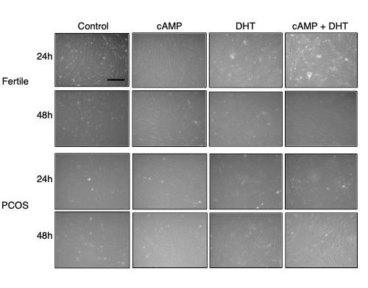

Supplementary Fig. 2 Magnified MAGEA11 expression in proliferative/secretory endometrium
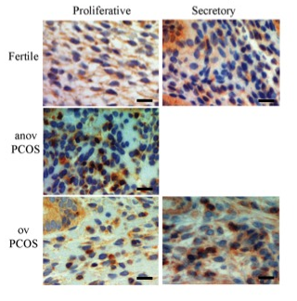

Supplementary Fig. 3 Co-localization of AR and MAGEA11 proteins
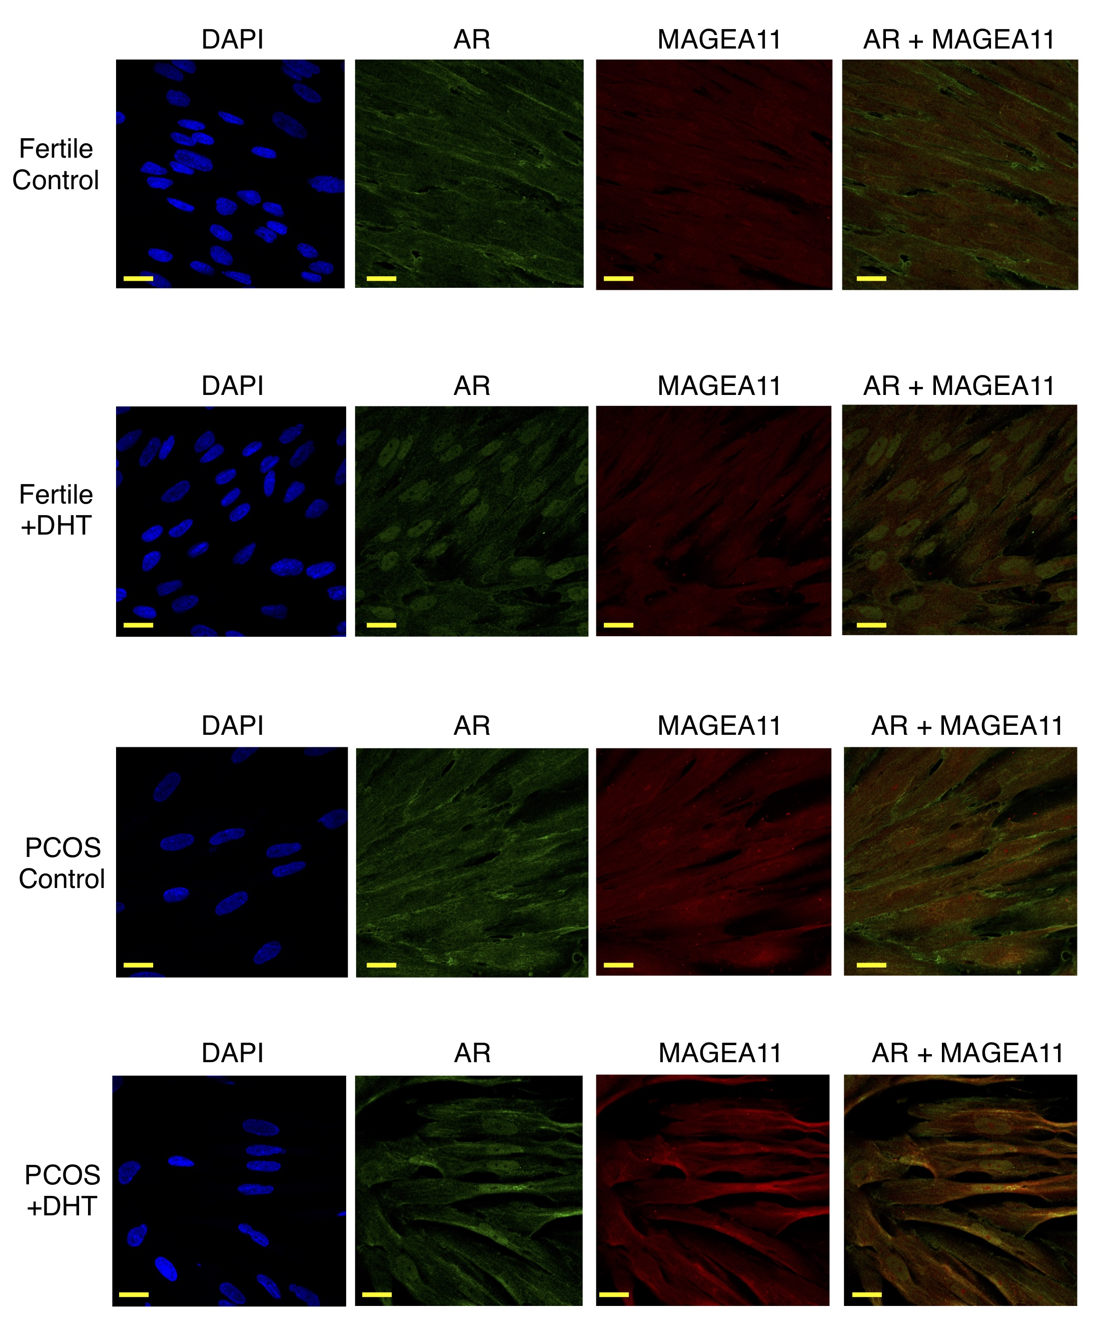

Supplementary Figure Legends

Supplementary Fig. 1 Morphological changes in ESC cells during in vitro decidualization
Representative images of endometrial stromal cell (ESC) shape changes during in vitro decidualization. ESCs were isolated from biopsies of fertile (n=8) and PCOS (n=9) patients and were either left untreated (C), incubated with cyclic AMP (cAMP, 0.5mM), dihydrotestosterone (DHT, 10⁻⁶M) or a combination of both for 24h and 48h. ESCs were obtained from cells in the secretory phase of the cycle. Scale = 40μm.

Supplementary Fig. 2 MAGEA11 expression in proliferative/secretory endometrium
Proliferative/secretory phase endometrium from fertile, anovulatory PCOS and ovulatory PCOS patients was analysed for the expression of MAGEA11 as described in Materials and Methods. Immunohistochemistry (IHC) images display x40 magnification. Scale = 20μm.

Supplementary Fig. 3 Co-localization of AR and MAGEA11 proteins
Immunofluorescence confocal microscopy images of fertile and PCOS hESCs that were either left untreated (Control) or treated with DHT for 48h (DHT). Fixed cells were stained with DAPI (blue, first column), anti-AR (green, second column) and anti-MAGEA11 (red, third column) for detection. The forth column represents a superposition of anti-AR and anti-MAGEA11 images. Scale =20μm.

