Electronic Supplementary material
Journal of Molecular Medicine
“Expanding and validating the biomarkers for mitochondrial diseases”
Alessandra Maresca, PhD¹, Valentina Del Dotto, PhD², Martina Romagnoli, PhD¹, Chiara La Morgia, MD, PhD ^{1,2}, Lidia Di Vito, MD¹, Mariantonietta Capristo, PhD¹, Maria Lucia Valentino^{1,2}, MD, Valerio Carelli, MD, PhD, ^{1,2*} and the ER-MITO study group.

¹IRCCS Istituto delle Scienze Neurologiche di Bologna, UOC Clinica Neurologica, Bologna, Italy
²Department of Biomedical and Neuromotor Sciences, University of Bologna, Bologna, Italy

*Corresponding author:
Valerio Carelli, MD, PhD
Department of Biomedical and Neuromotor Sciences, University of Bologna
IRCCS Istituto delle Scienze Neurologiche di Bologna
via Altura 3, 40139, Bologna, Italy
e-mail: valerio.carelli@unibo.it

List of content:
Supplementary Table 1
Supplementary Fig. 1
Supplementary Fig. 2
Supplementary Fig. 3
Supplementary Fig. 4
Supplementary Fig. 5

Supplementary Table 1- Mitochondrial patients categorized into phenotypic classes.

Phenotype | Genome | Gene | Males | Females | No.
MELAS  (28) | mtDNA | MT-TL1 | 16 | 11 | 27
MELAS  (28) |  | MT-ND3 | - | 1 | 1
MERRF  (6) | mtDNA | MT-TK | 3 | 3 | 6
NARP  (6) | mtDNA | MT-ATP6 | 4 | 2 | 6
LHON  (34) | mtDNA | MT-ND1 | 6 | 1 | 7
LHON  (34) |  | MT-ND4 | 17 | 5 | 22
LHON  (34) |  | MT-ND6 | 3 | - | 3
LHON  (34) | unknown |  | 1 | 1 | 2
Optic Atrophy  (16) | nDNA | OPA1 | 3 | 3 | 6
Optic Atrophy  (16) |  | SLC25A46 | 1 | - | 1
Optic Atrophy  (16) |  | SDHA | 1 | - | 1
Optic Atrophy  (16) |  | IBA57 | 1 | - | 1
Optic Atrophy  (16) |  | SSBP1 | 2 | - | 2
Optic Atrophy  (16) | unknown |  | 3 | 2 | 5
CPEO/SANDO  (21) | mtDNA | Single deletion | - | 4 | 4
CPEO/SANDO  (21) |  | MT-TY | 1 | - | 1
CPEO/SANDO  (21) |  | MT-TL1 | 2 | - | 2
CPEO/SANDO  (21) |  | MT-CO2 | 1 | - | 1
CPEO/SANDO  (21) | nDNA | OPA1/TWNK | 1 | - | 1
CPEO/SANDO  (21) |  | TWNK | - | 1 | 1
CPEO/SANDO  (21) |  | POLG | 1 | 3 | 4
CPEO/SANDO  (21) |  | DNA2 | - | 1 | 1
CPEO/SANDO  (21) | unknown |  | - | 6 | 6
Mitochondrial Encephalo-myopathy (12) | mtDNA | Single deletion | 1 | 1 | 2
Mitochondrial Encephalo-myopathy (12) |  | MT-TM | 1 | - | 1
Mitochondrial Encephalo-myopathy (12) |  | MT-ND3 | 1 | - | 1
Mitochondrial Encephalo-myopathy (12) |  | MT-CO2 | 1 | - | 1
Mitochondrial Encephalo-myopathy (12) | nDNA | MGME1 | 1 | - | 1
Mitochondrial Encephalo-myopathy (12) |  | SUCLA2 | 1 | - | 1
Mitochondrial Encephalo-myopathy (12) |  | SFNX4 | - | 1 | 1
Mitochondrial Encephalo-myopathy (12) |  | RARS2 | 1 | - | 1
Mitochondrial Encephalo-myopathy (12) | unknown |  | 2 | 1 | 3

Abbreviations: MT-TL1, transfer RNA Leucine; MT-TK, transfer RNA Lysine; MT-TY, transfer RNA Tyrosine; MT-TM, transfer RNA Methionine; MT-ND3, NADH dehydrogenase 3; MT-ATP6, ATP synthase 6; MT-ND1, NADH dehydrogenase 1; MT-ND4, NADH dehydrogenase 4; MT-ND6, NADH dehydrogenase 6; MT-CO3, cytochrome c oxidase III; MT-CO2, cytochrome c oxidase II; OPA1, Optic Atrophy 1; SLC25A46, Solute Carrier Family 25 Member 46; SDHA, Succinate Dehydrogenase Complex Flavoprotein Subunit A; IBA57, Iron-Sulfur Cluster Assembly Factor; SSBP1, Single strand binding protein 1; TWNK, Twinkle MtDNA Helicase; POLG, DNA Polymerase Gamma, Catalytic Subunit; DNA2, DNA replication ATP-dependent helicase/nuclease DNA2; MGME1, Mitochondrial Genome Maintenance Exonuclease 1; SUCLA2, Succinate-CoA Ligase ADP-Forming Subunit Beta; SFXN4, Sideroflexin-4; RARS2, Arginyl-TRNA Synthetase 2, Mitochondrial.

Supplementary Figure 1
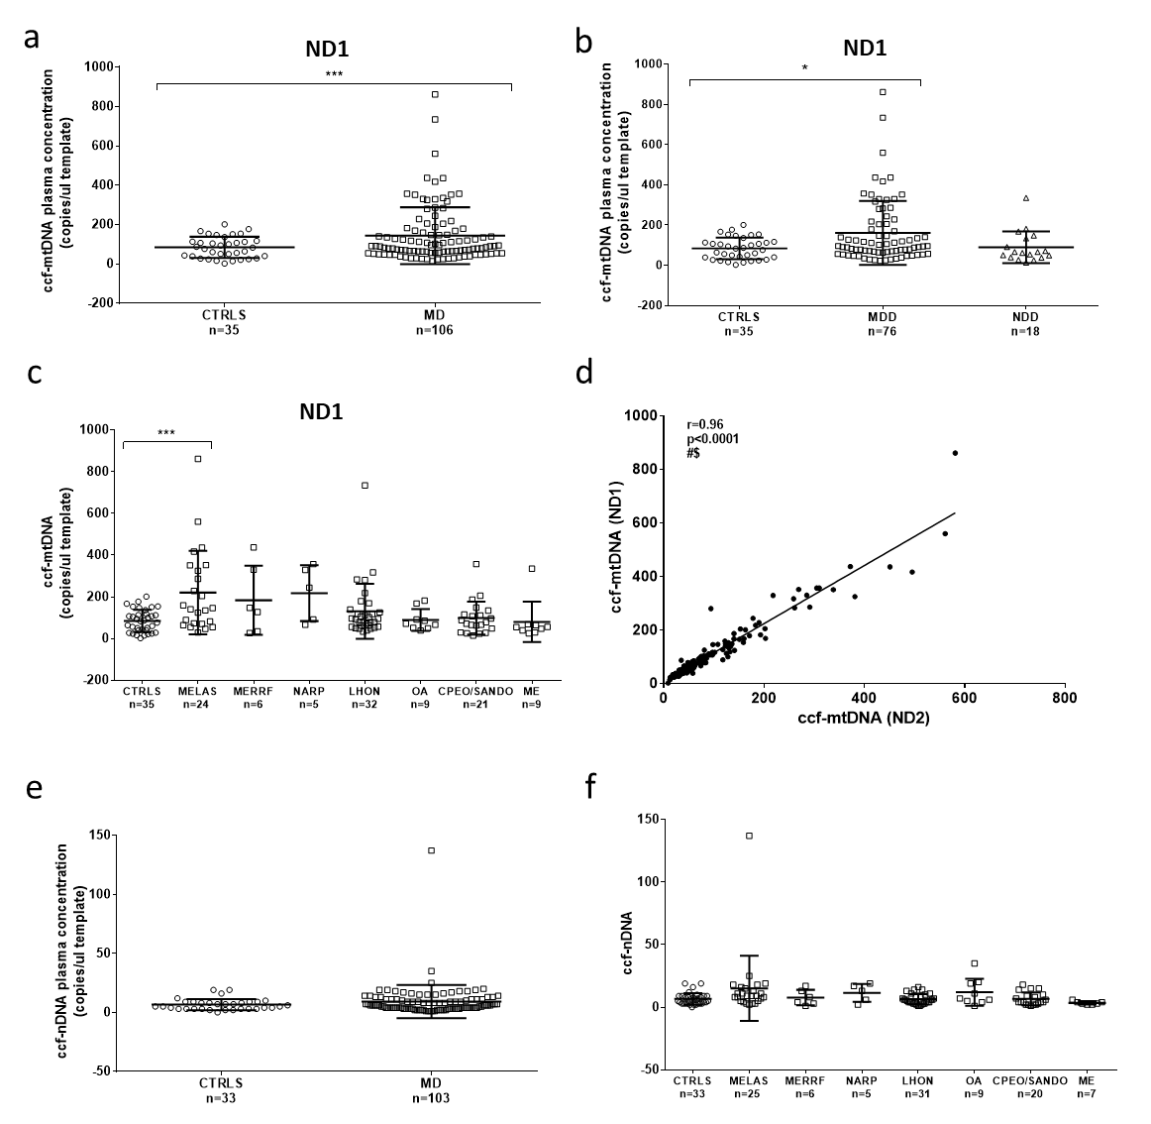

Supplementary Fig. 1 Ccf- mtDNA and ccf-nDNA evaluation in plasma from controls and mitochondrial patients.
(a) Ccf-mtDNA (MT-ND1) in controls (CTRLS) and mitochondrial patients (MD). (b) Ccf-mtDNA (MT-ND1) in CTRLS, patients with mtDNA genetic defects (MDD) and nuclear DNA genetic defects (NDD) (c) Ccf-mtDNA (MT-ND1) in CTRLS and mitochondrial patients stratified by phenotypes. (d) Pearson’s correlation between MT-ND2 and MT-ND1 assays for ccf-mtDNA. # Significance after Bonferroni’s correction (p<0.005), $ significance after Benjamini–Hochberg correction (FDR 0.10). (e) Ccf-nDNA in CTRLS and MD patients. (f) Ccf-nDNA in CTRLS and mitochondrial patients stratified by phenotypes. * p-value <0.05, *** p-value < 0.001.

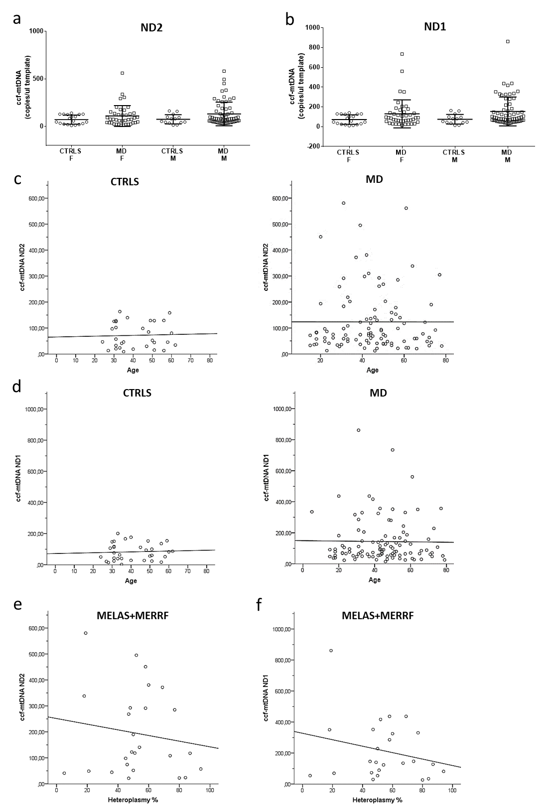
Supplementary Figure 2

Supplementary Fig. 2 Sex, age and heteroplasmy influence on ccf-mtDNA.
(a-b) Ccf-mtDNA shown for females and males in CTRLS and MD patients. (c-d) Linear regression for ccf-mtDNA and age in CTRLS and MD. No significant association was found. (e-f) Pearson’s correlation between ccf-mtDNA and heteroplasmy levels of m.3243 and m.8344 mutations in MELAS and MERRF merged group. No significant correlation was found.

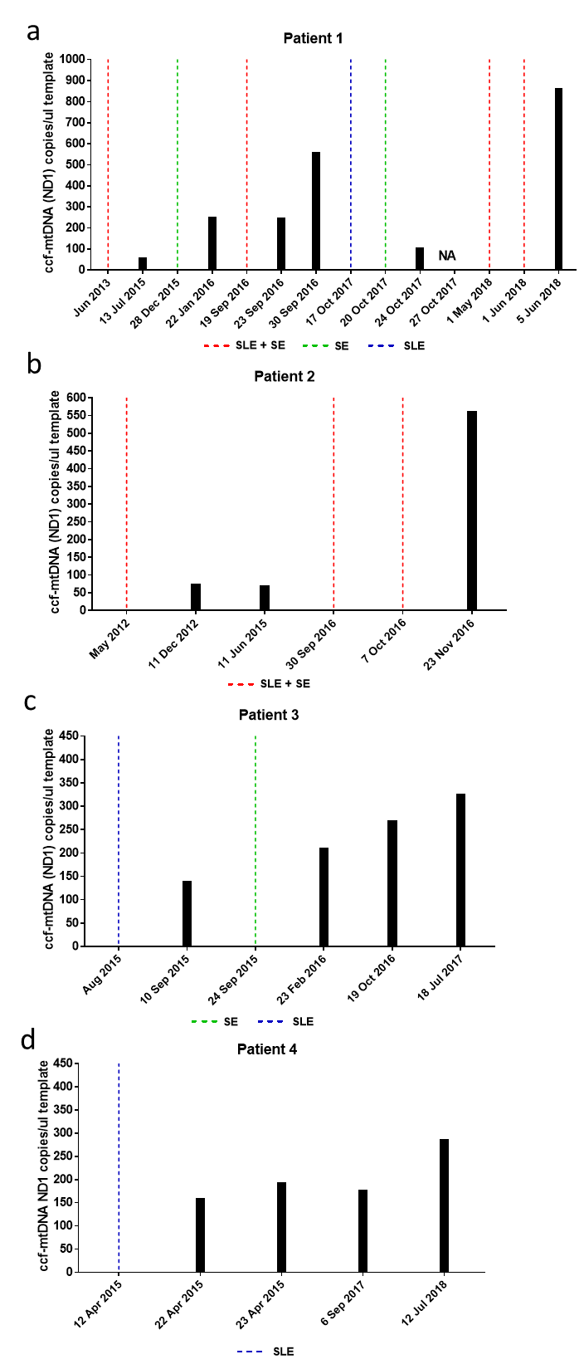
Supplementary Figure 3

Supplementary Fig. 3 Evaluation of ccf-mtDNA in longitudinal samples of MELAS patients.
Ccf-mtDNA (MT-ND1) evaluated in longitudinal samples in four different patients. SLE: stroke-like episode, SE: status epilecticus.

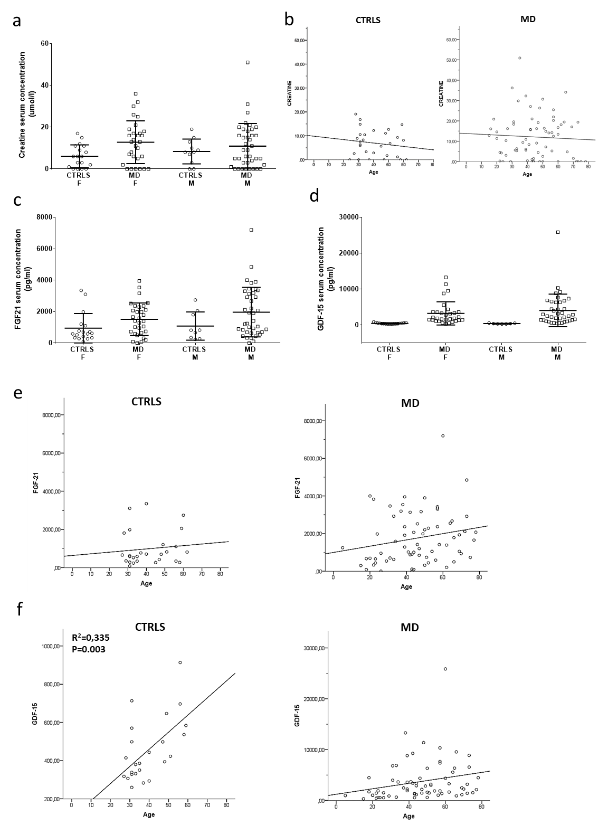
Supplementary Figure 4

Supplementary Fig. 4 Gender stratification and linear regression with age for creatine, FGF21 and GDF-15.
(a) Creatine shown for females and males in CTRLS and MD. (b) Linear regression for creatine and age in CTRLS and MD. No significant association was found. (c-d) FGF21 and GDF-15 shown for females and males in CTRLS and MD. (e-f) Linear regression for FGF21 (e) and GDF-15 (f) and age in CTRLS and MD. A significant association was found for GDF-15 and age in CTRLS R² = 0.335, p-value = 0.003.

Supplementary Figure 5

Supplementary Fig. 5 Correlation analyses amongst ccf-mtDNA, creatine, FGF21 and GDF-15.
Pearson’s correlation analyses amongst the four biomarkers of this study. The analysis was performed for both ccf-mDNA assays (MT-ND2 and MT-ND1). Graphs of Pearson’s correlations for FGF21/GDF-15 and MT-ND2/MT-ND1 are reported in Fig. 4h and in Supplementary Fig. 1d, respectively. NS Non significant after Bonferroni’s and Benjamini–Hochberg’s corrections (FDR 0.10).

