Suppelements

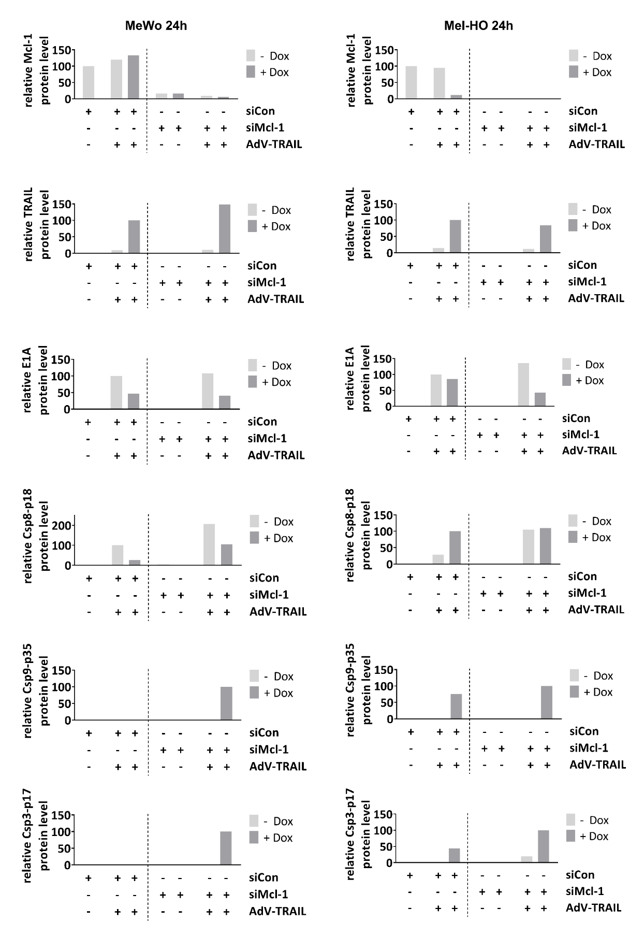 Figure S1. Quantifications of Westernblot signals from Fig. 3A and 5C. Signal intentities are shown relative to β-actin.

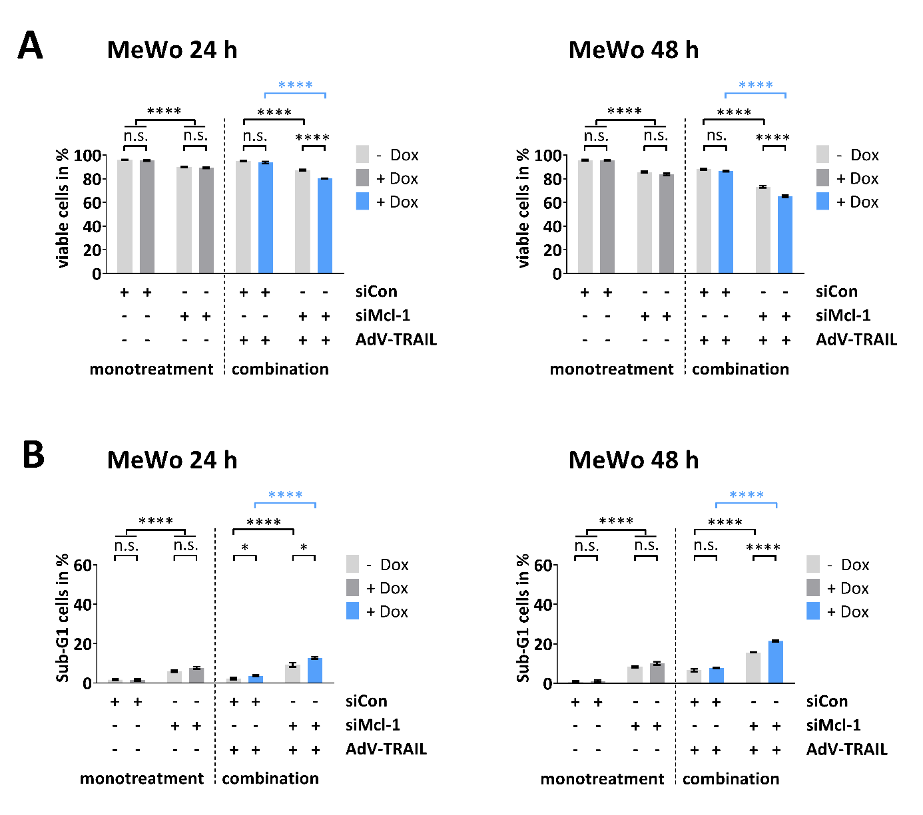

Figure S2. Viability of and apoptosis induction in MeWo cells treated with AdV-TRAIL and siMcl-1.
Cells were treated as described in Figure 4, but AdV-TRAIL was used at an MOI of 5. (A) Cell viability was determined by calcein-AM staining and flow cytometry 24 h and 48 h after infection with AdV-TRAIL. Data are expressed as mean percentages of calcein-AM positive cells (viable) ± SEM of three independent experiments. (B) Apoptosis was determined by propidium iodide staining and flow cytometry at 24 h and 48 h after transduction with AdV-TRAIL. The mean percentages of sub-G1 (apoptotic) cells ± SEMs of three independent experiments are shown. Statistical significance: * p < 0.05, ** p < 0.01, *** p < 0.001 and **** p < 0.0001

