Supplementary information
(JMME-D-21-00111)
HIF-1 mediated activation of antimicrobial peptide LL-37 in type 2 diabetic patients

Soumitra Mohanty¹, Witchuda Kamolvit¹, Silvia Zambrana^{2,3}, Eduardo Gonzales³, Jonas Tovi⁴, Kerstin Brismar², Claes-Göran Östenson², and Annelie Brauner¹*

¹ Department of Microbiology, Tumor and Cell Biology, Division of Clinical Microbiology,
Karolinska Institutet and Karolinska University Hospital, Stockholm, Sweden
² Department of Molecular Medicine and Surgery, Karolinska Institutet, Stockholm, Sweden
³ Area de Farmacologia, Instituto de Investigaciones Farmaco Bioquimicas, Facultad de Ciencias Farmacéuticas y Bioquimicas, Universidad Mayor de San Andres, La Paz, Bolivia
⁴ Capio Health Care Center, Solna, Sweden

* Corresponding author:
Annelie Brauner, Department of Microbiology, Tumor and Cell Biology, Division of Clinical Microbiology, Karolinska Institutet and Karolinska University Hospital, 17176 Stockholm, Sweden.
Phone +46 8 51770000, Fax: +46 8 308099
E-mail: Annelie.Brauner@ki.se

Supplementary fig.1

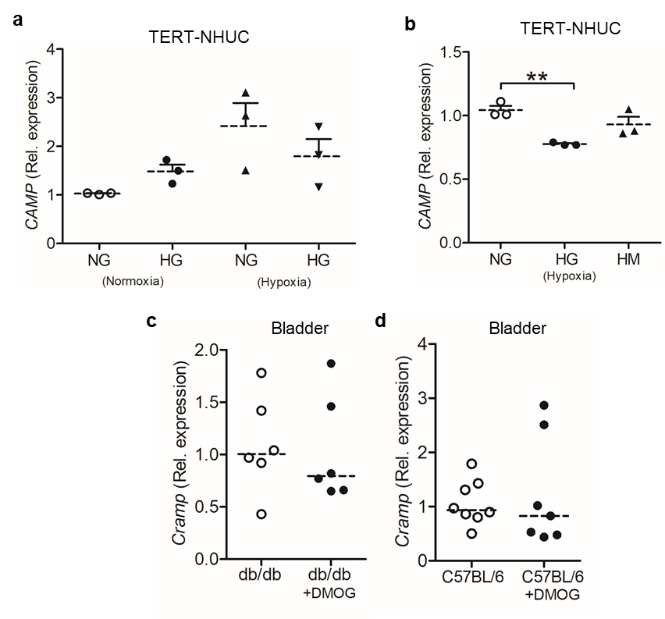

Supplementary fig. 1 Expression of antimicrobial peptide, LL-37. TERT-NHUC cells, demonstrating expression of CAMP mRNA 24 h post treatment of (a) glucose (n=3) and (b) mannitol (n=3, Bonferroni’s multiple comparison test) in both normoxia and hypoxia. Cramp mRNA in DMOG or vehicle (DMSO) treated uninfected (c) type 2 diabetic, db/db (n=6 each) and (d) nondiabetic C57BL/6 mice urinary bladder (n=8 each) after 7 days. In vitro analysis was performed in duplicate. Average values are shown for each set. Normal glucose; 6mM (NG), high glucose; 30mM (HG), High mannitol; 30mM (HM), normoxia; 21% O₂ (N) and hypoxia; 1% O₂ (H). Data are shown as mean + SEM. Results from mice are presented as median. Significance levels mentioned as **P < 0.01.

Supplementary fig.2

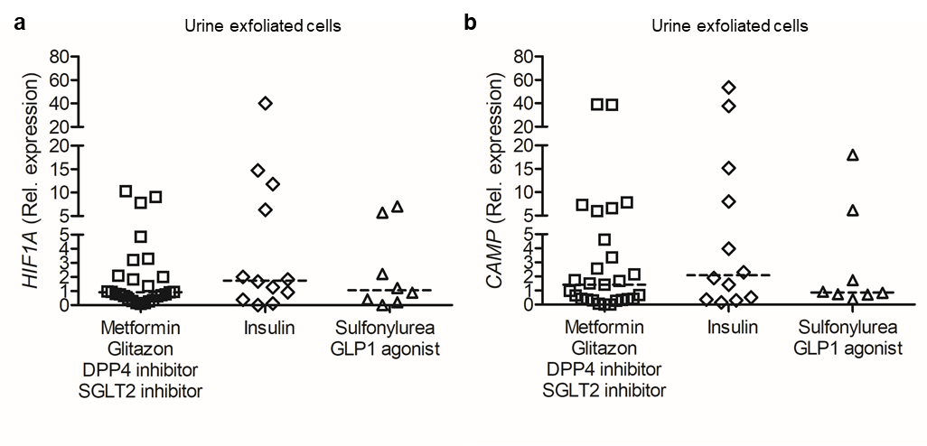

Supplementary fig. 2 Impact on HIF1A and CAMP by insulin and drugs affecting the insulin signaling pathway compared to other antidiabetic drugs. Human urine exfoliated cells from type 2 diabetic patients (T2D) living at low or high altitude were analyzed for (a) HIF1A (b) CAMP mRNA and grouped based on the antidiabetic treatment. Other antidiabetic drugs: metformin/glitazon/DPP4 inhibitor/SGLT2 inhibitor (n=27); insulin (n=12); Drugs affecting the insulin signaling pathway: sulfonylurea/GLP-1 agonists (n=8).

Supplementary fig. 3

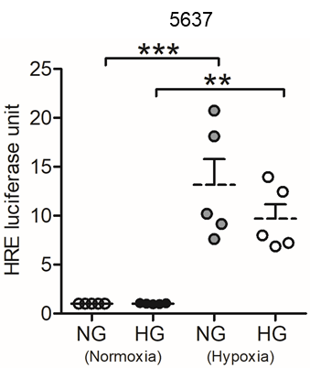

Supplementary fig. 3 High glucose impairs hypoxia induced luciferase activity. Uroepithelial cells, 5637, demonstrating expression of HRE luciferase assay 39 h post treatment of glucose in both normoxia and hypoxia (n=3, Bonferroni’s multiple comparison test). This analysis was performed in either duplicate or triplicate. Average values are shown for each set. Normal glucose; 5.5 mM (NG), High glucose; 30mM (HG), normoxia; 21% O₂ and hypoxia; 1% O₂. Data are shown as mean + SEM. Significance levels mentioned as **P < 0.01 and ***P < 0.001.

Supplementary fig.4

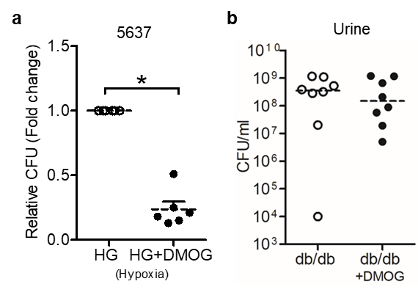

Supplementary fig. 4 HIF-1 activation decreased bacterial load in uroepithelial cells and diabetic mice. (a) Total number of bacteria in 5637 cells, 24 h after pretreatment with vehicle or DMOG (n=6, Wilcoxon matched pairs signed rank test). (b) Urine CFU, colony forming unit assay from DMOG treated diabetes, db/db and non-treated (n=8 each) mice after 24 h with or without DMOG treatment. In vitro experiments were performed in duplicate or triplicate. Average values are shown for each set. High glucose (HG). Data are shown as mean + SEM. Results from mice are presented as median. Significance levels mentioned as *P < 0.05.

