Supplementary Materials & Methods

1. Synthesis of IPMP acetic acid
1.1. Synthesis of 2IP5MP-Ac-Cys-Trp-OH
IPMP (0.1 mol) and 0.2 mol of potassium carbonate were dissolved in acetone. Ethyl bromoacetate (0.11 mol) was added to the reaction solution, and the mixture was stirred at room temperature for 12 h. After filtering the reaction mixture, 50 mL of distilled water with 0.2 mol of 50% hydroxide solution, was added to the filtrate, followed by stirring at room temperature for 2 h. After completion of the reaction, the mixture was neutralized with 3M HCl and evaporated. The evaporate was dissolved in ethyl acetate and washed with 0.1 N HCl and water. The organic layer was dried using magnesium sulfate and evaporated to obtain the crude compound of 17.7 g (85%) of IPMP acetic acid. After the crude was recrystallized in DCM/Hexane. White powder (15.7g, 75.3% yield over two steps). 1H-NMR(DMSO-d6) δ 12.93(br s, 1H), 7.06(d, 1H, J = 7.8Hz), 6.72(d, 1H, J = 7.2Hz), 6.63(s, 1H), 4.66(s, 2H), 3.29~3.22(m, 1H), 2.23(s, 3H), 1.15(d, 6H, J = 7.2Hz); 13C-NMR(DMSO-d6) δ 170.8, 155.2, 136.2, 133.7, 126.2, 121.9, 112.6, 65.1, 26.5, 23.1, 21.4.

1.2. Synthesis of H-Trp(Boc)-CTC resin
The 2-chloro trityl chloride resin (1.25 mmol) was stirred with 300 mL of DCM in the synthesizer chamber and then the solution was removed. DMF (300 mL) was added, and the mixture was stirred for 30 min, after which the solvent was removed. Fmoc-Trp(Boc)- OH (0.05 mol) and DIPEA (0.1 mol) in DMF (300 mL) were stirred for 4 h. The reaction mixture was filtered and washed with DCM. A 300 mL mixture of MC/MeOH/DIPEA (17/2/1) was added for 15 min to proceed with the capping reaction twice. After filtration, Fmoc- deprotection was performed twice in 300 mL of piperidine in DMF (20% v/v, 300 mL) for 15 min.

1.3. Synthesis of 2IP5MP-Ac-Cys-Trp-OH
The synthesized H-Cys(Trt)-Trp(Boc)-CTC resin was reacted with 0.075 mol of Fmoc- Cys(Trt)-OH and 0.0825 mol of HOBT in 300 mL of DMF. Completion of the reaction was confirmed using a positive Kaiser test for 4 h after the reaction. After the removal of the reaction solution, piperidine in DMF (20% v/v 300 mL) was added twice for 15 min for the deprotection reaction. Subsequently, the solution was filtered and washed three times with 300 mL of DMF and once with 300 mL of DCM.
The H-Cys(Trt)-Trp(Boc)-CTC resin and 0.083 mol of HOBt were dissolved in 300 mL of DMF. Subsequently, IPMP acetic acid (0.065 mol) and DIC (0.075 mol) were added to the resin and stirred for 30 min. Deprotection was assessed using a positive Kaiser test after 4 h. The solution was then filtered and rinsed three times with 300 mL each of DMF and DCM.
The peptides were cleaved from 2IP5MP-Ac-Cys(Trt)-Trp(Boc)-CTC resin by treatment with 90% trifluoroacetic acid in 350 mL DCM and 20 mL of triisopropylsilane, twice for 30 min. The crude peptides were filtered from the resin and precipitated using diethyl ether. Finally, the peptide product was dissolved in DW, purified using prep-LC, and lyophilized. The 2IP5MP-Ac-Cys-Trp-OH white powder (13.4 g) was obtained (53.9% yield, 97.5% purity by HPLC). 1H-NMR(DMSO-d6) δ 12.76(br s, 1H), 10.86(d, 1H, J = 1.8Hz), 8.40(d, 1H, J = 7.8Hz), 7.96(d, 1H, J = 7.8) 7.53(d, 1H, J = 7.8Hz), 7.32(d, 1H, J = 8.4), 7.15(d, 1H, J = 1.8Hz), 7.08~7.42(m, 2H), 6.98~6.96(m, 1H), 6.74(d, 1H, J = 7.8Hz), 6.72(s, 1H), 4.61~4.56(m, 1H), 4.53(d, 2H, J = 12Hz), 4.52~4.49(m, 1H), 3.34~3.24(m, 2H), 3.21~3.18(dd, 1H, J = 4.8, 15Hz), 3.08~3.04(dd, 1H, J = 7.8, 14.7), 2.87~2.80(m, 2H), 2.23(s, 3H), 2.12~2.09(t, 1H, J = 8.4), 1.16~1.15(d, 6H, J = 6.6). 13C-NMR(DMSO-d6) δ 3.4, 169.6, 168.3, 154.9, 136.5, 136.4, 133.7, 127.5, 126.2, 123.9, 122.4, 121.5, 119.0, 118.5, 113.3, 111.9, 109.9, 67.4, 53.6, 53.5, 27.2, 26.5, 23.2, 23.1, 21.3; The mass of the crude peptide was determined using liquid chromatography-mass spectrometry (LC-MS), which showed a peak at m/z 497.2. The molecular mass was determined to be M +1, theoretically M=497.2. The instrument used was a HPLC-MS Waters separations module Alliance e2695 with a quadrupole QDa Acquity and Waters Photodiode Array Detector 2996, working under positive electrospray ionization (ESI+), and equipped with a 3.0 × 150 mm, 3.5 μm, 95 Å, C18 Zorbax Eclipse Plus column (Waters). Chromatographic separation was accomplished using a program containing the eluents A (0.1% TFA/water), B (0.1% TFA/ACN) under a gradient from 90% A, 20% B to 0% A, 100% B for 50min, and a flow of 0.30 mL/min.

Supplementary Figure
Fig. 1. ¹H-NMR and ¹³C-NMR spectra of 2IP5MP-Ac-OH
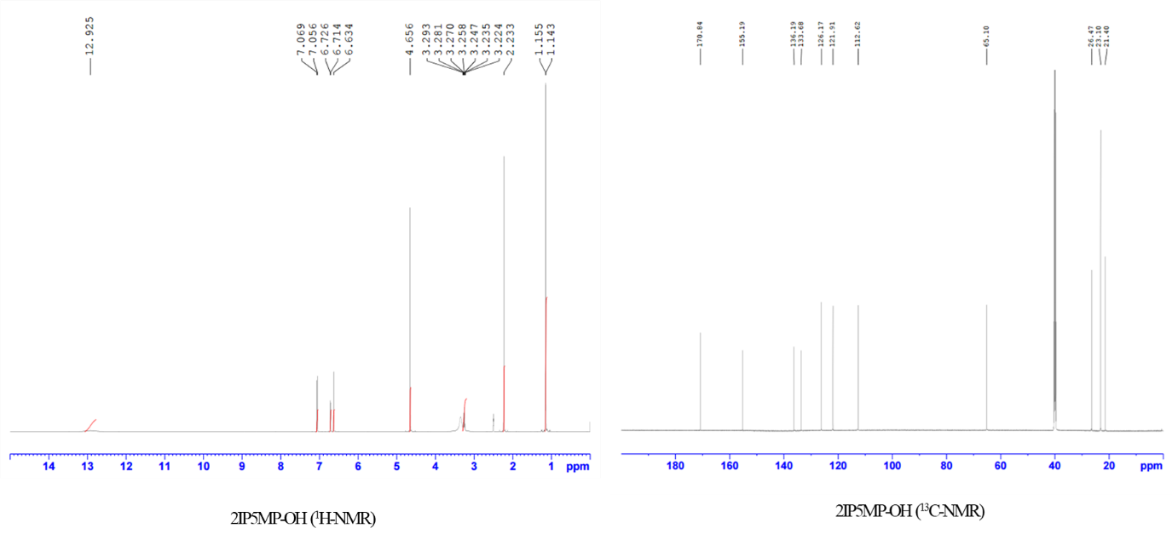

Fig. 2. Effects of 2IP5MP-CW and TPCA-1 on the expression of phosphorylated IKKβ, IkBα, and NF-kB protein in LPS-induced RAW 264.7 cells.
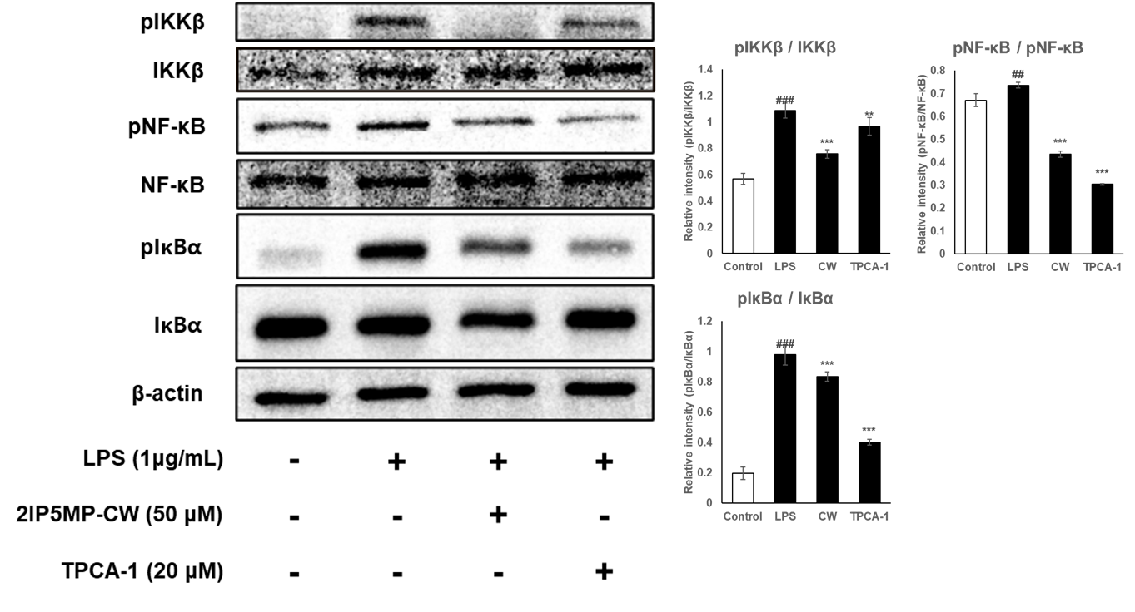
### P < 0.001 compared with the control group. ** P < 0.01 and *** P < 0.001 compared with LPS group. All experiments were performed in triplicate.

