Supplementary data
for

Controlling of enzymatic activity by immobilization on graphene oxide

Paulina Bolibok, Marek Wiśniewski, Katarzyna Roszek, Artur P. Terzyk

number of pages: 4
number of figures: 3

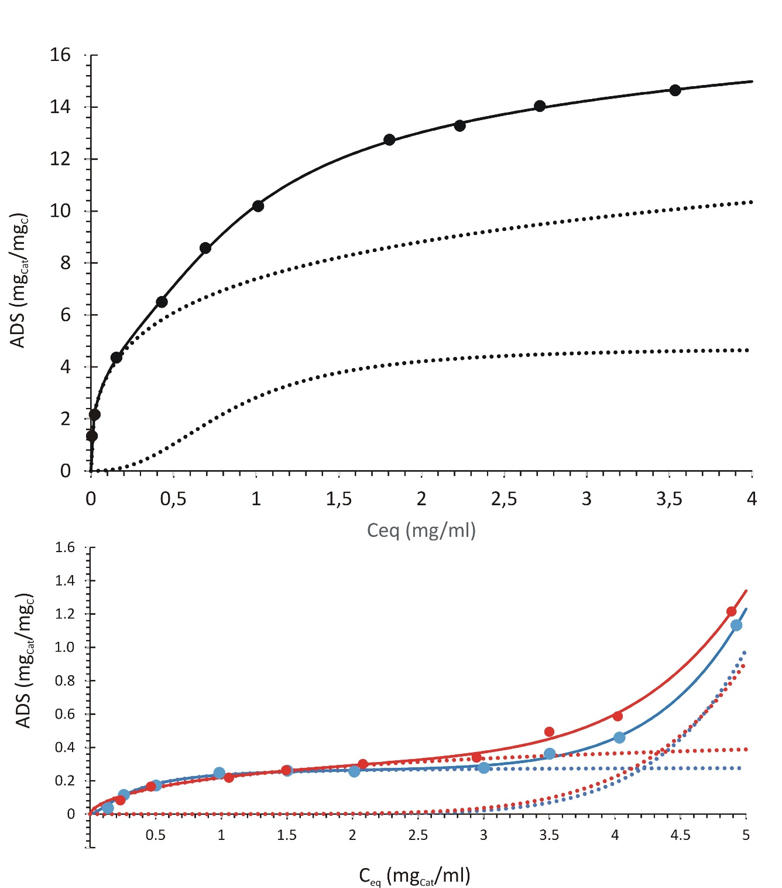

Figure S1. Adsorption isotherms of catalase on carbonaceous carriers. Upper panel – GO, bottom – CP3 (red), CS1 (blue).

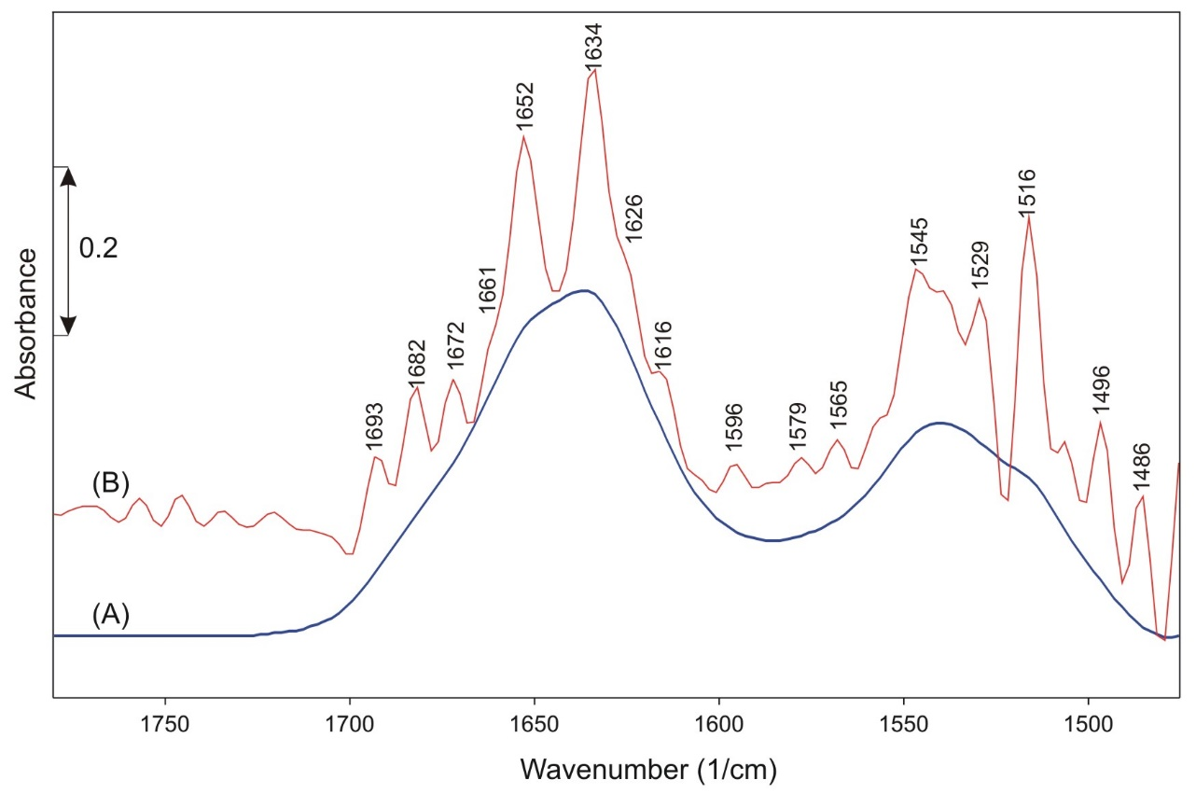
Figure S2. The amide I &II region FTIR spectrum of native catalase (A) with self-deconvolution (B).

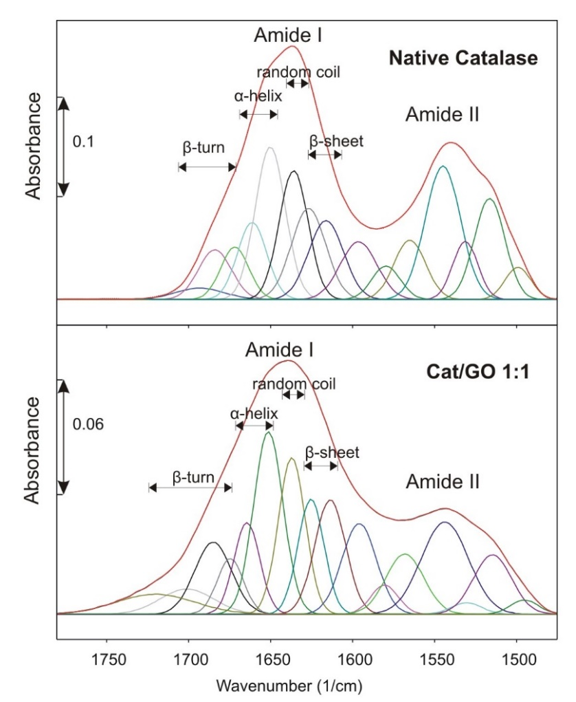

Figure S3. The spectral decomposition of amide I & II of native and immobilized enzyme.

