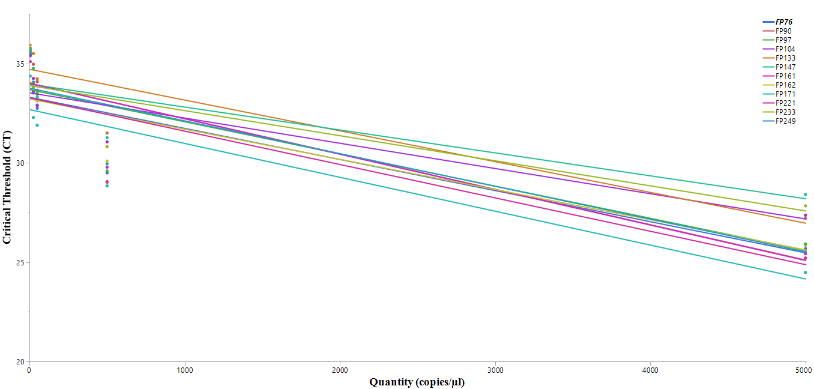
Fig 1: Mean slope of DNA quantity (copies/µl) to qPCR critical threshold (CT) across all 12 primer pairs using the Yangtze Finless Porpoise synthetic gene. For details, see Table 1.
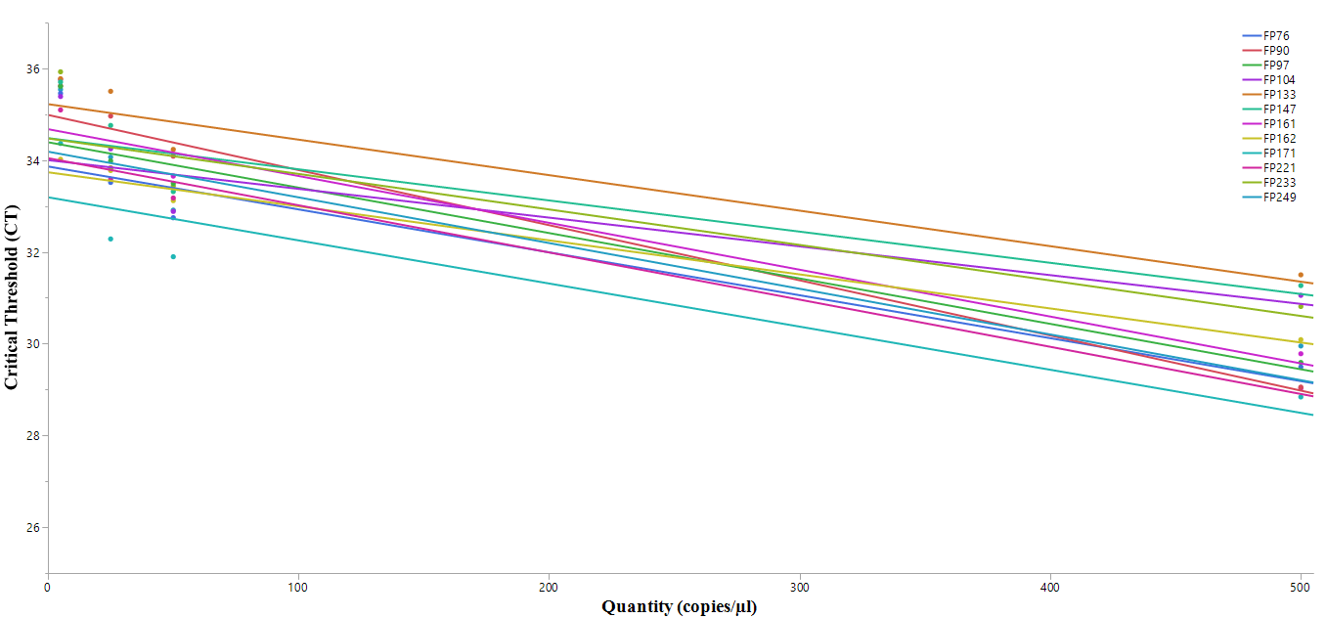
Fig 2: Mean slope of DNA quantity (copies/µl; to a maximum of 500 copies/µl) to qPCR critical threshold (CT) across all 12 primer pairs using the Yangtze Finless Porpoise synthetic gene.

