SUPPLEMENTARY INFORMATION
Innate floral object identification in a solitary pollinator employs a combination of both visual and olfactory cues
Aditi Mishra¹, Anupreksha Jain², Padmapriya S Iyer³, Ashwin Suryanarayanan¹, Karin Nordström^{4,5}, and Shannon B. Olsson¹

- Naturalist Inspired Chemical Ecology lab, National Centre for Biological Sciences (NCBS), Tata Institute of Fundamental Research, Bengaluru, Karnataka, India – 560065
- Department of Entomology, University of Wisconsin–Madison
- Tata- Institute of Fundamental Research - Hyderabad.
- Department of Medical Cell Biology, Uppsala University, 75123 Uppsala, Sweden
- Flinders Health, and Medical Research Institute, Flinders University, GPO Box 2100, Adelaide, SA 5001, Australia

Online Resource 1: Supplementary Data File - This file contains Supplementary methods S1-S2, Fig. S1- S3, Tables S1-S9, and description for Online Resource 2, Dataset1, Dataset2, Dataset3 and Dataset 4.

SUPPLEMENTARY METHODS
S1. Additional information on binomial GLMMs used in the study.
GLMMs (Generalized Linear Mixed Models) were used to test: (1) whether flies responded differently to the two models in the different assays (for all assays), (2) whether the proportion of responders out of the total number of flies tested in an assay depended on the sex of the fly (for all assays), (3) whether sex had an effect on the preference of one model over the other for n_{responder} flies (for assays in which sex of the fly had an impact on whether it responded to either of the models [based on (2)]), and (4) whether male and female responder flies responded differently to the two models (for assays in which sex of the fly did not have an impact on whether it responded to either of the models [based on (2)]).
For each assay, a series of GLMMs were performed to test for differences in responses to the two models in each assay.
Responder_Model1_Yes1_No0 ~ (1|Population), [eq.1]
where, Responder_Model1_Yes1_No0 denotes whether the fly responded to model1 in the assay or not (=1 if fly responded to model1; =0 if fly responded to model2), and
Population represented the batch from which the fly came, since multiple batches of flies were used in our experiments.
Next, we tested whether the proportion of n_{responder} flies responding to either of the models was different based on the sex of the fly (eq.2).
Responder_Yes1_No0 ~ SEX_female1_male0 + (1|Population), [eq.2]
where, Responder_Yes1_No0 denotes whether the fly responded to either of the models in the assay, and
SEX_female1_male0 denotes whether the fly is male or female (=0 if male; =1 if female).
If sex of the fly had an effect on whether it responded to either of the models (eq.2), we ran 2 separate GLMMs for each assay, one for only male flies and another only for female flies, testing for whether the n_{responder} flies responded to the two models differently (eq.3a and eq.3b). We also separately tested for whether the proportion of n_{responder} flies (irrespective of sex) were different in each assay (eq.3c).
Responder_Model1_Yes1_No0 ~ (1|Population); only male n_{responder} flies [eq.3a]
Responder_Model1_Yes1_No0 ~ (1|Population); only female n_{responder} flies [eq.3b]
Responder_Model1_Yes1_No0 ~ (1|Population); all n_{responder} flies [eq.3c]
If sex of the fly did not have an effect on whether it responded to either of the models (in eq.2), we tested for whether male and female n_{responder} flies responded differently to the two models in the assay (eq.4a).
Responder_Model1_Yes1_No0 ~ SEX_female1_male0 + (1|Population); [eq.4a]
In eq.4a, sex of the fly had an effect on response to model1 over model2 in only one assay (assay12; Supplementary Material Table S6). For the assays in which sex did not have an effect on one model over the other (eq.4a), we tested whether n_{responder} flies (irrespective of sex) responded to the models differently (eq.4b):
Responder_Model1_Yes1_No0 ~ (1|Population); all n_{responder} flies [eq.4b]
For the assays in which very few males were involved (assay1, assay2, assay17, assay20), we tested whether the response was different to the two models among the n_{responder} flies (eq.1). Note that we do not have data on the sex of the flies tested in model1=v+o+ vs. model2=v+1%GLV. Further, only gravid female flies were tested in the assay for model1=v+MC vs. model2=v-MC, and almost all female flies were tested in model1=v+o+ vs. model2=v-o- and model1=v+o+ vs. model2=v+o-.GLMMs were performed using the glmmTMB package (Brooks et al. 2017) in R version-4.0.5 (R Core Team 2021). Model diagnostics were checked using the DHARMa package (Hartig 2020), and model-predicted means and confidence intervals were extracted using the emmeans package (Lenth 2022),

S2. Power analysis
It should be noted that when a result is non-significant for a study with low power, it implies that that the sample size is inadequate to conclude absence of an actual difference. Further, generally power > 0.8 is considered good (VanVoorhis and Morgan, 2007).
In the absence of prior information, we simulated 1000 datasets using these conditions using the sim.glmm function (Johnson et al., 2014): a total of 60 flies, equally divided into 3 batches; within each batch, 50% flies were males and 50% were females; for each combination of batch and sex, 70% of flies visited Model1 and 30% visited Model2. We ran the GLMM (in Eq.1 in Supplementary material S1) on the 1000 different simulated datasets, and extracted the p-values for the Intercept in each of the 1000 GLMMs. Using this, we found that with 60 flies, power = 0.841 to detect a significant difference in the response of hoverflies to the two models (of 70:30 v/s 50:50), and hence a lack of significance is strong evidence that flies visit the two models similarly.
For power analysis to detect the effect of sex on differences in responses, we simulated 1000 datasets for each of the following total number of flies used in the assay: 60, or 120, or 180, or 240. Each of these 4000 datasets were populated using the following conditions: 3 equal batches where 50% of the flies were males and 50% of the flies were females; for male flies in each batch, flies visited both models equally, while for female flies in each batch, 70% flies visited Model1 and 30% flies visited Model2. Using this and the above-mentioned protocol, we found that power to detect the impact of sex on the difference in responses was equal to 0.039 when 60 flies are used, 0.355 when 120 flies are used, 0.793 when 180 flies are used, and 0.898 when 240 flies are used. So, a sample size of at least 180 or 240 flies would be required in every assay to detect the impact of sex on the differences in response, if the impact exists. Due to limitation of resources and because detecting the effect of sex on differences in responses was a secondary question, relevant only in assay17 and assay18 (assay numbers are described in Table S4), we did not increase the sample size for every assay, and used around 60 flies in most assays. Since pilot experiments had suggested that while male flies visit v+o+ and v+MC equally, female flies visit v+o+ much more than v+MC, we planned to test for the effect of sex for this assay in particular (assay17 and assay18) and used 240 flies for this assay.

SUPPLEMENTARY FIGURES AND TABLES
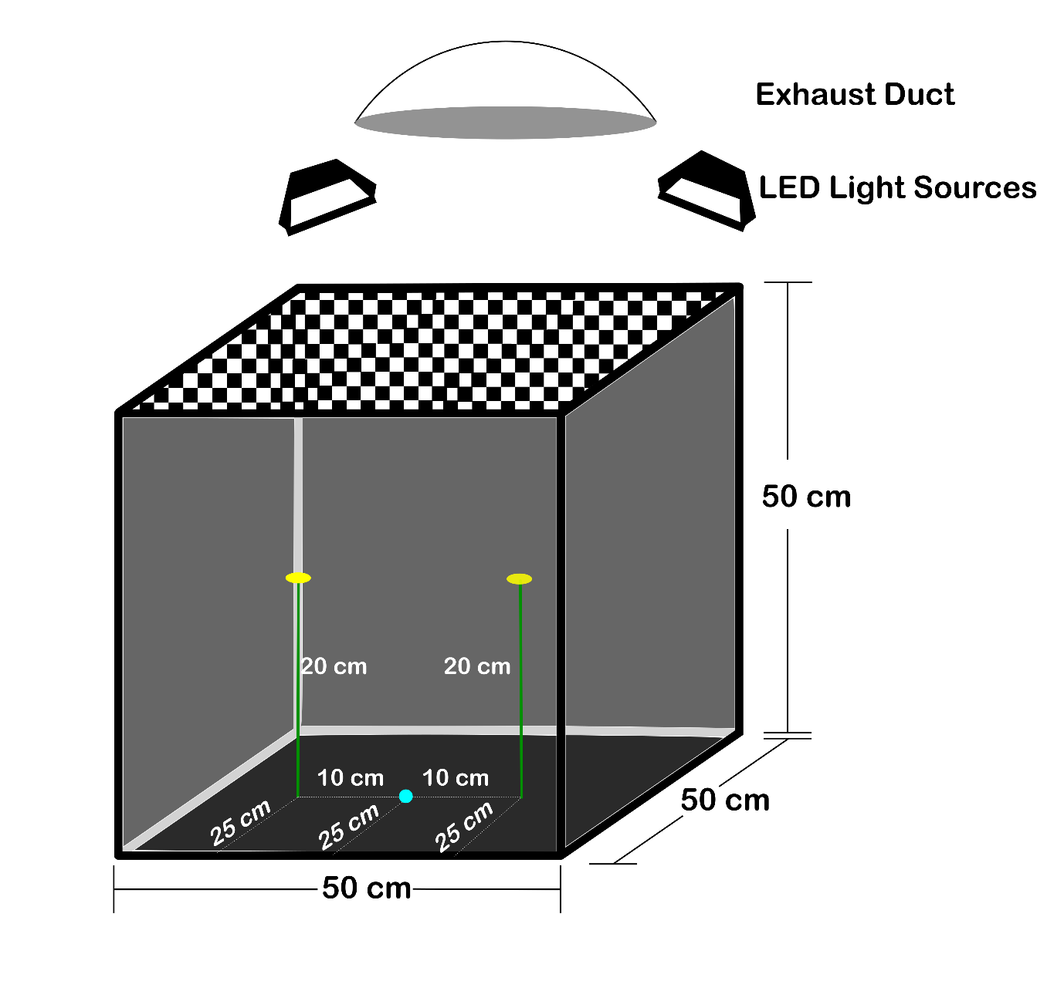
Fig. S1 Illustration of the experimental arena used in the study. The blue circle on the base of the experimental arena indicates where Eristalinus aeneus hoverflies were released.

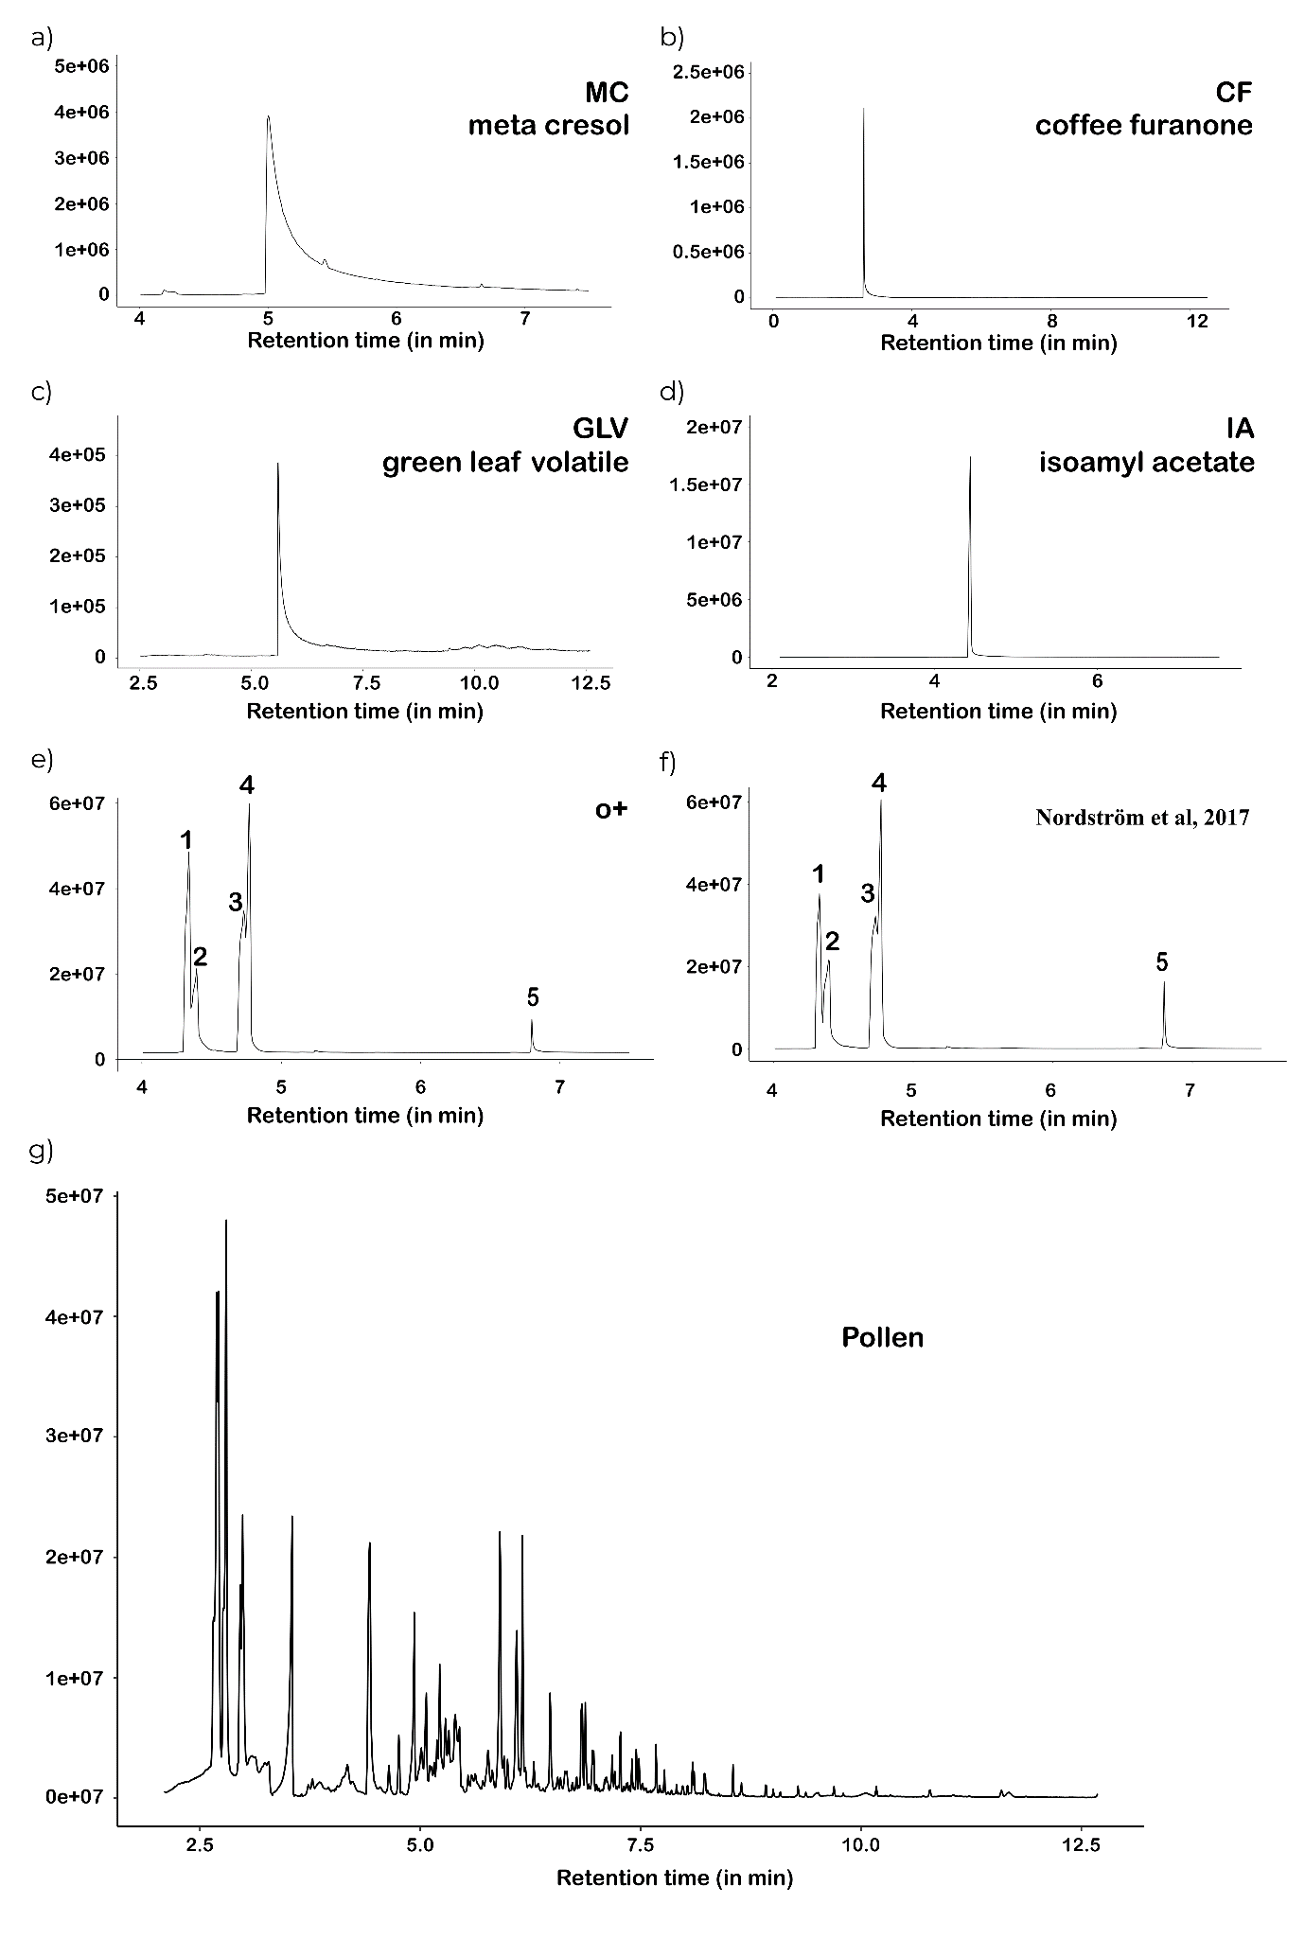
Fig. S2 Gas chromatograms indicating retention time in minutes and abundance for the volatiles used in the study.

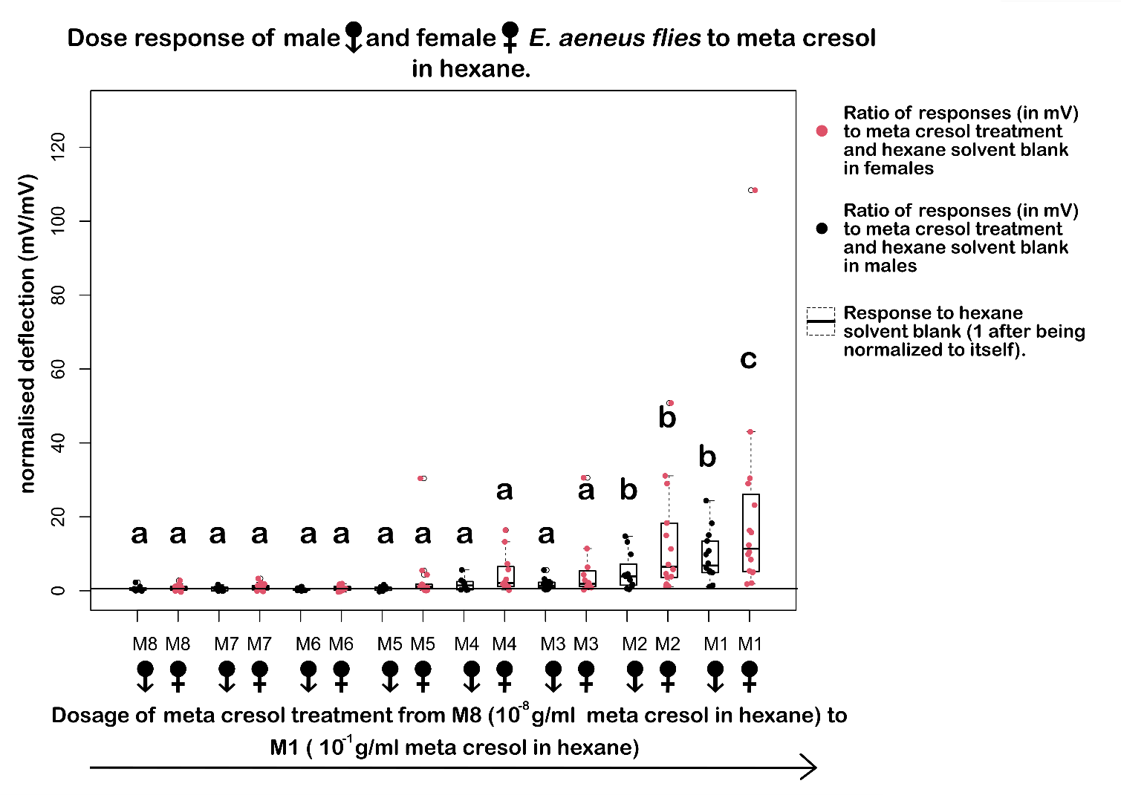
Fig. S3 Dose-response curves of male and female E. aeneus flies to meta cresol.
Table S1. Ratios of paints used in each floral model.
Floral model | Blend of Camlin acrylic colours
v+ /Asymmetric+/ Hexagon+ (all models have same paint as v+o+ i.e., yellow, reflectance peak 540-580 nm) | 14:1:3 ratio for Chrome yellow: sap green: white acrylic paint.
Low Reflectance LR+o+ (reflectance 540-580nm, reduced brightness compared to v+o+) | 14:1:3:1 ratio for chrome yellow: sap green: white: back acrylic paint.
Blue+ (reflectance peak 400-440 nm) | 100% Ultramarine blue acrylic paint.
White+ (reflectance peak 300-800 nm) | 100% White acrylic paint.
v- /Gray+ (reflectance peak 300-800 nm, reduced achromatic distance i.e., brightness compared to White+o+) | 9:1 ratio of White: black acrylic paint.

Table S2. Composition of volatiles used.
Odor blend | Composition
o+ (odour cues of v+o+) | 16.1 µl 2-Ethyltoluene [Sigma Aldrich, 99% purity]: 11.8 µl p-Cymene [Sigma Aldrich, 99% purity]: 60 µl Undecanal [Sigma Aldrich, 98% purity]: 24.1 µl r-Limonene [Sigma Aldrich, 97% purity]: 17.3 µl 6-Methyl-5-hepten-2-one [Fluka]: 82.7 µl mineral oil [Sigma Aldrich]
Coffee furanone (CF) | 10 µl 2-Methyltetrahydrofuran-3-one [Sigma Aldrich, 99% purity]: 90 µl mineral oil [Sigma Aldrich]
Vegetative odour – green leaf volatile (GLV) | 10 µl Cis-3-Hexenyl acetate [Sigma Aldrich, 98% purity]: 90 µl mineral oil [Sigma Aldrich]
Fruity odour- isoamyl acetate (IA) | 10 µl Isoamyl acetate [Sigma Aldrich, 98% purity]: 90 µl mineral oil [Sigma Aldrich]
Dung odor- meta cresol (MC) | 10 µl meta-Cresol [Sigma Aldrich]: 90 µl mineral oil [Sigma Aldrich]
1%o+ | 100-fold dilution of o+ blend in mineral oil
1%GLV | 100-fold dilution of GLV blend in mineral oil

Table S3. Relative ratios of chemicals in the headspace of o+ blend compared to blend from Nordström et al, 2017, which was constituted from empirically measured release rates from flowers in nature as measured in the study

Blend | Retention Time | Area | Base peak | chemical | Relative ratio of areas under different chemicals of the blend
o+ | 4.33 | 101406628 | 105.1 | 2-Ethyltoluene
  27.59: 16.59: 53.16: 2.65
o+ | 4.39 | 60991256 | 108.1 | 6-Methyl-5-hepten-2-one
o+ | 4.77 | 195407267 | 93.1 | Limonene - Cymene
o+ | 6.8 | 9752319 | 57.1 | Undecanal
Blend from Nordström et al. 2017 | 4.32 | 77557758 | 105.1 | 2-Ethyltoluene | 22.21: 19.49: 53.48: 4.82
Blend from Nordström et al. 2017 | 4.39 | 68037452 | 108.1 | 6-Methyl-5-hepten-2-one | 22.21: 19.49: 53.48: 4.82
Blend from Nordström et al. 2017 | 4.76 | 186748875 | 93.1 | Limonene - Cymene | 22.21: 19.49: 53.48: 4.82
Blend from Nordström et al. 2017 | 6.8 | 16831435 | 57.1 | Undecanal | 22.21: 19.49: 53.48: 4.82

Table S4. Number of flies tested in each assay, responding to either of the models in each assay (n_{responders}), and responding to Model1 in each assay. P-value denotes whether the number of responders to Model1 is different from the number of responders to Model2. Number of flies tested for each assay and the response percentage
Assay | Number of flies tested | n_{responders} | Number of responders  to Model1  (Preference  index  Model1) | Number of responders  to Model2  (Preference  index  Model2) | P value | Probability of flies responding to Model1 [Mean (Lower 95% confint, Upper 95% confint)] irrespective of sex | Proportion of all flies tested responding to Model1
assay1;  model1  =v+o+;  model2  =v-o- | 194 | 96 | 71 (73.96) | 25 (26.04) | 7.18*10⁻⁶ | 0.74  (0.64, 0.82) | 0.37
assay2;  model1  =v+o+;  model2  =v+o- | 180 | 108 | 76 (70.37) | 32 (29.63) | 4.05*10⁻⁵ | 0.70  (0.61, 0.78) | 0.42
assay3;  model1  =v+o+;  model2  =v-o+ | 200 | 90 | 66 (73.33) | 24 (26.67) | 2.2*10⁻⁵ | 0.733  (0.631, .815) | 0.33
assay4;  model1  =v+o+;  model2  =  Gray+o+ | 82 | 56 | 41(73.21) | 15 (26.79) | 0.000862 | 0.732  (0.599, 0.833) | 0.5
assay5;  model1=  v+o+_L,  model2=  v+o+_R | 190 | 103 | 50(48.53) | 53(51.46) | 0.768 | 0.485  (0.39, 0.582) | 0.26
assay6;  model1  =v+o+;  model2=  Blue+o+ | 128 | 64 | 47 (73.44) | 17 (26.56) | 0.000327 | 0.734  (0.611, 0.83) | 0.37
assay7;  model1  =v+o+;  model2=  v+GLV | 118 | 61 | 29 (47.54) | 32 (52.46) | 0.701 | 0.475  (0.352, 0.602) | 0.25
assay8;  model1  =v+o+;  model2=  White+o+ | 90 | 55 | 29 (52.73) | 26 (47.27) | 0.686 | 0.527  (0.394, 0.657) | 0.32
assay9;  model1  =v+o+;  model2=  v+1%o+ | 110 | 62 | 40 (64.52) | 22 (35.48) | 0.0243 | 0.645  (0.517, 0.756) | 0.36
Assay10;  model1  =v+o+;  model2  =v+CF | 120 | 60 | 44(73.33) | 16 (26.67) | 0.00053 | 0.733  (0.605, 0.831) | 0.37
assay11;  model1  =v+o+;  model2  =v+IA | 108 | 58 | 28 (48.28) | 30 (51.72) | 0.696 | 0.475  (0.349, 0.604) | 0.26
assay12;  model1  =v+o+;  model2=  *Asym+o+ | 100 | 61 | 46 (75.41) | 15 (24.59) | 0.00164 | 0.754  (0.628, 0.848) | 0.46
assay13;  model1  =v+o+;  model2  =LR+o+ | 54 | 30 | 24 (80) | 6 (20) | 0.00239 | 0.8  (0.611, 0.911) | 0.44
assay14;  model1  =v+o+;  model2=  **Hex+o+ | 108 | 65 | 39 (60) | 26(40) | 0.181 | 0.582  (0.459, 0.696) | 0.36
assay15;  model1  =LR+o+;  model2=  Blue+o+ | 100 | 64 | 32 (50) | 32 (50) | 1 | 0.5  (0.378, 0.622) | 0.32
assay16;  model1=  v+1%o+;  model2=  v+1%GLV | 50 | 30 | 13 (43.33) | 17 (56.67) | 0.467 | 0.433  (0.264, 0.619) | 0.26
assay17;  model1=  v+MC;  model2=  v-MC | 75 | 50 | 20 (40) | 30 (60) | 0.16 | 0.40  (0.27, 0.54) | 0.27
assay18;  model1  =v+o+;  model2  =v+MC  (males) | 192 | 126 | 65 (51.59) | 61 (48.41) | 0.469 | 0.602  (0.352, 0.808) | 0.34
assay18;  model1  =v+o+;  model2  =v+MC  (females) | 260 | 115 | 93 (80.87) | 22 (19.13) | 1.2*10⁻⁹ | 0.809  (0.725, 0.871) | 0.36
assay19;  model1=  v+1%o+;  model2=  v+GLV | 113 | 61 | 25 (40.98) | 36 (59.02) | 0.161 | 0.41  (0.292, 0.539) | 0.22
assay20;  model1  =v+o+;  model2=  v+1%GLV | 84 | 57 | 34 (59.65) | 23 (40.35) | 0.148 | 0.596  (0.463, 0.717) | 0.4

* Asym+o+ is Asymmetric+o+, ** Hex+o+ is Hexagon+o+.
Table S5. Differences in response percentage between male and female flies across assays.
Assay | Intercept estimate; Logit scale (p-value for estimate in brackets) | Estimate for effect of sex; Logit scale (p-value for estimate in brackets) | Probability of flies responding of sex 0,1  0 = male, 1 = female, [M  ean (Lower 95% confint, Upper 95% confint)] | Number of flies tested (number of responders) of sex 0,1  0 = male, 1 = female, | Number of flies tested  (Number of responders) with sex unknown.
 | -0.1643 (0.523) | 0.3596  (0.319) | 0:  0.459 (0.338, 0.585) | 0: 61 (28) | 0 (0)
  assay3;
  model1=v+o+;
  model2=v-o+
 | -0.1643 (0.523) | 0.3596  (0.319) | 1:  0.549 (0.456, 0.638) | 1: 113 (62) | 0 (0)
assay4;  model1=v+o+;  model2  =Gray+o+ | 0.3514 (0.2406) | 1.0349 (0.0457) | 0:  0.587 (0.439, 0.721) | 0: 46 (27) | 1(1)
assay4;  model1=v+o+;  model2  =Gray+o+ | 0.3514 (0.2406) | 1.0349 (0.0457) | 1:  0.8 (0.633, 0.903) | 1: 35 (28) | 1(1)
assay5;  model1  =v+o+_L,  model2  =v+o+_R | 0.0541  (0.849) | -0.05170 (0.848) | 0: 0.513 (0.363, 0.649) | 0: 64 (33) | 43 (28)
assay5;  model1  =v+o+_L,  model2  =v+o+_R | 0.0541  (0.849) | -0.05170 (0.848) | 1: 0.501 (0.379, 0.622) | 1: 84 (42) | 43 (28)
assay6;  model1=v+o+;  model2  =Blue+o+ | -0.3918 (0.349) | 1.4585 (0.000401) | 0: 0.403 (0.228,0.608) | 0: 73(26) | 3 (0)
assay6;  model1=v+o+;  model2  =Blue+o+ | -0.3918 (0.349) | 1.4585 (0.000401) | 1: 0.744 (0.547, 0.875) | 1: 52 (38) | 3 (0)
assay7;  model1=v+o+;  model2  =v+GLV | -0.4568  (0.119269) | 1.8738 (0.000136) | 0: 0.388  (0.261, 0.531) | 0: 49 (19) | 29 (9)
assay7;  model1=v+o+;  model2  =v+GLV | -0.4568  (0.119269) | 1.8738 (0.000136) | 1: 0.805  (0.653, 0.900) | 1: 41 (33) | 29 (9)
assay8;  model1=v+o+;  model2=  White+o+ | 0.8329 (0.029) | -0.5101 (0.2828) | 0: 0.697  (0.52, 0.83) | 0: 33 (23) | 7(3)
assay8;  model1=v+o+;  model2=  White+o+ | 0.8329 (0.029) | -0.5101 (0.2828) | 1: 0.580  (0.438, 0.71) | 1: 50 (29) | 7(3)
assay9;  model1=v+o+;  model2  =v+1%o+ | -0.2272 (0.4696) | 1.0201 (0.0198) | 0: 0.443  (0.299, 0.598) | 0: 45(20) | 12 (5)
assay9;  model1=v+o+;  model2  =v+1%o+ | -0.2272 (0.4696) | 1.0201 (0.0198) | 1: 0.688  (0.539, 0.807) | 1: 54 (37) | 12 (5)
assay10;  model1=v+o+;  model2=v+CF | 0.02985 (0.903) | -0.06759 (0.854) | 0: 0.507  (0.388, 0.626) | 0: 67 (34) | 1(0)
assay10;  model1=v+o+;  model2=v+CF | 0.02985 (0.903) | -0.06759 (0.854) | 1: 0.491  (0.358, 0.624) | 1: 53 (26) | 1(0)
 | -0.15414 (0.695) | 0.03637 (0.944) | 0: 0.462  (0.281, 0.653) | 0: 26 (12) | 48 (31)
  assay11;
  model1=v+o+;
  model2=v+IA
 | -0.15414 (0.695) | 0.03637 (0.944) | 1: 0.471  (0.309, 0.639) | 1: 34 (16) | 48 (31)
assay12;  model1=v+o+;  model2=  Asymmetric+o+ | 0.6495 (0.0397) | -0.4469 (0.2946) | 0: 0.657  (0.506, 0.782) | 0: 60 (39) | 1(0)
assay12;  model1=v+o+;  model2=  Asymmetric+o+ | 0.6495 (0.0397) | -0.4469 (0.2946) | 1: 0.550  (0.381, 0.709) | 1: 40 (22) | 1(0)
assay13;  model1=v+o+;  model2=LR+o+ | 0.4700 (0.244) | -0.4700 (0.395) | 0: 0.615  (0.416, 0.782) | 0: 26 (16) | 0 (0)
assay13;  model1=v+o+;  model2=LR+o+ | 0.4700 (0.244) | -0.4700 (0.395) | 1: 0.500  (0.319, 0.681) | 1: 27 (14) | 0 (0)
assay14;  model1=v+o+;  model2=  Hexagon+o+ | 0.43925 (0.220) | [-0.04513] (0.922) | 0: 0.609  (0.432, 0.760) | 0: 38(23) | 26(16)
assay14;  model1=v+o+;  model2=  Hexagon+o+ | 0.43925 (0.220) | [-0.04513] (0.922) | 1: 0.597  (0.419, 0.753) | 1: 44(26) | 26(16)
assay15;  model1=LR+o+;  model2=  Blue+o+ | 0.8650 (0.0401) | [-0.2869] (0.5625) | 0: 0.608  (0.432, 0.760) | 0: 27(19) | 9(4)
assay15;  model1=LR+o+;  model2=  Blue+o+ | 0.8650 (0.0401) | [-0.2869] (0.5625) | 1: 0.597  (0.419, 0.753) | 1: 64(41) | 9(4)
assay16;  model1=  v+1%o+;  model2=  v+1%GLV | 0.51083 (0.323) | -0.08004 (0.898) | 0: 0.625  (0.371, 0.825) | 0: 33(20) | 0(0)
assay16;  model1=  v+1%o+;  model2=  v+1%GLV | 0.51083 (0.323) | -0.08004 (0.898) | 1: 0.606  (0.429, 0.759) | 1: 16 (10) | 0(0)
assay18;  model1=v+o+;  model2=v+MC | 0.7932 (6.72^10-07) | [-1.0250] (4.24*10^-07) | 0: 0.689  (0.618, 0.752) | 0: 192 (126) | 0(0)
assay18;  model1=v+o+;  model2=v+MC | 0.7932 (6.72^10-07) | [-1.0250] (4.24*10^-07) | 1: 0.442  (0.383, 0.503) | 1: 260  (115) | 0(0)
assay19;  model1=  v+1%o+;  model2=  v+GLV | [-0.06643] (0.0788) | 0.72323 (0.125) | 0: 0.483  (0.365, 0.604) | 0: 83(40) | 4(4)
assay19;  model1=  v+1%o+;  model2=  v+GLV | [-0.06643] (0.0788) | 0.72323 (0.125) | 1: 0.659  (0.449, 0.820) | 1: 26(17) | 4(4)

Table S6. Differences in preference index for model 1 between male and female responders across assays where a significant difference in response rates was observed between male and female flies
Assay | Intercept estimate; Logit scale (p-value for estimate in brackets)  For males | Probability of flies responding to Model 1 [Mean (Lower 95% confint, Upper 95% confint)]  For males | Intercept estimate; Logit scale (p-value for estimate in brackets)  For females | Probability of flies responding to Model 1 [Mean (Lower 95% confint, Upper 95% confint)]  For females
assay4;  model1=v+o+;  model2=Gray+o+ | 0.6931 (0.0895) | 0.667  (0.463, 0.823) | 1.5261 (0.00198) | 0.821  (0.625, 0.927)
assay6;  model1=v+o+;  model2=Blue+o+ | 0.47 (0.244) | 0.615  (0.41, 0.786) | 1.4881 (0.000377) | 0.816  (0.655, 0.912)
assay7;  model1=v+o+;  model2=v+GLV | 0.3080 (0.546) | 0.576  (0.317, 0.8) | 0.1823 (0.602) | 0.545  (0.37, 0.71)
assay9;  model1=v+o+;  model2=v+1%o+ | 0.4129 (0.397) | 0.602  (0.352, 0.808) | 0.7349 (0.0366) | 0.676  (0.505, 0.81)
assay18;  model1=v+o+;  model2=v+MC | 0.1313 (0.469) | 0.602  (0.352, 0.808) | 1.4416 (1.2^10-09) | 0.809  (0.725, 0.871)

Table S7. Differences in preference index for model 1 between male and female responders across assays without a significant difference in response rates between males and females
Assay | Intercept estimate; Logit scale (p-value for estimate in brackets) | Estimate for effect of sex on preference index for model1; Logit scale (p-value for estimate in bracket) | Probability of male flies responding to Model 1 [Mean (Lower 95% confint, Upper 95% confint)] | Probability of female flies responding to Model 1 [Mean (Lower 95% confint, Upper 95% confint)]
Assay 3;  model1=v+o+;  model2=v-o+ | 0.7472 (0.0648) | 0.3949 (0.4312) | 0.679 (0.486, 0.825) | 0.758 (0.635, 0.85)
assay5;  model1=v+o+_L,  model2=v+o+_R | [-0.3054] (0.386) | 0.4964 (0.290) | 0.424 (0.267, 0.598) | 0.548 (0.395, 0.692)
assay8;  model1=v+o+;  model2=White+o+ | 0.4418 (0.301) | [-0.5108] (0.367) | 0.609 (0.397, 0.786) | 0.483 (0.307, 0.663)
assay10;  model1=v+o+;  model2=v+CF | [-0.33647] (0.566) | 0.08516 (0.912) | 0.417 (0.176, 0.705) | 0.438 (0.216, 0.687)
assay11;  model1=v+o+;  model2=v+IA | [-0.33647] (0.566) | 0.08516 (0.912) | 0.417 (0.176, 0.705) | 0.438 (0.216, 0.687)
assay12;  model1=v+o+;  model2=Asymmetric+o+ | 0.5798 (0.0824) | 2.4647 (0.0221) | 0.641 (0.478, 0.777) | 0.955 (0.730, 0.994)
assay13;  model1=v+o+;  model2=LR+o+ | 1.4663 (0.0221) | [-0.1671] (0.8549) | 0.812 (0.538, 0.942) | 0.786 (0.491, 0.933)
assay14;  model1=v+o+;  model2=Hexagon+o+ | 0.2624 (0.533) | 0.2076 (0.722) | 0.565 (0.358, 0.752) | 0.615 (0.415, 0.783)
assay15;  model1=LR+o+;  model2=Blue+o+ | [-0.1054] (0.819) | 0.1542 (0.781) | 0.474 (0.264, 0.693) | 0.512 (0.360, 0.662)
assay16;  model1=v+1%o+;  model2=v+1%GLV | [-1.3863] (0.0795) | 1.5870 (0.0810) | 0.20 (0.047, 0.559) | 0.55 (0.327, 0.755)
assay19;  model1=v+1%o+;  model2=v+GLV | [-0.51083] (0.118) | [-0.09531] (0.875) | 0.375 (0.238, 0.536) | 0.353 (0.165, 0.601)

Table S8. Differences in EAG response to doses of meta-Cresol treatment

Doses being compared | diff | Lower bound | Upper bound | P adj
p10⁻⁷ and 10⁻⁸ | 0.17938028 | -10.6415126 | 11.00027 | 1
10⁻⁶ and 10⁻⁸ | 0.03273742 | -10.6726559 | 10.73813 | 1
10⁻⁵ and 10⁻⁸ | 2.17536790 | -8.6455249 | 12.99626 | 0.9986146
10⁻⁴ and 10⁻⁸ | 3.32933714 | -7.6166569 | 14.27533 | 0.9823644
10⁻³ and 10⁻⁸ | 3.91437675 | -6.7910166 | 14.61977 | 0.9511907
10⁻² and 10⁻⁸ | 10.93617785 | 0.4371492 | 21.43521 | 0.0346344
10⁻¹ and 10⁻⁸ | 17.48192212 | 7.3902143 | 27.57363 | 0.0000090
10⁻⁶ and 10⁻⁷ | -0.14664286 | -10.7240898 | 10.43080 | 1.0000000
10⁻⁵ and 10⁻⁷ | 1.99598762 | -8.6983407 | 12.69032 | 0.9991438
10⁻⁴ and 10⁻⁷ | 3.14995686 | -7.6709360 | 13.97085 | 0.9863363
10⁻³ and 10⁻⁷ | 3.73499647 | -6.8424505 | 14.31244 | 0.9594616
10⁻² and 10⁻⁷ | 10.75679757 | 0.3882616 | 21.12533 | 0.0359678
10⁻¹ and 10⁻⁷ | 17.30254184 | 7.3466640 | 27.25842 | 0.0000083
10⁻⁵ and 10⁻⁶ | 2.14263048 | -8.4348164 | 12.72008 | 0.9985452
10⁻⁴ and 10⁻⁶ | 3.29659972 | -7.4087936 | 14.00199 | 0.9810670
10⁻³ and 10⁻⁶ | 3.88163933 | -6.5776201 | 14.34090 | 0.9472334
10⁻² and 10⁻⁶ | 10.90344043 | 0.6555009 | 21.15138 | 0.0282353
10⁻¹ and 10⁻⁶ | 17.44918470 | 7.6189645 | 27.27940 | 0.0000048
10⁻⁴ and 10⁻⁵ | 1.15396924 | -9.6669236 | 11.97486 | 0.9999799
10⁻³ and 10⁻⁵ | 1.73900885 | -8.8384381 | 12.31646 | 0.9996279
10⁻² and 10⁻⁵ | 8.76080995 | -1.6077261 | 19.12935 | 0.1657091
10⁻¹ and 10⁻⁵ | 15.30655422 | 5.3506764 | 25.26243 | 0.0001316
10⁻³ and 10⁻⁴ | 0.58503961 | -10.1203537 | 11.29043 | 0.9999998
10⁻² and 10⁻⁴ | 7.60684071 | -2.8921879 | 18.10587 | 0.3430947
10⁻¹ and 10⁻⁴ | 14.15258498 | 4.0608771 | 24.24429 | 0.0007296
10⁻² and 10⁻³ | 7.02180110 | -3.2261384 | 17.26974 | 0.4173878
10⁻¹ and 10⁻³ | 13.56754537 | 3.7373252 | 23.39777 | 0.0009548
10⁻² and 10⁻¹ | 6.54574427 | -3.0593265 | 16.15082 | 0.4246962

Table S9. Tukey HSD post hoc test on the EAG responses to meta-cresol in male and female E. aeneus, n = 14 (males), n = 18 (females)
p-value of the difference between | Male 10⁻² g/ml m-Cresol | Male 10⁻¹ g/ml m-Cresol
Female 10⁻² g/ml m-Cresol | 0.7937453
Female 10⁻¹ g/ml m-Cresol |  | 0.0943278

Online Resource 2. Representative experiment trials depicting E. aeneus choosing between v+o+ and other morphs.
GCMS traces Folder, datafiles, and R scripts are available in Dryad (https://datadryad.org/stash/share/r1cnDo5enioFS5sGli5hbhWY6jv736BrbSC7Naxct9k ) as follows –
Dataset1 – Compilation of all normalised EAG responses recorded in the study.
Dataset 2 - Rscripts for GLMM, and analysis of sex difference in EAG responses to meta cresol.
Dataset 3 – Compilation of all the observations undertaken in the study with information on response rate, sex, landings and visitations. This data is used in the GLMM described in supplementary methods S1.
Dataset 4 – Reflectance spectra of models used in the study, and background of the experimental arena, graphed in Fig. 1.
References-
Brooks ME, Kristensen K, Van Benthem KJ et al (2017) glmmTMB balances speed and flexibility among packages for zero-inflated generalized linear mixed modeling. The R journal 9(2):378-400. https://doi.org/10.3929/ethz-b-000240890
Hartig F (2020) DHARMa: residual diagnostics for hierarchical (multi-level/mixed) regression models. R package version 0.3, 3(5). https://CRAN.Rproject.org/package=DHARMa
Johnson, P. C., Barry, S. J., Ferguson, H. M., & Müller, P. (2015). Power analysis for generalized linear mixed models in ecology and evolution. Methods in ecology and evolution, 6(2), 133-142.
Lenth RV (2022) emmeans: Estimated Marginal Means, aka Least-Squares Means. R package version 1.7.3. https://CRAN.R-project.org/package=emmeans
VanVoorhis, C. W., & Morgan, B. L. (2007). Understanding power and rules of thumb for determining sample sizes. Tutorials in quantitative methods for psychology, 3(2), 43-50.

