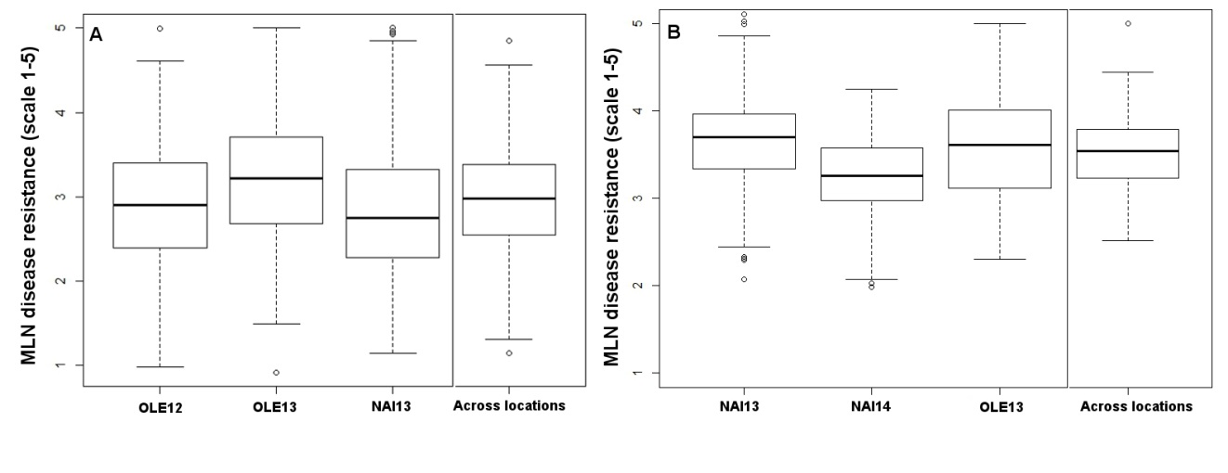
Supplementary Figure S1. Phenotypic distribution of MLND severity data at each and across MLND phenotyping environments in the IMAS (A) and DTMA (B) association mapping panels

Supplementary Table S1. Phenotypic correlations of the adjusted entry means of lines of three MLND phenotyping environments.

IMAS panel | Narok13 | Naivasha13
Narok12 | 0.53** | 0.35**
Narok13 |  | 0.39**
DTMA panel | Narok13 | Naivasha13
Naivasha14 | 0.34** | 0.50**
Narok13 |  | 0.35**
** indicates significance at P < 0.01

