Identification and reproducibility of diagnostic DNA markers for tuber starch and yield optimization in a novel association mapping population of potato (Solanum tuberosum L.)
E. M. Schönhals, F. Ortega, L. Barandalla, A. Aragones, J. I. Ruiz de Galarreta, J.-C. Liao, R. Sanetomo, B. Walkemeier, E. Tacke, E. Ritter, C. Gebhardt
Theoretical and Applied Genetics
Corresponding author: Christiane Gebhardt, Max-Planck Institute for Plant Breeding Research, Cologne, Germany (gebhardt@mpipz.mpg.de).

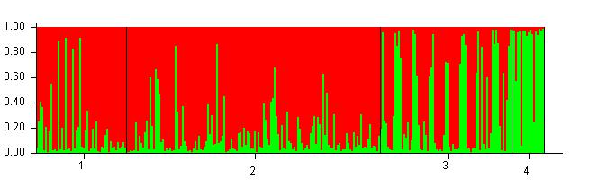

Online Resource 3: STRUCTURE graphical output of population structure for the QUEST population for subpopulations K=2. Barplot of inferred subpopulations K=2 are ordered according to genotype group: 1+2 = cultivars, 3 = breeding clones, 4 = landraces. Individual genotypes are plotted on the x-axis. The probability (Q-value) of each genotype belonging to subpopulation 1 (red) or 2 (green) is plotted on the y-axis.

