Appendix 1.

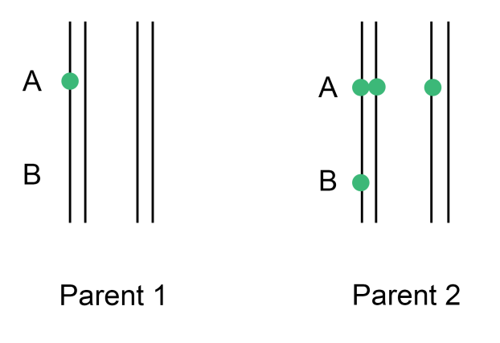
Example derivation of the maximum likelihood equations for a SxT with a NxS marker.
Figure I. Coupling pairing scenario 1

P1 gametes |  | P2 gametes
aa/bb | ½ | Aa/bb | ¼
Aa/bb | ½ | AA/bb | ¼
 |  | Aa/Bb | ¼
 |  | AA/Bb | ¼
F1 offspring
Aaaa/bbbb |  | 1/8
AAaa/bbbb |  | ¼
AAAa/bbbb |  | 1/8
Aaaa/Bbbb |  | 1/8
AAaa/Bbbb |  | ¼
AAAa/Bbbb |  | 1/8
Both coupling and repulsion phases are possible although we don’t initially know which is correct and therefore must calculate both. If the reference allele at locus B is physically linked to one of the three reference alleles at locus A (in parent 2) we term the phase “coupling”. Under a random bivalent model, there are two possible pairing scenarios we must consider. In scenario 1, the homologue carrying the reference alleles for locus A and B is paired with another homologue carrying the allele for locus A (Figure I), which occurs with probability 2/3. If the recombination frequency between locus A and B is r, we can derive the possible gametes from P1 and P2 and their probabilities (where a small letter indicates the alternative allele). Combining these gives the possible offspring genotypes for this situation.

P1 gametes |  | P2 gametes
aa/bb | ½ | Aa/bb | ½ (1-r)
Aa/bb | ½ | AA/bb | ½ r
 |  | Aa/Bb | ½ r
 |  | AA/Bb | ½ (1-r)
F1 offspring
Aaaa/bbbb |  | ¼ (1-r)
AAaa/bbbb |  | ¼
AAAa/bbbb |  | ¼ r
Aaaa/Bbbb |  | ¼ r
AAaa/Bbbb |  | ¼
AAAa/Bbbb |  | ¼ (1-r)
Scenario 2 pairing has probability 1/3 and is illustrated in Figure II. We again consider the possible gamete combinations and their probabilities (the probability of a non-recombinant is 1-r).
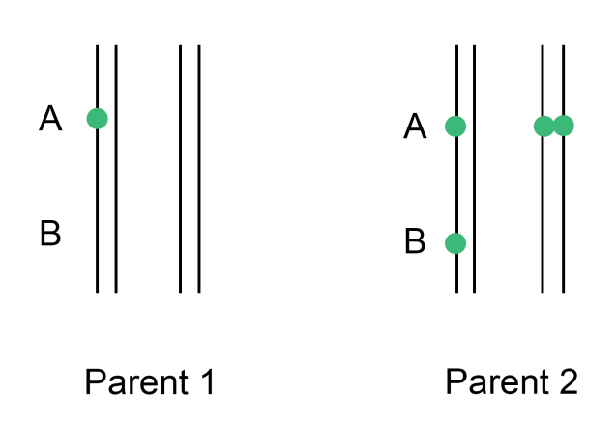
Figure II. Coupling pairing scenario 2

We now combine the probabilities from both pairing scenarios, scaled by their respective probabilities (2/3 and 1/3). These frequencies are then compared to the observed counts among the offspring in the six possible classes n₁₀ to n₃₁, where n₁₀ refers to a single copy of the SNP allele at locus A and no copies of the SNP at locus B (as dosage scores) etc.
F1 offspring
Aaaa/bbbb | 1/12 (2-r) | n₁₀
AAaa/bbbb | ¼ | n₂₀
AAAa/bbbb | 1/12 (1+r) | n₃₀
Aaaa/Bbbb | 1/12 (1+r) | n₁₁
AAaa/Bbbb | ¼ | n₂₁
AAAa/Bbbb | 1/12 (2-r) | n₃₁

The likelihood function follows; for details see e.g. (Van Ooijen and Jansen, 2013):
$$L\left(r\right)=MC{\left(\frac{1}{12}\left(2-r\right)\right)}^{n_{10}+n_{31}}{(\frac{1}{4})}^{n_{20}+n_{21}}{\left(\frac{1}{12}(1+r)\right)}^{n11+n30}$$
where MC refers to the multinomial coefficient, a constant which cancels in the subsequent calculations. The likelihood function (in fact, the log likelihood) is maximised to give the most likely estimate of r given the observed data ($\hat{r}$). This equation has an exact solution:
$$\hat{r}=\frac{2n_{11}-n_{10}-n_{31}+2n_{30}}{n_{10}+n_{11}+n_{30}+n_{31}}$$
In cases where neither marker has a SxN (or NxS) segregation type, the maximum likelihood equation cannot be solved analytically, and therefore a numerical maximisation method must be used (we used Brent’s algorithm (Brent, 1973)).
The LOD for linkage is defined as the log₁₀ of the likelihood ratio, i.e.
$$LOD=\log_{10}\left(\frac{L\left(\hat{r}\right)}{L\left(0.5\right)}\right)$$
The maximum likelihood framework for repulsion-phase follows a similar approach. To decide which phase is correct between the two markers, we select the phase for which the log likelihood is maximised (occasionally we select that for which r is minimised; see Results section “Optimal Phasing Strategy” for details.)

“Integrating haplotype-specific linkage maps in tetraploid species using SNP markers”, Theoretical and Applied Genetics, Peter M. Bourke, Roeland E. Voorrips, Twan Kranenburg, Johannes Jansen, Richard G. F. Visser, Chris Maliepaard. Wageningen UR Plant Breeding, Wageningen University and Research Centre, Droevendaalsesteeg 1, 6708 PB, Wageningen, The Netherlands. chris.maliepaard@wur.nl

