SUPPORTING INFORMATION

Table S1 The primers’ information of markers linked to resistance gene
Primers | motifs | Upstream primers | Downstream primers
Satt152 | (ATT)14 | GCGCTATTCCTATCACAACACA | TAGGGTTGTCACTGTTTTGTTCTTA
Satt631 | (ATT)21 | GGTAGATCCAGGAGCTTGAGTCAG | GCGCATCTCACTGCACTTGATTTT
Satt009 | (ATT)14 | CCAACTTGAAATTACTAGAGAAA | CTTACTAGCGTATTAACCCTT
Sat_084 | (AT)14 | AAAAAAGTATCCATGAAACAA | TTGGGACCTTAGAAGCTA
The sequences of DNA markers are from the website: http://www.soybase.org/
Table S2 Total numbers of SNPs per chromosome in parents and RILs population
Chromosome | Total numbers of homozygous SNPs  between parental lines | Total numbers of SNPs  in RILs population
Gm01 | 63662 | 5425
Gm02 | 38755 | 3280
Gm03 | 37388 | 4471
Gm04 | 57586 | 1108
Gm05 | 18522 | 1473
Gm06 | 39641 | 3697
Gm07 | 30220 | 2738
Gm08 | 30079 | 2517
Gm09 | 30345 | 2877
Gm10 | 10572 | 838
Gm11 | 41272 | 3704
Gm12 | 25833 | 2157
Gm13 | 31056 | 3438
Gm14 | 94719 | 8983
Gm15 | 51909 | 3871
Gm16 | 42470 | 5332
Gm17 | 63883 | 6446
Gm18 | 41644 | 3943
Gm19 | 22296 | 2267
Gm20 | 16030 | 1435
Total | 787882 | 70000

Table S3 The sequencing depth and coverage of the RILs
sample | coverage | depth（X） | sample | coverage | depth（X） | sample | coverage | depth（X）
CY-1 | 10.24% | 7.32 | CY-67 | 9.87% | 3.82 | CY-133 | 9.53% | 5.14
CY-2 | 10.48% | 4.77 | CY-68 | 11.34% | 7.77 | CY-134 | 9.97% | 6.46
CY-3 | 7.82% | 2.98 | CY-69 | 10.41% | 3.72 | CY-135 | 9.46% | 5.60
CY-4 | 10.64% | 7.40 | CY-70 | 10.76% | 6.28 | CY-136 | 9.14% | 4.48
CY-5 | 10.54% | 6.85 | CY-71 | 12.22% | 11.73 | CY-137 | 9.49% | 5.05
CY-6 | 10.01% | 6.80 | CY-72 | 11.72% | 9.73 | CY-138 | 9.40% | 5.12
CY-7 | 9.42% | 2.93 | CY-73 | 9.94% | 3.84 | CY-139 | 10.39% | 6.43
CY-8 | 11.20% | 6.14 | CY-74 | 8.14% | 2.83 | CY-140 | 9.28% | 5.15
CY-9 | 10.86% | 7.75 | CY-75 | 4.71% | 1.82 | CY-141 | 9.57% | 5.04
CY-10 | 9.39% | 5.28 | CY-76 | 10.01% | 3.54 | CY-142 | 9.69% | 4.40
CY-11 | 10.06% | 5.03 | CY-77 | 9.04% | 3.78 | CY-143 | 9.07% | 5.29
CY-12 | 7.74% | 3.24 | CY-78 | 10.02% | 4.01 | CY-144 | 10.77% | 9.15
CY-13 | 9.34% | 3.65 | CY-79 | 11.05% | 5.05 | CY-145 | 10.29% | 7.14
CY-14 | 9.55% | 5.52 | CY-80 | 9.52% | 3.84 | CY-146 | 9.49% | 3.65
CY-15 | 10.00% | 4.29 | CY-81 | 11.61% | 5.08 | CY-147 | 7.80% | 2.85
CY-16 | 7.79% | 3.18 | CY-82 | 8.92% | 3.57 | CY-148 | 4.95% | 1.89
CY-17 | 8.08% | 3.54 | CY-83 | 9.88% | 4.04 | CY-149 | 9.70% | 4.58
CY-18 | 10.30% | 4.19 | CY-84 | 7.19% | 2.51 | CY-150 | 9.52% | 4.10
CY-19 | 8.73% | 2.61 | CY-85 | 7.77% | 3.00 | CY-151 | 8.82% | 3.70
CY-20 | 9.10% | 4.58 | CY-86 | 10.42% | 5.47 | CY-152 | 11.24% | 5.65
CY-21 | 9.20% | 5.20 | CY-87 | 10.42% | 5.65 | CY-153 | 8.65% | 3.59
CY-22 | 10.35% | 4.61 | CY-88 | 8.69% | 3.03 | CY-154 | 10.16% | 3.94
CY-23 | 11.11% | 9.98 | CY-89 | 9.83% | 4.71 | CY-155 | 8.51% | 3.23
CY-24 | 10.92% | 7.31 | CY-90 | 10.24% | 3.97 | CY-156 | 9.92% | 4.62
CY-25 | 10.96% | 9.77 | CY-91 | 11.64% | 8.68 | CY-157 | 6.33% | 2.13
CY-26 | 9.36% | 5.04 | CY-92 | 10.84% | 5.78 | CY-158 | 10.29% | 3.32
CY-27 | 8.52% | 4.42 | CY-93 | 12.07% | 4.37 | CY-159 | 10.51% | 5.53
CY-28 | 12.34% | 6.76 | CY-94 | 10.59% | 5.54 | CY-160 | 10.84% | 5.09
CY-29 | 10.74% | 9.13 | CY-95 | 12.42% | 7.03 | CY-161 | 7.67% | 2.27
CY-30 | 10.56% | 8.90 | CY-96 | 11.87% | 6.90 | CY-162 | 10.76% | 3.69
CY-31 | 9.99% | 7.81 | CY-97 | 9.82% | 4.15 | CY-163 | 7.77% | 3.09
CY-32 | 11.41% | 5.73 | CY-98 | 8.65% | 3.45 | CY-164 | 8.47% | 2.69
CY-33 | 12.11% | 7.01 | CY-99 | 5.42% | 2.24 | CY-165 | 9.50% | 4.51
CY-34 | 11.65% | 5.95 | CY-100 | 9.80% | 4.35 | CY-166 | 10.83% | 4.87
CY-35 | 11.07% | 8.29 | CY-101 | 9.62% | 3.29 | CY-167 | 9.86% | 4.16
CY-36 | 8.21% | 3.52 | CY-102 | 9.83% | 3.15 | CY-168 | 10.68% | 5.78
CY-37 | 9.23% | 4.48 | CY-103 | 9.73% | 5.08 | CY-169 | 10.47% | 5.48
CY-38 | 10.77% | 9.68 | CY-104 | 6.85% | 2.50 | CY-170 | 8.48% | 3.44
CY-39 | 10.41% | 7.83 | CY-105 | 10.70% | 4.67 | CY-171 | 7.39% | 2.62
CY-40 | 7.58% | 2.89 | CY-106 | 9.52% | 4.35 | CY-172 | 5.31% | 2.22
CY-41 | 11.33% | 6.80 | CY-107 | 10.61% | 5.02 | CY-173 | 8.86% | 3.17
CY-42 | 6.14% | 2.58 | CY-108 | 6.02% | 2.15 | CY-174 | 8.69% | 4.10
CY-43 | 9.21% | 3.30 | CY-109 | 8.35% | 3.21 | CY-175 | 8.01% | 4.15
CY-44 | 9.78% | 4.33 | CY-110 | 10.77% | 5.86 | CY-176 | 0.30% | 0.01
CY-45 | 10.01% | 4.65 | CY-111 | 10.54% | 5.42 | CY-177 | 8.43% | 3.18
CY-46 | 3.42% | 1.62 | CY-112 | 8.06% | 3.30 | CY-178 | 10.08% | 5.91
CY-47 | 11.13% | 4.77 | CY-113 | 9.94% | 4.58 | CY-179 | 8.58% | 4.43
CY-48 | 9.36% | 4.83 | CY-114 | 8.46% | 3.46 | CY-180 | 8.36% | 4.74
CY-49 | 9.75% | 5.13 | CY-115 | 10.06% | 7.55 | CY-181 | 6.56% | 2.42
CY-50 | 7.00% | 2.30 | CY-116 | 9.85% | 4.66 | CY-182 | 7.93% | 4.00
CY-51 | 6.38% | 2.39 | CY-117 | 9.82% | 6.63 | CY-183 | 8.98% | 5.53
CY-52 | 10.82% | 6.72 | CY-118 | 10.05% | 4.75 | CY-184 | 9.34% | 6.50
CY-53 | 10.98% | 7.47 | CY-119 | 11.75% | 7.37 | CY-185 | 8.65% | 4.61
CY-54 | 9.64% | 4.26 | CY-120 | 11.25% | 4.68 | CY-186 | 8.50% | 4.41
CY-55 | 10.27% | 3.90 | CY-121 | 9.60% | 4.81 | CY-187 | 7.80% | 3.77
CY-56 | 11.25% | 7.25 | CY-122 | 8.99% | 4.64 | CY-188 | 9.14% | 4.21
CY-57 | 10.51% | 6.56 | CY-123 | 5.00% | 1.99 | CY-189 | 9.76% | 5.67
CY-58 | 8.13% | 3.05 | CY-124 | 9.33% | 4.98 | CY-190 | 8.26% | 3.89
CY-59 | 10.41% | 4.78 | CY-125 | 8.25% | 3.65 | CY-191 | 9.50% | 6.41
CY-60 | 8.60% | 3.32 | CY-126 | 9.10% | 4.79 | CY-192 | 10.47% | 7.52
CY-61 | 9.40% | 4.32 | CY-127 | 10.46% | 6.03 | CY-193 | 11.32% | 8.91
CY-62 | 12.00% | 7.78 | CY-128 | 8.52% | 3.95 | CY-194 | 11.01% | 7.35
CY-63 | 11.49% | 7.40 | CY-129 | 9.82% | 6.02 | CY-195 | 5.97% | 2.19
CY-64 | 11.58% | 6.21 | CY-130 | 7.93% | 3.50 | CY-196 | 7.38% | 3.32
CY-65 | 11.46% | 8.60 | CY-131 | 9.20% | 4.89
CY-66 | 10.17% | 5.02 | CY-132 | 5.57% | 2.27

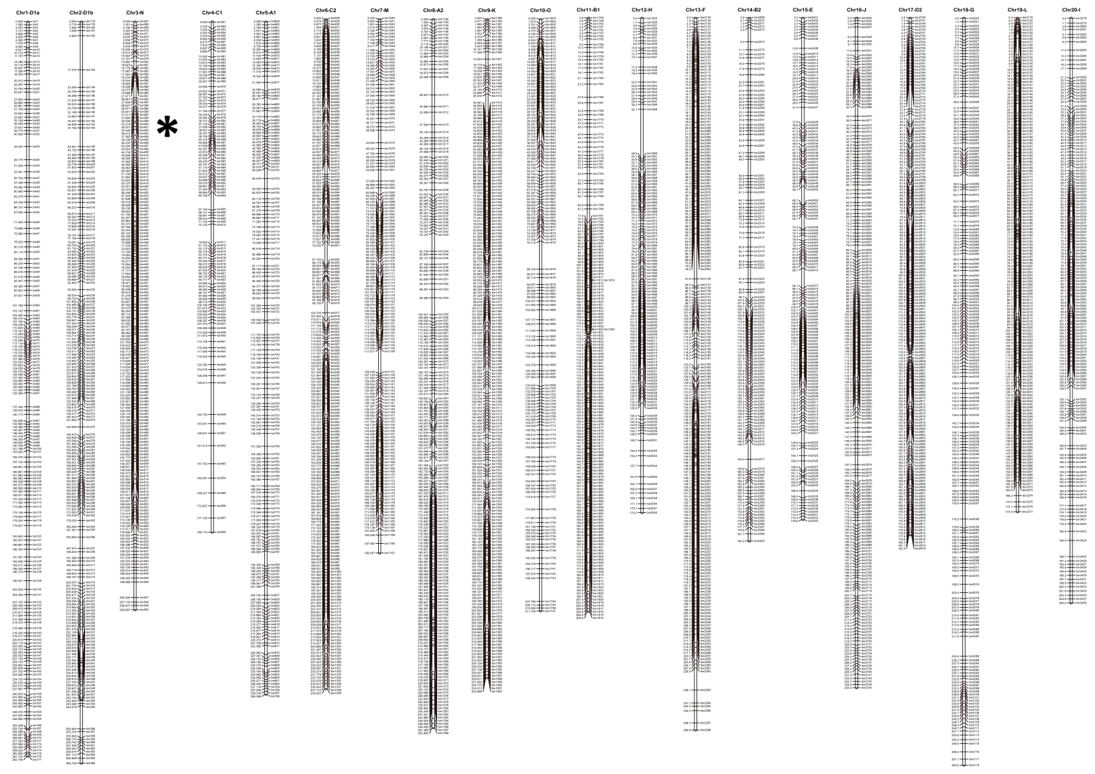
Figure S1 Genetic map of soybean chromosomes
The asterisk indicates the location of bin401.

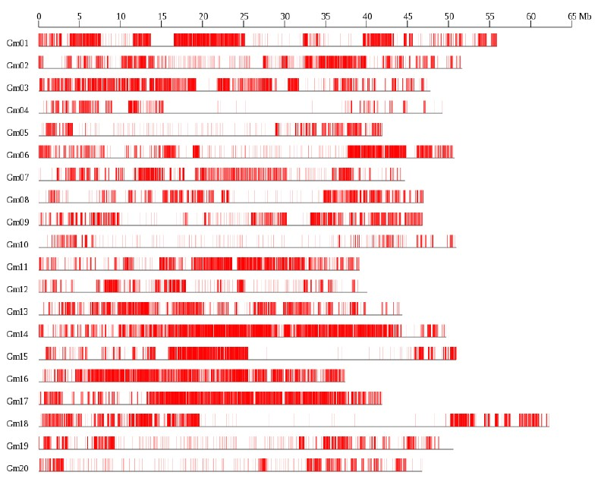

Figure S2 SNP distribution on the 20 soybean chromosomes
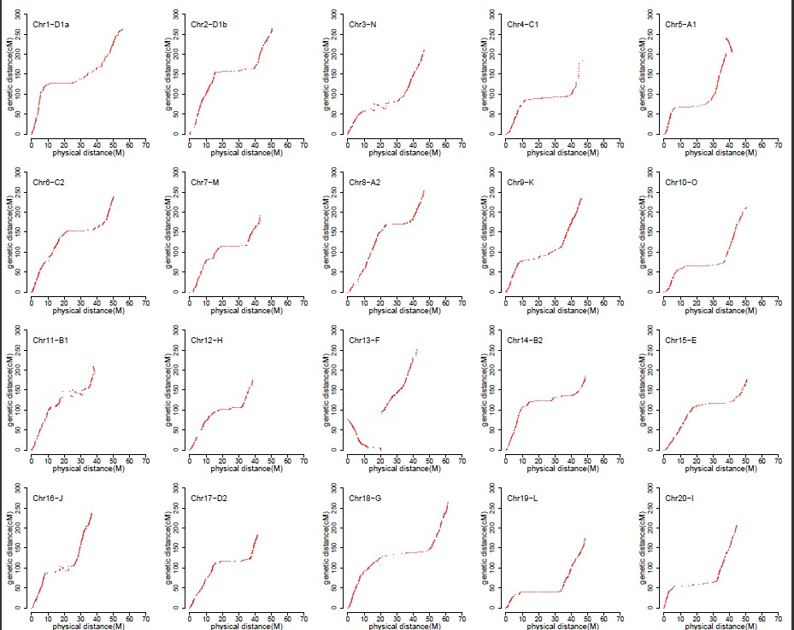

Figure S3 The linear analysis of genetic map and physical map
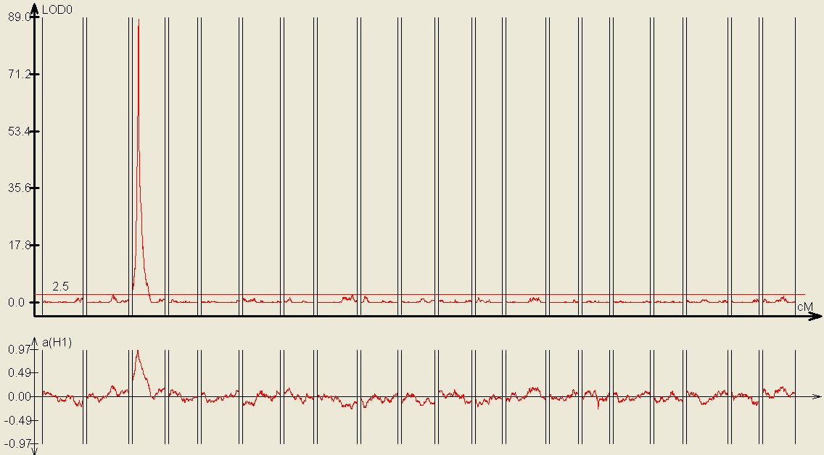

Figure S4 Gene mapping of the race resistant to P. sojae Pm14
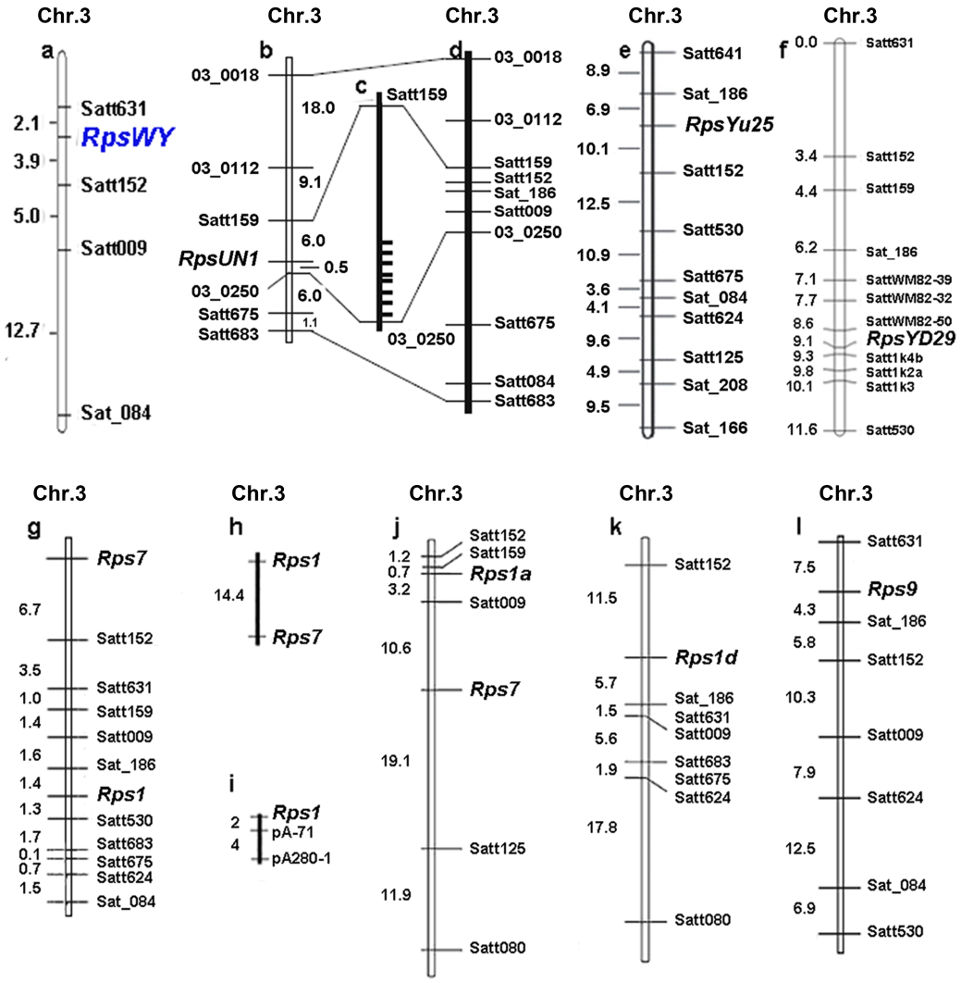
Figure S5 Genetic and physical map of RpsWY and linked Rps genes on chromosome 3
a Genetic linkage map of RpsWY from this study. b Linkage map of RpsUN1 reported by Lin et al (2013). c Distribution of annotated NBS-LRR genes within mapped region of RpsUN1(Lin et al. 2013). Each bar represents the position of a NBS-LRR gene (Lin et al. 2013). d Physical position of SSR markers on chromosome 3 reported by Song et al(2010). e Linkage map of RpsYu25 reported by Sun et al (2011). f Linkage map of RpsYD29 reported by zhang et al (2013a). g Composite genetic map of Rps1 and Rps7 region reported by Cregan (2003). h Linkage map of Rps1 and Rps7 reported by Anderson and Buzzell (1992). i Linkage map of Rps1 reported by Diers (1992). j Linkage map of Rps1a and Rps7 reported by Weng et al (2001). k Linkage map of Rps1d reported by Sugimoto et al (2008). l Linkage map of Rps9 reported by Wu et al(2011a). Marker names and genetic distances (cM) are on the left and right, respectively. Chr.3: chromosome 3.

