Figure S1: Population structure of 215 spring barley accessions based on 6355 SNPs information (Alqudah et al. 2014). 92 accessions showing photoperiod sensitive (Ppd-H1) and 123 accessions with reduced photoperiod sensitivity (ppd-H1).

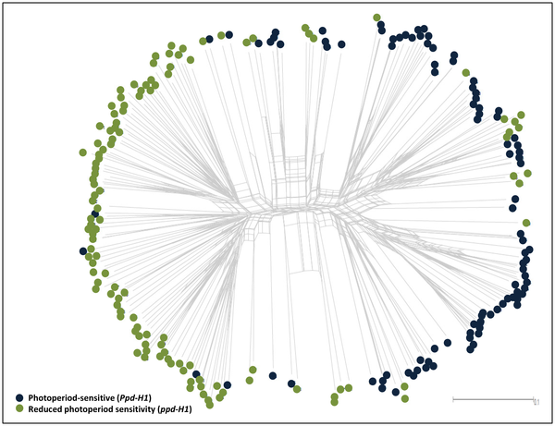

Figure S2: Correlation analysis between leaf blade area and leaf number per the main culm in both photoperiod group across all developmental stages. n = 92 accessions of photoperiod sensitive (Ppd-H1) and 123 for reduced photoperiod sensitivity (ppd-H1).

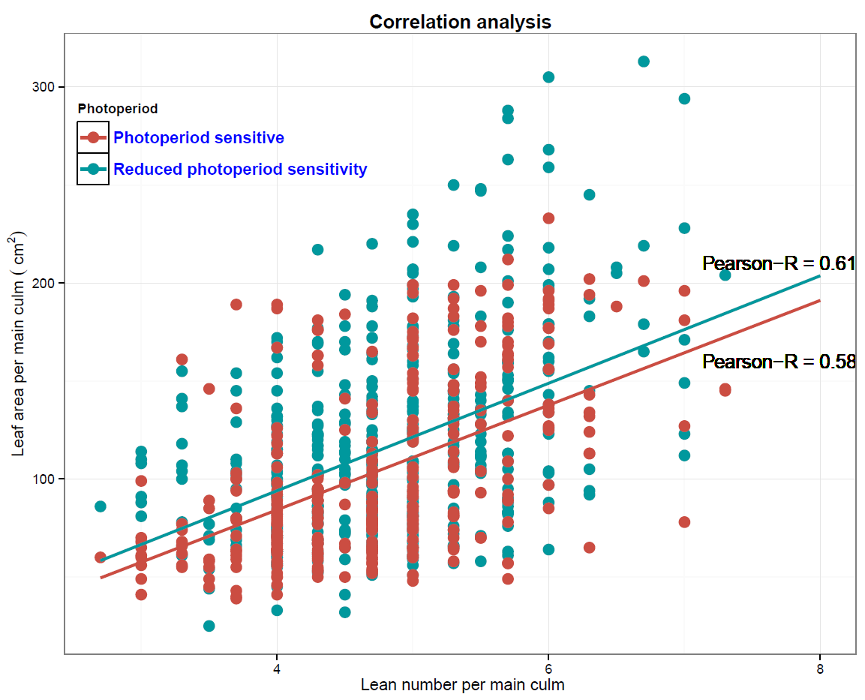

Figure S3: Leaf blade area per the main culm at different developmental stages for a) reduced photoperiod sensitivity (ppd-H) and b) photoperiod-sensitive (Ppd-H1) from different origins. Leaf area from sowing to the beginning of awn primordium, tipping, heading and anther extrusion stages. Number of Ppd-H1-carrying accessions for WANA = 34, EU = 13, EA = 28 and AM = 17. Number of accessions with reduced photoperiod sensitivity (ppd-H1) for WANA = 11, EU = 92, EA = 8 and AM = 11. Asterisk denotes leaf area significantly different at P ≤ 0.05 according to LSD between geographical regions within the same photoperiod group. The degree of significance indicated as *P, 0.05; **P, 0.01; ***P, 0.001.

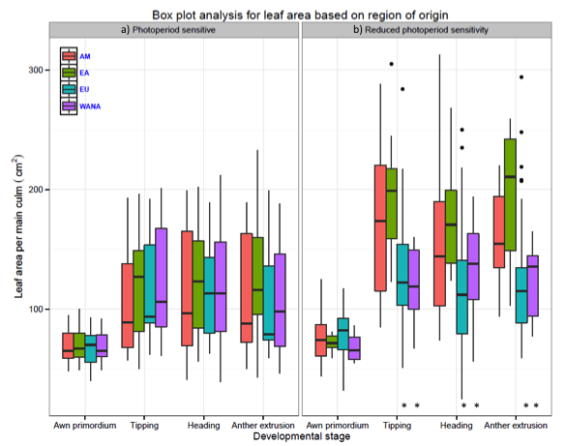

Figure S4: Leaf number per the main culm at different developmental stages of 215 spring barley accessions from different geographical origins at the same developmental stage. Asterisk denotes leaf area significantly different at P ≤ 0.05 according to LSD between geographical regions. The degree of significance indicated as *P, 0.05; **P, 0.01; ***P, 0.001. (n = 92 and 123 for Ppd-H1 and ppd-H1 barleys, respectively).
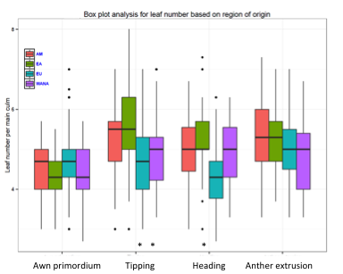

Figure S5: Principal component analysis (PCA) of 215 spring barley accessions of leaf area at tipping stage using 6355 SNPs. (n=92 spring barley accessions with photoperiod-sensitive (Ppd-H1) and n=123 accessions with reduced photoperiod sensitivity (ppd-H1)).

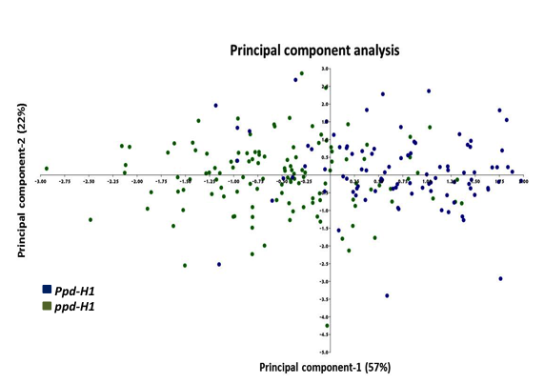

Figure S6: Manhattan plots of association findings. The figures summarize GWAS obtained leaf blade area at different stages in a) photoperiod-sensitive (Ppd-H1) and b) reduced photoperiod sensitivity (ppd-H1) barley accessions using the iSELECT 9K SNP chip. The yellow line marks the false discovery rate (FDR) threshold, and SNPs in loci exceeding this threshold are considered as significantly associated. (n=92 spring barley accessions with photoperiod-sensitive (Ppd-H1) and n=123 accessions with reduced photoperiod sensitivity (ppd-H1)).

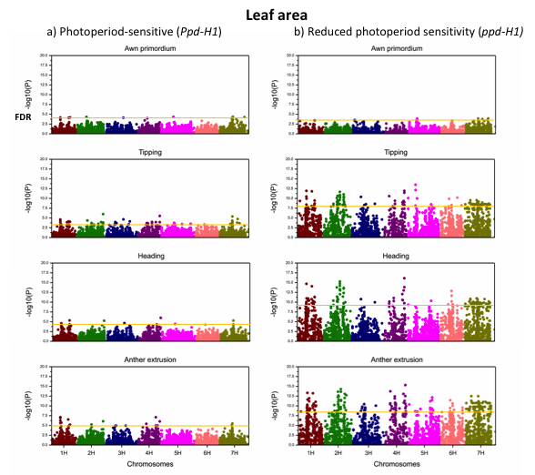

Table S1: Collection information based on origin and photoperiod-sensitivity of spring barleys accessions.
Accession no. | Photoperiodic status | Region of origin | Country of origin | AP-Leaf area | Tip-Leaf area | Head-Leaf area | AnthExt-leaf area
BCC003 | Sensitive | WANA | AFG | 53 | 93 | 77 | 91
BCC093 | Sensitive | WANA | IRQ | 49 | 61 | 39 | 55
BCC118 | Sensitive | WANA | LBY | 60 | 91 | 113 | 134
BCC126 | Sensitive | WANA | MAR | 64 | 106 | 109 | 130
BCC129 | Sensitive | WANA | MAR | 80 | 170 | 152 | 167
BCC131 | Sensitive | WANA | MAR | 62 | 109 | 122 | 125
BCC1368 | Sensitive | EU | NLD | 53 | 94 | 80 | 74
BCC1370 | Insensitive | EU | FRA | 86 | 151 | 25 | 39
BCC1371 | Sensitive | EU | FRA | 66 | * | 143 | 79
BCC1372 | Insensitive | EU | POL | 74 | 122 | 41 | *
BCC1373 | Insensitive | EU | GBR | 90 | 145 | 140 | 110
BCC1374 | Insensitive | EU | NLD | 61 | 135 | 162 | 47
BCC1376 | Insensitive | EU | DNK | 81 | * | * | *
BCC1377 | Insensitive | EU | FRA | 103 | 181 | 140 | 136
BCC1378 | Insensitive | EU | GBR | 67 | 122 | 103 | 89
BCC1379 | Insensitive | EU | CZE | 103 | 117 | 97 | 100
BCC1380 | Insensitive | EU | FRA | 61 | 89 | 126 | 99
BCC1381 | Insensitive | EU | GBR | 69 | 121 | 77 | *
BCC1382 | Insensitive | EU | GBR | 73 | 119 | * | *
BCC1383 | Insensitive | EU | GBR | 78 | 104 | 148 | 105
BCC1384 | Insensitive | EU | DEU | 98 | 71 | 33 | *
BCC1385 | Insensitive | EU | POL | 75 | 117 | 118 | 60
BCC1386 | Insensitive | EU | DEU | 74 | 170 | 69 | *
BCC1387 | Insensitive | EU | NLD | 74 | 164 | 133 | 115
BCC1389 | Insensitive | EU | IRL | 105 | 159 | 119 | 112
BCC1390 | Insensitive | EU | SWE | 97 | 113 | 74 | 44
BCC1391 | Insensitive | EU | DEU | 104 | 99 | 54 | *
BCC1392 | Insensitive | EU | DNK | 83 | 97 | 143 | 77
BCC1394 | Sensitive | EU | NLD | 86 | 179 | 141 | 114
BCC1395 | Insensitive | EU | NLD | 71 | 131 | 138 | 88
BCC1396 | Insensitive | EU | SWE | 71 | 105 | 60 | *
BCC1397 | Insensitive | EU | HUN | 60 | 80 | 104 | 116
BCC1398 | Insensitive | EU | HUN | 74 | 110 | 100 | 105
BCC1399 | Insensitive | EU | SWE | 66 | 104 | 112 | 52
BCC1400 | Insensitive | EU | FRA | 117 | 178 | 129 | 93
BCC1401 | Insensitive | EU | DEU | 89 | 94 | 114 | 109
BCC1402 | Insensitive | EU | SWE | 108 | 110 | 57 | *
BCC1403 | Insensitive | EU | DEU | 65 | 155 | 169 | 61
BCC1405 | Insensitive | EU | GBR | 85 | 71 | 63 | *
BCC1407 | Insensitive | EU | AUT | 92 | 138 | 100 | 81
BCC1408 | Insensitive | EU | GBR | 92 | 107 | 127 | 92
BCC1409 | Insensitive | EU | AUT | 109 | 126 | 108 | 71
BCC1410 | Insensitive | EU | SWE | 81 | 79 | 86 | 62
BCC1411 | Insensitive | EU | DEU | 80 | 94 | 74 | 130
BCC1412 | Insensitive | EU | SWE | 90 | 81 | 77 | 97
BCC1413 | Insensitive | EU | DEU | 53 | 86 | 74 | 65
BCC1414 | Insensitive | EU | CZE | 109 | 109 | 102 | 75
BCC1415 | Insensitive | EU | GBR | 99 | 123 | 91 | 92
BCC1416 | Insensitive | EU | SWE | 97 | 113 | 90 | 93
BCC1417 | Insensitive | EU | DEU | 90 | 75 | * | *
BCC1418 | Insensitive | EU | DNK | 92 | 190 | 142 | 67
BCC1419 | Insensitive | EU | DEU | 86 | 81 | 70 | 52
BCC1420 | Insensitive | EU | NLD | 77 | 67 | 73 | 66
BCC1421 | Insensitive | EU | CZE | 99 | 205 | 72 | 58
BCC1422 | Insensitive | EU | NLD | 66 | 128 | 86 | 86
BCC1423 | Insensitive | EU | FRA | 61 | 154 | 107 | 70
BCC1424 | Insensitive | EU | DEU | 82 | 119 | 102 | 95
BCC1425 | Insensitive | EU | DEU | 95 | 85 | 78 | 50
BCC1428 | Insensitive | EU | GBR | * | 103 | * | *
BCC1430 | Insensitive | EU | FRA | 108 | 151 | 125 | 55
BCC1431 | Insensitive | EU | AUT | 73 | 64 | 66 | 44
BCC1432 | Insensitive | EU | CZE | 71 | 160 | 113 | 85
BCC1433 | Insensitive | EU | DEU | 93 | 103 | 115 | 108
BCC1439 | Insensitive | EU | CZE | 82 | 100 | 99 | 113
BCC1440 | Insensitive | EU | AUT | 99 | 126 | 110 | 117
BCC1441 | Insensitive | EU | DEU | 84 | 105 | 66 | 103
BCC1442 | Insensitive | EU | GBR | 65 | 201 | 147 | 80
BCC1443 | Insensitive | EU | DEU | 100 | 123 | 102 | 99
BCC1444 | Insensitive | EU | CZE | 112 | 162 | 61 | 51
BCC1445 | Insensitive | EU | FRA | 90 | 153 | 155 | 102
BCC1447 | Insensitive | EU | FRA | 108 | 166 | 137 | 95
BCC1448 | Insensitive | EU | FIN | 83 | 170 | 177 | 158
BCC1450 | Insensitive | EU | FIN | 68 | * | * | *
BCC1452 | Insensitive | EU | NLD | 88 | 126 | 235 | 187
BCC1453 | Insensitive | EU | FIN | 83 | 197 | 178 | 228
BCC1455 | Insensitive | EU | RUS | 63 | 217 | 217 | 199
BCC1456 | Insensitive | EU | RUS | 82 | 130 | 133 | 75
BCC1457 | Sensitive | EU | RUS | 57 | 77 | 113 | 77
BCC1458 | Insensitive | EU | RUS | 88 | 115 | 87 | 43
BCC1459 | Sensitive | EU | RUS | 55 | 68 | 77 | 63
BCC1461 | Insensitive | EU | RUS | 71 | 137 | 170 | 135
BCC1463 | Insensitive | EU | RUS | 63 | 179 | 112 | 104
BCC1465 | Insensitive | EU | UKR | 97 | 115 | 120 | 126
BCC1466 | Insensitive | EU | UKR | 52 | 91 | 123 | 92
BCC1467 | Insensitive | EU | BLR | 62 | * | * | *
BCC1468 | Insensitive | WANA | KAZ | 69 | 145 | 166 | 125
BCC1469 | Insensitive | WANA | KAZ | 86 | * | * | *
BCC1470 | Sensitive | WANA | UZB | 40 | 62 | 63 | 59
BCC1471 | Insensitive | EU | ARM | 51 | 76 | 83 | 91
BCC1472 | Insensitive | EU | LTU | 58 | 127 | 158 | 129
BCC1474 | Sensitive | EU | UKR | 61 | 145 | 205 | 249
BCC1476 | Sensitive | WANA | UZB | 54 | 93 | 64 | 60
BCC1479 | Insensitive | EU | RUS | 86 | 164 | 207 | 188
BCC1480 | Insensitive | EU | RUS | 63 | 155 | 137 | 150
BCC1481 | Insensitive | EU | RUS | 97 | 132 | 88 | 107
BCC1482 | Insensitive | EU | RUS | 58 | 104 | 133 | 85
BCC1483 | Insensitive | EU | RUS | 57 | 123 | 169 | 136
BCC1484 | Insensitive | EU | RUS | 83 | 135 | 188 | 163
BCC1485 | Sensitive | EU | RUS | 60 | 89 | 113 | 146
BCC1487 | Insensitive | EU | RUS | 92 | 114 | 167 | *
BCC1488 | Insensitive | EU | RUS | 95 | 284 | 250 | 274
BCC149 | Sensitive | WANA | MAR | 77 | 201 | 196 | 170
BCC1490 | Insensitive | EU | RUS | 32 | 63 | 61 | 62
BCC1493 | Insensitive | EU | UKR | 66 | 199 | 178 | 172
BCC1494 | Sensitive | WANA | KAZ | 65 | 182 | 206 | 249
BCC1497 | Sensitive | WANA | KGZ | 74 | 98 | 101 | 122
BCC1498 | Sensitive | WANA | UZB | 61 | 62 | 64 | 68
BCC1500 | Sensitive | WANA | TJK | 65 | 91 | 172 | 163
BCC1503 | Sensitive | WANA | TKM | 76 | 161 | 163 | *
BCC1504 | Insensitive | EU | RUS | 65 | 107 | 145 | 152
BCC1505 | Sensitive | EU | UKR | 86 | 151 | 138 | 136
BCC1506 | Insensitive | EU | UKR | 45 | 132 | 108 | 63
BCC1524 | Insensitive | EU | DEU | 56 | 119 | 140 | 108
BCC1529 | Insensitive | EU | AUT | 61 | * | * | *
BCC1541 | Sensitive | EU | YUG | 70 | 92 | 102 | 94
BCC1561 | Sensitive | EU | BGR | 71 | 209 | 217 | 236
BCC1565 | Sensitive | EU | ALB | 65 | 126 | 113 | 106
BCC1566 | Insensitive | EU | GRC | 65 | 172 | 218 | *
BCC1589 | Insensitive | EU | ITA | 73 | 51 | 76 | *
BCC161 | Sensitive | WANA | MAR | 89 | 84 | 136 | 94
BCC167 | Sensitive | WANA | OMN | 81 | 94 | 79 | 65
BCC173 | Sensitive | WANA | PAK | 64 | 213 | 224 | 216
BCC182 | Sensitive | WANA | PAK | 89 | 168 | 94 | 84
BCC190 | Sensitive | WANA | SYR | 58 | 128 | 119 | 77
BCC192 | Sensitive | WANA | SYR | 89 | 177 | 229 | *
BCC195 | Sensitive | WANA | SYR | 69 | 74 | 121 | 64
BCC197 | Sensitive | WANA | SYR | 55 | 184 | 141 | 70
BCC218 | Sensitive | WANA | TJK | 92 | 165 | 212 | 188
BCC219 | Sensitive | WANA | TJK | 103 | 209 | 178 | 98
BCC421 | Sensitive | EA | CHN | 49 | 105 | 135 | 102
BCC423 | Sensitive | EA | CHN | 100 | * | * | *
BCC427 | Sensitive | EA | CHN | 52 | 50 | 56 | 43
BCC432 | Insensitive | EA | CHN | 69 | 123 | 124 | *
BCC434 | Sensitive | EA | CHN | 83 | 145 | 103 | 84
BCC436 | Insensitive | EA | CHN | 68 | 208 | 133 | 83
BCC438 | Sensitive | EA | CHN | 67 | 78 | 84 | 100
BCC439 | Sensitive | EA | CHN | 67 | 205 | 177 | 175
BCC445 | Insensitive | EA | CHN | 68 | 205 | 224 | 239
BCC446 | Insensitive | EA | CHN | 74 | 193 | 191 | 173
BCC447 | Insensitive | EA | CHN | 77 | 305 | 268 | 227
BCC502 | Sensitive | EA | CHN | 58 | 56 | 101 | 66
BCC524 | Sensitive | EA | IND | 54 | 113 | 124 | 104
BCC526 | Sensitive | EA | IND | 79 | 132 | 123 | 119
BCC532 | Sensitive | EA | IND | 70 | 85 | 78 | 81
BCC533 | Sensitive | EA | IND | 64 | 60 | 74 | 79
BCC535 | Sensitive | EA | IND | 52 | 80 | 83 | 118
BCC538 | Sensitive | EA | IND | 59 | 94 | 75 | 95
BCC551 | Sensitive | EA | IND | 103 | 99 | 207 | *
BCC577 | Sensitive | EA | IND | * | 182 | 164 | 149
BCC579 | Sensitive | EA | IND | 85 | 149 | 120 | 126
BCC581 | Sensitive | EA | IND | 98 | 163 | 146 | 192
BCC625 | Sensitive | EA | JPN | 63 | 146 | 110 | 109
BCC642 | Sensitive | EA | JPN | 93 | 81 | 100 | 97
BCC666 | Sensitive | EA | KOR | 66 | 127 | 123 | 140
BCC667 | Sensitive | EA | KOR | 62 | 128 | 157 | 114
BCC675 | Insensitive | EA | KOR | 59 | 160 | 168 | *
BCC695 | Sensitive | EA | KOR | 68 | 187 | 199 | 234
BCC718 | Insensitive | EA | KOR | 79 | 245 | 173 | 208
BCC719 | Sensitive | EA | KOR | 60 | 183 | 195 | 216
BCC732 | Sensitive | EA | NPL | * | 181 | 262 | 233
BCC759 | Sensitive | EA | NPL | 80 | 213 | 202 | 161
BCC761 | Sensitive | EA | NPL | 115 | 234 | 242 | 163
BCC766 | Sensitive | EA | NPL | 85 | 309 | 254 | 191
BCC768 | Sensitive | EA | NPL | 103 | 196 | 196 | 156
BCC776 | Insensitive | EA | NPL | 81 | 156 | 140 | 114
BCC801 | Insensitive | AM | CAN | 72 | 119 | 103 | 74
BCC806 | Sensitive | AM | MEX | 59 | * | * | *
BCC807 | Sensitive | AM | URY | 95 | 224 | 194 | 169
BCC812 | Sensitive | AM | MEX | 48 | 58 | 68 | 50
BCC814 | Sensitive | AM | USA | 69 | 147 | 134 | 88
BCC817 | Sensitive | AM | USA | 49 | 57 | 50 | 70
BCC818 | Sensitive | AM | USA | 103 | 205 | 240 | 187
BCC844 | Sensitive | AM | COL | 70 | 134 | 171 | 180
BCC846 | Sensitive | AM | USA | 93 | 138 | 131 | 145
BCC847 | Sensitive | AM | USA | 59 | 96 | 88 | 88
BCC852 | Insensitive | AM | CAN | 125 | 288 | 313 | 159
BCC857 | Insensitive | AM | MEX | 63 | 85 | 102 | 128
BCC860 | Sensitive | AM | URY | 65 | 68 | 70 | 56
BCC861 | Sensitive | AM | URY | 50 | 57 | 41 | 51
BCC868 | Insensitive | AM | MEX | 44 | 176 | 150 | 141
BCC869 | Insensitive | AM | MEX | 60 | 104 | 107 | 114
BCC875 | Insensitive | AM | USA | 60 | 221 | 197 | 179
BCC881 | Insensitive | AM | CAN | * | 263 | 230 | 200
BCC888 | Insensitive | AM | CAN | 83 | 219 | 183 | 184
BCC892 | Sensitive | AM | BOL | 64 | * | 41 | *
BCC899 | Sensitive | AM | USA | 76 | 114 | 74 | *
BCC900 | Insensitive | AM | CHL | 88 | * | 91 | 103
BCC907 | Sensitive | AM | USA | 55 | 75 | 105 | 86
BCC913 | Sensitive | AM | USA | 62 | 82 | 84 | 79
BCC921 | Sensitive | AM | COL | 79 | 89 | 87 | *
BCC927 | Sensitive | AM | PER | 87 | 193 | 163 | 189
BCC929 | Insensitive | AM | CAN | 88 | 171 | 144 | 116
BCC942 | Sensitive | AM | USA | 80 | 208 | 199 | 236
HOR11370 | Insensitive | WANA | ISR | 57 | 141 | 130 | 123
HOR11371 | Insensitive | WANA | ISR | 63 | 119 | 138 | 125
HOR11372 | Insensitive | WANA | ISR | 81 | 154 | 177 | 123
HOR11373 | Insensitive | WANA | ISR | 65 | 99 | 160 | *
HOR11374 | Insensitive | WANA | ISR | 78 | 160 | 131 | 145
HOR11403 | Sensitive | EA | IND | 82 | 127 | 81 | 67
HOR12830 | Sensitive | WANA | SYR | 80 | 209 | 203 | 215
HOR1391 | Sensitive | EU | ROM | 93 | 192 | 189 | 176
HOR1804 | Sensitive | WANA | AFG | 103 | 176 | 158 | 125
HOR1842 | Sensitive | WANA | AFG | 65 | 253 | 181 | 154
HOR1962 | Sensitive | na | na | 106 | 231 | 268 | 199
HOR2800 | Sensitive | WANA | IRN | 71 | 78 | 65 | 69
HOR2828 | Insensitive | WANA | IRN | 55 | 107 | 86 | 69
HOR2829 | Insensitive | WANA | IRN | 58 | 67 | 56 | 65
HOR2835 | Insensitive | WANA | IRN | 76 | 154 | 194 | 108
HOR4727 | Sensitive | WANA | TUR | 92 | 187 | 189 | 167
HOR7985 | Sensitive | WANA | TUR | 57 | 71 | 100 | 77
HOR8006 | Sensitive | WANA | TUR | 67 | 64 | 45 | 46
HOR8050 | Insensitive | WANA | TUR | 66 | 101 | 76 | 89
HOR8113 | Sensitive | WANA | TUR | 64 | 78 | 83 | 89
HOR8160 | Insensitive | WANA | TUR | 56 | 82 | 139 | 57
HOR930 | Sensitive | WANA | TUR | 73 | 106 | 156 | 148

Table S2: GenBank accession number for known leaf development, heading time and plant stature candidate genes with their POPSEQ genetic position.
Chr. | Gene | GenBank accession number | Reference | cM (POP SEQ) | Contig identifier
1H | HvCMF10 | JQ791225 | (Cockram et al., 2012) | 47.82 | morex_contig_53826 CAJW010053826
1H | HEXOKINASE 1 (HvHXK1),  SOLUBLE STARCH SYNTHASE (HvSSIIIa) | HM037127.1  FN179377.1 | (Cho et al., 2006),  (Radchuk et al., 2009) | 48.08 | morex_contig_42192 CAJW010042192,  morex_contig_41334 CAJW010041334
1H | HEXOSE  TRANSPORTATION1, 2/SUGAR TRANSPORTER (HvSTP1,2/HvSuT4) | AJ534445.1  AJ534446 | (Weschke et al., 2003) | 49.85 | morex_contig_38718 CAJW010038718
1H | GIBBERELLIN INSENSITIVE DWARF1 (HvGID1) | AK074026 | http://rice.plantbiology.msu.edu/cgi-bin/ORF_infopage.cgi?orf=LOC_Os05g33730.1 | 55.52 | morex_contig_137029 CAJW010137029
1H | GIBBERELLIN 20 OXIDASE 2/ SEMIDWARF 1 (HvGA20ox2/HvSD1) | CT834906 | (Yang et al., 2009) (Sakamoto et al., 2004) | 59.13 | morex_contig_244138 CAJW010244138
1H | HvCO9/HvCMF11 | AY082965 | (Griffiths et al., 2003;Comadran et al., 2012) | ~60 | morex_contig_67944 CAJW010067944
1H | HvCMF5 | JQ791219 | (Cockram et al., 2012) | 81.72 | morex_contig_79857 CAJW010079857
1H | HEXOKINASE 5 (HvHXK5) | HM037131.1 | (Mangelsen et al., 2011) | 90.43 | morex_contig_38242 CAJW010038242
1H | Ppd-H2/HvFT3 | HM133570.1 | (Casao et al., 2011) | 92.35 | morex_contig_2551337 CAJW012551337
1H | GIBBERELLIN 20 OXIDASE 4 (HvGA2ox4) | AY551432.1 | (Spielmeyer et al., 2004) | 94.75 | morex_contig_1566970 CAJW011566970
1H | SOLUBLE STARCH SYNTHASE (HvSSIV) | FN179379.1 | (Radchuk et al., 2009) | 100.56 | morex_contig_48282 CAJW010048282
1H | HEXOKINASE 2 (HvHXK2) | HM037128.1 | (Mangelsen et al., 2011) | 102.94 | morex_contig_1560054 CAJW011560054
2H | SEMI-ROLLED LEAF1(HvSRL1) | AK101907 | (Xiang et al., 2012) | 58.05 | morex_contig_1562222 CAJW01156222
2H | SIX-ROWED SPIKE 1 (Vrs1) | AB259782.1 | (Komatsuda et al., 2007) | 79.30 | morex_contig_135757 CAJW010135757
2H | MORE AXILLARY BRANCHES 3/ CAROTENOID CLEAVAGE DIOXYGENASE 7/ HIGH-TILLERING DWARF 1/ DWARF 17 (HvMAX3/HvCCD7/HvHTD1/HvD17) | FJ957945.1 | (Booker et al., 2004)  http://rice.plantbiology.msu.edu/cgi-bin/ORF_infopage.cgi?orf=LOC_Os04g46470.1 | 90.43 | morex_contig_40001 CAJW010040001
2H | NARROW LEAF  1 (HvNAL1) | EU093963.1 | (Qi et al., 2008) | 94.68 | morex_contig_52862 CAJW010052862
2H | BARLEY FLORICAULA LEAFY/ ABERRANT PANICLE ORGANIZATION2 (BFL/HvAPO2) | AB005620.1 | (Kyozuka et al., 1998) | 107.36 | morex_contig_1567741 CAJW011567741
2H | SOLUBLE STARCH SYNTHASE (HvSSIIIb) | FN179378.1 | (Radchuk et al., 2009) | 112.18 | morex_contig_39371 CAJW010039371
2H | LIGULELESS 1 (HvLG1) | AK068104 | http://rice.plantbiology.msu.edu/cgi-bin/ORF_infopage.cgi?orf=LOC_Os04g56170.1 | 118.35 | morex_contig_41806 CAJW010041806
3H | BRASSINOSTEROID INSENSITIVE 1 /SEMIBRACHYTIC/ Dwarf61 (HvBRI1/ uzu1 HvD61/) | AB109215.1 | (Saisho et al., 2004) | 51.34 | morex_contig_58772 CAJW010058772
3H | ROOT ARCHITECTURE ASSOCIATED 1 (HvRAA1) | AY659938.1 | (Ge et al., 2004) | 51.55 | morex_contig_54700 CAJW010054700
3H | HEXOKINASE 6 (HvHXK6) | HM037132.1 | (Mangelsen et al., 2011) | 62.53 | morex_contig_38880 CAJW010038880
3H | MORE AXILLARY BRANCHES 4/ CAROTENOID CLEAVAGE DIOXYGENASE 8 /DWARF 10 (HvMAX4/CHvCD8/ HvD10) | FJ957946 | (Guan et al., 2012) | 62.93 | morex_contig_51744 CAJW010051744
3H | GIBBERELLIN 20 OXIDASE 1 (HvGA2ox1) | JQ994304.1 | (Kebrom et al., 2013) | 64.16 | morex_contig_2550522 CAJW012550522
4H | INTERMEDIUM-C (INT-C) | JF904738 | (Youssef et al., 2012) | 25.84 | morex_contig_5747 CAJW010005747
4H | HvCO10 | JQ791236.1 | (Cockram et al., 2012) | 26.34 | morex_contig_7813 CAJW010007813
4H | HvPhyA | DQ201141.1 | (Szucs et al., 2006) | 34.56 | morex_contig_9764 CAJW010009764
4H | GDSL ESTERASE/LIPASE PROTEIN 112, WILTED DWARF AND LETHAL 1 (HvGELP112/HvWDL1) | AK067429 | http://rice.plantbiology.msu.edu/cgi-bin/ORF_infopage.cgi?orf=LOC_Os11g48070.1 | 51.40 | morex_contig_1569047 CAJW011569047
4H | HvCO16 | JQ791248.1 | (Cockram et al., 2012) | 51.13 | morex_contig_44067 CAJW010044067
4H | HvPRR59 | JQ791228 | (Cockram et al., 2012) | 51.34 | morex_contig_46739 CAJW010046739
4H | HvphyB | DQ201142 | (Szucs et al., 2006) | 51.40 | morex_contig_1557904 CAJW011557904
4H | HvPRR73 | JQ791230 | (Cockram et al., 2012) | 51.40 | morex_contig_1563982 CAJW01156398
4H | NARROW LEAF  7, CONSTITUTIVELY WILTED1/YUCCA-LIKE GENE 8/ FLAVIN MONOOXYGENASE  (HvNAL7/COW1/YUC8) | AK072466 | (Fujino et al., 2008) | 78.61 | morex_contig_43351 CAJW010043351
4H | HvCMF4 | JQ791217 | (Cockram et al., 2012) | 103.75 | morex_contig_135706 CAJW010135706
4H | TILLERING AND DWARF 1 (HvTAD1) | AK070642 | http://rice.plantbiology.msu.edu/cgi-bin/ORF_infopage.cgi?orf=LOC_Os03g03150.1 | 107.36 | morex_contig_7057
4H | HvSOC1 | JN673265.1 | (Papaefthimiou et al., 2012) | 107.32 | barke_contig_1803142 CAJV011657847
4H | RICE DWARF VIRUS MULTIPLICATION 1 (HvRIM1) | AB265821.1 | http://rice.plantbiology.msu.edu/cgi-bin/ORF_infopage.cgi?orf=LOC_Os03g02800.1 | 111.11 | morex_contig_65072 CAJW010065072
5H | SUCROSE TRANSPORTER 2 (HvSUT2) | AJ272308.1 | (Weschke et al., 2000) | 0.97 | morex_contig_156785 CAJW010156785
5H | HvCO3 | AF490473 | (Griffiths et al., 2003) | 43.76 | morex_contig_67117 CAJW010067117
5H | TREHALOSE-6-PHOSPHATE SYNTHASE 1 (HvTPS1) | HM446020.1 | (Mangelsen et al., 2011) | 43.76 | morex_contig_1561802 CAJW011561802
5H | BRASSINOSTEROID C-23 HYDROXYLASE (HvCPD) | KF360233.1 | (Dockter et al., 2014) | 44.02 | morex_contig_1559549 CAJW011559549
5H | NARROW LEAF AND DWARF 1/ TERMINAL FLOWER1/ CURLED LEAF AND DWARF 1 (HvND1/TFL1/CSLD) | AK242601.1 | http://rice.plantbiology.msu.edu/cgi-bin/ORF_infopage.cgi?orf=LOC_Os12g36890.1 | 44.09 | morex_contig_1576831 CAJW011576831
5H | HISTONE DEACETYLASE 2 (HvHDA714/HDAC10) | AK072557.1 | (Hu et al., 2009) | 44.23 | morex_contig_45342 CAJW010045342
5H | narrow leaf 2 (HvNAL2) | AM490243.1 | (Nardmann et al., 2007) | 46.45 | morex_contig_140081 CAJW010140081
5H | HvCMF13 | JQ791226.1 | (Cockram et al., 2012) | 46.45 | morex_contig_1558212 CAJW011558212
5H | ASPARAGINE SYNTHASE1 (HvAS1) | AF307145.1 | (Møller et al., 2003) | 46.45 | morex_contig_47260 CAJW010047260
5H | DWARF KYUSHU 3 (HvD53) | AK240842 | http://rice.plantbiology.msu.edu/cgi-bin/ORF_infopage.cgi?orf=LOC_Os11g01330.1  http://rapdb.dna.affrc.go.jp/viewer/gene_detail/irgsp1?name=Os11t0104300-01;feature_id=2814952 | 46.59 | morex_contig_244827 CAJW010244827
5H | BRITTLE CULM12/ GIBBERELLIN-DEFICIENT DWARF 1 (HvBC12/GGD1) | AK100974 | http://rice.plantbiology.msu.edu/cgi-bin/ORF_infopage.cgi?orf=LOC_Os09g02650.1 | 47.22 | morex_contig_45441 CAJW010045441
5H | BROAD LEAF1(BLF1) | KU494020.1 | (Jost et al., 2016) | 60.83 | Morex_contig_41925 CAJW010041925
5H | REGULATOR OF AXILLARY MERISTEMS3 (HvRAX3) | NP_190538.1 | (Lin et al., 1999) | 130.69 | morex_contig_37892
6H | HvCMF3 | JQ791216 | (Cockram et al., 2012) | 49.22 | morex_contig_56141 CAJW010056141
6H | HvCry1b | DQ201152 | (Szucs et al., 2006) | 59.06 | morex_contig_48345 CAJW010048345
6H | ADAXIALIZED LEAF 1 (HvADL1) | AB477099.1 | http://rice.plantbiology.msu.edu/cgi-bin/ORF_infopage.cgi?orf=LOC_Os02g47970.1 | 66.07 | morex_contig_1564648 CAJW011564648
6H | HvCO14 | JQ791244 | (Cockram et al., 2012) | 67.91 | morex_contig_367999 CAJW010367999
6H | HvCO2 | AF490469 | (Griffiths et al., 2003) | 68.20 | morex_contig_6805 CAJW010006805
6H | HvCO11 | JQ791238 | (Cockram et al., 2012) | 69.26 | morex_contig_1577721 CAJW011577721
6H | TREHALOSE-6-PHOSPHATE SYNTHASE 2 (HvTPS2) | HM446021.1 | (Mangelsen et al., 2011) | 95.04 | morex_contig_1581754 CAJW011581754
6H | ABNORMAL LEAF SHAPE 2 (HvALE2) | AK069234 | http://rice.plantbiology.msu.edu/cgi-bin/ORF_infopage.cgi?orf=LOC_Os02g57080.1 | 113.24 | morex_contig_8203 CAJW010008203
7H | ENT-KAURENOIC ACID HYDROXYLASE 1 (HvKAO1) | AF326277.1 | (Helliwell et al., 2001) | 1.71 | morex_contig_39067 CAJW010039067
7H | DWARF 3 (HvD3), CYTOCHROME P450 88A3 | AK069429 | (Consortium et al., 2003) | 1.91 | morex_contig_39067 CAJW010039067
7H | WAXY | AF486515.1 | (Patron et al., 2002) | 13.88 | morex_contig_49158 CAJW010049158
7H | MORE AXILLARY BRANCHES 2 (HvMAX2) | AK065478 | http://rice.plantbiology.msu.edu/cgi-bin/ORF_infopage.cgi?orf=LOC_Os06g06050.1 | 29.95 | morex_contig_134615 CAJW01013461
7H | Vrn-H3/HvFT1 | DQ100327 | (Comadran et al., 2012) | 34.43 | morex_contig_54983 CAJW010054983
7H | SOLUBLE STARCH SYNTHASE (HvSSI) | FN179374.1 | (Radchuk et al., 2009) | 37.60 | morex_contig_58077 CAJW010058077
7H | HvCO8 | AY082964 | (Griffiths et al., 2003) | 41.99 | morex_contig_368769 CAJW010368769
7H | CURLY LEAF (HvCLF) | AK111743 | http://rice.plantbiology.msu.edu/cgi-bin/ORF_infopage.cgi?orf=LOC_Os06g16390.1 | 44.02 | morex_contig_1564637 CAJW011564637
7H | SUCROSE SYNTHASE(HvSS) | X65871.1 | (de la Hoz et al., 1992) | 54.39 | morex_contig_1561797 CAJW011561797
7H | HvVRT-2 | AK355370 | (Szucs et al., 2006) | 61.75 | morex_contig_37339 CAJW010037339
7H | HvCO12 | JQ791240 | (Cockram et al., 2012) | 67.77 | morex_contig_140238 CAJW010140238
7H | HvCO13/HvM | JQ791242 | (Cockram et al., 2012) | 67.77 | morex_contig_45996 CAJW010045996
7H | HvCO1 | AF490468.1 | (Griffiths et al., 2003) | 67.91 | morex_contig_138334 CAJW010138334
7H | NO APICAL MERISTEM/CUP-SHAPED COTYLEDON3 (HvNAM/CUC3) | DD234777.1 | http://rice.plantbiology.msu.edu/cgi-bin/ORF_infopage.cgi?orf=LOC_Os08g40030.1 | 70.12 | morex_contig_1566840 CAJW011566840
7H | WEALTHY FARMERS PANICLE 1/ IDEAL PLANT ARCHITECTURE 1/SQUAMOSA PROMOTER BINDING PROTEIN-LIKE 14 (HvWFP1/HvIPA1/HvSPL14) | GU136674.1 | (Jiao et al., 2010) | 70.50 | morex_contig_45350 CAJW010045350
7H | HvCO15 | JQ791246 | (Cockram et al., 2012) | 70.53 | morex_contig_59119 CAJW010059119
7H | HvCCA1 | HQ850271.1 | (Faure et al., 2012) | 70.82 | morex_contig_1567295 CAJW011567295
7H | HvLHY | HQ222606.1 | http://www.uniprot.org/uniprot/E9M5R6 | 70.82 | morex_contig_1567295 CAJW011567295
7H | HISTONE DEACETYLASE 2 (HvsHDAC2/HDA710) | AK068051 | (Hu et al., 2009) | 76.41 | morex_contig_59125 CAJW010059125
7H | DWARF 35 (HvD35), CYTOCHROME P450 701A6 | AK066285 | (Itoh et al., 2004) | 77.40 | morex_contig_1575857 CAJW011575857
7H | REGULATOR OF AXILLARY MERISTEMS2 (HvRAX2) | NP_181226.1 | (Lin et al., 1999;Müller et al., 2006) | 89.13 | morex_contig_274295 CAJW010274295
7H | HvCMF7 | JQ791222 | (Cockram et al., 2012) | 91.78 | morex_contig_104939 CAJW010104939
7H | ENHANCER OF SHOOT REGENERATION (HvESR1) | CV063802.1 | (Ali et al., 2000) | 120.39 | morex_contig_39720 CAJW010039720
7H | HvCO6 | AY082960 | (Griffiths et al., 2003) | 120.82 | morex_contig_7405 CAJW010007405
7H | BRASSINOSTEROID DEFICIENT DWARF 2/ DIMINUTO, DWARF1 (HvBRD2/HvDIM/HvDWF1) | AK111949 | http://rice.plantbiology.msu.edu/cgi-bin/ORF_infopage.cgi?orf=LOC_Os10g25780.1 | 140.65 | morex_contig_37512 CAJW010037512

Ali, S., Holloway, B., and Taylor, W. (2000). Normalisation of cereal endosperm EST libraries for structural and functional genomic analysis. Plant Molecular Biology Reporter 18, 123-132. doi: 10.1007/BF02824020.
Booker, J., Auldridge, M., Wills, S., Mccarty, D., Klee, H., and Leyser, O. (2004). MAX3/CCD7 Is a Carotenoid Cleavage Dioxygenase Required for the Synthesis of a Novel Plant Signaling Molecule. Current Biology 14, 1232-1238. doi: http://dx.doi.org/10.1016/j.cub.2004.06.061.
Casao, M.C., Igartua, E., Karsai, I., Lasa, J.M., Gracia, M.P., and Casas, A.M. (2011). Expression analysis of vernalization and day-length response genes in barley (Hordeum vulgare L.) indicates that VRNH2 is a repressor of PPDH2 (HvFT3) under long days. J Exp Bot 62, 1939-1949. doi: 10.1093/jxb/erq382.
Cho, J.I., Ryoo, N., Ko, S., Lee, S.K., Lee, J., Jung, K.H., Lee, Y.H., Bhoo, S.H., Winderickx, J., An, G., Hahn, T.R., and Jeon, J.S. (2006). Structure, expression, and functional analysis of the hexokinase gene family in rice (Oryza sativa L.). Planta 224, 598-611. doi: 10.1007/s00425-006-0251-y.
Cockram, J., Thiel, T., Steuernagel, B., Stein, N., Taudien, S., Bailey, P.C., and O'sullivan, D.M. (2012). Genome dynamics explain the evolution of flowering time CCT domain gene families in the Poaceae. PLoS One 7, e45307. doi: 10.1371/journal.pone.0045307.
Comadran, J., Kilian, B., Russell, J., Ramsay, L., Stein, N., Ganal, M., Shaw, P., Bayer, M., Thomas, W., Marshall, D., Hedley, P., Tondelli, A., Pecchioni, N., Francia, E., Korzun, V., Walther, A., and Waugh, R. (2012). Natural variation in a homolog of Antirrhinum CENTRORADIALIS contributed to spring growth habit and environmental adaptation in cultivated barley. Nat Genet 44, 1388-1392. doi: 10.1038/ng.2447.
Consortium, T.R.F.-L.C., Team:, N.I.O.a.S.R.F.-L.C.P., Kikuchi, S., Satoh, K., Nagata, T., Kawagashira, N., Doi, K., Kishimoto, N., Yazaki, J., Ishikawa, M., Yamada, H., Ooka, H., Hotta, I., Kojima, K., Namiki, T., Ohneda, E., Yahagi, W., Suzuki, K., Li, C.J., Ohtsuki, K., Shishiki, T., Sequencing, F.O.a.O.I.S.G., Group:, A., Otomo, Y., Murakami, K., Iida, Y., Sugano, S., Fujimura, T., Suzuki, Y., Tsunoda, Y., Kurosaki, T., Kodama, T., Masuda, H., Kobayashi, M., Xie, Q., Lu, M., Narikawa, R., Sugiyama, A., Mizuno, K., Yokomizo, S., Niikura, J., Ikeda, R., Ishibiki, J., Kawamata, M., Yoshimura, A., Miura, J., Kusumegi, T., Oka, M., Ryu, R., Ueda, M., Matsubara, K., Riken:, Kawai, J., Carninci, P., Adachi, J., Aizawa, K., Arakawa, T., Fukuda, S., Hara, A., Hashidume, W., Hayatsu, N., Imotani, K., Ishii, Y., Itoh, M., Kagawa, I., Kondo, S., Konno, H., Miyazaki, A., Osato, N., Ota, Y., Saito, R., Sasaki, D., Sato, K., Shibata, K., Shinagawa, A., Shiraki, T., Yoshino, M., and Hayashizaki, Y. (2003). Collection, Mapping, and Annotation of Over 28,000 cDNA Clones from japonica Rice. Science 301, 376-379. doi: 10.1126/science.1081288.
De La Hoz, P.S., Vicente-Carbajosa, J., Mena, M., and Carbonero, P. (1992). Homologous sucrose synthase genes in barley (Hordeum vulgare) are located in chromosomes 7H (syn. 1 and 2H Evidence for a gene translocation? FEBS Letters 310, 46-50. doi: http://dx.doi.org/10.1016/0014-5793(92)81143-A.
Dockter, C., Gruszka, D., Braumann, I., Druka, A., Druka, I., Franckowiak, J., Gough, S.P., Janeczko, A., Kurowska, M., Lundqvist, J., Lundqvist, U., Marzec, M., Matyszczak, I., Muller, A.H., Oklestkova, J., Schulz, B., Zakhrabekova, S., and Hansson, M. (2014). Induced variations in brassinosteroid genes define barley height and sturdiness, and expand the green revolution genetic toolkit. Plant Physiol 166, 1912-1927. doi: 10.1104/pp.114.250738.
Faure, S., Turner, A.S., Gruszka, D., Christodoulou, V., Davis, S.J., Von Korff, M., and Laurie, D.A. (2012). Mutation at the circadian clock gene EARLY MATURITY 8 adapts domesticated barley (Hordeum vulgare) to short growing seasons. Proc Natl Acad Sci U S A 109, 8328-8333. doi: 10.1073/pnas.1120496109.
Fujino, K., Matsuda, Y., Ozawa, K., Nishimura, T., Koshiba, T., Fraaije, M., and Sekiguchi, H. (2008). NARROW LEAF 7 controls leaf shape mediated by auxin in rice. Molecular Genetics and Genomics 279, 499-507. doi: 10.1007/s00438-008-0328-3.
Ge, L., Chen, H., Jiang, J.-F., Zhao, Y., Xu, M.-L., Xu, Y.-Y., Tan, K.-H., Xu, Z.-H., and Chong, K. (2004). Overexpression of OsRAA1 Causes Pleiotropic Phenotypes in Transgenic Rice Plants, including Altered Leaf, Flower, and Root Development and Root Response to Gravity. Plant Physiology 135, 1502-1513. doi: 10.1104/pp.104.041996.
Griffiths, S., Dunford, R.P., Coupland, G., and Laurie, D.A. (2003). The evolution of CONSTANS-like gene families in barley, rice, and Arabidopsis. Plant Physiol 131, 1855-1867. doi: 10.1104/pp.102.016188.
Guan, J.C., Koch, K.E., Suzuki, M., Wu, S., Latshaw, S., Petruff, T., Goulet, C., Klee, H.J., and Mccarty, D.R. (2012). Diverse Roles of Strigolactone Signaling in Maize Architecture and the Uncoupling of a Branching-Specific Subnetwork. Plant Physiology 160, 1303-1317. doi: 10.1104/pp.112.204503.
Helliwell, C.A., Chandler, P.M., Poole, A., Dennis, E.S., and Peacock, W.J. (2001). The CYP88A cytochrome P450, ent-kaurenoic acid oxidase, catalyzes three steps of the gibberellin biosynthesis pathway. Proceedings of the National Academy of Sciences 98, 2065-2070. doi: 10.1073/pnas.98.4.2065.
Hu, Y., Qin, F., Huang, L., Sun, Q., Li, C., Zhao, Y., and Zhou, D.-X. (2009). Rice histone deacetylase genes display specific expression patterns and developmental functions. Biochemical and Biophysical Research Communications 388, 266-271. doi: http://dx.doi.org/10.1016/j.bbrc.2009.07.162.
Itoh, H., Tatsumi, T., Sakamoto, T., Otomo, K., Toyomasu, T., Kitano, H., Ashikari, M., Ichihara, S., and Matsuoka, M. (2004). A Rice Semi-Dwarf Gene, Tan-Ginbozu (D35), Encodes the Gibberellin Biosynthesis Enzyme, ent-Kaurene Oxidase. Plant Molecular Biology 54, 533-547. doi: 10.1023/B:PLAN.0000038261.21060.47.
Jiao, Y., Wang, Y., Xue, D., Wang, J., Yan, M., Liu, G., Dong, G., Zeng, D., Lu, Z., Zhu, X., Qian, Q., and Li, J. (2010). Regulation of OsSPL14 by OsmiR156 defines ideal plant architecture in rice. Nat Genet 42, 541-544. doi: 10.1038/ng.591.
Jost, M., Hensel, G., Kappel, C., Druka, A., Sicard, A., Hohmann, U., Beier, S., Himmelbach, A., Waugh, R., Kumlehn, J., Stein, N., and Lenhard, M. (2016). The INDETERMINATE DOMAIN Protein BROAD LEAF1 Limits Barley Leaf Width by Restricting Lateral Proliferation. Curr Biol 26, 903-909. doi: 10.1016/j.cub.2016.01.047.
Kebrom, T.H., Spielmeyer, W., and Finnegan, E.J. (2013). Grasses provide new insights into regulation of shoot branching. Trends Plant Sci 18, 41-48. doi: 10.1016/j.tplants.2012.07.001.
Komatsuda, T., Pourkheirandish, M., He, C., Azhaguvel, P., Kanamori, H., Perovic, D., Stein, N., Graner, A., Wicker, T., Tagiri, A., Lundqvist, U., Fujimura, T., Matsuoka, M., Matsumoto, T., and Yano, M. (2007). Six-rowed barley originated from a mutation in a homeodomain-leucine zipper I-class homeobox gene. Proc Natl Acad Sci U S A 104, 1424-1429. doi: 10.1073/pnas.0608580104.
Kyozuka, J., Konishi, S., Nemoto, K., Izawa, T., and Shimamoto, K. (1998). Down-regulation of RFL, the FLO/LFY homolog of rice, accompanied with panicle branch initiation. Proc Natl Acad Sci U S A 95, 1979-1982.
Lin, X., Kaul, S., Rounsley, S., Shea, T.P., Benito, M.-I., Town, C.D., Fujii, C.Y., Mason, T., Bowman, C.L., Barnstead, M., Feldblyum, T.V., Buell, C.R., Ketchum, K.A., Lee, J., Ronning, C.M., Koo, H.L., Moffat, K.S., Cronin, L.A., Shen, M., Pai, G., Van Aken, S., Umayam, L., Tallon, L.J., Gill, J.E., Adams, M.D., Carrera, A.J., Creasy, T.H., Goodman, H.M., Somerville, C.R., Copenhaver, G.P., Preuss, D., Nierman, W.C., White, O., Eisen, J.A., Salzberg, S.L., Fraser, C.M., and Venter, J.C. (1999). Sequence and analysis of chromosome 2 of the plant Arabidopsis thaliana. Nature 402, 761-768.
Mangelsen, E., Kilian, J., Harter, K., Jansson, C., Wanke, D., and Sundberg, E. (2011). Transcriptome Analysis of High-Temperature Stress in Developing Barley Caryopses: Early Stress Responses and Effects on Storage Compound Biosynthesis. Molecular Plant 4, 97-115. doi: http://dx.doi.org/10.1093/mp/ssq058.
Møller, M.G., Taylor, C., Rasmussen, S.K., and Holm, P.B. (2003). Molecular cloning and characterisation of two genes encoding asparagine synthetase in barley (Hordeum vulgare L.). Biochimica et Biophysica Acta (BBA) - Gene Structure and Expression 1628, 123-132. doi: http://dx.doi.org/10.1016/S0167-4781(03)00137-4.
Müller, D., Schmitz, G., and Theres, K. (2006). Blind Homologous R2R3 Myb Genes Control the Pattern of Lateral Meristem Initiation in Arabidopsis. The Plant Cell Online 18, 586-597. doi: 10.1105/tpc.105.038745.
Nardmann, J., Zimmermann, R., Durantini, D., Kranz, E., and Werr, W. (2007). WOX Gene Phylogeny in Poaceae: A Comparative Approach Addressing Leaf and Embryo Development. Molecular Biology and Evolution 24, 2474-2484. doi: 10.1093/molbev/msm182.
Papaefthimiou, D., Kapazoglou, A., and Tsaftaris, A.S. (2012). Cloning and characterization of SOC1 homologs in barley (Hordeum vulgare) and their expression during seed development and in response to vernalization. Physiol Plant 146, 71-85. doi: 10.1111/j.1399-3054.2012.01610.x.
Patron, N.J., Smith, A.M., Fahy, B.F., Hylton, C.M., Naldrett, M.J., Rossnagel, B.G., and Denyer, K. (2002). The altered pattern of amylose accumulation in the endosperm of low-amylose barley cultivars is attributable to a single mutant allele of granule-bound starch synthase I with a deletion in the 5'-non-coding region. Plant Physiol 130, 190-198. doi: 10.1104/pp.005454.
Qi, J., Qian, Q., Bu, Q., Li, S., Chen, Q., Sun, J., Liang, W., Zhou, Y., Chu, C., Li, X., Ren, F., Palme, K., Zhao, B., Chen, J., Chen, M., and Li, C. (2008). Mutation of the Rice Narrow leaf1 Gene, Which Encodes a Novel Protein, Affects Vein Patterning and Polar Auxin Transport. Plant Physiology 147, 1947-1959. doi: 10.1104/pp.108.118778.
Radchuk, V.V., Borisjuk, L., Sreenivasulu, N., Merx, K., Mock, H.-P., Rolletschek, H., Wobus, U., and Weschke, W. (2009). Spatiotemporal Profiling of Starch Biosynthesis and Degradation in the Developing Barley Grain. Plant Physiology 150, 190-204. doi: 10.1104/pp.108.133520.
Saisho, D., Tanno, K., Chono, M., Honda, I., Kitano, H., and Takeda, K. (2004). Spontaneous Brassinolide-insensitive barley mutants 'uzu' adapted to East Asia. Breeding Science 54, 409-416. doi: 10.1270/jsbbs.54.409.
Sakamoto, T., Miura, K., Itoh, H., Tatsumi, T., Ueguchi-Tanaka, M., Ishiyama, K., Kobayashi, M., Agrawal, G.K., Takeda, S., Abe, K., Miyao, A., Hirochika, H., Kitano, H., Ashikari, M., and Matsuoka, M. (2004). An Overview of Gibberellin Metabolism Enzyme Genes and Their Related Mutants in Rice. Plant Physiology 134, 1642-1653. doi: 10.1104/pp.103.033696.
Spielmeyer, W., Ellis, M., Robertson, M., Ali, S., Lenton, J., and Chandler, P. (2004). Isolation of gibberellin metabolic pathway genes from barley and comparative mapping in barley, wheat and rice. Theoretical and Applied Genetics 109, 847-855. doi: 10.1007/s00122-004-1689-6.
Szucs, P., Karsai, I., Von Zitzewitz, J., Meszaros, K., Cooper, L.L., Gu, Y.Q., Chen, T.H., Hayes, P.M., and Skinner, J.S. (2006). Positional relationships between photoperiod response QTL and photoreceptor and vernalization genes in barley. Theor Appl Genet 112, 1277-1285. doi: 10.1007/s00122-006-0229-y.
Weschke, W., Panitz, R., Gubatz, S., Wang, Q., Radchuk, R., Weber, H., and Wobus, U. (2003). The role of invertases and hexose transporters in controlling sugar ratios in maternal and filial tissues of barley caryopses during early development. The Plant Journal 33, 395-411. doi: 10.1046/j.1365-313X.2003.01633.x.
Weschke, W., Panitz, R., Sauer, N., Wang, Q., Neubohn, B., Weber, H., and Wobus, U. (2000). Sucrose transport into barley seeds: molecular characterization of two transporters and implications for seed development and starch accumulation. The Plant Journal 21, 455-467. doi: 10.1046/j.1365-313x.2000.00695.x.
Xiang, J.-J., Zhang, G.-H., Qian, Q., and Xue, H.-W. (2012). SEMI-ROLLED LEAF1 Encodes a Putative Glycosylphosphatidylinositol-Anchored Protein and Modulates Rice Leaf Rolling by Regulating the Formation of Bulliform Cells. Plant Physiology 159, 1488-1500. doi: 10.1104/pp.112.199968.
Yang, Y.H., Zhang, F.M., and Ge, S. (2009). Evolutionary rate patterns of the Gibberellin pathway genes. BMC Evol Biol 9, 206. doi: 10.1186/1471-2148-9-206.
Youssef, H.M., Koppolu, R., and Schnurbusch, T. (2012). Re-sequencing of vrs1 and int-c loci shows that labile barleys (Hordeum vulgare convar. labile) have a six-rowed genetic background. Genetic Resources and Crop Evolution 59, 1319-1328. doi: 10.1007/s10722-011-9759-5.

Table S3: Analysis of variance (P ≥ 0.05) of leaf blade area at different developmental stages between genotypes, a region of origin and photoperiod status.
Variance component | Leaf area at stage
Variance component | AP† |  | TIP TIP |  | HD |  | AE
 | Var. | F pr. | Var. | F pr. | Var. | F pr. | Var. | F pr.
Accessions | 8.461 | <0.001 | 12.93 | < 0.001 | 2.78 | < 0.001 | 12.99 | < 0.001
Region of origin | 5.461 | 0.001 | 1.96 | 0.0091 | 1.82 | 0.0144 | 4.691 | 0.0041
Photoperiod status | 14.61 | < 0.001 | 7.03 | <0.001 | 0.52 | 0.0025 | 0.611 | 0.0035
The population includes 215 accessions; n= 92 accessions of photoperiod sensitive (Ppd-H1) and n= 123 accessions with reduced photoperiod sensitivity (ppd-H1). †AP: awn primordium, Alqudah and Schnurbusch (2014); TIP: tipping, Z49; HD: heading, Z55; AE: anther extrusion, Z65; Hrv: Harvesting, Zadoks et al. (1974).

