Supplementary Table S1 List of 12 best performing maize lines for MCMV resistance, and their disease severity scores for MLN.
Inbreds | MCMV |  | MLN |  | Heterotic group
Inbreds | DS | AUDPC | DS | AUDPC | Heterotic group
CML550 | 3.36 | 147.06 | 4.58 | 137.44 | B
LaPostaSeqC7-F71-1-2-1-1-B | 3.37 | 139.49 | 4.13 | 124.34 | A
(CML550/CML504)DH73 | 3.47 | 168.41 | 4.94 | 140.41 | B
(CML550/CML504)DH128 | 3.50 | 173.91 | 4.71 | 120.95 | B
DTPWC9-F31-1-3-1-1-B | 3.53 | 146.18 | 5.08 | 161.32 | A
(CML550/CML504)DH30 | 3.55 | 175.40 | 5.14 | 137.76 | B
CLWN276 | 3.55 | 140.71 | 4.99 | 163.84 | B
CML342 | 3.55 | 152.52 | 4.11 | 128.25 | AB
CML373 | 3.56 | 139.82 | 4.65 | 149.72 | A
(CML550/CML504)DH91 | 3.56 | 179.92 | 4.88 | 136.24 | B
(CML550/CML504)DH35 | 3.56 | 178.60 | 4.97 | 143.75 | B
(CML550/CML504)DH161 | 3.58 | 179.70 | 4.96 | 136.71 | B

Supplementary Table S2. Summary of the linkage groups constructed for three DH populations.
Population | No of progenies | No of SNPs | Map length | Avg distance (cM)
CML550 X CML504 - DH pop1 | 219 | 931 | 2666.08 | 2.86
CML550 X CML511 - DH pop2 | 111 | 929 | 2922.24 | 3.14
CML550 X CML494 - DH pop3 | 229 | 940 | 2706.95 | 2.88

Supplementary Table S3 Chromosomal position and SNPs significantly associated with MLN disease severity (DS) and Area under Disease Progress Curve (AUDPC) detected by SNP-based GWAS in the IMAS association mapping panel.
Trait | SNP-name | Chr | Position (bp) | MLM |  | MAF | Alleleª | Putative candidate gene | Predicted function of candidate gene
 |  |  |  | P values | R²
MLN disease severity | S1_24941000 | 1 | 24941000 | 7.79E-06 | 0.066 | 0.28 | T/C | GRMZM2G032423 | Unknown
MLN disease severity | S1_148456035 | 1 | 148456035 | 5.58E-06 | 0.069 | 0.04 | T/A | GRMZM2G135045 | Manganese ion binding; proteolysis; aminopeptidase activity
MLN disease severity | S1_182356356 | 1 | 182356356 | 4.50E-05 | 0.063 | 0.43 | T/C | GRMZM2G379179 | Uncharacterized protein
MLN disease severity | S2_105760109 | 2 | 105760109 | 5.02E-05 | 0.057 | 0.12 | G/A | GRMZM2G137984 | Protein binding; retrograde transport endosome to Golgi
MLN disease severity | S2_184968171 | 2 | 184968171 | 1.40E-05 | 0.06 | 0.33 | T/A | GRMZM2G414252 | Uncharacterized protein; Transcription regulator activity
MLN disease severity | S2_193503877 | 2 | 193503877 | 3.83E-05 | 0.06 | 0.33 | G/C | GRMZM2G150503 | Unknown
MLN disease severity | S2_211771737 | 2 | 211771737 | 1.12E-05 | 0.063 | 0.02 | G/T | GRMZM2G169087 | Carbon-nitrogen ligase activity with glutamine as amido-N-donor
MLN disease severity | S3_34036135 | 3 | 34036135 | 1.37E-05 | 0.065 | 0.14 | G/T | GRMZM2G094523 | Uncharacterized protein; plant-type cell wall organization; sugar binding
MLN disease severity | S3_44062810 | 3 | 44062810 | 1.60E-05 | 0.062 | 0.33 | T/C | GRMZM2G404316 | Ice binding; response to freezing
MLN disease severity | S3_114355785 | 3 | 114355785 | 2.65E-05 | 0.057 | 0.2 | T/C | GRMZM2G405385 | response to freezing; ice binding
MLN disease severity | S3_165904362 | 3 | 165904362 | 2.84E-05 | 0.064 | 0.07 | A/G | GRMZM2G177198 | Hypothetical protein
MLN disease severity | S3_189356738 | 3 | 189356738 | 5.14E-05 | 0.055 | 0.27 | A/C | GRMZM2G396029 | Unknown
MLN disease severity | S5_5205032 | 5 | 5205032 | 3.75E-06 | 0.07 | 0.39 | T/A | GRMZM5G892151 | Unknown
MLN disease severity | S5_182137972 | 5 | 182137972 | 4.62E-05 | 0.056 | 0.1 | A/G | GRMZM2G137375 | Uncharacterized protein
MLN disease severity | S5_198047758 | 5 | 198047758 | 2.32E-05 | 0.059 | 0.15 | C/T | GRMZM2G428242 | Pathogenesis; ATP binding; Helicase activity; DNA binding
MLN disease severity | S5_198047802 | 5 | 198047802 | 3.26E-05 | 0.06 | 0.14 | T/A | GRMZM2G428242 | pathogenesis; ATP binding; Helicase activity;
MLN disease severity | S7_2874978 | 7 | 2874978 | 5.06E-05 | 0.06 | 0.42 | C/T | GRMZM2G067946 | freezing; G-protein coupled receptor protein signaling pathway; vasopressin receptor activity
MLN disease severity | S7_115310293 | 7 | 115310293 | 1.14E-05 | 0.063 | 0.17 | T/C | GRMZM2G125653 | WRKY76-superfamily of TFs having WRKY and zinc finger domains; regulation of transcription;
MLN disease severity | S7_159410999 | 7 | 159410999 | 4.51E-05 | 0.06 | 0.14 | C/G | GRMZM5G816386 | Unknown
MLN disease severity | S8_82856421 | 8 | 82856421 | 2.57E-05 | 0.063 | 0.02 | A/C | GRMZM2G055116 | Uncharacterized protein
Trait | SNP-name | Chr | Position (bp) | MLM |  | MAF | Minor Allele | Putative candidate gene | Predicted function of candidate gene
 |  |  |  | P values | R²
MLN AUDPC value | S1_18630252 | 1 | 18630252 | 1.62E-05 | 0.06 | 0.12 | C/T | GRMZM2G398848 | Putative uncharacterized protein
MLN AUDPC value | S1_24941000 | 1 | 24941000 | 7.79E-06 | 0.07 | 0.28 | T/C | GRMZM2G032423 | Unknown
MLN AUDPC value | S1_52083545 | 1 | 52083545 | 3.16E-05 | 0.06 | 0.20 | A/G | GRMZM2G138814 | SNF1-related protein kinase regulatory subunit beta-1
MLN AUDPC value | S1_199485008 | 1 | 199485008 | 1.20E-05 | 0.07 | 0.39 | G/A | GRMZM2G478417 | BZIP transcription factor ABI5 ; transcription factor activity
MLN AUDPC value | S1_230797791 | 1 | 230797791 | 4.12E-05 | 0.06 | 0.10 | C/T | GRMZM2G069976 | Putative uncharacterized protein; Hypothetical protein
MLN AUDPC value | S2_8916323 | 2 | 8916323 | 5.27E-05 | 0.06 | 0.02 | A/T | GRMZM2G076239 | Hydroxyacid oxidase 1;oxidoreductase activity
MLN AUDPC value | S2_51229897 | 2 | 51229897 | 2.86E-05 | 0.07 | 0.37 | T/C | GRMZM2G131177 | Serine-type endopeptidase activity
MLN AUDPC value | S2_104511943 | 2 | 104511943 | 1.97E-05 | 0.06 | 0.05 | G/C | GRMZM2G079616 | Transferase activity transferring acyl groups other than amino-acyl groups
MLN AUDPC value | S2_155536752 | 2 | 155536752 | 2.74E-05 | 0.06 | 0.10 | T/C | GRMZM2G703211 | Gamma-glutamyltransferase activity
MLN AUDPC value | S2_193503877 | 2 | 193503877 | 2.77E-05 | 0.06 | 0.33 | G/C | GRMZM2G150503 | Unknown
MLN AUDPC value | S3_22944526 | 3 | 22944526 | 3.33E-05 | 0.06 | 0.39 | C/T | GRMZM2G471517 | Response to freezing; ice binding; homoiothermy
MLN AUDPC value | S3_44062810 | 3 | 44062810 | 1.60E-05 | 0.06 | 0.34 | T/C | GRMZM2G404316 | Response to freezing; ice binding; homoiothermy
MLN AUDPC value | S3_44224185 | 3 | 44224185 | 2.56E-05 | 0.06 | 0.45 | G/A | GRMZM2G003883 | Pyruvate kinase; potassium ion binding; glycolysis
MLN AUDPC value | S3_45037427 | 3 | 45037427 | 2.84E-05 | 0.06 | 0.36 | G/A | GRMZM2G078895 | Putative uncharacterized protein
MLN AUDPC value | S3_114355785 | 3 | 114355785 | 2.87E-05 | 0.06 | 0.21 | T/C | GRMZM2G405385 | Response to freezing; ice binding; homoiothermy
MLN AUDPC value | S5_5205032 | 5 | 5205032 | 3.75E-06 | 0.07 | 0.39 | T/A | GRMZM5G892151 | Unknown
MLN AUDPC value | S5_198047758 | 5 | 198047758 | 2.32E-05 | 0.06 | 0.16 | C/T | GRMZM2G428242 | Pathogenesis; ATP binding; helicase activity
MLN AUDPC value | S6_158471262 | 6 | 158471262 | 5.46E-05 | 0.05 | 0.1 | A/C | GRMZM2G435445 | Putative uncharacterized protein
MLN AUDPC value | S7_2874978 | 7 | 2874978 | 1.84E-05 | 0.07 | 0.43 | C/T | GRMZM2G067946 | Response to freezing; G-protein coupled receptor protein signaling pathway; vasopressin receptor activity
MLN AUDPC value | S7_135837858 | 7 | 135837858 | 4.88E-05 | 0.06 | 0.79 | C/G | GRMZM2G128121 | catalytic activity
MLN AUDPC value | S7_140411743 | 7 | 140411743 | 3.77E-05 | 0.06 | 0.10 | C/T | GRMZM2G071015 | Unknown
MLN AUDPC value | S7_158464599 | 7 | 158464599 | 2.68E-05 | 0.06 | 0.23 | A/C | GRMZM2G006942 | Putative uncharacterized protein
MLN AUDPC value | S7_170395340 | 7 | 170395340 | 3.88E-05 | 0.06 | 0.28 | G/T | GRMZM2G019666 | oxidation reduction; heme binding; iron ion binding
MLN AUDPC value | S8_82856421 | 8 | 82856421 | 1.40E-05 | 0.07 | 0.03 | A/C | GRMZM2G055116 | Putative uncharacterized protein
MLN AUDPC value | S9_11775297 | 9 | 11775297 | 1.89E-05 | 0.06 | 0.38 | C/A | GRMZM2G165390 | Anthocyanidin 3-O-glucosyltransferase
MLN AUDPC value | S10_23785810 | 10 | 23785810 | 2.13E-05 | 0.06 | 0.03 | G/A | GRMZM2G451231 | microtubule-based movement; ATP binding; microtubule motor activity
MAF minor allele frequency, ª Minor allele is underlined, R² proportion of phenotypic variance explained, MLM Mixed linear model
ªThe exact physical position of the SNP can be inferred from marker’s name, for example, S1_24941000: chromosome 1; 24,941,000 bp

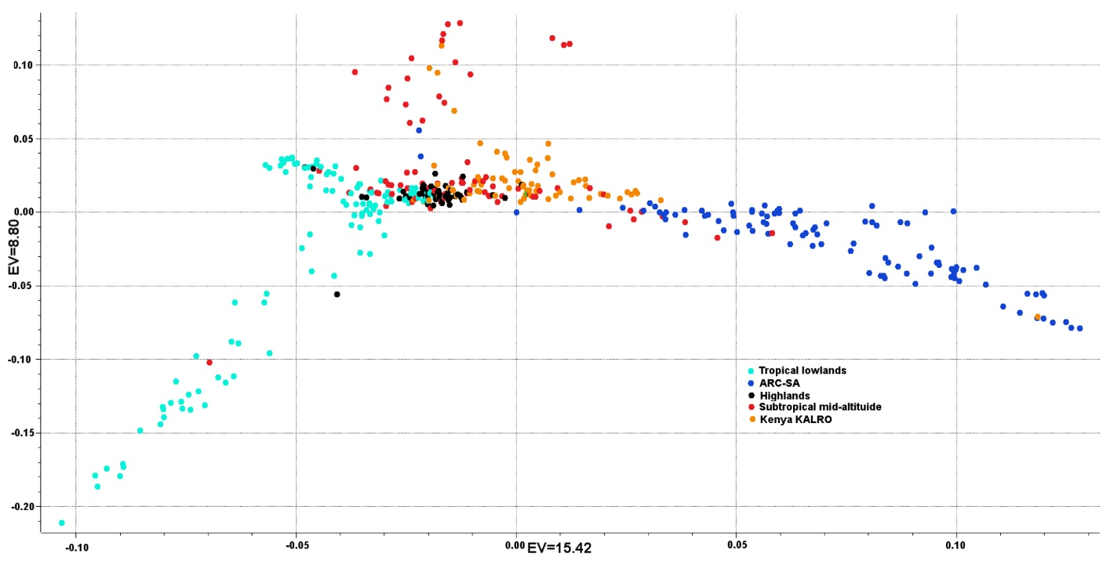

Supplementary Figure S1: Population structure based on principal component (PC) analysis of IMAS association mapping panel

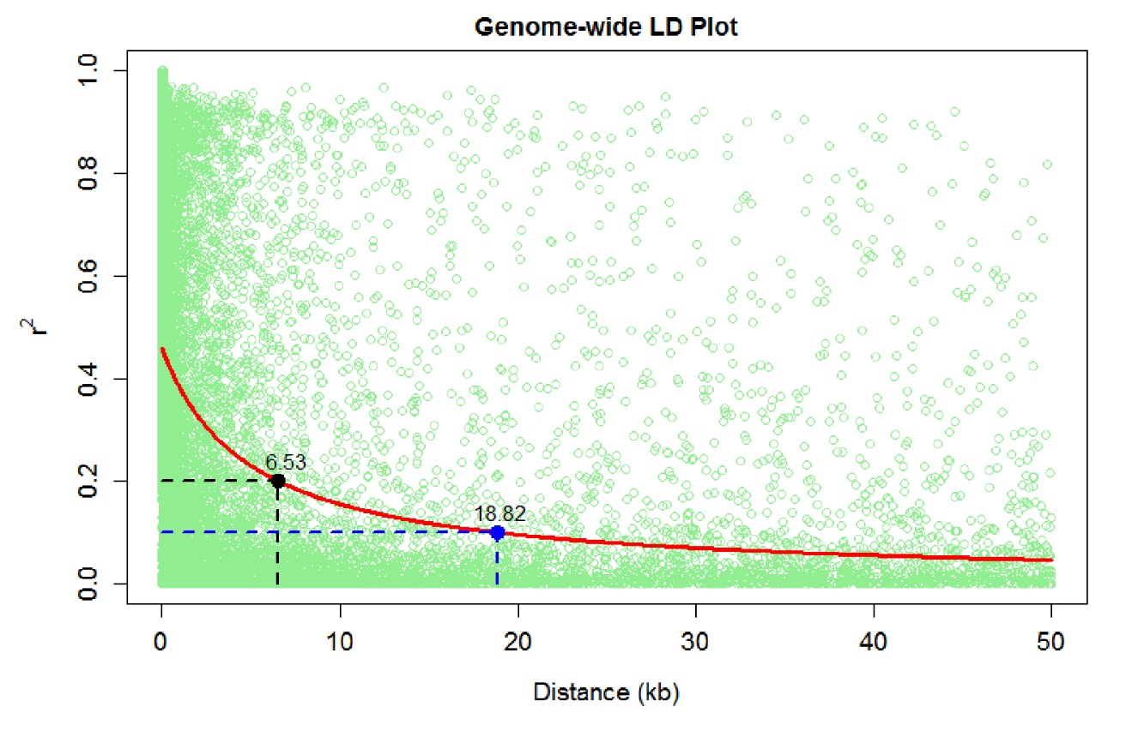
Supplementary Figure S2. Linkage disequilibrium (LD) plot representing the average genome-wide LD decay of the IMAS panel. The values on the Y-axis represent the squared correlation coefficient (r²) and the X-axis represents the genetic distance in kilobases (Kb). The blue and black dashed lines show the LD threshold for the association panel at r²=0.1 and 0.2, respectively.

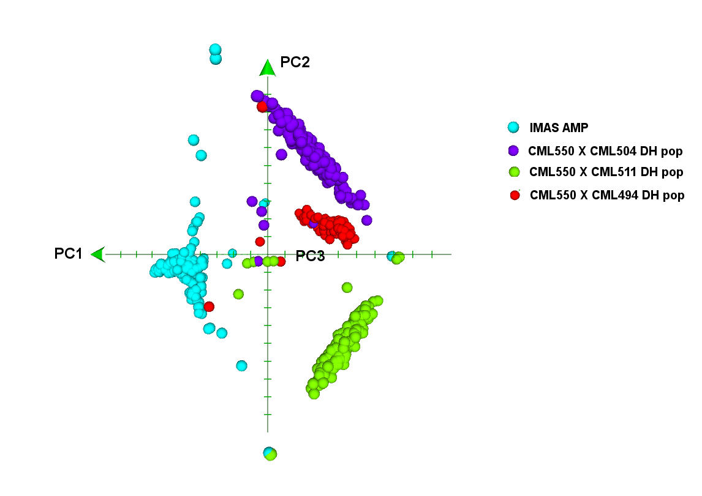

Supplementary Figure S3. Principal component (PC) analysis across IMAS association mapping panel and three DH populations.

Supplementary Figure S4: Integrated physical map and positioning of the QTL detected in three DH populations and joint linkage association mapping and IMAS association mapping for MCMV and MLN resistance. The number in the left side of the map are the distance in Mbp. QTL name composed by the trait code followed by the chromosome number in which the QTL was mapped and a physical position of the QTL. QTL detected for MCMV and MLN were marked with green and red color, respectively. Pop1 – CML550 x CML504; Pop2 – CML550 x CML511; Pop3 – CML550 x CML494; JLAM – Joint linkage association mapping; GWAS – Genome-wide association mapping
.

