T. aestivum A copy (TraesCS5A02G133000)
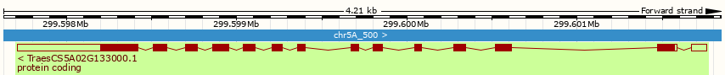

T. urartu A copy (TRIUR3_13472)
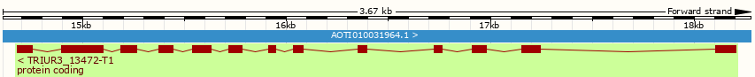

T. dicoccoides A copy (TRIDC5AG022500)
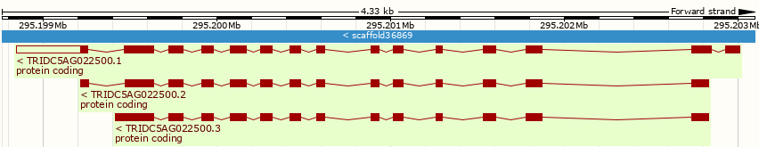

T. aestivum B copy (TraesCS5B02G131900)
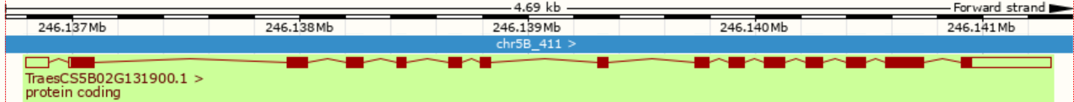

T. dicoccoides B copy (TRIDC5BG023380)
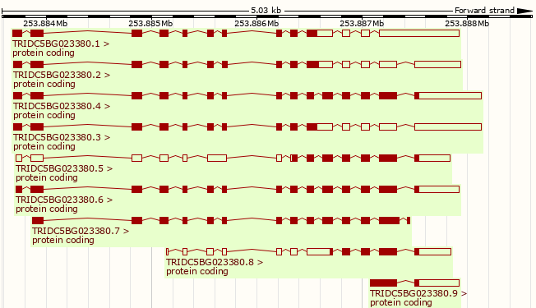

T. aestivum D copy (TraesCS5D02G141200)
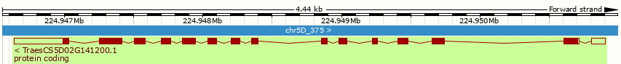

Ae. tauschii D copy (AET5Gv20357200)
